Alexa Summers, Santhoshini Sree Bolisetty, Gireesh Kumar Muppalla

CS 5565 Dr. Song

10.

(a)

The plot does not show any linear relationship between predictors

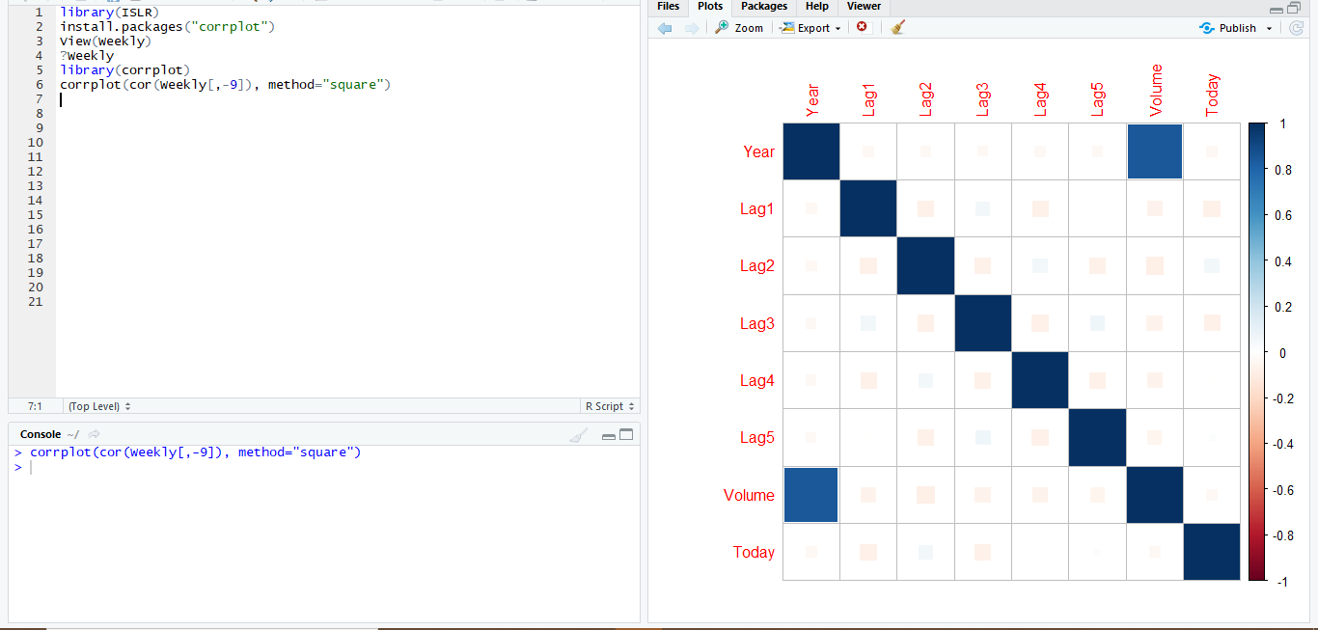

(b)

The only variable which has low p value(<0.05) is lag2. Hence, it is the only predictor to be considered as statistically significant

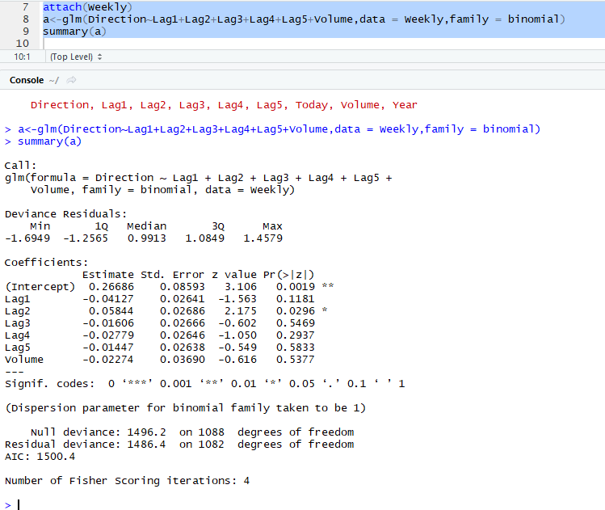

( c)

Total weekly trend:

(54+557)/(54+48+430+557)=0.5611

Up weekly trends:

557/(430+557)=0.9207

Down weekly trends:

54/(430+54)=0.1115

From the above information, we can conclude that the model predicted the up weekly trend 92.07% correctly.

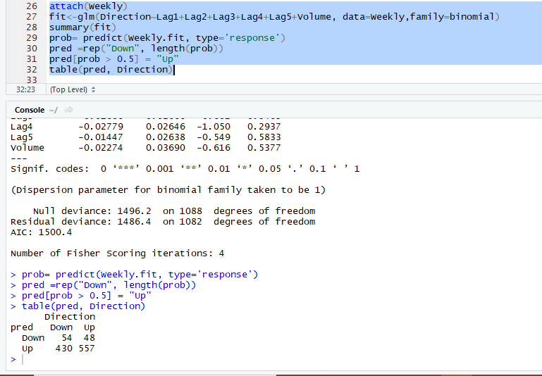

(d)

From below, we can say that the model gave 62.5% accuracy rate. While the downward and upward trends gives 91.80% and 20.83% accuracy.

This means that the model is predicting downward trends way more correct than the upward trends

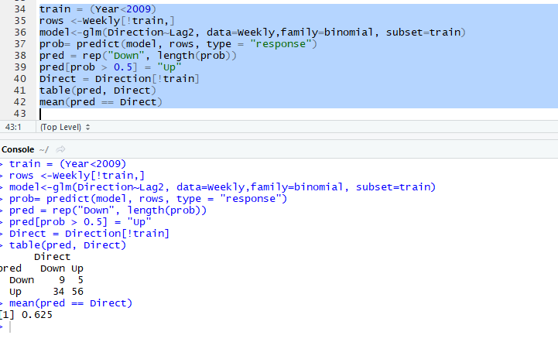

( e)

The logistic and lda are giving the same accuracy rates.

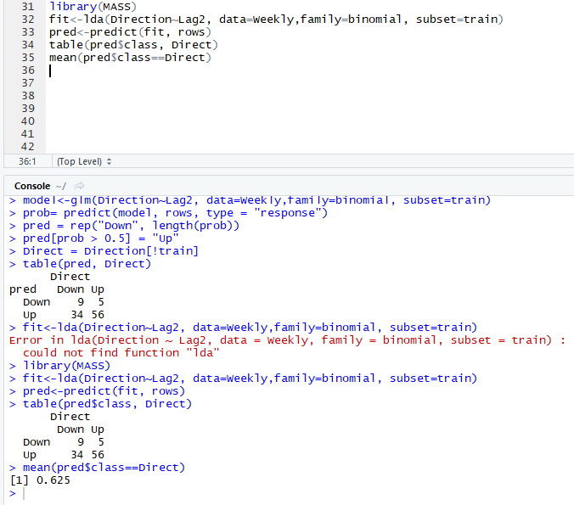

(f)

The qda is giving the lower accuracy compared to logistic and lda models.

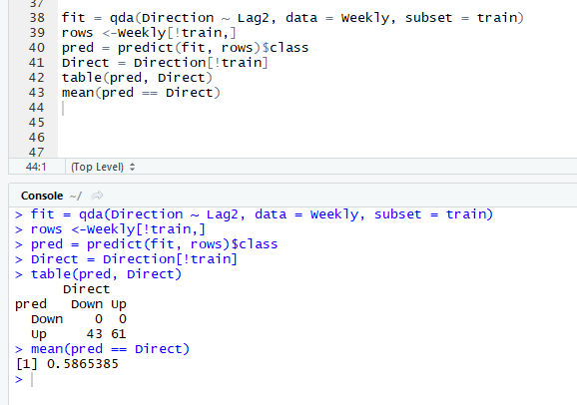

(g)

The knn model is giving a 50% accuracy. 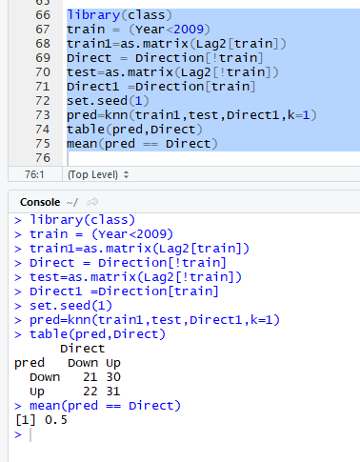

(h)

From this we say that the logistic and lda models are giving the better accuracy rates(62.5%)

(i)

The below shows the logistic model, which is giving a 54.06% accuracy

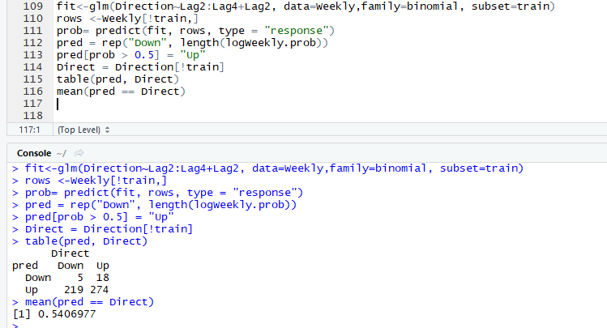

The lda model is giving 55.2% accuracy

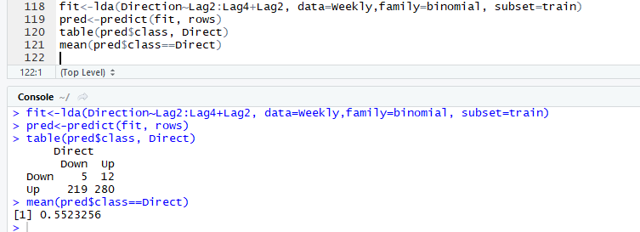

When k=1 and k=2, the knn model is giving accuracy rates 49.4% and 52.1%

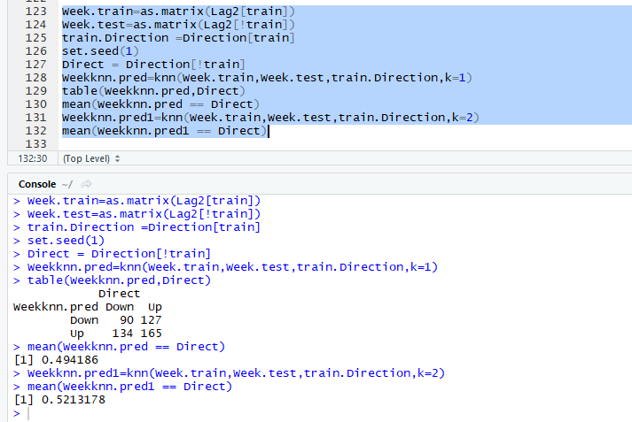

From this we can conclude that the lda and logistic models are giving a better accuracy rates for this data.

11.

(a)

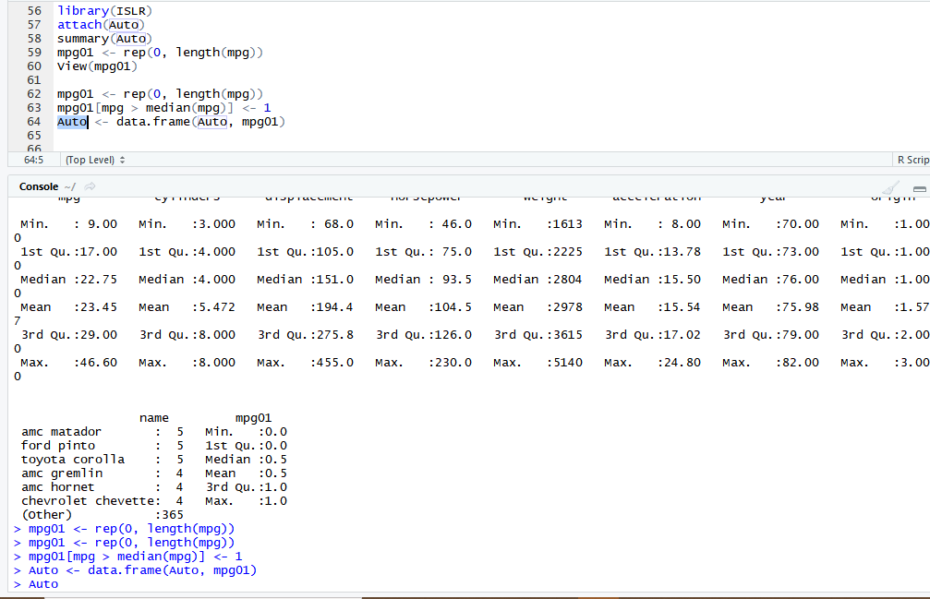

(b)

Cylinder, displacement and weight are correlating strongly with mpg01. horsepower and origin also correlate with mpg01.

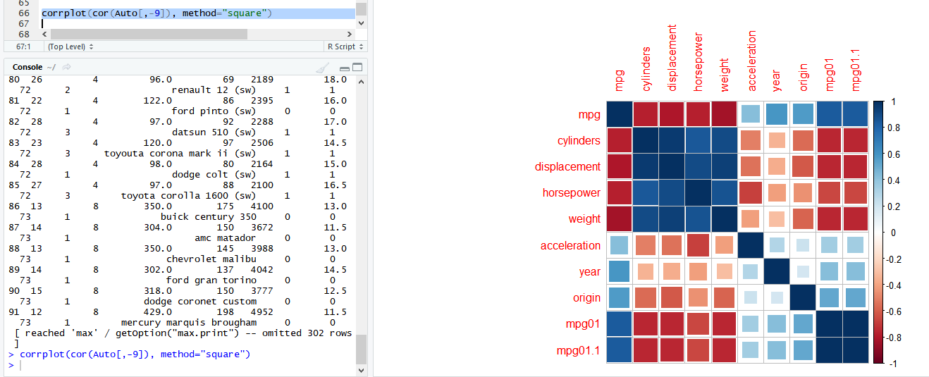

( c)

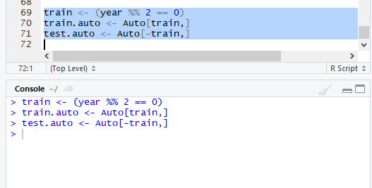

(d)

lda model is giving an error rate of 8.44%

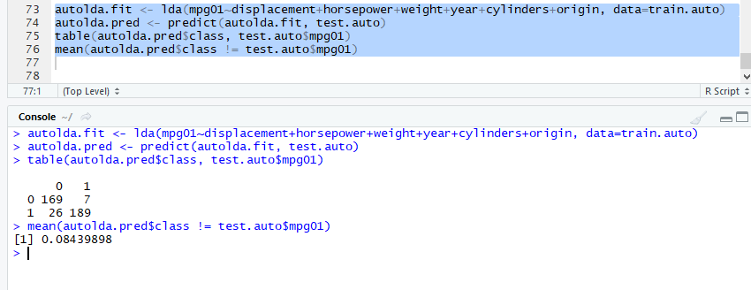

( e)

Qda is giving an error rate of 9.97%

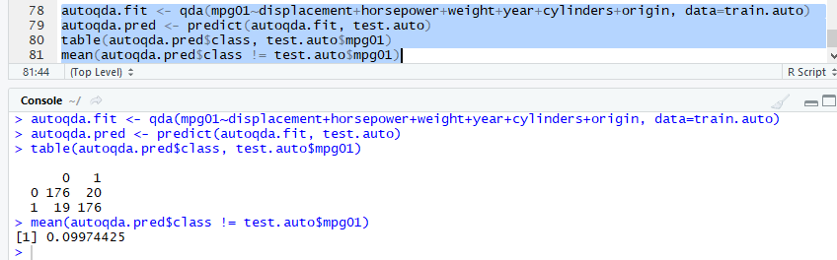

(f)

The logistic regression method is giving an error rate of 8.44%

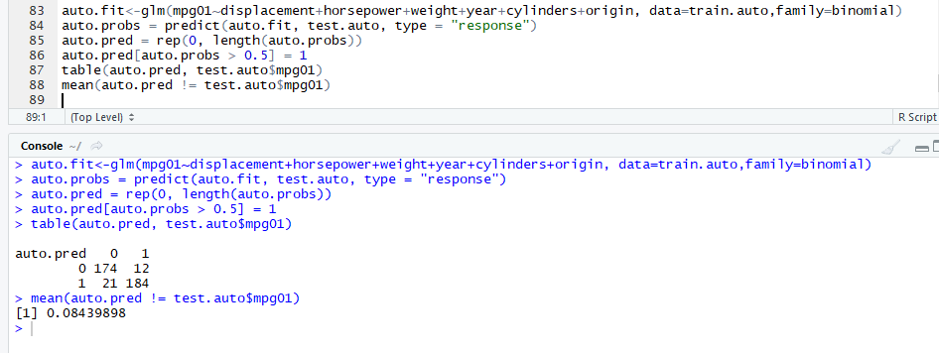

(g)

K=1 is giving a lower error rate compared to k=2 and k=3. This can concluded as the error rate keeps increasing with an increasing value of k.

