**SQL Analysis**

--create the database

CREATE DATABASE bankLoans;

--use the database

USE bankLoans;

--create an schema for the tables and more

create schema operations;

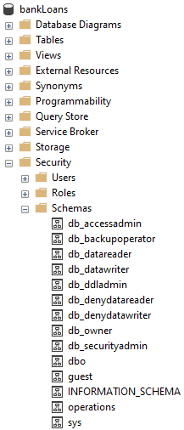

--we import the csv file into a new table in the database

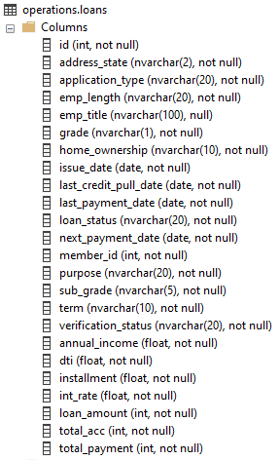

--show the table

SELECT * FROM operations.loans;

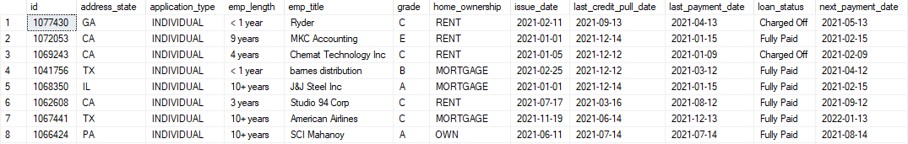

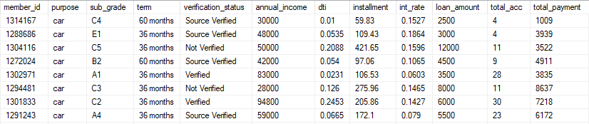

--measures

SELECT

COUNT(id) AS CountOfId,

SUM(loan_amount) AS SumOfLoanAmount,

SUM(total_payment) AS SumOfTotalPayment,

CAST((AVG(int_rate) * 100) AS DECIMAL(10,2)) AS AverageIntRate,

CAST((AVG(dti) * 100) AS DECIMAL(10,2)) AS AverageDti

FROM

operations.loans



--month to date (MTD) measures

SELECT

COUNT(id) AS CountOfId,

SUM(loan_amount) AS SumOfLoanAmount,

SUM(total_payment) AS SumOfTotalPayment,

CAST((AVG(int_rate) * 100) AS DECIMAL(10,2)) AS AverageIntRate,

CAST((AVG(dti) * 100) AS DECIMAL(10,2)) AS AverageDti

FROM

operations.loans

WHERE

MONTH(issue_date) = 12



--previous month to date (PMTD) measures

SELECT

COUNT(id) AS CountOfId,

SUM(loan_amount) AS SumOfLoanAmount,

SUM(total_payment) AS SumOfTotalPayment,

CAST((AVG(int_rate) * 100) AS DECIMAL(10,2)) AS AverageIntRate,

CAST((AVG(dti) * 100) AS DECIMAL(10,2)) AS AverageDti

FROM

operations.loans

WHERE

MONTH(issue_date) = 11



--create a table to store measures

CREATE TABLE operations.#measures (

MonthToDateMeasures FLOAT NOT NULL,

PreviousMonthToDateMeasures FLOAT NOT NULL

)

SELECT * FROM operations.#measures



--CountOfId MTD and CountOfId PMTD

DECLARE @CountOfIdMTD FLOAT = ( SELECT

COUNT(id) AS CountOfId

FROM

operations.loans

WHERE

MONTH(issue_date) = 12 )

DECLARE @CountOfIdPMTD FLOAT = ( SELECT

COUNT(id) AS CountOfId

FROM

operations.loans

WHERE

MONTH(issue_date) = 11 )

--SumOfLoanAmount MTD and SumOfLoanAmount PMTD

DECLARE @SumOfLoanAmountMTD FLOAT = ( SELECT

SUM(loan_amount) AS SumOfLoanAmount

FROM

operations.loans

WHERE

MONTH(issue_date) = 12 )

DECLARE @SumOfLoanAmountPMTD FLOAT = ( SELECT

SUM(loan_amount) AS SumOfLoanAmount

FROM

operations.loans

WHERE

MONTH(issue_date) = 11 )

--SumOfTotalPayment MTD and SumOfTotalPayment PMTD

DECLARE @SumOfTotalPaymentMTD FLOAT = ( SELECT

SUM(total_payment) AS SumOfTotalPayment

FROM

operations.loans

WHERE

MONTH(issue_date) = 12 )

DECLARE @SumOfTotalPaymentPMTD FLOAT = ( SELECT

SUM(total_payment) AS SumOfTotalPayment

FROM

operations.loans

WHERE

MONTH(issue_date) = 11 )

--AverageIntRate MTD and AverageIntRate PMTD

DECLARE @AverageIntRateMTD FLOAT = ( SELECT

CAST((AVG(int_rate) * 100) AS DECIMAL(10,2)) AS AverageIntRate

FROM

operations.loans

WHERE

MONTH(issue_date) = 12 )

DECLARE @AverageIntRatePMTD FLOAT = ( SELECT

CAST((AVG(int_rate) * 100) AS DECIMAL(10,2)) AS AverageIntRate

FROM

operations.loans

WHERE

MONTH(issue_date) = 11 )

--AverageDti MTD and AverageDti PMTD

DECLARE @AverageDtiMTD FLOAT = ( SELECT

CAST((AVG(dti) * 100) AS DECIMAL(10,2)) AS AverageDti

FROM

operations.loans

WHERE

MONTH(issue_date) = 12 )

DECLARE @AverageDtiPMTD FLOAT = ( SELECT

CAST((AVG(dti) * 100) AS DECIMAL(10,2)) AS AverageDti

FROM

operations.loans

WHERE

MONTH(issue_date) = 11 )

INSERT INTO operations.#measures

VALUES

(@CountOfIdMTD,@CountOfIdPMTD),

(@SumOfLoanAmountMTD,@SumOfLoanAmountPMTD),

(@SumOfTotalPaymentMTD,@SumOfTotalPaymentPMTD),

(@AverageIntRateMTD,@AverageIntRatePMTD),

(@AverageDtiMTD,@AverageDtiPMTD)

SELECT * FROM operations.#measures

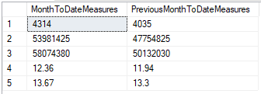

--getting MonthOverMonth measures

SELECT

*,

CAST(((MonthToDateMeasures - PreviousMonthToDateMeasures) / PreviousMonthToDateMeasures * 100) AS DECIMAL(10,2)) AS MonthOverMonthMeasures

FROM

operations.#measures

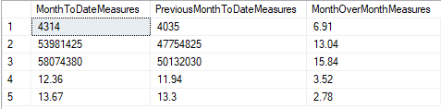

--there is three loan status

--Fully Paid is Good Loan

--Current is Good Loan

--Charged Off is Bad Loan

SELECT DISTINCT [loan_status] FROM operations.loans

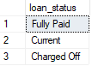

--create a new column depending in the loan status

BEGIN TRAN

ALTER TABLE

operations.loans

ADD

goodLoanVsBadLoan NVARCHAR(10) NULL;

SELECT * FROM operations.loans;

COMMIT TRAN

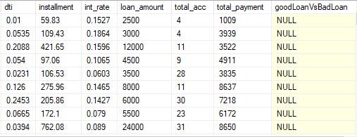

--Filling the goodLoanVsBadLoan column

--Fully Paid is Good Loan

--Current is Good Loan

--Charged Off is Bad Loan

BEGIN TRAN

UPDATE

operations.loans

SET

goodLoanVsBadLoan =

CASE

WHEN loan_status = 'Fully Paid' THEN 'Good Loan'

WHEN loan_status = 'Current' THEN 'Good Loan'

WHEN loan_status = 'Charged Off' THEN 'Bad Loan'

END

SELECT * FROM operations.loans

COMMIT TRAN

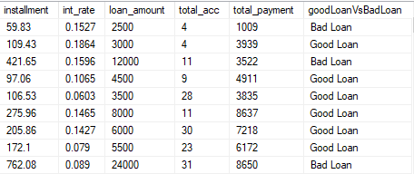

--bad loan and good loan measures

DECLARE @totalCount FLOAT = ( SELECT

COUNT(*)

FROM

operations.loans)

SELECT

goodLoanVsBadLoan,

CAST((COUNT(*) / @totalCount * 100) AS DECIMAL(10,2)) AS PercentageOfTotal,

COUNT(*) AS CountOfLoans,

SUM(loan_amount) AS SumOfLoanAmount,

SUM(total_payment) AS SumOfTotalPayment

FROM

operations.loans

GROUP BY

goodLoanVsBadLoan



--loan status measures

DECLARE @totalCount FLOAT = ( SELECT

COUNT(*)

FROM

operations.loans)

SELECT

loan_status,

CAST((COUNT(*) / @totalCount * 100) AS DECIMAL(10,2)) AS PercentageOfTotal,

COUNT(*) AS CountOfLoans,

SUM(loan_amount) AS SumOfLoanAmount,

SUM(total_payment) AS SumOfTotalPayment,

CAST((AVG(int_rate) * 100) AS DECIMAL(10,2)) AS AverageIntRate,

CAST((AVG(dti)*100) AS DECIMAL(10,2)) AS AverageDti

FROM

operations.loans

GROUP BY

loan_status

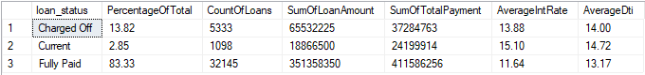

--Monthly Trends By Loan Issue Date

WITH monthAdded AS (

SELECT

*,

FORMAT(

issue_date,

'MMMM'

) AS loanIssueDateMonth

FROM

operations.loans

)

SELECT

loanIssueDateMonth,

COUNT(*) AS CountOfLoans

FROM

monthAdded

GROUP BY

loanIssueDateMonth

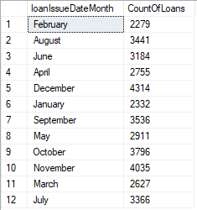

--Regional Analysis By State

SELECT

address_state,

COUNT(*) AS CountOfLoans

FROM

operations.loans

GROUP BY

address_state

ORDER BY

address_state ASC

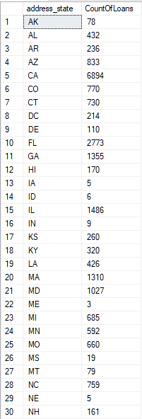

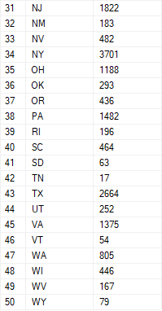

--loan termn analysis

DECLARE @totalCount FLOAT = ( SELECT

COUNT(*)

FROM

operations.loans)

SELECT

term,

COUNT(*) AS CountOfLoans,

CAST((COUNT(*) / @totalCount * 100) AS DECIMAL(10,2)) AS PercentageOfTotal

FROM

operations.loans

GROUP BY

term



--employee lenght analysis

SELECT

emp_length,

COUNT(*) AS CountOfLoans

FROM

operations.loans

GROUP BY

emp_length

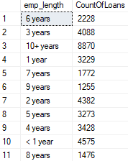

--purpose analysis

SELECT

purpose,

COUNT(*) AS CountOfLoans

FROM

operations.loans

GROUP BY

purpose

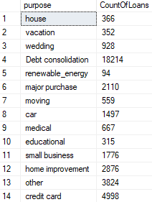

--purpose analysis

SELECT

home_ownership,

COUNT(*) AS CountOfLoans

FROM

operations.loans

GROUP BY

home_ownership

