**SQL Analysis**

--create the database

CREATE DATABASE hinoStore;

--use the database

USE hinoStore;

--create an schema for the tables and more

create schema operations;

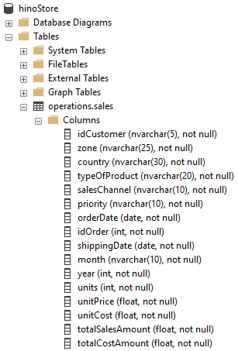

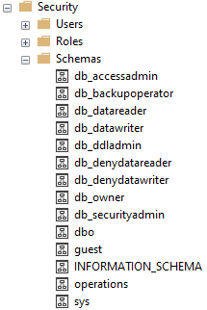

--we import the csv file into a new table in the database

--show the table

SELECT * FROM operations.sales;

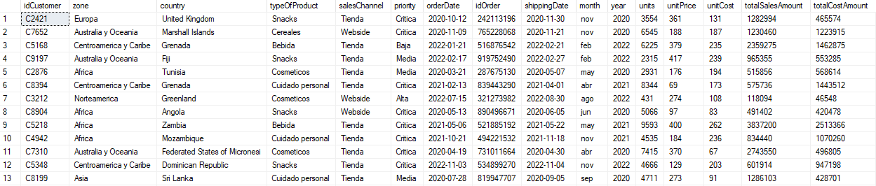

--analysis of the column totalSalesAmount

SELECT

SUM(totalSalesAmount) AS SumOfTotalSalesAmount

FROM

operations.sales



--analysis of the column estado

DECLARE @totalCount FLOAT = (SELECT COUNT(*) FROM operations.sales)

SELECT @totalCount AS totalCountOfSales

SELECT

salesChannel,

COUNT(*) AS SalesCount,

CAST((COUNT(*) / @totalCount * 100) AS DECIMAL(10,2)) AS PercentageOfTotal

FROM

operations.sales

GROUP BY

salesChannel





--total sales amount by type of product

SELECT

typeOfProduct,

SUM(totalSalesAmount) AS SumOfTotalSalesAmount

FROM

operations.sales

GROUP BY

typeOfProduct

ORDER BY

SumOfTotalSalesAmount DESC

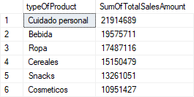

--analysis of the distinct values of the column month

SELECT

DISTINCT month

FROM

operations.sales

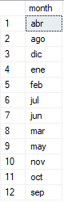

--setting the full name of months in the column month using a transaction

BEGIN TRAN

UPDATE

operations.sales

SET

month =

CASE

WHEN month = 'ene' THEN 'Enero'

WHEN month = 'feb' THEN 'Febrero'

WHEN month = 'mar' THEN 'Marzo'

WHEN month = 'abr' THEN 'Abril'

WHEN month = 'may' THEN 'Mayo'

WHEN month = 'jun' THEN 'Junio'

WHEN month = 'jul' THEN 'Julio'

WHEN month = 'ago' THEN 'Agosto'

WHEN month = 'sep' THEN 'Septiembre'

WHEN month = 'oct' THEN 'Octubre'

WHEN month = 'nov' THEN 'Noviembre'

WHEN month = 'dic' THEN 'Diciembre'

END

--check the full name of the months

SELECT

DISTINCT month

FROM

operations.sales

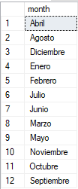

SELECT * FROM operations.sales

COMMIT TRAN

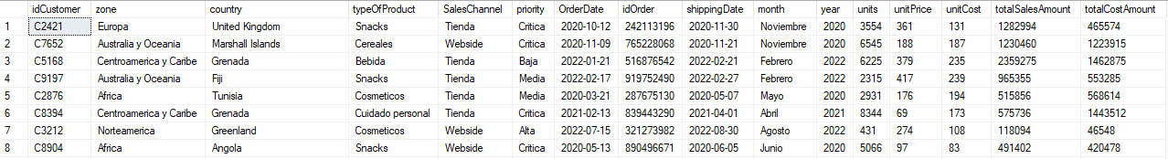

--total sales amount by month

SELECT

month,

SUM(totalSalesAmount) AS SumOfTotalSalesAmount

FROM

operations.sales

GROUP BY

month

ORDER BY

SumOfTotalSalesAmount DESC

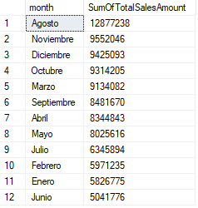

--sum of total sales amount by sales channel and percentage of total

DECLARE @totalSum FLOAT = (SELECT SUM(totalSalesAmount) FROM operations.sales)

SELECT @totalSum AS SumOftotalSalesAmount

SELECT

salesChannel,

SUM(totalSalesAmount) AS SumOftotalSalesAmount,

CAST((SUM(totalSalesAmount) / @totalSum * 100) AS DECIMAL(10,2)) AS PercentageOfTotal,

(100 - CAST((SUM(totalSalesAmount) / @totalSum * 100) AS DECIMAL(10,2))) AS RestOfPercentageTotal

FROM

operations.sales

GROUP BY

salesChannel

ORDER BY

SumOftotalSalesAmount DESC





--sum of total sales amount by country

SELECT

country,

SUM(totalSalesAmount) AS SumOftotalSalesAmount

FROM

operations.sales

GROUP BY

country

ORDER BY

SumOftotalSalesAmount DESC

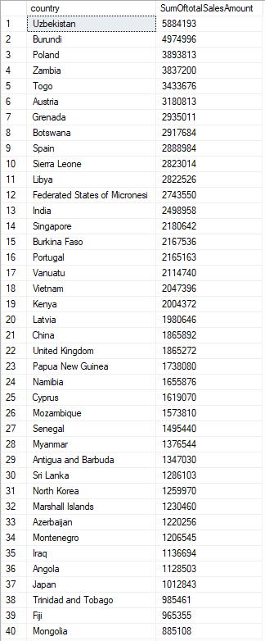

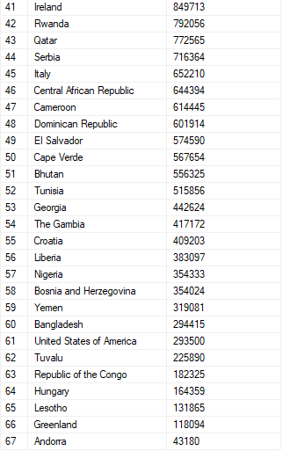

--the top 5 countries by sum of total sales amount

SELECT

TOP 5 country,

SUM(totalSalesAmount) AS SumOftotalSalesAmount

FROM

operations.sales

GROUP BY

country

ORDER BY

SumOftotalSalesAmount DESC

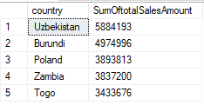

--the last 5 countries by sum of total sales amount

SELECT

TOP 5 country,

SUM(totalSalesAmount) AS SumOftotalSalesAmount

FROM

operations.sales

GROUP BY

country

ORDER BY

SumOftotalSalesAmount ASC

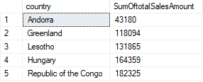

--sum of total sales amount

DECLARE @SumOftotalSalesAmount FLOAT = (SELECT SUM(totalSalesAmount) FROM operations.sales)

SELECT @SumOftotalSalesAmount AS SumOftotalSalesAmount



--sum of total cost amount

DECLARE @SumOftotalCostAmount FLOAT = (SELECT SUM(totalCostAmount) FROM operations.sales)

SELECT @SumOftotalCostAmount AS SumOftotalCostAmount



--sum of units by zone

SELECT

zone,

SUM(units) AS SumOfUnits

FROM

operations.sales

GROUP BY

zone

ORDER BY

SumOfUnits DESC

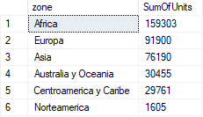

--sum of total sales amount by year

SELECT

year,

SUM(totalSalesAmount) AS SumOftotalSalesAmount

FROM

operations.sales

GROUP BY

year

ORDER BY

SumOftotalSalesAmount DESC

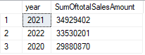

--sum of total sales amount

DECLARE @SumOftotalSalesAmount FLOAT = (SELECT SUM(totalSalesAmount) FROM operations.sales)

SELECT @SumOftotalSalesAmount AS SumOftotalSalesAmount



--sum of total sales amount by zone

SELECT

zone,

SUM(totalSalesAmount) AS SumOftotalSalesAmount,

CAST((SUM(totalSalesAmount) / @SumOftotalSalesAmount * 100) AS DECIMAL(10,2)) AS PercentageOfTotal

FROM

operations.sales

GROUP BY

zone

ORDER BY

SumOftotalSalesAmount DESC

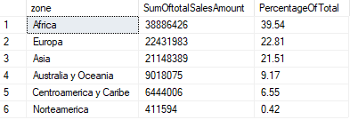

--count of sales by priority

SELECT

priority,

COUNT(*) AS SalesCount

FROM

operations.sales

GROUP BY

Priority

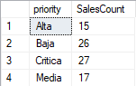

--sum of total sales amount by sales channel and type of product

SELECT

salesChannel,

typeOfProduct,

SUM(totalSalesAmount) AS SumOftotalSalesAmount

FROM

operations.sales

GROUP BY

salesChannel,

typeOfProduct

ORDER BY

salesChannel ASC,

SumOftotalSalesAmount DESC

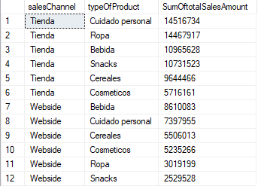

--sum of total sales amount by year and type of product

SELECT

year,

typeOfProduct,

SUM(totalSalesAmount) AS SumOftotalSalesAmount

FROM

operations.sales

GROUP BY

year,

typeOfProduct

ORDER BY

year DESC,

SumOftotalSalesAmount DESC

