**SQL Analysis**

--create the database

CREATE DATABASE mayoHospital;

--use the database

USE mayoHospital;

--create an schema for the tables and more

create schema humanResources;

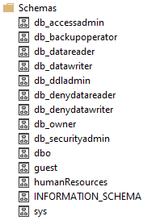

--we import the csv file into a new table in the database

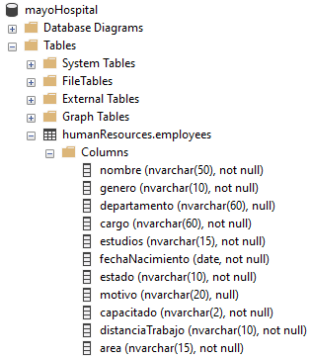

--show the table

SELECT * FROM humanResources.employees;

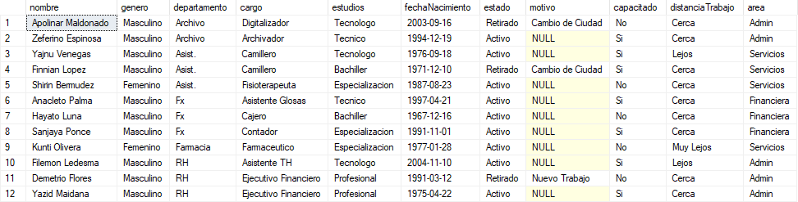

--adding a new columns

BEGIN TRAN

ALTER TABLE humanResources.employees

ADD

edad INT NULL,

intervalo NVARCHAR(10) NULL,

icono NVARCHAR(1) NULL

SELECT * FROM humanResources.employees

COMMIT TRAN

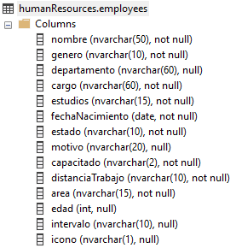

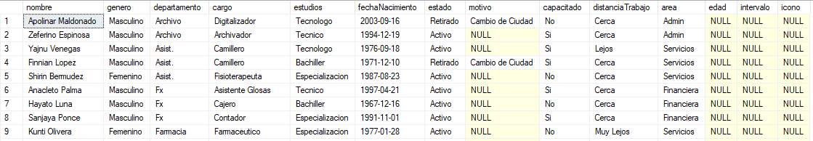

--set administracion instead of admin in the area column

BEGIN TRAN

UPDATE

humanResources.employees

SET

area =

CASE

WHEN area = 'Admin' THEN 'Administracion'

ELSE area

END

SELECT

DISTINCT area

FROM

humanResources.employees

SELECT * FROM humanResources.employees

COMMIT TRAN

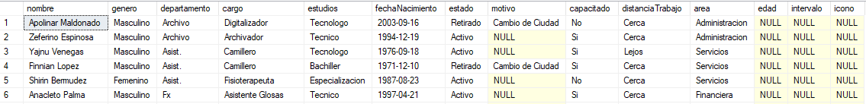

--filling the edad column

BEGIN TRAN

UPDATE

humanResources.employees

SET

edad =

FLOOR(

DATEDIFF(

DAY,

fechaNacimiento,

GETDATE()

)

/ 365.0

)

SELECT * FROM humanResources.employees

COMMIT TRAN

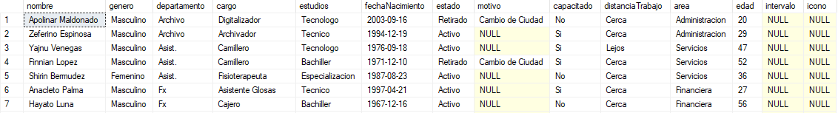

--filling the intervalo column with the ranges

--there are ages from 19 to 61

--use the follow intervals

--18-25

--26-35

--36-45

--46-55

--56 o Más

BEGIN TRAN

UPDATE

humanResources.employees

SET

intervalo =

CASE

WHEN edad <= 25 THEN '18-25'

WHEN edad <= 35 THEN '26-35'

WHEN edad <= 45 THEN '36-45'

WHEN edad <= 55 THEN '46-55'

ELSE '56 o Mas'

END

SELECT * FROM humanResources.employees

COMMIT TRAN

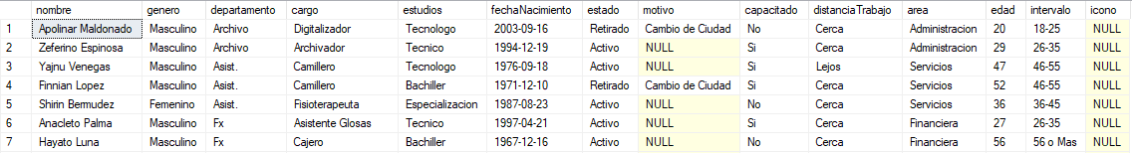

--filling the icono column

BEGIN TRAN

UPDATE

humanResources.employees

SET

icono =

CASE

WHEN genero = 'Masculino' THEN 'M'

WHEN genero = 'Femenino' THEN 'F'

END

SELECT * FROM humanResources.employees

COMMIT TRAN

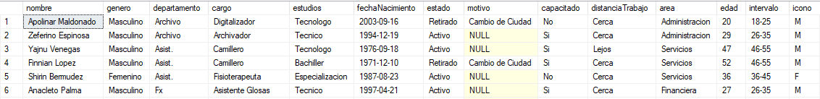

--analysis of the column estado

DECLARE @totalCount FLOAT = (SELECT COUNT(*) FROM humanResources.employees)

SELECT @totalCount AS totalCountOfEmployees

SELECT

estado,

COUNT(*) AS SumOfEmployees,

CAST((COUNT(*) / @totalCount * 100) AS DECIMAL(10,2)) AS PercentageOfTotal

FROM

humanResources.employees

GROUP BY

Estado





--analysis of the column intervalo and genero

SELECT

intervalo,

genero,

COUNT(*) AS SumOfEmployees

FROM

humanResources.employees

WHERE

estado = 'Retirado'

GROUP BY

intervalo,

genero

ORDER BY

intervalo ASC

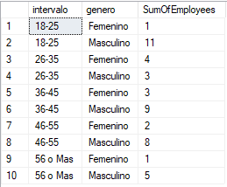

--analysis of job dropout in the column genero

DECLARE @totalCount FLOAT = (SELECT COUNT(*) FROM humanResources.employees WHERE estado = 'Retirado')

SELECT @totalCount AS totalCountOfEmployeesRetired

SELECT

genero,

COUNT(*) AS SumOfEmployees,

CAST((COUNT(*) / @totalCount * 100) AS DECIMAL(10,2)) AS PercentageOfTotal

FROM

humanResources.employees

WHERE

estado = 'Retirado'

GROUP BY

Genero





--analysis of job dropout in the column estudios

SELECT

estudios,

COUNT(*) AS SumOfEmployees

FROM

humanResources.employees

WHERE

estado = 'Retirado'

GROUP BY

Estudios

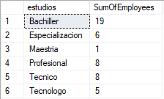

--analysis of job dropout in the column area

SELECT

area,

COUNT(*) AS SumOfEmployees

FROM

humanResources.employees

WHERE

estado = 'Retirado'

GROUP BY

Área

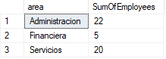

--analysis of the column cargo

SELECT

TOP 10 cargo,

COUNT(*) AS SumOfEmployees

FROM

humanResources.employees

WHERE

estado = 'Retirado'

GROUP BY

cargo

ORDER BY

SumOfEmployees DESC

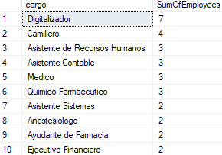

--analysis of the column capacitado

SELECT

capacitado,

COUNT(*) AS SumOfEmployees

FROM

humanResources.employees

WHERE

estado = 'Retirado'

GROUP BY

capacitado



--analysis of the column edad

SELECT

AVG(edad) AS AverageAge

FROM

humanResources.employees



--analysis of the column motivo

SELECT

motivo,

COUNT(*) AS SumOfEmployees

FROM

humanResources.employees

WHERE

estado = 'Retirado'

GROUP BY

motivo

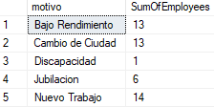

--analysis of the column distancia trabajo

DECLARE @totalCount FLOAT = (SELECT COUNT(*) FROM humanResources.employees WHERE estado = 'Retirado')

SELECT @totalCount AS totalCountOfEmployeesRetired

SELECT

distanciaTrabajo,

COUNT(*) AS SumOfEmployees,

CAST((COUNT(*) / @totalCount * 100) AS DECIMAL(10,2)) AS PercentageOfTotal,

CAST((100 - (COUNT(*) / @totalCount * 100)) AS DECIMAL(10,2)) AS TheRestOfPorcentage

FROM

humanResources.employees

WHERE

estado = 'Retirado'

GROUP BY

distanciaTrabajo



