**SQL Analysis**

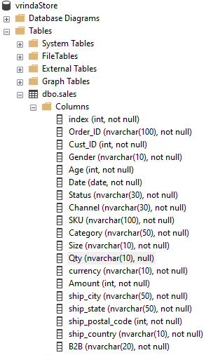

--we use the data base created

USE vrindaStore;

--showing the records

SELECT * FROM sales

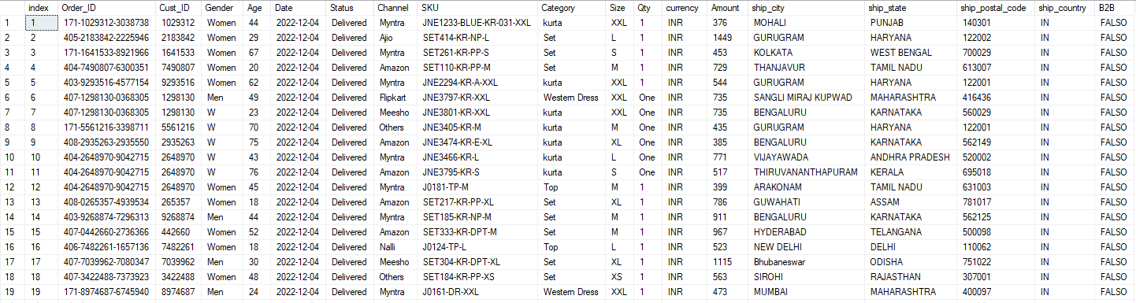

--Gender DISTINCT

SELECT

DISTINCT Gender

FROM

Sales

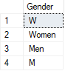

--Gender

BEGIN TRAN

UPDATE

sales

SET

Gender =

CASE

WHEN Gender = 'W' THEN 'Women'

WHEN Gender = 'M' THEN 'Men'

WHEN Gender = 'Women' THEN 'Women'

WHEN Gender = 'Men' THEN 'Men'

END

SELECT * FROM sales

COMMIT TRAN

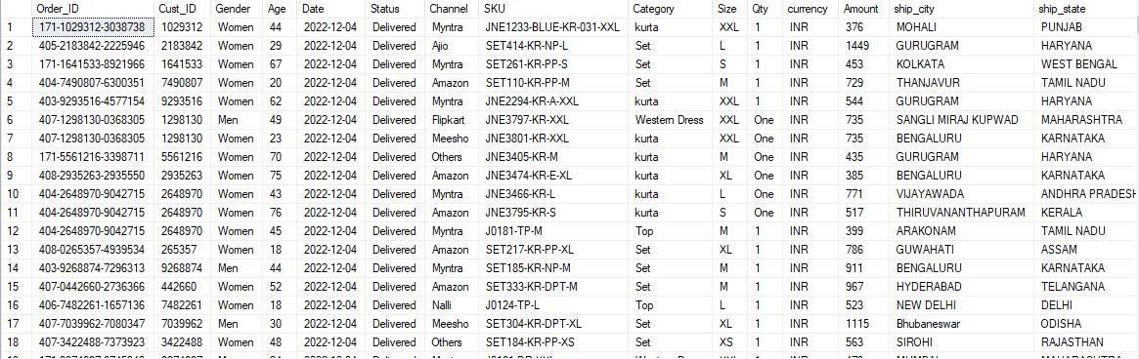

--adding a column for ageGroup

BEGIN TRAN;

ALTER TABLE sales

ADD ageGroup NVARCHAR(20)

SELECT * FROM sales

COMMIT TRAN

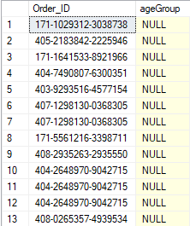

--adding a column for ageGroup

BEGIN TRAN

UPDATE

sales

SET

ageGroup =

CASE

WHEN Age < 30 THEN 'Young Adult'

WHEN Age < 50 THEN 'Adult'

ELSE 'Senior'

END

SELECT * FROM sales

COMMIT TRAN

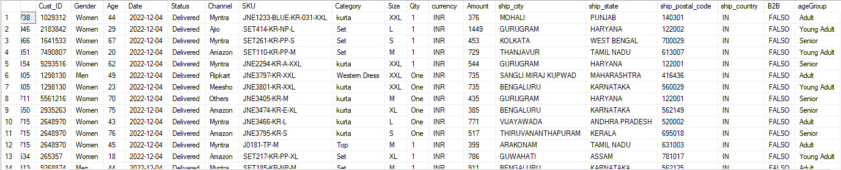

--adding a month column

BEGIN TRAN;

ALTER TABLE sales

ADD [month] NVARCHAR(20)

SELECT * FROM sales

COMMIT TRAN

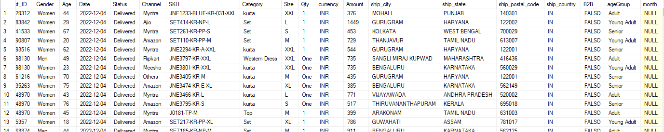

--getting the month of the date

BEGIN TRAN;

UPDATE

sales

SET

[month] =

FORMAT(

Date,

'MMMM'

);

SELECT * FROM sales

COMMIT TRAN

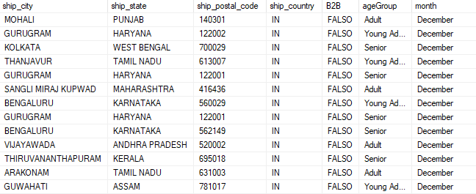

--quantity cleaning

BEGIN TRAN

UPDATE

sales

SET

Qty =

CASE

WHEN Qty = 'One' THEN 1

WHEN Qty = 'Two' THEN 2

WHEN Qty IN (1,2,3,4,5) THEN Qty

END

SELECT * FROM sales

COMMIT TRAN

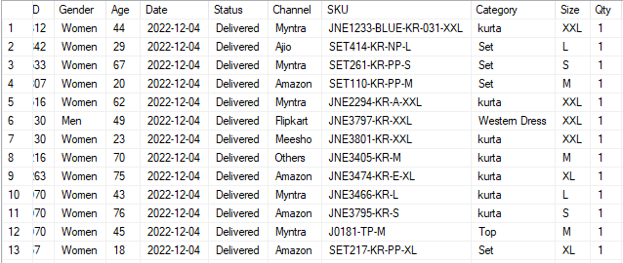

--sum of amount and total sales by month

SELECT

month,

SUM(Amount) AS SumOfAmount,

COUNT(*) AS CountOfSales

FROM sales

GROUP BY month

ORDER BY SumOfAmount DESC

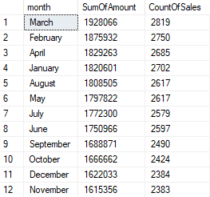

--sum of amount and total sales by month with monetary and numeric format

SELECT

month,

FORMAT(SUM(Amount), 'C') AS SumOfAmount,

FORMAT(COUNT(*),'N2') AS CountOfSales

FROM sales

GROUP BY month

ORDER BY SumOfAmount DESC

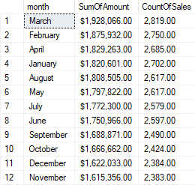

--women vs men sales percentage

WITH percentages AS (

SELECT

COUNT(*) AS totalSales,

SUM(

CASE

WHEN Gender = 'Women' THEN 1 ELSE 0

END

) AS WomenSalesCount,

SUM(

CASE

WHEN Gender = 'Men' THEN 1 ELSE 0

END

) AS MenSalesCount

FROM

sales

)

--getting the percentages

SELECT

CAST((CAST(WomenSalesCount AS DECIMAL(10,2)) / totalSales * 100) AS DECIMAL(10,2)) AS WomenPercentage,

CAST((CAST(MenSalesCount AS DECIMAL(10,2)) / totalSales * 100) AS DECIMAL(10,2)) AS MenPercentage

FROM percentages



--men vs women sales amount percentage

WITH percentages AS (

SELECT

SUM(Amount) AS TotalSumOfAmount,

SUM(

CASE

WHEN Gender = 'Women' THEN Amount ELSE 0

END

) AS SumOfWomenSalesAmount,

SUM(

CASE

WHEN Gender = 'Men' THEN Amount ELSE 0

END

) AS SumOfMenSalesAmount

FROM

sales

)

--getting the percentages

SELECT

CAST((CAST(SumOfWomenSalesAmount AS DECIMAL(10,2)) / TotalSumOfAmount * 100) AS DECIMAL(10,2)) AS WomenAmountPercentage,

CAST((CAST(SumOfMenSalesAmount AS DECIMAL(10,2)) / TotalSumOfAmount * 100) AS DECIMAL(10,2)) AS MenAmountPercentage

FROM percentages



--Status percentages

WITH percentages AS (

SELECT

COUNT(*) AS TotalSales,

SUM(

CASE

WHEN [Status] = 'Refunded' THEN 1 ELSE 0

END

) AS RefundedCount,

SUM(

CASE

WHEN [Status] = 'Returned' THEN 1 ELSE 0

END

) AS ReturnedCount,

SUM(

CASE

WHEN [Status] = 'Delivered' THEN 1 ELSE 0

END

) AS DeliveredCount,

SUM(

CASE

WHEN [Status] = 'Cancelled' THEN 1 ELSE 0

END

) AS CancelledCount

FROM

sales

)

--getting the percentages

SELECT

CAST((CAST(RefundedCount AS DECIMAL(10,2)) / TotalSales * 100) AS DECIMAL(10,2)) AS RefundedPercentage,

CAST((CAST(ReturnedCount AS DECIMAL(10,2)) / TotalSales * 100) AS DECIMAL(10,2)) AS ReturnedPercentage,

CAST((CAST(DeliveredCount AS DECIMAL(10,2)) / TotalSales * 100) AS DECIMAL(10,2)) AS DeliveredPercentage,

CAST((CAST(CancelledCount AS DECIMAL(10,2)) / TotalSales * 100) AS DECIMAL(10,2)) AS CancelledPercentage

FROM percentages



--sales: top 5 states

SELECT

TOP 5

ship_state,

SUM(Amount) AS SumOfAmount

FROM

sales

GROUP BY

ship_state

ORDER BY

SumOfAmount DESC

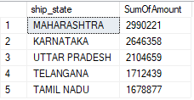

--sales formatted: top 5 states

SELECT

TOP 5

ship_state,

SUM(Amount) AS SumOfAmount,

FORMAT(SUM(Amount),'C') AS SumOfAmountFormatted

FROM

sales

GROUP BY

ship_state

ORDER BY

SumOfAmount DESC

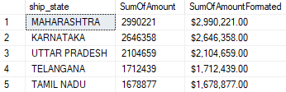

--age and gender percentages

DECLARE @totalSales INT

SET @totalSales = (SELECT COUNT(*) FROM sales)

SELECT

ageGroup,

Gender,

CAST((CAST(COUNT(*) AS DECIMAL(10,2)) / @totalSales * 100) AS DECIMAL(10,2)) AS SalesPercentage

FROM

sales

GROUP BY

ageGroup,

Gender

ORDER BY

ageGroup ASC,

Gender ASC

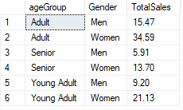

--channels percentages

DECLARE @totalSales INT

SET @totalSales = (SELECT COUNT(*) FROM sales)

SELECT

Channel,

CAST((CAST(COUNT(*) AS DECIMAL(10,2)) / @totalSales * 100) AS DECIMAL(10,2)) AS SalesPercentage

FROM

sales

GROUP BY

Channel

ORDER BY

SalesPercentage DESC

