University of Central Florida
Department of Computer Science
CDA 5106: Fall 2020
Machine Problem 2: Branch Prediction

by

Alexander Baekey

Honor Pledge: "I have neither given nor received unauthorized aid on this test or assignment."

Student’s electronic signature: __Alexander Baekey_____________
(sign by typing your name)

Smith Predictor:
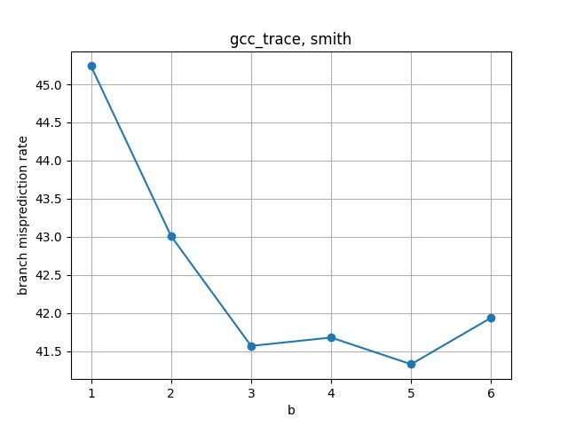

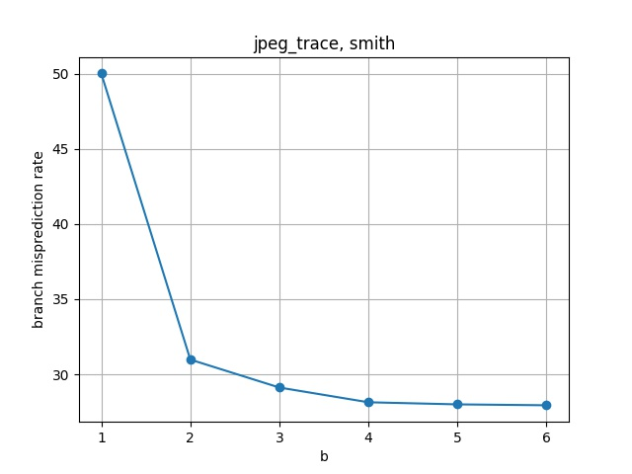

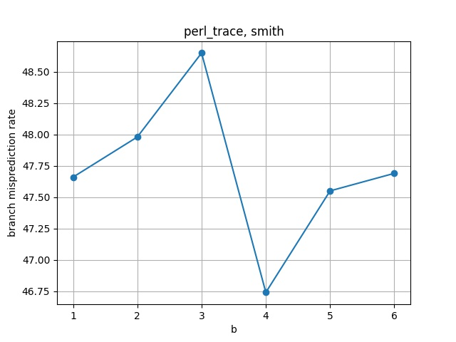

Bimodal Predictor:
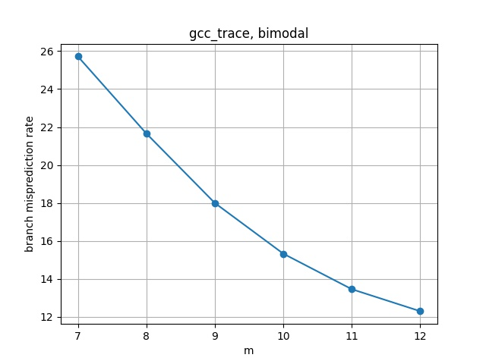

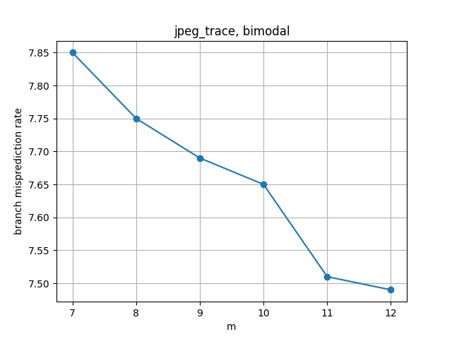

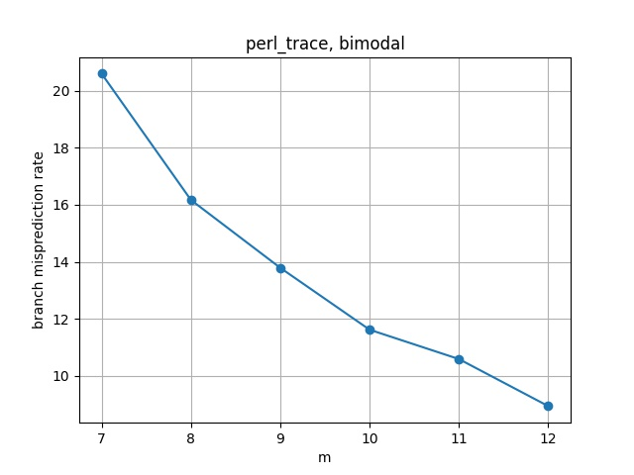

Gshare Predictor:

