University of Central Florida
Department of Computer Science
CDA 5106: Fall 2020
Machine Problem 3: Dynamic Instruction Scheduling

by

Alexander Baekey

Honor Pledge: "I have neither given nor received unauthorized aid on this test or assignment."

Student’s electronic signature: ______Alexander Baekey_______________
(sign by typing your name)

#1)

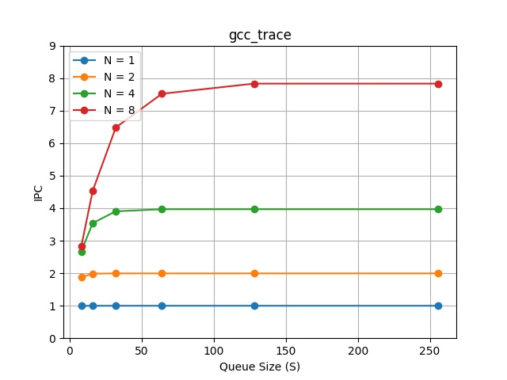

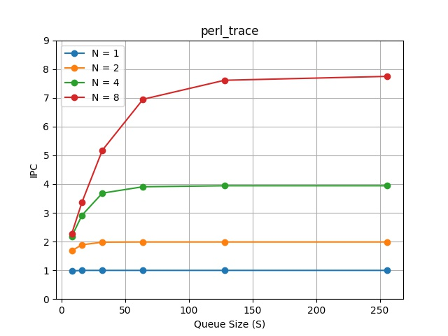

#2)

Optimized Scheduling Queue size per peak Fetch Rate
 | Benchmark = gcc | Benchmark = perl
N = 1 | 8 | 8
N = 2 | 16 | 16
N = 4 | 32 | 64
N = 8 | 64 | 128

#3)
3) Discussion.
A) The goal of a superscalar processor is to achieve an IPC that is close to peak
fetch rate (which is the peak theoretical IPC of the processor). Given this goal, please explain the
relationship between S and N.
B) With different benchmark (trace) files, one IPC is higher or
lower than the other with the same microarchitecture configuration. What could be reason?

