**Работа над ошибками**

**Лабораторная работа N1**

**Вариант:18.01.1998**

**Распечатка файла even-odd.cpp**

**#include "mlisp.h"**

**double dd = 18;**

**double mm = 01;**

**double yyyy = 1998;**

**double even__bits(double);**

**double odd__bits(double);**

**double odd__bits(double n)**

**{**

**return (n == 0 ? 0**

**: remainder(n,2) == 0 ?**

**odd__bits (quotient(n,2))**

**: true ? even__bits(quotient(n,2))**

**: _infinity);**

**}**

**double even__bits(double n)**

**{**

**return (n == 0 ? 1**

**: remainder(n,2) == 0 ?**

**even__bits (quotient(n,2))**

**: (odd__bits(quotient(n,2))));**

**}**

**double display__bin(double n)**

**{**

**display(remainder(n,2));**

**return (n == 0 ? 0**

**: display__bin(quotient(n,2)));**

**}**

**double report__results(double n)**

**{**

**display("Happy birthday to you!\n\t");**

**display(n);**

**display("(decimal)\n\t");**

**display__bin(n);**

**display("(reversed binary)\n");**

**display("\teven?\t");**

**display((even__bits(n) == 1 ? "yes" : "no"));**

**newline();**

**display("\todd?\t");**

**display((odd__bits(n) == 1 ? "yes" : "no"));**

**newline();**

**return 0;**

**}**

**int main(){**

**display(report__results (dd*1000000+**

**mm*10000+**

**yyyy));**

**newline();**

**std::cin.get();**

**}**

**Скриншот запуска на С++**

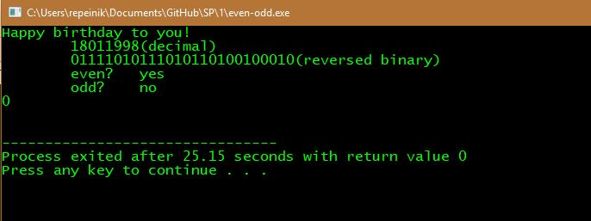

**Лабораторная работа N2**

**Вариант:06**

**Распечатка файла half-interval.cpp**

**#include "mlisp.h"**

**double tolerance = 0.00001;**

**double fun(double z);**

**double half__interval__metod(double a, double b);**

**double __BAT__try(double neg__point, double pos__point);**

**double average(double a, double b);**

**bool close__enough_Q(double neg__point, double pos__point);**

**double root(double a, double b);**

**double fun(double z)**

**{**

**z = z - (double)106/107 - (double)1/e;**

**return 0.25 * expt(z, 3) + z - 1.2502;**

**}**

**double average(double a, double b)**

**{**

**return (double)(a + b) / 2;**

**}**

**bool close__enough_Q(double x, double y)**

**{**

**abs(x - y) < tolerance ? true : false;**

**}**

**double half__interval__metod(double a, double b)**

**{**

**{**

**double a__value = fun(a);**

**double b__value = fun(b);**

**return ((a__value < 0 && b__value > 0) ? __BAT__try(a, b)**

**: (a__value > 0 && b__value < 0) ? __BAT__try(b, a)**

**: b = b + 1);**

**}**

**}**

**double __BAT__try(double neg__point, double pos__point)**

**{**

**{**

**double midpoint = average(neg__point, pos__point);**

**double test__value = 0;**

**display("+");**

**return(close__enough_Q(neg__point, pos__point) ? midpoint**

**: test__value = fun(midpoint), test__value > 0 ? __BAT__try(neg__point, midpoint)**

**: test__value < 0 ? __BAT__try(midpoint, pos__point)**

**: midpoint);**

**}**

**}**

**double root(double a, double b)**

**{**

**display(" BAT variant 6");newline();**

**display("interval=\t[");**

**display(a);**

**display(" , ");**

**display(b);**

**display("]\n");**

**{**

**double temp = half__interval__metod(a, b);**

**newline();**

**display("discrepancy=\t");**

**display(fun(temp));**

**newline();**

**display("root=\t\t");**

**display(((temp - b - 1) == 0) ? "[bad]" : "[good]");**

**return temp;**

**}**

**}**

**int main()**

**{**

**display(root(2,3));**

**std::cin.get();**

**}**

**Скриншот запуска на C++**

