Transactions

Transaction processing is designed to maintain a system’s integrity (typically a database or some modern filesystems) in a known, consistent state, by ensuring that interdependent operations on the system are either all completed successfully or all canceled successfully.
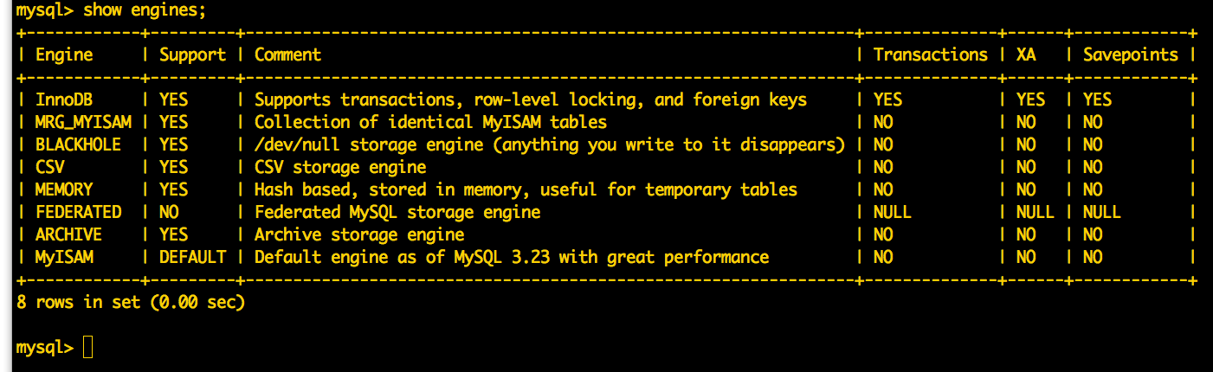

- Allows a sequence of steps to work as a unit or not work at all
- Handles the fact that some things take time
- Locks data on read so that it cannot be read by another transaction until the current transaction completes

Tables where transactions will be used require the use of the InnoDB engine.

- BEGIN - Starts a transaction
- SELECT .... FOR UPDATE – Reads and locks row (or rows)
- COMMIT - Completes a transaction
- ROLLBACK - Gives up on a transaction

Transaction Deadlock

- If process A Locks X, and process B locks Y, and then process A waits for Y and process B waits for Y - they wait forever.

- This is called a “deadlock”.

- Deadlocks are avoided by making sure all transactions take locks in the same order - this way one will “win” at the beginning

Solve deadlock problem =>

$stmt = $pdo->prepare("SELECT rps_guid, play1, play2, displayname FROM {$p}rps
LEFT JOIN {$p}user ON {$p}rps.user1_id = {$p}user.user_id
WHERE play2 IS NULL ORDER BY started_at ASC LIMIT 1 FOR UPDATE");
$stmt1 = $pdo->prepare("UPDATE {$p}rps SET user2_id = :U2ID, play2 = :PLAY
WHERE rps_guid = :GUID");

$pdo->beginTransaction();
$stmt->execute();
$row = $stmt->fetch(PDO::FETCH_ASSOC);
if ( $row == FALSE ) {
$pdo->rollBack();
} else {
$stmt1->execute(array(":U2ID" => $_SESSION['id'], ":PLAY" => $play,
":GUID" => $row['rps_guid']));
$pdo->commit();
}

Trasde-offs

- Transactions are essential in situations where data is read, updated, and written in a way that timing is critical.

- But transactions incur a cost because they lock areas of the database and pause other operations waiting for the transaction to finish.

- There is both a resource and performance cost if transactions are used excessively.

