When a server is interacting with many different browsers at the same time, the server needs to know *which* browser a particular request came from.

Cookies

- Technically, cookies are arbitrary pieces of data chosen by the Web server and sent to the browser. The browser returns them unchanged to the server, introducing a state (memory of previous events) into otherwise stateless HTTP transactions.

- Cookies are marked as to the web addresses they come from. The browser only sends back cookies that were originally set by the same web server.

- Cookies have an expiration date. Some last for years, others are short-term and go away as soon as the browser is closed

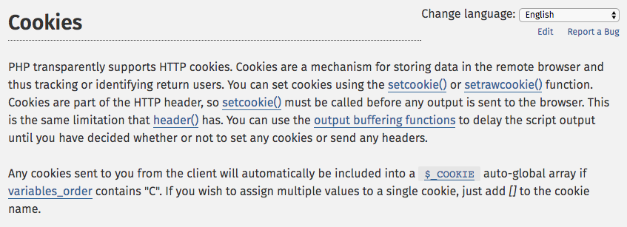

Sessions

- In most server applications, as soon as we meet a new (unmarked) browser we create a session.
- We set a session cookie to be stored in the browser, which indicates the session id in use – gives this browser a unique “mark”.
- The creation and destruction of sessions is handled by a web framework or some utility code that we use in our applications.

Session Identifier

- A large, random number that we place in a browser cookie the first time we encounter a browser
- This number is used to pick from the many sessions that the server has active at any one time.
- Server software stores data in the session that it wants to have from one request to another from the same browser.
- Shopping cart or login information is stored in the session in the server.

PHP sessions

- We can establish / initialize a PHP session by calling session_start() before any output has come out.
- If the user has cookies set, we can use the array $_SESSION to store data from one request to the next with a particular browser.
- We have a bit of data that persists from one request to the next.
- By default, these are stored in a temporary folder on disk (fancier apps store it in cache memory like Redis).

PHP session without cookies

- For a simple application handling login, logout, and shopping cart-like information, cookie sessions are sufficient.
- But if an application needs to function within an iframe, or have more than one session active (i.e., multiple tabs to the same site), we cannot use session cookies.

Issues:
- Session id is not automatically added in JavaScript, Ajax, Redirect, or other elements of HTML.
- With the session id on the URL, folks can email URLs or even bookmark them and be logged in.

