One to many relationship

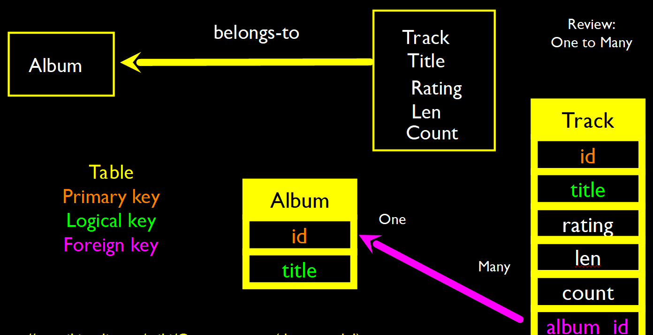

Many to many relationship => We need to add a “connection” table with two foreign keys.

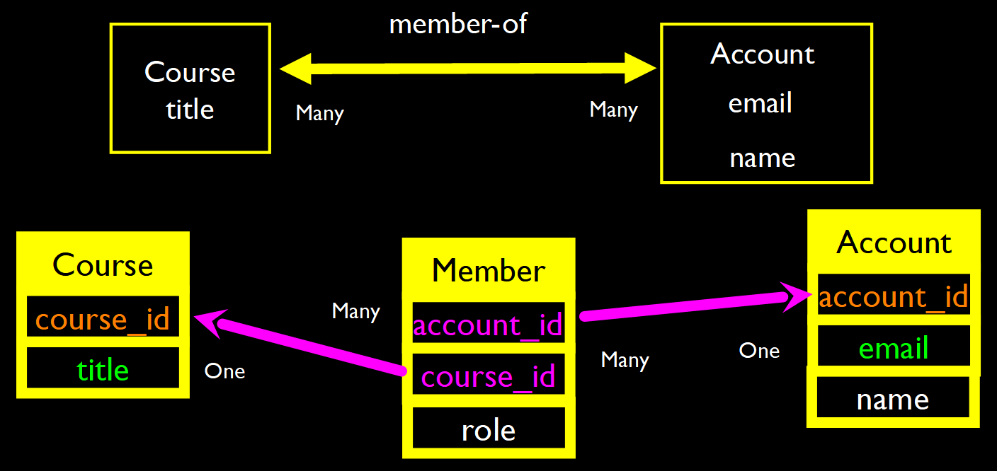

Complexity Enables Speed

- By normalizing the data and linking it with integer keys, the overall amount of data which the relational database must scan is far lower than if the data were simply flattened out.

- It might seem like a tradeoff - spend some time designing your database so it continues to be fast when your application is a success.

