Database design is an art form of its own with particular skills and experience.

Building a Data Model

- Drawing a picture of the data objects for our application and then figuring out how to represent the objects and their relationships
- Basic Rule: Don’ t put the same string data in twice - use a relationship instead
- When there is one thing in the “ real world” there should only be one copy of that thing in the database

Database Normalization (3NF – three normal form)

Do not replicate data. Instead, reference data. Point at data.
Use integers for keys and for references.
Add a special “key” column to each table, which you will make references to.

Integer Reference Pattern

=> We use integer columns in one table to reference (or look up) rows in another table.

- Primary key - generally an integer auto-increment field
- Logical key - what the outside world uses for lookup
- Foreign key - generally an integer key pointing to a row in another table

Primary Key Rules
- Never use your logical key as the primary key.
- Logical keys can and do change, albeit slowly.
- Relationships that are based on matching string fields are less efficient than integers.
Foreign Keys
A foreign key is when a table has a column containing a key that points to the primary key of another table.
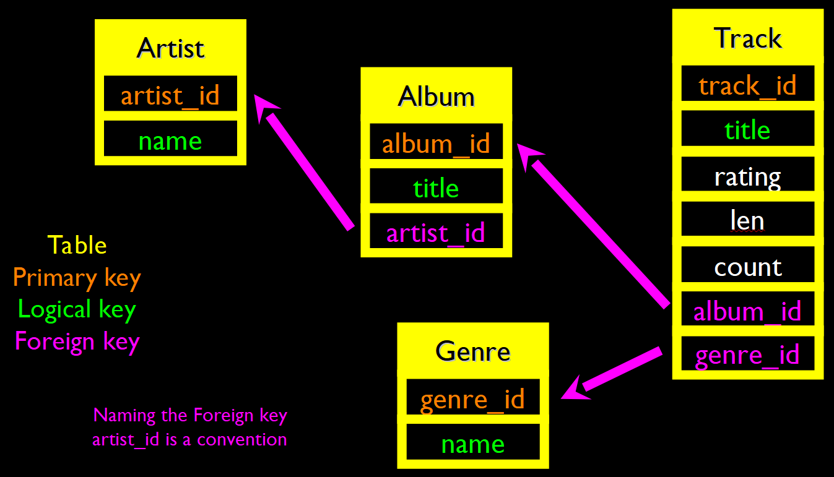

Using Join

Relational Power => By removing the replicated data and replacing it with references to a single copy of each bit of data, we build a “web” of information that the relational database can read through very quickly - even for very large amounts of data.

The JOIN Operation

- The JOIN operation links across several tables as part of a SELECT operation.
- You must tell the JOIN how to use the keys that make the connection between the tables using an ON clause.

SELECT Album.title, Artist.name FROM Album JOIN Artist ON Album.artist_id = Artist.artist_id;

It can get complex:

SELECT Track.title, Artist.name, Album.title, Genre.name FROM Track JOIN Genre JOIN Album JOIN Artist ON Track.genre_id = Genre.genre_id AND Track.album_id = Album.album_id AND Album.artist_id = Artist.artist_id;

ON DELETE CASCADE (We are telling MySQL to "clean up" broken references)

DELETE FROM Genre WHERE name = ‘Metal’;

ON DELETE Choices

- Default / RESTRICT – Don’t allow changes that break the constraint
- CASCADE – Adjust child rows by removing or updating to maintain consistency
- SET NULL – Set the foreign key columns in the child rows to null

