Relational databases (SQL)

- Relational databases model data by storing rows and columns in tables.

- The power of the relational database lies in its ability to efficiently retrieve data from those tables - in particular, where the query involves multiple tables and the relationships between those tables.

Terminology:
- Database - contains one or more tables
- Relation (or table) - contains tuples and attributes => A relation is defined as a set of tuples that have the same attributes.
=> A relation is usually described as a table, which is organized into rows and columns.
- Tuple (or row) - a set of fields which generally represent an “ object” like a person or a music track => A tuple usually represents an object and information about that object
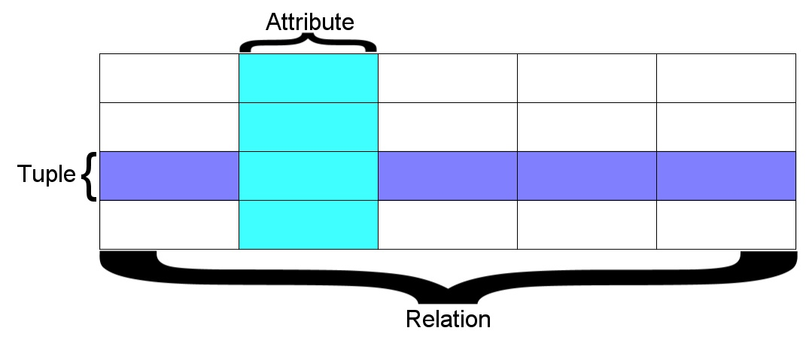
- Attribute (also column or field)

SQL basic commands

CREATE TABLE Users(
name VARCHAR(128),
email VARCHAR(128)
);

DESCRIBE Users;

INSERT INTO Users (name, email) VALUES ('Ted', 'ted@umich.edu');

DELETE FROM Users WHERE email='ted@umich.edu';

UPDATE Users SET name='Charles' WHERE email='csev@umich.edu';

SELECT * FROM Users WHERE email='csev@umich.edu';

SELECT * FROM Users ORDER BY email;

SELECT * FROM Users WHERE name LIKE '%e%';

SELECT * FROM Users ORDER BY email LIMIT 1,2;

* You can request to receive the count of the rows that would be retrieved instead of the rows.
SELECT COUNT(*) FROM Users WHERE email='csev@umich.edu';
Table Schema

Data Types

1)String fields:

- CHAR allocates the entire space (faster for small strings where length is known)
- VARCHAR allocates a variable amount of space depending on the data length (less space)

=> CAN BE INDEXED

Text fields (general for paragraphs, textual information) :

Have a character set - paragraphs or HTML pages
- TINYTEXT up to 255 characters
- TEXT up to 65K
- MEDIUMTEXT up to 16M
- LONGTEXT up to 4G

=> not used with indexing or sorting - and only then limited to a prefix

2) Binary Tyes (rarely used)
- Character = 8 - 32 bits of information depending on character set
- Byte = 8 bits of information
  - BYTE (n) up to 255 bytes
  - VARBINARY (n) up to 65K bytes
- Small Images – data
- Not indexed or sorted

3) Binary large object (BLOB)
Large raw data, files, images, word documents, PDFs, movies, etc.
No translation, indexing, or character set
- TINYBLOB (n) - up to 255
- BLOB (n) - up to 65K
- MEDIUMBLOB (n) - up to 16M
- LONGBLOB (n) - up to 4G

4) Integer numbers
Integer numbers are very efficient, take little storage, and are easy to process because CPUs can often compare them with a single instruction.
- TINYINT (-128, 128)
- SMALLINT (-32768, +32768)
- INT or INTEGER (2 Billion)
- BIGINT - (10**18 ish)
5) Floating point numbers
Floating point numbers can represent a wide range of values, but accuracy is limited.
- FLOAT (32-bit) 10**38 with seven digits of accuracy
- DOUBLE (64-bit) 10**308 with 14 digits of accuracy

6)Date
TIMESTAMP - 'YYYY-MM-DD HH:MM:SS' (1970, 2037)
DATETIME - 'YYYY-MM-DD HH:MM:SS'
DATE - 'YYYY-MM-DD'
TIME - 'HH:MM:SS'
Built-in MySQL function NOW()

7) Indexes

AUTOINCREMENT → Often as we make multiple tables and need to JOIN them together we need an integer primary key for each row so we can efficiently add a reference to a row in some other table as a foreign key

=> user_id INT UNSIGNED NOT NULL AUTO_INCREMENT,

Index Types:

PRIMARY KEY - Very little space, exact match, requires no duplicates, extremely fast for integer fields

INDEX - Good for individual row lookup and sorting / grouping results - works best with exact matches or prefix lookups - can suggest HASH or BTREE

B-Tree => A B-tree is a tree data structure that keeps data sorted and allows searches, sequential access, insertions, and deletions in logarithmic amortized time. The B-tree is optimized for systems that read and write large blocks of data. It is commonly used in databases and file systems.

ALTER TABLE Users ADD INDEX (“email”) USING BTREE

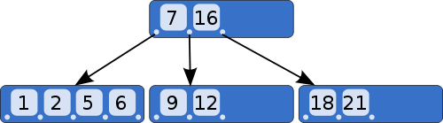
Hashes => A hash function is any algorithm or subroutine that maps large data sets to smaller data sets, called keys. For example, a single integer can serve as an index to an array (cf. associative array). The values returned by a hash function are called hash values, hash codes, hash sums, checksums, or simply hashes.
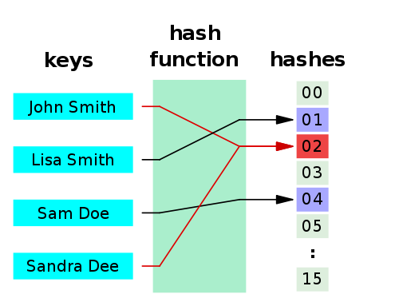
Hash functions are mostly used to accelerate table lookup or data comparison tasks such as finding items in a database...

