Lab Report: ls -l
Author: Shuvalov Fjodor (https://github.com/zer0rbt/Development-Essentials)

1. Screenshot
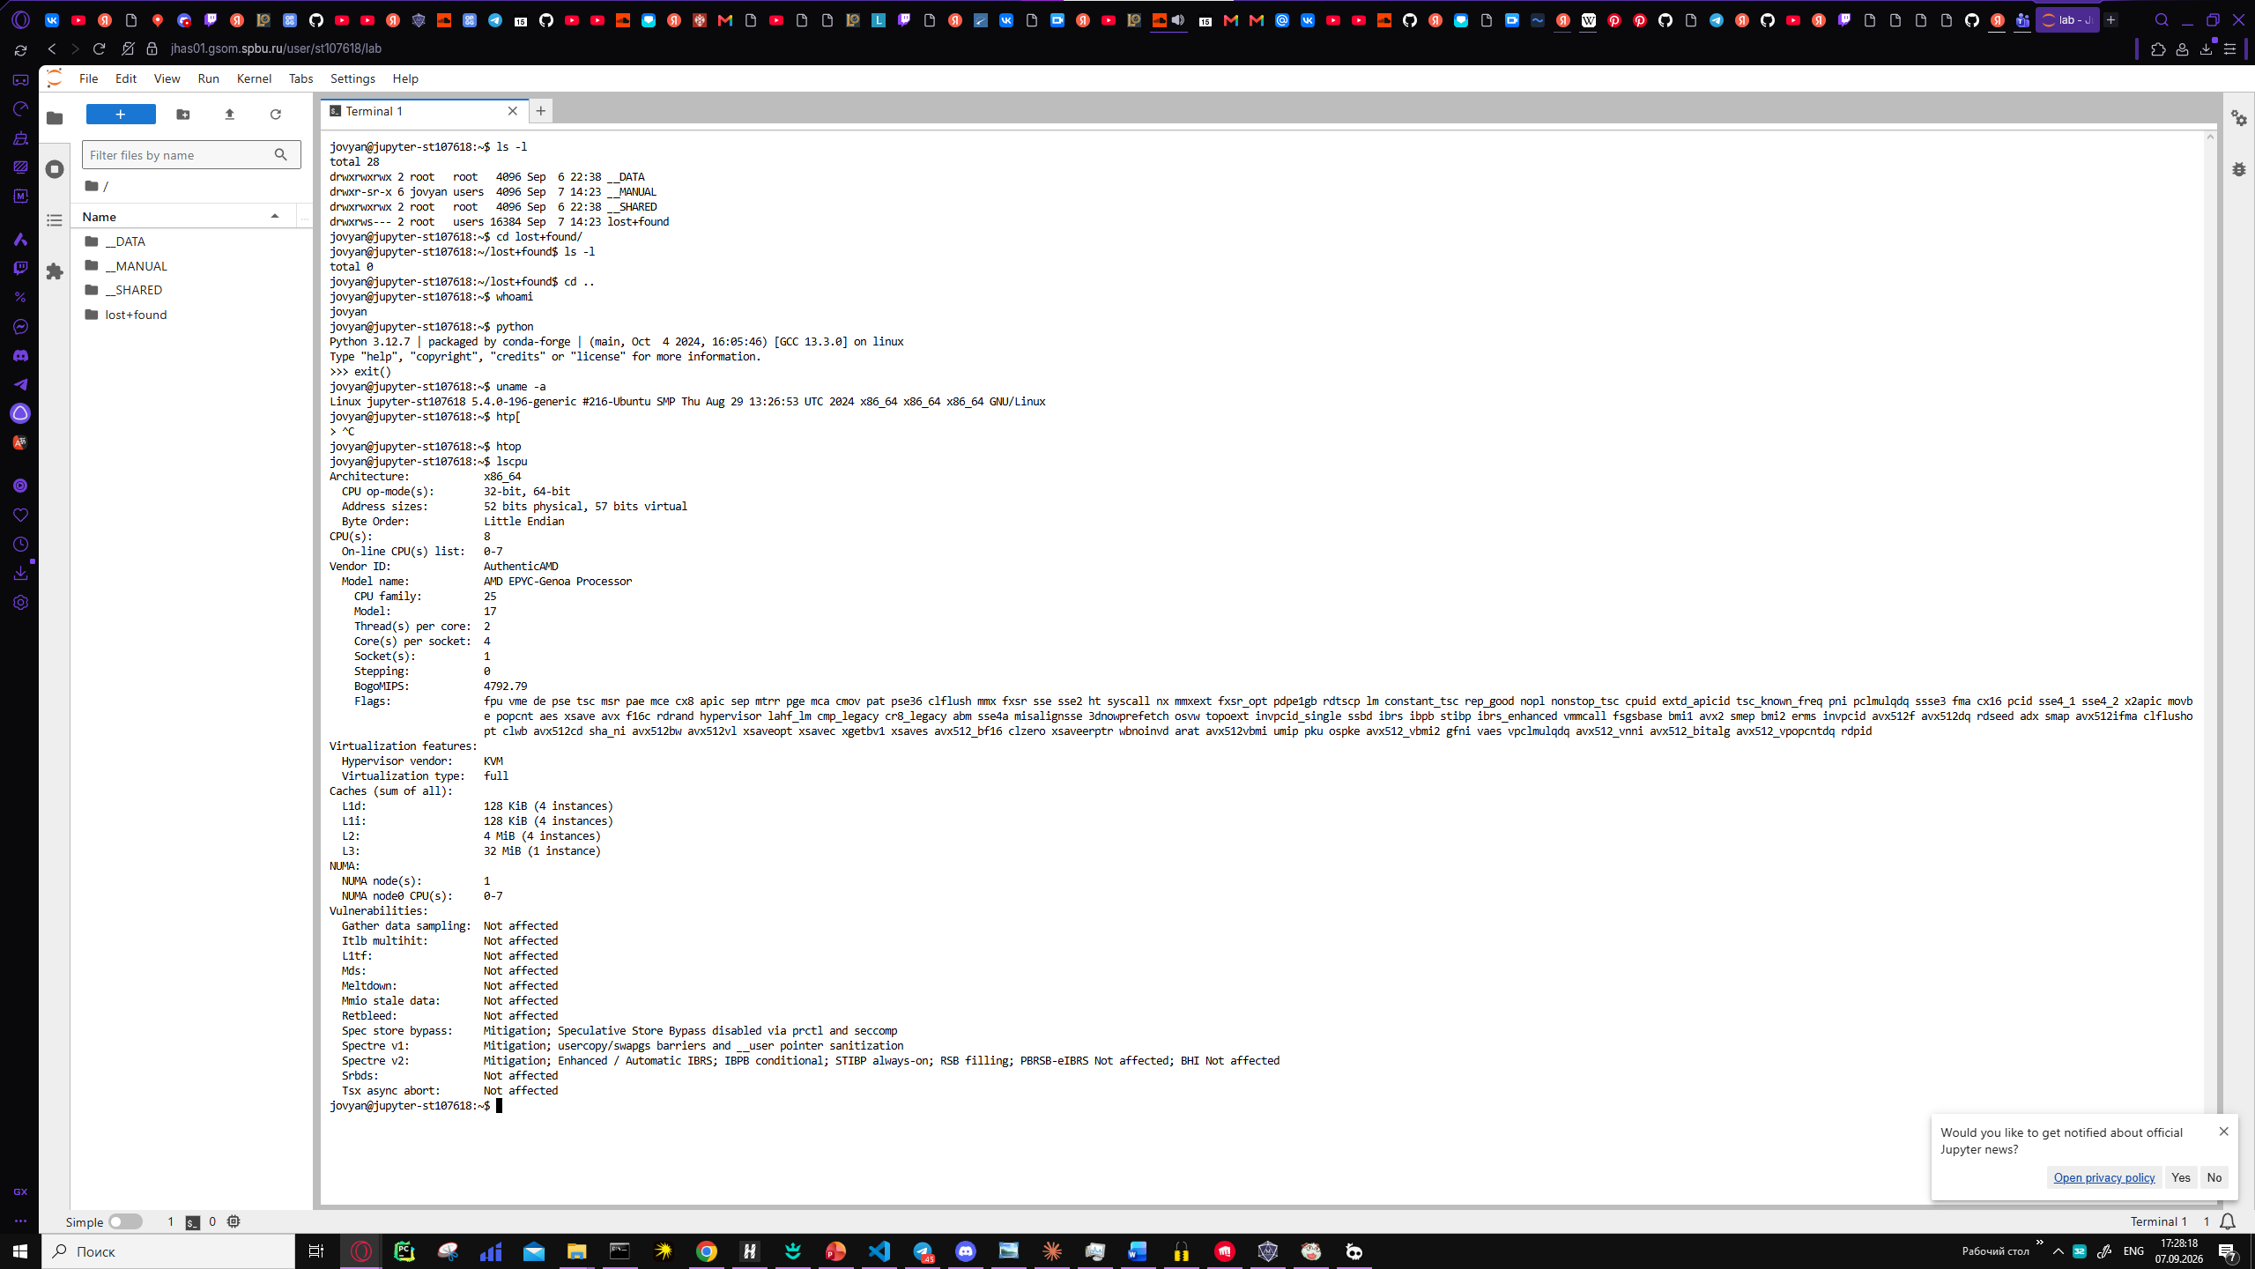

2. Explanation of the "ls -l" output
drwxrwxrwx 2 root root 4096 Sep 6 22:38 __DATA
drwxr-sr-x 6 jovyan users 4096 Sep 7 14:23 __MANUAL
drwxrwxrwx 2 root root 4096 Sep 6 22:38 __SHARED
drwxrws--- 2 root users 16384 Sep 7 14:23 lost+found
Each line: file type + permissions (d = directory; rwx for owner/group/others) → link count → owner and group → size in bytes → modification date → name.
__DATA and __SHARED are open to everyone (rwx-rwx-rwx), __MANUAL is owned by jovyan (write access restricted to the owner), and lost+found is locked down for other users.

3. Conclusions
"ls -l" reveals not just the list of files, but also the owner, group, and access permissions for each entry — unlike a plain "ls".
The permissions of the directories in the home folder reflect their purpose: __DATA/__SHARED — shared access, __MANUAL — jovyan's working directory, lost+found — a service directory with restricted access.

