Harmony and button control
  - PhD progress report
My goal is to combine harmonic guidance with useful performer control. Chord conditioning now works much better than conditioning on harmonic function or tension. The remaining difficulty is making it compatible with the learned button-to-pitch mapping. Direct probability adjustment offers stronger control, at the cost of overriding the model's preferred notes.
Approach | Observed result | Main limitation
1 Harmony FiLM | Weak harmonic control | Noisy labels; overlapping tension levels
2 Chord FiLM | Stronger chord adherence | Pitch selection remains indirect
3 Chords and buttons | Weaker harmonic steering | Button and chord cues can conflict
4 Probability adjustment | Effective chord-tone control | Can favor unlikely notes

1 Harmonic function and tension
I trained models with FiLM in the final two blocks, using Roman-numeral labels and tension levels. The Roman-numeral annotations were noisy. Tension was too coarse for steering between diatonic chords: tonic and dominant can receive the same low tension level despite having different harmonic functions.
Chord in C major | Standardized tension score | Training level
Tonic I (C-E-G) | -1.377 | 0
Dominant V (G-B-D) | -0.660 | 0
Illustrative calculation with the current offline calibration: isolated triads, equal pitch-class weights, C major as home and local key, and no previous level history. Actual scores depend on context.
Both scores fall below the first boundary (-0.5324) and become level 0, so this command cannot distinguish tonic from dominant. I therefore moved to chord pitch-class conditioning.

2 Chord conditioning
I kept the FiLM mechanism and conditioned on chord pitch classes, without specifying harmonic function. Chord chroma matches the pitch-class content of the musical window more directly, giving the model a clearer relationship to learn. Conditioning became substantially more effective.

Probability assigned to the requested chord tones
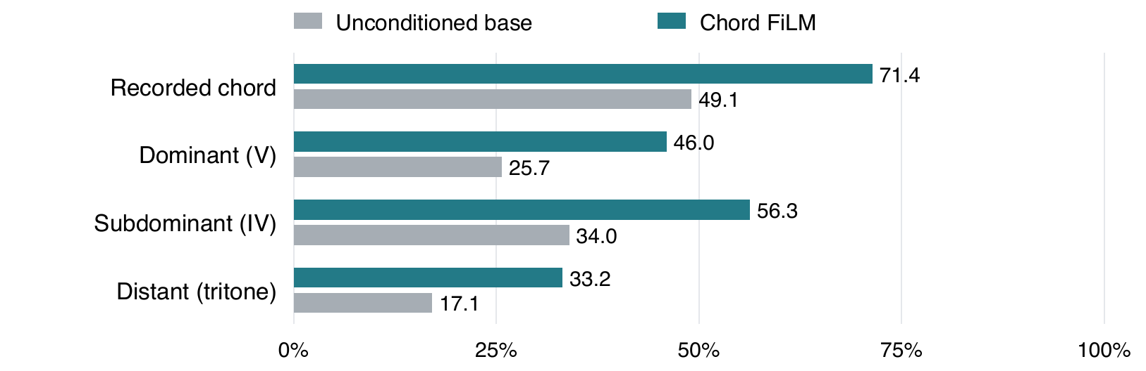
Evaluation: 100 chord changes across five unseen pieces, two sampling seeds and 16-note continuations. The chart shows mean probability mass over the first four notes, in any octave.
For the recorded chord, FiLM raised probability by 22.3 percentage points. V, IV and the distant chord also gained probability, showing steering beyond the existing context. The effect was already visible on the first generated note. These results establish chord adherence; they do not by themselves establish musical quality.

3 Why button input is more difficult
With button input, the same chord-conditioned model responds less effectively to harmonic guidance. My working explanation is that a button can already favor pitches outside the requested chord. FiLM then has to reconcile competing cues. A controlled comparison of compatible and conflicting button requests is still needed to test this explanation.

What the previous mapping study showed
I examined 100 passages of 16 notes across five pieces. Encoder assignments showed a median of four button steps between notes an octave apart, with a 10th-90th percentile range of two to six. This describes assignments across notes in a passage; it does not predict the immediate interval produced by moving to the next button.
In a separate decoder probe, I tried all 19 buttons against one fixed Bach context. Averaged equally across buttons, 97% of output probability lay in C major, but there were only 10 distinct most-likely pitches. A subset of the mapping was:
Button | 3 | 4 | 5 | 6 | 7 | 8 | 9
Most likely pitch | C4 | C4 | D4 | G4 | G4 | C5 | C5
Example from one fixed context. Repeated pitches show several buttons favoring the same note.
Even the best button for E4 assigned it only 1.2% probability; for F4, the maximum was 0.012%. These are context-specific findings, but they expose the distinction between generating scale notes and allowing the performer to select them. Several buttons may duplicate a choice while other scale notes remain difficult to request.

4 Adjusting note probabilities before sampling
I tried modifying each note's probability directly before sampling. This works well for producing chord tones because it directly biases the output toward them. The cost is that it can force notes the model originally considered unlikely. Lower model probability alone does not establish poor musical quality, so this trade-off needs listening evaluation.
The same mechanism could progressively move each button's pitch distribution toward a distinct assigned scale pitch, including its octave. At low strength, the learned distribution would retain more influence; at high strength, the mapping would approach one button per scale pitch. The effect of this proposed mapping on note access and musical coherence remains to be evaluated.
A fixed mapping would also change the available range: 19 consecutive diatonic pitches cover two octaves plus a fifth. Flexible register and chromatic notes would therefore need additional controls.

For discussion and the next experiment
The main decision is how much predictable note control the performer should have, and how much freedom should remain with the model. Should the scale mapping be an optional, adjustable mode?
A focused next test would compare compatible and conflicting button-chord requests at several control strengths, using the same primers and sampling seeds. I would measure chord adherence, the probability of reaching intended notes, and mapping stability, alongside listening judgments of musical coherence.

