
TOASTMASTER
Taking on this role improves your critical thinking, organization, and time management, motivational and team-building skills.

prior to the meeting:
♦ Chose a novel or unusual word, that we might be interested using, or to just learn about. This should be a learning experience for the club.
"It should be a word that will help members increase their vocabulary – a word that can be incorporated easily in to everyday conversation but is different from the way people usually express themselves."
♦ Obtain a dictionary definition of your work. Know what part of speech the word is, a noun, adjective, verb, etc. Prepare an example of your word in a sentence.
♦ (IN-PERSON MEETINGS) Bring at least 2 "signs", with your word clea rly printed on them in large letters. TAPE one sign ON THE LECTERN AND THE OTHER ON THE table on the opposite side. You can post an additional sign(s) around the room as further reminders.
♦ You can also write your word in very large letters on the white board at the SIDE of the room (optional).
♦ (VIRTUAL) ENTER THE WORD IN THE CHAT BOX ALONG WITH THE DEFINITION AND EXAMPLE SENTENCE.
♦ WRITE THE WORD ON A SLIDE IN POWERPOINT OR ANY FORMAT AND SAVE AS JPEG. tHEN USE IT AS YOUR VIRTUAL BACKGROUND
DURING THE MEETING
YOU WILL BE INTRODUCED NEAR THE START OF THE MEETING by the TOASTMASTEr:
♦ Acknowledge the person introducing you, and the members, & guests
♦ Explain your role (which is to introduce a word, to count how many times we use it and to count umms & ahhs)
♦ Introduce your word, it's part of speech, it's dictionary definition, and use it in a sentence.
♦ Encourage everyone to use the word in tHE meeting.
SCRIPT EXAMPLE
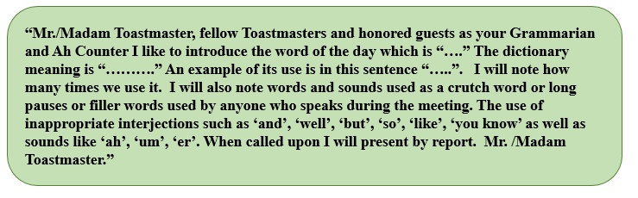
The following table might help to keep a count.
Name | Word | Long pause | And, So, But, Well, Like, Then… | Ahs, Ums, Er
Near the end of the MEETing, you will be asked to disclose the number of times:
1. word of the day was used 2. number of umms & ahhs.
make your report and sit down.

