Lab 1 – Computer Vision basics using OpenCV (ANSWERS)
TO BE HANDED-IN AFTER SESSION 2
Student name:

Lab Question 1. How much memory (in MB) will it require to represent the following images?
- A grey scale image with 256 grey levels, which is 512 x 512 pixels. (5 marks)
- An RGB image, 1280 x 720 pixels, with 256 levels on each colour channel. No transparency (alpha) channel. (5 marks)
- An RGB image, 1280 x 720 pixels, with 256 levels on each colour channel and transparency (alpha) channel. (5 marks)

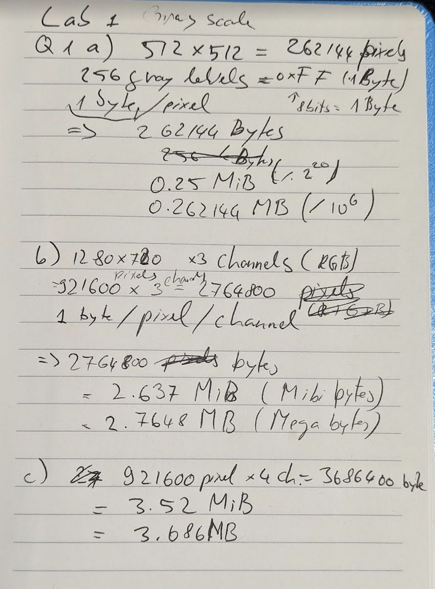
You can get the description of any other OpenCV function from the official reference pages:
https://docs.opencv.org/2.4/index.html

Lab Question 2. Use the OpenCV reference pages above to explain IN DETAIL what the following function is doing, the meaning of the H, S and V channels, and how they are obtained from the initial RGB image: (5 marks)
cvtColor(image, img_HSV, CV_BGR2HSV);

The function cvtColor() is part of the OpenCV library and is used to convert images from a colour space to another. It can be given up to 4 parameters, input source image (src), output destination image (dst), from which colour space to which (code) and also the number of channels but this can be left zero. The more interesting parameter is the code, an argument that tells the funtion what colour space the original image is, and to what colour space we want the image to be transforemd to. For example, passing the argument "CV_BGR2HSV" "COLOR_BGR2HSV" in later versions as the third parameter, will tell the function we want to convert an RGB image to the Hue (0-180°, Saturation (0-255 color intensity ), Value (0-255 brighness) (HSV) gammut.

Lab Question 3. Write down the upper and lower thresholds you selected for edge linking and paste at least 3 of the resulting edge images you get. (5 marks)
What happens with the carpeted floor, and why this is happening? (10 marks)

Upper 60 Lower 40:
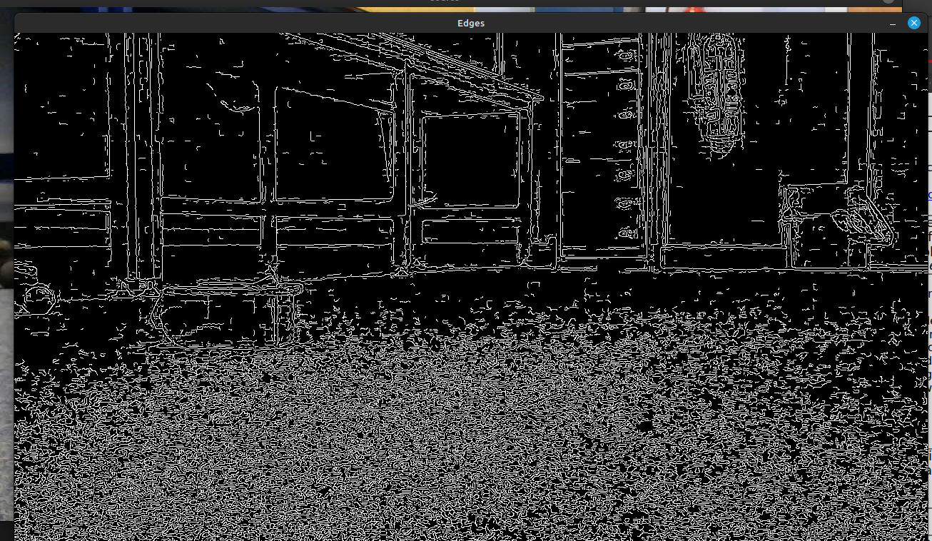

Upper 90 Lower 60:
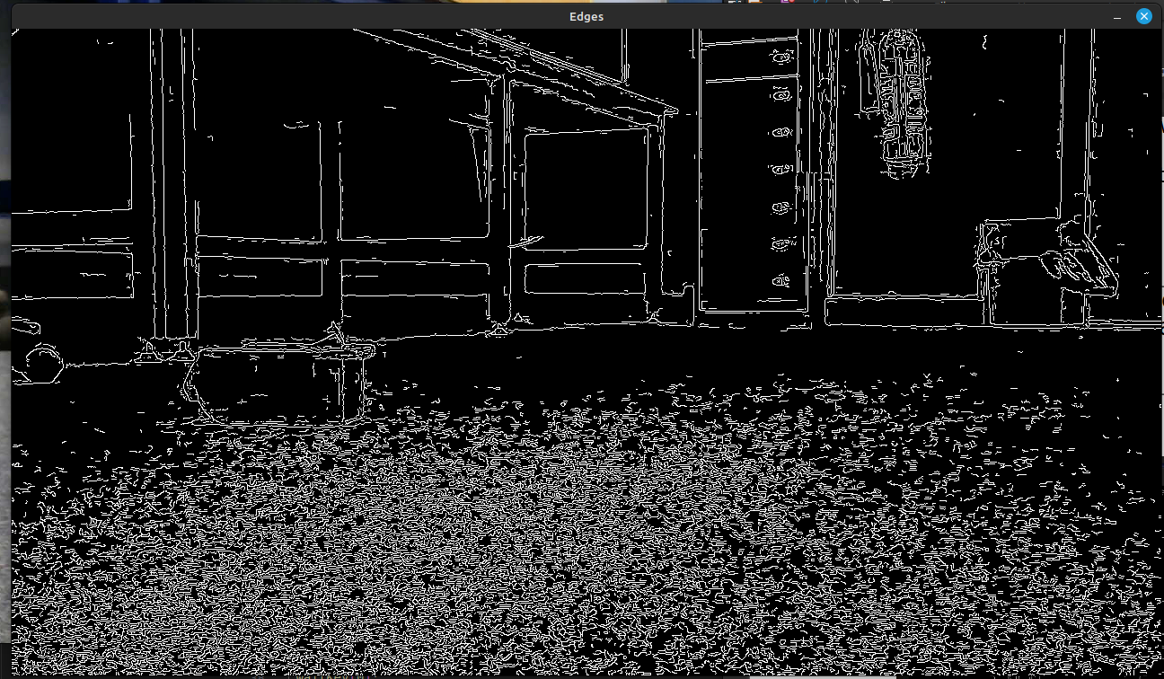

Upper 100 Lower 95:
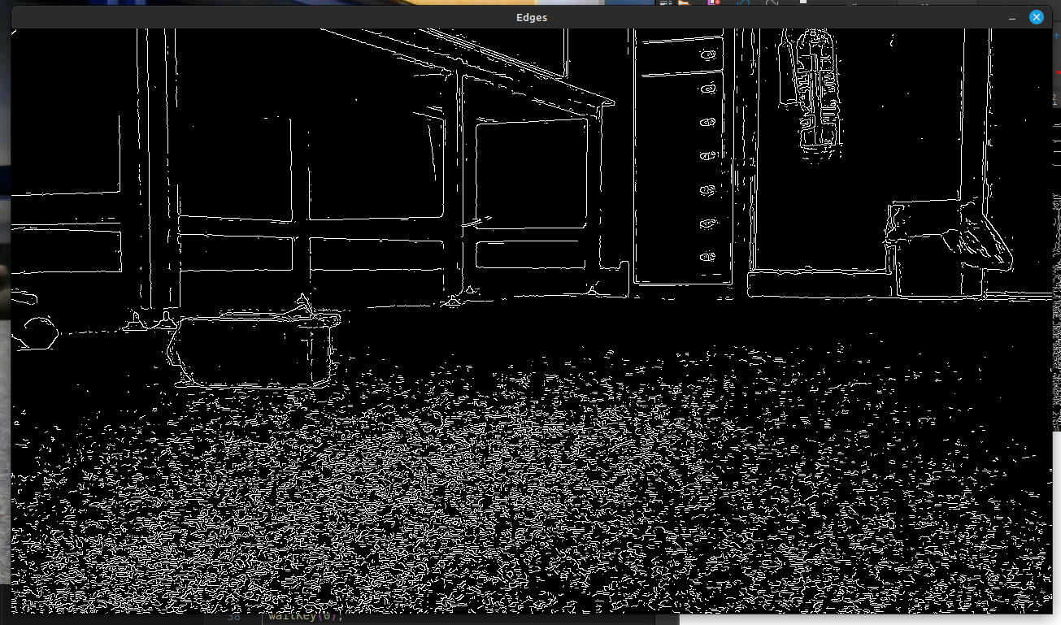
The floor is detected as having edges where in reality there are none because of the pattern on the carpet creating a lot of noise. One solution to avoid this might be to add a blurr before creating the image.

Lab Question 4. Practice your math skills: find the expressions to calculate the slope (m) and intercept (b) of a line, from its corresponding r and θ parameters. Notice that they are alternative parametrizations, they represent the same line, so all (x,y) must satisfy both Cartesian and polar equations (5 marks)

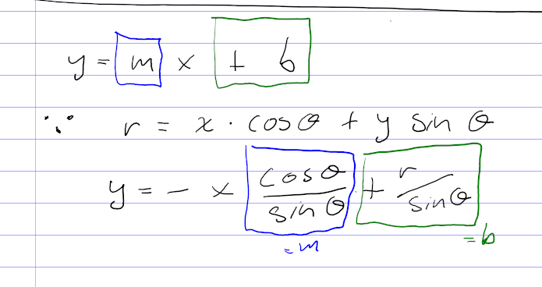

Lab Question 5. Write down the Hough threshold value for the number of votes that you selected, and paste some of the resulting line-cluttered images you get (5 marks)

Note: the GaussianBlur() method was used to remove the lines from the carpet by first blurring the image. As can be seen in the output in the terminal asking for blur level.
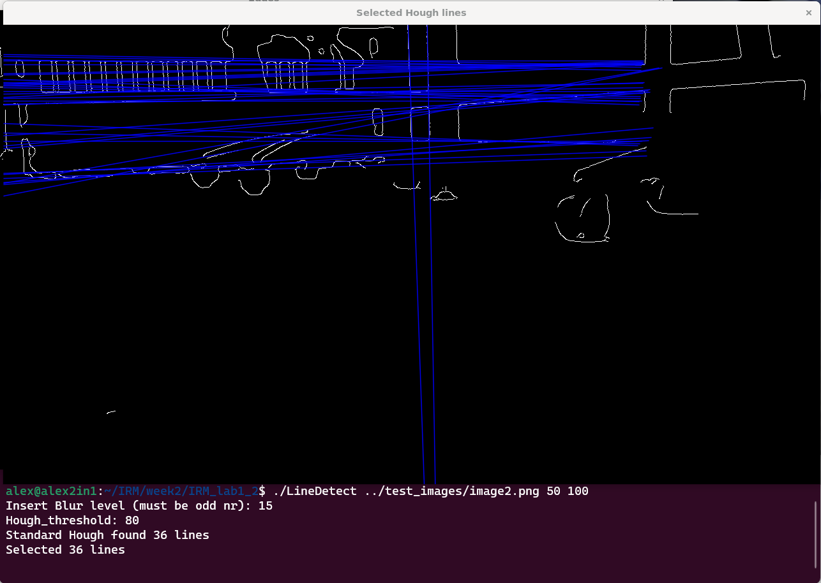
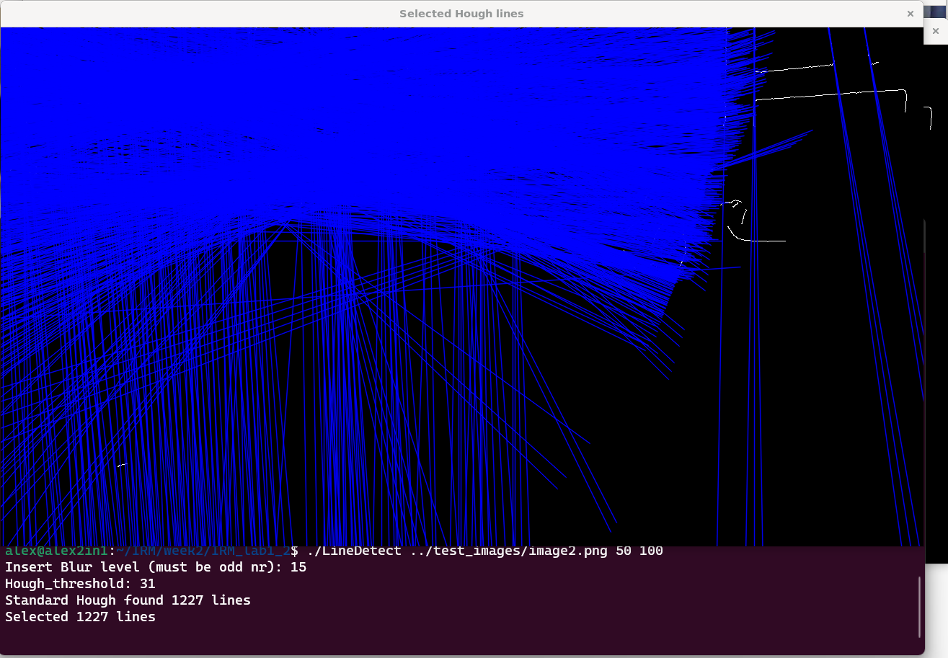

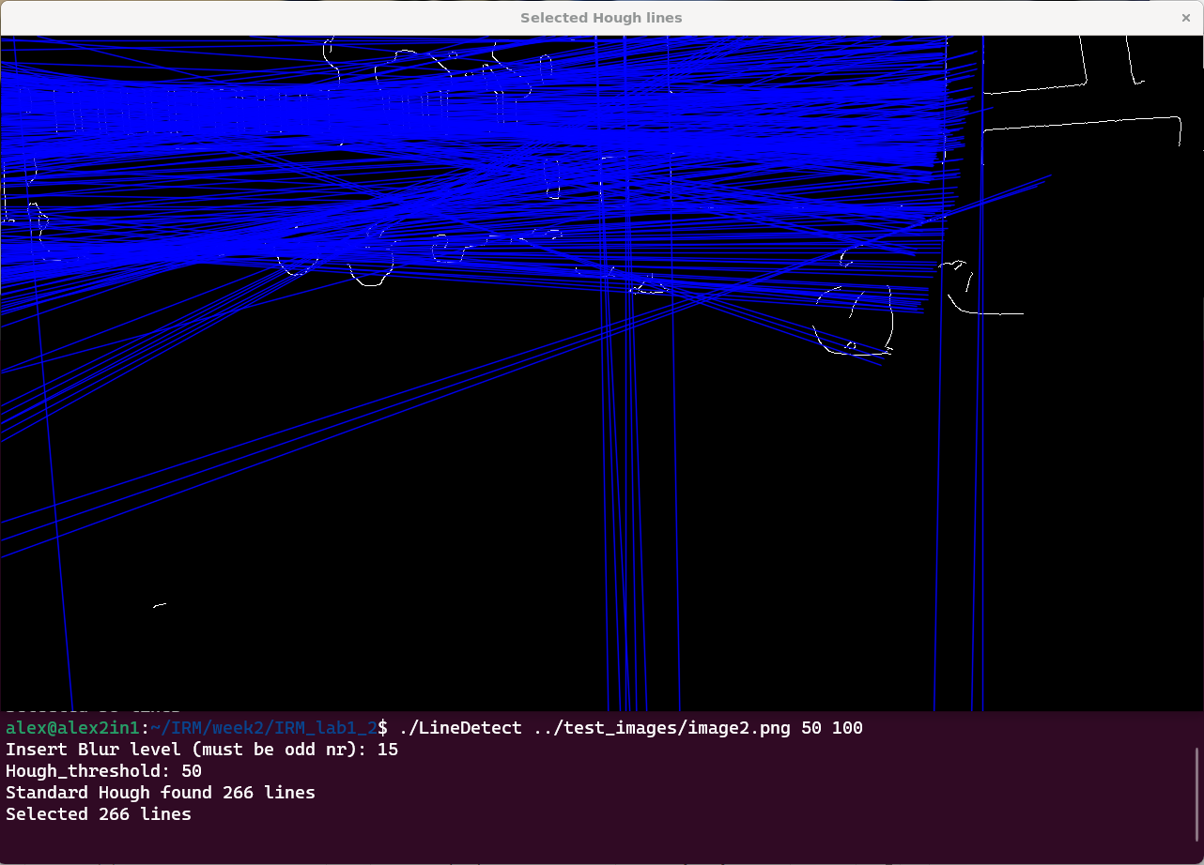

Lab Question 6. Write down the updated if() code to retrieve vertical lines only (10 marks)
Paste at least 3 of the resulting annotated line images you got (5 marks)
Discuss your results (10 marks)
printf("Please insert the slope Threshold: ");
double slope_threshold = 0.0;
scanf("%lf",&slope_threshold);
for( size_t i = 0; i < lines.size(); i++ ) //'size_t' is 'unsigned long int'
{
Vec2f l = lines[i];
float rho = l[0], theta = l[1];
// only select the lines approaching vertical
// Calculate line slope using theta
double slope = tan(theta);
// Define a maximum allowed deviation from perfect vertical slope
if (abs(slope) < slope_threshold)

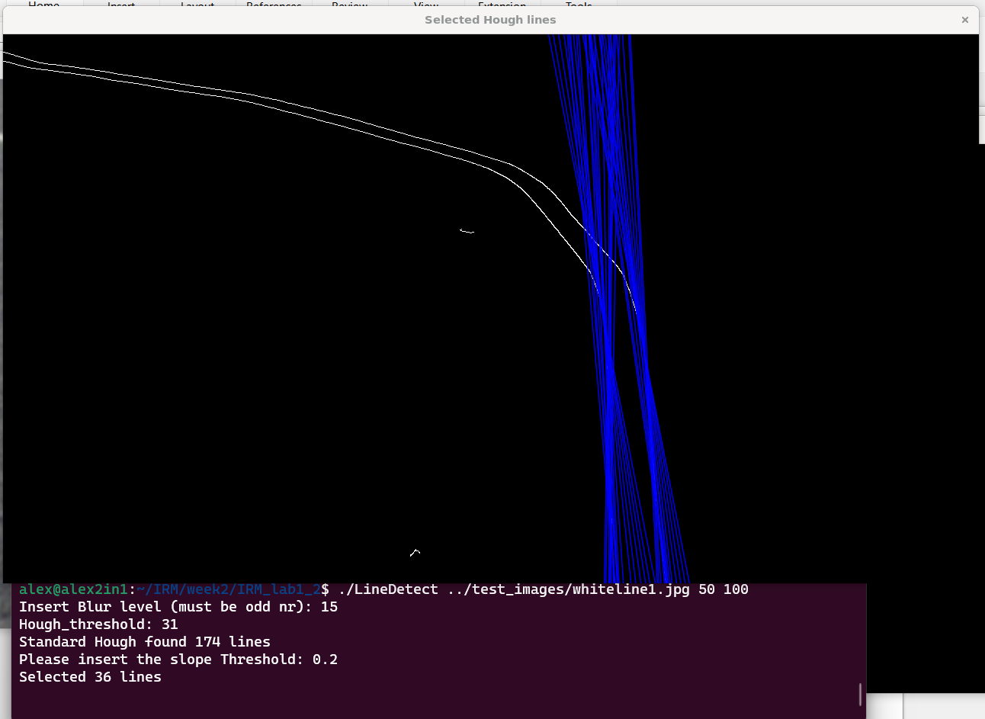
Because we have the angle of the Hough lines in radians (on the R theta plane)– this can give us the ratio between the x and y axis using the tangent function. Which can be used to deremine how close to vertical the line is. We just give a threshold value – the smaller the ratio it means closer to vertical.
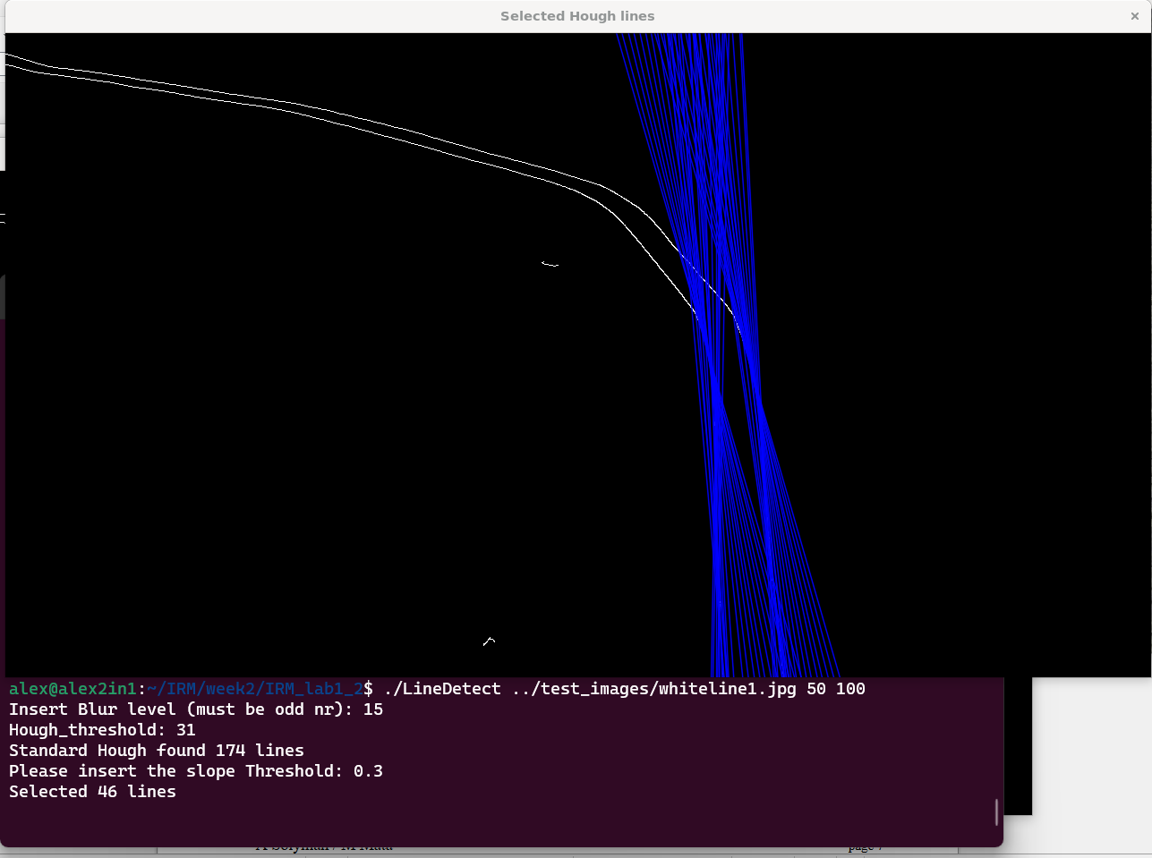

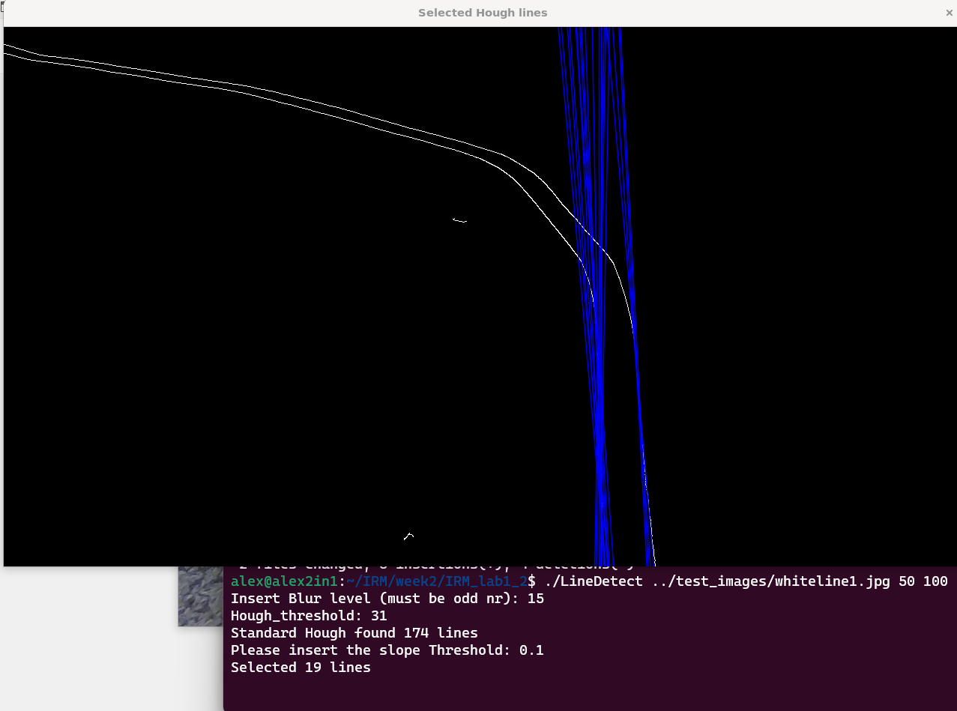
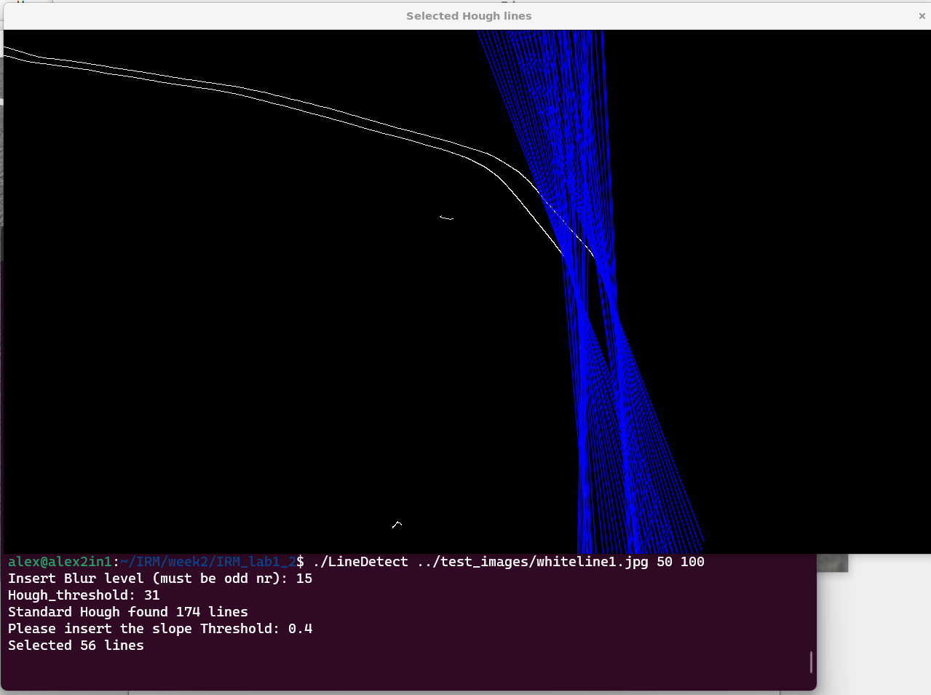
END OF SESSION 1 QUESTIONS. NEXT QUESTIONS ARE FROM SESSION 2

Lab Question 7. Write down the Hue and Saturation thresholds you selected, and paste at least 3 of the resulting images with the box pixels highlighted (10 marks)
Hue: 0, 9
Sat 50 255
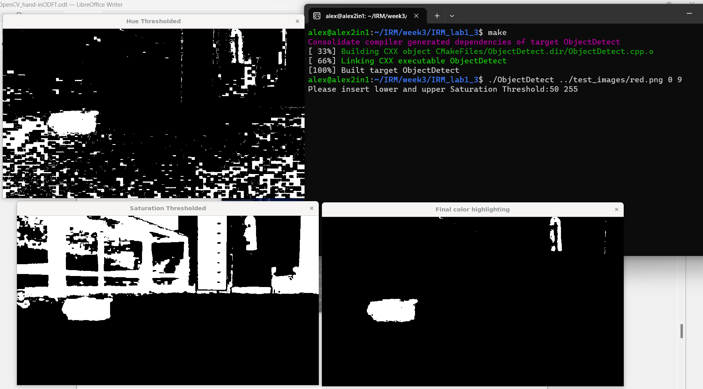
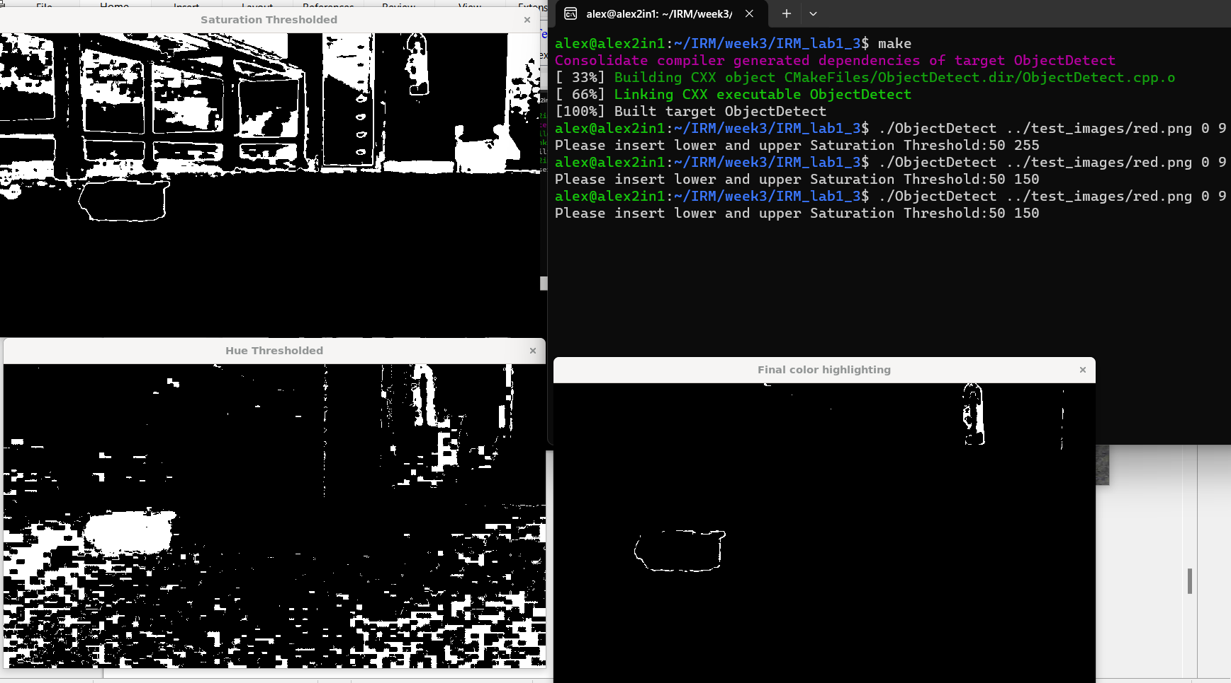
Hue: 0 – 9
Sat: 50 - 150

Hue: 0 – 9
Sat: 100 – 255
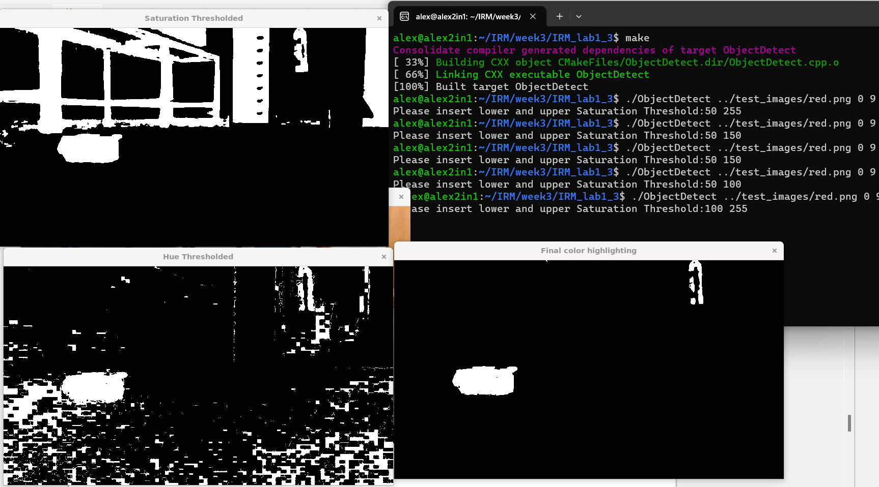
Hue: 0 – 4
Sat: 100 – 255

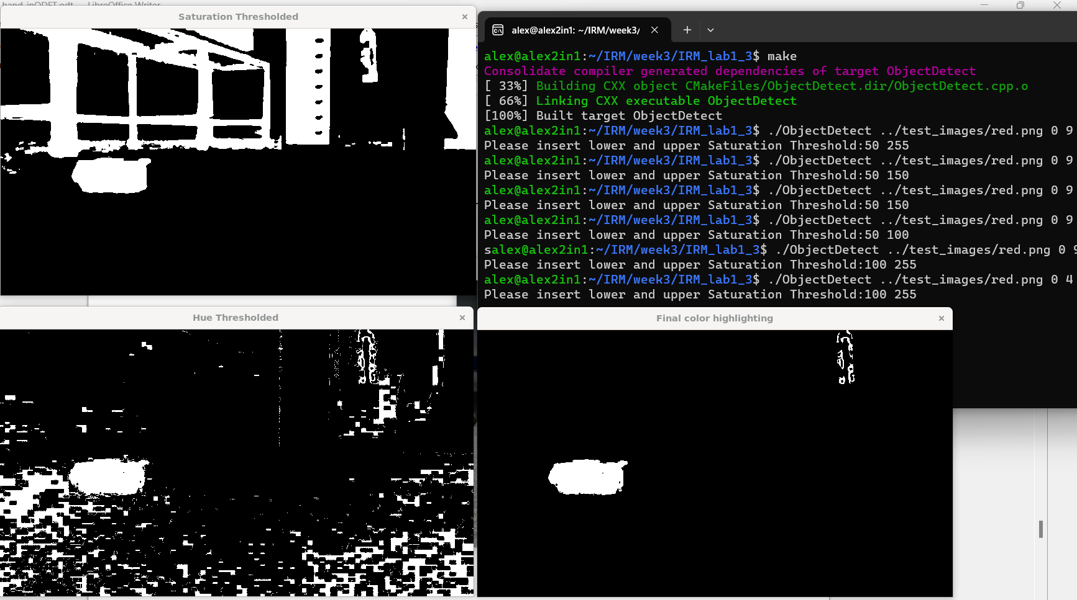

Lab Question 8.
- What will happen in the resulting image if you do the dilation operation first, then the erosion (that’s called a Closing operation)? (5 marks)
- Try it out if and show its effects (5 marks)

If switching the order, then the dilation should add an edge to every pixel still there – making the pixels we don't want even bigger.

First Erosion --> dilation
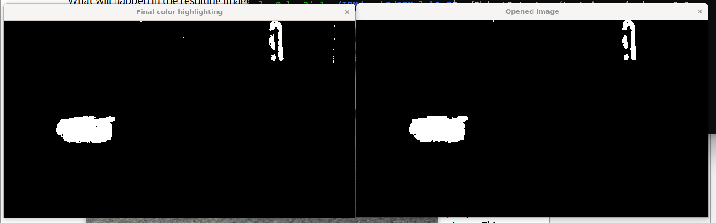
First Dilaition --> Erosion:
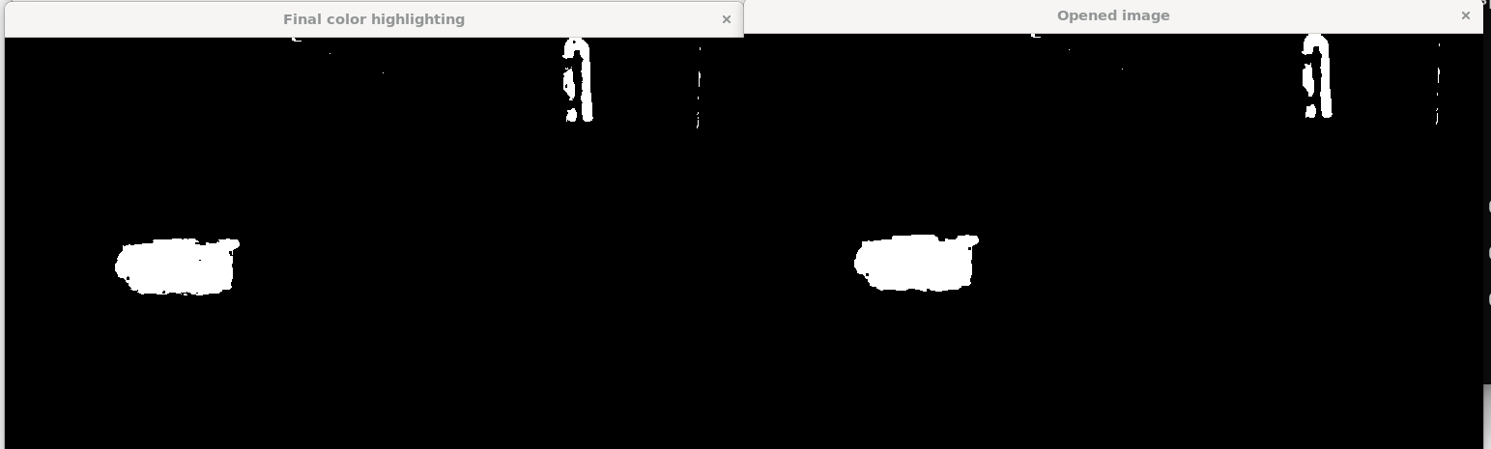
Lab Question 9.
- a) Explain the selection steps you’ve designed to keep only the red box (20 marks)
- b) Write here your code to implement them (15 marks)
- c) Paste at least 4 annotated images showing your results, at least one where there’s no box (10 marks)

Explanation:
There are multiple ways in which to select the box, for example height and width of the blobs, or placement on screen (higher – or lower, for a robot to avoid obstacles, we might create a program that ignores blobs higher on screen). Or if we are interested that the program detects the box in particular as opposed to other ojects of other shapes, we could select based on width.

For this exercise I am choosing to go with both lower on screen and width. We can use the Width (or area) parameter quite easily as the box is a lot larger than other blobs.

A simple for loop compares all the already found blobs and selects only the blobs with the area and/or width (depending how specific we want to be – here the box is quite "unique" so an or will do).

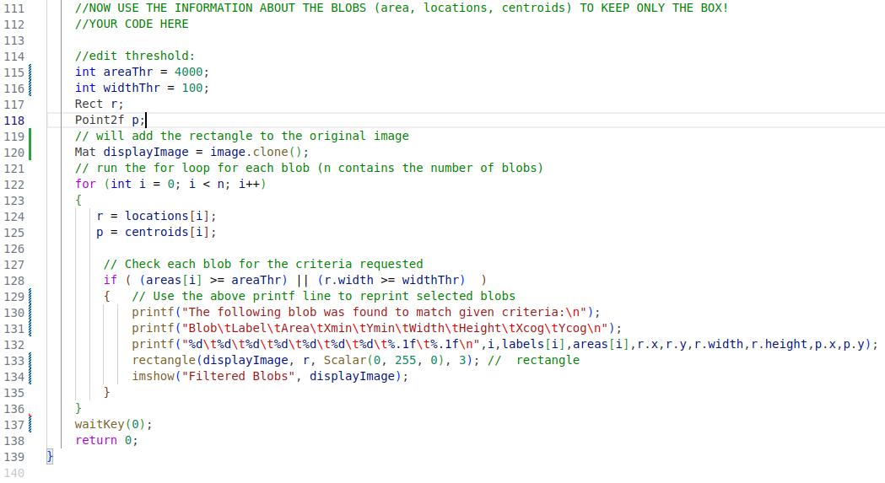

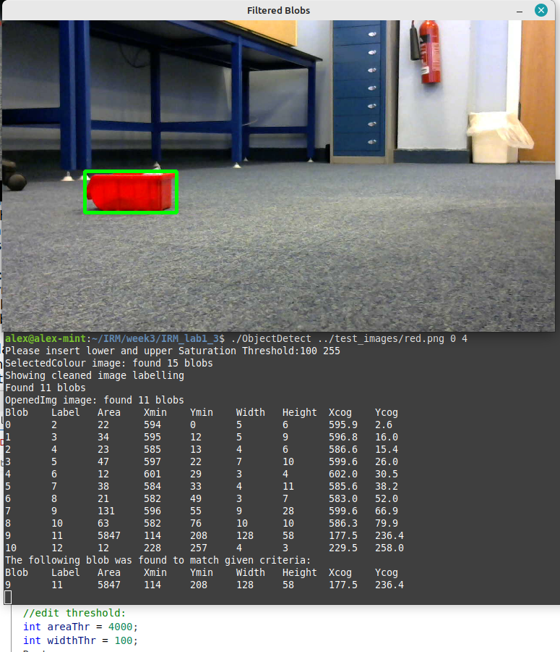
Here an area and width were chosen that will definitley select the right label – one or the other would have done in this case.

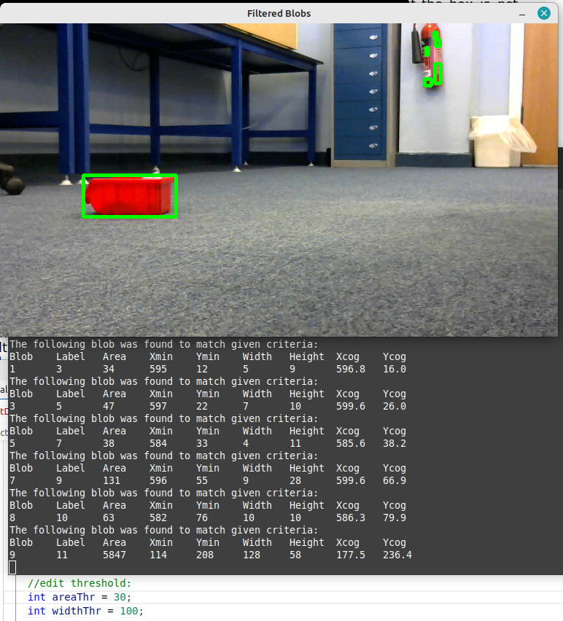
Here, because we decreased the area threshold quite a a bit, several blobs are showing – width doesn't even make any difference since we used an or (||) in the conditional statement.

A problem was found in the code when both width and height was above the parameters of any blobs: no image would be created becase the imshow() function was inside the conditional statement. To fix this, the imshow() was moved outside the for loop:
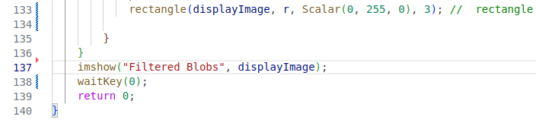
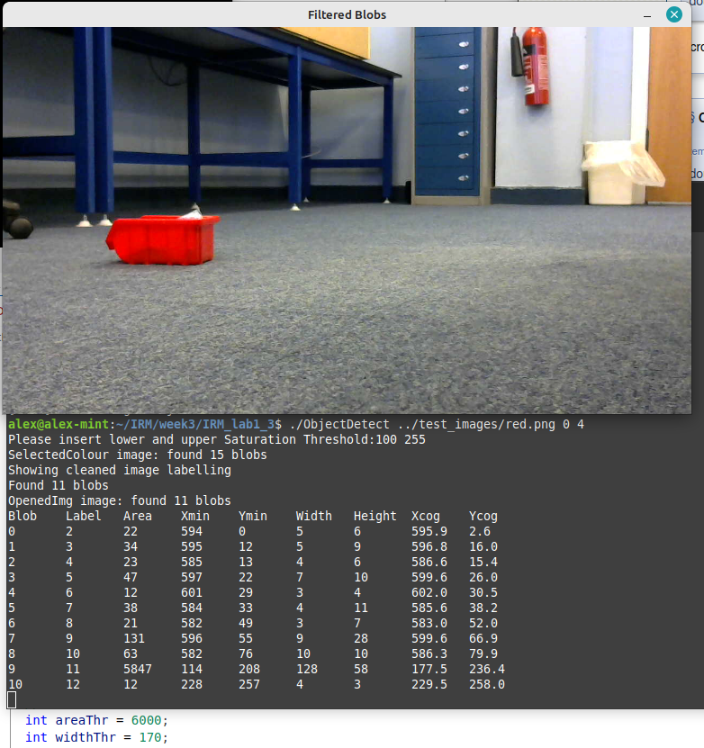
No rectangle is shown because no blobs were matching the given criteria (both width and area were too large).
Lab Reflection
In general, your lab write-up should indicate that you have acquired a better understanding of the
topics treated by the laboratory assignment. You should write half a page of text that explains the following aspects in the box below. Please create a cohesive piece of text and do not just provide unconnected sentences in response to the following aspects of your learning experience. This section is essential for you to place the learning outcomes of the laboratory in context.

- What has been the hardest part of the lab (5 marks)

The hardest part for me was uncovering and understanding all the functions available in openCV – it is a very large library. Also I am a beginner at c++ and vectors so I am trying to discover all the functionality offered. Otherwise the actual steps and methods of extracting the information was not very hard.

- The most useful thing that you’ve learnt (5 marks)

- What you’d suggest I could change to improve this lab (5 marks)
(70 + 65 marks in questions, 15 marks reflection)

