R Markdown Notes

Alex Berry

2025-02-26

Table of Contents

This is an example of R code.

# this is R code  
summary(mtcars)

## mpg cyl disp hp   
## Min. :10.40 Min. :4.000 Min. : 71.1 Min. : 52.0   
## 1st Qu.:15.43 1st Qu.:4.000 1st Qu.:120.8 1st Qu.: 96.5   
## Median :19.20 Median :6.000 Median :196.3 Median :123.0   
## Mean :20.09 Mean :6.188 Mean :230.7 Mean :146.7   
## 3rd Qu.:22.80 3rd Qu.:8.000 3rd Qu.:326.0 3rd Qu.:180.0   
## Max. :33.90 Max. :8.000 Max. :472.0 Max. :335.0   
## drat wt qsec vs   
## Min. :2.760 Min. :1.513 Min. :14.50 Min. :0.0000   
## 1st Qu.:3.080 1st Qu.:2.581 1st Qu.:16.89 1st Qu.:0.0000   
## Median :3.695 Median :3.325 Median :17.71 Median :0.0000   
## Mean :3.597 Mean :3.217 Mean :17.85 Mean :0.4375   
## 3rd Qu.:3.920 3rd Qu.:3.610 3rd Qu.:18.90 3rd Qu.:1.0000   
## Max. :4.930 Max. :5.424 Max. :22.90 Max. :1.0000   
## am gear carb   
## Min. :0.0000 Min. :3.000 Min. :1.000   
## 1st Qu.:0.0000 1st Qu.:3.000 1st Qu.:2.000   
## Median :0.0000 Median :4.000 Median :2.000   
## Mean :0.4062 Mean :3.688 Mean :2.812   
## 3rd Qu.:1.0000 3rd Qu.:4.000 3rd Qu.:4.000   
## Max. :1.0000 Max. :5.000 Max. :8.000

This is how to include figures

data("mtcars")  
library(ggplot2)  
ggplot(mtcars, aes(x = wt, y = mpg)) +  
 geom_smooth(method = lm, se = FALSE) +  
 geom_point(aes(color = wt)) +  
 xlab("Weight") +  
 ylab("Miles Per Gallon") +  
 scale_color_gradient(low = "dodgerblue", high = "black")

## `geom_smooth()` using formula = 'y ~ x'

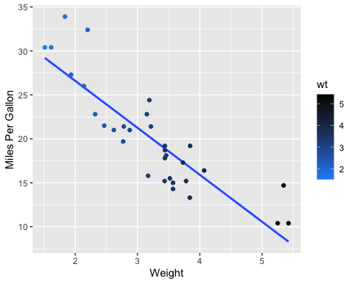

R Markdown formatting options

# First level header

*this text is italics* **this text is italics and bold**

## Links

[Link to my github](https://github.com/alexberry8/In-Class-Coding-Challenges.git)

## Images

|  |
| --- |
| Shrek ggplot |

Shrek ggplot

## Formatted tables

library(knitr)  
kable(mtcars, digits = 3, format = "markdown")

|  | mpg | cyl | disp | hp | drat | wt | qsec | vs | am | gear | carb |
| --- | --- | --- | --- | --- | --- | --- | --- | --- | --- | --- | --- |
| Mazda RX4 | 21.0 | 6 | 160.0 | 110 | 3.90 | 2.620 | 16.46 | 0 | 1 | 4 | 4 |
| Mazda RX4 Wag | 21.0 | 6 | 160.0 | 110 | 3.90 | 2.875 | 17.02 | 0 | 1 | 4 | 4 |
| Datsun 710 | 22.8 | 4 | 108.0 | 93 | 3.85 | 2.320 | 18.61 | 1 | 1 | 4 | 1 |
| Hornet 4 Drive | 21.4 | 6 | 258.0 | 110 | 3.08 | 3.215 | 19.44 | 1 | 0 | 3 | 1 |
| Hornet Sportabout | 18.7 | 8 | 360.0 | 175 | 3.15 | 3.440 | 17.02 | 0 | 0 | 3 | 2 |
| Valiant | 18.1 | 6 | 225.0 | 105 | 2.76 | 3.460 | 20.22 | 1 | 0 | 3 | 1 |
| Duster 360 | 14.3 | 8 | 360.0 | 245 | 3.21 | 3.570 | 15.84 | 0 | 0 | 3 | 4 |
| Merc 240D | 24.4 | 4 | 146.7 | 62 | 3.69 | 3.190 | 20.00 | 1 | 0 | 4 | 2 |
| Merc 230 | 22.8 | 4 | 140.8 | 95 | 3.92 | 3.150 | 22.90 | 1 | 0 | 4 | 2 |
| Merc 280 | 19.2 | 6 | 167.6 | 123 | 3.92 | 3.440 | 18.30 | 1 | 0 | 4 | 4 |
| Merc 280C | 17.8 | 6 | 167.6 | 123 | 3.92 | 3.440 | 18.90 | 1 | 0 | 4 | 4 |
| Merc 450SE | 16.4 | 8 | 275.8 | 180 | 3.07 | 4.070 | 17.40 | 0 | 0 | 3 | 3 |
| Merc 450SL | 17.3 | 8 | 275.8 | 180 | 3.07 | 3.730 | 17.60 | 0 | 0 | 3 | 3 |
| Merc 450SLC | 15.2 | 8 | 275.8 | 180 | 3.07 | 3.780 | 18.00 | 0 | 0 | 3 | 3 |
| Cadillac Fleetwood | 10.4 | 8 | 472.0 | 205 | 2.93 | 5.250 | 17.98 | 0 | 0 | 3 | 4 |
| Lincoln Continental | 10.4 | 8 | 460.0 | 215 | 3.00 | 5.424 | 17.82 | 0 | 0 | 3 | 4 |
| Chrysler Imperial | 14.7 | 8 | 440.0 | 230 | 3.23 | 5.345 | 17.42 | 0 | 0 | 3 | 4 |
| Fiat 128 | 32.4 | 4 | 78.7 | 66 | 4.08 | 2.200 | 19.47 | 1 | 1 | 4 | 1 |
| Honda Civic | 30.4 | 4 | 75.7 | 52 | 4.93 | 1.615 | 18.52 | 1 | 1 | 4 | 2 |
| Toyota Corolla | 33.9 | 4 | 71.1 | 65 | 4.22 | 1.835 | 19.90 | 1 | 1 | 4 | 1 |
| Toyota Corona | 21.5 | 4 | 120.1 | 97 | 3.70 | 2.465 | 20.01 | 1 | 0 | 3 | 1 |
| Dodge Challenger | 15.5 | 8 | 318.0 | 150 | 2.76 | 3.520 | 16.87 | 0 | 0 | 3 | 2 |
| AMC Javelin | 15.2 | 8 | 304.0 | 150 | 3.15 | 3.435 | 17.30 | 0 | 0 | 3 | 2 |
| Camaro Z28 | 13.3 | 8 | 350.0 | 245 | 3.73 | 3.840 | 15.41 | 0 | 0 | 3 | 4 |
| Pontiac Firebird | 19.2 | 8 | 400.0 | 175 | 3.08 | 3.845 | 17.05 | 0 | 0 | 3 | 2 |
| Fiat X1-9 | 27.3 | 4 | 79.0 | 66 | 4.08 | 1.935 | 18.90 | 1 | 1 | 4 | 1 |
| Porsche 914-2 | 26.0 | 4 | 120.3 | 91 | 4.43 | 2.140 | 16.70 | 0 | 1 | 5 | 2 |
| Lotus Europa | 30.4 | 4 | 95.1 | 113 | 3.77 | 1.513 | 16.90 | 1 | 1 | 5 | 2 |
| Ford Pantera L | 15.8 | 8 | 351.0 | 264 | 4.22 | 3.170 | 14.50 | 0 | 1 | 5 | 4 |
| Ferrari Dino | 19.7 | 6 | 145.0 | 175 | 3.62 | 2.770 | 15.50 | 0 | 1 | 5 | 6 |
| Maserati Bora | 15.0 | 8 | 301.0 | 335 | 3.54 | 3.570 | 14.60 | 0 | 1 | 5 | 8 |
| Volvo 142E | 21.4 | 4 | 121.0 | 109 | 4.11 | 2.780 | 18.60 | 1 | 1 | 4 | 2 |

## Links to analysis

* [Link to Markdown Tutorial](MarkdownTutorial.md)

# DOI

[Link to Mycotoxin Graph](https://doi.org/10.1094/PDIS-06-21-1253-RE)

# Mycotoxin Data

mycotoxin <- read.csv("MycotoxinData.csv", na.strings="na")  
cbbPalette <- c("#000000", "#E69F00", "#56B4E9", "#009E73", "#F0E442", "#0072B2", "#D55E00", "#CC79A7")  
library(ggplot2)  
library(ggpubr)  
  
### Question 1 - Create a Box Plot  
boxplot <- ggplot(mycotoxin, aes(x = Treatment, y = DON, fill = Cultivar, color = Cultivar)) +  
 geom_boxplot(outlier.shape = NA, position = position_dodge()) +   
 geom_point(position = position_jitterdodge(0.9), alpha = 0.6, shape = 21, color = "black") +  
 scale_fill_manual(values = c("Ambassador" = "#56B4E9", "Wheaton" = "#009E73")) +   
 scale_color_manual(values = c("Ambassador" = "#56B4E9", "Wheaton" = "#009E73")) +  
 labs(y = "DON (ppm)", x = "") +   
 theme_classic() +   
 facet_wrap(~Cultivar)   
boxplot

## Warning: Removed 8 rows containing non-finite outside the scale range  
## (`stat_boxplot()`).

## Warning: Removed 8 rows containing missing values or values outside the scale range  
## (`geom_point()`).

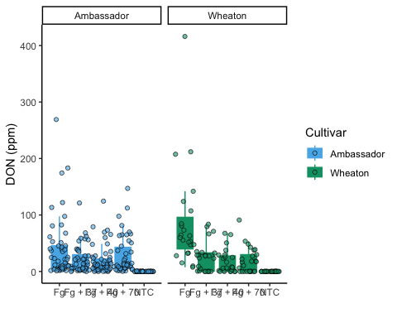

### Question 2 - Reorder Treatment Levels  
mycotoxin$Treatment <- factor(mycotoxin$Treatment, levels = c("NTC", "Fg", "Fg + 37", "Fg + 40", "Fg + 70"))  
boxplot1 <- ggplot(mycotoxin, aes(x = Treatment, y = DON, fill = Cultivar, color = Cultivar)) +  
 geom_boxplot(outlier.shape = NA, position = position_dodge()) +   
 geom_point(position = position_jitterdodge(0.9), alpha = 0.6, shape = 21, color = "black") +  
 scale_fill_manual(values = c("Ambassador" = "#56B4E9", "Wheaton" = "#009E73")) +   
 scale_color_manual(values = c("Ambassador" = "#56B4E9", "Wheaton" = "#009E73")) +  
 labs(y = "DON (ppm)", x = "") +   
 theme_classic() +   
 facet_wrap(~Cultivar)   
boxplot1

## Warning: Removed 8 rows containing non-finite outside the scale range  
## (`stat_boxplot()`).  
## Removed 8 rows containing missing values or values outside the scale range  
## (`geom_point()`).

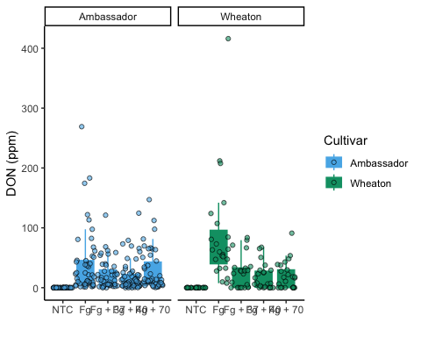

### Question 3 - X15ADON and MassperSeed_mg Plots  
# X15ADON Plot  
boxplot2 <- ggplot(mycotoxin, aes(x = Treatment, y = X15ADON, fill = Cultivar, color = Cultivar)) +  
 geom_boxplot(outlier.shape = NA, position = position_dodge()) +   
 geom_point(position = position_jitterdodge(0.9), alpha = 0.6, shape = 21, color = "black") +  
 scale_fill_manual(values = c("Ambassador" = "#56B4E9", "Wheaton" = "#009E73")) +   
 scale_color_manual(values = c("Ambassador" = "#56B4E9", "Wheaton" = "#009E73")) +  
 labs(y = "X15ADON", x = "") +   
 theme_classic() +   
 facet_wrap(~Cultivar)   
boxplot2

## Warning: Removed 10 rows containing non-finite outside the scale range  
## (`stat_boxplot()`).

## Warning: Removed 10 rows containing missing values or values outside the scale range  
## (`geom_point()`).

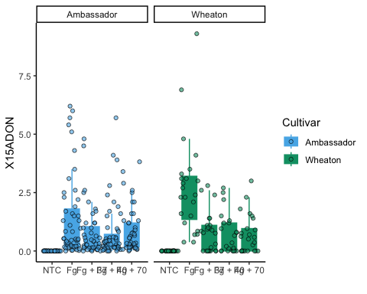

# MassperSeed_mg Plot  
boxplot3 <- ggplot(mycotoxin, aes(x = Treatment, y = MassperSeed_mg, fill = Cultivar, color = Cultivar)) +  
 geom_boxplot(outlier.shape = NA, position = position_dodge()) +   
 geom_point(position = position_jitterdodge(0.9), alpha = 0.6, shape = 21, color = "black") +  
 scale_fill_manual(values = c("Ambassador" = "#56B4E9", "Wheaton" = "#009E73")) +   
 scale_color_manual(values = c("Ambassador" = "#56B4E9", "Wheaton" = "#009E73")) +  
 labs(y = "MassperSeed_mg", x = "") +   
 theme_classic() +   
 facet_wrap(~Cultivar)   
boxplot3

## Warning: Removed 2 rows containing non-finite outside the scale range  
## (`stat_boxplot()`).

## Warning: Removed 2 rows containing missing values or values outside the scale range  
## (`geom_point()`).

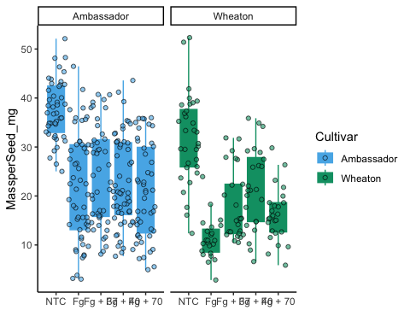

### Question 4 - Combine all Three Plots  
boxplot1 <- boxplot1 + theme(axis.text.x = element_text(angle = 45, hjust = 1))  
boxplot2 <- boxplot2 + theme(axis.text.x = element_text(angle = 45, hjust = 1))  
boxplot3 <- boxplot3 + theme(axis.text.x = element_text(angle = 45, hjust = 1))  
combinedplot <- ggarrange(boxplot1, boxplot2, boxplot3, labels = "auto", nrow = 1, ncol = 3, common.legend = T)

## Warning: Removed 8 rows containing non-finite outside the scale range  
## (`stat_boxplot()`).

## Warning: Removed 8 rows containing missing values or values outside the scale range  
## (`geom_point()`).

## Warning: Removed 8 rows containing non-finite outside the scale range  
## (`stat_boxplot()`).

## Warning: Removed 8 rows containing missing values or values outside the scale range  
## (`geom_point()`).

## Warning: Removed 10 rows containing non-finite outside the scale range  
## (`stat_boxplot()`).

## Warning: Removed 10 rows containing missing values or values outside the scale range  
## (`geom_point()`).

## Warning: Removed 2 rows containing non-finite outside the scale range  
## (`stat_boxplot()`).

## Warning: Removed 2 rows containing missing values or values outside the scale range  
## (`geom_point()`).

combinedplot

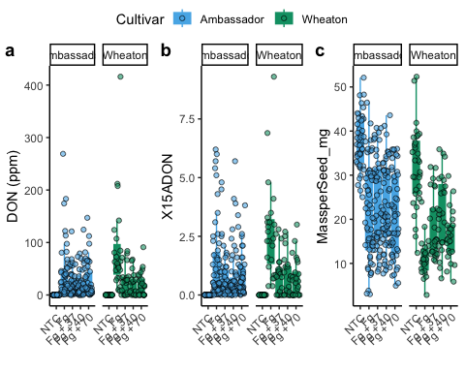

### Question 5 - Add T-Test and Rearrange all Three Plots  
# boxplot1  
boxplot1_ttest <- boxplot1 +   
 geom_pwc(aes(group = Treatment), method = "t.test", label = "p.adj.format")  
boxplot1_ttest

## Warning: Removed 8 rows containing non-finite outside the scale range  
## (`stat_boxplot()`).

## Warning: Removed 8 rows containing non-finite outside the scale range  
## (`stat_pwc()`).

## Warning: Removed 8 rows containing missing values or values outside the scale range  
## (`geom_point()`).

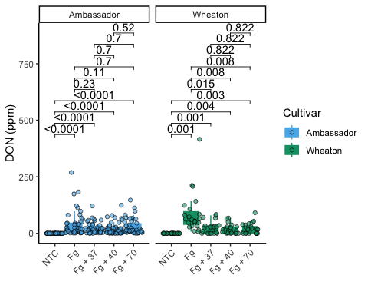

# boxplot2  
boxplot2_ttest <- boxplot2 +   
 geom_pwc(aes(group = Treatment), method = "t.test", label = "p.adj.format")  
boxplot2_ttest

## Warning: Removed 10 rows containing non-finite outside the scale range  
## (`stat_boxplot()`).

## Warning: Removed 10 rows containing non-finite outside the scale range  
## (`stat_pwc()`).

## Warning: Removed 10 rows containing missing values or values outside the scale range  
## (`geom_point()`).

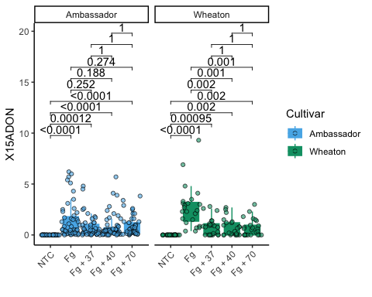

# boxplot3  
boxplot3_ttest <- boxplot3 +   
 geom_pwc(aes(group = Treatment), method = "t.test", label = "p.adj.format")  
boxplot3_ttest

## Warning: Removed 2 rows containing non-finite outside the scale range  
## (`stat_boxplot()`).

## Warning: Removed 2 rows containing non-finite outside the scale range  
## (`stat_pwc()`).

## Warning: Removed 2 rows containing missing values or values outside the scale range  
## (`geom_point()`).

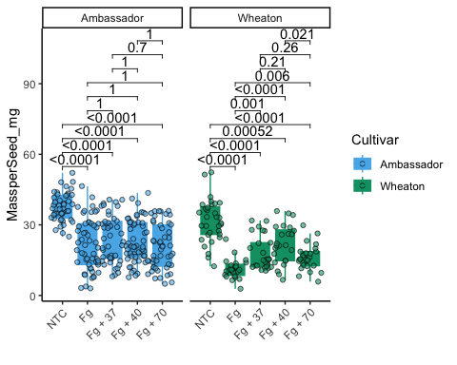

# Combine all Three Plots with P-Values  
combinedplot2 <- ggarrange(boxplot1_ttest, boxplot2_ttest, boxplot3_ttest, labels = "auto", nrow = 1, ncol = 3, common.legend = T)

## Warning: Removed 8 rows containing non-finite outside the scale range  
## (`stat_boxplot()`).

## Warning: Removed 8 rows containing non-finite outside the scale range  
## (`stat_pwc()`).

## Warning: Removed 8 rows containing missing values or values outside the scale range  
## (`geom_point()`).

## Warning: Removed 8 rows containing non-finite outside the scale range  
## (`stat_boxplot()`).

## Warning: Removed 8 rows containing non-finite outside the scale range  
## (`stat_pwc()`).

## Warning: Removed 8 rows containing missing values or values outside the scale range  
## (`geom_point()`).

## Warning: Removed 10 rows containing non-finite outside the scale range  
## (`stat_boxplot()`).

## Warning: Removed 10 rows containing non-finite outside the scale range  
## (`stat_pwc()`).

## Warning: Removed 10 rows containing missing values or values outside the scale range  
## (`geom_point()`).

## Warning: Removed 2 rows containing non-finite outside the scale range  
## (`stat_boxplot()`).

## Warning: Removed 2 rows containing non-finite outside the scale range  
## (`stat_pwc()`).

## Warning: Removed 2 rows containing missing values or values outside the scale range  
## (`geom_point()`).

combinedplot2

