Five Sections of the Site: Attached Data Products and Prototypes
24 September 2026 · Alex Newhouse

How to read this
This is the five-section site outline with the concrete thing that backs each element attached under it: a screenshot of the prototype screen where one exists, the data product (table, chart, or summary) where one exists, and the repo path so anyone can open the original. Where an element has no data product yet, it says so in one line rather than leaving the slot blank.
Each attachment is labelled with the folder it comes from in the linkedin_analysis repository. Screenshots were taken from the HTML prototypes as they stand on 24 September 2026. The original outline text is kept verbatim as the lead of each element, and the open questions in it are answered from the data where the data can answer them.

1. Intro/Landing Page
Outline text: top-level advocacy arguments and entry points to the four sections below.
Two landing pages exist, and both already do the two things the outline asks the intro to do: say who is in the data, and open the possibility space. The Humanities Workforce portal leads with "There is no default job" over a destination fan. The journey-site prototype leads with what a quarter of a million people did in their first ten years of work.
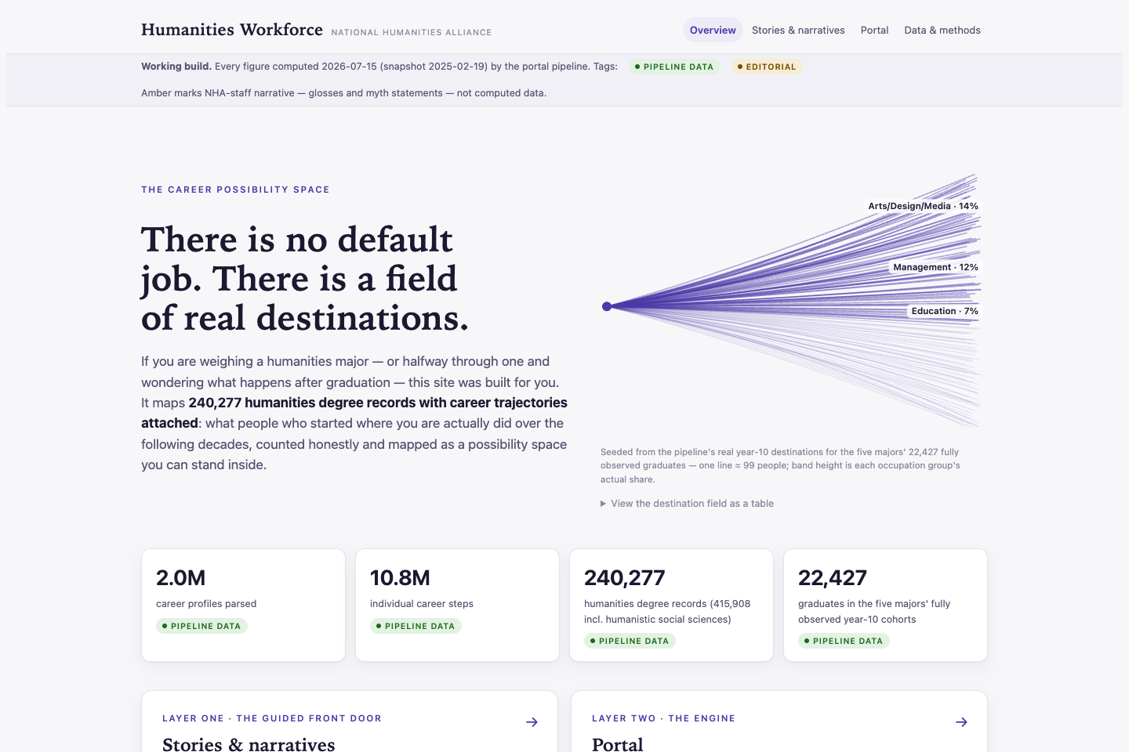
Attachment 1.1. Humanities Workforce portal, Overview view. Built from portal/share_template.html by make portal; this is the build of 15 July 2026, recovered from git commit ed06a7d because built pages are not tracked.
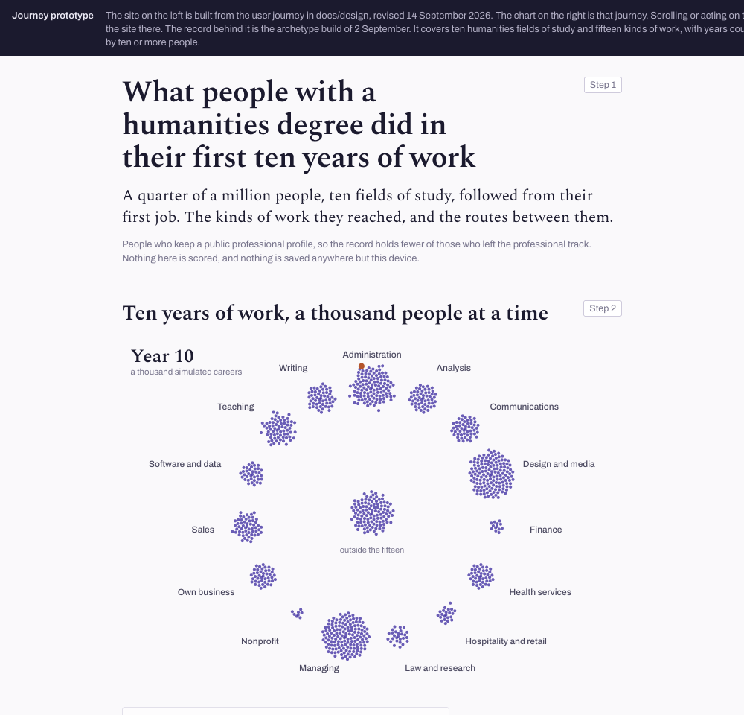
Attachment 1.2. Journey-site prototype, arrival screen. prototype/journey-site.html, revised 14 September 2026, generated from the user journey in docs/design/.
The data product behind the landing claim. The chart is the whole field at career year ten for all ten humanities fields. The largest single kind of work holds 14.4% of people, which is the "about one in eight" sentence both prototypes use.
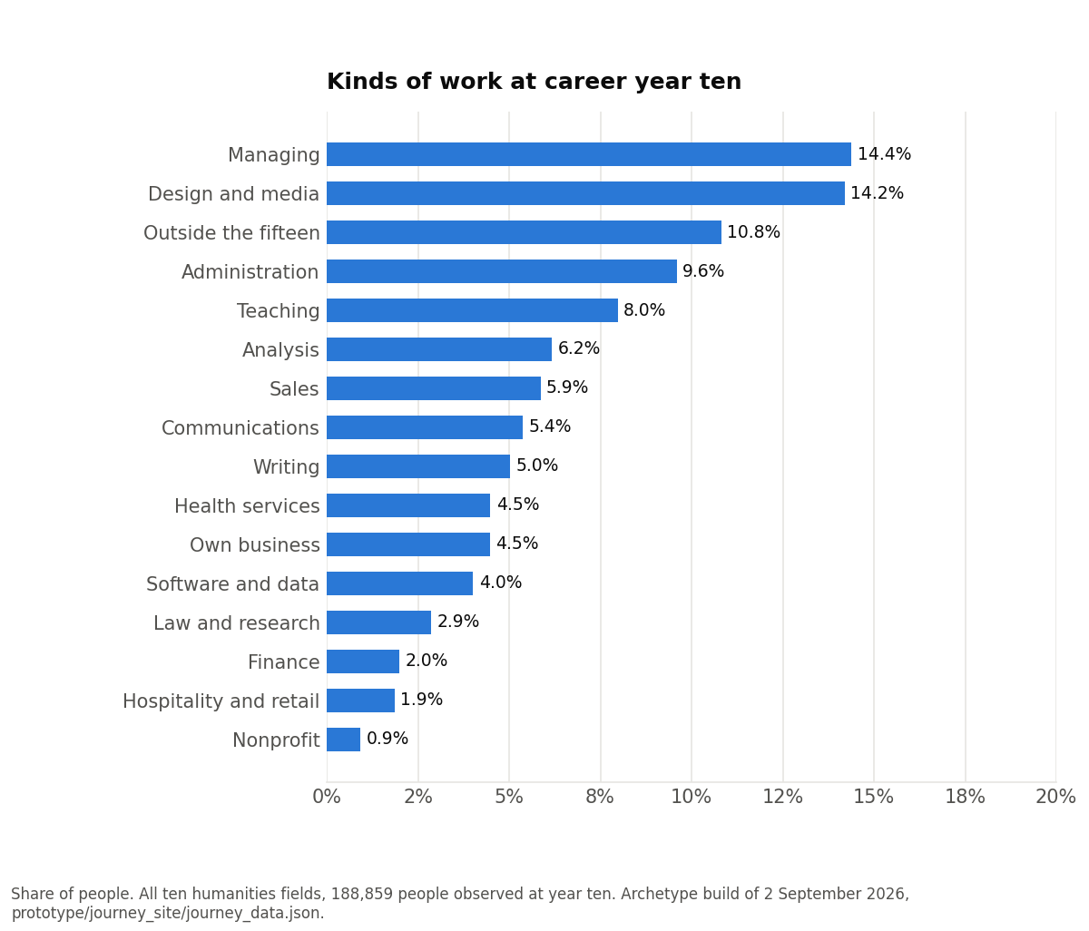
Chart 1. Kinds of work at career year ten. prototype/journey_site/journey_data.json, year-10 mix, all ten fields.
The population statement the landing page has to carry, as the prototypes state it:
Figure | Value | Source
Career profiles parsed (snapshot of 19 Feb 2026) | 2.0M | PIPELINE.md
Humanities degree records, narrow definition (L1) | 240,277 | portal/FINDINGS.md
Same, adding humanistic social sciences (L2) | 415,908 | portal/FINDINGS.md
Graduates in the five majors fully observed at year ten | 22,427 | portal Overview
People in ten fields followed from their first job | 246,258 | prototype/journey_site/journey_data.json

The advocacy arguments themselves are written up as eight messages in docs/MESSAGES.md (24 August 2026), each with a definition, the measurement behind it, and where it lands on the report versus the site. The audit of 12 August 2026 (docs/notes/2026-08-12-eight-arguments-audit.md) scored them: two hold as stated, three need restating, and three are not supportable from this corpus (skills, leadership convergence, coursework). Section 3 attaches the data behind each.
Entry points to the four sections:
Outline entry point | Where it exists today | See
Explore the humanities career possibility space | Journey site "Three ways in"; portal "The possibility space" | Section 2
Learn how humanities majors leverage fundamental capabilities | No screen yet. The Atlas prototype is the closest, on placeholder data | Sections 2 and 3
Examine the data yourself (portal) | Portal views for space, decade and choices; the earlier Pathways prototype | Section 4
Data Stories | Portal "Six things people will tell you" cards and the Stories walkthrough | Section 5

2. Pathways: Explore the humanities career possibility space
Outline text: Choose your own adventure. Discover unexpected pathways to dynamic careers across a wide variety of industries ("Unexpected is not unusual"). Trace how humanities majors have built careers in target career fields. Learn how archetypal humanities capabilities propel students to leadership roles. Interactive archetype analysis prototype.
The journey-site prototype is the working version of this section. It is one canvas where the reader sets a starting point, a destination, or both, and any job, field or employer on screen becomes the next question. Two earlier prototypes fed it: the Pathways design prototype of July 2026 (share/deprecated/NHA-Pathways-prototype.html) and the portal's Stories walkthrough.

2a. Choose your own adventure ("Unexpected is not unusual")
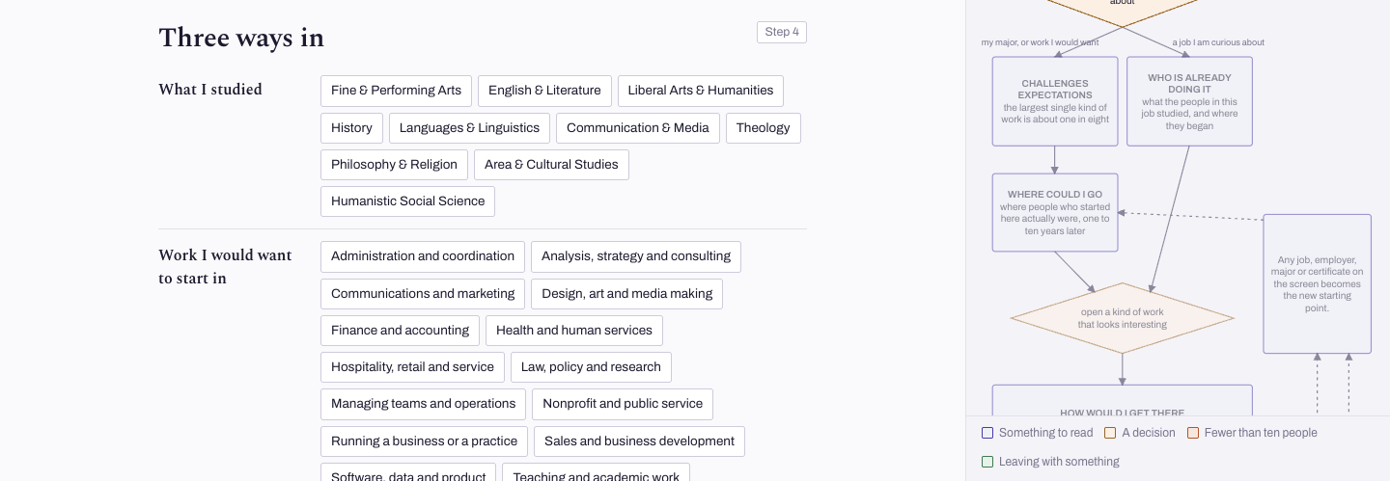
Attachment 2.1. Journey site, step 4, "Three ways in": what I studied (ten fields), work I would want to start in (fifteen kinds), or a job title I am curious about (13,933 titles clear the ten-person bar). prototype/journey-site.html.
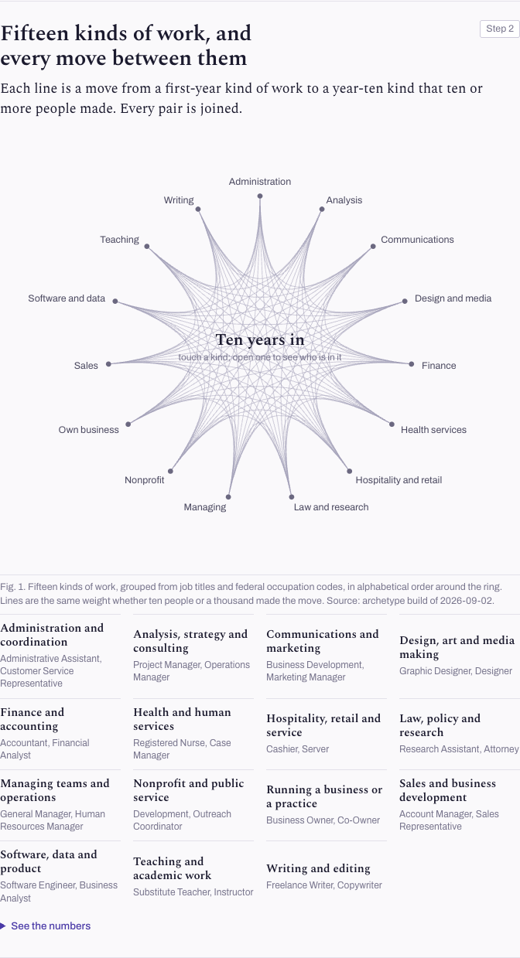
Attachment 2.2. Journey site, step 2. Each line is a year-one to year-ten move made by ten or more people; every pair of the fifteen kinds is joined. The data product behind it is the 144-cell origin-to-destination table in docs/design/2026-09-01-product-maps.md section 0.1: all 144 cells clear ten people, the median cell holds 614.
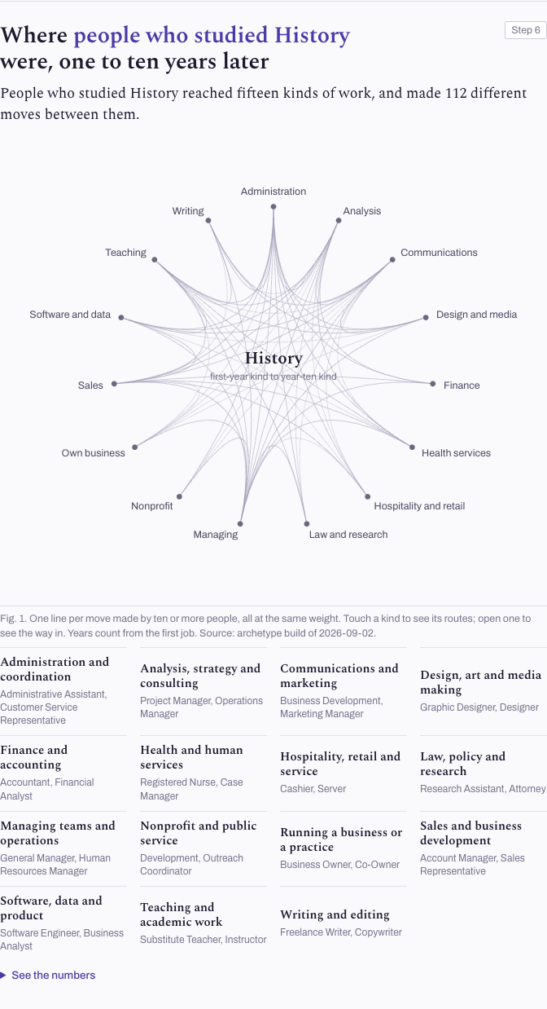
Attachment 2.3. Journey site with a starting point set (History): fifteen kinds of work reached, 112 distinct moves between them. Any kind can be opened to see who is in it.
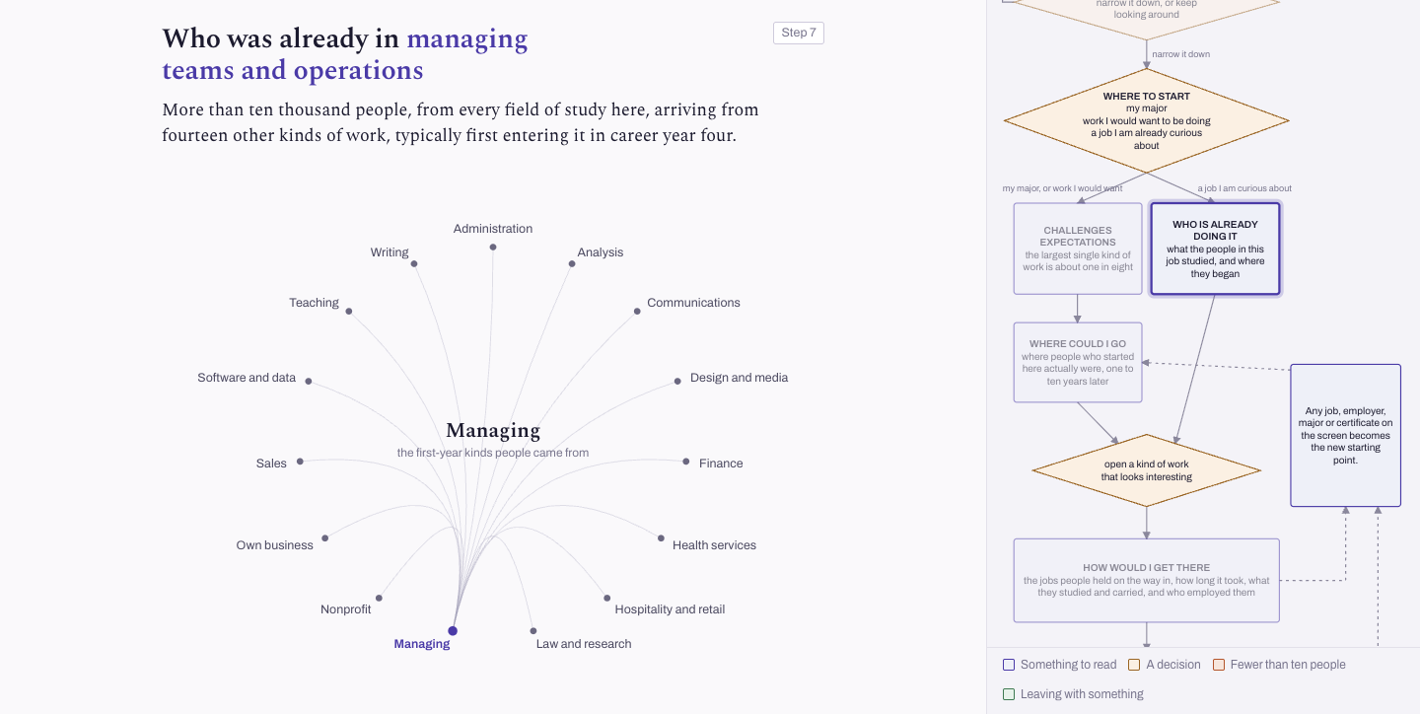
Attachment 2.4. The same canvas read backwards, with only a destination set: what the people in this work studied and where they began. This is the form the messages doc recommends for "chart a course": always where people came from, never where someone will end up.
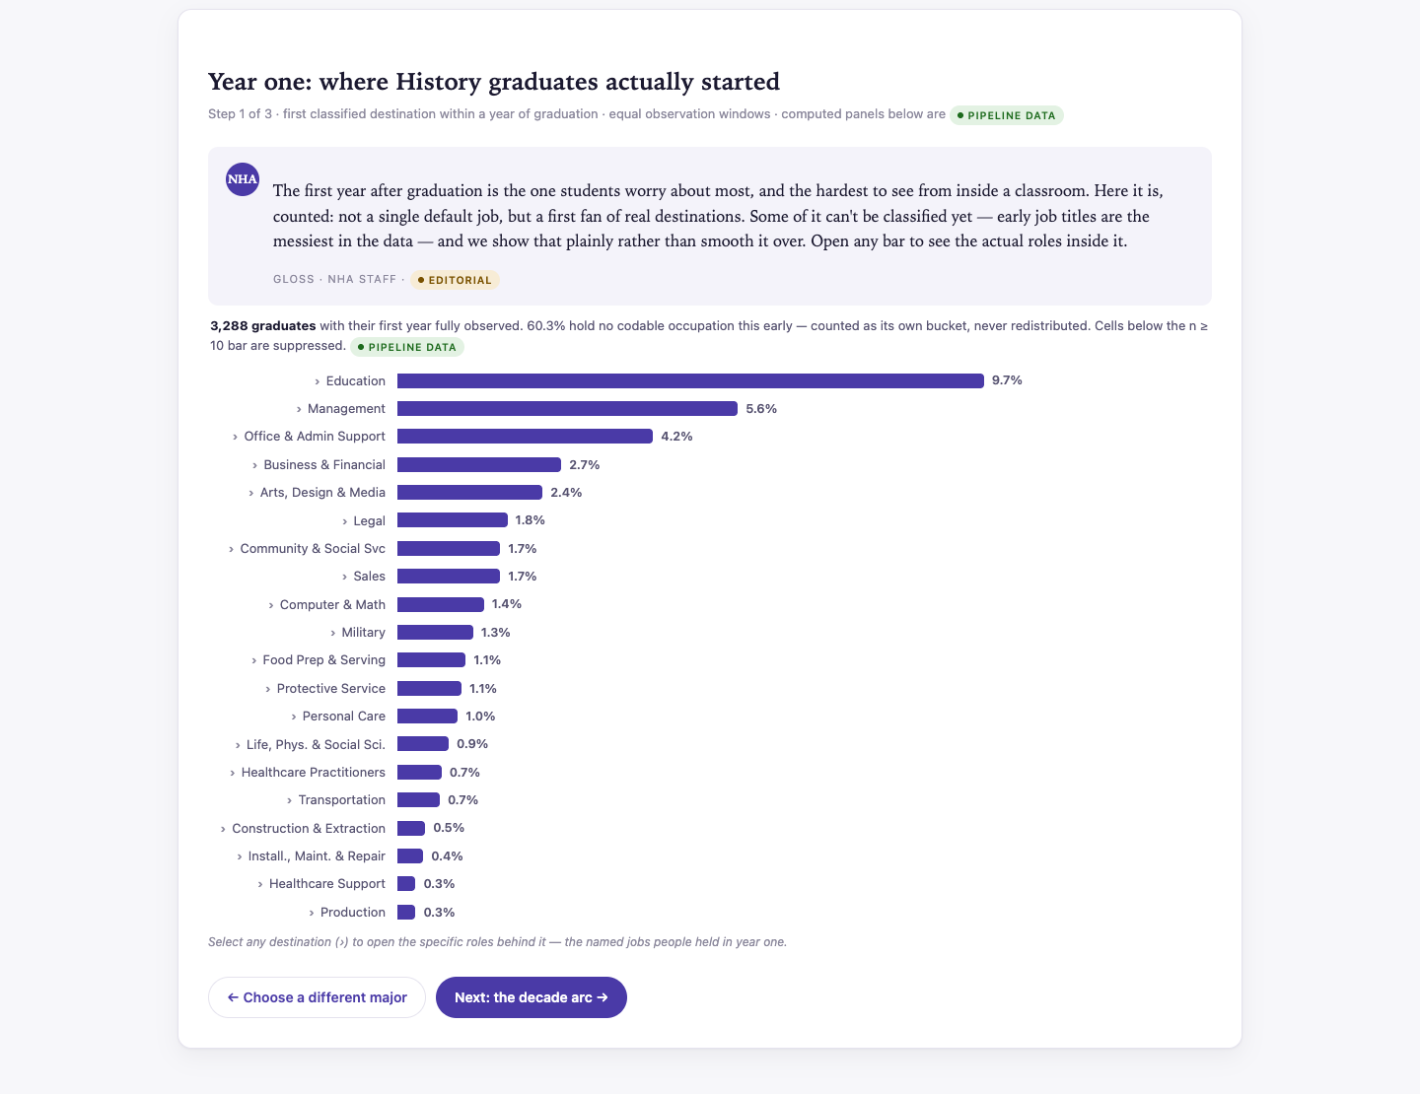
Attachment 2.5. Humanities Workforce portal, Stories and narratives, History, step 1 of 3 (year one, then the decade arc, then the choices). Build of 15 July 2026.
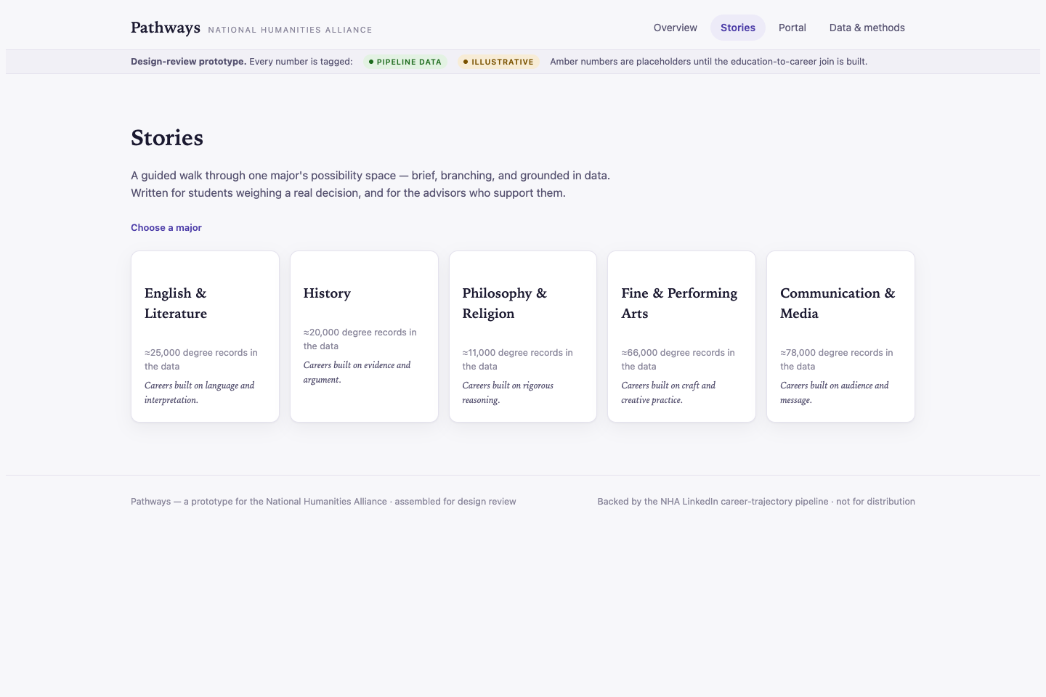
Attachment 2.6. The earlier Pathways design prototype (7 July 2026), Stories view: pick a major, walk a branch. Superseded by the portal on 8 July 2026; kept in share/deprecated/.
Data behind "unexpected": the distinctive destinations per field in portal/FINDINGS.md (History into legal work at 4.1 times the all-graduate rate; Philosophy and Religion into community and social service at 8.8 times; Arts into arts, design and media at 7.3 times) and the rare-title tail (638,368 distinct job titles, 86.4% held by exactly one person, 13,933 clearing the reporting bar). One caveat carries into the copy: "unexpected" is relative to the stereotype, not to other majors. Humanities cohorts reach 4.18 to 8.04 equally common destinations against an all-graduate 8.25, so the site must not say the space is wider than other majors' (docs/notes/2026-08-12-eight-arguments-audit.md, A1).

2b. Trace how humanities majors built careers in target career fields
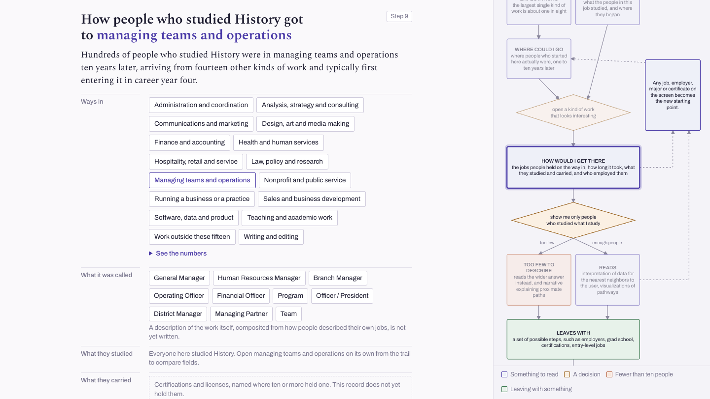
Attachment 2.7. Journey site, step 9, both ends set. Panels in the order the site concept fixes: ways in, what it was called, what they studied, what they carried, where it happened. "What they carried" is empty because the certification records are not yet wired to the page.
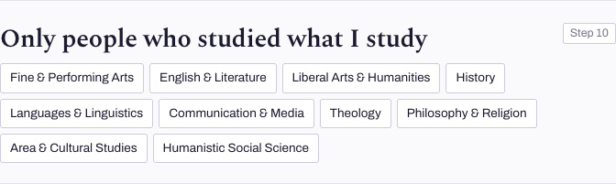
Attachment 2.8. Step 10, the narrowing control. It restricts the same answer to one field of study. Below ten people the site widens the answer instead of going blank.
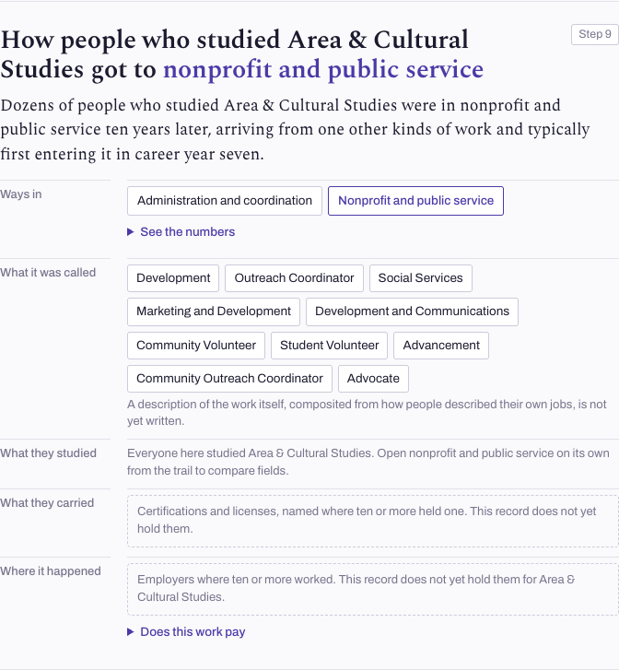
Attachment 2.9. The same screen for a small field (Area and Cultural Studies, 4,414 people) into nonprofit work: dozens of people and one named way in; the other origins fall under the ten-person bar and are not named.
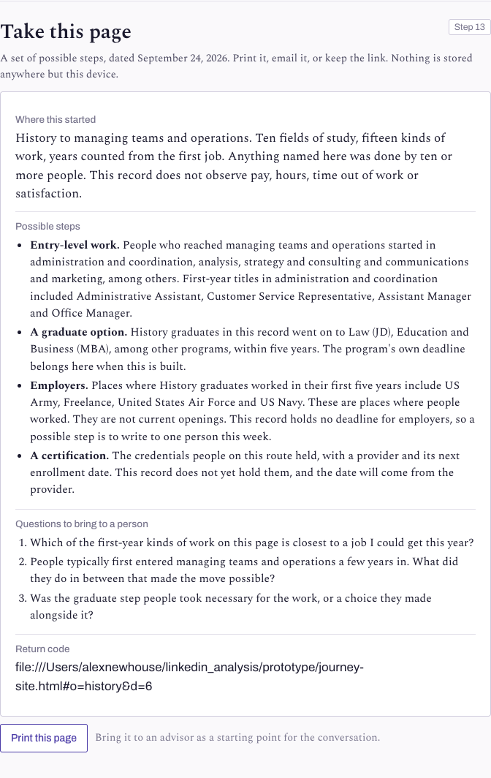
Attachment 2.10. Step 13, the exit: entry-level jobs, graduate degrees, employers and a certification, dated, printable, held only on the device.
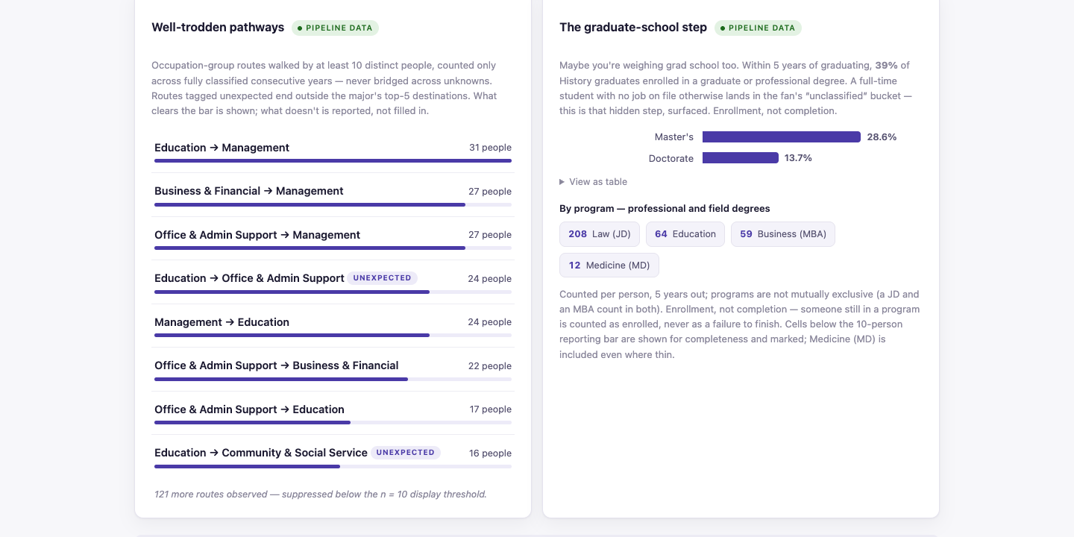
Attachment 2.11. Portal, The first decade, History: occupation-group routes walked by ten or more people, and the graduate-school step. At job-title grain no three- or four-step route clears forty people (maximum support is eight), so named routes are shown at occupation-group grain or written editorially (portal/FINDINGS.md).
The other data products for tracing routes are the first-job to current-job transition table per group in persons/results/metrics.json (for example 2,591 humanities graduates went from arts, design and media into management) and the occupation transition network in transition_network/ (824 occupations, 39,310 edges, weighted by relative risk so that size-controlled ladders surface).

2c. Archetypal capabilities, leadership, and the interactive archetype prototype
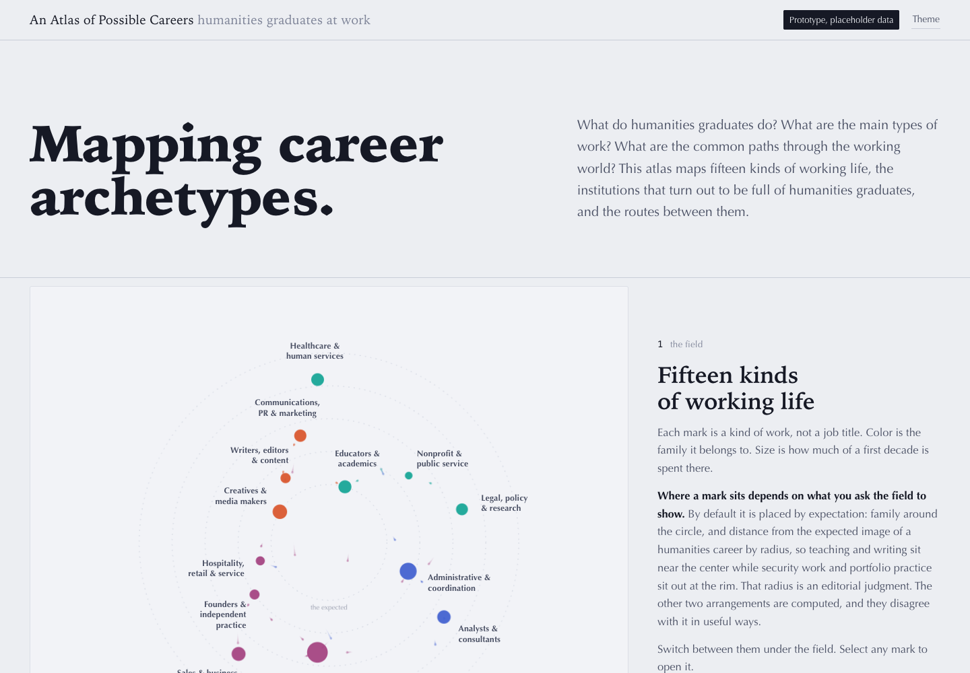
Attachment 2.12. The interactive archetype prototype: "An Atlas of Possible Careers", archive/atlas-prototype.html (moved from prototype/atlas.html on 1 September 2026). Fifteen kinds of working life placed by expectation, movement or language. Labelled "Prototype, placeholder data": only two plates are measured.
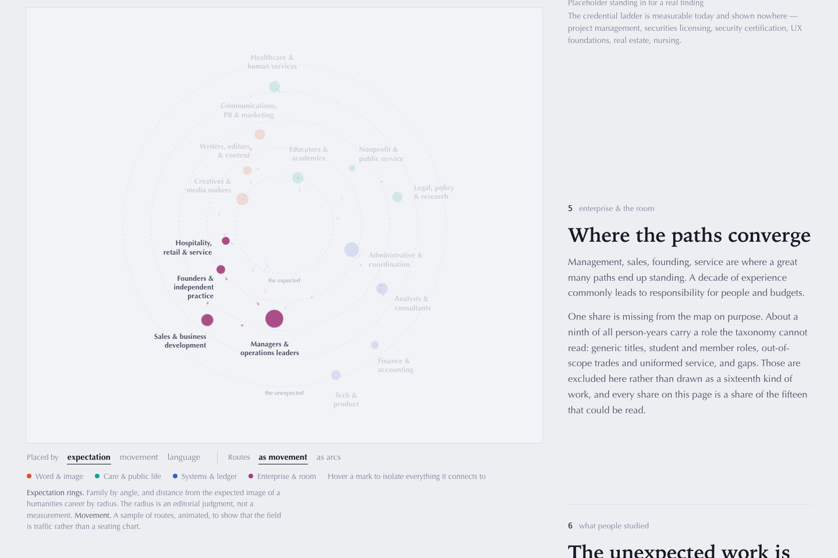
Attachment 2.13. Atlas, step 5, "Where the paths converge": management, sales, founding and service as the places a decade of experience leads. Illustrative weights.
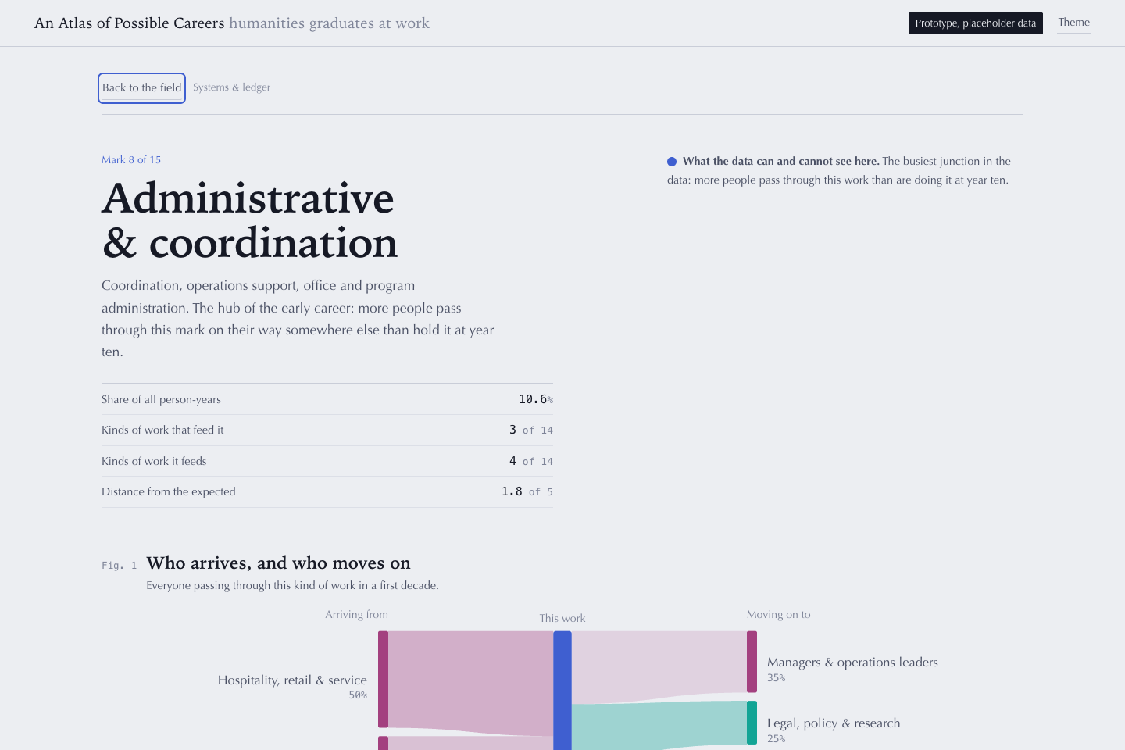
Attachment 2.14. Atlas mark plate for administrative and coordination work: who arrives, who moves on. The plate layout is the reference for a per-archetype view.
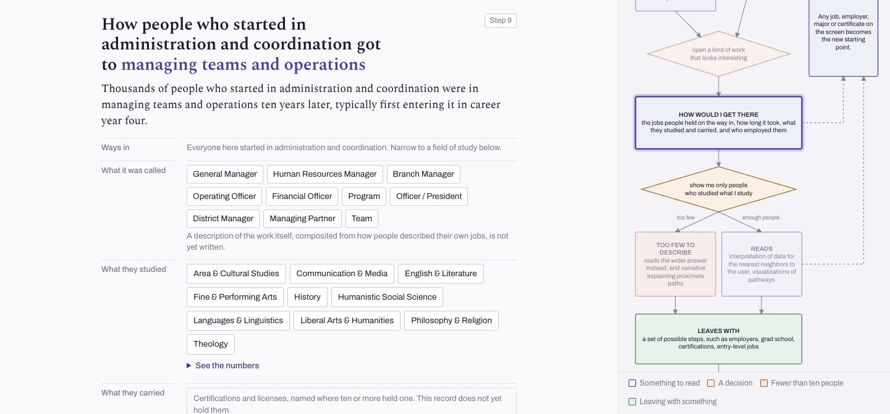
Attachment 2.15. The same route on measured data: journey site, starting kind set to administration, destination managing. Thousands of people, typically first entering management in career year four.
The data product for "paths converge in leadership": the chart shows the year-one kind of work of everyone managing teams at year ten. After those already managing, administration is the largest single door, ahead of any creative, sales or analytical start.
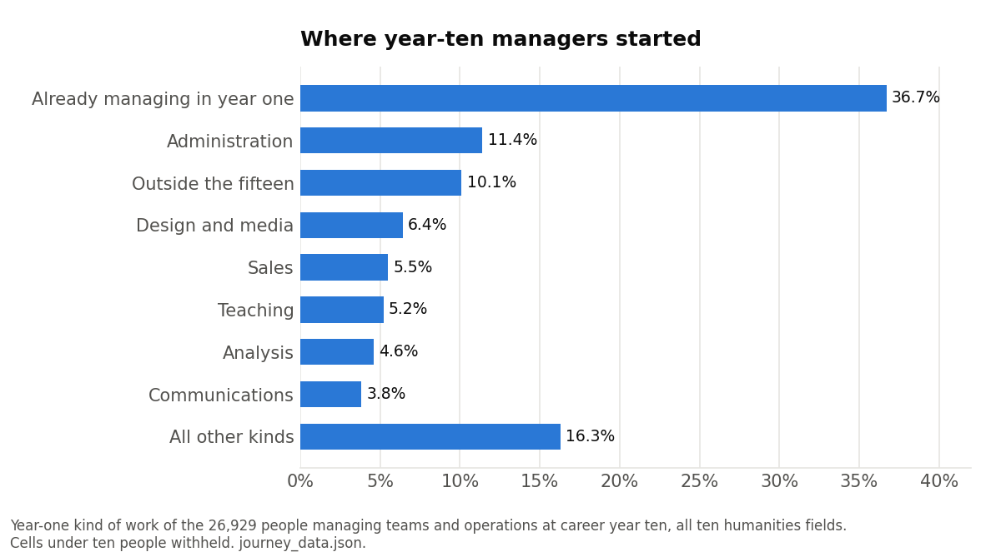
Chart 2. Where year-ten managers started. prototype/journey_site/journey_data.json, year-1 to year-10 flows into Managing.
Two archetype vocabularies exist, and the site uses neither on screen. The director's Career Skill Archetypes framework (docs/notes/nha-career-skill-archetypes-framework.md, PDF in docs/reference/) is nine archetypes with signature skills in coursework language; it is a normative taxonomy, not fitted to the data. The pipeline's own archetypes (archetypes/FINDINGS.md) are fifteen role and skillset states assigned to every career step, covering 407,265 humanities people and 5.03 million person-years. The site concept rules the archetype vocabulary off screen, so the journey site shows plain names:
Pipeline archetype | Name on the journey site
Educators and Academics | Teaching
Creatives and Media Makers | Design and media
Writers, Editors and Content | Writing
Communications, PR and Marketing | Communications
Sales and Business Development | Sales
Managers and Operations Leaders | Managing
Business and Strategy Analysts | Analysis
Finance and Accounting | Finance
Tech and Product | Software and data
Administrative and Coordination | Administration
Legal, Policy and Research | Law and research
Healthcare and Human Services | Health services
Nonprofit, Public Service and Advocacy | Nonprofit
Hospitality, Retail and Service | Hospitality and retail
Founders and Independent Practitioners | Own business

The Atlas's visualization phase was never built on measured data (archetypes/FINDINGS.md section 7); its flow tensors exist on the Linux build machine, and the journey site is the first surface to draw them.

3. Our Findings: playing the long game, adapting nimbly
Outline text: Some of this is covered in what Alex presented in March. Widely transferable capabilities enable humanities majors to transition more fluidly across industries and roles to adapt to changing circumstances. Humanities majors rise to leadership positions by mid-career, frequently surpassing peers they initially trailed during an initial exploratory phase. Secondary points: the open-ended, iterative nature of humanities career pathways is not so distinct as it seems; a humanities background is an ideal foundation for graduate study across all fields.
The March presentation is not in the repository, so nothing below is drawn from it. What follows is the measured data product for each claim, the answer to each open question in the outline, and the places where the data refuses the claim as written. The two documents that already do this work are docs/MESSAGES.md (24 August 2026) and docs/notes/2026-08-12-eight-arguments-audit.md; the product review of 24 August (docs/notes/2026-08-24-product-review.md) sets the recommendations.

3a. Transferable capabilities and moves across industries and roles
What is the data for the skills? There is none in the corpus. LinkedIn's skills and endorsements section was not captured, and the audit rates the skills claim "unfalsifiable, not merely unproven": every proxy is a job title, a self-written description or a certification, and a title-inferred skill is collinear with the move it would explain. Three things stand in for it:
Stand-in | What exists | Where
The framework's skills language | Nine archetypes, each with signature skills in coursework terms (close reading, source evaluation, argument construction). NHA's position, not a measurement | docs/notes/nha-career-skill-archetypes-framework.md
Certifications people added | 1.67 million certification records across 545,409 people; 58.9% mapped to a skills domain (project management, securities licensing, IT security, real estate, Scrum, UX, nursing). Built, never surfaced | cert_clean/, normalized/_cert_manifest.json
Activity beyond titles | Humanities vs everyone else: volunteering 16.1% vs 13.0%; publications 5.6% vs 3.6%; honors 10.7% vs 8.5%; professional multilingual 10.8% vs 8.7% (31.2% for language majors) | enrichment/results/enrichment.json

The messages doc's rule for the site: show what people carried, never say skills transfer. The certification layer is the one piece a student can act on this semester.
What is the data for transferability and adaptability? The moves themselves are measured directly. At the fifteen-kinds grain, 54% of humanities graduates are in a different kind of work at career year ten than at year one; the chart splits that by field.
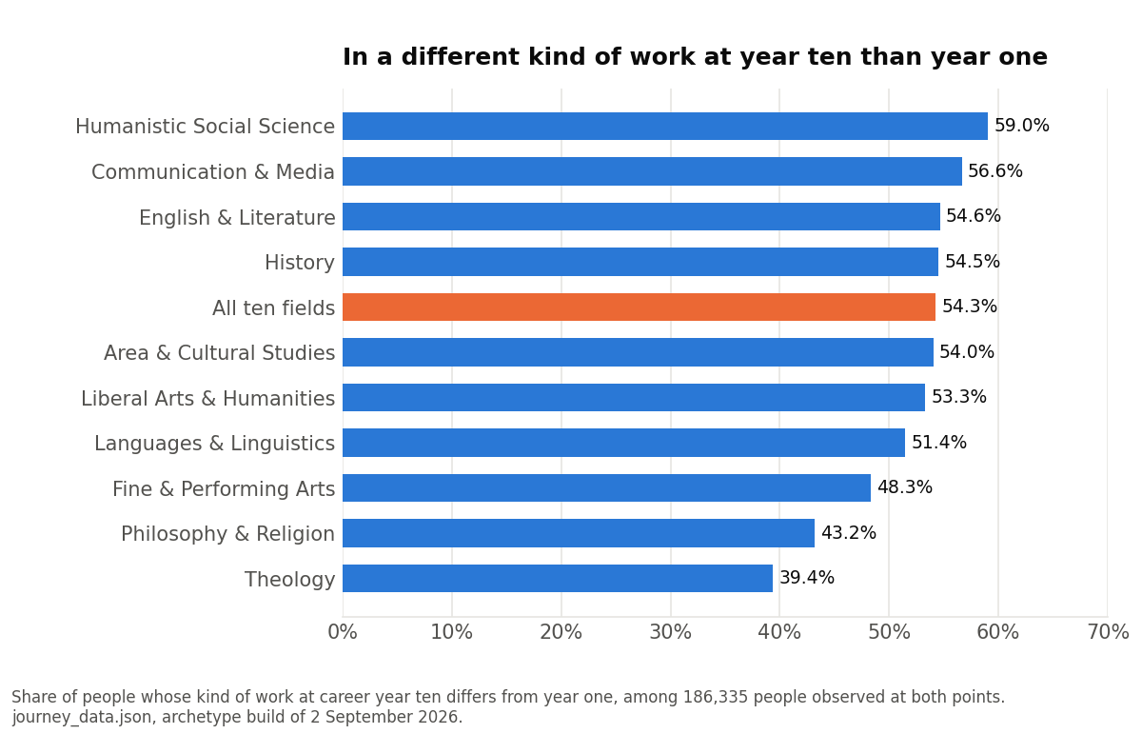
Chart 3. In a different kind of work at year ten than year one, by field. prototype/journey_site/journey_data.json, year-1 to year-10 flows by field.
At occupation-group grain the audit found the same shape with a comparison attached: History graduates change occupation group between years one and ten more than the all-graduate baseline (54.5% vs 42.1%) while their rate of changing industry sits at baseline (37.6% vs 33.8%). Humanities graduates carry the same sector into different work. Two caveats travel with it. The audit's comparative numbers are marked ad hoc (throwaway queries, not yet reproduced in the pipeline), and portability is conditional: management spans an effective 11.4 of 24 industries and administration 10.1, but education work sits 88.4% in one industry, so the portability thesis is weakest for the most stereotypically humanities destinations. Fine and Performing Arts is the exception throughout, with the lowest change rate and the most pipeline-like destinations.
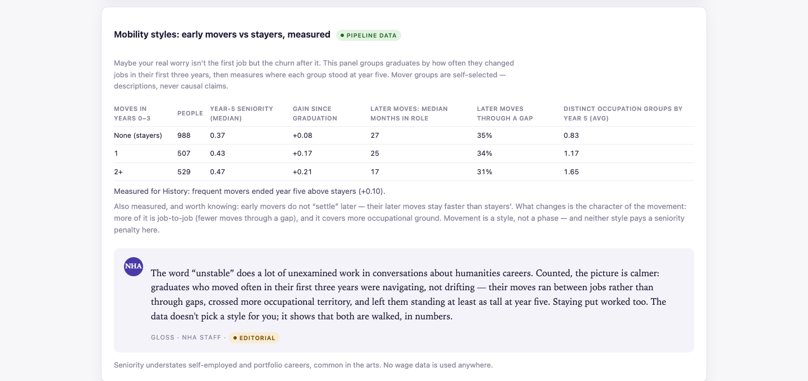
Attachment 3.1. Portal, The first decade, History: mobility styles, early movers versus stayers. Frequent movers ended year five above stayers on seniority; neither style pays a penalty.
How are we representing the industries? With the project's own four-level employer taxonomy: 17 top-level sectors and 162 nodes in total (industry/taxonomy.json, method in industry/METHODS.md), applied to employers by deterministic rules, a curated head of household names, and a calibrated LLM jury. Top-level coverage is 59.2% of career steps; humanities jobs resolve at the top level 53.9% of the time, and unresolved steps are reported as their own bucket, never redistributed. Spot-check precision at the top level is 0.90 on 29 companies. The portal's "Sectors reached" panel and the chart below both use it.
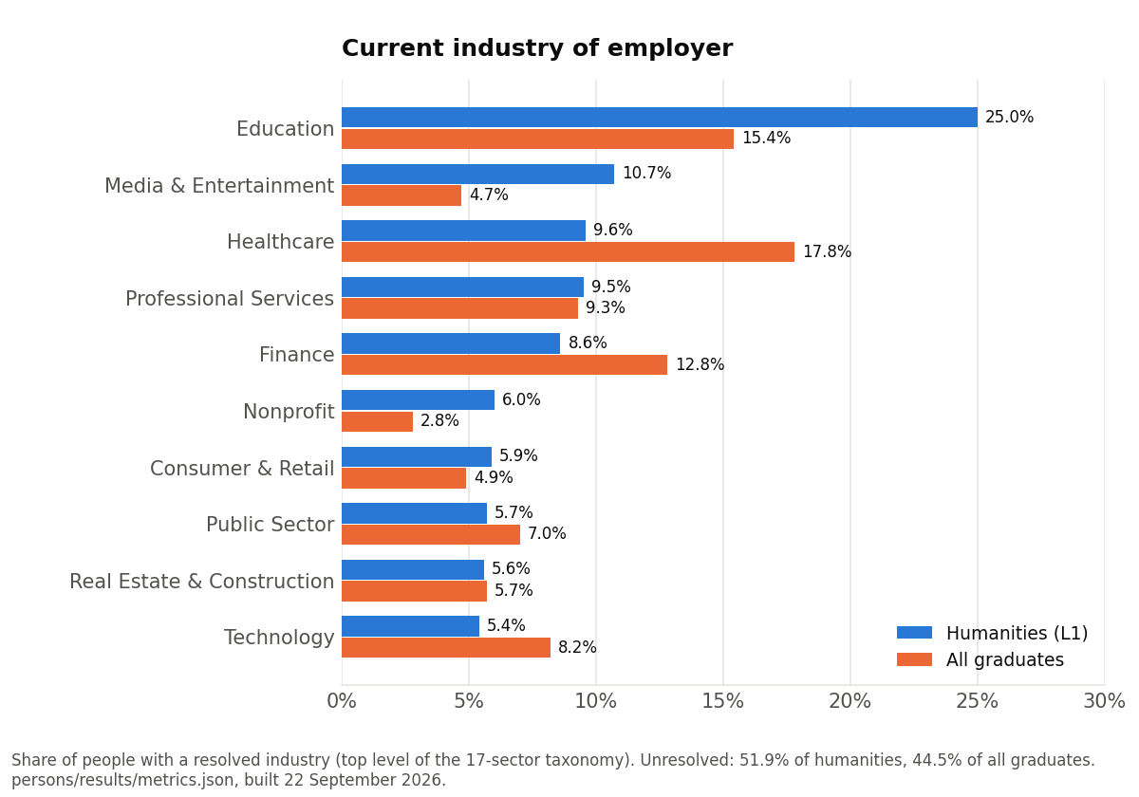
Chart 4. Current industry of employer, humanities (L1) versus all graduates. persons/results/metrics.json, current industry at the top level.
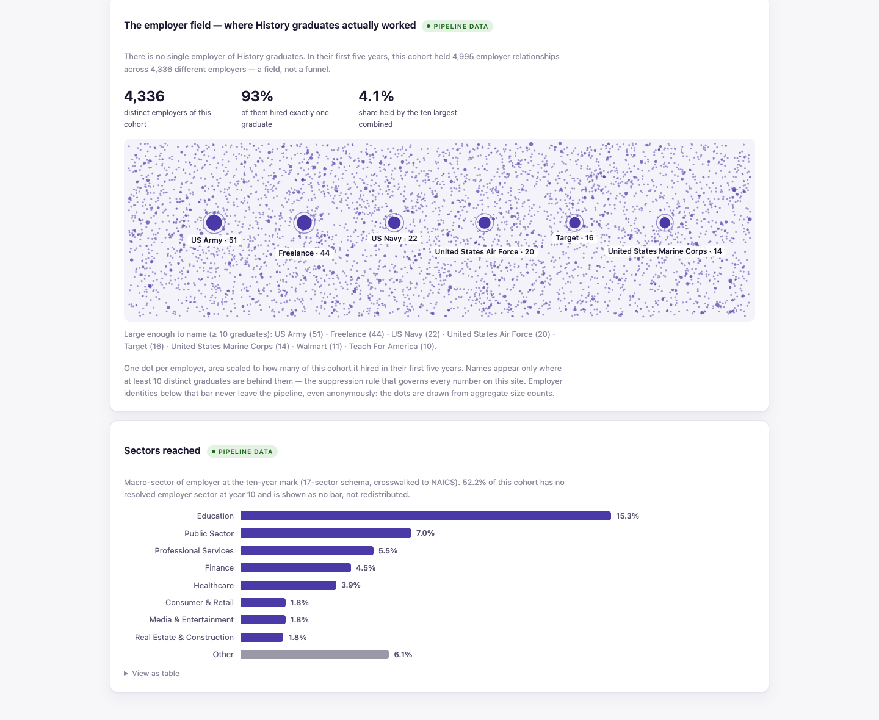
Attachment 3.2. Portal, The possibility space, History: the employer field (4,336 employers, 93% hired exactly one graduate) and sectors reached at year ten.

3b. Rising to leadership by mid-career
How are we defining leadership? Four ways exist in the repository, and they disagree, which is the finding.
Definition | What it counts | Where
Title seniority words | Manager-plus, director-plus, VP-plus in the current title; "ever manager", "ever director", "ever VP" across the record | persons/results/metrics.json
Management occupation | SOC major group 11, from coded titles (21.5% rule coverage, 61% with the jury) | portal destination fans; the audit
Fused seniority score | 0 = intern to 1 = chief executive, from lexical rank and revealed rank in the transition network; the portal's "long view" curve | paths/seniority.py, portal
Managing kind of work | The Managers and Operations Leaders archetype by career year | journey data, archetypes/

How is this comparative? On the title measure, humanities graduates reach director-or-above at a higher rate than all graduates at every career stage, and than business majors from six years on.
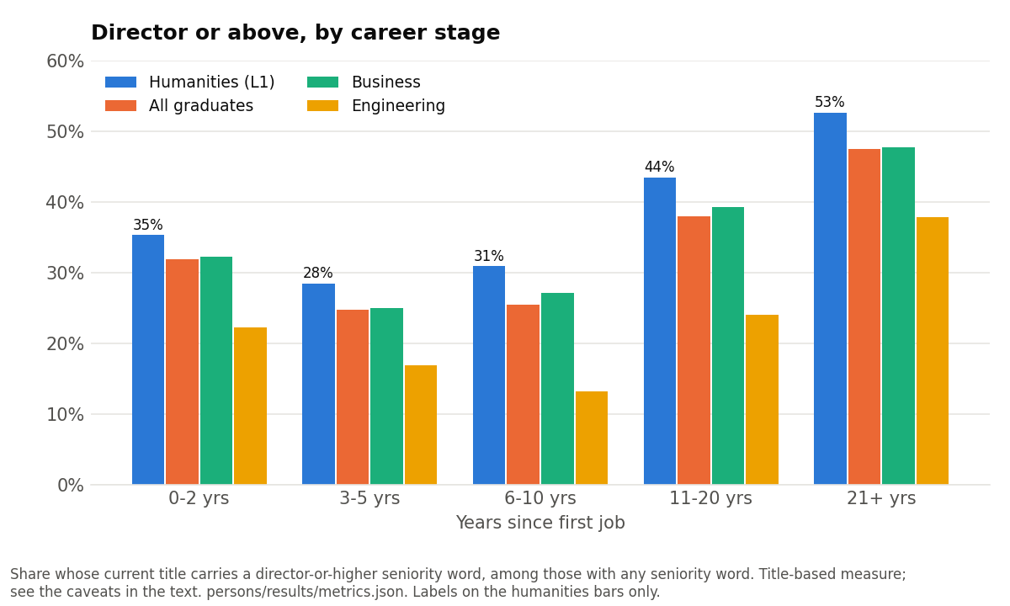
Chart 5. Director or above, by career stage. persons/results/metrics.json, seniority by stage, entry axis.
The portal's seniority curve says the same for the five majors: five of five finish within 0.05 of the all-graduate line or above it at year twenty (History 0.65 vs 0.62), most starting lower, so the gap closes over the decades and not the other way.
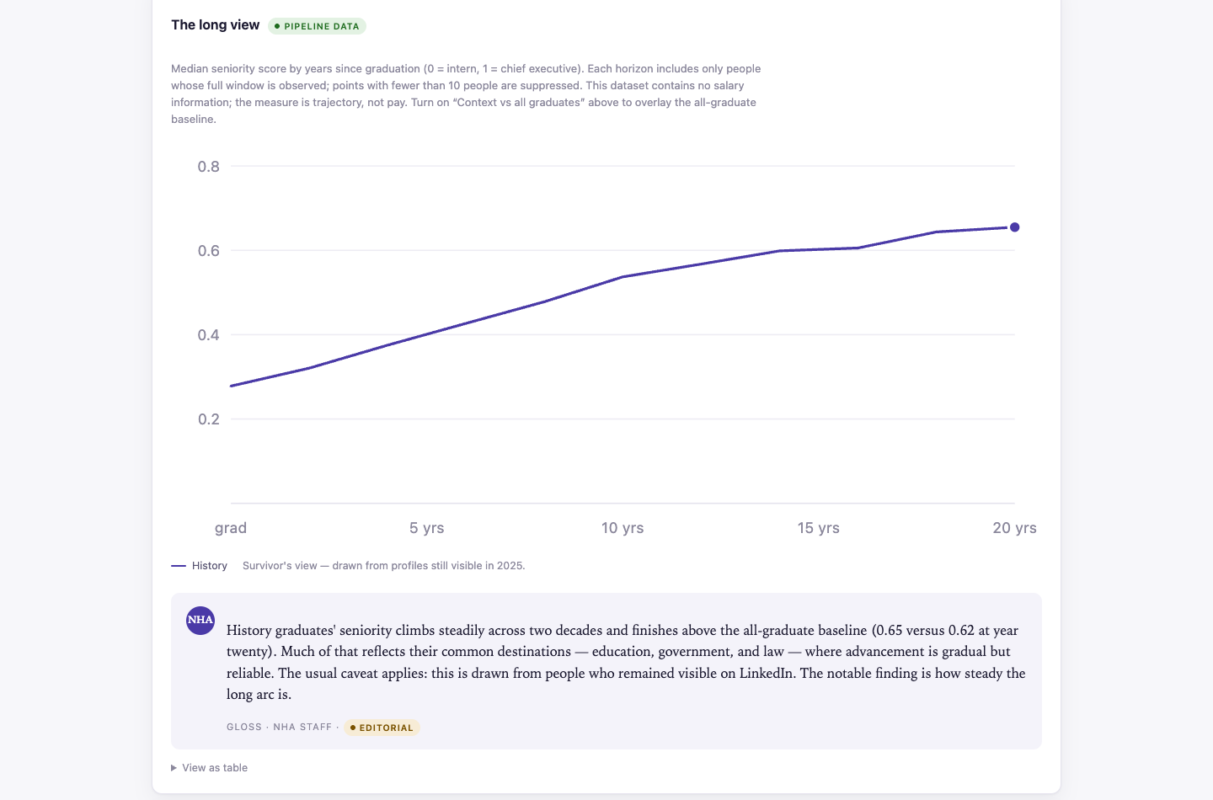
Attachment 3.3. Portal, The first decade, History: median seniority score by years since graduation, to year twenty.
On the occupation measure the comparison reverses: humanities are below baseline in management occupations at every career age, 20.7% vs 32.0% at year ten and 25.6% vs 39.6% at year twenty, and the gap widens. Two constructs drive the disagreement. The title measure covers only people whose titles carry a seniority word (24,937 of 62,552 humanities people at 11 to 20 years), and the audit shows that subset can flip a comparison. The occupation measure is inflated on the other side: 28% of humanities management person-years at year one, rising to 40% by year fifteen, carry the "Chief Executives" code, which also collects founders and owners. Within humanities the rise is clean and the chart shows it by field.
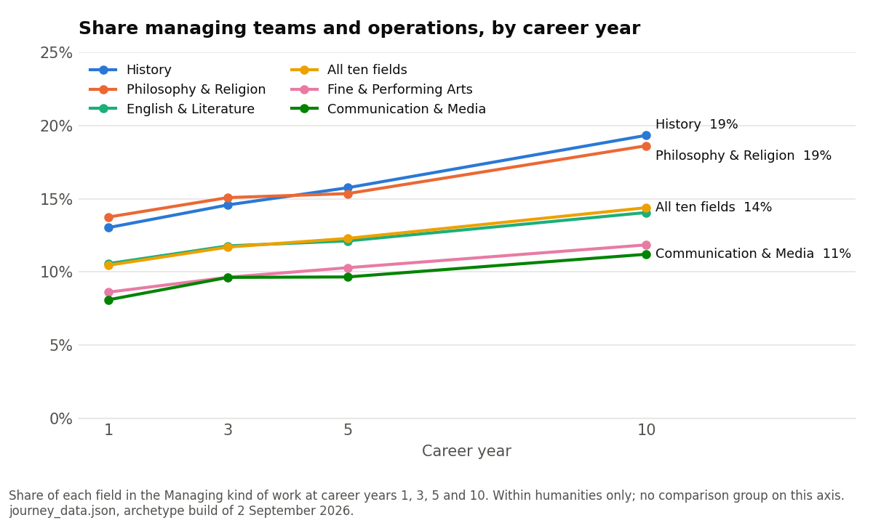
Chart 6. Share managing teams and operations, by career year and field. prototype/journey_site/journey_data.json.
"Surpassing peers they initially trailed" is supportable only on the title and seniority-score measures, within the caveats above, and the cohort work adds a counterweight: humanities graduates reach their first upward move more slowly (hazard ratio 0.87; median 12 vs 11 years; 28.4% vs 30.2% advanced by year five, cohorts/_survival_manifest.json). Both the audit and the product review say not to lead with leadership in any venue and never to attach earnings to it. What survives descriptively is the administrative on-ramp in Section 2 and the fact that responsibility accumulates.

3c. Secondary point: the open-ended path is most careers
What does the comparative measure look like? It does not exist yet. The messages doc calls the share of straight-line careers "the single most valuable uncomputed number" and the product review repeats it. What is measured, within humanities only (docs/design/2026-09-01-product-maps.md section 0.2, 238,967 people observed for all ten years): 41.7% held one kind of work for the whole decade, 35.1% two, 17.2% three, 6.0% four or more. Two in five stayed put, so the planned headline that almost nobody's decade is a straight line is refutable from the project's own panel. The sentence the product maps recommend instead: three in five people changed the kind of work they do, two in five did not, and both are ordinary.
The pieces of comparison that do exist: job-hopping is the same, humanities 1.59 vs 1.62 moves per profile and upward-move share 0.357 vs 0.377 (cohorts/generational.json); at equal observation windows the entry cohorts barely differ from one another (cohorts/README.md); and self-employment, the best-covered claim available, runs 1.7 to 1.8 times baseline at every career band (7.9% vs 4.4% in years one to three, 12.0% vs 7.3% in years thirteen to twenty, audit section 7, ad hoc).

3d. Secondary point: a foundation for graduate study across all fields
Is this comparative, or does it show which graduate fields humanities majors enter? Both products exist, and the review calls this the best-supported message with the least surface.
The comparative product is the metrics cube: History, Philosophy and Religion, and English hold graduate degrees at rates above biology and engineering majors, while Arts and Communication sit below business.
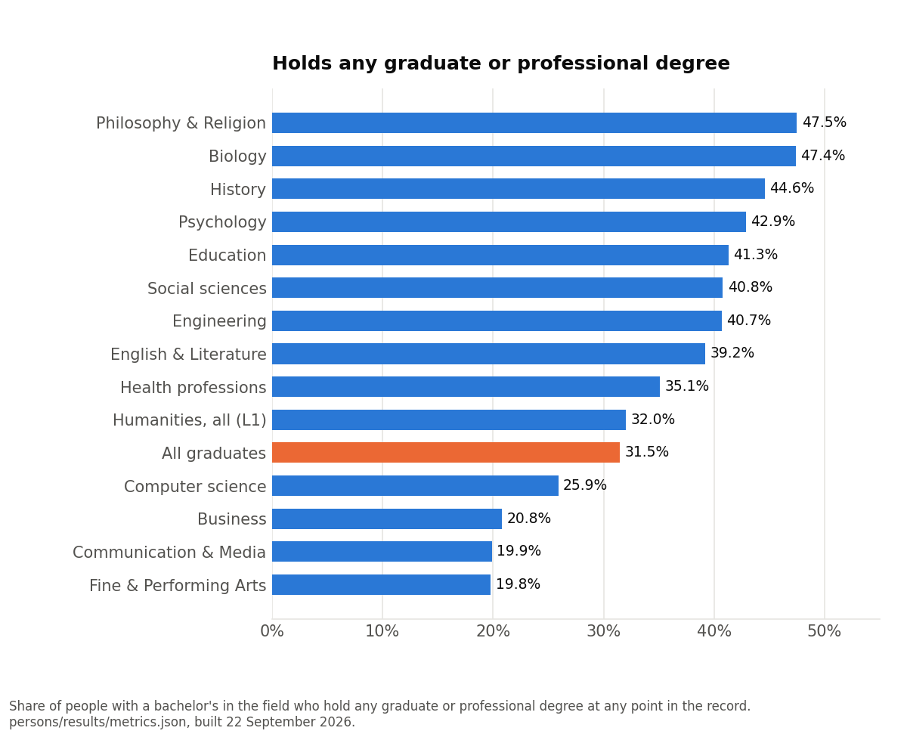
Chart 7. Holds any graduate or professional degree, by bachelor's field. persons/results/metrics.json, grad_any by group.
The within-humanities product is the enrollment-within-five-years panel in the portal: History 39.2% (law at 5.2 times the all-graduate rate), English 35.1% (fine arts MFA at 8.5 times), Philosophy and Religion 34.1% (law at 2.9 times), Communication and Media 16.9%, Fine and Performing Arts 16.3% (MFA at 9.3 times). Written as a claim about "the humanities" it is wrong about 14,564 of the 22,427 windowed people; written per field it is strong. The external check holds: 42.9% of narrow-humanities bachelor's holders who graduated by 2015 hold an advanced degree, against the Humanities Indicators' 42% (validation/results/external_benchmarks.json).
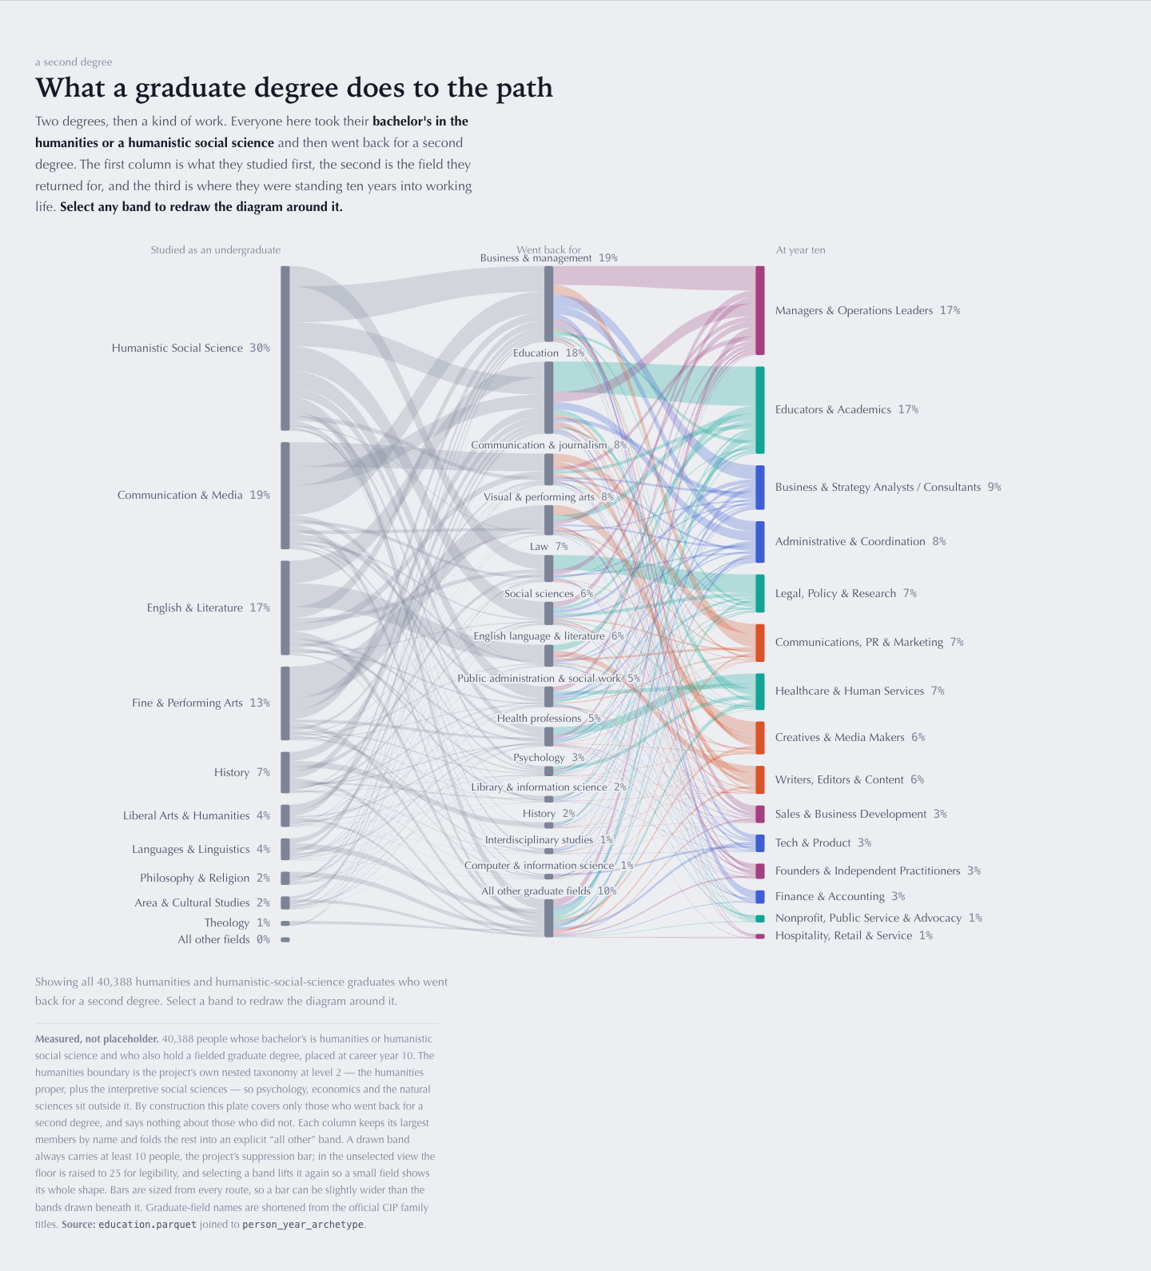
Attachment 3.4. Atlas, the paths plate, one of its two measured plates: 40,388 people with a humanities or humanistic-social-science bachelor's and a fielded graduate degree, from undergraduate field to graduate field to kind of work at year ten. This is the three-sided view the messages doc asks for as its own screen.
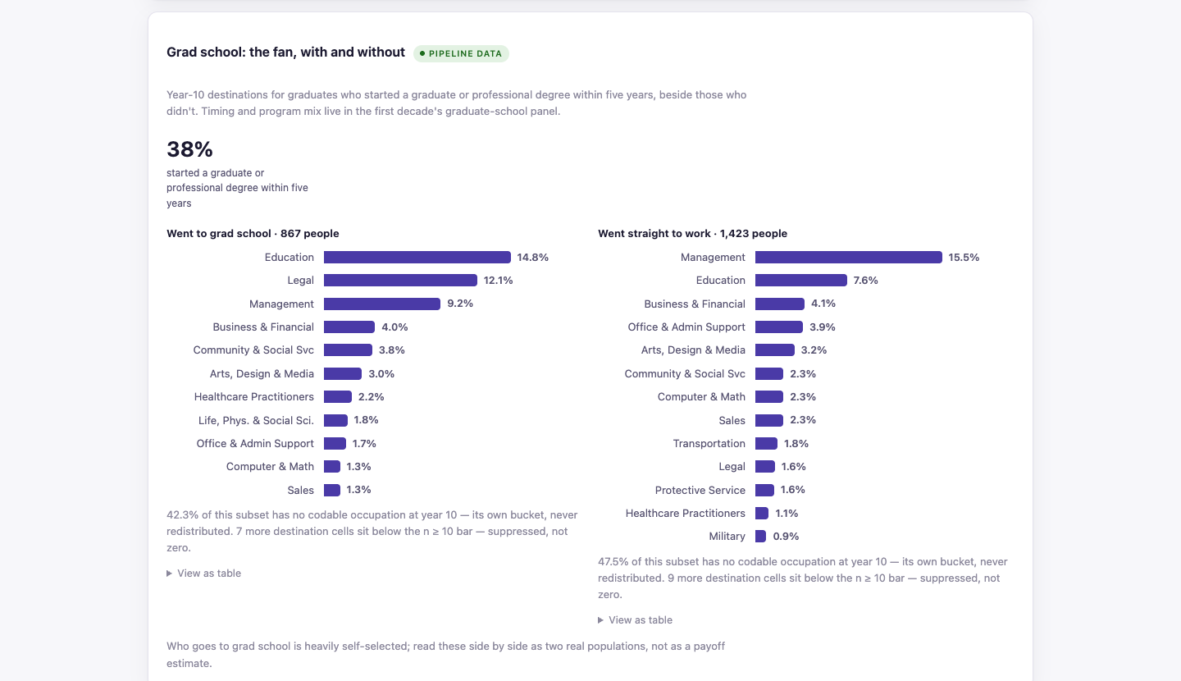
Attachment 3.5. Portal, Choices, History: year-ten destinations for the 38% who started a graduate or professional degree within five years, beside those who went straight to work.
How do we treat graduate study throughout the other data points? A person enters a major's population only through a bachelor's-level degree; graduate degrees never admit anyone, so a history PhD with an English BA counts as English (portal/FINDINGS.md). Careers are measured from first job on the journey site and the archetype panels, and from graduation in the portal, so a graduate degree is a step inside the observed career rather than a reset of it. The Choices panel splits every year-ten fan by whether the person went to graduate school, and the exit page names the graduate step among the things to leave with. The correction still owed: the educational-background figures in the Atlas were computed over a broader population than intended and need re-cutting before use (docs/MESSAGES.md, message 7).

4. Data Analysis Portal: Examine the data yourself
Outline text: Prototype 1. Prototype 2: Atlas.html. Additional types of data interfaces?
Three interfaces exist for examining the data directly, and only one of them runs on pipeline numbers today: the Humanities Workforce portal. The Atlas is on placeholder data except for two plates, and the journey site is a student instrument rather than a portal. Nothing yet exists for the advisor-facing portal the product maps describe. This document reads "Prototype 1" as the Humanities Workforce portal and "Prototype 2" as the archived Atlas.

4a. Prototype 1: the Humanities Workforce portal
The portal is portal/share_template.html with portal/results/portal_data.json injected by make portal; every number on the page comes from that JSON, so the page cannot drift from the pipeline. The built page (share/Humanities-Workforce-portal.html) is not tracked and its inputs live on the Linux build machine, so the screenshots here are the build of 15 July 2026 recovered from git commit ed06a7d. Its predecessor, the Pathways design prototype of 7 July 2026, is kept in share/deprecated/ with the original UI/UX spec and dashboard mockup.
View | Route | What it shows
Overview | #overview | The destination fan, the stats band, doors to Stories and Portal
Stories and narratives | #stories/<major>/1..3 | Year one, the decade arc, the choices, then six myth cards
Portal, the possibility space | #portal/space/<major> | Breadth stats, "Where it leads" fan with role drill-down, employer field, sectors reached
Portal, the first decade | #portal/decade/<major> | Snapshots at years 1, 3, 5, 10; the long view; mobility styles; well-trodden pathways; the graduate-school step
Portal, choices | #portal/choices/<major> | Double majoring, grad school, internships, military, service year, self-employment, pooled across the five majors
Data and methods | #methods | Dataset, boundaries, cohort funnel, evidence bar, honesty commitments

Majors: english, history, philrel, arts, commmedia. The population boundary (narrow humanities, plus humanistic social science, liberal arts) and the "context vs all graduates" overlay are clicks, not routes.
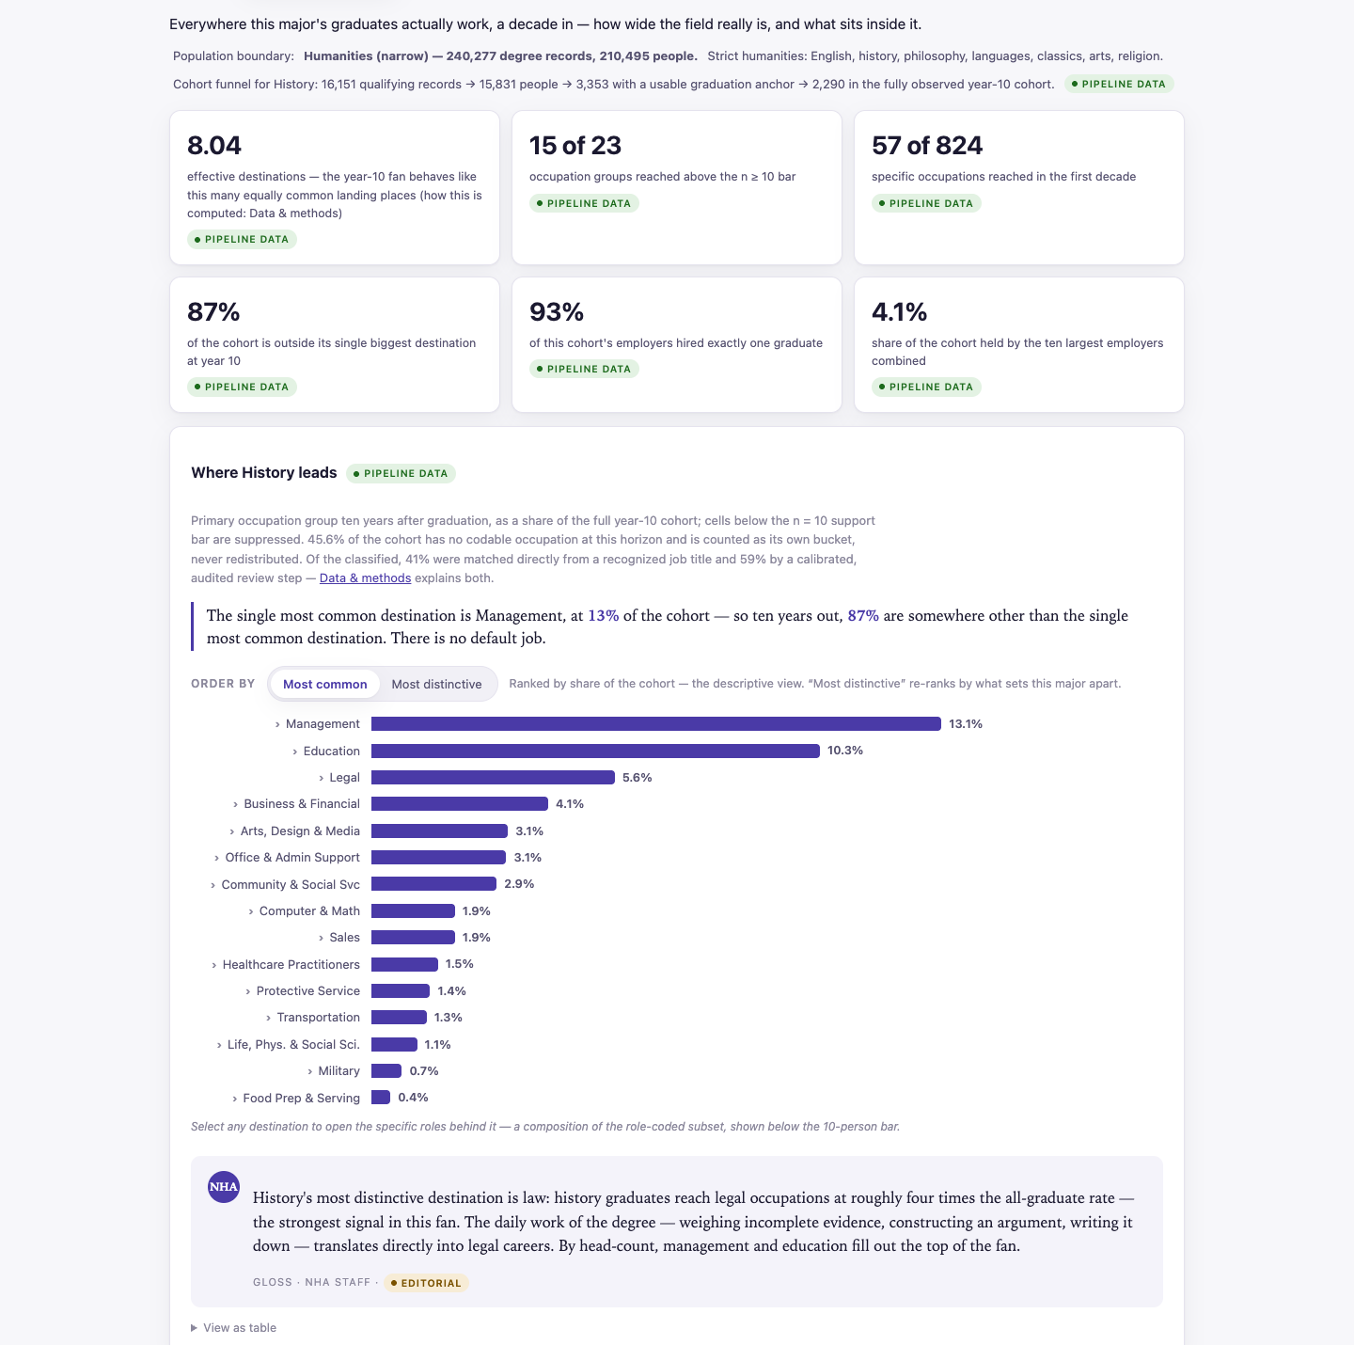
Attachment 4.1. Portal, The possibility space, History: breadth stats and the year-ten fan, ordered by most common or most distinctive, each bar opening to the specific roles behind it.
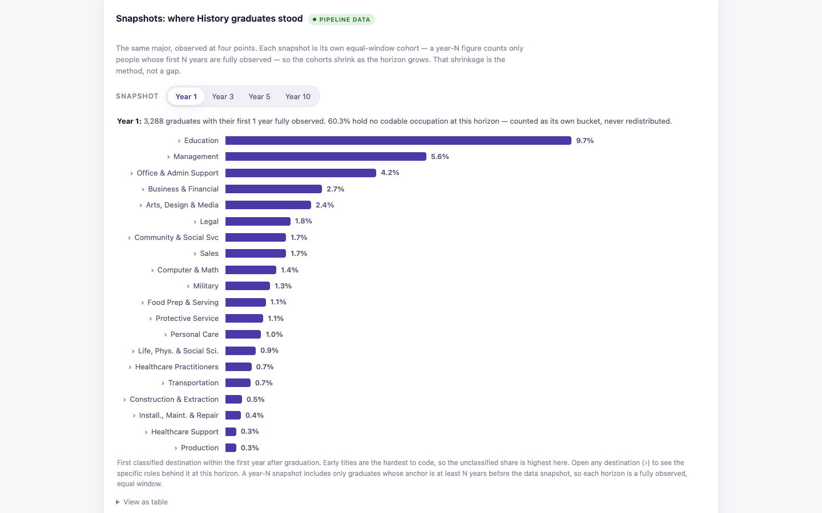
Attachment 4.2. Portal, The first decade, History: the snapshot scrubber. Each year is its own equal-window cohort.
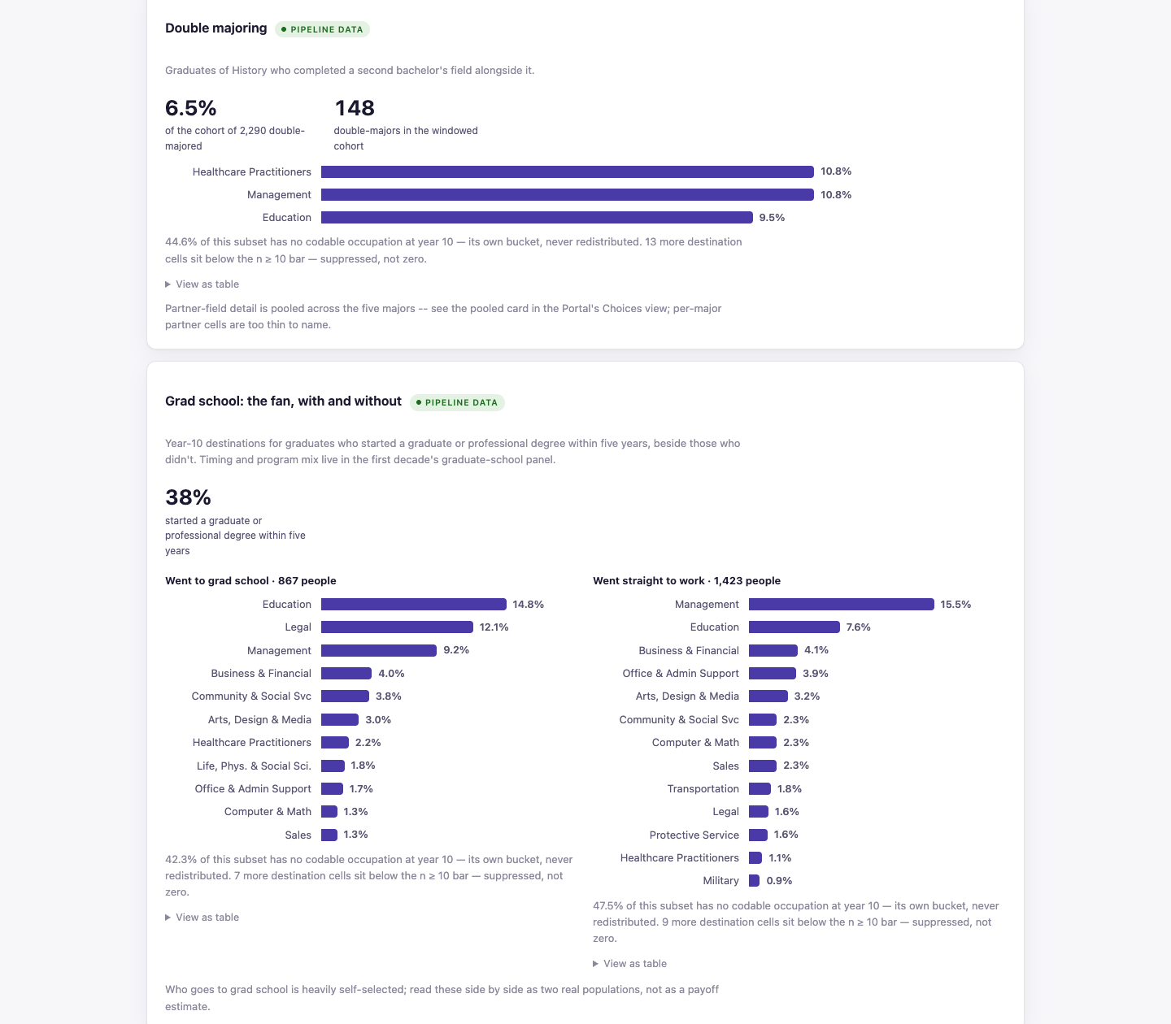
Attachment 4.3. Portal, Choices, History: double majoring and the grad-school split. "Read first: every number here is a description of people who chose these paths and stayed visible on LinkedIn, not the effect of the choice."
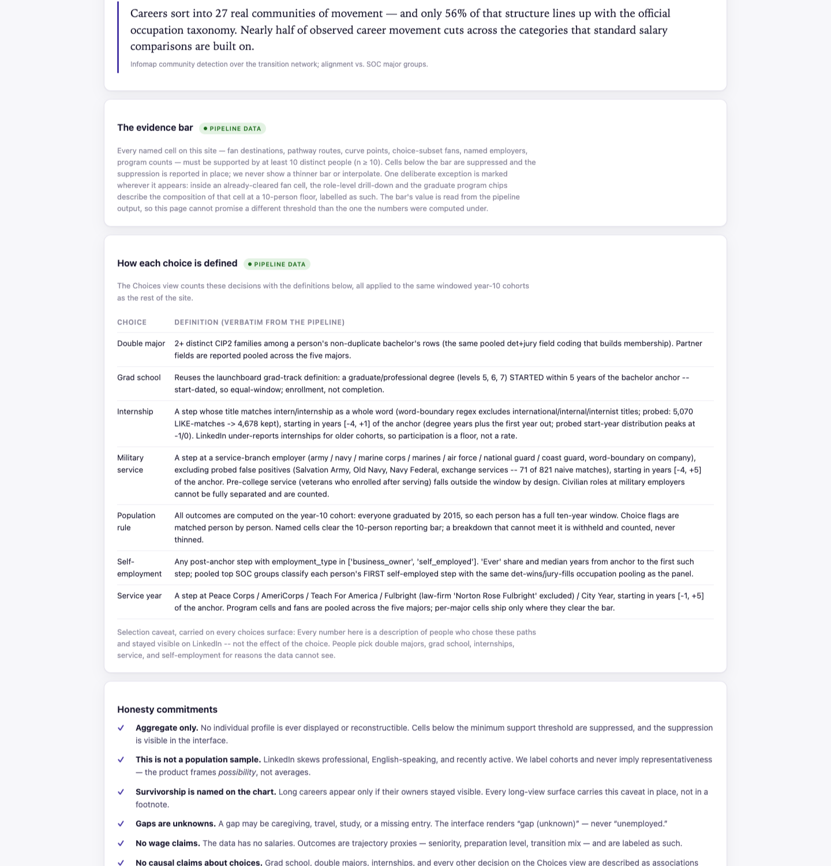
Attachment 4.4. Portal, Data and methods: the dataset, who counts as humanities, and the evidence bar.
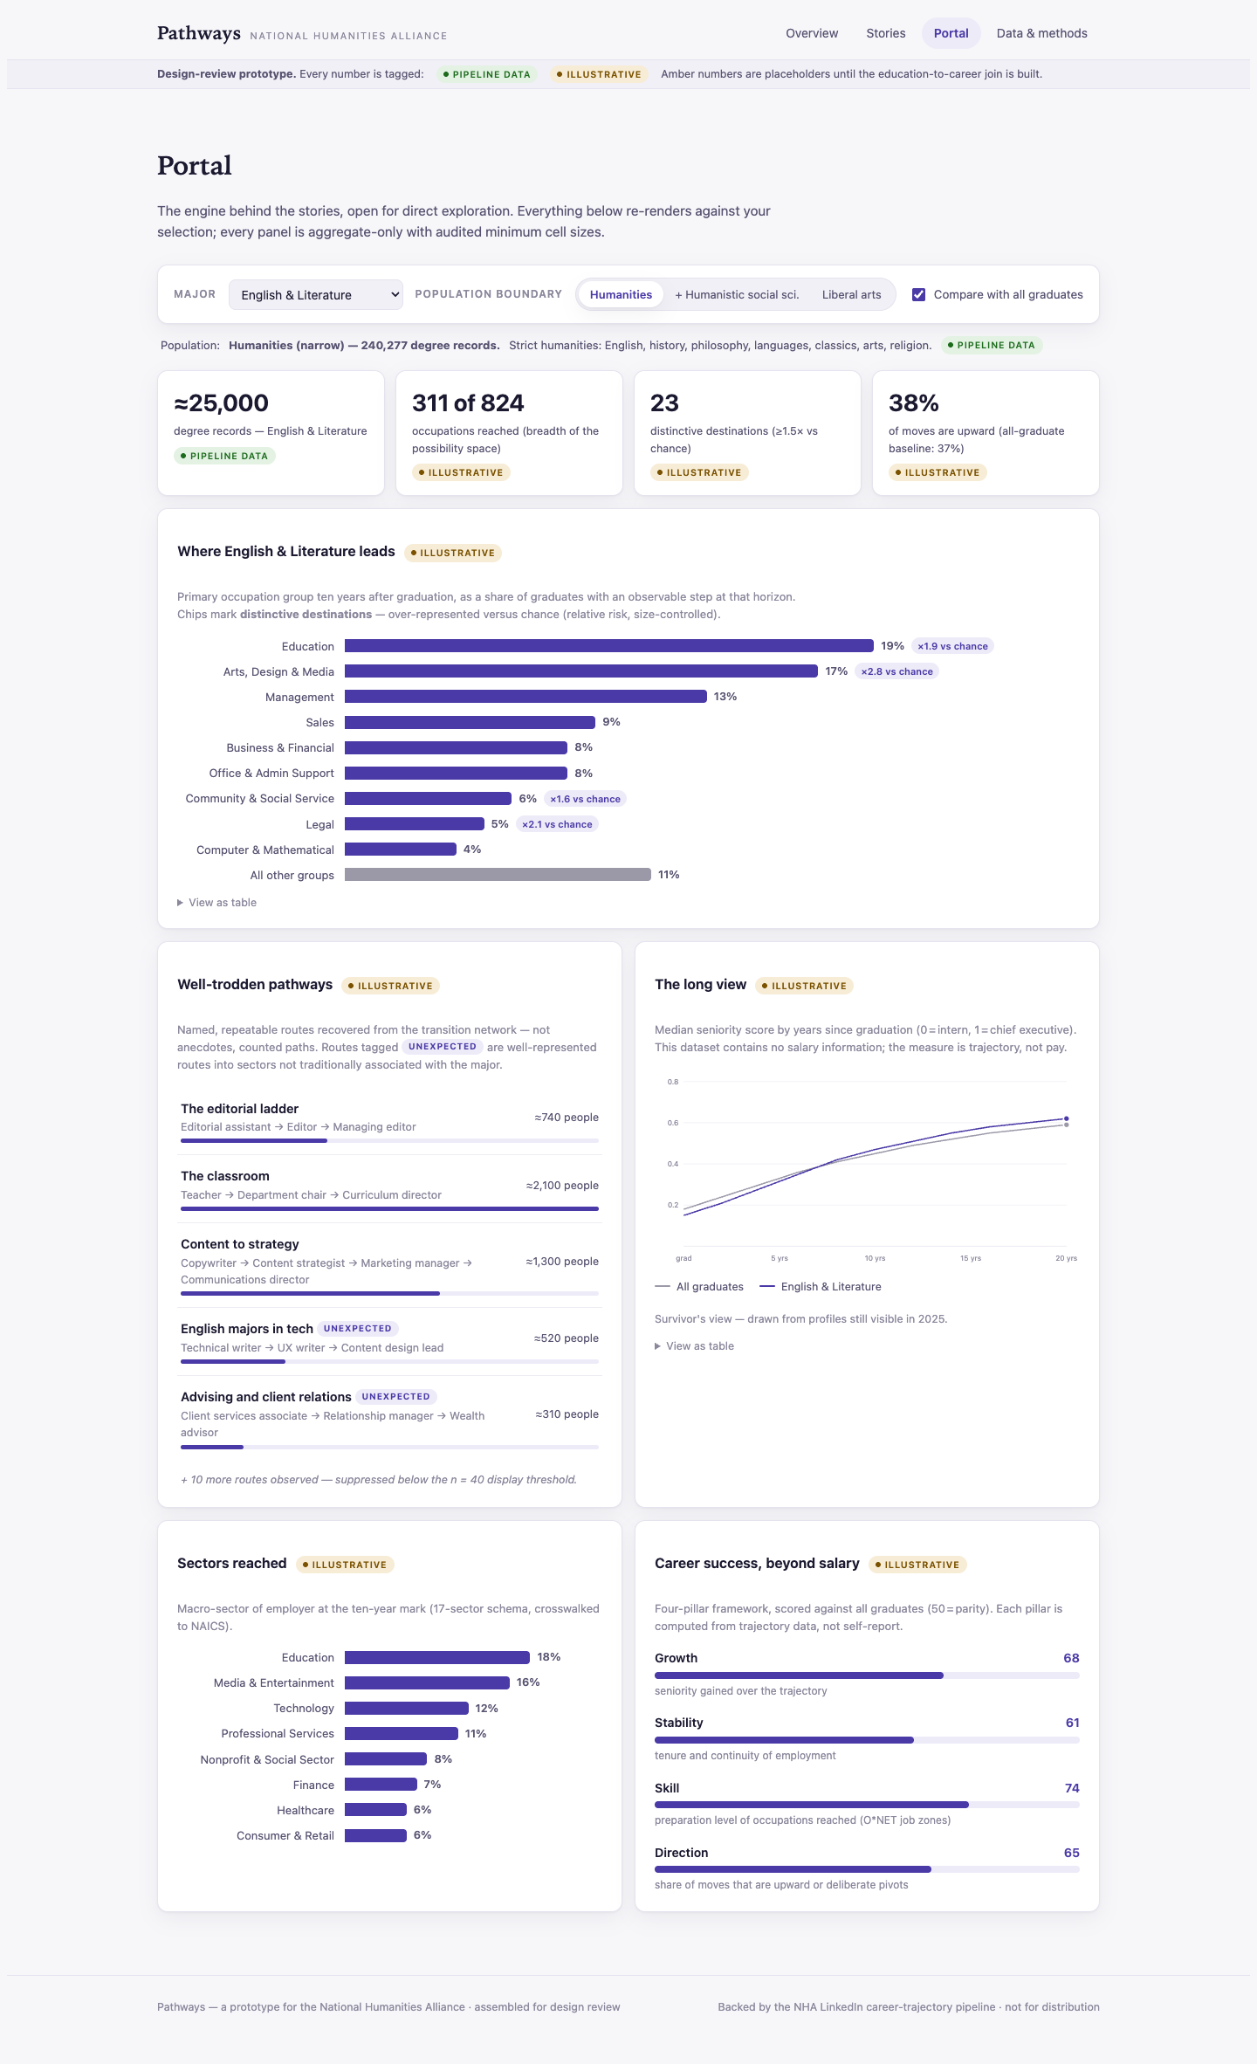
Attachment 4.5. The Pathways design prototype's Portal view (7 July 2026), with amber "illustrative" badges on placeholder panels and the four-pillar "career success beyond salary" panel that the portal later demoted to an editorial device. share/deprecated/NHA-Pathways-prototype.html.
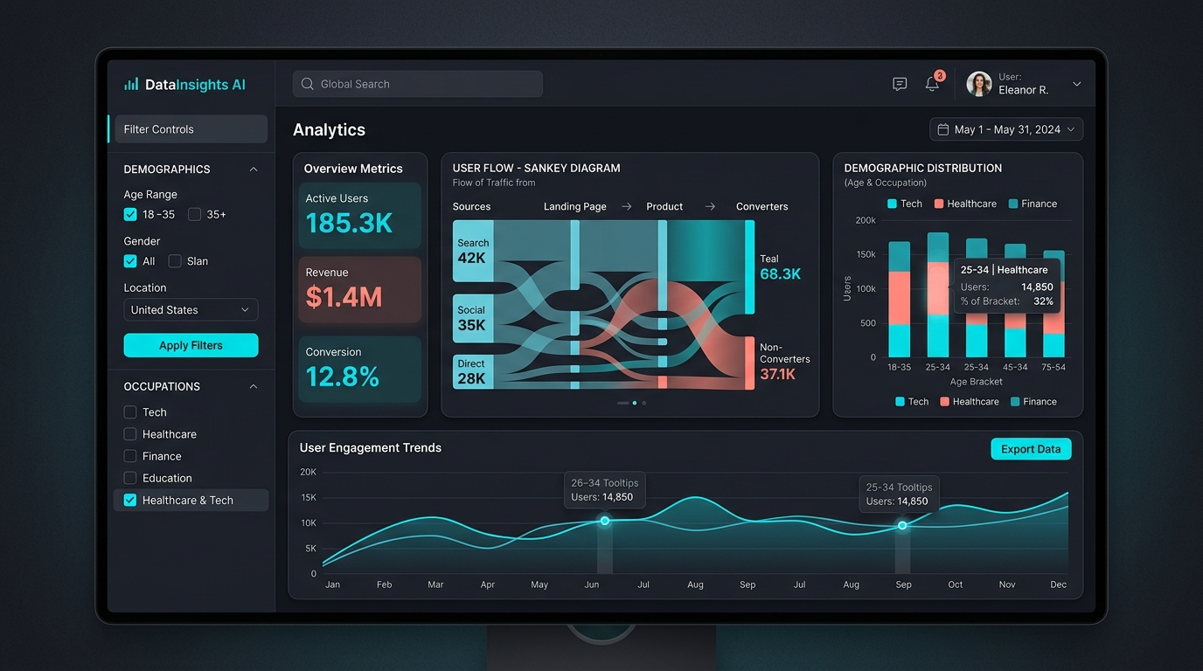
Attachment 4.6. The dashboard mockup from the original UI/UX specification, share/deprecated/portal_dashboard_mockup.jpg with portal_ui_ux_spec.md. Reference for the sidebar-filter layout, stateful URLs and export buttons; the demographic filters it shows are ruled out by the site concept.

4b. Prototype 2: Atlas.html
The file is archive/atlas-prototype.html, titled "An Atlas of Possible Careers", moved out of prototype/ on 1 September 2026. It is a scrolling essay over one field of fifteen marks with three layouts (placed by expectation, by movement, by language) and two route styles, eight steps, a mark plate per kind of work (#/managers, #/admin, #/legal and so on), and a paths plate. Only the educational-background plate and the paths plate are measured; the rest is labelled placeholder. Its design spec is docs/superpowers/specs/2026-08-03-atlas-education-provenance-design.md and reviewer reactions are in docs/notes/2026-08-12-stakeholder-feedback.md.
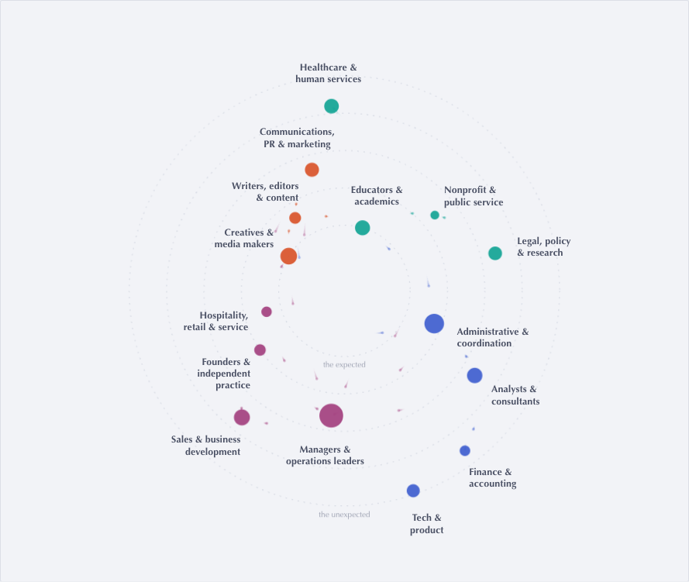
Attachment 4.7. Atlas, the field: fifteen kinds of working life, size is share of a first decade, colour is family, radius is an editorial judgment of distance from the expected image of a humanities career.
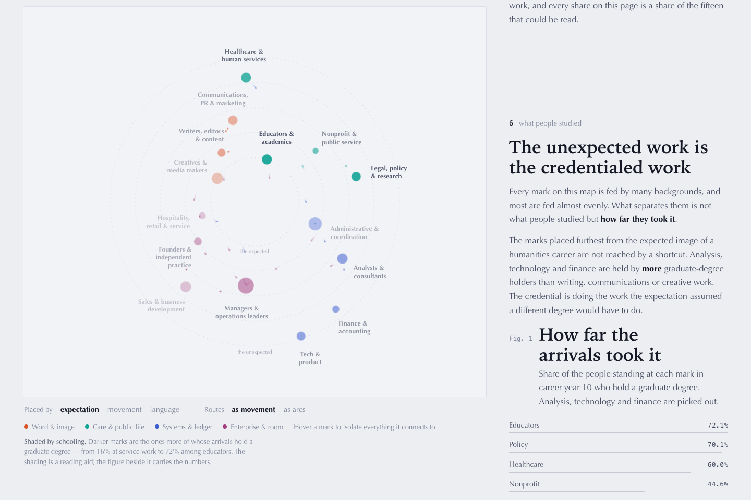
Attachment 4.8. Atlas, step 6, "The unexpected work is the credentialed work": the share of people at each mark in career year ten who hold a graduate degree (educators 72.1%, policy 70.1%, healthcare 60.0%, nonprofit 44.6%). One of the Atlas's two measured plates, computed over 551,560 people at career year ten, a population the messages doc flags as broader than intended and due for a re-cut.
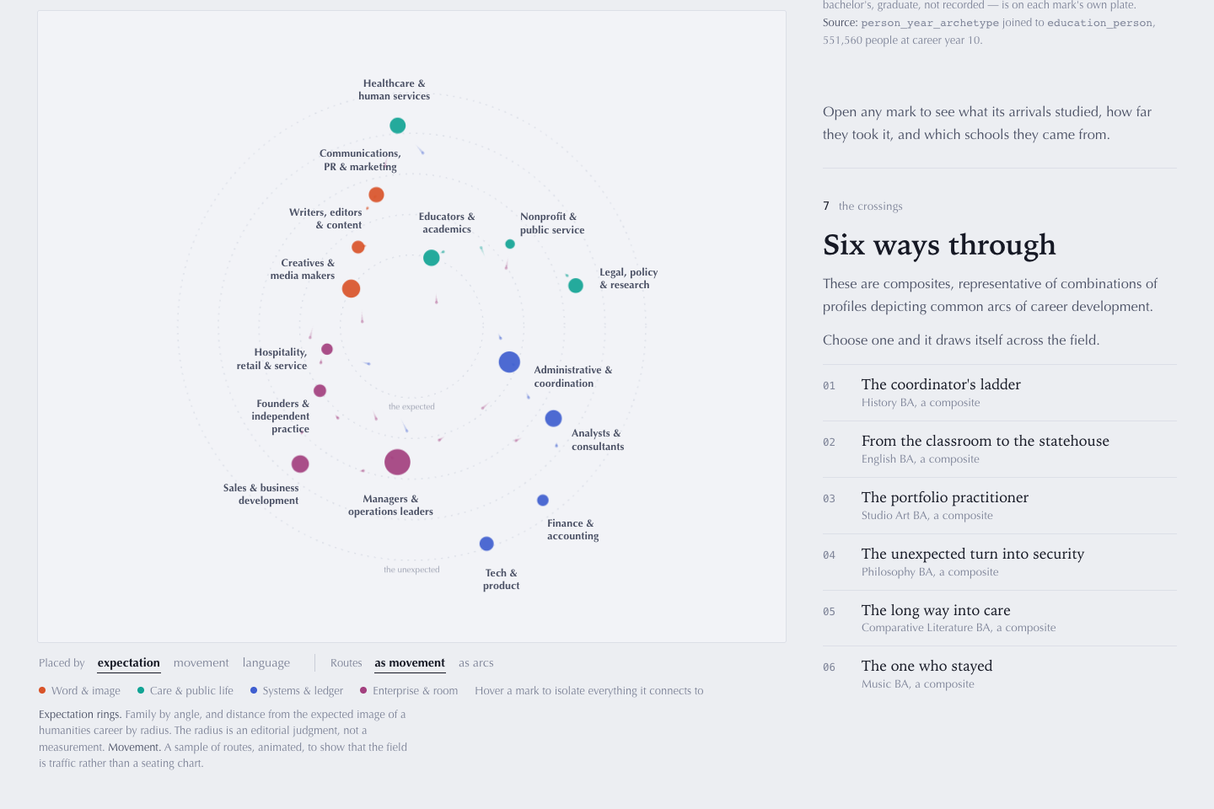
Attachment 4.9. Atlas, step 7, "Six ways through": clickable composites (ladder, statehouse, portfolio, security, care, stayed). Composites, not people; the site concept bars any individual profile.

4c. Additional types of data interfaces
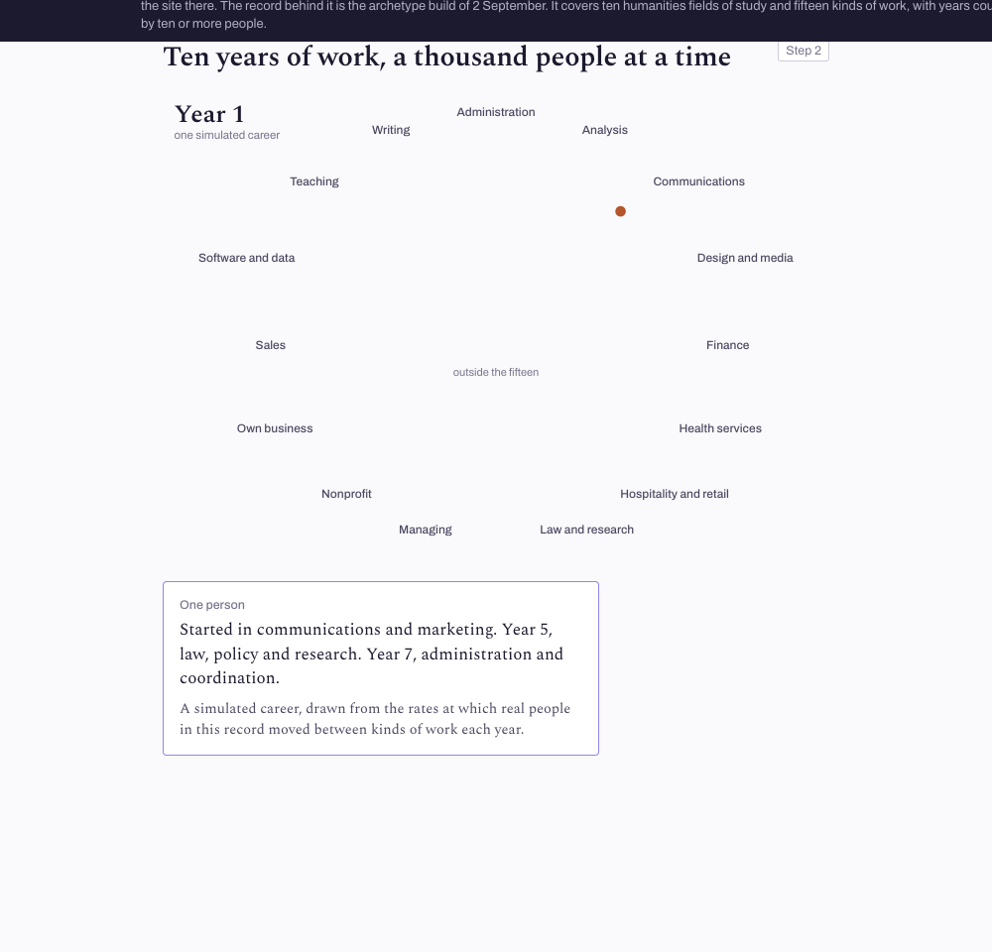
Attachment 4.10. Journey site, step 2 opener: a thousand simulated careers redistributing across the decade, driven by year-to-year transition rates with cells under ten people zeroed. No individual sequence is shipped.
Four further interfaces are designed or implied by what is built:
- The advisor portal in docs/design/2026-09-01-product-maps.md, Map 3: look up any cell with its count shown, "brief me" (one sentence, one number, one source), "take it away" (per-major packs to print or embed), and "show me the method" (including "is my profile in this?"). No prototype exists. The maps recommend it as a second product, not a mode of the student site.
- The metrics cube, persons/results/metrics.json (built 22 September 2026): 62 groups (the humanities tiers, ten field groups, 37 two-digit CIP fields) by 13 panels (graduate degrees, ever-manager and director and VP, first and current occupation group, title family, industry, US state, top employers, first-to-current transitions, seniority by career stage, occupation at years 1, 5, 10 and 20), every cell floored at ten people and release-stamped. This is the natural backend for a self-serve comparison view and no page reads it yet.
- The transition network in transition_network/ (occupation, role, company, employment-type and seniority grains, with relative-risk weights, backbone edges and communities): the data for a network or Sankey interface. Only its JSON summaries are on this machine.
- The production architecture in share/System-Map.html and share/System-Schema.html: the four shared stages, then a fork between today's static export and a live database with a read API feeding a portal web app.
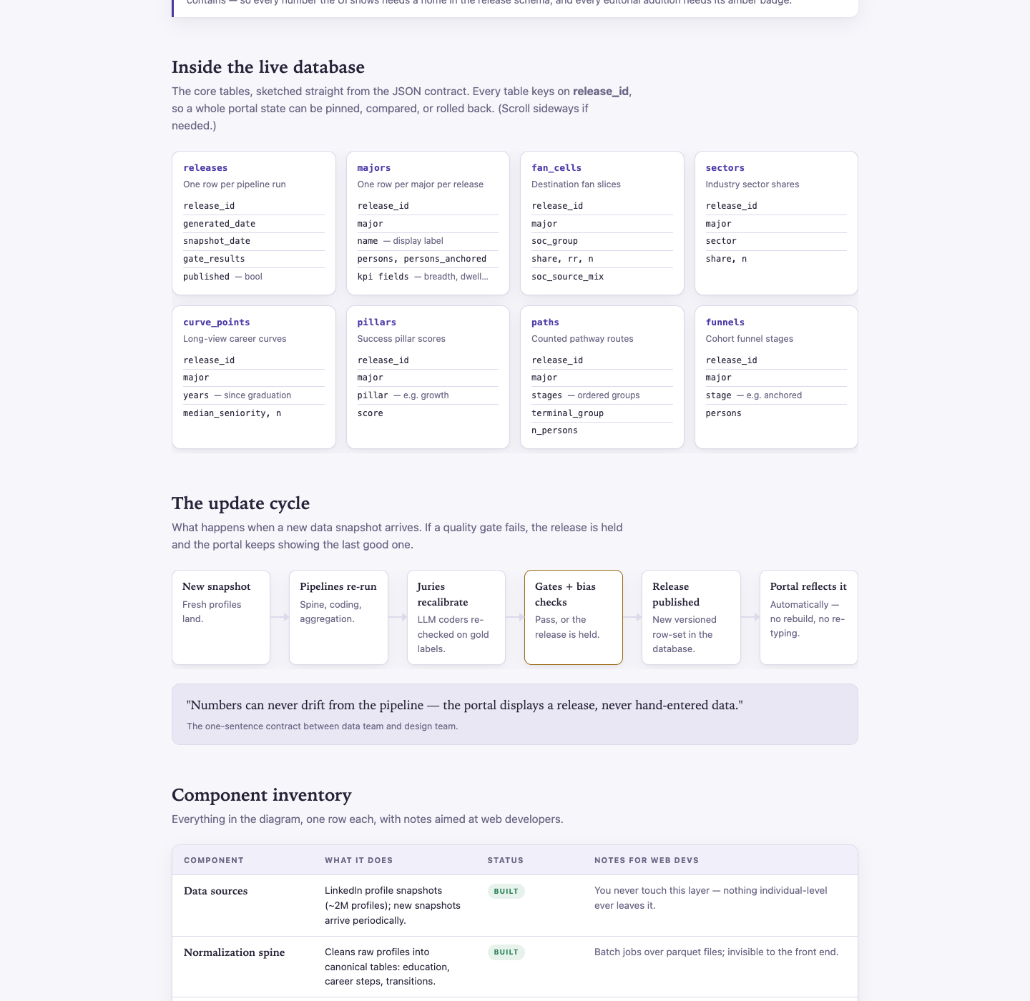
Attachment 4.11. share/System-Map.html: how numbers travel from raw profiles to the page, marked built versus to build.

5. Data Stories: deeper dives that may surprise you
Outline text: Data Stories: deeper dives on what we've learned about humanities pathways that may surprise you (topical essays). For example a humanities tech-industry analysis, or an analysis of available later-career data from a sample of older individuals.
No topical essay exists yet. Two prototype pieces already work as stories, the report outline gives a ready-made chapter form for them, and the data for both named examples is on hand.

Attachment 5.1. Portal, Stories and narratives: "Six things people will tell you". Each card takes a claim ("a humanities degree funnels you into one default job", "you won't advance", "the degree only works if you add grad school") and answers it with numbers computed at render time from the same pipeline output as every chart. These are the myth-correction pieces the messages doc asks for, and the closest thing to a data story in the product today.
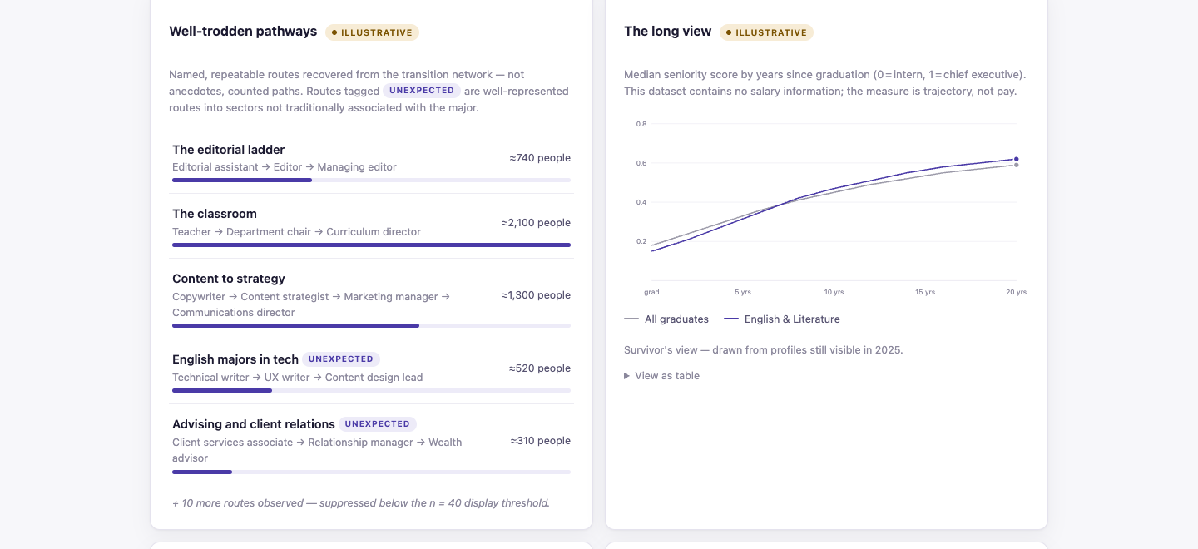
Attachment 5.2. The Pathways design prototype's "well-trodden pathways" panel for English, with the route tagged unexpected: technical writer to UX writer to content design lead. Illustrative numbers (amber badge); shown for the form a tech story could take, not for its figures.
The report outline (docs/design/2026-09-01-report-outline.md) writes every finding chapter as claim, evidence, figure and must-not-say, which is the unit a data story needs. Its chapters are already story titles: "There is no funnel", "Six hundred thousand jobs", "The first decade has two modes", "How people got where they are", "Concrete places", "What kind of working life".

5a. Example: humanities in the tech industry
Nothing is written, and the data says the story is "open door, not a tilted floor" rather than a success story:
Measure | Humanities (L1) | Comparison | Source
Technology as current employer industry, share of resolved | 5.4% | 8.2% all graduates; 20.9% engineering; 25.5% computer science | persons/results/metrics.json
Tech and Product kind of work, share of person-years | 4.8% |  | archetypes/FINDINGS.md
Software and data at career year ten | 4.0% |  | journey data
Computer and mathematical occupations at year ten, per major | 1.7% to 2.4% | 2.7% all graduates | portal/FINDINGS.md, myth card
Graduate degree among people in Tech and Product | 39.3% |  | Atlas paths plate

The transition network adds the movement: Software Developers became a top-three bridge occupation in the 2020 to 2025 era, and the engineer-to-software-developer flow grew about 78 times across eras (transition_network/temporal.json). The portal's card "You're locked out of business and tech" is the seed sentence: counted, mostly no; the door is open and the count is neither locked nor favored.

5b. Example: later-career data from older individuals
The sample is large and the products exist; the caveats are the story's first paragraph.
Measure | Value | Source
Humanities (L1) people 21 or more years past their first job | 88,393 | persons/results/metrics.json, stage panel
Same, 11 to 20 years | 62,552 | same
Director or above at 21+ years, humanities vs all graduates | 52.6% vs 47.5% | same, seniority by stage
VP or above at 21+ years | 24.4% vs 25.9% | same
Self-employed or owner at years 13 to 20, humanities vs baseline | 12.0% vs 7.3% | eight-arguments audit, section 7 (ad hoc)
Occupation held 20 years after the first job, per group | panel at_k, year 20 | persons/results/metrics.json
Earliest entry cohort (first job before 2005) | 157,081 people, observed 15 years | archetypes/FINDINGS.md
Seniority curve, humanities vs all graduates | converges by about year 18 | portal/FINDINGS.md
Entering in a recession | a small scar that fades in about 4.5 years; humanities not scarred more | cohorts/_scarring_manifest.json

Caveats to write in, from cohorts/README.md: the older cohorts are the survivors still visible on LinkedIn in 2026, their early careers are backfilled from memory, and every career is measured from first job rather than graduation.

5c. Other stories the data already supports
- The administrative on-ramp. About one in ten person-years are administrative and coordination work; it is the largest single door into managing at year ten (Section 2).
- Independent work grows with age. Self-employment runs 1.7 to 1.8 times the all-graduate rate at every career band, and 88% are not freelancing.
- A field, not a funnel. 93% of employers hired exactly one graduate; the honest list of biggest first-five-year employers is Self-employed, US Army, US Navy, Target, Air Force, Walmart, Starbucks, with legible cells such as the US House of Representatives, Condé Nast, NYC Public Schools and NYU (audit section 8).
- The decade has two modes. 41.7% held one kind of work for ten years, 58.3% did not, and both are ordinary.
- The Arts exception. Fine and Performing Arts is the most pipeline-like cohort on every measure; any story written for "the humanities" as a bloc is wrong about Arts.
- History into law. Legal work at 4.1 times the all-graduate rate at year ten, and law school at 5.2 times within five years.
- The far edge. 638,368 distinct job titles, 86.4% held by one person, and 13,933 that clear the reporting bar.

Appendix: index of attachments and gaps
Every screenshot was taken on 24 September 2026 from the files as they stand in the linkedin_analysis repository. Charts were drawn from the two summary files present on this machine, prototype/journey_site/journey_data.json (archetype build of 2 September 2026) and persons/results/metrics.json (built 22 September 2026).
Attachment | What it is | Repo path | Status
1.1, 4.1 to 4.4, 2.5, 2.11, 3.1 to 3.3, 3.5, 5.1 | Humanities Workforce portal views | portal/share_template.html, build via make portal | Build of 15 July 2026, recovered from git commit ed06a7d; current build lives on the Linux machine
1.2, 2.1 to 2.4, 2.7 to 2.10, 2.15, 4.10 | Journey-site prototype screens | prototype/journey-site.html (template and data in prototype/journey_site/) | Revised 14 September 2026; data from the archetype build of 2 September
2.6, 4.5, 5.2 | Pathways design prototype | share/deprecated/NHA-Pathways-prototype.html | Superseded 8 July 2026; illustrative numbers
2.12 to 2.14, 3.4, 4.7 to 4.9 | Atlas of Possible Careers | archive/atlas-prototype.html | Archived 1 September 2026; placeholder data except the education and paths plates
4.6 | Dashboard mockup and UI/UX spec | share/deprecated/portal_dashboard_mockup.jpg, portal_ui_ux_spec.md | Reference only
4.11 | System Map | share/System-Map.html (schema in System-Schema.html) | Current
Charts 1, 2, 3, 6 | Year-ten mix, manager origins, change by field, managing by year | prototype/journey_site/journey_data.json | Ten-person bar applied at extraction
Charts 4, 5, 7 | Industry mix, director share by stage, graduate degrees by field | persons/results/metrics.json | Floor of ten per cell, release-stamped

Source documents behind the findings: docs/MESSAGES.md, docs/notes/2026-08-12-eight-arguments-audit.md, docs/notes/2026-08-24-product-review.md, docs/design/2026-09-01-product-maps.md, docs/design/2026-09-01-report-outline.md, docs/design/2026-09-10-site-concept.md, portal/FINDINGS.md, archetypes/FINDINGS.md, FOUNDATION.md.
Gaps: elements with no data product or screen yet
- The March presentation is not in the repository, so nothing here is checked against it.
- Skills have no field in the corpus; the certification layer (cert_clean/, 545,409 people) is built and shown nowhere.
- The comparative linearity measure (share of straight-line careers, humanities vs others) has never been computed; it is the highest-value uncomputed number in the project.
- The graduate-study view is measured but sits in one panel of a walkthrough; the review asks for it as its own screen.
- The advisor-facing portal is designed in the product maps and has no prototype.
- The archetype visualization phase was never built on measured data; the Atlas is placeholder and the journey site is the first surface to draw the flow tensors.
- The tech-industry and later-career stories have data (Section 5) and no text.
- The educational-background figures in the Atlas need re-cutting on the intended population before use.
- Three decisions gate several elements: the canonical humanities definition, the time axis (first job versus graduation), and whether the report and site are two products. All three are still open in docs/design/2026-09-10-site-concept.md.
- Numbers to re-check before quoting: archetypes/FINDINGS.md was computed on a panel that predates the snapshot-date fix of 5 August 2026; the audit's comparative figures are marked ad hoc; the built portal on this machine is the July data, not the September pipeline.

