Chapter 29: Code-Tuning Techniques

Overview
ALTHOUGH CODE TUNING HAS BEEN neglected in recent years, it has been a popular topic during most of the history of computer programming. Consequently, once you've decided that you need to improve performance and that you want to do it at the code level, you have a rich set of techniques at your disposal.
This chapter focuses on improving speed and includes a few tips for making code smaller. Performance usually refers to both speed and size, but size reductions tend to come more from redesigning data structures than from tuning code. Code tuning refers to changing the implementation of a design rather than changing the design itself.
Few of the techniques in this chapter are so generally applicable that you'll be able to copy the example code directly into your programs. The main purpose of the discussion here is to illustrate a handful of techniques that you can adapt to your situation.

29.1 Loops
CROSS-REFERENCE For other details on loops, see Chapter 15, "Controlling Loops."
Because loops are executed many times, the hot spots in a program are often inside loops. The techniques in this section make the loop itself faster.

Unswitching
Switching refers to making a decision inside a loop every time it's executed. If the decision doesn't change while the loop is executing, you can unswitch the loop by making the decision outside the loop. Usually this requires turning the loop inside out, putting loops inside the conditional rather than putting the conditional inside the loop. Here's an example of a loop before unswitching:

C Example of a Switched Loop
for ( i = 0; i < Count; i++ )
{
if ( SumType == Net )
{
NetSum = NetSum + Amount[ i ];
}
else /* SumType == Gross */
{
GrossSum = GrossSum + Amount[ i ];
}
}

In this code, the test if( SumType == Net ) is repeated through each iteration even though it'll be the same each time through the loop. You can rewrite the code for a speed gain this way:

C Example of an Unswitched Loop

if ( SumType == Net )
{
for ( i = 0; i < Count; i++ )
{
NetSum = NetSum + Amount[ i ];
}
}
else /* SumType == Gross */
{
for ( i = 0; i < Count; i++ )
{
GrossSum = GrossSum + Amount[ i ];
}
}

The for statement is repeated, so the code uses more space, but the time savings speak for themselves:

Language | Straight Time | Code-Tuned Time | Time Savings
C | 1.81 | 1.43 | 21%
Basic | 4.07 | 3.30 | 19%
Note | (1) Times in these tables are given in seconds and are meaningful only for comparisons across rows of each table. Actual times will vary according to the compiler and compiler options used and the environment in which each test is run. (2) Benchmark results are typically made up of several hundred to several thousand executions of the code fragments to smooth out the sample-to-sample fluctuations in the results. (3) Specific brands and versions of compilers aren't indicated. Performance characteristics vary significantly from brand to brand and version to version. (4) Comparisons among results from different languages aren't always meaningful because compilers for different languages don't always offer comparable code-generation options.

The hazard in this case is that the two loops have to be maintained in parallel. If Count changes to ClientCount, you have to remember to change it in both places, which is an annoyance for you and a maintenance headache for anyone else who has to work with the code.
If your code were really this simple, you could sidestep the maintenance issue and get the code-tuning benefit by introducing a new variable, using it in the loop, and assigning it to NetSum or GrossSum after the loop.

Jamming
Jamming, or "fusion," is the result of combining two loops that operate on the same set of elements. The gain lies in cutting the loop overhead from two loops to one. Here's a candidate for loop jamming:

Basic Example of Separate Loops That Could Be Jammed

for i = 1 to Num
EmployeeName( i ) = ""
next i
...

for i = 1 to Num
EmployeeEarnings( i ) = 0
next i

When you jam loops, you find code in two loops that you can combine into one. Usually, that means the loop counters have to be the same. In this example, both loops run from 1 to Num, so you can jam them. Here's how:

Basic Example of a Jammed Loop

for i = 1 to Num
EmployeeName( i ) = ""
EmployeeEarnings( i ) = 0
next i

Here are the savings:
Language | Straight Time | Code-Tuned Time | Time Savings
Basic | 6.54 | 6.31 | 4%
C | 4.83 | 4.72 | 2%
Fortran | 6.15 | 5.88 | 4%
Note | Benchmarked for the case in which Num equals 100.

As you can see, the savings aren't earthshaking in these cases. They might be more significant in other environments, but you'd have to measure to know whether they were.
Loop jamming has two main hazards. First, the indexes for the two parts that have been jammed might change so that they're no longer compatible. Second, the location of each loop might be significant. Before you combine the loops, make sure they'll still be in the right order with respect to the rest of the code.

Unrolling

The goal of loop unrolling is to reduce the amount of loop housekeeping. In Chapter 28, a loop was completely unrolled, and five lines of code were shown to be faster than one. In that case, the loop that went from one to five lines was unrolled so that all five array accesses were done individually.
Although completely unrolling a loop is a fast solution and works well when you're dealing with a small number of elements, it's not practical when you have a large number of elements or when you don't know in advance how many elements you'll have. Here's an example of a general loop:
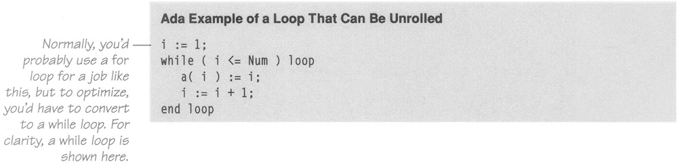
To unroll the loop partially, you handle two or more cases in each pass through the loop instead of one. This unrolling hurts readability but doesn't hurt the generality of the loop. Here's the loop unrolled once:
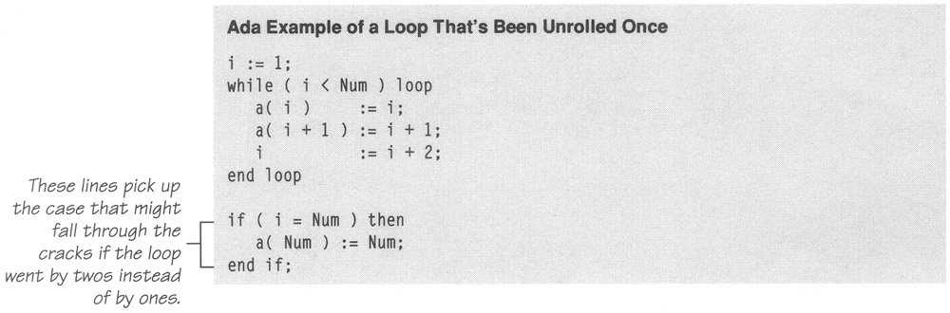
When five lines of straightforward code expand to nine lines of tricky code, the code becomes harder to read and maintain. Except for the gain in speed, its quality is poor. Part of any design discipline, however, is making necessary trade-offs. So, even though a particular technique generally represents poor coding practice, specific circumstances may make it the best one to use.
The technique replaced the original a( i ) := i line with two lines, and i is incremented by 2 rather than by 1. The extra code after the while loop is needed when Num is odd and the loop has one iteration left after the loop terminates. Here are the results of unrolling the loop:
Language | Straight Time | Code-Tuned Time | Time Savings
Ada | 1.04 | 0.82 | 21%
C | 1.59 | 1.15 | 28%
Note | Benchmarked for the case in which Num equals 100.

A gain of 21 to 28 percent is respectable. The main hazard of loop unrolling is an off-by-one error in the code after the loop that picks up the last case.
What if you unroll the loop even further, going for two or more unrollings? Do you get more benefit? Here's the code for a loop unrolled twice:

Ada Example of a Loop That's Been Unrolled Twice

i := 1;
while ( i < Num−1 ) loop
a( i ) := i;
a( i + 1 ) := i + 1;
a( i + 2 ) := i + 2;
i ;= i + 3;
end loop;

if ( i <= Num ) then
a( Num ) := Num;
end if;
if ( i = Num−1 ) then
a( Num−1 ) := Num−1;
end if;

Here are the results of unrolling the loop the second time:

Language | Straight Time | Single Unrolled Time | Double Unrolled Time | Additional Time Savings
Ada | 1.04 | 0.82 | 0.72 | 10%
C | 1.59 | 1.15 | 0.99 | 10%
Note | Benchmarked for the case in which Num equals 100.

The results indicate that further loop unrolling can result in further time savings. The main concern is how Byzantine your code becomes. When you look at the code above, you might not think it looks incredibly complicated, but when you realize that it started life a couple of pages ago as a five-line loop, you can appreciate the trade-off between performance and readability.

Minimizing the Work Inside Loops
One key to writing effective loops is to minimize the work done inside a loop. If you can evaluate a statement or part of a statement outside a loop so that only the result is used inside the loop, do so. It's good programming practice, and, in some cases, it improves readability.
Suppose you have a complicated pointer expression inside a hot loop that looks like this:

C Example of a Complicated Pointer Expression Inside a Loop

for ( i = 0; i < Num; i++ )
{
NetRate[ i ] = BaseRate[ i ] * Rates->Discounts->Factors->Net;
}

In this case, assigning the complicated pointer expression to a well-named variable improves readability and often improves performance.

C Example of Simplifying a Complicated Pointer Expression
QuantityDiscount = Rates->Discounts->Factors->Net;
for ( i = 0; i < Num; i++ )
{
NetRate[ i ] = BaseRate[ i ] * QuantityDiscount;
}

The extra variable, QuantityDiscount, makes it clear that the BaseRate array is being multiplied by a quantity-discount factor to compute the net rate. That wasn't at all clear from the original expression in the loop. Putting the complicated pointer expression into a variable outside the loop also saves the pointer from being dereferenced three times for each pass through the loop, resulting in the following savings:

Language | Straight Time | Code-Tuned Time | Time Savings
C | 9.56 | 8.29 | 13%
C++ | 8.51 | 8.40 | 1%
Pascal | 10.44 | 10.33 | 1%
Note | Benchmarked for the case in which Num equals 100.

Except for the C compiler, the savings aren't anything to crow about, implying that during initial coding you can use whichever technique is more readable without worrying about the speed of the code until later.

Sentinel Values
When you have a loop with a compound test, you can often save time by simplifying the test. If the loop is a search loop, one way to simplify the test is to use a sentinel value, a value that you put just past the end of the search range and that's guaranteed to terminate the search.
The classic example of a compound test that is improved by use of a sentinel is the search loop that checks both whether it has found the value it is seeking and whether it has run out of values. Here's the code:
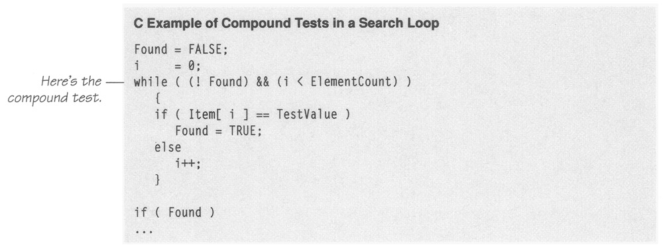
In this code, each iteration of the loop tests for !Found and for i < ElementCount. The purpose of the ! Found test is to determine when the desired element has been found. The purpose of the i < ElementCount test is to avoid running past the end of the array. Inside the loop, each value of Item is tested individually, so the loop really has three tests for each iteration.
In this kind of search loop, you can combine the three tests so that you test only once per iteration by putting a sentinel at the end of the search range to stop the loop. In this case, you can simply assign the value you're looking for to the element just beyond the end of the search range. You then check each element, and if the first element you find is the one you stuck at the end, you know that the value you're looking for isn't really there. Here's the code:
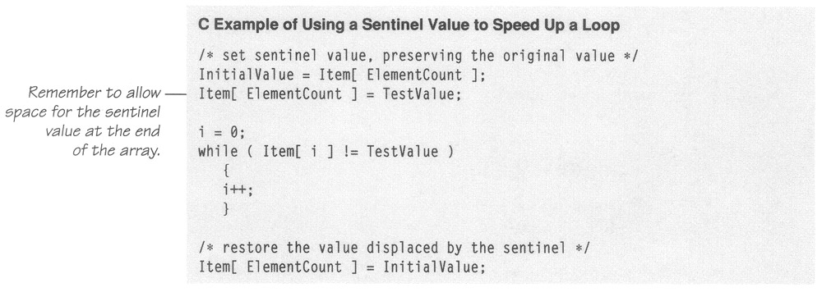
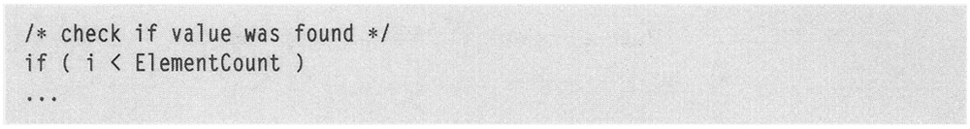

When Item is an array of integers, the savings are dramatic:

Language | Straight Time | Code-Tuned Time | Time Savings | Performance Ratio
C++ | 6.21 | 4.45 | 28% | 1:1
Pascal | 0.21 | 0.10 | 52% | 2:1
Basic | 6.65 | 0.60 | 91% | 11:1
Note | Search is of a 100-element array of integers.

The Basic-compiler results are particularly dramatic, but all the results are good. When the kind of array changes, however, the results also change. Here are the results when Item is an array of single-precision floating-point numbers:
Language | Straight Time | Code-Tuned Time | Time Savings | Performance Ratio
C++ | 20.93 | 21.48 | −3% | 1:1
Pascal | 21.42 | 21.97 | −3% | 1:1
Basic | 59.84 | 30.07 | 49% | 2:1
Note | Search is of a 100-element array of 4-byte floating-point numbers.

In this case, the results vary significantly, which shows once again that you have to measure the effect in your particular environment before you can be sure your optimization will help.
The sentinel technique can be applied to virtually any situation in which you use a linear search—to linked lists as well as arrays. The only caveats are that you must choose the sentinel value carefully and that you must be careful about how you put the sentinel value into the array or linked list, remembering to preserve the original value and replace it.

Putting the Busiest Loop on the Inside
When you have nested loops, think about which loop you want on the outside and which you want on the inside. On the next page is an example of a nested loop that can be improved.

Pascal Example of a Nested Loop That Can Be Improved

for column := 1 to 100 do
begin
for row := 1 to 5 do
begin
Sum := Sum + Table[ row, column ]
end
end;

The key to improving the loop is that the outer loop executes much more often than the inner loop. Each time the loop executes, it has to initialize the loop index, increment it on each pass through the loop, and check it after each pass. The total number of loop executions is 100 for the outer loop and 100 * 5 = 500 for the inner loop, for a total of 600 iterations. By merely switching the inner and outer loops, you can change the total number of iterations to 5 for the outer loop and 5 * 100 = 500 for the inner loop, for a total of 505 iterations. Analytically, you'd expect to save about (600 − 505) / 600 = 16 percent by switching the loops. Here's the measured difference in performance:

Language | Straight Time | Code-Tuned Time | Time Savings | Performance Ratio
Pascal | 2.53 | 2.42 | 4% | 1:1
Ada | 2.14 | 2.03 | 5% | 1:1
Fortran | 1.97 | 3.57 | −81% | 1:2
These results are instructive in two senses. First, the loop overhead might have decreased by 16 percent, but the loop has other, more time-consuming activities that dilute the effect of the optimization—resulting in modest 4 and 5 percent savings with the Pascal and Ada compilers.
The wild card in this case is the Fortran compiler. Reordering the loops caused the performance police to fine the program 81 percent. Since the Fortran code's straight time is faster than any of the other compilers' optimized times, apparently the Fortran compiler's optimization should be left alone. This counterintuitive result illustrates again that you have to measure the effects of code tuning before you put your savings in the bank.

Strength Reduction
Reducing strength means replacing an expensive operation such as multiplication with a cheaper operation such as addition. Sometimes you'll have an expression inside a loop that depends on multiplying the loop index by a factor. Addition is usually faster than multiplication, and if you can compute the same number by adding the amount on each iteration of the loop rather than by multiplying, the code will run faster. Here's an example of code that uses multiplication:

Basic Example of Multiplying a Loop Index

for i = 1 to Num
Commission( i ) = i * Revenue * BaseCommission * Discount
next i

This code is straightforward but expensive. You can rewrite the loop so that you accumulate multiples rather than computing them each time. This reduces the strength of the operations from multiplication to addition. Here's the code:

Basic Example of Adding Rather Than Multiplying

Increment = Revenue * BaseCommission * Discount
TotalCommission = Increment
for i = 1 to Num
Commission( i ) = TotalCommission
TotalCommission = TotalCommission + Increment
next i

Multiplication is expensive, and this kind of change is like a manufacturer's coupon that gives you a discount on the cost of the loop. The original code incremented i each time and multiplied it by Revenue * BaseCommission * Discount—first by 1, then by 2, then by 3, and so on. The optimized code sets Increment equal to Revenue * BaseCommission * Discount. It then adds Increment to TotalCommission on each pass through the loop. On the first pass, it's been added once; on the second pass, it's been added twice; on the third pass, it's been added three times; and so on. The effect is the same as multiplying Increment by 1, then by 2, then by 3, and so on, but it's cheaper.
The key is that the original multiplication has to depend on the loop index. In this case, the loop index was the only part of the expression that varied, so the expression could be recoded more economically. Here's how much the rewrite helped in some test cases:

Language | Straight Time | Code-Tuned Time | Time Savings
Basic | 3.85 | 2.85 | 26%
C | 3.35 | 2.64 | 21%
Note | Benchmark performed with Num equals 20. All computed variables are floating point.

29.2 Logic
CROSS-REFERENCE For other details on using control structures, see Chapters 13 through 17.
Much of programming consists of manipulating logic. This section describes how to manipulate logical expressions to your advantage.

Stop Testing When You Know the Answer
Suppose you have a statement like
if ( 5 < x ) and ( x < 10 ) then ...
Once you've determined that x is less than 5, you don't need to perform the second half of the test.
Some languages provide a form of expression evaluation known as "short-circuit evaluation," which means that the compiler generates code that automatically stops testing as soon as it knows the answer. Short-circuit evaluation is part of ANSI-standard C. Ada supports explicit short-circuit comparisons with the and then and or else keywords. A short-circuit version of the previous example would look like this:
if ( 5 < x ) and then ( x < 10 ) then ...
In other languages, either short-circuit evaluation is compiler dependent or you're on your own. If you want to stop testing when you know the answer, you have to avoid using and and or, adding logic instead. With short-circuit evaluation, the code above changes to this:
if ( 5 < x ) then
if ( x < 10 ) then ...
The principle of not testing after you know the answer is a good one for many other kinds of cases as well. A search loop is a common case. If you're scanning an array of input numbers for a negative value and you simply need to know whether a negative value is present, one approach is to check every value, setting a NegativeFound variable when you find one. Here's how the search loop would look:

C Example of Not Stopping After You Know the Answer

NegativeFound = False;
for ( i = 0; i < Num; i++ )
{
if ( Input[ i ] < 0 )
{
NegativeFound = True;
}
}

A better approach would be to stop scanning as soon as you find a negative value. Here are the approaches you could use to solve the problem:
- Add a break statement after the NegativeFound = True line. In Ada, you would use exit.
- If your language doesn't have break, emulate a break with a goto that goes to the first statement after the loop.
- Change the for loop to a while loop and check for NegativeFound as well as for incrementing the loop counter past Num.
- Change the for loop to a while loop, put a negative sentinel value in the first array element after the last value entry, and simply check for a negative value in the while test. After the loop terminates, see whether the position of the negative value is in the array or one past the end. Sentinels were discussed in more detail earlier in the chapter.
Here are the results of using the break keyword in C and a standard while test in Pascal:

Language | Straight Time | Code-Tuned Time | Time Savings
C | 2.03 | 1.48 | 27%
Pascal | 2.97 | 2.69 | 9%
Note | The impact of this change varies a great deal depending on how many values you have and how often you expect to find a negative value. This test assumed an average of 100 values and assumed that a negative value would be found 50 percent of the time. The Pascal example used a standard while test without a sentinel.

Order Tests by Frequency
Arrange tests so that the one that's fastest and most likely to be true is performed first. It should be easy to drop through the normal case, and if there are inefficiencies, they should be in processing the exceptions. This principle applies to case statements and to chains of if-then-elses.
Here's a case statement that responds to keyboard input in a word processor:

Pascal Example of a Poorly Ordered Logical Test

case( InputChar ) of
'+',
'=': ProcessMathSymbol( InputChar );
',',
'.',
':',
';',
'!',
'?': ProcessPunctuation( InputChar );
'0'..'9': ProcessDigit( InputChar );
' ': ProcessSpace( InputChar );
'A'..'Z',
'a'..'z': ProcessAlpha( InputChar );
else ProcessError( InputChar )
end;

The cases in this case statement are ordered in something close to the ASCII sort order. In a case statement, however, the effect is often the same as if you had written a big set of if-then-elses, so if you get an 'a' as an input character, the program tests whether it's a math symbol, a punctuation mark, a digit, or a space before determining that it's an alphabetic character. If you know the likely frequency of your input characters, you can put the most common cases first. Here's the reordered case statement:

Pascal Example of a Well-Ordered Logical Test
case( InputChar ) of
'A'..'Z',
'a'..'z': ProcessAlpha( InputChar );
' ': ProcessSpace( InputChar );
',',
'.',
':',
';',
'!',
'?': ProcessPunctuation( InputChar );
'0'..'9': ProcessDigit( InputChar );
'+',
'=': ProcessMathSymbol( InputChar );
else ProcessError( InputChar )
end;

Since the most common case is usually found sooner in the optimized code, the net effect will be the performance of fewer tests. Here are the results of this optimization with a typical mix of characters:
Language | Straight Time | Code-Tuned Time | Time Savings
Pascal | 3.13 | 1.97 | 37%
C | 5.17 | 3.47 | 33%
Note | Benchmarked with an input mix of 78 percent alphabetic characters, 17 percent spaces, and 5 percent punctuation symbols.

Substitute Table Lookups for Complicated Expressions

CROSS-REFERENCE For details on using table lookups to replace complicated logic, see Section 12.2, "Table-Driven Methods."
In some circumstances, a table lookup may be quicker than traversing a complicated chain of logic. The point of a complicated chain is usually to categorize something and then to take an action based on its category. As an abstract example, suppose you want to assign a class number to something based on which of Groups A, B, and C it falls into:
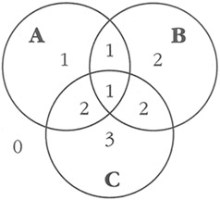
Here's an example of the complicated logic chain that assigns the class numbers:

C Example of a Complicated Chain of Logic

if ( ( A && !C ) || ( A && B && C ) )
Class = 1;
else if ( ( B && !A ) || ( A && C && !B ) )
Class = 2;
else if ( C && !A && !B )
Class = 3;
else
Class = 0;

You can replace this test with a more modifiable and higher-performance lookup table. Here's how:
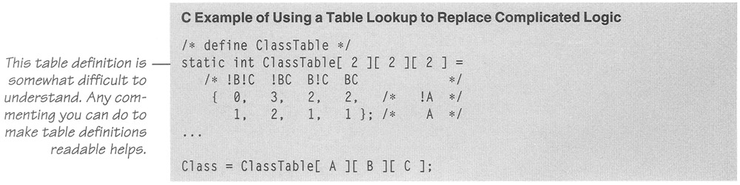
Although the definition of the table is hard to read, if it's well documented, it won't be any harder to read than the code for the complicated chain of logic was. If the definition changes, the table will be much easier to maintain than the earlier logic would have been. Here are the performance results:

Language | Straight Time | Code-Tuned Time | Time Savings | Performance Ratio
C | 2.31 | 1.59 | 31% | 1:1
Basic | 58.88 | 23.00 | 60% | 3:1
In this case, the table-lookup version also reaps a small size advantage. The logic-chain version uses 88 bytes in C, and the table version uses only 43 including the space for the table.

Use Lazy Evaluation
One of my former roommates was a great procrastinator. He justified his laziness by saying that many of the things people feel rushed to do simply don't need to be done. If he waited long enough, he claimed, the things that weren't important would be procrastinated into oblivion, and he wouldn't waste his time doing them.
Lazy evaluation is based on the principle my roommate used. If a program uses lazy evaluation, it avoids doing any work until the work is needed. Lazy evaluation is similar to just-in-time strategies that do the work closest to when it's needed.
Suppose, for example, that your program contains a table of 5000 values, generates the whole table at startup time, and then uses it as the program executes. If the program uses only a small percentage of the entries in the table, it might make more sense to compute them as they're needed rather than all at once. Once an entry is computed, it can still be stored for future reference ("cached").

29.3 Data Transformations
Changes in data structures can be a powerful aid in reducing program size and improving execution speed. Data-structure design is outside the scope of this book, but modest changes in the implementation of a specific data structure can also benefit performance. Here are a few ways to tune your data structures.
CROSS-REFERENCE For details on using integers and floating point, see Chapter 11, "Fundamental Data Types."

Use Integers Rather Than Floating-Point Numbers
As the data in Table 28-1 on the cost of common operations suggests, integer addition and multiplication tend to be much faster than floating point, at least when floating point is implemented in software rather than hardware. Changing a loop index from a floating point to an integer, for example, can save time. Floating point isn't a problem in many languages, but in some, like Basic, all variables default to single-precision floating-point numbers, and explicitly making them integers can help. Here's an example:

Basic Example of a Loop That Uses a Time-Consuming Floating-Point Loop Index

for i = 1 to 100
x( i ) = 0
next i

Unless i is declared to be an integer, in Basic it's a floating-point number. Contrast this with a similar Basic loop that explicitly uses integer subscripts:
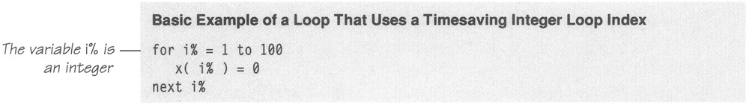
How much difference does it make? Here are the results for this Basic code and for similar code in Fortran:
Language | Straight Time | Code-Tuned Time | Time Savings | Performance Ratio
Basic | 5.54 | 0.94 | 83% | 6:1
Fortran | 5.51 | 0.93 | 83% | 6:1

Use the Fewest Array Dimensions Possible
CROSS-REFERENCE For details on arrays, see Chapter 11, "Fundamental Data Types."
Conventional wisdom maintains that multiple dimensions on arrays are expensive. If you can structure your data so that it's in a one-dimensional array rather than a two-dimensional or three-dimensional array, you might be able to save some time.
Suppose you have initialization code like this:

Pascal Example of a Standard, Two-Dimensional Array Initialization

for Row := 1 to NumRows do
begin
for Col := 1 to NumCols do
begin
Matrix[ Row, Col ] := 0
end;
end;

When this code is run with 50 rows and 20 columns, it takes 3.32 milliseconds. But when the array is restructured so that it's one-dimensional instead of two-dimensional, it takes only 2.28 milliseconds. Here's how the revised code would look:

Pascal Example of a One-Dimensional Representation of an Array

for Entry := 1 to NumRows * NumCols do
begin
Matrix[ Entry ] := 0
end;

Here's a summary of the results, with the addition of comparable results in C and C++:
Language | Straight Time | Code-Tuned Time | Time Savings | Performance Ratio
Pascal | 6.64 | 4.55 | 32% | 4:3
C | 7.57 | 5.71 | 25% | 5:4
C++ | 4.29 | 7.69 | −79% | 1:2
Note | Times for the Pascal case don't match the times in the text discussion because the performance benchmarks are run many times (in this case 2000 times) in order to smooth out sample-to-sample fluctuations in the results.

The results are good in Pascal and C but terrible in C++. You might wonder whether the negative savings is an upshot of some defect in the C++ compiler, but the initial, unoptimized, C++ code is faster than either of the optimized versions from the other two compilers, so you can't be too hard on it. More likely, the code tuning thwarted automatic compiler optimizations, which in this case seem to be more effective than manual ones.
These results also show the hazard of following any code-tuning advice blindly. You can never be sure until you try the advice in your specific circumstances.
A hazard of this particular technique—turning a two-dimensional array into a one-dimensional array—is the possibility that the computation of NumRows * NumCols will inadvertently overflow the Entry index. You can solve the problem by making Entry a long integer, which avoids the overflow problem but might bring you full circle with an adverse effect on performance. Here's what happens to performance when you change Entry from an integer to a long integer:

Language | Initial Time | Time for Entry as an Integer | Time for Entry as a Long Integer | Total Time Savings
Pascal | 6.64 | 4.55 | 7.25 | −9%
C | 7.57 | 5.71 | 15.43 | −104%
C++ | 4.29 | 7.69 | 9.62 | −124%
Note | "Total Time Savings" is the difference between Entry as a long integer and the initial, two-dimensional array time.

The penalty for switching to long integers ranges from 9 through 124 percent, but in none of these cases is the optimization better than the initial time for a two-dimensional array.

Minimize Array References
In addition to minimizing accesses to doubly or triply dimensioned arrays, it's often advantageous to minimize array accesses, period. A loop that repeatedly uses one element of an array is a good candidate for the application of this technique. Here's an example of an unnecessary array access:

C Example of Unnecessarily Referencing an Array Inside a Loop

for ( DiscountLevel = 0; DiscountLevel < NumLevels; DiscountLevel++ )
{
for ( RateIdx = 0; RateIdx < NumRates; RateIdx++ )
{
Rate[ RateIdx ] = Rate[ RateIdx ] * Discount[ DiscountLevel ];
}
}

The reference to Discount[ DiscountLevel ] doesn't change when RateIdx changes in the inner loop. Consequently, you can move it out of the inner loop so that you'll have only one array access per execution of the outer loop rather than one for each execution of the inner loop. The next example shows the revised code.

C Example of Moving an Array Reference Outside a Loop
for ( DiscountLevel = 0; DiscountLevel < NumLevels; DiscountLevel++ )
{
ThisDiscount = Discount[ DiscountLevel ];
for ( RateIdx = 0; RateIdx < NumRates; RateIdx++ )
{
Rate[ RateIdx ] = Rate[ RateIdx ] * ThisDiscount;
}
}

Here are the results:
Language | Straight Time | Code-Tuned Time | Time Savings
C | 16.09 | 13.51 | 16%
C++ | 15.16 | 15.16 | 0%
Basic | 31.09 | 21.37 | 31%
Note | Benchmark times were computed for the case in which NumLevels equals 10 and NumRates equals 100.

Once again, the results vary significantly from compiler to compiler.

Use Supplementary Indexes
Using a supplementary index means adding related data that makes accessing a data structure more efficient. You can add the related data to the main data structure, or you can store it in a parallel structure.

String-length index
In C, strings are terminated by a byte that's set to 0. In Pascal, a length byte hidden at the beginning of each string indicates how long the string is. To determine the length of a string in C, a program has to start at the beginning of the string and count each byte until it finds the byte that's set to 0. In Pascal, the program just looks at the length byte. Pascal's length byte is an example of augmenting a data structure with an index to make certain operations—like computing the length of a string—faster.
You can apply the idea of indexing for length to any variable-length data structure. It's often more efficient to keep track of the length of the structure rather than computing the length each time you need it.

Index for an ordered list of one-way pointers
If you want to find a specific entry in an ordered list of one-way pointers, you have to start at the beginning and check each pointer until you find the one you need. If the list is long, say 1000 pointers, you'll have to check an average of half the pointers before you find the one you want.

FURTHER READING For an extended discussion of tuning linked-list code, see "Software Exploratorium: Writing Efficient C Programs" (Bentley 1991).
If performance is an issue, you can augment the linked list with another, smaller, linked list that acts as an index into the main list. Suppose the index has 10 entries. The first entry would point to the beginning of the main list. The second would point one-tenth of the way through the list; the third, two-tenths; the fourth, three-tenths; and so on. When you search for a pointer in the main linked list, you go first to the index list. You'll check an average of half the index pointers before you figure out which tenth of the main list the value is in. Then you check the values in that tenth, an average of half of them, to find the value you want.
If the list is 1000 links long, the 10-pointer augmentation reduces the average number of pointers you have to check from 500 to 55. The augmentation increases the amount of time required to insert an element, however, so you have to weigh the trade-offs between search time, insertion time, and storage.
This idea is useful for linked lists and even more useful for accessing disk-based data structures. A similar scheme is used for storing B-trees.

Independent, parallel index structure
Sometimes it's more efficient to manipulate an index to a data structure than it is to manipulate the data structure itself. If the items in the data structure are big or hard to move (on disk, perhaps), sorting and searching index references is faster than working with the data directly. If each data item is large, you can create an auxiliary structure that consists of key values and pointers to the detailed information. If the difference in size between the data structure item and the auxiliary-structure item is great enough, sometimes you can store the key item in memory even when the data item has to be stored externally. All searching and sorting is done in memory, and you have to access the disk only once, when you know the exact location of the item you want.

Use Caching
Caching means saving a few values in such a way that you can retrieve the most commonly used values more easily than the less commonly used values. If a program randomly reads records from a disk, for example, a routine might use a cache to save the records most frequently read. When the routine receives a request for a record, it checks the cache to see whether it has the record. If it does, the record is returned directly from memory rather than from disk.
In addition to caching records on disk, you can apply caching in other areas. In a Microsoft Windows font-proofing program, the performance bottleneck was in retrieving the width of each character as it was displayed. Caching the most recently used character width roughly doubled the display speed. Jon Bentley reports a spelling-correction program that cached the 1000 most frequently used words in memory (1982). The program had a 500,000-word dictionary on disk, but the in-memory cache made disk accesses rare.
You can cache the results of time-consuming computations too—especially if the parameters to the calculation are simple. Suppose, for example, that you need to compute the length of the hypotenuse of a right triangle, given the lengths of the other two sides. The straightforward implementation of the routine would look like this:

Pascal Example of a Routine That's Conducive to Caching
function Hypotenuse
(
SideA: real;
SideB: real
): real;
begin
Hypotenuse := sqrt( SideA * SideA + SideB * SideB );
end;

If you know that the same values tend to be requested repeatedly, you can cache values this way:
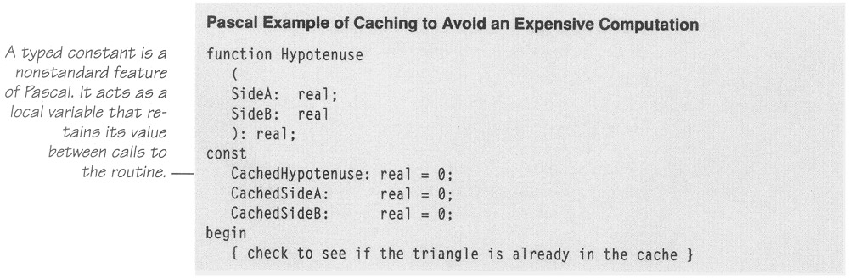
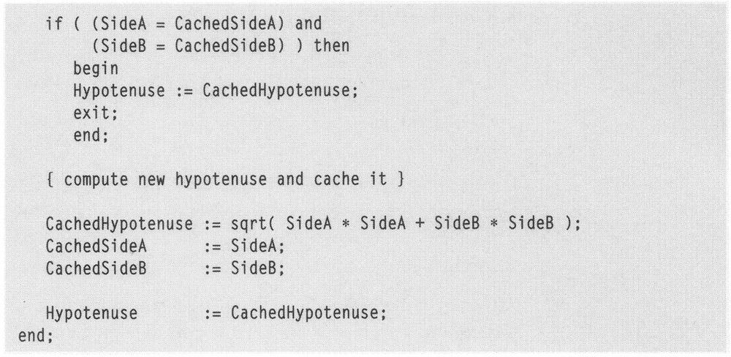
The second version of the routine is more complicated than the first and takes up more space, so speed has to be at a premium to justify it. Many caching schemes cache more than one element, so they have even more overhead. Here's the speed difference between these two versions:

Language | Straight Time | Code-Tuned Time | Time Savings
Pascal | 2.63 | 2.25 | 14%
C | 1.99 | 1.93 | 3%
Basic | 1.75 | 2.52 | −44%
Note | The results shown assume that the cache is hit twice for each time it's set. The break-even point was 1 hit for the Pascal routine, 2 for the C, and 19 for the Basic.

Once again, the results from different compilers vary wildly. The success of the cache depends on the relative costs of accessing a cached element, creating an uncached element, and saving a new element in the cache. Success also depends on how often the cached information is requested. In some cases, success might also depend on caching done by the hardware. Generally, the more it costs to generate a new element and the more times the same information is requested, the more valuable a cache is. The cheaper it is to access a cached element and save new elements in the cache, the more valuable a cache is.

29.4 Expressions
CROSS-REFERENCE For more information on expressions, see Section 17.1, "Boolean Expressions."
Much of the work in a program is done inside mathematical or logical expressions. Complicated expressions tend to be expensive, so this section looks at ways to make them cheaper.

Exploit Algebraic Identities
You can use algebraic identities to replace costly operations with cheaper ones. For example, the following expressions are logically equivalent:

not A and not B
not (A or B)

If you choose the second expression instead of the first, you can save a not operation. If you can reverse the polarity of the test—for example, by using a repeat-until loop instead of a while-do loop in Pascal—you can drop the not from the second option and save two nots.
Although the savings from avoiding a single not operation are probably slight, the general principle is powerful. Jon Bentley describes a program that tested whether sqrt(x) <sqrt(y) (1982). Since sqrt(x) is less than sqrt(y) only when x is less than y, you can replace the first test with x < y. Given the cost of the sqrt() routine, you'd expect the savings to be dramatic, and they are. Here are the results:

Language | Straight Time | Code-Tuned Time | Time Savings | Performance Ratio
C | 3.63 | 0.71 | 80% | 5:1
Basic | 2.37 | 0.94 | 60% | 3:1

Use Strength Reduction
As mentioned earlier, strength reduction means replacing an expensive operation with a cheaper one. Here are some possible substitutions:
- Replace multiplication with addition.
- Replace exponentiation with multiplication.
- Replace trigonometric routines with their trigonometric identities.
- Replace long integers with short integers.
- Replace floating-point numbers with fixed-point numbers or integers.
- Replace double-precision floating points with single-precision numbers.
- Replace integer multiplication and division by two with shift operations.
Here is a detailed example. Suppose you have to evaluate a polynomial. If you're rusty on polynomials, they're the things that look like

The letters A, B, and C are coefficients, and x is a variable. General code to evaluate an nth-order polynomial looks like this:

Basic Example of Evaluating a Polynomial

Value = Coefficient( 0 )
for Power = 1 to Order
Value = Value + Coefficient( Power ) * x^Power
next Power

If you're thinking about strength reduction, you'll look at the exponentiation operator with a jaundiced eye. One solution would be to replace the exponentiation with a multiplication on each pass through the loop, which is analogous to the strength-reduction case a few sections ago in which a multiplication was replaced with an addition. Here's how the reduced-strength polynomial evaluation would look:

Basic Example of a Reduced-Strength Method of Evaluating a Polynomial

Value = Coefficient( 0 )
PowerOfX = x
for Power = 1 to Order
Value = Value + Coefficient( Power ) * PowerOfX
PowerOfX = PowerOfX * x
next Power

This produces a noticeable advantage if you're working with second-order polynomials (polynomials in which the highest-power term is squared) or higher-order polynomials.

Language | Straight Time | Code-Tuned Time | Time Savings | Performance Ratio
Basic | 25.43 | 3.24 | 87% | 8:1
Ada | 28.72 | 11.42 | 60% | 3:1
If you're serious about strength reduction, you still won't care for those two floating-point multiplications. You can further reduce the strength of the operations in the loop by accumulating powers rather than multiplying them each time. Here's that code:

Basic Example of Further Reducing the Strength Required to Evaluate a Polynomial

Value = 0
for Power = Order to 1 Step −1
Value = ( Value + Coefficient( Power ) ) * X
next Power
Value = Value + Coefficient( 0 )

This method eliminates the extra PowerOfX variable and replaces the two multiplications in each pass through the loop with one. It's not exactly straightforward, but that's the penalty you pay for code tuning. The code is considerably faster.

Language | Straight Time | First Optimization | Second Optimization | Savings over First Optimization
Basic | 25.43 | 3.24 | 1.98 | 39%
Ada | 28.72 | 11.42 | 6.97 | 39%
The lesson to be learned here is Don't stop after the first optimization. Even though the first produced a nice benefit, the second was better.

Initialize at Compile Time
If you're using a named constant or a magic number in a routine call and it's the only argument, that's a clue that you could precompute the number, put it into a constant, and avoid the routine call. The same principle applies to multiplications, divisions, additions, and other operations.
I once needed to compute the base-two logarithm of an integer, truncated to the nearest integer. The system didn't have a log-base-two routine, so I wrote my own. The quick and easy approach was to use the fact that
log(x) base = log(x) / log(base)
Given this identity, I could write a routine like this one:
CROSS-REFERENCE For details on binding variables to their values, see Section 10.3, "Binding Time."

C Example of a Log-Base-Two Routine Based on System Routines

unsigned int log2( unsigned int x )
{
return( (unsigned int) (log( x ) / log( 2 )) );
}

This routine was really slow, and since the value of log( 2 ) never changed, I replaced log( 2 ) with its computed value, 0.69314718. Then the code looked like this:

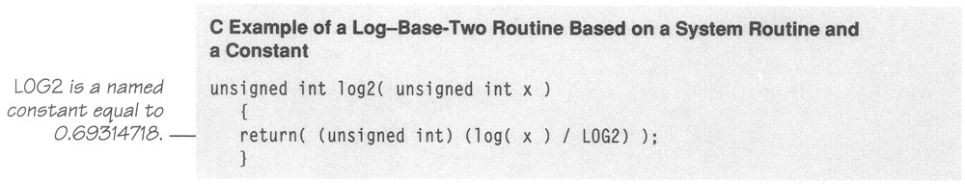

Since log() tends to be an expensive routine, much more expensive than type conversions or division, you'd expect that cutting the calls to the log() function by half would cut the time required for the routine by about half. Here are the measured results:

Language | Straight Time | Code-Tuned Time | Time Savings
C | 29.00 | 21.74 | 25%
Fortran | 43.06 | 32.95 | 23%
The savings is not as large as expected, apparently because a floating-point division and two type conversions dilute the effect of the optimization. The educated guess about the relative importance of the division and type conversions and the estimate of 50 percent were simply wrong, as educated guesses often are when optimization is concerned.

Be Wary of System Routines
System routines are expensive and provide accuracy that's often wasted. The system math routines, for example, are designed to put an astronaut on the moon within ± 2 feet of the target. If you don't need that degree of accuracy, you don't need to spend the time to compute it either.
In the previous example, the log2() routine returned an integer value but used a floating-point log() routine to compute it. That was overkill for an integer result, so after my first attempt, I wrote a series of integer tests that were perfectly accurate for calculating an integer log₂. Here's the code:

C Example of a Log-Base-Two Routine Based on Integers

unsigned int log2( unsigned int x )
{
if ( x < 2 ) return( 0 );
if ( x < 4 ) return( 1 );
if ( x < 8 ) return( 2 );
if ( x < 16 ) return( 3 );
if ( x < 32 ) return( 4 );
if ( x < 64 ) return( 5 );
if ( x < 128 ) return( 6 );
if ( x < 256 ) return( 7 );
if ( x < 512 ) return( 8 );
if ( x < 1024 ) return( 9 );
if ( x < 2048 ) return( 10 );
if ( x < 4096 ) return( 11 );
if ( x < 8192 ) return( 12 );
if ( x < 16384 ) return( 13 );
if ( x < 32768 ) return( 14 );
return( 15 );
}

This routine uses integer operations, never converts to floating point, and blows the doors off both floating-point versions. Here are the results:

Language | Straight Time | Code-Tuned Time | Time Savings | Performance Ratio
C | 29.00 | 0.15 | 99.5% | 200:1
Fortran | 43.06 | 0.44 | 98.9% | 100:1
Most of the so-called "transcendental" functions are designed for the worst case—that is, they convert to double-precision floating point internally even if you give them an integer argument. If you find one in a tight section of code and don't need that much accuracy, give it your immediate attention.
Another option is to take advantage of the fact that a right-shift operation is the same as dividing by two. The number of times you can divide a number by two and still have a nonzero value is the same as the log₂ of that number. Here's how code based on that observation looks:

C Example of an Alternative Log-Base-Two Routine Based on the Right-Shift Operator

unsigned int log2( unsigned int x )
{
unsigned int i = 0;
while ( (x = (x >> 1)) != 0 )
{
i++;
}
return( i );
}

To non-C programmers, this code is particularly hard to read. The complicated expression in the while condition is an example of a coding practice you should avoid unless you have a good reason to use it.
This routine takes about 40 percent longer than the longer version above, executing in 0.21 seconds rather than 0.15 seconds. It takes only about one-sixth of the memory (27 vs. 174 bytes), however, so you might prefer it in some circumstances.

This example highlights the value of not stopping after one successful optimization. The first optimization earned a respectable 25 percent savings but had nowhere near the impact of the second or third optimization. An additional attempt produced a compromise between speed and memory use.

Use the Correct Type of Constants
Use named constants and literals that are the same type as the variables they're assigned to. When a constant and its related variable are different types, the compiler has to do a type conversion to assign the constant to the variable. A good compiler does the type conversion at compile time so that it doesn't affect run-time performance.
A less advanced compiler or an interpreter, however, generates code for a runtime conversion, so you might be stuck. Here are some differences in performance between the initializations of a floating-point variable x and an integer variable i in two cases. In the first case, the initializations look like this:
x = 5
i = 3.14
and require type conversions. In the second case, they look like this:
x = 3.14
i = 5
and don't require type conversions. Here are the results:

Language | Straight Time | Code-Tuned Time | Time Savings | Performance Ratio
Compiled Basic | 5.38 | 5.38 | 0% | 1:1
Interpreted Basic | 15.27 | 6.42 | 58% | 2:1
C | 20.65 | 5.45 | 74% | 4:1
C++ | 4.94 | 4.94 | 0% | 1:1
Fortran | 3.07 | 3.07 | 0% | 1:1
It's not surprising that all but one of the compilers produced no savings or that the Basic interpreter's time improved. It is surprising that the C compiler—the current, third generation of a popular product—did such an abysmal job. The lesson is that each compiler has specific strengths and weaknesses, and sometimes the weaknesses are surprising.

Precompute Results
A common low-level design decision is the choice of whether to compute results on the fly or compute them once, save them, and look them up as needed. If the results are used many times, it's often cheaper to compute them once and look them up.
This choice manifests itself in several ways. At the simplest level, you might compute part of an expression outside a loop rather than inside. An example of this appeared earlier in the chapter. At a more complicated level, you might compute a lookup table once when program execution begins, using it every time thereafter, or you might store results in a data file or embed them in a program.
In a space-wars video game, for example, the programmers initially computed gravity coefficients for different distances from the sun. The computation for the gravity coefficients was expensive and affected performance. The program recognized relatively few distinct distances from the sun, however, so the programmers were able to precompute the gravity coefficients and store them in a 10-element array. The array lookup was much faster than the expensive computation.
Suppose you have a routine that computes payment amounts on automobile loans. The code for such a routine would look like this:

Pascal Example of a Complex Computation That Could Be Precomputed
function ComputePayment
(
LoanAmount; longint;
Months: integer;
InterestRate: real;
): real;

begin
Payment := LoanAmount /
(
( 1.0 − Power( 1.0+(InterestRate/12.0), − Months ) ) /
( InterestRate/12.0 )
)
end;

The formula for computing loan payments is complicated and fairly expensive. Putting the information in a table instead of computing it each time would probably be cheaper.
How big would the table be? The widest-ranging variable is LoanAmount. The variable InterestRate might range from 5% through 20% by quarter points, but that's only 61 distinct rates. Months might range from 12 through 72, but that's only 61 distinct periods. LoanAmount could conceivably range from $1000 through $100,000, which is more entries than you'd generally want to handle in a lookup table.
Most of the computation doesn't depend on LoanAmount, however, so you can put the really ugly part of the computation (the denominator of the larger expression) into a table that's indexed by InterestRate and Months. You recompute the LoanAmount part each time. Here's the revised code:
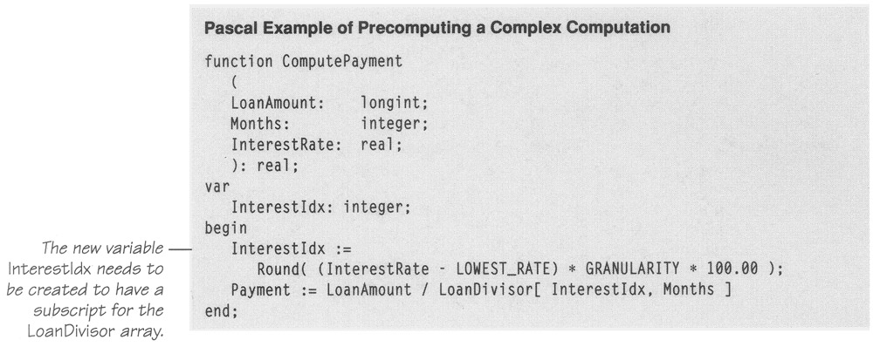
In this code, the hairy calculation has been replaced with the computation of an array index and a single array access. Here are the results of the change:

Language | Straight Time | Code-Tuned Time | Time Savings | Performance Ratio
Pascal | 3.13 | 0.82 | 74% | 4:1
Ada | 9.39 | 2.09 | 78% | 4:1
Note | The Ada compiler's results are considerably slower than the Pascal compiler's, but they're not comparable because the Pascal program didn't perform range checking on its array accesses. To the Ada compiler's credit, its optimizer is the only one that fully optimized any of the test programs in this chapter. In this case, it detected the fact that the Payment variable was never used and removed all the code that computed it—resulting in initial benchmark times of 0.0 and 0.0.

Depending on your circumstances, you would need to precompute the LoanDivisor array at program initialization time or read it from a disk file. Alternatively, you could initialize it to 0, compute each element the first time it's requested, store it, and look it up each time it's requested subsequently. That would be a form of caching, discussed earlier.
You don't have to create a table to take advantage of the performance gains you can achieve by precomputing an expression. Code similar to the code in the previous examples raises the possibility of a different kind of precomputation. Suppose you have code that computes payments for many loan amounts, as shown on the next page.
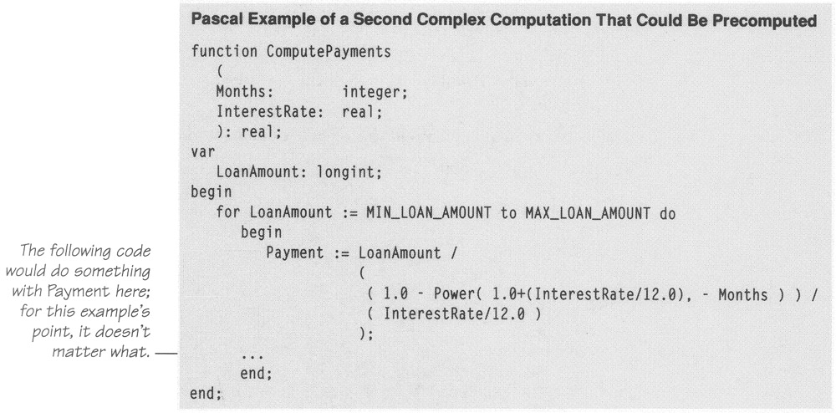
Even without precomputing a table, you can precompute the complicated part of the computation outside the loop and use it inside the loop. Here's how it would look:
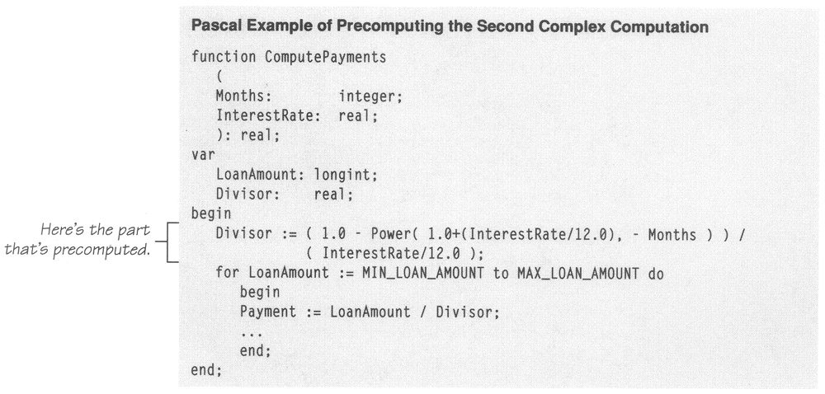
This is similar to the techniques suggested earlier of putting array references and pointer dereferences outside a loop. The results in this case are comparable to the results of using the precomputed table in the first optimization:
Language | Straight Time | Code-Tuned Time | Time Savings | Performance Ratio
Pascal | 3.51 | 0.77 | 78% | 5:1
Ada | 10.33 | 1.70 | 84% | 6:1
Optimizing a program by precomputation can take several forms:
- Computing results before the program executes and wiring them into constants that are assigned at compile time
- Computing results before the program executes and hard-coding them into variables used at run time
- Computing results before the program executes and putting them into a file that's loaded at run time
- Computing results once, at program startup, and then referencing them each time they're needed
- Computing as much as possible before a loop begins, minimizing the work done inside the loop
- Computing results the first time they're needed and storing them so that you can retrieve them when they're needed again

Eliminate Common Subexpressions
If you find an expression that's repeated several times, assign it to a variable and refer to the variable rather than recomputing the expression in several places. The loan-calculation example has a common subexpression that you could eliminate. Here's the original code:
Pascal Example of a Common Subexpression

Payment := LoanAmount /
(
( 1.0 − Power( 1.0+(InterestRate/12.0), − Months ) ) /
( InterestRate/12.0 )
);

In this sample, you can assign InterestRate/12.0 to a variable that is then referenced twice rather than computing the expression twice. If you have chosen the variable name well, this optimization can improve the code's readability at the same time that it improves performance. The next example shows the revised code.

Pascal Example of Eliminating a Common Subexpression
MonthlyInterest := InterestRate / 12.0;
Payment := LoanAmount /
(
( 1.0 − Power( 1.0+MonthlyInterest, − Months ) ) /
MonthlyInterest
);

The savings in this case don't seem impressive:

Language | Straight Time | Code-Tuned Time | Time Savings
Pascal | 3.13 | 3.08 | 2%
Ada | 9.56 | 9.33 | 2%

It appears that the Power() routine is so costly that it overshadows the savings from subexpression elimination. In other cases, if the subexpression were a bigger part of the cost of the whole expression, the optimization would have more impact.
Not all subexpression eliminations are created equal. For example, suppose you wanted to eliminate the Mtx[ InsertPos−1 ] expression in the following code fragment:

C Example of a Candidate for Subexpression Removal
for ( Boundary = 1; Boundary < NUM; Boundary++ )
{
InsertPos = Boundary;
while ( InsertPos > 0 && Mtx[ InsertPos ] < Mtx[ InsertPos−1 ] )
{
SwapVal = Mtx[ InsertPos ];
Mtx[ InsertPos ] = Mtx[ InsertPos−1 ];
Mtx[ InsertPos−1 ] = SwapVal;
InsertPos--;
}
}

You could replace the common expression in a couple of ways. The most common way would be to assign it a value and use the value, where possible. In this example, you could replace Mtx[ InsertPos−1 ] with TestVal. That code would look like this:
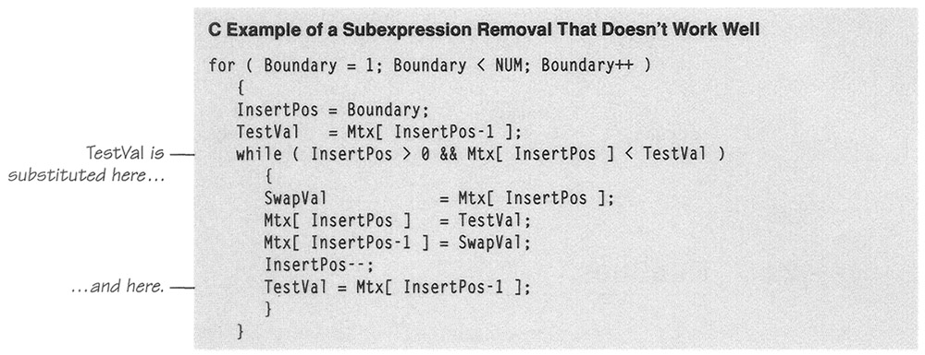

This approach eliminates only one array reference and one computation of InsertPos−1 for each pass through the loop. The results aren't impressive:
Language | Straight Time | Code-Tuned Time | Time Savings
C | 1.53 | 1.58 | −3%
Ada | 1.43 | 1.59 | −11%
The technique actually hurt performance. But C does support a different kind of subexpression—namely, a pointer. Here is an example of how to use a pointer, TestValPtr, to remove the common subexpression:

C Example of a Subexpression Removal That Works Better
for ( Boundary = 1; Boundary < NUM; Boundary++ )
{
InsertPos = Boundary;
TestValPtr = &Mtx[ InsertPos−1 ];
while ( InsertPos > 0 && Mtx[ InsertPos ] < *TestValPtr )
{
SwapVal = Mtx[ InsertPos ];
Mtx[ InsertPos ] = *TestValPtr;
*TestValPtr = SwapVal;
InsertPos--;
TestValPtr--;
}
}

This approach eliminates three array references and three computations of InsertPos−1 for each pass through the loop. The results are correspondingly more impressive:

Language | Straight Time | Code-Tuned Time | Time Savings
C | 1.53 | 1.33 | 13%

29.5 Routines
CROSS-REFERENCE For details on working with routines, see Chapter 5, "Characteristics of High-Quality Routines."
One of the most powerful tools in code tuning is a good routine decomposition. Small, well-defined routines save space because they take the place of doing jobs separately in multiple places. They make a program easy to optimize because you can adjust one routine and thus improve every routine that calls it. Small routines are relatively easy to rewrite in assembler. Long, tortuous routines are hard enough to understand on their own; in assembler they're impossible. For well-defined tasks, you may be able to buy routines from a vendor who has probably had more time to polish the routines than you're likely to have.

Rewrite Routines In Line
In the early days of computer programming, some machines imposed prohibitive performance penalties for using a routine. A call to a routine meant that the operating system had to swap out the program, swap in a directory of routines, swap in the particular routine, execute the routine, swap out the routine, and swap the calling routine back in. All this swapping chewed up resources and made the program slow. Modern machines—and "modern" means any machine you're ever likely to work on—impose virtually no penalty for calling a routine. Moreover, because of the increased code size resulting from putting code in line and the extra swapping that's associated with increased code size on demand-paged virtual-memory machines, a recent study found a slight timing penalty for using inline code rather than routines (Davidson and Holler 1992).
In some cases, you might be able to save a few microseconds by putting the code from a routine into the program directly where it's needed. If you're working in a language with a macro preprocessor, you can use a macro to put the code in, switching it in and out as needed. Here are the results of putting a string-copy routine in line:

Language | Routine Time | Inline-Code Time | Time Savings
C | 1.81 | 1.65 | 9%
Pascal | 1.20 | 1.04 | 13%
The percentage gains shown in this table are probably higher than those you'd normally see. String copying is simple, so the ratio of routine-call overhead to work is higher than it is for other kinds of operations. The less work a routine does, the greater the potential benefit from putting it in line. If a routine does a lot of work, don't expect much improvement.

29.6 Recoding in Assembler
One piece of conventional wisdom that shouldn't be left unmentioned is the advice that when you run into a performance bottleneck, you should recode in assembler. Recoding in assembler tends to improve both speed and code size. Here is a typical approach to optimizing with assembler:
- Write 100 percent of an application in a high-level language.
- Fully test the application, and verify that it's in compliance with the requirements.
- If performance improvements are needed after that, profile the application to identify hot spots. Since about 5 percent of a program usually accounts for about 50 percent of the running time, you can usually identify small pieces of the program as hot spots.
- Recode a few small pieces in assembler to improve overall performance.

CROSS-REFERENCE For details on the phenomenon of a small percentage of a program accounting for most of its run time, see "The Pareto Principle" in Section 28.2.
Whether you follow this well-beaten path depends on how comfortable you are with assembler and on your level of desperation.
I got my first exposure to assembler on the DES encryption program I mentioned in the previous chapter. I had tried every optimization I'd ever heard of, and the program was still twice as slow as the speed goal. Recoding part of the program in assembler was the only remaining option. As an assembler novice, about all I could do was make a straight translation from a high-level language to assembler, but I got a 50 percent improvement even at that rudimentary level.
Suppose you have a routine that converts binary data to uppercase ASCII characters for transmission over a modem. The next example shows the Pascal code to do it.

Pascal Example of Code That's Better Suited to Assembler
procedure HexGrow
(
var Source: ByteArray;
var Target: WordArray;
num: word
);
var
Index: integer;
LowerByte: byte;
UpperByte: byte;
TgtIndex: integer;
begin
TgtIndex := 1;
for Index := 1 to Num do
begin
Target[ TgtIndex ] := ( (Source[ Index ] and $F0) shr 4 ) + $41;
Target[ TgtIndex+1 ] := (Source[ Index ] and $0f) + $41;
TgtIndex := TgtIndex + 2;
end;
end;

Although it's hard to see where the fat is in this code, it contains a lot of bit manipulation, which isn't exactly Pascal's forte. Bit manipulation is assembler's forte, however, so this code is a good candidate for recoding. Here's the assembler code:

Example of: a Routine Recoded in Assembler
HexExpand PROC NEAR

MOV BX,SP ; get stack pointer for routine arg's
MOV CX,SS:[BX+2] ; load number of bytes to expand
MOV SI,SS:[BX+8] ; load source offset
MOV DI,SS:[BX+4] ; load target offset

XOR AX,AX ; zero-out array offset

EXPAND:

MOV BX,AX ; array offset
MOV DL,DS:[SI+BX] ; get source byte
MOV DH,DL ; copy source byte
AND DH,15 ; get msb's
ADD DH,65 ; add 65 to make modem ready

SHR DL,1 ; move lsb's into position
SHR DL,1 ; move lsb's into position
SHR DL,1 ; move lsb's into position
SHR DL,1 ; move lsb's into position
AND DL,15 ; get lsb's
ADD DL,65 ; add 65 to make modem ready

SHL BX,1 ; double offset for target array index
MOV DS:[DI+BX],DX ; put target word

INC AX ; increment array offset
LOOP EXPAND ; repeat until finished

RET 10 ; pop arg's off stack and return
HexExpand ENDP

Rewriting in assembler in this case was profitable, resulting in a time savings of 65 percent. It's logical to assume that code in a language that's more suited to bit manipulation—C, for instance—would have less to gain than Pascal code would, but as is often the case, real-world optimization results don't pay much attention to logical assumptions. Here are the results:

Language | High-Level Time | Assembler Time | Time Savings | Performance Ratio
Pascal | 1.59 | 0.55 | 65% | 3:1
C | 0.83 | 0.38 | 54% | 2:1
The assembler routine shows that rewriting in assembler doesn't have to produce a huge, ugly routine. Such routines are often quite modest, as this one is. Sometimes assembler code is almost as compact as its high-level-language equivalent.
A relatively easy and effective strategy for recoding in assembler is to start with a compiler that generates assembler listings as a by-product of compilation. Extract the assembler code for the routine you need to tune, and save it in a separate source file. Using the compiler's assembler code as a base, hand-optimize the code, checking for correctness and measuring improvements at each step. Some compilers intersperse the high-level-language statements as comments in the assembler code. If yours does, keep them in the assembler code as documentation.

29.7 Quick Reference to Tuning Techniques
Depending on the circumstances, you might try any of the techniques in Table 29-1 to optimize your code.
Table 29-1: Summary of Code-Tuning Techniques
Technique | See Page
Improve Both Speed and Size
Jam loops | 697
Substitute table lookups for complicated logic | 709
Use integer instead of floating-point variables | 711
Initialize data at compile time | 720
Use constants of the correct type | 723
Precompute results | 723
Eliminate common subexpressions | 727
Translate key routines to assembler | 731
Improve Speed Only
Unswitch loops that contain if tests | 696
Unroll loops | 698
Minimize work performed inside loops | 700
Use sentinels in search loops | 701
Put the busiest loop on the inside of nested loops | 703
Reduce the strength of operations performed inside loops | 704
Stop testing when you know the answer | 706
Order tests in case statements and if-then-else chains by frequency | 707
Use lazy evaluation | 710
Change multiple-dimension arrays to a single dimension | 711
Minimize array references | 713
Augment data structures with indexes | 714
Cache frequently used values | 715
Exploit algebraic identities | 718
Reduce strength in logical and mathematical expressions | 720
Be wary of system routines | 721
Rewrite routines in line | 730

Further Reading
Bentley, Jon. Writing Efficient Programs. Englewood Cliffs, N.J.:Prentice Hall, 1982. This book is an expert treatment of code tuning, broadly considered. Bentley describes techniques that trade time for space and space for time. He provides several examples of redesigning data structures to reduce both space and time. His approach is a little more anecdotal than the one taken here, and his anecdotes are interesting. He takes a few routines through several optimization steps so that you can see the effects of first, second, and third attempts on a single problem. Bentley strolls through the primary contents of the book in 135 pages. The book has an unusually high signal-to-noise ratio—it's one of the rare gems that every practicing programmer should own.
Abrash, Michael. "Flooring It: The Optimization Challenge." PC Techniques 2, no. 6 (February/March 1992): 82–88. This is an interesting report on the top entries in an assembler code-tuning contest. The winning entry was about 4 times faster than the original hand-tuned assembler code and about 13 times as fast as the original code in C. The report illustrated some of the techniques described in this chapter.

