DPR Next Gen Sustainability User Guide

Newly Migrated System and DPR Cal Rewrite - Spring 2022

This document will serve as a general user guide for all roles in the DPR Cal application. There will be step-by-step instructions for all implemented use cases for admin, instructor, and attendee’s. There will be instructions for how to start interacting with our application along with in-depth guides and visuals to help navigate through every step of the way.

## Sign-In and User Profiles

When first accessing the new DPR Cal, you will first see the new log-in page for all user authentication.

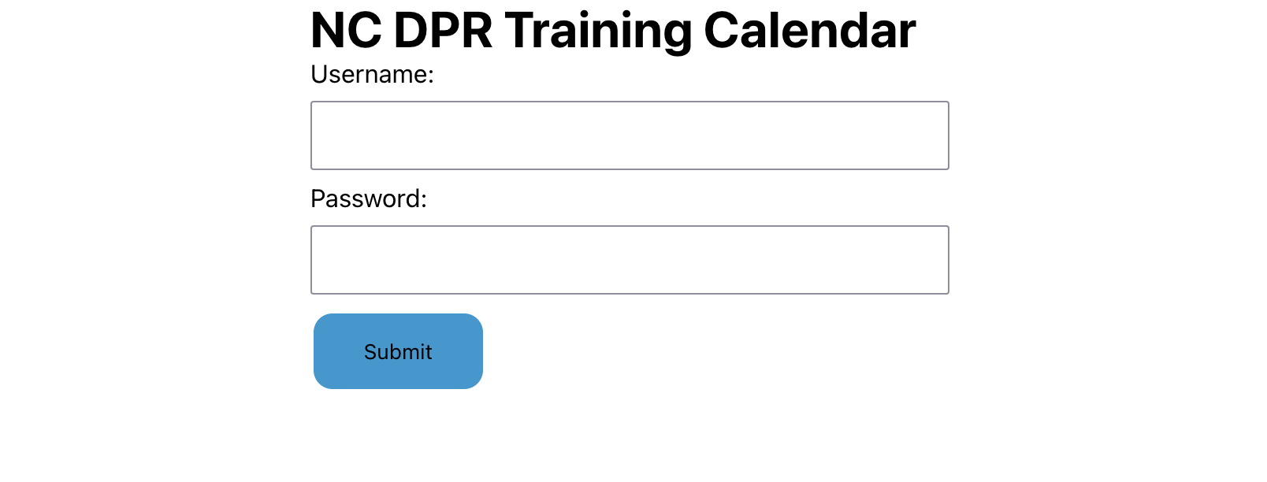

From this log-in screen, the user can log-in with their valid credentials. Our authentication system will then route the user to the appropriate landing page: Admin, Instructor, or Attendee.

## Admin Use Cases

**General Use:**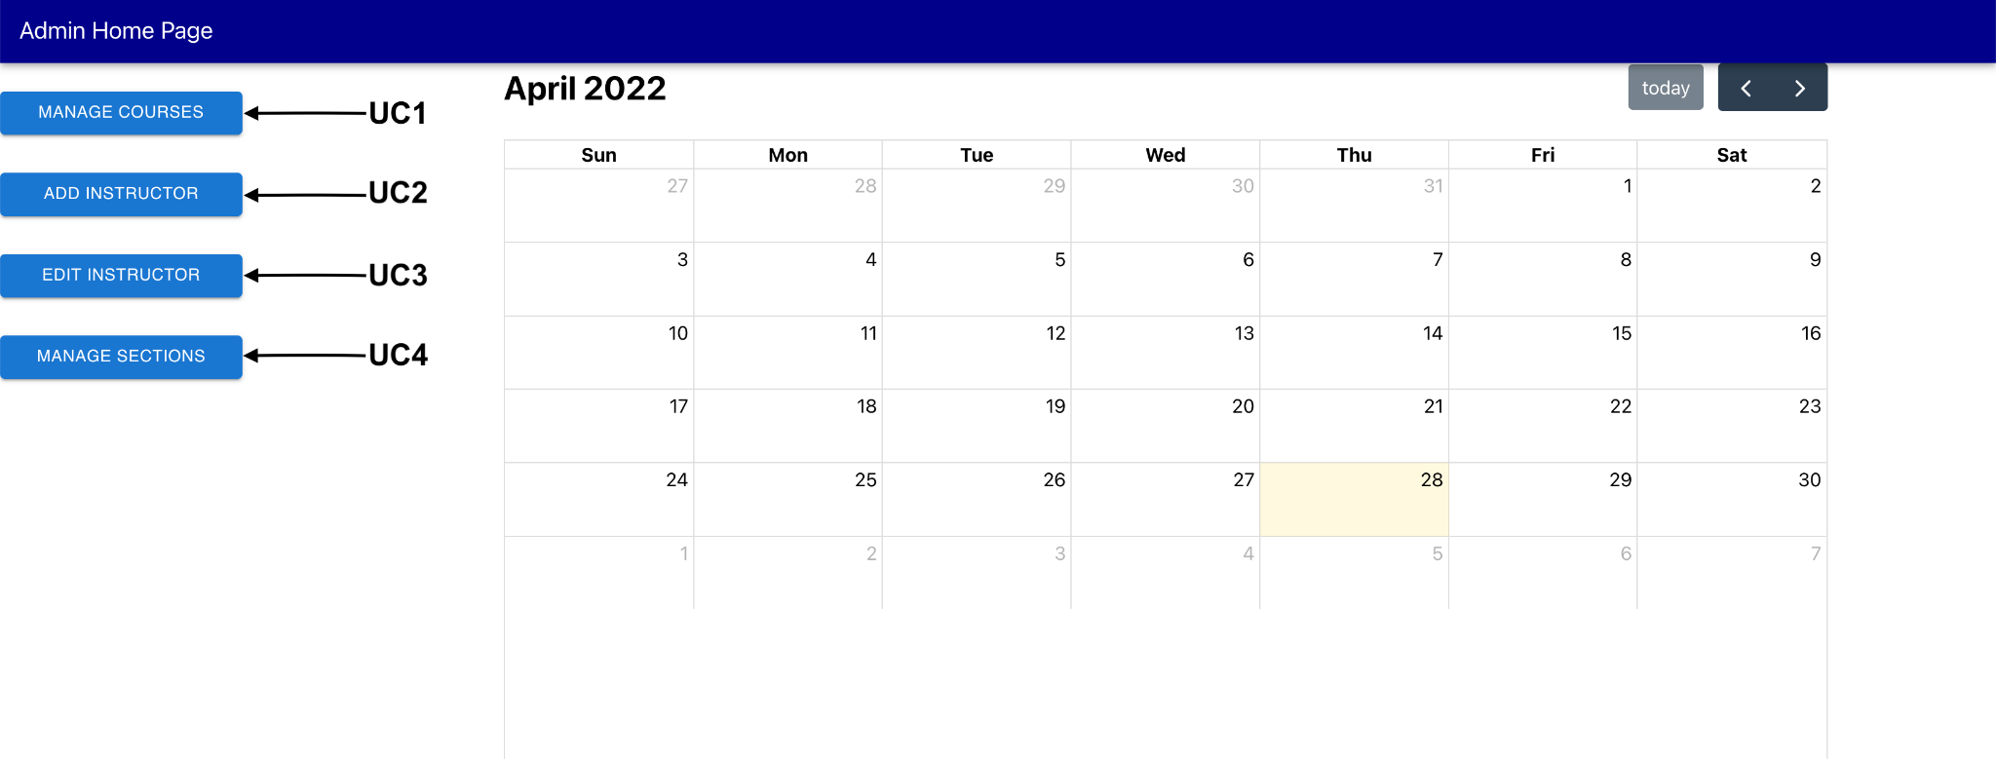

When an administrator logs in, they will be directed to the Admin Home Page, from there they can use different functionality that can be accessed by pressing any of the buttons that are pointed at by the arrows in the figure above. Also, the administrator will be able to see all classes being held in the calendar view.

**UC1: Manage Courses**

* If an administrator would like to manage existing courses, then they would select the ‘Manage Courses’ button and be directed to the Manage Courses Form.
* When an administrator reaches this form, they will then have the ability to select an existing course to edit.
* Upon selecting a course from the drop down menu, an administrator will then be able to change the course name, course category, course description, and course requirements as necessary.
* When an administrator is finished, they can choose to ‘Save Course’ and have that updated course be available to the rest of the system.
* If an administrator makes a mistake or wants to clear multiple fields, then they can select the ‘Clear Form’ button and have all fields reset.
* If an administrator wishes to return back to the home page for administrators, they may choose the ‘Home’ button and be taken back.

**UC2: Add an Instructor**

* If an administrator would like to add a new Instructor to the DPR Cal application, they may select the ‘Add Instructor’ button and then be taken to the ‘Add an Instructor’ form.
* From this form, an administrator may fill out the relevant fields starting from ‘Title’ all the way to ‘Courses’ as appropriate to the new Instructor.
* When an administrator is finished filling out the form, they can select the ‘Add Instructor’ button at the bottom of the page and have that Instructor be available to the rest of the system.
* If an administrator is finished or chooses to exit the form, they can select the ‘Home’ button at the bottom of the form and return to the Administrator Home Page.

**UC3: Edit an Instructor**

* If an administrator would like to edit an existing Instructor, they may select the Edit Instructor’ button and then be taken to the ‘Manage Instructors’ form.
* From this form, an administrator can select an instructor from the drop-down menu and the fields will be auto-filled for what is in the system.
* The administrator can then update any and all information as necessary and when they are finished, they can hit the ‘Submit Form’ button and have the instructor information updated in the system.
* If the administrator wants to clear all the information, they can hit the ‘Clear Form’ button and have all the instructor information fields cleared.
* If an administrator is finished or chooses to exit the form, they can select the ‘Home’ button at the bottom of the form and return to the Administrator Home Page.

**UC4: Manage Sections**

* If an administrator wants to manage the sections associated with a course, they can select the ‘Manage Sections’ button and be directed to the ‘Manage Sections’ form.
* From there, an administrator can select a section from the drop-down menu. Then, the fields for the section will be automatically filled in and the administrator can edit anything they need from ‘Location’ to the ‘Days of week’ options.
* When an administrator has made all the changes they wish to make, they can select the ‘Save Section’ button and have the section information be updated in the system.
* If an administrator would like to create a new section, they can forgo selecting any section and instead choose a course and instructor from their respective drop-down menus and fill in the information in the same way as described above. When finished, the administrator can select ‘Save Section’ and that new section will be saved in the system.
* If at any point the administrator would like to clear all fields, they may select the ‘Clear Form’ button at the bottom of the page and have all fields reset to empty.
* If at any point the administrator would like to return to the Administrator Home Page or they are finished managing sections, they can select the ‘Home’ button and be returned.

## Instructor Use Cases

**General Use:**

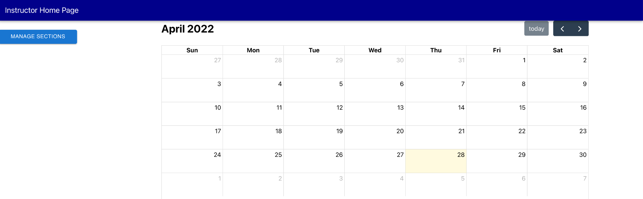

When an Instructor logs in, they will be met with the Instructor Home Page where they can go in and manage the sections where they are assigned as an instructor. Also, they will be able to see all classes that they are teaching in the calendar view.

**UC1: Manage Sections**

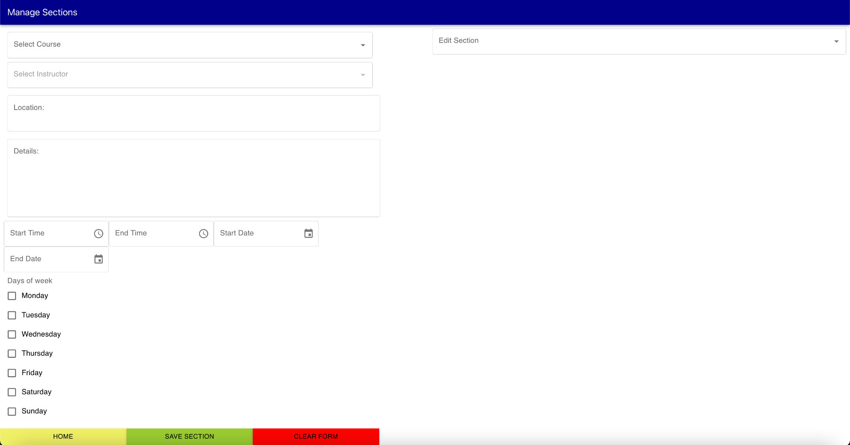

* If an instructor wants to manage the sections that they are assigned to teach, they can select the ‘Manage Sections’ button and be directed to the ‘Manage Sections’ form.
* From there, an instructor can select a section from the drop-down menu. These sections will only contain ones they are assigned as an instructor for. Then, the fields for the section will be automatically filled in and the instructor can edit anything they need from ‘Location’ to the ‘Days of week’ options.
* When an instructor has made all the changes they wish to make, they can select the ‘Save Section’ button and have the section information be updated in the system.
* If an instructor would like to create a new section to teach, they can forgo selecting any section and instead choose a course from the drop-down menu and fill in the information in the same way as described above. When finished, the instructor can select ‘Save Section’ and that new section will be saved in the system.
* If at any point the instructor would like to clear all fields, they may select the ‘Clear Form’ button at the bottom of the page and have all fields reset to empty.
* If at any point the instructor would like to return to the Instructor Home Page or they are finished managing sections, they can select the ‘Home’ button and be returned.

## Attendee Use Cases

**General Use:**

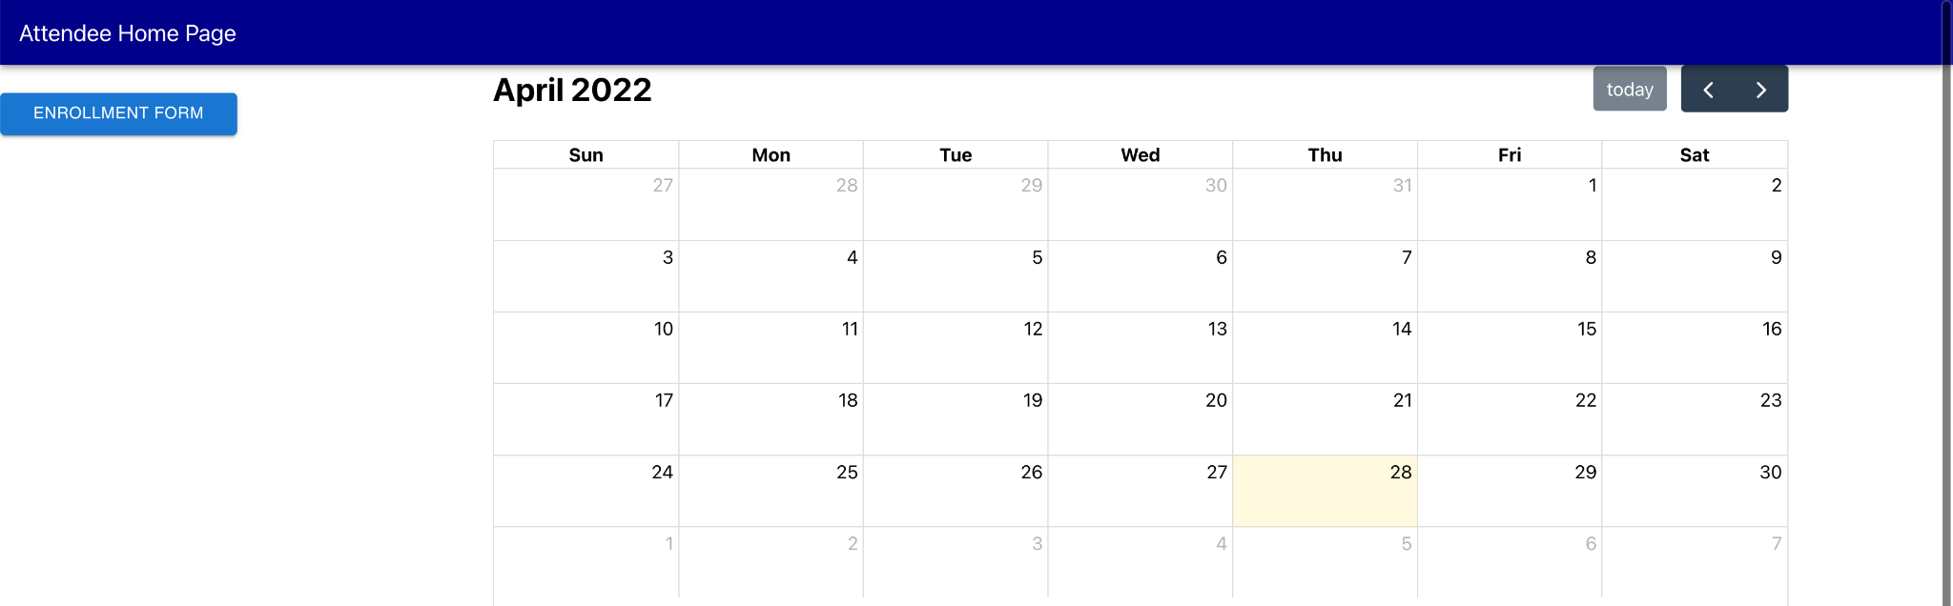

When an attendee logs in, they will be directed to the Attendee Home Page as shown above and will have the option to enroll into classes. Any classes that the attendee is enrolled in will display on the calendar view.

**UC1: Enrollment**

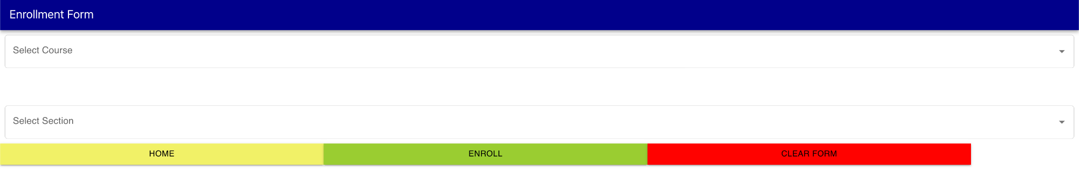

* If an attendee wants to enroll into a class, they can select the ‘Enrollment Form’ button and be navigated to the ‘Enrollment Form.’ From here, the attendee will be able to select a course and section from their respective drop-down menus.
* Once an attendee selects their desired course and section, they can select the ‘Enroll’ button at the bottom of the page and the system will automatically enroll them and add them into the class roster.
* When an attendee is finished, they can select the ‘Home’ button and be returned to the Attendee Home Page and they can view their classes in the calendar.
* If an attendee wants to clear their selections, they can select the ‘Clear Form’ button and have all fields reset to empty.