Process for Cashiers to Report Park Gas issued to DOA/MFM Vehicles (Any cashier listed in the Cash Handling Plan can complete steps 1 to 14:

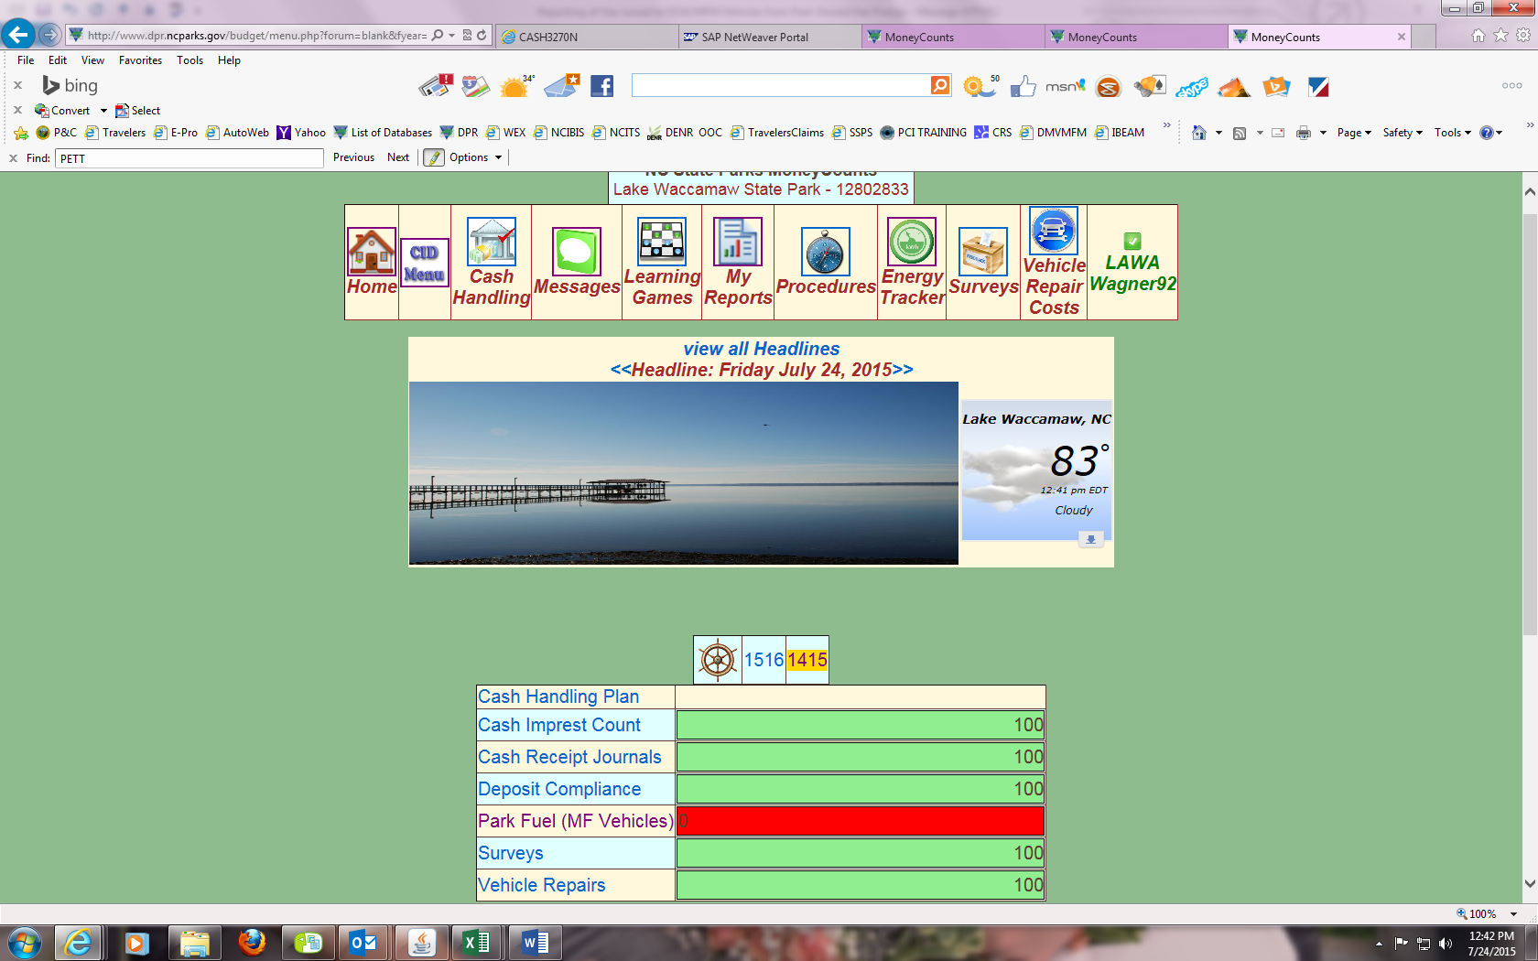

1. Log into the Money Counts Database, go down to the Wheelhouse and click on the “FY1415” link (next month for July report you will already be on the FY1516 link)
2. Click on “Park Fuel (MF Vehicles) link

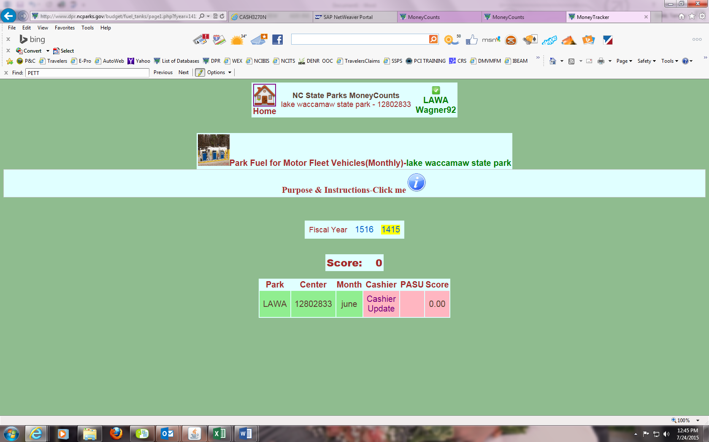

1. Click on “Cashier Update” for the month you are reporting

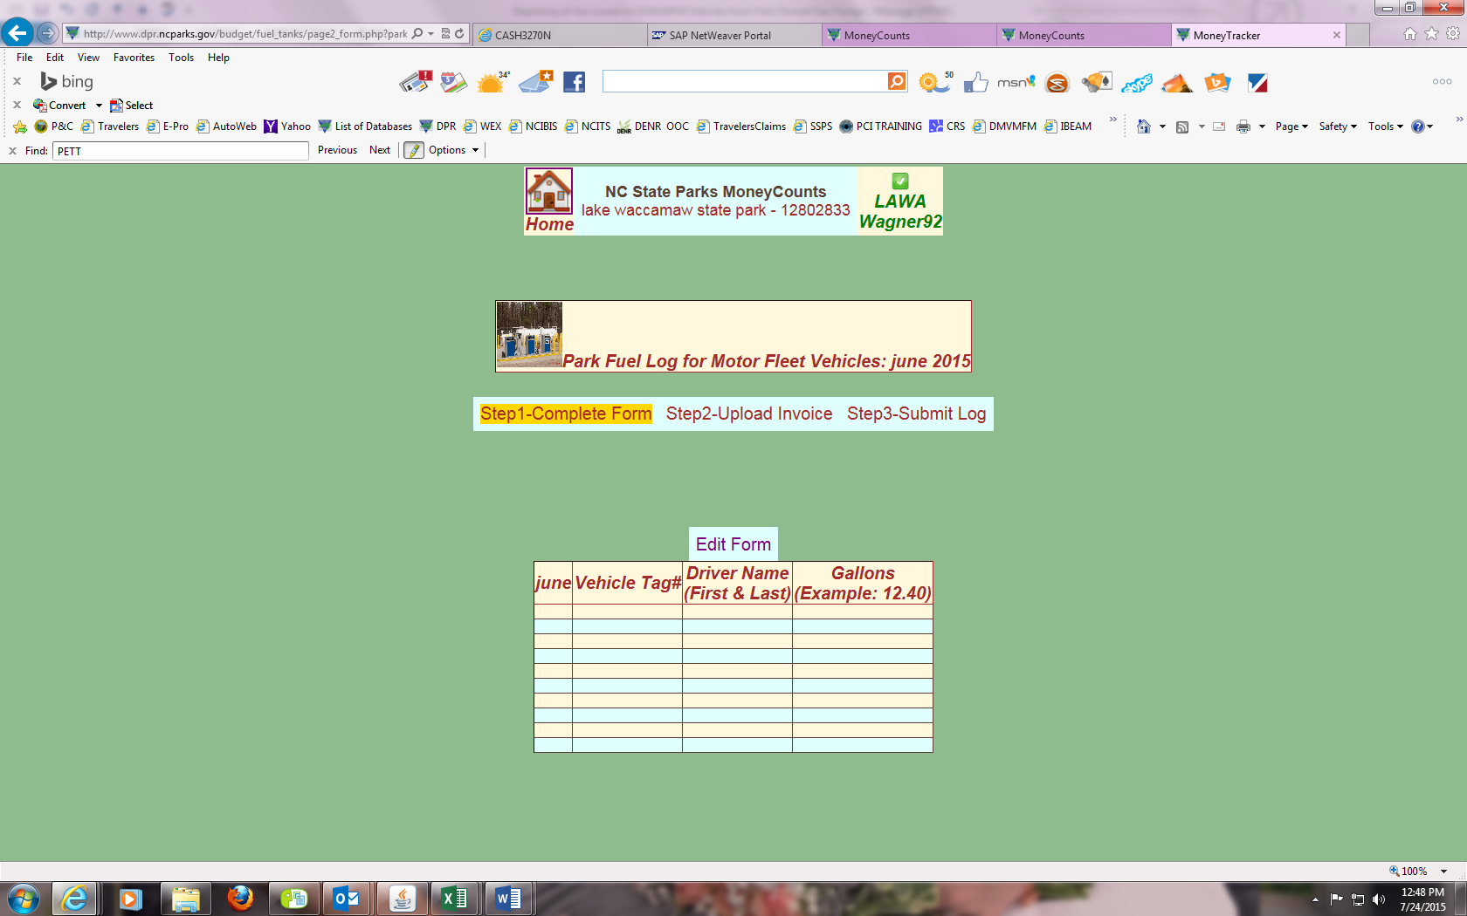

1. Click on the “Edit Form”

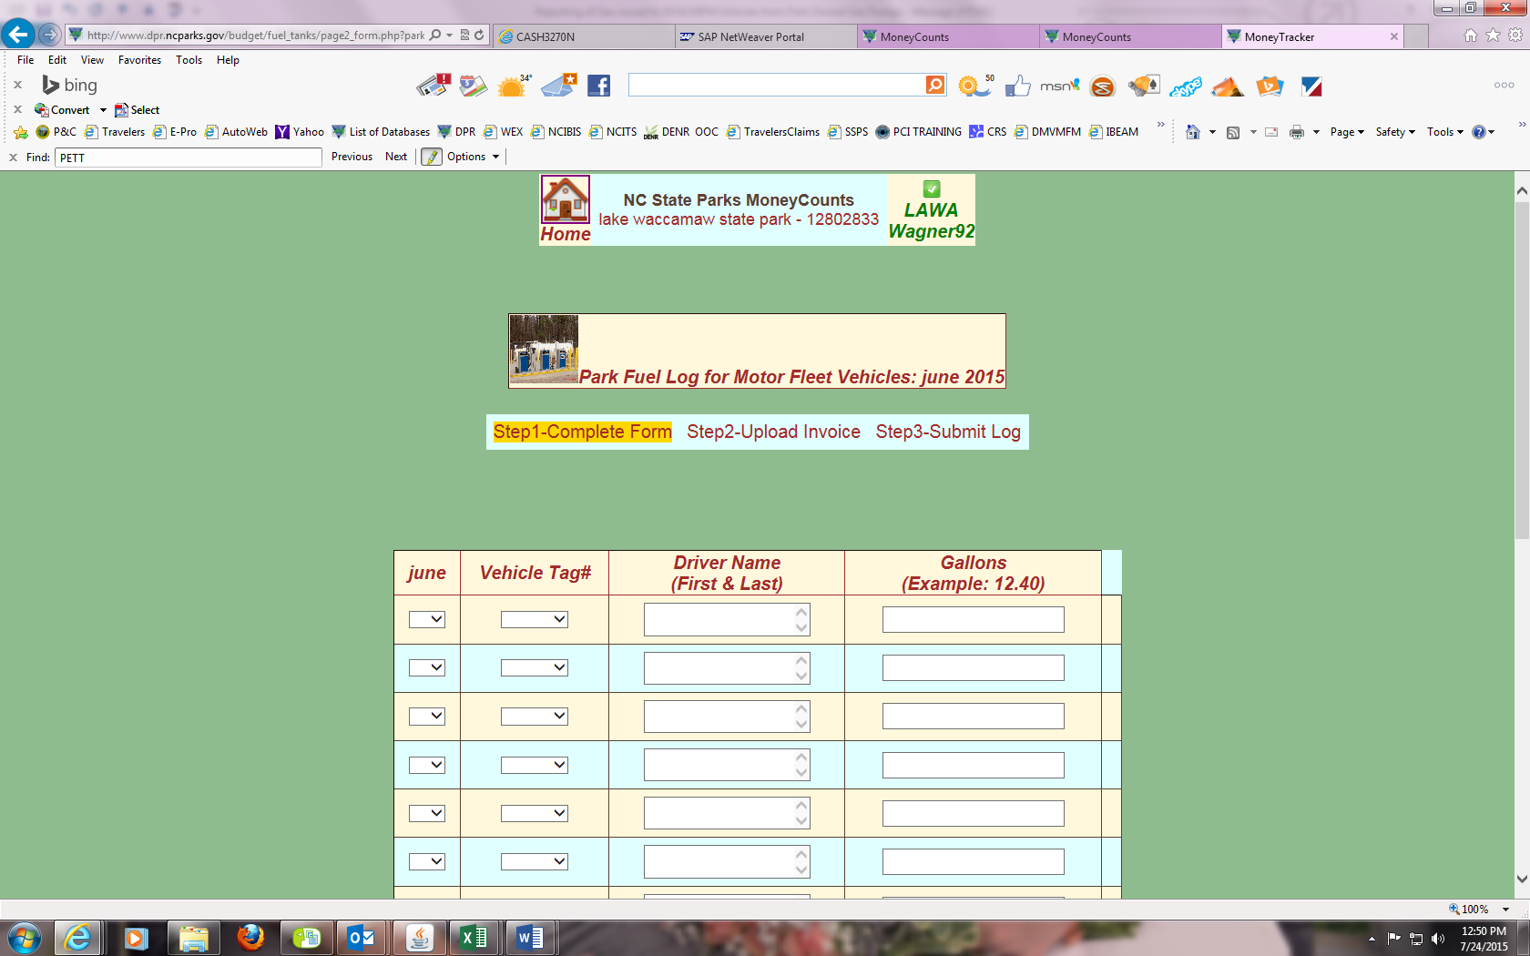

1. Under the Month, click the drop down button to choose the day gas was put in vehicle (must enter every day gas was put into vehicle, no summarizing)
2. Under “Vehicle Tag”, click drop down button to find plate number (all plates of all DPR DOA/MFM vehicles are in the drop down menu)
3. Under “Driver Name”, type in name of driver
4. Under “Gallons” type in gallons pumped
5. Once all entries are done, scroll down to bottom of form and click “Update” (see below for how it looks before you hit update)

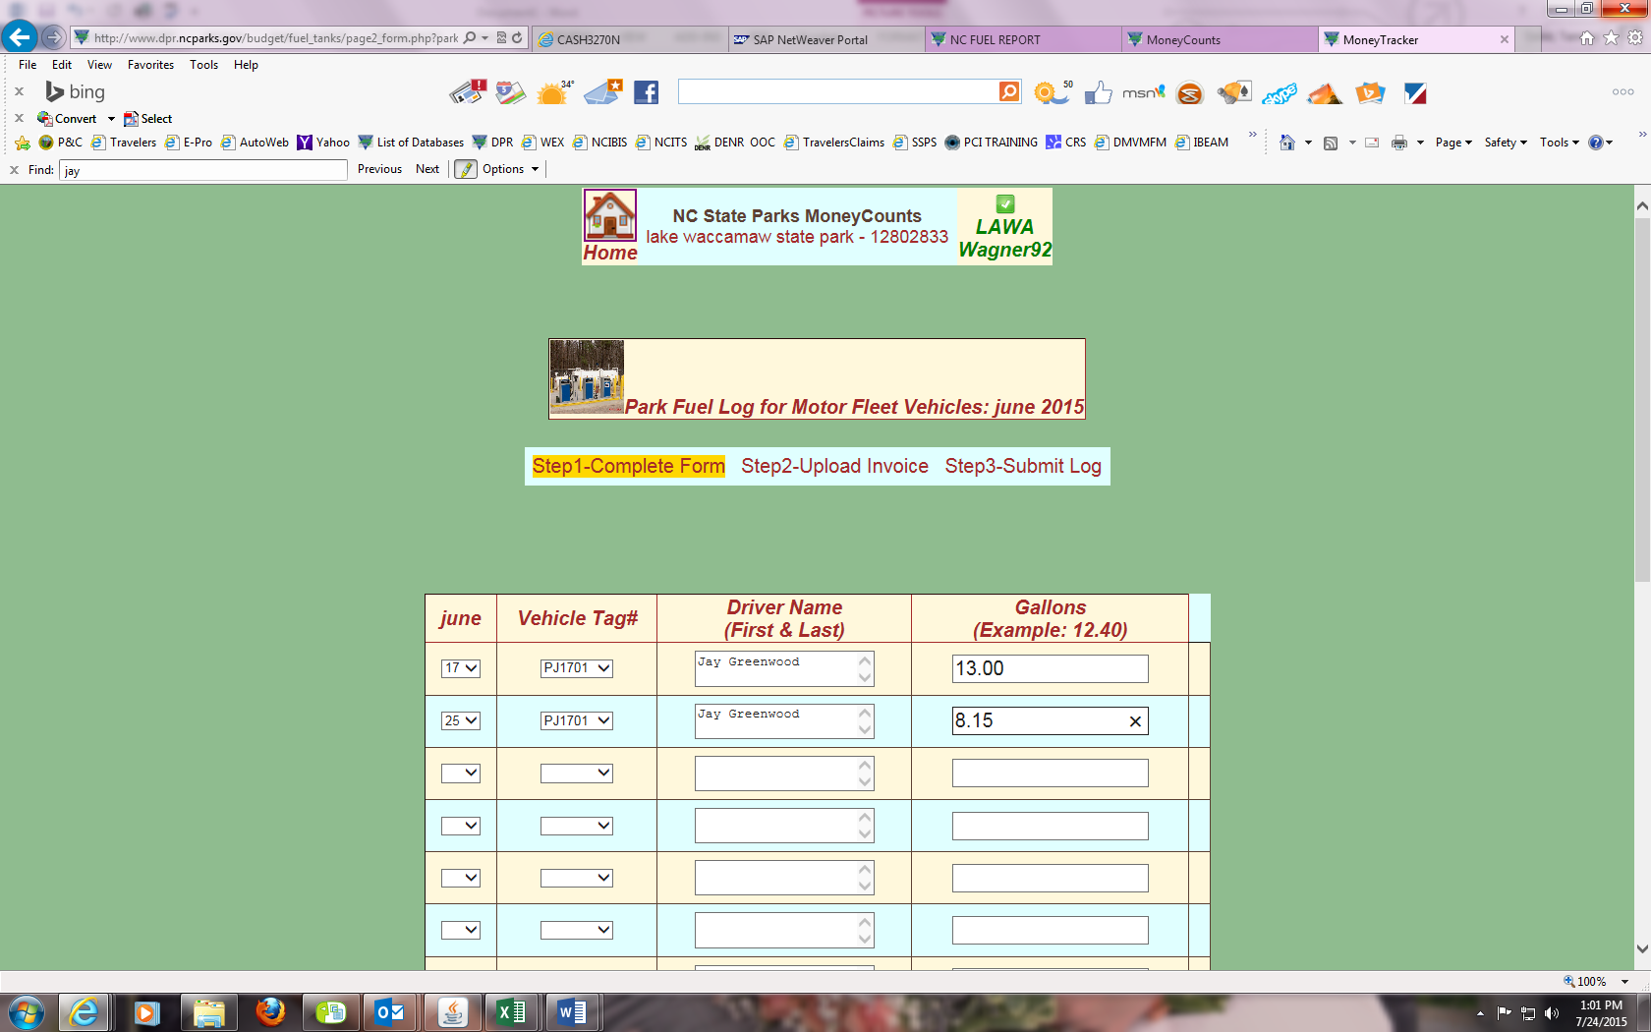

Special Note: If you have no gas to report, choose the last work day of the month, leave plate blank, in driver field type “None to Report”, in gallons type “00.00”

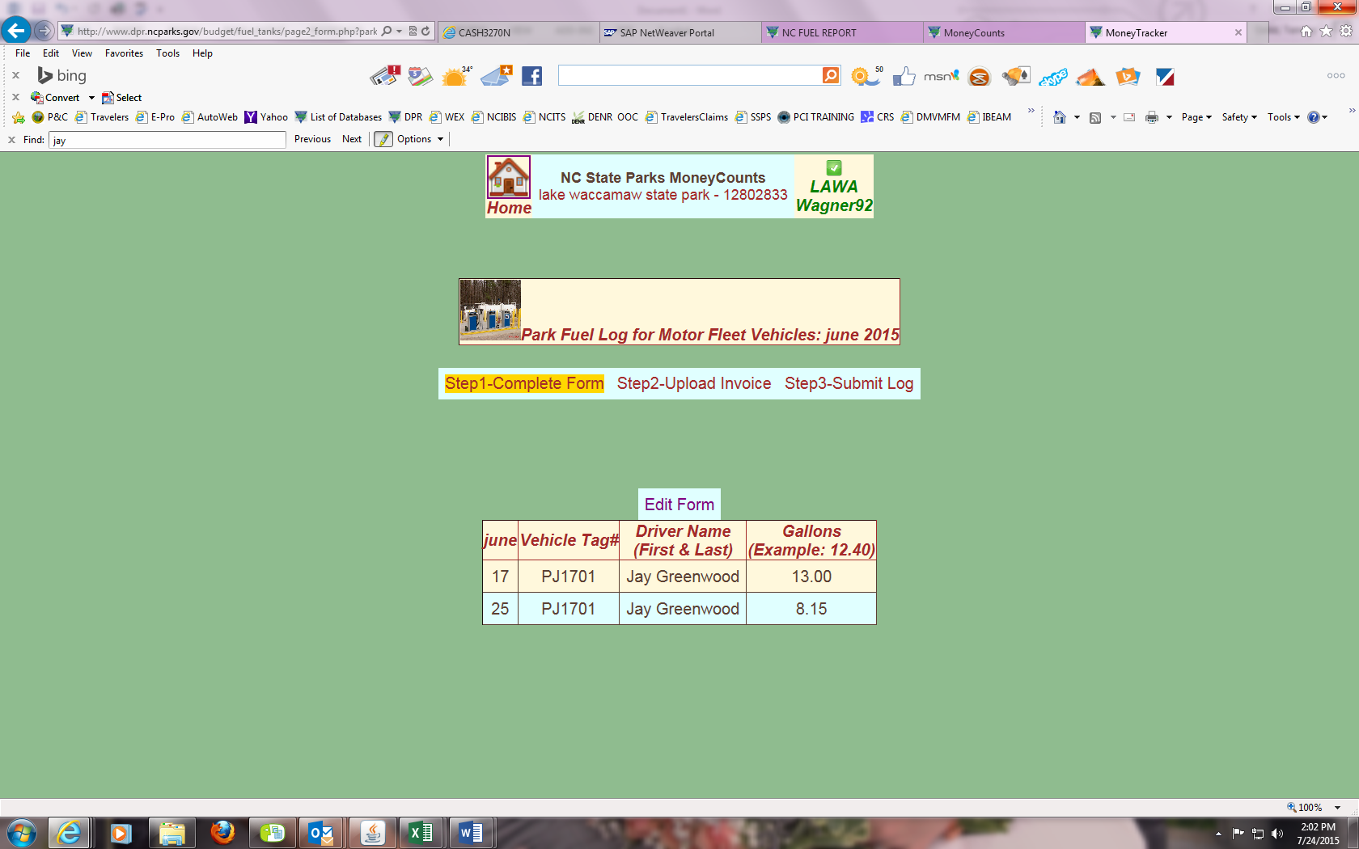

1. After you hit “update”, you are taken back to the main screen and Step 1 of this process is complete (if you need to make corrections, click the edit button and follow steps 5 to 9)
2. Click the link “Step2-Upload Invoice” if you have no edits to make to your form

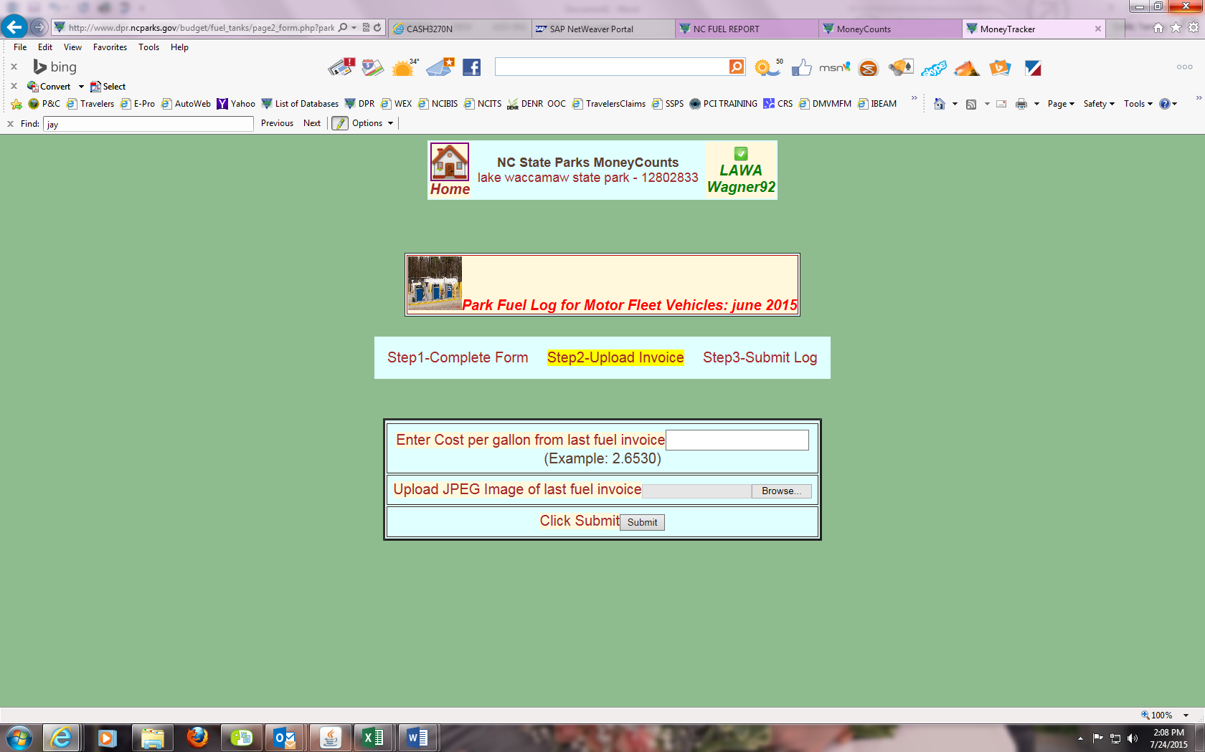

1. Enter the cost per gallon from your last fuel purchase invoice and upload a JPEG image of same invoice and click submit.

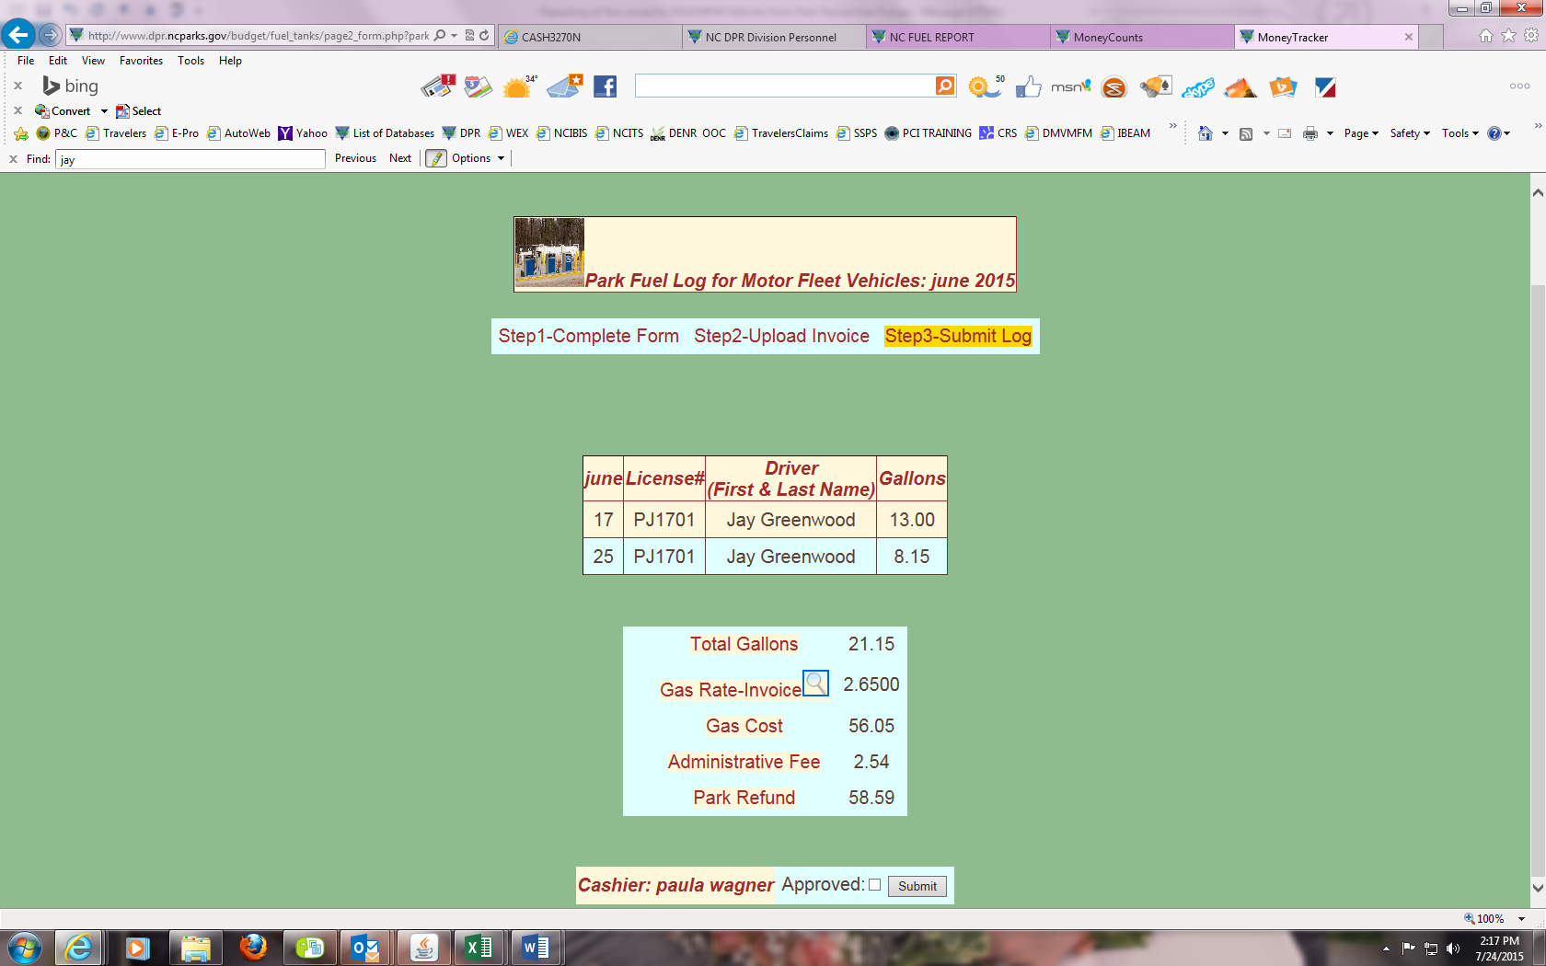

1. Double check your work and if you need to make changes to the cost per gallon, click on the magnifying glass beside “Gas Rate-Invoice” and then follow step 12
2. If no changes, scroll down and click “Approve” and then click “Submit”

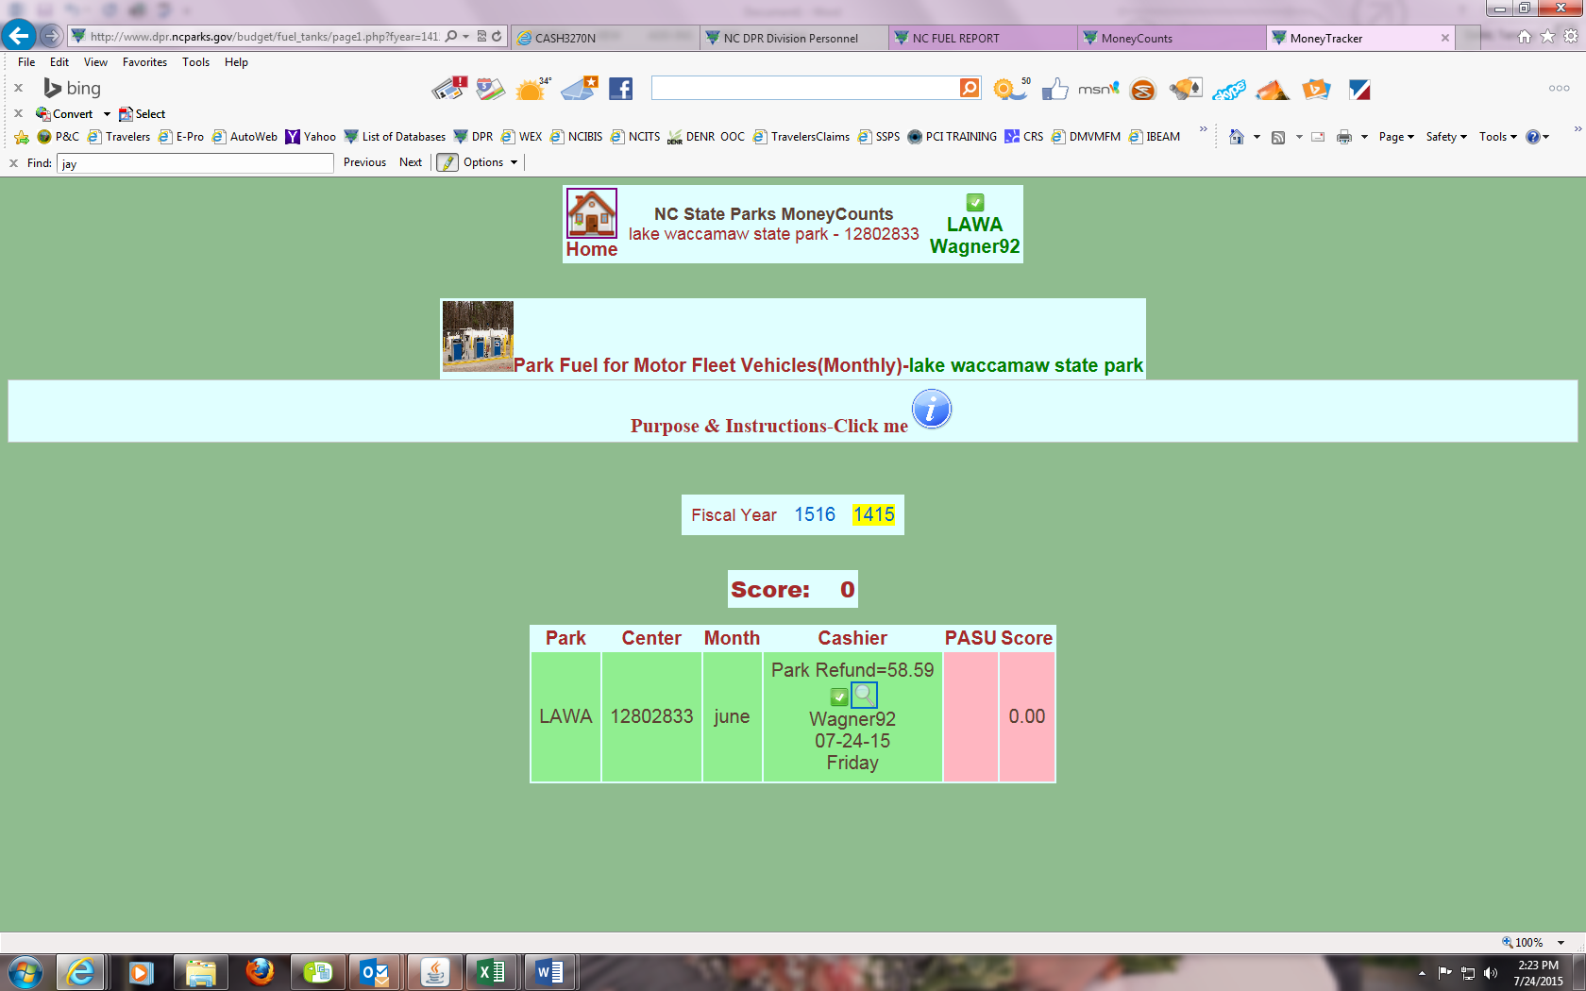

1. Cashier duties are done

Process for Managers to approve the Report (any manager listed in the cash handling plan can approve the report):

1. Log into the Money Counts Database, go down to the Wheelhouse and click on the “FY1415” link (next month for July report you will already be on the FY1516 link)
2. Click on “Park Fuel (MF Vehicles) link
3. Click on “PASU Update”

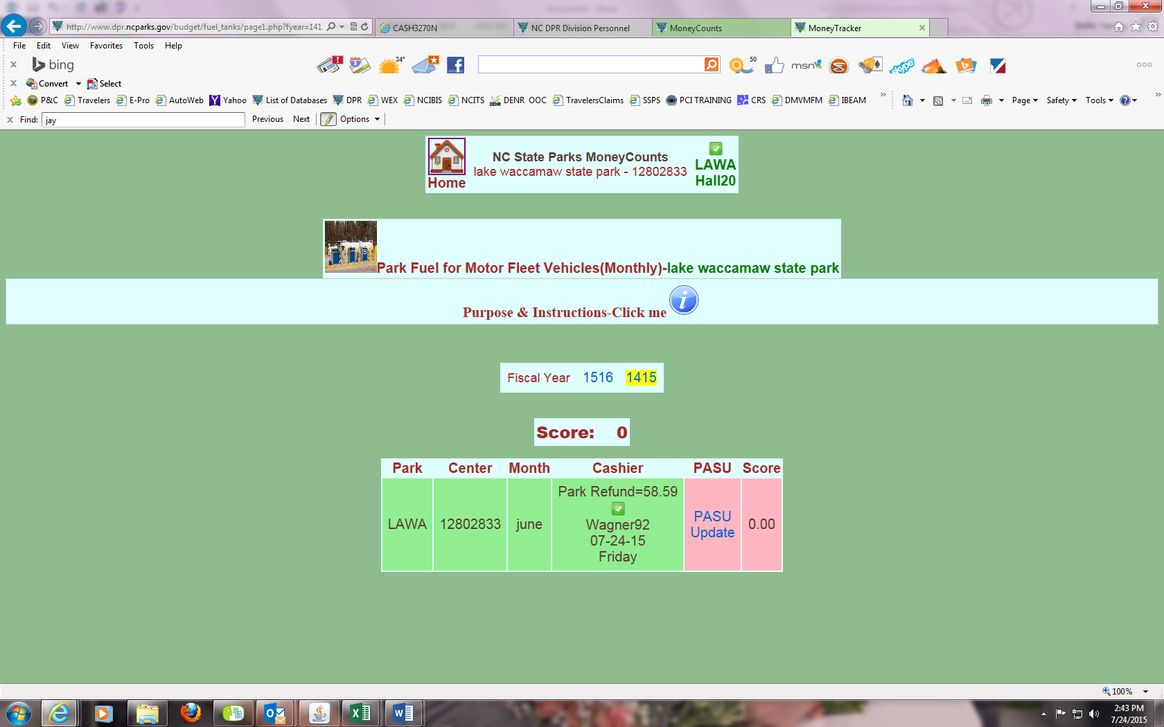

1. Click “Approve” and then click “Submit”
2. Manager duties are done

