**Find Your Closest Corvel In-Network Urgent Care Facility**

1. **Go to Corvel’s website:** [**https://www.caremc.com**](https://www.caremc.com)
2. **Select PPO Lookup (No Log In Necessary)**

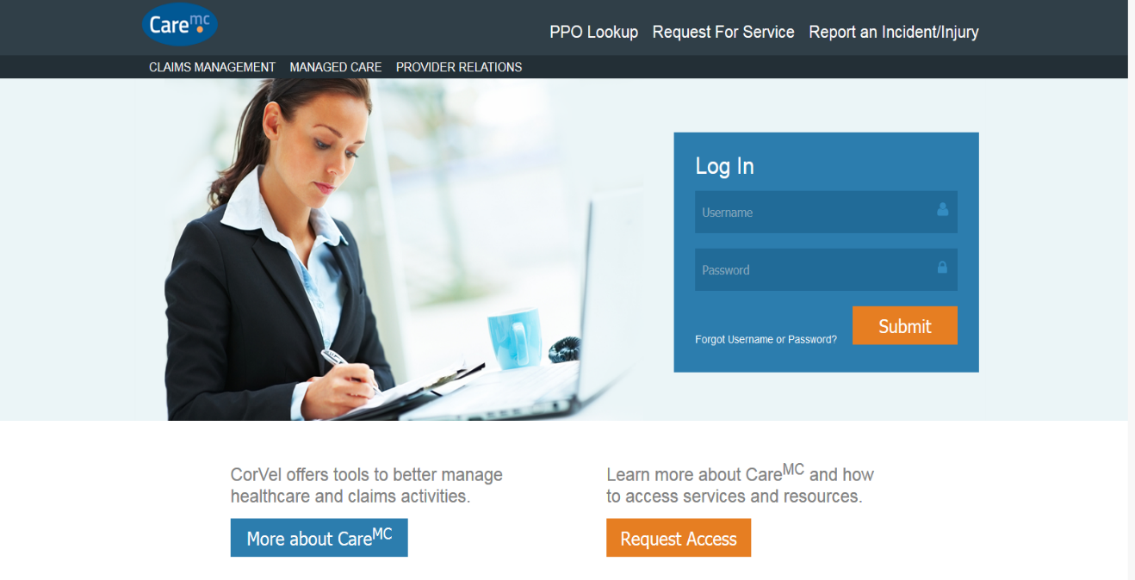

1. **Go To ‘Find a Provider’ and select ‘Search’**

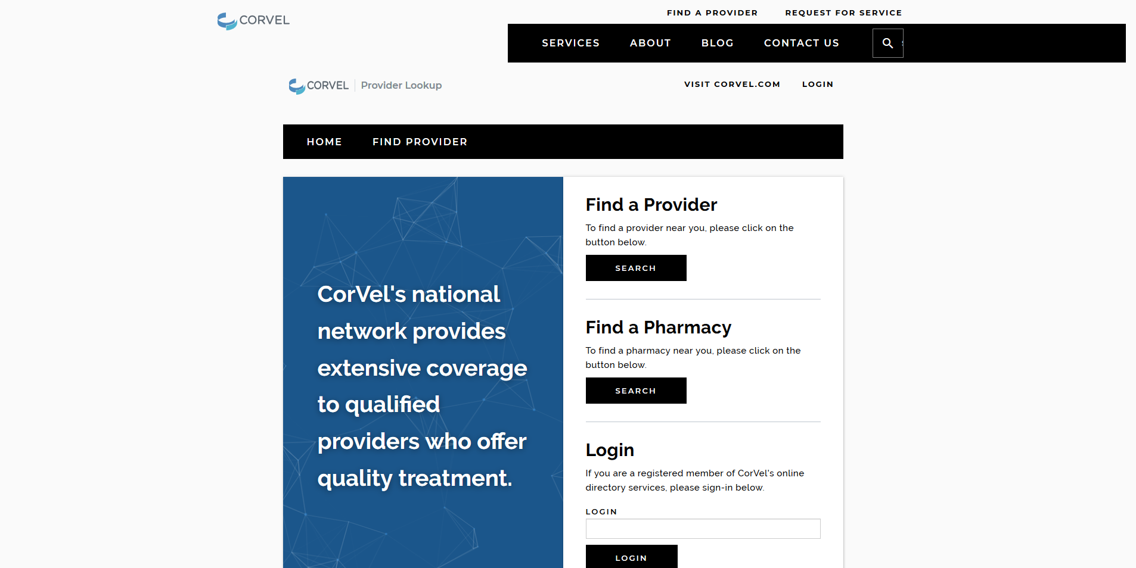

1. **Enter the criteria for finding a provider near you.**

**4a. Network = Workers’ Compensation**

**4b. Search Type = Radius**

**4c. Starting Location = Your Park Name or City, State**

**4d. Distance = Adjust this accordingly; urban areas use shorter distance, rural areas use greater distance**

**4e. Provider = Leave as is (Physician, Facility, Both)**

**4f. Select the right arrow in the Optional Search Fields Box**

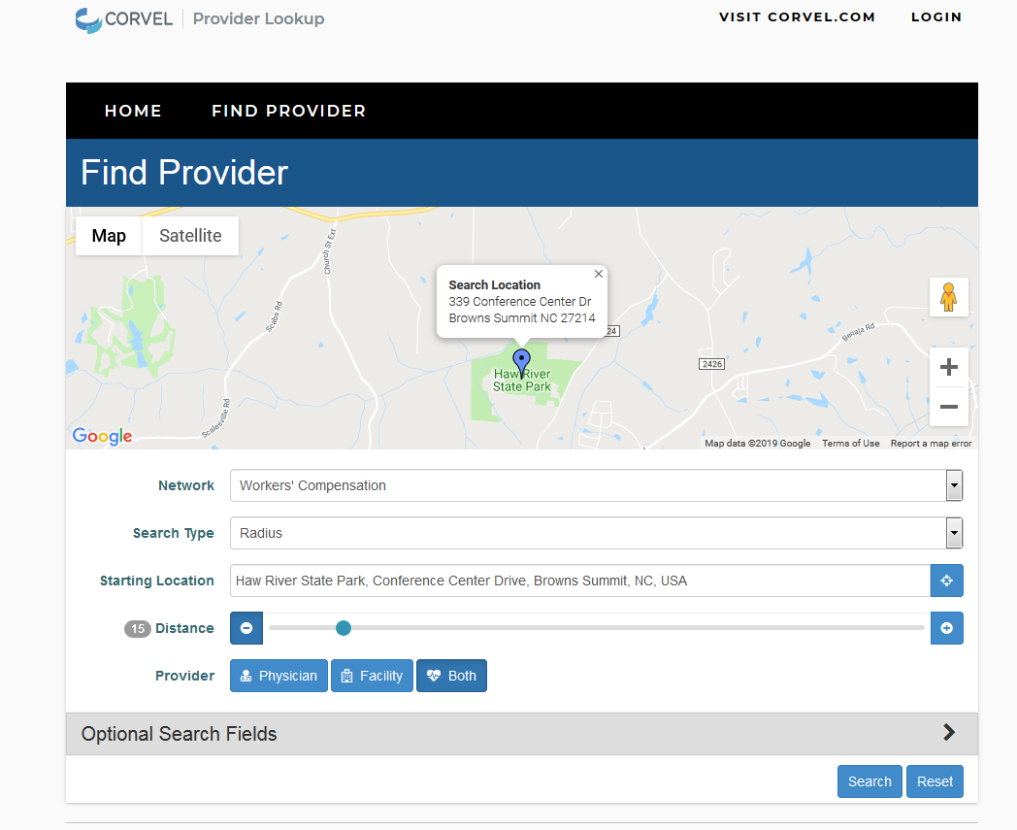

1. **Optional Search Fields**

**5a. Name: Leave Blank**

**5b. Tax ID: Leave Blank**

**5c. Specialty: Scroll down and check the box for Minor Emergency/Urgent Care Center**

**5d. Services: Leave Blank**

**5d. Select ‘Search’**

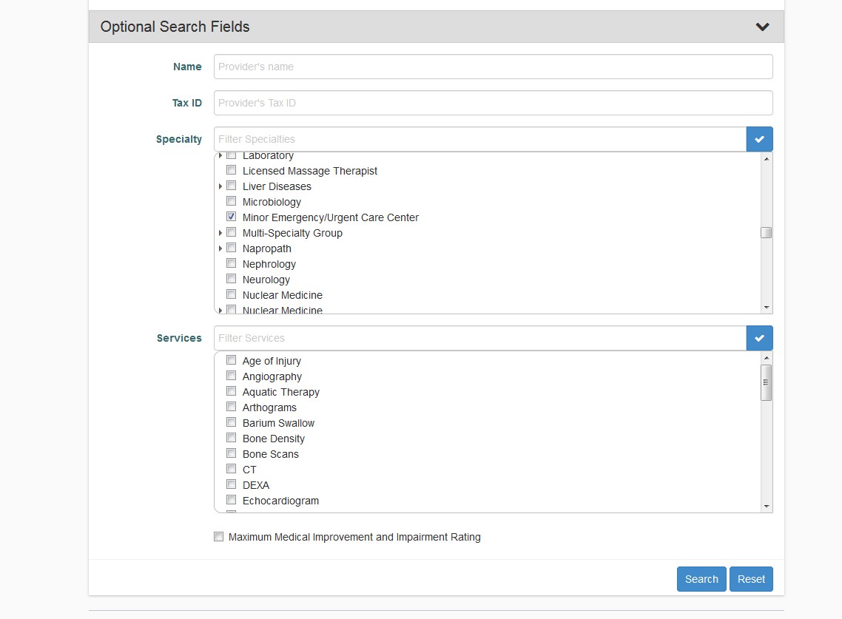

1. **Search Results**

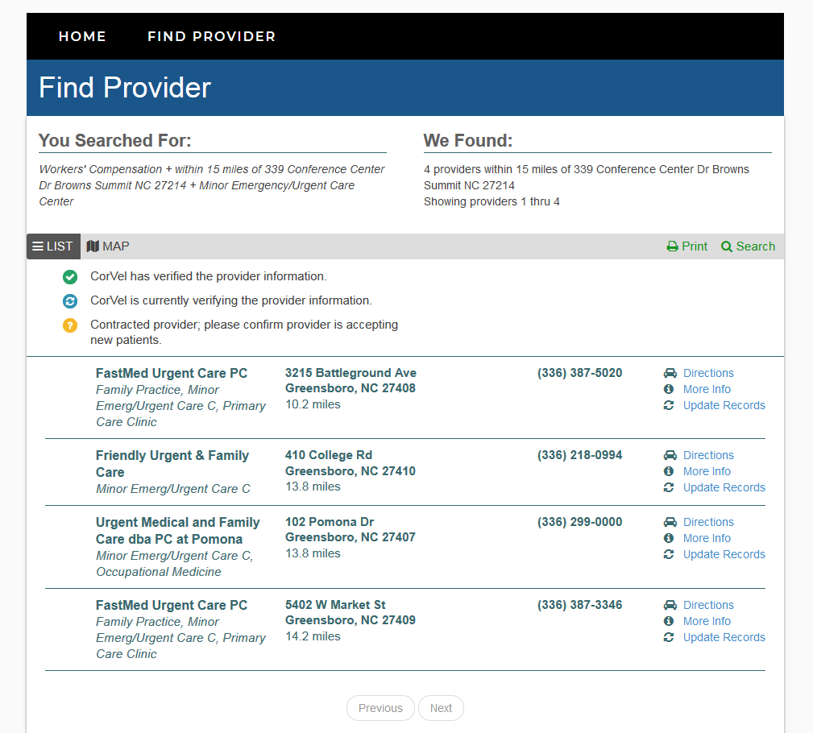

Note 1: If you get too many providers reduce your radius and if you get too few providers increase your radius.

Note 2: Always take the [Corvel Workers’ Comp Authorization Form](https://auth.dpr.ncparks.gov/find/graphics/2019/CorvelMedAuthRTWForm2011.pdf) with you.

