APPENDIX A

Article 1A.
Special Peace Officers.

§ 113-28.1. Designated employees commissioned special peace officers by Governor.
Upon application by either the Secretary of Natural and Cultural Resources or the Secretary of Environmental Quality, the Governor is hereby authorized and empowered to commission as special peace officers such of the employees of the Departments as the Secretary may designate for the purpose of enforcing the laws and rules enacted or adopted for the protection, preservation and government of State parks, lakes, reservations and other lands or waters under the control or supervision of the respective Departments. (1947, c. 577; 1973, c. 1262, s. 86; 1977, c. 771, s. 4; 1987, c. 783, s. 5; 1989, c. 727, s. 46; 1997-443, s. 11A.119(a); 2015-241, s. 14.30(oo).)

§ 113-28.2. Powers of arrest.
Any employee of either the Department of Natural and Cultural Resources or the Department of Environmental Quality commissioned as a special peace officer shall have the right to arrest with warrant any person violating any law or rule on or relating to the State parks, lakes, reservations and other lands or waters under the control or supervision of the employee's respective Department, and shall have the power to pursue and arrest without warrant any person violating in his presence any law or rule on or relating to said parks, lakes, reservations and other lands or waters under the control or supervision of the employee's respective Department. (1947, c. 577; 1973, c. 1262, s. 86; 1977, c. 771, s. 4; 1989, c. 727, s. 47; 1997-443, s. 11A.119(a); 2015-241, s. 14.30(pp).)

§ 113-28.2A. Cooperation between law enforcement agencies.
Special peace officers employed by either the Department of Natural and Cultural Resources or the Department of Environmental Quality are officers of a "law enforcement agency" for purposes of G.S. 160A-288, and each Department shall have the same authority as a city or county governing body to approve cooperation between law enforcement agencies under that section. (2002-111, s. 1; 2015-241, s. 14.30(qq).)

§ 113-28.3: Repealed by Session Laws 1989, c. 485, s. 1.

§ 113-28.4. Oaths required.
Before any employee of either the Department of Natural and Cultural Resources or the Department of Environmental Quality commissioned as a special peace officer shall exercise any power of arrest under this Article, the employee shall take the oaths required of public officers before an officer authorized to administer oaths. (1947, c. 577; 1973, c. 1262, s. 86; 1977, c. 771, s. 4; 1989, c. 727, s. 218(48); 1997-443, s. 11A.119(a); 2015-241, s. 14.30(rr).)

Referenced from website https://www.ncleg.gov/EnactedLegislation/Statutes/PDF/ByArticle/Chapter_113/Article_1A.pdf
12/18/2020

APPENDIX B

§ 17C-2. Definitions.
Unless the context clearly otherwise requires, the following definitions apply in this Article:
(1) Commission. – The North Carolina Criminal Justice Education and Training
Standards Commission.
(2) Criminal justice agencies. – The State and local law-enforcement agencies,
the State correctional agencies, other correctional agencies maintained by
local governments, and the juvenile justice agencies, but shall not include
deputy sheriffs, special deputy sheriffs, sheriffs' jailers, or other sheriffs'
department personnel governed by the provisions of Chapter 17E of these
General Statutes.
(3) Criminal justice officers. – The administrative and subordinate personnel of
all the departments, agencies, units or entities comprising the criminal justice
agencies who are sworn law-enforcement officers, both State and local, with
the power of arrest; State correctional officers; State probation/parole officers;
State probation/parole officers-surveillance; officers, supervisory and
administrative personnel of local confinement facilities; State juvenile justice
officers; chief court counselors; and juvenile court counselors.
(4) Entry level. – The initial appointment or employment of any person by a
criminal justice agency, or any appointment or employment of a person
previously employed by a criminal justice agency who has not been employed
by a criminal justice agency for the 12-month period preceding this
appointment or employment, or any appointment or employment of a
previously certified criminal justice officer to a position which requires a
different type of certification. (1971, c. 963, s. 2; 1979, c. 763, s. 1; 1983, c.
558, s. 2; c. 745, s. 2; 1989, c. 757, s. 1; 1989 (Reg. Sess., 1990), c. 1024, s.
4(a); 1997-503, s. 2; 2001-490, s. 1.1; 2018-5, s. 17.1(a).)

Referenced from website https://www.ncleg.gov/EnactedLegislation/Statutes/PDF/BySection/Chapter_17C/GS_17C-2.pdf
12/18/2020

APPENDIX C

§ 15A-405. Assistance to law-enforcement officers by private persons to effect arrest or
prevent escape; benefits for private persons.

- Assistance upon Request; Authority. – Private persons may assist law-enforcement
officers in effecting arrests and preventing escapes from custody when requested to do so by the
officer. When so requested, a private person has the same authority to effect an arrest or prevent
escape from custody as the officer making the request. He does not incur civil or criminal liability
for an invalid arrest unless he knows the arrest to be invalid. Nothing in this subsection constitutes justification for willful, malicious or criminally negligent conduct by such person which injures
or endangers any person or property, nor shall it be construed to excuse or justify the use of
unreasonable or excessive force.

(b) Benefits to Private Persons. – A private person assisting a law-enforcement officer
pursuant to subsection (a) is:
(1) Repealed by Session Laws 1989, c. 290, s. 1.
(2) Entitled to the same benefits as a "law-enforcement officer" as that term is
defined in G.S. 143-166.2, the Public Safety Employees' Death Benefit Act;
and
(3) To be treated as an employee of the employer of the law-enforcement officer
within the meaning of G.S. 97-2(2) (Workers' Compensation Act)
.
The Governor and the Council of State are authorized to allocate funds from the Contingency
and Emergency Fund for the payment of benefits under subdivision (3) when no other source is
available for the payment of such benefits and when they determine that such allocation is
necessary and appropriate. (1868-9, c. 178, subch. 1, s. 2; Code, s. 1125; Rev., s. 3181; C.S., s.
4547; 1973, c. 1286, s. 1; 1979, c. 714, s. 2; 1989, c. 290, s. 1; 2018-5, s. 35.29(b).)

Referenced from website https://www.ncleg.gov/EnactedLegislation/Statutes/PDF/BySection/Chapter_15A/GS_15A-405.pdf
12/18/2020
APPENDIX D

§ 15A-404. Detention of offenders by private persons.
(a) No Arrest; Detention Permitted. - No private person may arrest another person except as provided in G.S. 15A-405. A private person may detain another person as provided in this section.
(b) When Detention Permitted. - A private person may detain another person when he has probable cause to believe that the person detained has committed in his presence:
(1) A felony,
(2) A breach of the peace,
(3) A crime involving physical injury to another person, or
(4) A crime involving theft or destruction of property.
(c) Manner of Detention. - The detention must be in a reasonable manner considering the offense involved and the circumstances of the detention.
(d) Period of Detention. - The detention may be no longer than the time required for the earliest of the following:
(1) The determination that no offense has been committed.
(2) Surrender of the person detained to a law-enforcement officer as provided in subsection (e).
(e) Surrender to Officer. - A private person who detains another must immediately notify a law-enforcement officer and must, unless he releases the person earlier as required by subsection (d), surrender the person detained to the law-enforcement officer. (1973, c. 1286, s. 1.)

Referenced from website https://www.ncleg.gov/EnactedLegislation/Statutes/HTML/BySection/Chapter_15a/GS_15a-404.html
12/18/2020

APPENDIX E

§ 15A-401. Arrest by law-enforcement officer.

(a) Arrest by Officer Pursuant to a Warrant. –
(1) Warrant in Possession of Officer. – An officer having a warrant for arrest in
his possession may arrest the person named or described therein at any time
and at any place within the officer's territorial jurisdiction.
(2) Warrant Not in Possession of Officer. – An officer who has knowledge that a
warrant for arrest has been issued and has not been executed, but who does
not have the warrant in his possession, may arrest the person named therein
at any time. The officer must inform the person arrested that the warrant has
been issued and serve the warrant upon him as soon as possible. This
subdivision applies even though the arrest process has been returned to the
clerk under G.S. 15A-301.

Referenced from website https://www.ncleg.gov/EnactedLegislation/Statutes/PDF/BySection/Chapter_15A/GS_15A-401.pdf
12/18/2020
APPENDIX F

§ 15A-402 Territorial jurisdiction of officers to make arrests.

- Territorial Jurisdiction of State Officers. — Law enforcement officers of the State of North Carolina may arrest persons at any place within the State.

Referenced from website https://www.ncleg.gov/EnactedLegislation/Statutes/PDF/BySection/Chapter_15A/GS_15A-402.pdf
12/18/2020

APPENDIX G

§ 15A-401 Arrest by law enforcement officer.

(b) Arrest by Officer Without a Warrant. –
(1) Offense in Presence of Officer. – An officer may arrest without a warrant
any person who the officer has probable cause to believe has committed a
criminal offense, or has violated a pretrial release order entered under G.S.
15A-534 or G.S. 15A-534.1(a)(2), in the officer's presence.
(2) Offense Out of Presence of Officer. – An officer may arrest without a
warrant any person who the officer has probable cause to believe:
a. Has committed a felony; or
b. Has committed a misdemeanor, and:
1. Will not be apprehended unless immediately arrested, or
2. May cause physical injury to himself or others, or damage to
property unless immediately arrested; or
c. Has committed a misdemeanor under G.S. 14-72.1, 14-134.3,20-138.1, or 20-138.2; or
d. Has committed a misdemeanor under G.S. 14-33(a), 14-33(c)(1),
14-33(c)(2), or 14-34 when the offense was committed by a person
with whom the alleged victim has a personal relationship as defined in G.S. 50B-1; or
e. Has committed a misdemeanor under G.S. 50B-4.1(a); or
f. Has violated a pretrial release order entered under G.S. 15A-534 or
G.S. 15A-534.1(a)(2).
(3) Repealed by Session Laws 1991, c. 150.
(4) A law enforcement officer may detain an individual arrested for violation of
an order limiting freedom of movement or access issued pursuant to G.S.
130A-475 or G.S. 130A-145 in the area designated by the State Health
Director or local health director pursuant to such order. The person may be
detained in such area until the initial appearance before a judicial official
pursuant to G.S. 15A-511 and G.S. 15A-534.5.

Referenced from website
https://www.ncleg.gov/EnactedLegislation/Statutes/PDF/BySection/Chapter_15A/GS_15A-401.pdf
12/18/2020

APPENDIX H

§ 14-269. Carrying concealed weapons.
(a) It shall be unlawful for any person willfully and intentionally to carry concealed about his or her person any bowie knife, dirk, dagger, slung shot, loaded cane, metallic knuckles, razor, shuriken, stun gun, or other deadly weapon of like kind, except when the person is on the person's own premises.
(a1) It shall be unlawful for any person willfully and intentionally to carry concealed about his or her person any pistol or gun except in the following circumstances:
(1) The person is on the person's own premises.
(2) The deadly weapon is a handgun, the person has a concealed handgun permit issued in accordance with Article 54B of this Chapter or considered valid under G.S. 14-415.24, and the person is carrying the concealed handgun in accordance with the scope of the concealed handgun permit as set out in G.S. 14-415.11(c).
(3) The deadly weapon is a handgun and the person is a military permittee as defined under G.S. 14-415.10(2a) who provides to the law enforcement officer proof of deployment as required under G.S. 14-415.11(a).
(a2) This prohibition does not apply to a person who has a concealed handgun permit issued in accordance with Article 54B of this Chapter, has a concealed handgun permit considered valid under G.S. 14-415.24, or is exempt from obtaining a permit pursuant to G.S. 14-415.25, provided the weapon is a handgun, is in a closed compartment or container within the person's locked vehicle, and the vehicle is in a parking area that is owned or leased by State government. A person may unlock the vehicle to enter or exit the vehicle, provided the handgun remains in the closed compartment at all times and the vehicle is locked immediately following the entrance or exit.
(b) This prohibition shall not apply to the following persons:
(1) Officers and enlisted personnel of the Armed Forces of the United States when in discharge of their official duties as such and acting under orders requiring them to carry arms and weapons;
(2) Civil and law enforcement officers of the United States;
(3) Officers and soldiers of the militia and the National Guard when called into actual service;
(3a) A member of the North Carolina National Guard who has been designated in writing by the Adjutant General, State of North Carolina, who has a concealed handgun permit issued in accordance with Article 54B of this Chapter or considered valid under G.S. 14-415.24, and is acting in the discharge of his or her official duties, provided that the member does not carry a concealed weapon while consuming alcohol or an unlawful controlled substance or while alcohol or an unlawful controlled substance remains in the member's body.
(4) Officers of the State, or of any county, city, town, or company police agency charged with the execution of the laws of the State, when acting in the discharge of their official duties;
(4a) Any person who is a district attorney, an assistant district attorney, or an investigator employed by the office of a district attorney and who has a concealed handgun permit issued in accordance with Article 54B of this Chapter or considered valid under G.S. 14-415.24; provided that the person shall not carry a concealed weapon at any time while in a courtroom or while consuming alcohol or an unlawful controlled substance or while alcohol or an unlawful controlled substance remains in the person's body. The district attorney, assistant district attorney, or investigator shall secure the weapon in a locked compartment when the weapon is not on the person of the district attorney, assistant district attorney, or investigator. Notwithstanding the provisions of this subsection, a district attorney may carry a concealed weapon while in a courtroom;
(4b) Any person who is a qualified retired law enforcement officer as defined in G.S. 14-415.10 and meets any one of the following conditions:
a. Is the holder of a concealed handgun permit in accordance with Article 54B of this Chapter.
b. Is exempt from obtaining a permit pursuant to G.S. 14-415.25.
c. Is certified by the North Carolina Criminal Justice Education and Training Standards Commission pursuant to G.S. 14-415.26;
(4c) Detention personnel or correctional officers employed by the State or a unit of local government who park a vehicle in a space that is authorized for their use in the course of their duties may transport a firearm to the parking space and store that firearm in the vehicle parked in the parking space, provided that: (i) the firearm is in a closed compartment or container within the locked vehicle, or (ii) the firearm is in a locked container securely affixed to the vehicle;
(4d) Any person who is a North Carolina district court judge, North Carolina superior court judge, or a North Carolina magistrate and who has a concealed handgun permit issued in accordance with Article 54B of this Chapter or considered valid under G.S. 14-415.24; provided that the person shall not carry a concealed weapon at any time while consuming alcohol or an unlawful controlled substance or while alcohol or an unlawful controlled substance remains in the person's body. The judge or magistrate shall secure the weapon in a locked compartment when the weapon is not on the person of the judge or magistrate;
(4e) Any person who is serving as a clerk of court or as a register of deeds and who has a concealed handgun permit issued in accordance with Article 54B of this Chapter or considered valid under G.S. 14-415.24; provided that the person shall not carry a concealed weapon at any time while consuming alcohol or an unlawful controlled substance or while alcohol or an unlawful controlled substance remains in the person's body. The clerk of court or register of deeds shall secure the weapon in a locked compartment when the weapon is not on the person of the clerk of court or register of deeds. This subdivision does not apply to assistants, deputies, or other employees of the clerk of court or register of deeds;
(5) Sworn law-enforcement officers, when off-duty, provided that an officer does not carry a concealed weapon while consuming alcohol or an unlawful controlled substance or while alcohol or an unlawful controlled substance remains in the officer's body;
(6) State probation or parole certified officers, when off-duty, provided that an officer does not carry a concealed weapon while consuming alcohol or an unlawful controlled substance or while alcohol or an unlawful controlled substance remains in the officer's body.
(7) A person employed by the Department of Public Safety who has been designated in writing by the Secretary of the Department, who has a concealed handgun permit issued in accordance with Article 54B of this Chapter or considered valid under G.S. 14-415.24, and has in the person's possession written proof of the designation by the Secretary of the Department, provided that the person shall not carry a concealed weapon at any time while consuming alcohol or an unlawful controlled substance or while alcohol or an unlawful controlled substance remains in the person's body.
(8) Any person who is an administrative law judge described in Article 60 of Chapter 7A of the General Statutes and who has a concealed handgun permit issued in accordance with Article 54B of this Chapter or considered valid under G.S. 14-415.24, provided that the person shall not carry a concealed weapon at any time while consuming alcohol or an unlawful controlled substance or while alcohol or an unlawful controlled substance remains in the person's body.
(9) State correctional officers, when off-duty, provided that an officer does not carry a concealed weapon while consuming alcohol or an unlawful controlled substance or while alcohol or an unlawful controlled substance remains in the officer's body. If the concealed weapon is a handgun, the correctional officer must meet the firearms training standards of the Division of Adult Correction and Juvenile Justice of the Department of Public Safety.
(b1) It is a defense to a prosecution under this section that:
(1) The weapon was not a firearm;
(2) The defendant was engaged in, or on the way to or from, an activity in which the defendant legitimately used the weapon;
(3) The defendant possessed the weapon for that legitimate use; and
(4) The defendant did not use or attempt to use the weapon for an illegal purpose.
The burden of proving this defense is on the defendant.
(b2) It is a defense to a prosecution under this section that:
(1) The deadly weapon is a handgun;
(2) The defendant is a military permittee as defined under G.S. 14-415.10(2a); and
(3) The defendant provides to the court proof of deployment as defined under G.S. 14-415.10(3a).
(c) Any person violating the provisions of subsection (a) of this section shall be guilty of a Class 2 misdemeanor. Any person violating the provisions of subsection (a1) of this section shall be guilty of a Class 2 misdemeanor for the first offense and a Class H felony for a second or subsequent offense. A violation of subsection (a1) of this section punishable under G.S. 14-415.21(a) is not punishable under this section.
(d) This section does not apply to an ordinary pocket knife carried in a closed position. As used in this section, "ordinary pocket knife" means a small knife, designed for carrying in a pocket or purse, that has its cutting edge and point entirely enclosed by its handle, and that may not be opened by a throwing, explosive, or spring action. (Code, s. 1005; Rev., s. 3708; 1917, c. 76; 1919, c. 197, s. 8; C.S., s. 4410; 1923, c. 57; Ex. Sess. 1924, c. 30; 1929, cc. 51, 224; 1947, c. 459; 1949, c. 1217; 1959, c. 1073, s. 1; 1965, c. 954, s. 1; 1969, c. 1224, s. 7; 1977, c. 616; 1981, c. 412, s. 4; c. 747, s. 66; 1983, c. 86; 1985, c. 432, ss. 1-3; 1993, c. 539, s. 163; 1994, Ex. Sess., c. 24, s. 14(c); 1995, c. 398, s. 2; 1997-238, s. 1; 2003-199, s. 2; 2005-232, ss. 4, 5; 2005-337, s. 1; 2006-259, s. 5(a); 2009-281, s. 1; 2011-183, s. 127(a); 2011-243, s. 1; 2011-268, s. 3; 2013-369, ss. 1, 21, 25; 2014-119, s. 12(a); 2015-5, s. 1; 2015-195, s. 1(a); 2015-215, s. 2.5; 2015-264, s. 3; 2017-186, s. 2(hh).)

Referenced from website
https://www.ncleg.gov/EnactedLegislation/Statutes/PDF/BySection/Chapter_15A/GS_15A-401.pdf
12/18/2020

APPENDIX I

Operations Policy for the Management and Control of
Injured, Dangerous, and Feral Animals

The presence of feral animals and diseased wildlife within a park can pose a real threat to park visitors and employees, as well as to the park’s natural resources. This policy is issued to provide each park employee with guidance concerning the proper methods for resolving these problems when they develop.

Definitions:

Injured Animal - an animal, either wildlife or domesticated, that is determined to be in poor health due to an infectious disease, the observation of obviously serious injuries or severe mal nourishment.

Feral Animal - a domesticated animal such as dogs, cats, hogs, cows, or horses, that have been abandoned in or near the park or that have otherwise reverted to a wild state. An animal will not be classified as “feral” until there are repeated, documented incidents, similar in nature involving the same animal(s) and ownership cannot be established in the local area.

Dangerous Animal - a wild animal, that poses an obvious threat to park visitors or park employees; or a domestic animal that poses a threat to park visitors, park employees or resident wildlife through its actions, or as a result of its poor health.

All park employees during their normal duties should be aware of any unusual activities involving resident wildlife or domestic animals. If the observed activities indicate to the employee an abnormal situation, these observations should be brought to the attention of the Park Superintendent. If, in the superintendent’s opinion, a report or series of reports indicates that a problem is emerging, he should initiate a preliminary investigation to determine the extent and character of the problem.

1. If it is determined that the problem involves resident wildlife, the Park Superintendent should initially document the investigation and summarize its findings. He will request, through the District Superintendent, the assistance of other division personnel or he may elect to work directly with the local Wildlife Officer. Capture of the animal will be the preferred method of resolution; however, if destruction of the animal is recommended by the Wildlife Officer as the most humane method, the animal’s destruction will be done by the Wildlife Officer or under his/her direct supervision.

2. If the problem involves domestic animals, whether they be feral, injured, dangerous, or a simple case of local animals running free in the park, the Park Superintendent will attempt to identify the animals’ owners by contacting neighboring landowners. Every effort will be made to locate the animals’ owners and allow them to remove their animals. If unsuccessful, he will contact the local animal control officials or humane society for assistance in capturing and removing the animals. If these agencies are unwilling or unable to assist the park staff in removing the animals, the Park Superintendent will attempt to set live traps or otherwise apprehend the animals. If successful, the captured animals will be delivered to the appropriate animal control facility or Humane Society shelter. The capture attempts will be reported on the Case Incident Report, PR-63, which will be used to document the resolution of the problem, or if unsuccessful, used to justify further action.

Capture attempts will not be done in any manner that may place the safety of any park employee in jeopardy. If the animals are too large to be safely trapped, too wild or wary, or appear too dangerous to be caught by hand or with appropriate equipment, the Park Superintendent will request permission from the District Superintendent to destroy the animal(s); part of this request will be the PR-63 documenting all previous attempts to resolve the animal problem. If the District Superintendent concurs with the recommendation, a Plan of Action will be recommended by the Park Superintendent and discussed in detail with the District Superintendent. This plan of action will include coordination with the local animal control agency or Humane Society, if possible.

Wildlife that has been so severely injured that rescue or rehabilitative efforts would be obviously futile and prolong suffering of the animal may be destroyed immediately. Such incidents must be documented on a Case Incident Report.

If any animal, wild or domestic, presents a serious and imminent threat to the safety of an employee or visitor, such dangerous animals may be immediately destroyed, or otherwise rendered harmless. This will be done immediately if the employee at the scene has such means available and can do so without endangering persons or property; the authorization of the District Superintendent is not required in this situation. Likewise, the District Superintendent’s authorization is not required to destroy or render harmless a feral animal that is in the act of chasing or has caught wildlife in the park; this condition applies only to feral animals that have been proven to meet all the criteria for this classification as defined above. A Case Incident Report will document the destruction of any animal and the circumstances which dictated the action. The destruction of wildlife or other animals, when necessary, will be done discreetly and as humanely as possible. It will not be done in the presence of park visitors or park neighbors unless the animal presents an imminent threat to life or limb. If it is known or suspected that a park visitor or neighbor may have witnessed the animal’s death, the Park Superintendent will immediately notify the District Superintendent.

ALL EMPLOYEES ARE REMINDED THAT EXTREME CARE MUST BE EXERCISED TO ASSURE THAT FIREARM PROJECTILES WILL NOT ENDANGER PARK VISITORS OR NEIGHBORS AND WILL IMPACT IN A SAFE AREA WHEN ANIMALS ARE DESTROYED.

APPENDIX J

§ 143-116.8. Motor vehicle laws applicable to State parks and forests road system.
(a) Except as otherwise provided in this section, all the provisions of Chapter 20 of the General Statutes relating to the use of highways and public vehicular areas of the State and the operation of vehicles thereon are made applicable to the State parks and forests road system. For the purposes of this section, the term "State parks and forests road system" shall mean the streets, alleys, roads, public vehicular areas and driveways of the State parks, State forests, State recreation areas, State lakes, and all other lands administered by the Department of Natural and Cultural Resources or the Department of Agriculture and Consumer Services. This term shall not be construed, however, to include streets that are a part of the State highway system. Any person violating any of the provisions of Chapter 20 of the General Statutes hereby made applicable in the State parks and forests road system shall, upon conviction, be punished in accordance with Chapter 20 of the General Statutes. Nothing herein contained shall be construed as in any way interfering with the ownership and control of the State parks road system by the Department of Natural and Cultural Resources and the forests road system by the Department of Agriculture and Consumer Services.
(b) (1) It shall be unlawful for a person to operate a vehicle in the State parks road system at a speed in excess of twenty-five miles per hour (25 mph). When the Secretary of Natural and Cultural Resources determines that this speed is greater than reasonable and safe under the conditions found to exist in the State parks road system, the Secretary may establish a lower reasonable and safe speed limit. No speed limit established by the Secretary pursuant to this provision shall be effective until posted in the part of the system where the limit is intended to apply.
(1a) It shall be unlawful for a person to operate a vehicle in the State forests road system at a speed in excess of 25 miles per hour. When the Commissioner of Agriculture determines that this speed is greater than reasonable and safe under the conditions found to exist in the State forests road system, the Commissioner may establish a lower reasonable and safe speed limit. No speed limit established by the Commissioner pursuant to this provision shall be effective until posted in the part of the system where the limit is intended to apply.
(2) Any person convicted of violating this subsection by operating a vehicle on the State parks and forests road system while fleeing or attempting to elude arrest or apprehension by a law enforcement officer with authority to enforce the motor vehicle laws, shall be punished as provided in G.S. 20-141.5.
(3) For the purposes of enforcement and administration of Chapter 20, the speed limits stated and authorized to be adopted by this section are speed limits under Chapter 20.
(4) The Secretary may designate any part of the State parks road system and the Commissioner may designate any part of the State forests road system for one-way traffic and shall erect appropriate signs giving notice thereof. It shall be a violation of G.S. 20-165.1 for any person to willfully drive or operate any vehicle on any part of the State parks and forests road system so designated except in the direction indicated.
(5) The Secretary shall have power, equal to the power of local authorities under G.S. 20-158 and G.S. 20-158.1, to place vehicle control signs and signals and yield-right-of-way signs in the State parks road system; the Secretary also shall have power to post such other signs and markers and mark the roads in accordance with Chapter 20 of the General Statutes as the Secretary may determine appropriate for highway safety and traffic control. The failure of any vehicle driver to obey any vehicle control sign or signal, or any yield-right-of-way sign placed under the authority of this section in the State parks road system shall be an infraction and shall be punished as provided in G.S. 20-176.
(5a) The Commissioner shall have power, equal to the power of local authorities under G.S. 20-158 and G.S. 20-158.1, to place vehicle control signs and signals and yield right-of-way signs in the State forests road system. The Commissioner also shall have power to post such other signs and markers and mark the roads in accordance with

Chapter 20 of the General Statutes as the Commissioner may determine appropriate for highway safety and traffic control. The failure of any vehicle driver to obey any vehicle control sign or signal or any yield right-of-way sign placed under the authority of this section in the State forests road system shall be an infraction and shall be punished as provided in G.S. 20-176.
(c) The Secretary of Natural and Cultural Resources may, by rule, regulate parking and establish parking areas, and provide for the removal of illegally parked motor vehicles on the State parks road system, and the Commissioner of Agriculture may, by rule, regulate and establish parking areas and provide for the removal of illegally parked motor vehicles on the State forests road system. Any rule of the Secretary or the Commissioner shall be consistent with the provisions of G.S. 20-161, 20-161.1, and 20-162. Any removal of illegally parked motor vehicles shall be in compliance with Article 7A of Chapter 20 of the General Statutes.
(d) A violation of the rules issued by the Secretary of Natural and Cultural Resources or the Commissioner of Agriculture under subsection (c) of this section is an infraction pursuant to G.S. 20-162.1, and shall be punished as therein provided. These rules may be enforced by the Commissioner of Motor Vehicles, the Highway Patrol, forest law enforcement officers, or other law enforcement officers of the State, counties, cities or other municipalities having authority under Chapter 20 of the General Statutes to enforce laws or rules on travel or use or operation of vehicles or the use or protection of the highways of the State.
(e) The provisions of Chapter 20 of the General Statutes are applicable at all times to the State parks and forests road system, including closing hours, regardless of the fact that during closing hours the State parks and forests road system is not open to the public as a matter of right.
(f) Notwithstanding any other provision of this section, a person may petition the Department of Natural and Cultural Resources for a waiver authorizing the person to operate a vehicle in the State parks road system at a speed in excess of 25 miles per hour in connection with a special event. The Secretary may impose any conditions on a waiver that the Secretary determines to be necessary to protect public health, safety, welfare, and the natural resources of the State park. These conditions shall include a requirement that the person receiving the waiver execute an indemnification agreement with the Department and obtain general liability insurance in an amount not to exceed three million dollars ($3,000,000) covering personal injury and property damage that may result from driving in excess of 25 miles per hour in the State parks road system subject to the conditions determined by the Secretary.
(g) Notwithstanding any other provision of this section, a person may petition the Department of Agriculture and Consumer Services for a waiver authorizing the person to operate a vehicle in the State forests road system at a speed in excess of 25 miles per hour in connection with a special event. The Commissioner may impose any conditions on a waiver that the Commissioner determines to be necessary to protect public health, safety, welfare, and the natural resources of the State forest. These conditions shall include a requirement that the person receiving the waiver execute an indemnification agreement with the Department and obtain general liability insurance in an amount not to exceed three million dollars ($3,000,000) covering personal injury and property damage that may result from driving in excess of 25 miles per hour in the State forests road system subject to the conditions determined by the Commissioner. (1987, c. 474, s. 1; 1989, c. 727, s. 218(96); 1997-443, ss. 11A.119(a), 19.26(e); 2013-155, s. 19; 2014-120, s. 31(a); 2015-241, s. 14.30(xx).)

Referenced from website
https://www.ncleg.gov/EnactedLegislation/Statutes/HTML/ByChapter/Chapter_143.html
12/20/2020

APPENDIX K

PROCEDURES FOR SEPARATION OF COMMISSIONED EMPLOYEES

The Criminal Justice Standards FORM F-5B (LE) shall be completed by the immediate supervisor for every commissioned officer who is separated from the Division for any reason. It is also to be completed for those commissioned officers who move to a non-law enforcement position within the Division.

The following procedures shall be followed for completion of FORM F-5B (LE):

1. The form must be typed and submitted to the Criminal Justice Standards Division not later than ten days after final separation. The District Superintendent will sign the form as the Division's authorized representative for subordinate personnel. The Superintendent of State Parks will sign the form for direct subordinates.

2. The separating agency is the N.C. Division of Parks and Recreation.

3. The ORI number is the park ORI number. Separated officers not assigned or located at a particular park will use ORI number NC 0922600.

4. The immediate supervisor will obtain the separated officer's special peace officer commission, photo/identification card and oath of office form. These documents will be forwarded with the Report of Separation to the District Superintendent.

5. The Parks Chief Ranger or Law Enforcement Specialist will review and sign the original Report of Separation with the commission, photo/identification card and oath of office form They will retain copies of the Report of Separation for inclusion in the separated officer's personnel records.

6. The Parks Chief Ranger or Law Enforcement Specialist will forward the Report of Separation to the Criminal Justice Standards Division.

These procedures supersede Staff Directive 89-16.

APPENDIX L

MINIMUM STANDARDS FOR TRANSPORTATION OF PRISONERS

Currently the vehicle most frequently used for transporting prisoners is the automobile wherein two officers transport from one to three persons.

In all prisoner movements using other than specifically screened vehicles, the guarding officer shall always be seated to the rear, and immediately behind, the driver. This is done to prevent the prisoner from butting the driver with his head. The guarding officer, while in this position, MUST NOT BE ARMED. His or her weapon, and any extra weapons, should be locked in the trunk of the vehicle during transit. Prisoners should always be seated in the vehicle before law enforcement personnel. When transporting one or two prisoners, the first prisoner should be seated on the right side of the rear seat and secured with safety seat belt.

The second prisoner should be seated in the rear center and secured with a safety seat belt. The officer should enter the vehicle on the left side (avoid crossing over your prisoners) and take his seat immediately behind the driver’s seat. The driver enters the vehicle last. When transporting three prisoners, repeat the same seating arrangement with one exception. Prior to the officer taking his seat in the rear, the third prisoner should be seated on the right front seat and secured with a safety seat belt and shoulder harness.

One area that is always inherently dangerous to law enforcement officers is the one officer, one prisoner transport. After the appropriate restraints have been applied, under the ideal situation the officer should request transportation assistance. If this is not available, the officer should proceed as follows.

If using a vehicle with a screen device between the front and rear vehicle seats, the officer after securing his prisoner should place him on the right rear (passenger side) seat. The subject should have been seat belted in place.

Upon entering the driver’s seat, the officer should adjust his rear view mirror so that he can observe the prisoner’s actions. He should then notify the dispatcher of his location, destination, situation and estimated time of arrival.

If using an unscreened vehicle, the prisoner should be placed on the passenger side, front seat of vehicle and strapped into place with the safety belt. The officer again needs to notify his dispatcher of the situation.

Three safety notes that need to be mentioned are: First, do not cuff a prisoner to any part of your vehicle. Second the officer needs to be aware of the position of his firearm when transporting a prisoner in the front seat and, if at all possible, consider moving the weapon to his left side. Third, when transporting with the use of handcuffs alone all prisoners will be handcuffed behind the back.

APPENDIX M

SUBCHAPTER 09E - IN-SERVICE TRAINING PROGRAMS

SECTION .0100 - LAW ENFORCEMENT OFFICER'S IN-SERVICE TRAINING PROGRAM

12 NCAC 09E .0101 PURPOSE
In order to ensure a minimum level of proficiency in specific topical areas for law enforcement officers serving the governmental agencies within the state, the Commission establishes the law enforcement officers' annual in-service training program.

History Note: Authority G.S. 17C-6; 17C-10;
Eff. July 1, 1989;
Pursuant to G.S. 150B-21.3A, rule is necessary without substantive public interest Eff. May 25, 2019.

12 NCAC 09E .0102 REQUIRED ANNUAL IN-SERVICE TRAINING TOPICS

History Note: Authority G.S. 17C-6; 17C-10;
Eff. July 1, 1989;
Amended Eff. January 1, 2005;
Temporary Amendment Eff. January 1, 2005;
Amended Eff. February 1, 2011; January 1, 2010; April 1, 2009; April 1, 2008; February 1, 2007; January 1, 2006; Repealed Eff. February 1, 2013.

12 NCAC 09E .0103 DEPARTMENT HEAD RESPONSIBILITIES: ANNUAL IN-SERVICE TRAINING
The Department head shall ensure that the annual in-service training is conducted according to specifications as outlined in Rules 09E .0105 and 09E .0106. In addition, the Department head or designated representative:
(1) shall review departmental policies regarding the use of force during the agency's annual in-service training program. The Department head or designated representative shall certify that this review has been completed by submitting a Commission form to the Criminal Justice Standards Division; and
(2) shall report to the Criminal Justice Standards Division once each calendar year a roster of all law enforcement officers who fail to successfully complete the annual in-service training and firearms qualification and shall certify that all law enforcement officers in the agency not listed did successfully complete the training. This roster shall reflect the annual in-service training and firearms qualification status of all law enforcement officers employed by the agency as of December 31 of each calendar year and shall be received by the Criminal Justice Standards Division no later than the following January 15th; and
(3) shall maintain in each officer's file documentation on a Commission form that the officer has completed the annual in-service training requirement; and
(4) shall, where the officer fails to successfully qualify with any of the weapons specified in Rule 09E .0106(a) and (b), prohibit access to such weapon(s) until such time as the officer obtains qualification; and
(5) shall, where the officer fails to successfully qualify with any of the weapons specified in Rule 09E .0106(d), prohibit the possession of such weapon(s) while on duty or when acting in the discharge of that agency's official duties, and shall deny the officer authorization to carry such weapon(s) concealed when off-duty, except when the officer is on his own premises; and
(6) shall, where the officer has access to any specialized or tactical weapon(s) not specifically covered in Rule 09E .0106(a) and (b), use industry accepted practices and procedures to ensure that officers authorized to use such weapon(s) are qualified. Where the officer fails to qualify, the agency head or designated representative shall restrict access to such weapon(s).

History Note: Authority G.S. 17C-6; 17C-10;
Eff. July 1, 1989;
Amended Eff. January 1, 2005; January 1, 1995;
Pursuant to G.S. 150B-21.3A, rule is necessary without substantive public interest Eff. May 25, 2019.

12 NCAC 09E .0104 INSTRUCTORS: ANNUAL IN-SERVICE TRAINING
The following requirements and responsibilities are hereby established for instructors who conduct the law enforcement officers' annual in-service training program:
(1) The instructor shall hold Instructor Certification issued by the Commission as outlined in 12 NCAC 09B .0302, 09B .0304, and 09B .0306, except for instructors:
(A) delivering CPR certifications that include cognitive and skills testing;
(B) delivering use of equipment training conducted by a manufacturer, manufacturer's representative or a service provider and documented through a certificate of completion; or
(C) delivering Incident Command System training for NIMS (National Incident Management System) compliance who are certified through FEMA (Federal Emergency Management Agency) as Incident Command Instructors.
In addition, each instructor certified by the Commission to teach in a Commission-accredited basic training, Speed Measuring Instrument Operator or Instructor training, Instructor or Specialized Instructor training, or Commission-recognized in-service training course shall remain competent in his or her specific or specialty areas. Such competence includes remaining current in the instructor's area of expertise, which may be demonstrated by completing all instructor updates issued by the Commission.
(2) Instructors who teach a required in-service training topic, other than a topic taught pursuant to Paragraph (1) of this Rule, or a Firearms Training and Qualification course pursuant to Rule .0105(a)(1) of this Section, shall achieve a passing grade on a topic specific test developed by the North Carolina Justice Academy or by the agency delivering the training. Instructors who teach a required in-service training topic online shall also complete the in-service training for the topic he or she will be teaching. Instructors who teach an in-service training topic in a traditional classroom format will receive credit toward their own in-service training requirements, provided that they pass all required tests and have their instruction documented by the Department Head or In-Service Training Coordinator once completed.
(3) Instructors who, no more than 60 days prior to the upcoming calendar year, complete mandated in-service topics in their entirety pursuant to 12 NCAC 09E .0105 as presented by the North Carolina Justice Academy as part of the Instructor Training Update program shall have satisfied the requirements of 12 NCAC 09E .0105 for the upcoming calendar year.
(4) The instructor shall deliver the training consistent with the specifications established in Rules 09E .0105 and .0106.
(5) The instructor shall report the successful or unsuccessful completion of training for each officer to the Department Head.
(6) When the officer fails to qualify with a weapon, the instructor shall inform the officer that the officer did not qualify and the instructor shall deliver a Commission form F-9A (Firearms Qualification and Record) to the officer that shall be signed by the officer. This form shall instruct the officer not to use the weapon and shall require the officer to notify the Department Head or designated representative within 24 hours of the failure to qualify. The instructor shall personally deliver this form or send the form by certified mail to the Department head or designated representative within 72 hours of the failure to qualify.
All Commission forms are available for download on the Criminal Justice Standards Division website: https://ncdoj.gov/law-enforcement-training/criminal-justice/forms-and-publications/.

History Note: Authority G.S. 17C-6; 17C-10;
Eff. July 1, 1989;
Amended Eff. July 1, 2016; May 1, 2014; February 1, 2013; April 1, 2008; January 1, 2006; January 1, 2005;
Pursuant to G.S. 150B-21.3A, rule is necessary without substantive public interest Eff. May 25, 2019; Amended Eff. July 1, 2020.

12 NCAC 09E .0105 MINIMUM TRAINING SPECIFICATIONS: ANNUAL IN-SERVICE TRAINING
(a) The following topics, specifications, and hours shall be included in each law enforcement officer's annual in-service training courses. For the purposes of this Subchapter, a credit shall be equal to one hour of traditional classroom instruction. All sworn law enforcement officers shall complete a minimum of 24 in-service training credits. The following topics, totaling 14 credits, shall be specifically required:
(1) 2021 Firearms (minimum 4 credits);
(2) 2021 Legal Update (minimum 4 credits);
(3) 2021 Continue to Make a Difference: Positive Engagement Stories and Studies (minimum 2 credits);
(4) 2021 School Safety and Responding to School Incidents (minimum 4 credits); and
(5) Topics of Choice (12 credits);
(A) Officer Awareness: Responding to Victims of Trauma (minimum 4 credits);
(B) Patrol Vehicle Operations (minimum 4 credits);
(C) Hemp Industry: Overview and Officer Roles (minimum 2 credits); and
(D) Physical and Mental Wellness: Building & Implementing a Plan for Improvement (minimum 2 credits).
(b) All sworn law enforcement officers shall complete a minimum of 10 in-service credits, in topics identified by their respective agency heads. The agency head may choose any topic, provided the lesson plan is written in Instructional Systems Design format and is taught by an instructor who is certified by the Commission. Topics delivered pursuant to Rule .0104(1) of this Section and National Certification Programs administered by the International Association of Directors of Law Enforcement Standards and Training (IADLEST) completed during the mandated in-service year, shall satisfy in part or in whole the topic requirements set forth by the agency head. To satisfy this requirement these topics shall not be required to be written in Instructional Systems Design format or delivered by an instructor certified by the Commission.
(c) The "Specialized Firearms Instructor Training Manual" published by the North Carolina Justice Academy shall be applied as a guide for conducting the annual in-service firearms training program. Copies of this publication may be inspected at the office of the:
Criminal Justice Standards Division
North Carolina Department of Justice
1700 Tryon Park Drive
Raleigh, North Carolina 27610
and may be obtained at the cost of printing and postage from the Academy at the following address:
North Carolina Justice Academy
Post Office Drawer 99
Salemburg, North Carolina 28385
(d) The "In-Service Lesson Plans" published by the North Carolina Justice Academy shall be applied as a minimum curriculum for conducting the annual in-service training program. Copies of this publication may be inspected at the office of the:
Criminal Justice Standards Division
North Carolina Department of Justice
1700 Tryon Park Drive
Raleigh, North Carolina 27610
and may be obtained at the cost of printing and postage from the Academy at the following address:
North Carolina Justice Academy
Post Office Drawer 99
Salemburg, North Carolina 28385
(e) Lesson plans are designed to be delivered in hourly increments. A student who completes an online in-service training topic shall receive the number of credits that correspond to the number of hours of traditional classroom training, regardless of the amount of time the student spends completing the course.
(f) Completion of training shall be demonstrated by passing a written test for each in-service training topic, as follows:
(1) A written test comprised of at least five questions per credit shall be developed by the agency or the North Carolina Justice Academy for each in-service training topic requiring testing. The Firearms Training and Qualifications in-service course and topics delivered pursuant to Rule .0104(1) of this Section shall be exempt from this written test requirement;
(2) A student shall pass each test by achieving at least 70 percent correct answers; and
(3) A student who completes a topic of in-service training in a traditional classroom setting or online and fails the end of topic exam shall be given one attempt to re-test. If the student fails the exam a second time, the student shall complete the in-service training topic in a traditional classroom setting before taking the exam a third time.

History Note: Authority G.S. 17C-6; 17C-10;
Eff. July 1, 1989;
Amended Eff. January 1, 2005; November 1, 1998;
Temporary Amendment Eff. January 1, 2005;
Amended Eff. January 1, 2019; January 1, 2018; January 1, 2017; July 1, 2016; January 1, 2016; January 1, 2015; February 1, 2014; June 1 ,2012; February 1, 2011; January 1, 2010; April 1, 2009; April 1, 2008; February 1, 2007; January 1, 2006;
Pursuant to G.S. 150B-21.3A, rule is necessary without substantive public interest Eff. May 25, 2019;
Amended Eff. January 1, 2021; January 1, 2020.

12 NCAC 09E .0106 ANNUAL IN-SERVICE FIREARMS QUALIFICATION SPECIFICATIONS
(a) All certified law enforcement officers shall qualify for both day and night use with their individual and department-approved service handguns at least once each calendar year. For the purpose of this specification, service handgun shall include any semi-automatic pistol or revolver. In addition to the requirements specified in Rule .0105 of this Subchapter, the course of fire shall not be less stringent than the "Basic Training Law Enforcement Officers" course requirements for firearms qualification.
(b) If an officer's duty handgun is replaced the officer shall qualify both day and night with the new handgun within 15 days of issuance.
(c) All certified law enforcement officers who are issued or authorized to use a shotgun, rifle, or automatic weapon shall qualify with each weapon respectively for both day and night use at least once each calendar year.
(d) The qualifications required by Paragraphs (a) through (c) of this Rule shall be completed with duty equipment and duty ammunition or ballistic-equivalent ammunition, including lead-free ammunition that meets the same point of aim, point of impact, and felt recoil of the duty ammunition for all weapons.
(e) All certified law enforcement officers who are authorized to carry off-duty handguns shall qualify with each such handgun consistent with the specifications outlined in Rules .0105(1) and .0106(a) and (h) of this Section.
(f) To satisfy the training requirements for all in-service firearms qualifications, an officer shall attain at least 70 percent accuracy with each weapon.
(g) The qualifications required by Paragraphs (a) and (c) of this Rule shall be achieved at least once in a single day in no more than three attempts in a single day for each course of fire and for each weapon for which qualification is required. Individuals not qualifying in a single day for each course of fire or for a certain weapon for which qualification is required shall be deemed as having failed and Rule .0103(4) and (5) of this Section shall apply.
(h) The In-Service Firearms Qualification Manual as published by the North Carolina Justice Academy shall be applied as a guide for conducting the annual in-service firearms qualification. Copies of this publication may be inspected at the office of the agency:
Criminal Justice Standards Division
North Carolina Department of Justice
1700 Tryon Park Drive
Raleigh, North Carolina 27610
and may be viewed and downloaded at no cost from the Academy's website at the following address:
http://www.jus.state.nc.us/NCJA

History Note: Authority G.S. 17C-6; 17C-10;
Eff. July 1, 1989;
Amended Eff. January 1, 2019; April 1, 2018; January 1, 2006; January 1, 2005; November 1, 1998; March 1, 1992;
Pursuant to G.S. 150B-21.3A, rule is necessary without substantive public interest Eff. May 25, 2019.

12 NCAC 09E .0107 FAILURE TO QUALIFY: ANNUAL IN-SERVICE FIREARMS TRAINING
(a) Where an officer is employed with an agency that establishes a higher standard for annual in-service firearms training than those specified in this Subchapter and the officer has failed to meet the requirements of the employing agency as of December 31 of each calendar year, such officer shall meet the requirements of this Rule and the higher standard of the employing agency for continued employment. Prior to transfer to another agency, the officer shall meet the requirements of this Rule and the requirements of the subsequent agency, if the subsequent agency requires a higher standard for annual in-service firearms training than those required in 12 NCAC 09E .0105(1) and .0106.
(b) Upon notification that an officer has failed to meet the requirements for in-service firearms training and qualification as specified in 12 NCAC 09E .0106(a) of this Subchapter, the law enforcement officer's certification shall be suspended.
(c) The suspended officer shall be granted limited enrollment in a presentation of the "Basic Law Enforcement Training" course to complete the firearms training topic.
(d) Such enrollment and successful completion must occur within the 12 month period following suspension of law enforcement officer certification.
(e) Failure to enroll and successfully complete the firearms training topic in a "Basic Law Enforcement Training" course within the prescribed 12 month period shall subject the officer to training evaluation as specified in 12 NCAC 09B .0403.
(f) No officer suspended under Paragraph (b) of this Rule may work as a certified law enforcement officer until:
(1) the department head or designated representative forwards to the Commission documentary evidence verifying that the officer has successfully completed the firearms training topic during a limited enrollment in a Basic Law Enforcement Training Course within the 12 month period following suspension of law enforcement officer certification, and has successfully qualified with a duty weapon as required in 12 NCAC 09E .0106(a) and (b).
(2) the department head or designated representative and the officer receive from the Commission documentation that the Commission has terminated the suspension and reissued law enforcement certification to the suspended officer.

History Note: Authority G.S. 17C-6; 17C-10;Eff. July 1, 1989;
Amended Eff. January 1, 2005; August 1, 2000; March 1, 1992; March 1, 1990;
Pursuant to G.S. 150B-21.3A, rule is necessary without substantive public interest Eff. May 25, 2019.

Referenced from website
http://reports.oah.state.nc.us/ncac/title%2012%20-%20justice/chapter%2009%20-%20criminal%20justice%20education%20and%20training%20standards/subchapter%20e/subchapter%20e%20rules.html
12/20/2020

APPENDIX N
SAMPLE OF REQUEST FOR SERVICE WEAPON MEMO- updated 12/15/2020

NC DIVISION OF PARKS AND RECREATION
Date

MEMORANDUM

TO: (name of director), Director, NCDPR

FROM: (name of retiring officer), (job title), NCDPR

SUBJECT: Request for Service Weapon and Badge

I will be retiring from the Division of Parks and Recreation on (date here) Pursuant to GS: 20-187.2, I am requesting that my service weapon Glock Model 21, serial number (serial number here) (DNCR FAS# here) and badge number (badge number here) to be issued/sold to me for $1.00 upon my retirement. Enclosed is the documentation as requested to include a completed Surplus OC-50 form form and a copy of my North Carolina pistol purchase permit.

I appreciate your assistance and consideration of this request.

Attachments: Copy of North Carolina pistol purchase permit
State Surplus OC-50
NC Drivers License Copy
Cashier’s Check to SSP

REQUEST APPROVED

______________________________
Dwayne Patterson, Director
Division of Parks and Recreation

_______________________________
Date

APPENDIX O

Oleoresin Capsicum Spray Policy

NORTH CAROLINA DIVISION OF PARKS AND RECREATION
Oleoresin Capsicum Spray Policy

- POLICY

The Division’s Law Enforcement Guideline, Program Direction, Section 1.2 sets forth division policy regarding the role of the law enforcement program. Commissioned staff should emphasize a basic educational approach in every enforcement contact where it is possible and reasonable to do so. The Division’s objective is to gain compliance at the lowest possible level of enforcement action.

Levels of enforcement action range from mere officer presence up to and including the use of deadly force. Commissioned staff are trained in the appropriate use of a wide spectrum of enforcement actions generally referred to as the “use of force model” (ref. L. E. Guideline, Section 8.2, Use of Defensive Equipment). Aerosol chemical agents represent a non-lethal defensive weapon that is placed on the low to middle range of the use of force model.

The Division issues oleoresin capsicum (O.C.) Spray to qualified commissioned staff as an optional chemical agent. Only commissioned staff who have been trained in the use of Division issued O.C. Spray, including experiencing the effects of the spray, are authorized to carry it.

- DEFINITION

- Oleoresin Capsicum Spray is an organically based, less-than-lethal weapon designed to incapacitate without lasting aftereffects. Oleoresin Capsicum (O.C.) is a mixture of essential oil and a resin found in any solanaceous plant of the genus capsicum, such as cayenne pepper, which is a natural product listed in many foodstuffs. O.C. spray may be referred to as pepper spray, pepper mace or pepper gas.

- O.C. spray is a personal defense spray that disables a suspect by causing severe irritation of the eyes, throat and upper respiratory tract. This product can create spasms and involuntary closing of the eyes, coughing, gasping and shortness of breath similar to a severe asthma attack. These effects may last up to 45 minutes.

- DEPARTMENTALLY-APPROVED SPRAY

- An officer shall only possess and use O.C. spray approved and issued by the Division.

- Issued O.C. spray will be carried on the equipment belt in a holster approved and
issued by the Division.

- TRAINING

- Each officer must receive training prior to being issued the product.

- The training will be delivered in the following format:

    - Classroom instruction and practical exercise provided by an instructor who has received training from a manufacturer of O.C. spray or an instructor recognized as appropriate by the North Carolina Justice Academy, North Carolina Department of Justice.

    - The training will be delivered in a four-hour block of instruction which includes lecture and practical exercise including decontamination.

    - The classroom instruction will include the following topical areas:

      - History of Oleoresin Capsicum Spray
      - Product Components
      - Physiological Effects of O.C. spray
      - Use of Force (Continuum)
      - Proper Deployment of O.C. spray
      - Decontamination Procedures
      - Documentation of Use of Spray

    - A written examination will be given to each officer with regard to the above-mentioned topics.

    - Each officer will be required to participate in a practical exercise in which they will be sprayed with a one (1) second burst of Division approved and issued O.C. in order to receive the effects of the spray. In addition, each officer will assist in the decontamination procedures used on the participants who have been sprayed. A BLET exposure meets these criteria if it is performed with a Division issued O.C. canister. Subjects not sprayed with Division issued O.C. will be subject to an exposure by a Division approved instructor. Officers are required to be exposed with the same product that the Division issues them to carry on duty. This policy also pertains to officers transferring from another agency with a previous O.C. exposure.

- ANTICIPATED REACTIONS OF SUBJECTS EXPOSED TO O.C. SPRAY

- The effects of O.C. spray are usually instantaneous; however, the effects to the eyes usually precede the effects to the respiratory or skin areas.

- When a subject is surprised with an application of O.C. spray, he/she will often gasp in surprise, thus inhaling additional amounts of spray into the lungs. This will result in a broader range of field-observed effects from those observed and experienced in the classroom training exercise.

- Generally, the subject experiencing O.C.. spray exposure may:

    - Drop to both knees and fall onto their chest. [A forward moving subject still operating on inertia must be avoided. The officer must be prepared to deflect and/or sidestep the subject that has been sprayed.]

    - Drop whatever is in his/her hands;

    - Bend forward at the waist;

    - Put his/her hands to his/her face; or

    - Place his/her hands on the knees or will go down on one knee.

- The officer should note at this point that the subject is reacting to the O.C. spray and he/she should be ordered into a prone position for handcuffing. The officer should reassure the subject that he/she will be treated and that the effects will wear off shortly. The officer will notify EMS and have the subject checked by a medical professional prior to the transporting to a detention facility. The subject may sign a waiver if no medical treatment is desired. This EMS notification shall be documented by the officer in his/her notes and reports. It is noteworthy that most detention facilities will not accept a prisoner that has been exposed to O.C. spray and not been medically evaluated prior to arriving for intake procedures and detention.

- GUIDELINES FOR USAGE

- The officer may use O.C. spray in situations where physical force is authorized by law and Division policy. In particular, O.C. spray may be used:

    - where the officer’s presence and verbal commands are ineffective or inappropriate; or

    - where soft hand techniques (light touching, escort techniques) have failed and the officer may be required to use hard hand techniques to maintain control, or where the officer has reasonable grounds to believe soft hands techniques will not succeed or will expose the officer to physical assault by the subject.

  - An officer may use the O.C. spray under any other circumstances where it is reasonably necessary to effect an arrest, prevent an escape, or protect the officer, the arrestee, or another from injury. When practical, O.C. spray should be used in place of striking the subject with a fist or weapon in order to avoid injury to the subject and the officer.

  - O.C. spray shall be used in accordance with prescribed training procedures. An officer shall not engage in horseplay with O.C. spray. The spray shall not be used to quiet a verbally abusive subject, to punish a subject, as part of interrogation of a subject, as a pain compliance technique, or against a subject who peacefully complies with orders and commands.

- PROCEDURES

- An officer should disengage from a subject, when possible, prior to drawing the O.C. spray. The effective range of the O.C. canister is 8 to 12 feet.

- Once the O.C. canister is drawn, the officer, when possible, should give a verbal warning to the subject prior to the use of the spray. Example: “Stop resisting. Get down on the ground, or I’ll pepper spray you.” This warning is recommended if a warning can be given without risk of injury to the officer or other officers on the scene.

- The target area for the spraying of O.C. is the bridge of the nose.

- An officer should utilize a spray pattern consistent with approved training and adequate for the circumstances.

- A one-second spraying onto the facial area of a person will usually produce effective results. Additional spraying may be required if the person remains aggressive and does not respond to verbal commands.

- After the subject has been sprayed, he/she should assure the subject that he/she will be treated and that the effects will dissipate shortly. The officer will first handcuff and then search the subject.

- DECONTAMINATION

- Officers must pay strict attention to the physical condition of a prisoner after using pepper spray. Immediate medical attention should be provided if breathing difficulties persist after 2 minutes or the prisoner loses consciousness, appears sick, or sweats profusely.

- When circumstances permit, the officer should wait a period of fifteen (15) minutes before transporting the subject to allow natural evaporation to reduce the effects of the O.C. spray in the patrol car. During these fifteen (15) minutes, the officer should handcuff and search the subject. The officer will also decontaminate the subject at the scene of the arrest when an officer’s safety is not jeopardized.

- After handcuffing and searching the subject, an officer should instruct the subject to stay still, not to rub his/her eyes, breathe normally, and relax as much as possible.

- An officer should move the subject into an uncontaminated area as soon as possible and face the subject into the wind.

- Prior to transporting the subject and when safety permits, an officer will utilize an appropriate spray bottle and spray water only into the subject’s face and eyes. The subject’s face may be patted dry with paper towels.

- While transporting the subject, an officer shall provide ventilation to the subject by opening the window and/or directing the air conditioning vent toward the subject’s face.

- Upon arrival, an officer shall allow the subject to flush his face and eyes with cool water. A non oil-based soap or detergent can be used and will help remove the resin from the skin.

- Do not use any commercial eye wash during the decontamination process.

- Subjects wearing contact lenses should remove them before flushing the eyes with water and soak the lenses with appropriate cleaning solutions.

- Under normal circumstances, all symptoms should disappear within forth-five (45) minutes. If symptoms persist beyond forth-five (45) minutes, an officer must seek medical attention for the subject. If the subject requests medical attention after the flushing of the eyes and face, an officer shall verbally reassure the subject that medical attention will be on scene as soon as possible. Officers shall notify EMS for patient care.

- DOCUMENTATION

The use of O.C. spray will be documented in detail on a Case Incident Report. The supervisor and district superintendent shall be notified within 24 hours. All other use of force will be documented in accordance with the Division law enforcement policies and guidelines.

APPENDIX P

§ 14-315.1. Storage of firearms to protect minors.

(a) Any person who resides in the same premises as a minor, owns or possesses a
firearm, and stores or leaves the firearm (i) in a condition that the firearm can be discharged
and (ii) in a manner that the person knew or should have known that an unsupervised minor
would be able to gain access to the firearm, is guilty of a Class 1 misdemeanor if a minor gains
access to the firearm without the lawful permission of the minor's parents or a person having
charge of the minor and the minor:
(1) Possesses it in violation of G.S. 14-269.2(b);
(2) Exhibits it in a public place in a careless, angry, or threatening manner;
(3) Causes personal injury or death with it not in self-defense; or
(4) Uses it in the commission of a crime.
(b) Nothing in this section shall prohibit a person from carrying a firearm on his or her
body, or placed in such close proximity that it can be used as easily and quickly as if carried on
the body.
(c) This section shall not apply if the minor obtained the firearm as a result of an
unlawful entry by any person.
(d) "Minor" as used in this section means a person under 18 years of age who is not
emancipated. (1993, c. 558, s. 2; 1994, Ex. Sess., c. 14, s. 11.)

Referenced from website
https://www.ncleg.gov/EnactedLegislation/Statutes/PDF/BySection/Chapter_14/GS_14-315.1.pdf
12/20/2020
APPENDIX Q
Use of Force Report
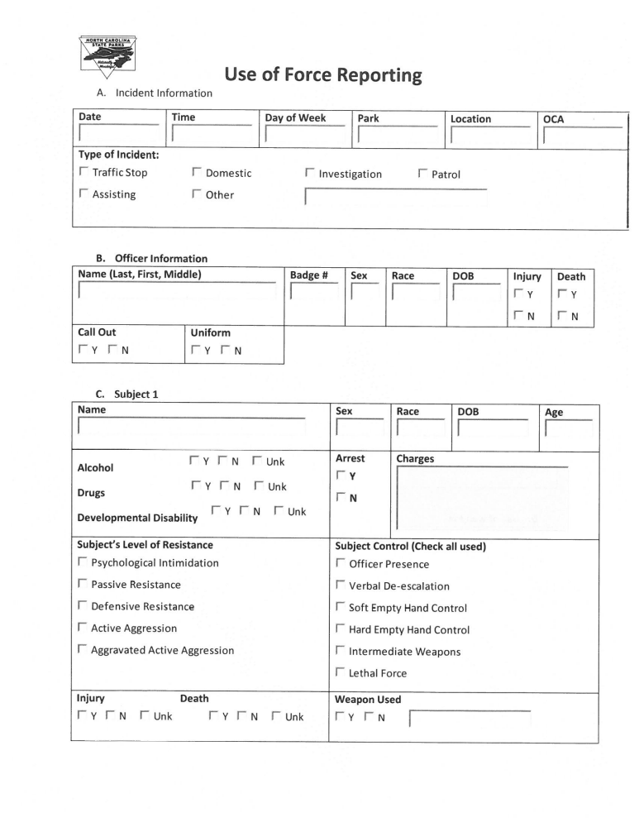
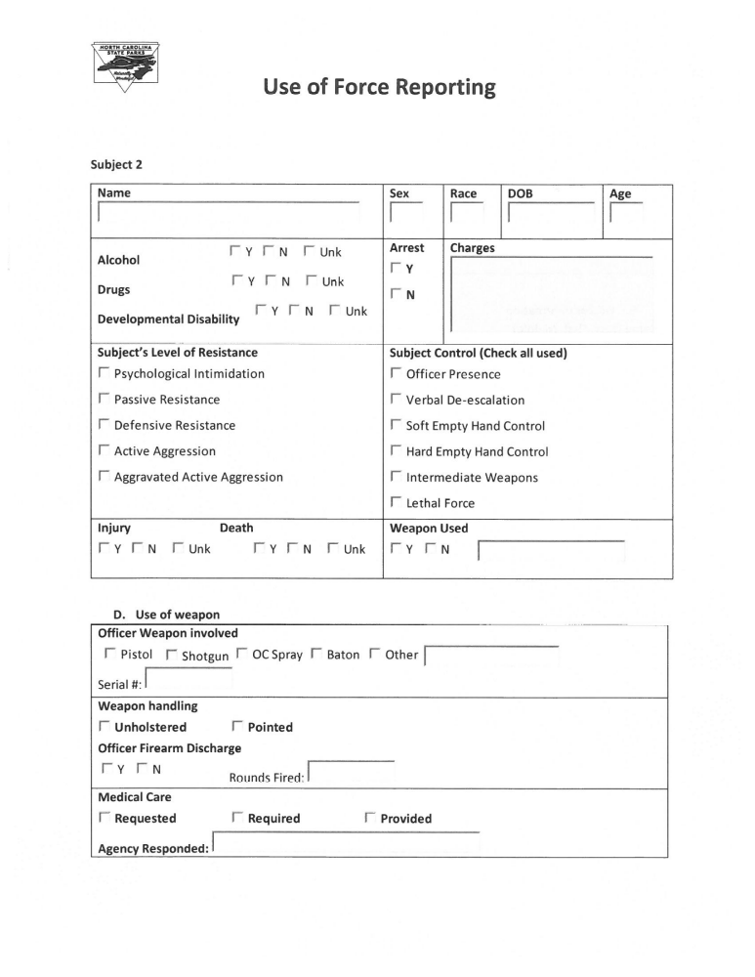
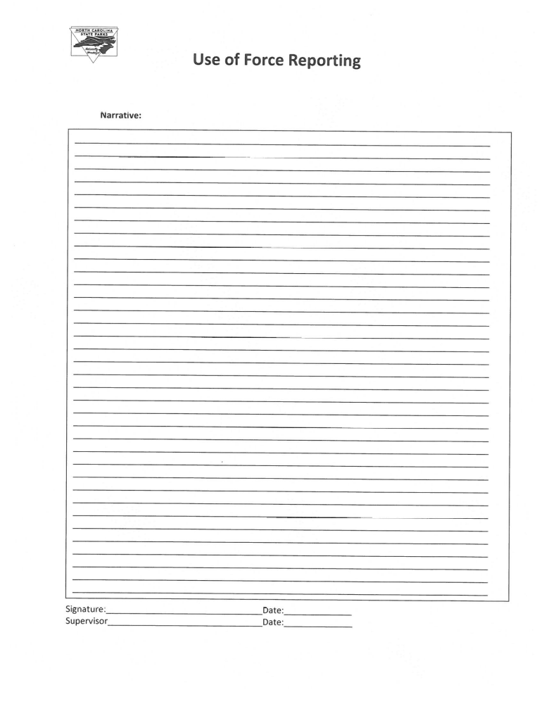
APPENDIX R
Consent to Search and Seize

NORTH CAROLINA
DIVISION OF PARKS AND RECREATION
Consent to Search and Seize

I, ______________________________ hereby authorize _________________________
(Name of person Consenting to Search) (Name of Commissioned Officer)

of the North Carolina Division of Parks and Recreation and any other law enforcement officer designated to assist to conduct a complete search of ________________________
(Description of residence, property, vehicle, etc.) ________________________________________________________________________

________________________________________________________________________

Located at ______________________________________________________________
(Description of location and/or complete address)

I further authorize the above officers to remove any letters, documents, papers, materials, or other property which is considered important to the investigation, provided that I am given a receipt for anything that is removed.

I have knowingly and voluntarily given my consent to search the above described location without fear, threat or promise either expressed or implied. Further, I understand that I have a constitutional right to refuse consent to this search and that any items seized may be used against me in a court of law.

_______________________________ Witness: ______________________
(Signature of person consenting to search)

Date: ___________________ Time: _______________
 | ITEMIZED LIST OF ARTICLES TAKEN AS EVIDENCE
Item Number | Description of what was taken, location found and by whom located
Case # | Signature of officer and date

