DIVISION OF PARKS AND RECREATION

February 1, 2013

STAF DIRECTIVE 13-1

TO: Administrative Staff
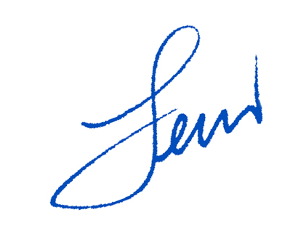
Section Chiefs
District Superintendents
Park Superintendents

FROM: Lewis R. Ledford, Director

SUBJECT: Revisions to the Division’s Fire Management Guidelines

Attached are revisions to the January 1, 2003 Fire Management Guidelines. The purpose of the revision is to implement key changes to the fire management guidelines identified by the Division’s Fire Management Team. Please replace the sections noted in the attached revisions and begin using the new guidelines immediately.

LRL/BLS

Attachment

