**File Xplorer User Guide**

This user-guide provides a walkthrough of all the features our application has to offer. This document provides a step-by-step guide for each use case for each user level wherever applicable.

**User access for each action:**

This table shows the actions each user can perform in the application based on their roles.

| **User Role** | **Access Admin Actions** | **Upload Files** | **Delete Files** | **Replace Files** | **Archive Files** | **Download Files** | **Edit Topics** | **Add Files** |
| --- | --- | --- | --- | --- | --- | --- | --- | --- |
| Super Admin | ✅ | ✅ | ✅ | ✅ | ✅ | ✅ | ✅ | ✅ |
| Admin | ❌ | ✅ | ✅ | ✅ | ✅ | ✅ | ✅ | ✅ |
| Manager | ❌ | ✅ | ❌ | ✅ | ✅ | ✅ | ✅ | ✅ |
| Base | ❌ | ✅ | ❌ | ✅ | ✅ | ✅ | ✅ | ✅ |

**Sign-in:**

Users will be taken to the sign in page before accessing the application. Upon entering valid credentials the application will authenticate the user and will take them to the application's landing page (search page).

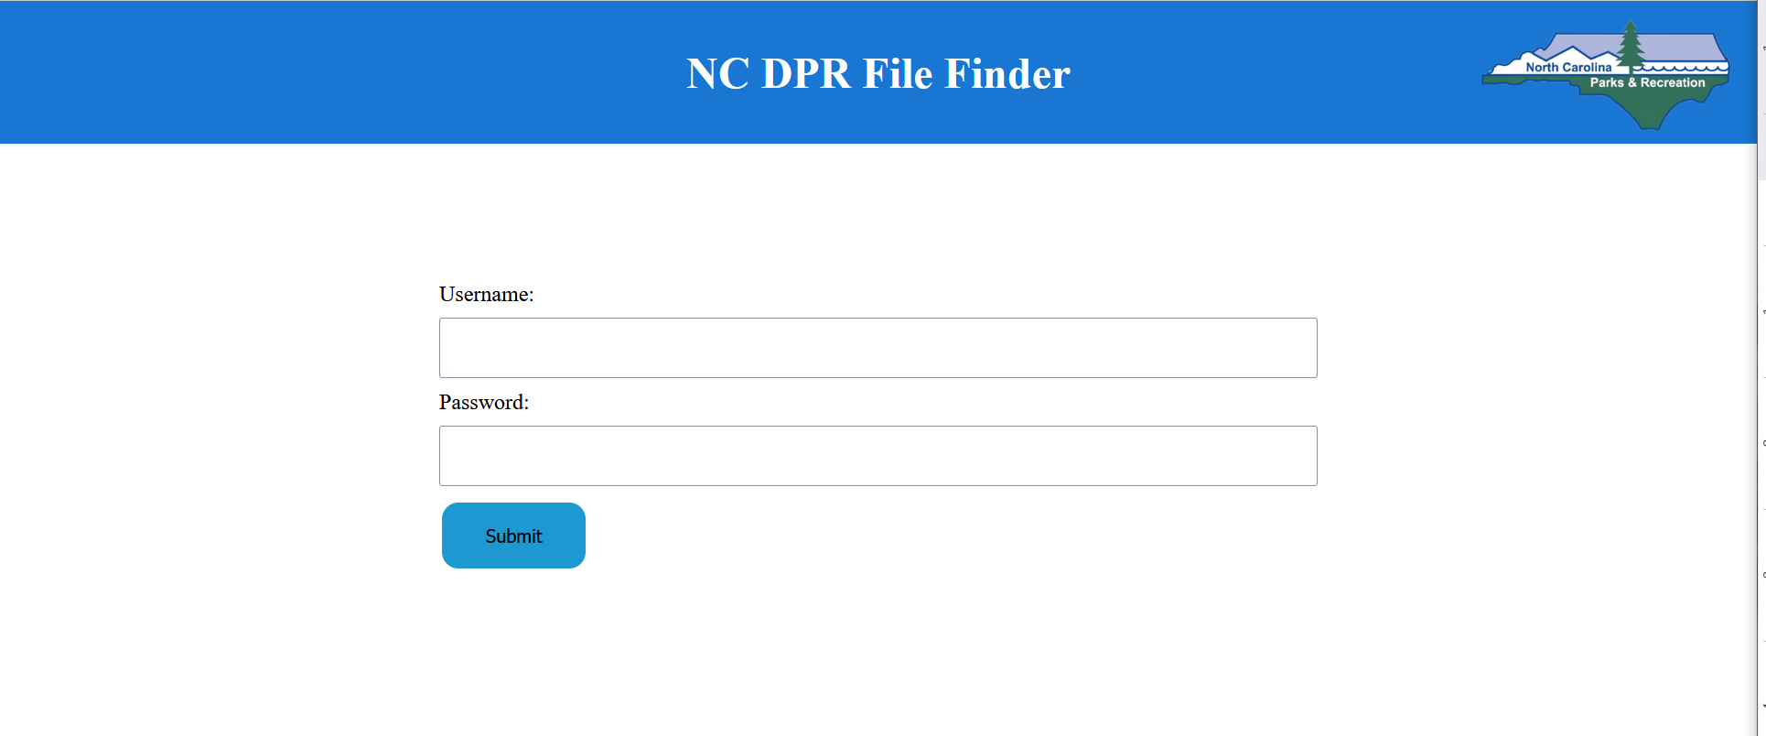

**Common use cases for all users:**

After a user is authenticated they are redirected to the application’s search page. Here the user can search for files and topics.

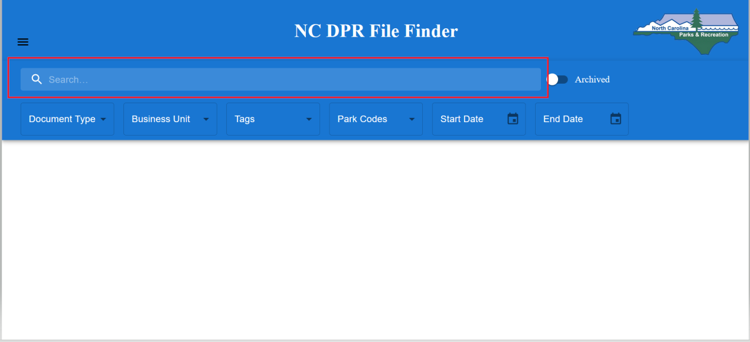

*Figure 1 Search landing page*

To **execute a search**, the user needs to click on the search text box (highlighted in red in Figure 1) and press the enter key on the keyboard.

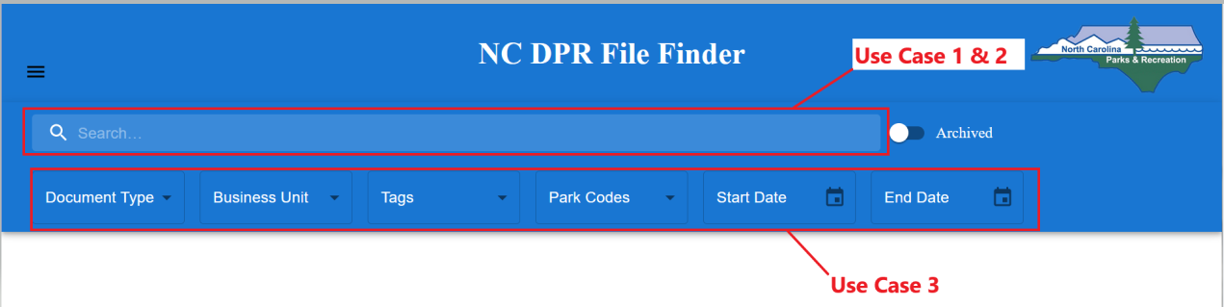

*Figure 2*

**UC1 View List Of All Topics:**

A user can view all the topics in the system via an empty search.

**Steps:**

1. Once on the search page, make sure that no filters are selected and that the text box is empty
2. Press the **Enter** button on the keyboard.

A list of all the topics in the system should be shown as in *Figure 3*.

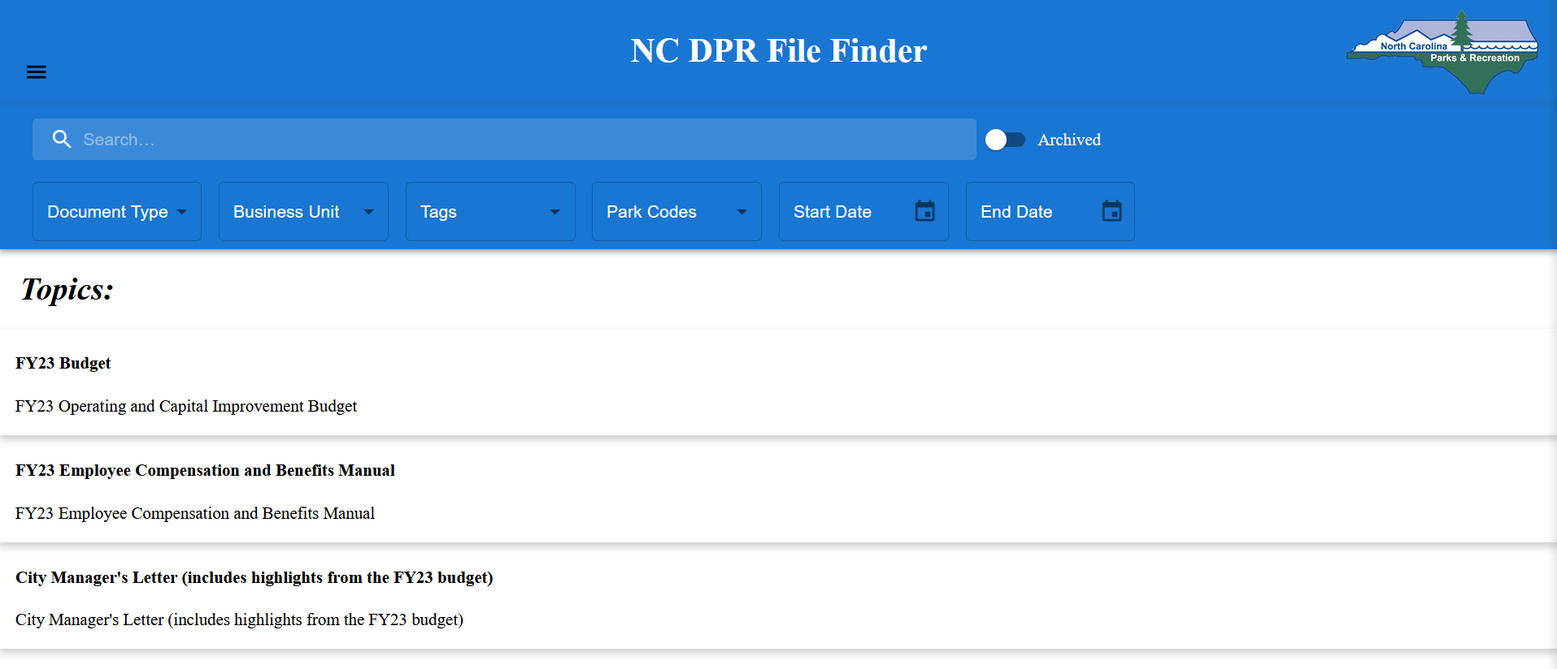

*Figure 3 UC1 View All Topics*

**UC2 Search Via Keyword:**

A user can search for a file or a topic in the system using keywords.

**Steps:**

1. In the **search box** enter the keyword(s) that you want to search for.
2. Press the **Enter** button on the keyboard to execute search.

If the system has topics or files that match the input keywords, it shall present a list of files and topics as shown in *Figure 4*

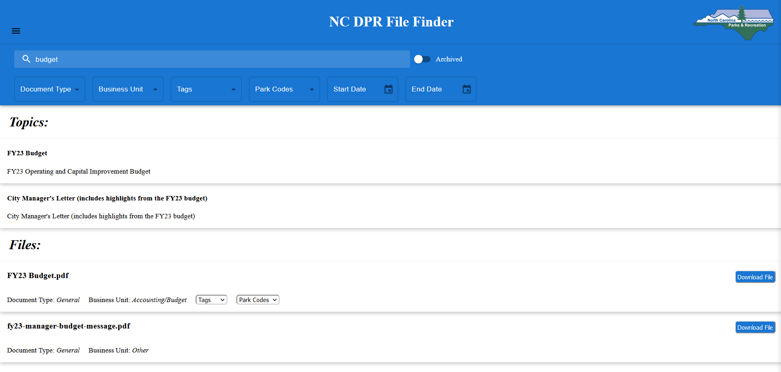

*Figure 4 UC2 Results for a search via keyword.*

**UC3 Search with Filters**

A user shall be able to search for files that match the selected filters

**Steps:**

1. Select any combination of filters from the options below the search bar (Document Type, Business Unit, Tags, Park Codes, Start & End Dates)
2. Press the **Enter** button on the keyboard to execute search.

If the system has files that match the user's selected filter options, it shall present a list of files as shown in *Figure 5*.

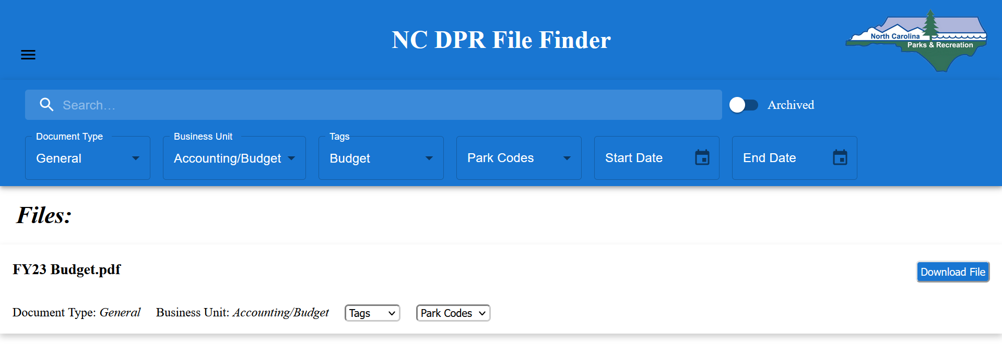

*Figure 5 UC3 Result for a search via filter options*

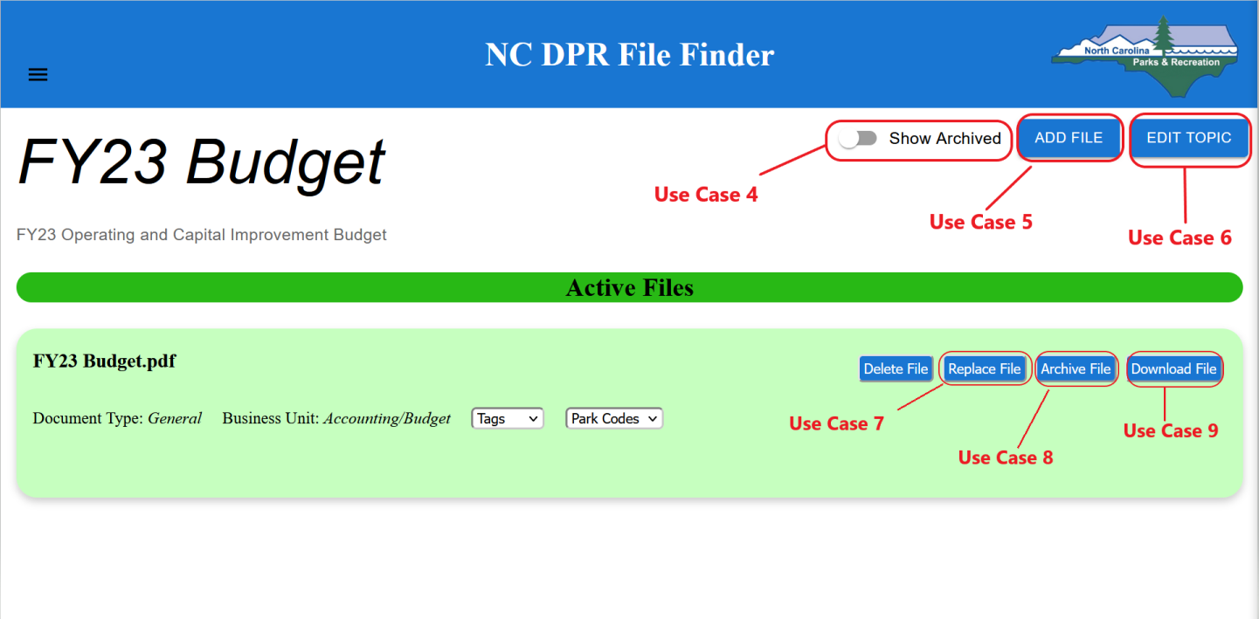

*Figure 6*

The **Topic view** page is shown when the user clicks on one of the topic results shown on the search page.

**UC4 View archived files:**

A user can view all archived files that belong to the Topic in view

**Steps:**

1. Once on the topic view page click on the **Show Archive** toggle button.

A list of archived files is displayed beneath the Active Files listing (*Figure 7*).

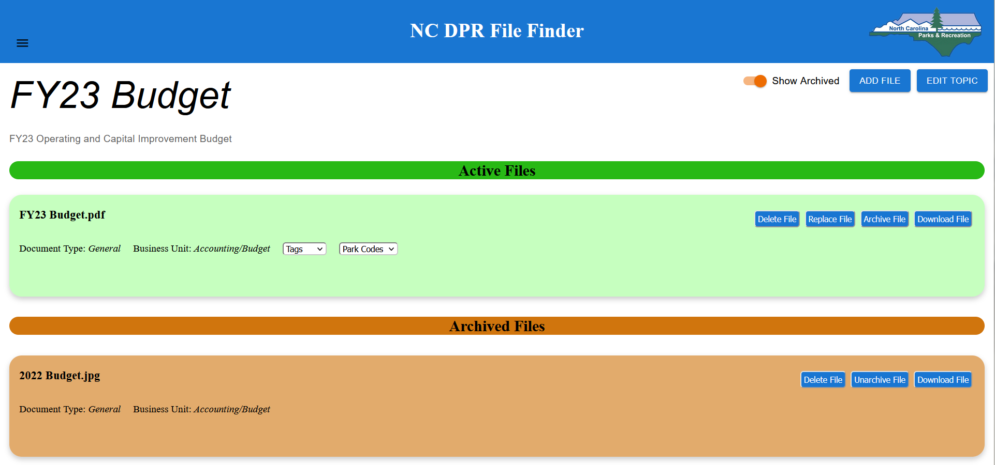

*Figure 7 UC4 View Archived Files.*

**UC5 Add File To Existing Topic:**

A user can add new files to an existing Topic.

**Steps:**

1. On the topic view page for an existing topic, click on the **Add File** Button.
2. Drag & Drop or upload file from local system to the Upload File popup, and select desired attributes
3. Click **Save**.

The file is uploaded to the system and is visible on the same topic view page (*Figure 8*)

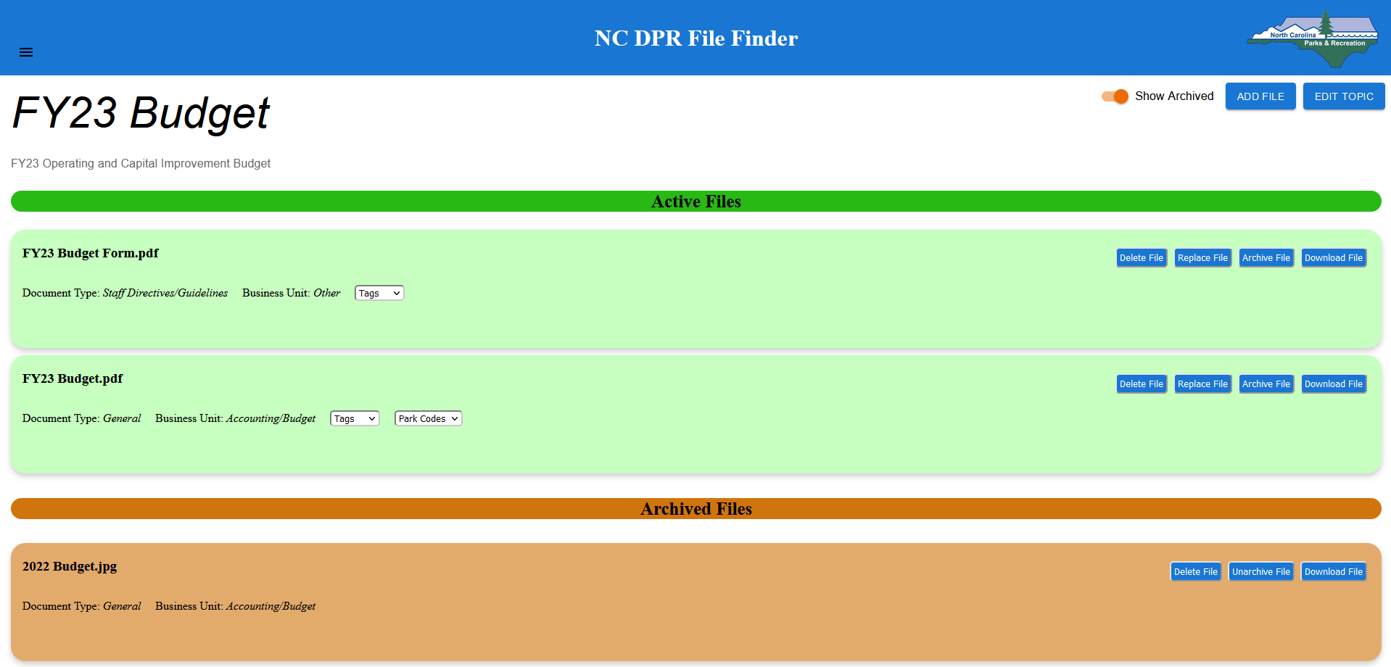

*Figure 8 UC5 View after adding a form document to the current topic.*

**UC6 Edit Topic Metadata:**

A user should be able to edit a topic’s title and description.

**Steps:**

1. Click on the **Edit Topic** button on the topic view page for an existing topic.
2. Update the topic’s title or description via the given text boxes for each section.
3. Click on the **Save** button.

After clicking on the save button the user is redirected back to the topic view page. The topic view should reflect the updated topic title and or description as changed by the user. *Figure 9* shows the topic view page after the title and description is updated compared to *Figure 8*.

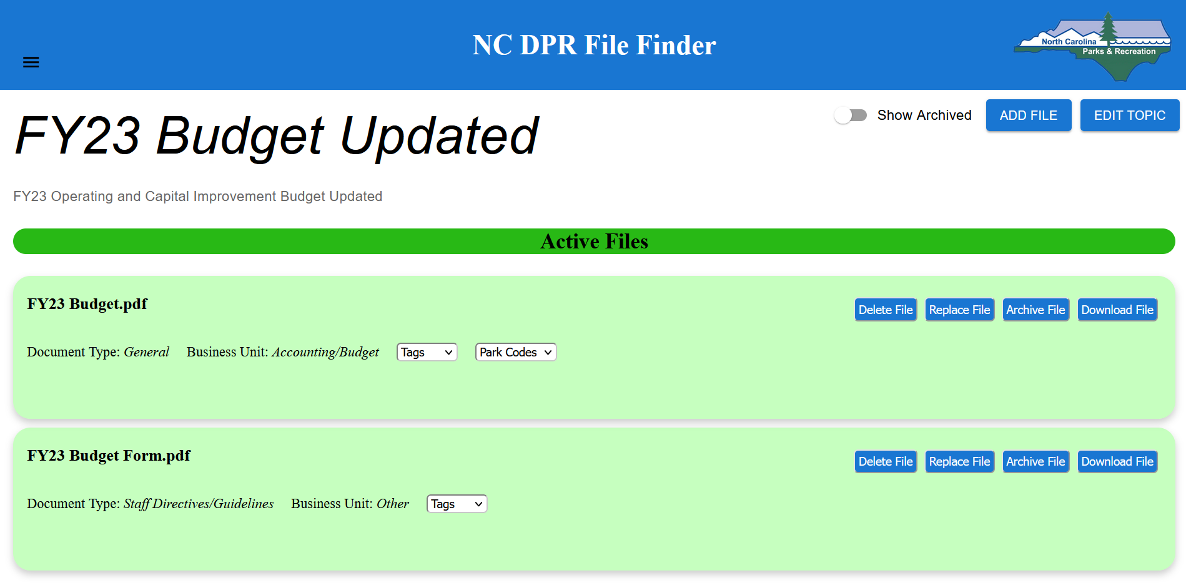

*Figure 9 UC6 Topic view after editing its title and description.*

**UC7 Replace File In a Topic:**

A user should be able to replace a file under an existing topic from its topic view

**Steps:**

1. On the topic view for an existing topic, click on the **Replace File** button on the file that needs to be replaced
2. Drag & Drop or upload file from local system to the Upload File popup, and select desired attributes
3. Click on the **Save** button.

After clicking on the save button the user is redirected back to the topic view page. In the Active Files section of the topic view, the newly uploaded file should be visible. The file that was replaced is now archived and can be seen via the Show Archived toggle button. *Figure 10* shows the updated FY23 Budget file is now replaced by the FY23 Budget Updated file.

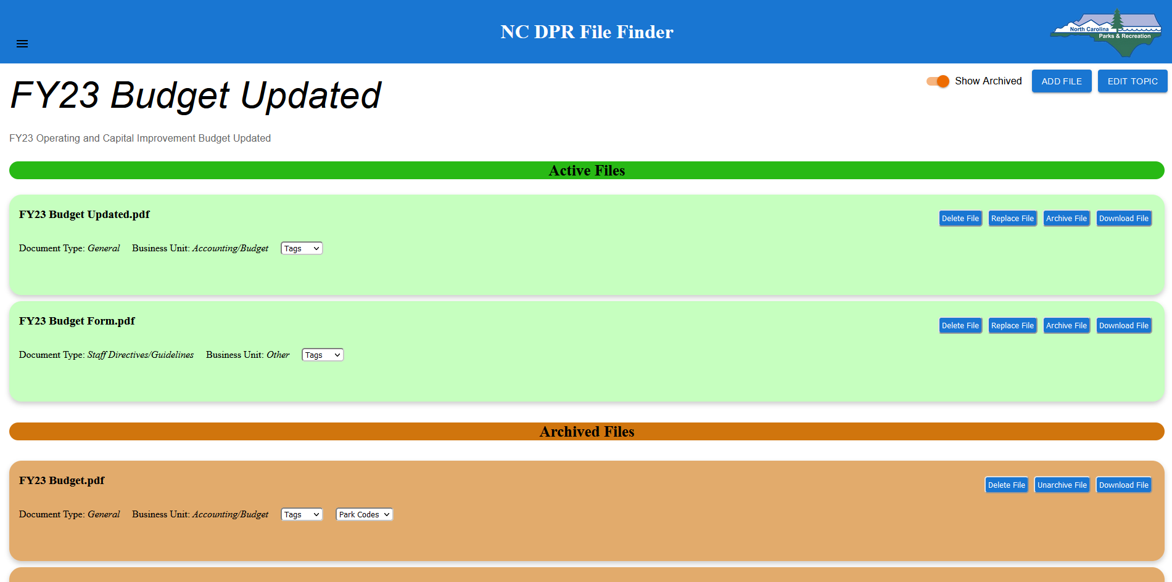

*Figure 10 UC7 Topic view after replacing a file.*

**UC8 Archive a File:**

A user should be able to archive a file from the current topic they are looking at. Archiving a file removes it from any future search results unless archived files are being explicitly included in the search result by toggling the “archive” filter.

**Steps:**

1. Click on the **Archive File** button on the file you want to archive.

The file disappears from the topic view.

1. To view the newly archived file, click on the Show Archive toggle button.

The archived file can be seen on the topic view. Figure 11 shows the updated Archived File section after archiving the FY23 Budget Form file.

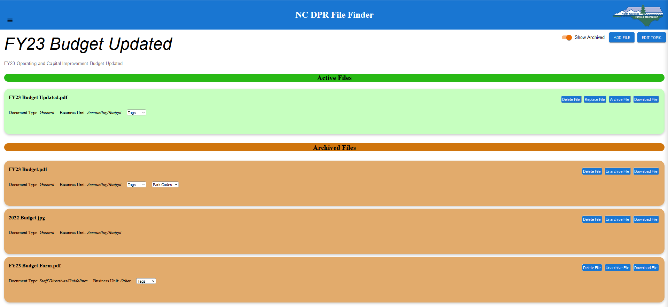

*Figure 11 UC8 Topic view after archiving a file from active files section.*

**UC9 Download A File From Topic View:**

A user should be able to download a file from the topic view page.

**Steps:**

1. Click on the **Download File** button for the file you want to download.

The file should be downloaded to the system Downloads folder. Note that some file types may automatically open on the web browser and will require the user to download the file contents from there.

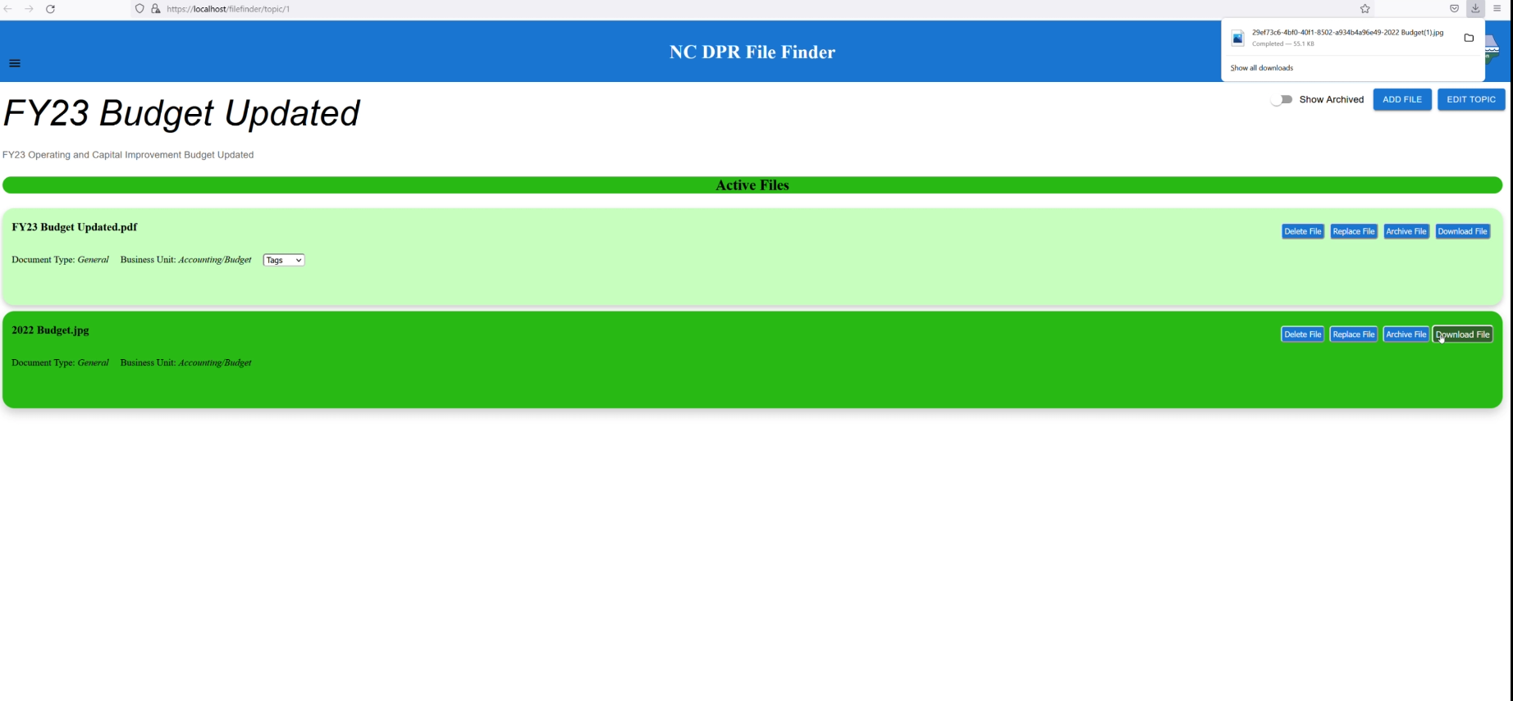

*Figure 12 UC9 Download File.*

**UC10 Upload Files:**

A user should be able to create new topics and upload new files under that topic. Note that a user can upload a maximum of five files at a time.

**Steps:**

1. On the Search page click on the hamburger menu on the top left of the page.
2. From the menu click on the **UPLOAD FILES** button.
3. On the upload file page, enter a value for topic title and optionally enter a value for topic description. Note that upload will fail if the topic title is not unique.
4. Click on the **Add Files** button.
5. Drag and drop or upload the file from your local system to the Upload File popup, and select the necessary file attributes.
6. Click **Save**.
7. Click **Upload Files**.

A new topic with the given files is created and a successful upload message is displayed as shown in Figure 13.

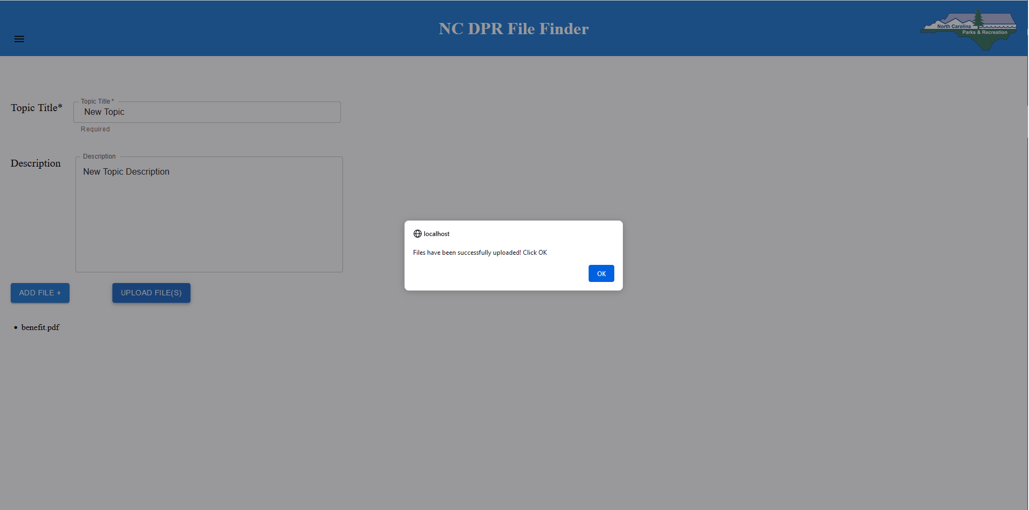

*Figure 13 UC10 Upload Files*

**Use cases for Super Admin & Admin:**

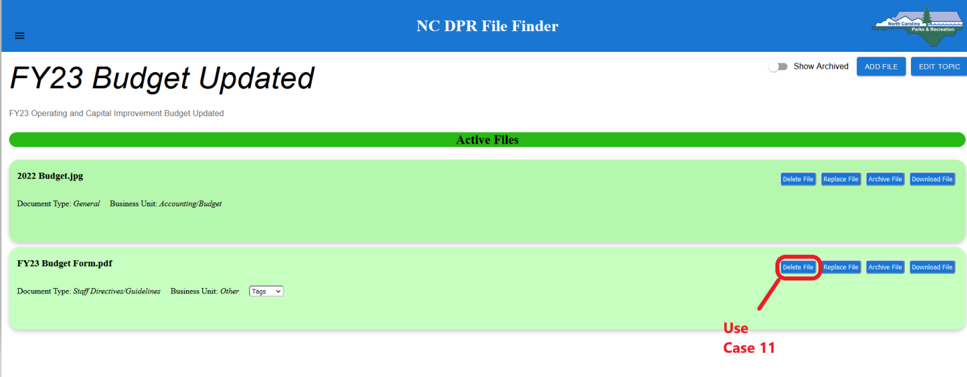

*Figure 14*

**UC11 Delete Files:**

An Admin and Super Admin should be able to delete a File from the system.

**Steps:**

1. Click on the **Delete File** button for the file you want to delete.

As shown in figure 15, the deleted file will disappear from the page.

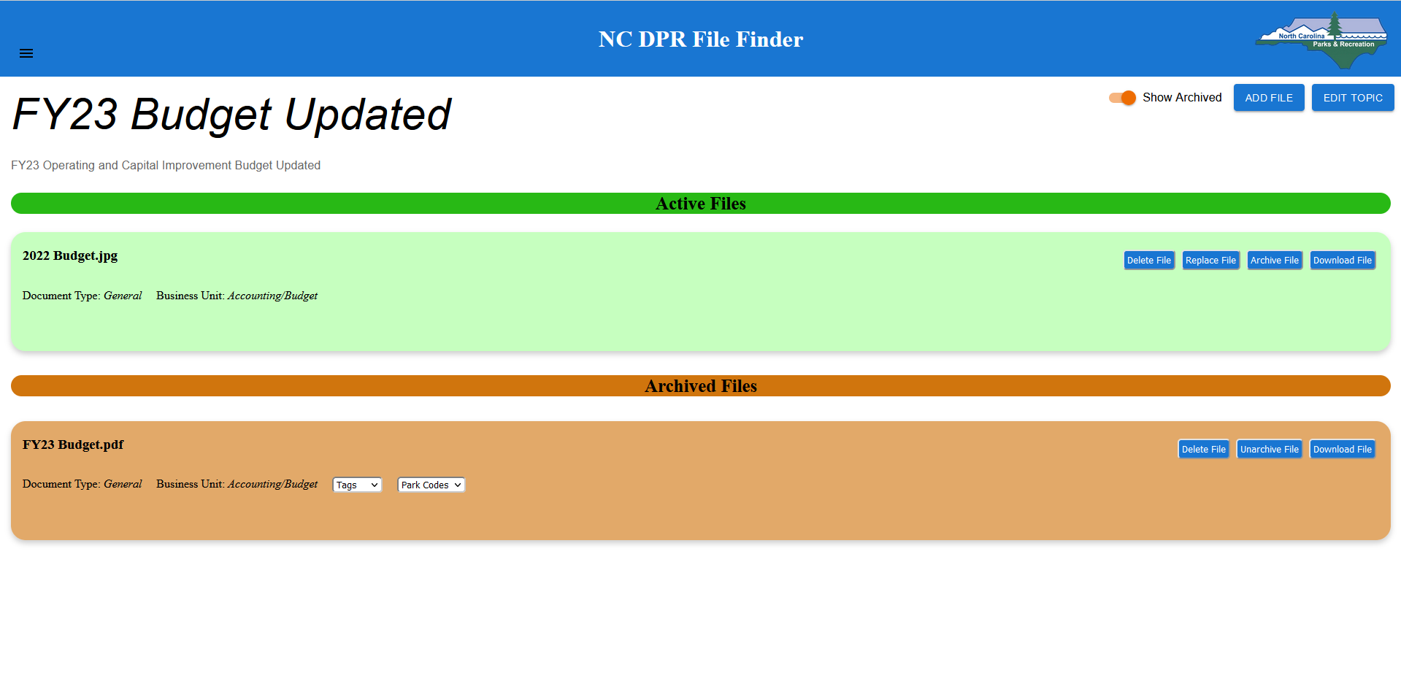

*Figure 15 UC11 Delete Files*

**Use cases exclusive to a Super Admin:**

A super admin user can access **ADMIN ACTIONS** from the hamburger menu as shown in figure 16.

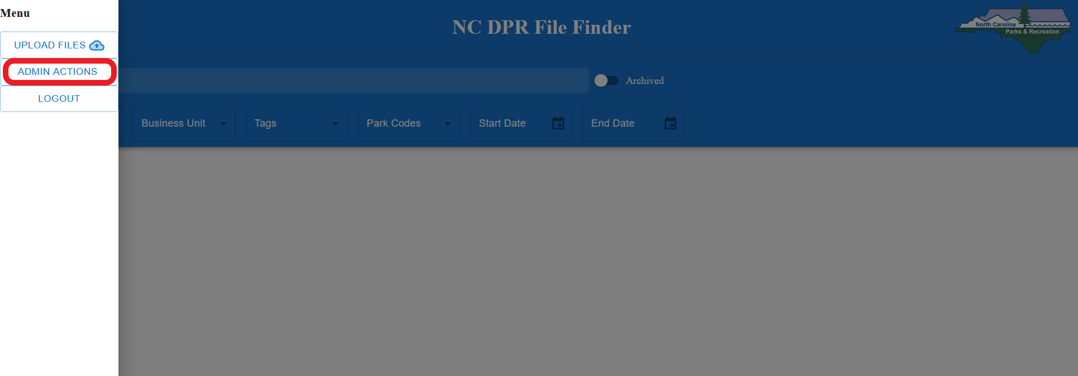

*Figure 16*

Figure 17 represents the landing page for Admin Actions. Dedicated tabs represent different file attributes the user can view/create/edit. For brevity, screenshots below show interactions on the Tag tab. Note that other file attributes work the same way.

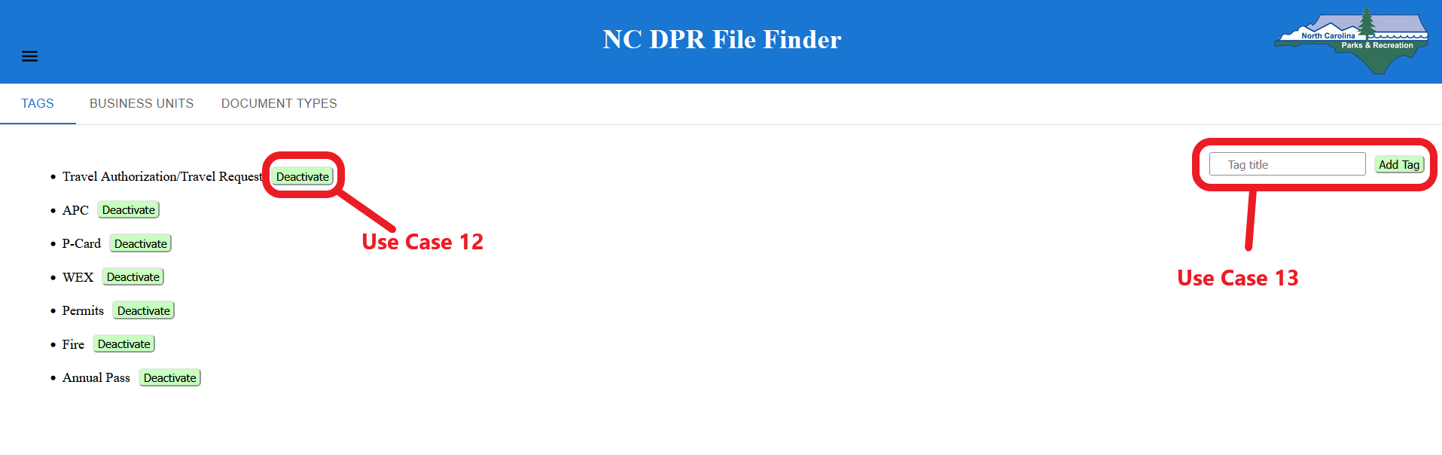

*Figure 17*

**UC12 Activate/Deactivate File Attribute**

A Super Admin should be able to activate or deactivate a file attribute. Deactivating a file attribute will remove it from the list of attributes offered on the file upload page. Note that the **Deactivate** button is shown when the file attribute is active, and the **Activate** button is shown when the file attribute is not active.

**Steps:**

1. Click on the **Deactivate** button next to the file attribute to deactivate that file attribute (Refer to Figure 17).

The file attribute will now display an “Activate” button, as shown in Figure 18, which means the attribute has been deactivated, and if you would like to activate it again click on the Activate button.

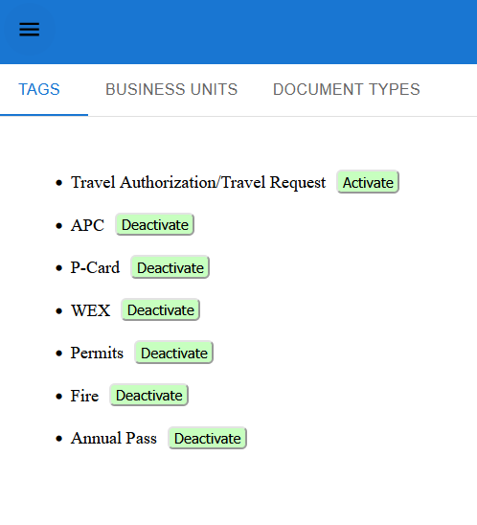

*Figure 18 UC12 Activate/Deactivate File Attribute*

**UC13 Add New File Attribute**

A Super-Admin should be able to add a new file attribute. There are three file attributes: tags, business units, and document types in this context.

**Steps:**

1. Enter the title for the new file attribute in the text box (Refer to Figure 17).
2. Click on **Add <File Attribute>** (in this case; button depends on the file attribute).

As shown in Figure 19, the new attribute is added at the bottom. By default, it is an active attribute, but you can deactivate it if desired as shown in UC12.

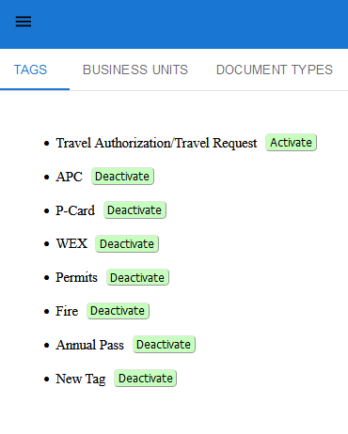

*Figure 19 UC13 Add New File Attribute*