DPR Visitation Application User Guide

Updated Application with Unified Authentication - Fall 2022

This document will serve as a general user guide for all roles in the DPR Visitation application. There will be step-by-step instructions for all implemented use cases for base level, manager, admin, and super admin user roles. There will be instructions for how to start interacting with our application along with in-depth guides and visuals to help navigate through every step of the way. All users will be authorized to use the functionality described in their roles section as well as previous sections for lower level roles.

## Sign-In and User Profiles

When first accessing the new DPR Cal, you will first see the new log-in page for all user authentication.

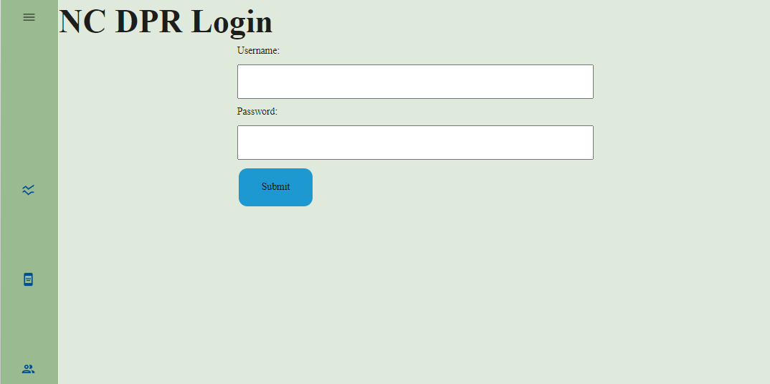

From this log-in screen, the user can log-in with their valid credentials. Our application will authenticate this information with the user information shared across all applications in order to log the user in and authorize functionality based on the appropriate role.

## Base Level Use Cases

**General Use:**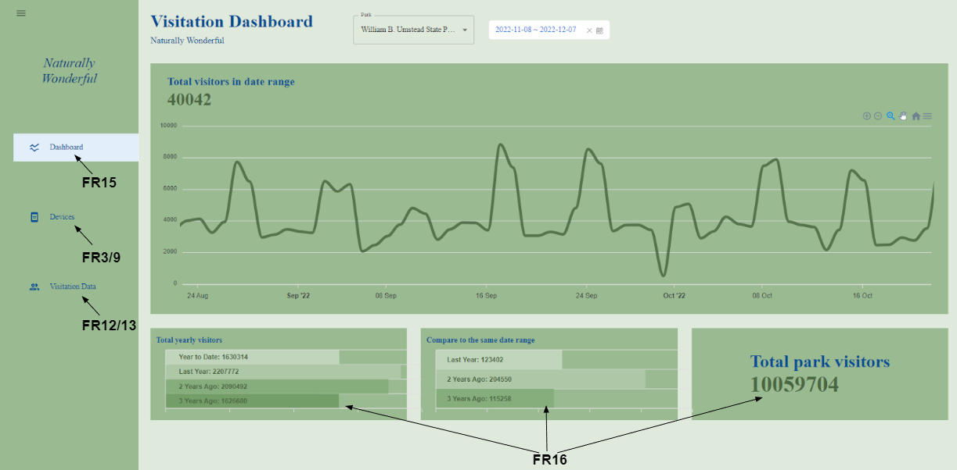

When all users log in, they will be directed to the Dashboard landing page of their currently assigned park which they can navigate back to at any time. From there, they can use different functionality that can be accessed by pressing any of the buttons on the navigation sidebar as well as the dashboard selectors in the middle.

**FR15: View Park Dashboard**

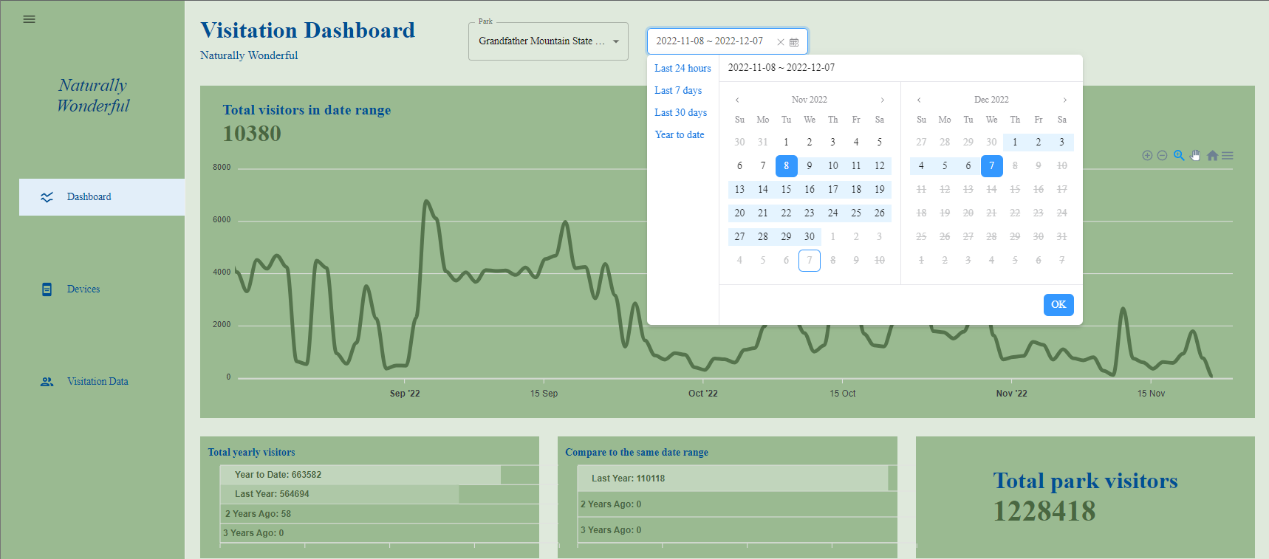

* If the user would like to view the dashboard that visualizes all of the collected data, then they can select the “Dashboard” button on the top of the sidebar to be taken to the above visualization.
* If the user would like to view data for any other park that they are not associated with, then they can use the “Park” dropdown box to select a new park which will update the dashboard accordingly.
* If the user would like to specify a timeframe for the chart to compare data, then they can select the date dropdown along the top which shows the current start and end of the graph.
  + This menu provides options for the last day, week, month and year along with a custom calendar picker which allows the user to select a specific start/end
* If the user wants to interact with the graph, then they can highlight a section of the graph with their mouse or use the tools along the top right of the graph to move the timeframe and control the granularity of data.

**FR16: View Comparison Metrics**

* If the user wants to know statistically calculated comparison metrics about a park’s visitation trends over time, then they can view a variety of the metric boxes located below the graph.
  + The first box displays total yearly visitors for the current year through the past three years.
  + The second box compares the data within the graph’s range to the past three years of data within that same range.
  + The third box displays the total number of recorded visitors to the park across all of the time data.
  + The top left of the graph displays a summary of total park visitors within the date range.

**FR3: View Device List**

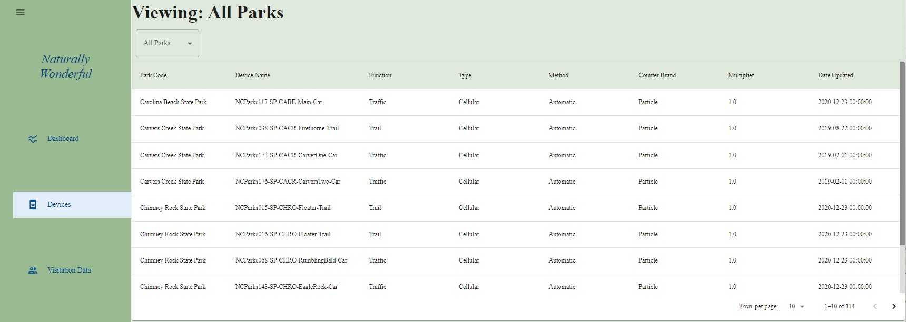

* If the user would like to view all of the devices in the database, then they can select the “Devices” button on the sidebar to be taken to the above webpage
  + This displays a list of devices where each row specifies their park, name, function, type, method, brand, multiplier, and date uploaded.
* If the user would like to filter devices to a specific park, then they can select the “All Parks” dropdown and select the park they want to dynamically update the list.

**FR7: View Counter Rule List**

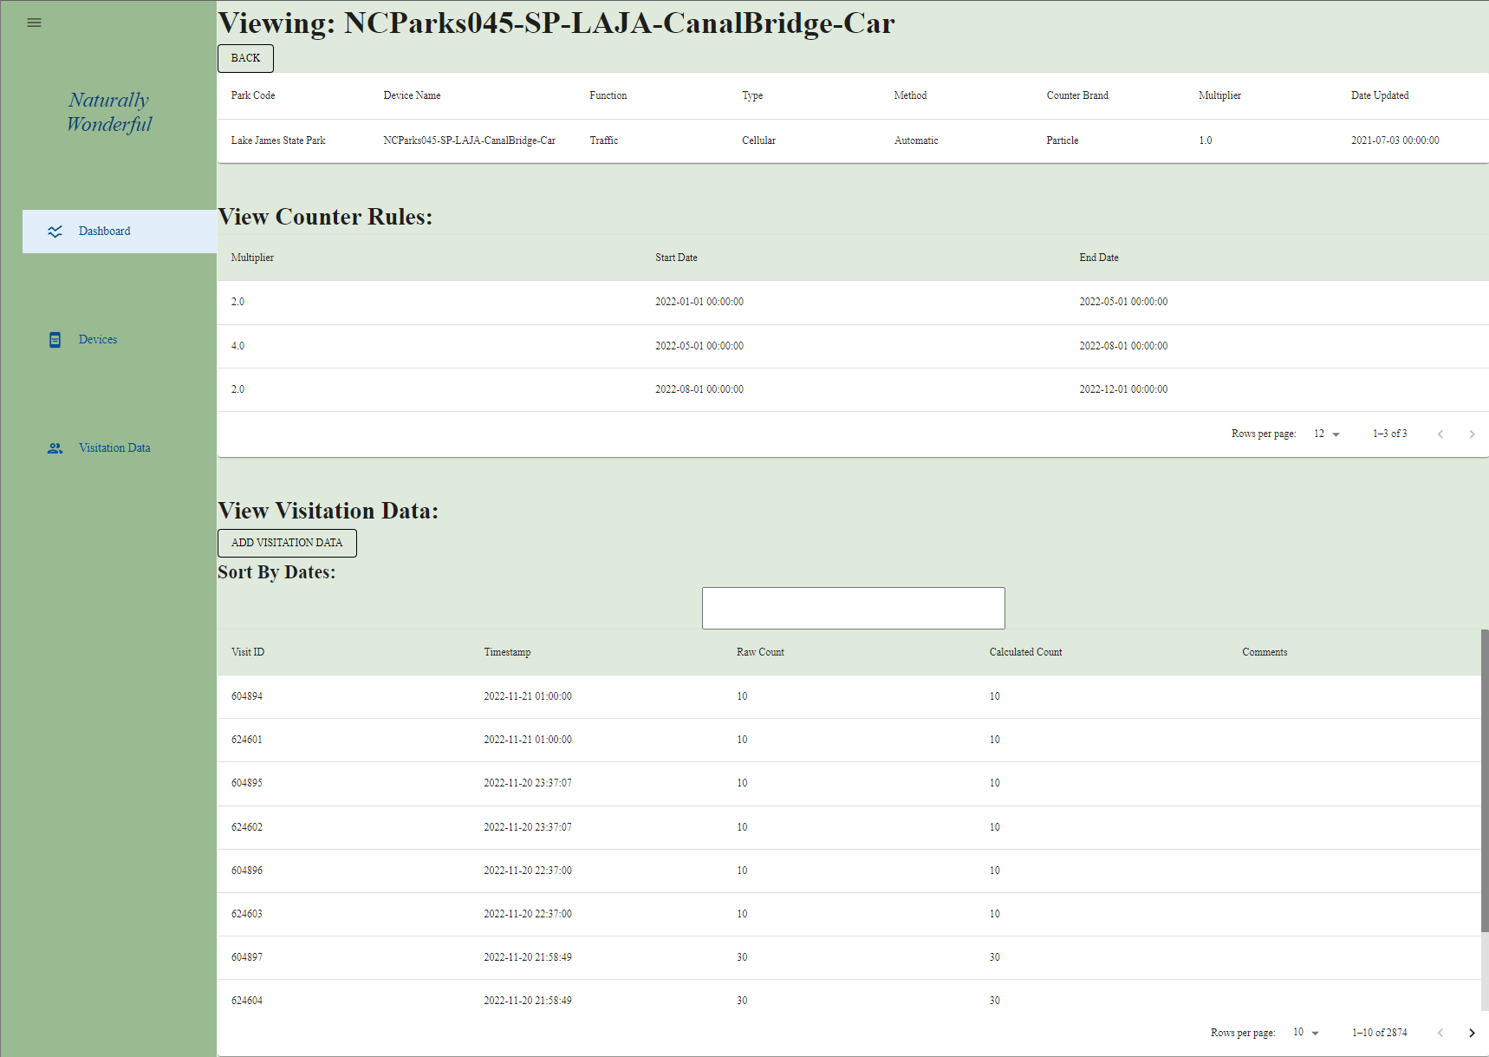

* If the user would like to view the counter rules for a device, then they can select the specified device’s row from the list shown in FR3.
  + This displays a new page listing the device’s information along with its associated counter rules and visitation data.
  + Each row in the middle list of counter rules specifies their multiplier and the start and end date for when they are applied.

**FR12: View Calculated Visitation Data**

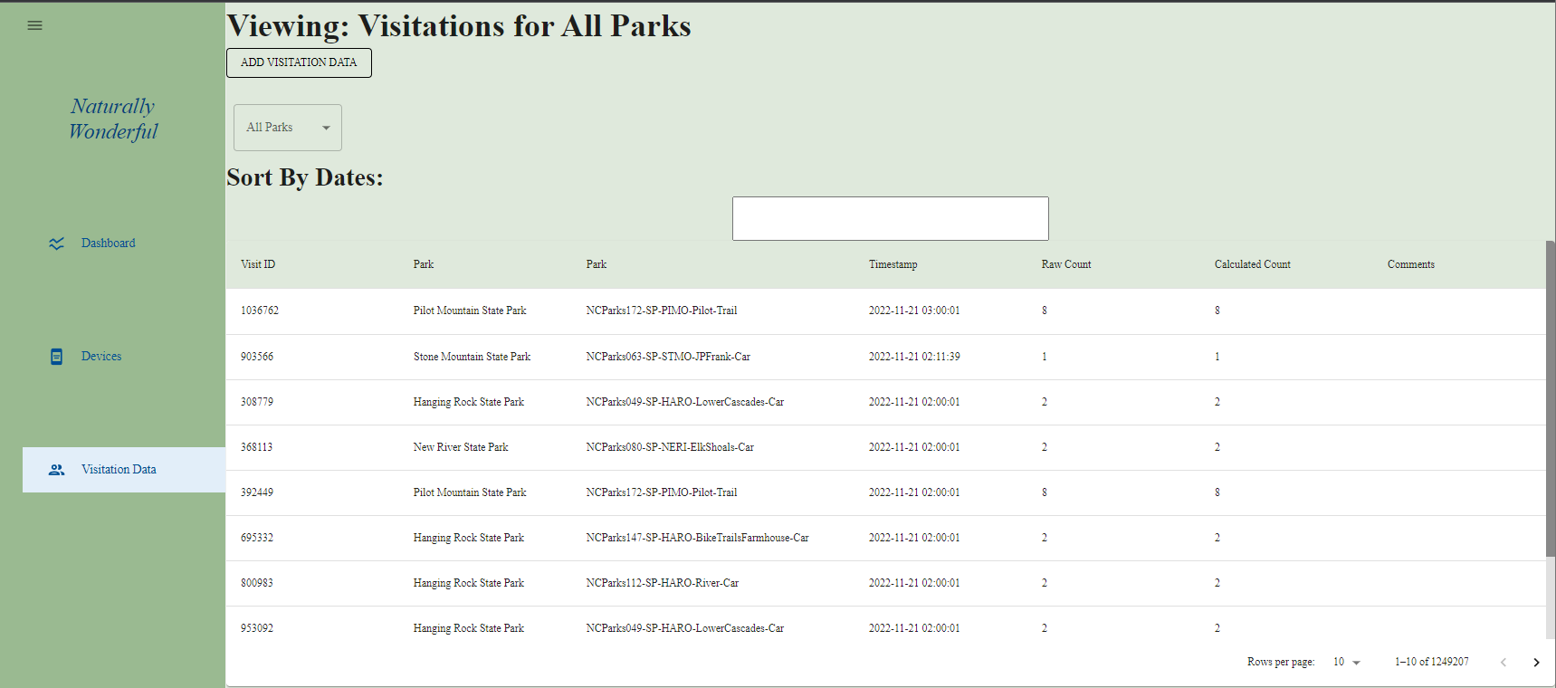

* If the user would like to view the visitation data associated with a device, then they can select the specified device’s row from the list shown in FR3 which will take them to the visualization shown in FR7.
  + This displays a list of visitation data where each row specifies their ID, timestamp, raw count, calculated count, and comments.
* If the user would like to view all visitation data or just data associated with a park, then they can select the "Visitation Data” button on the sidebar to be taken to the above webpage.
  + This displays a list of visitation data where each row specifies their ID, timestamp, raw count, calculated count, and comments.
* If the user would like to filter either of these lists based on timestamp, they can select the date picker directly above the list labeled as “Sort By Dates:” to update the lists based on a start and end date.

**FR13: Edit Calculated Visitation Data**

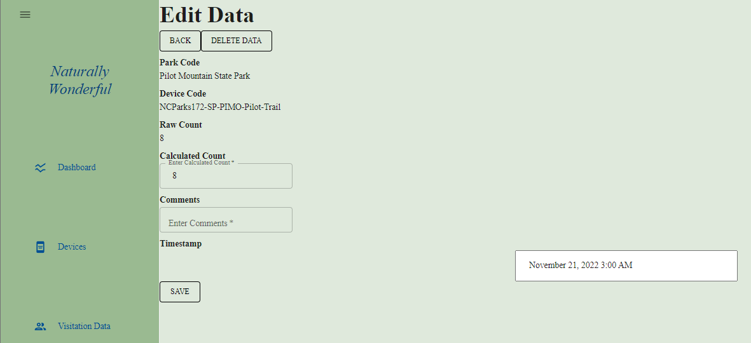

* If the user wants to edit visitation data in the database, then they can select any row in either list specified in FR12 to edit that singular visitation data log.
  + The user is then prompted to enter a calculated count and comment before saving.
* All users can edit visitation data, however, base level users can only edit the current month’s worth of data or the previous month’s worth of data if it is within the first week of the month.

## Manager Use Cases

**General Use:**

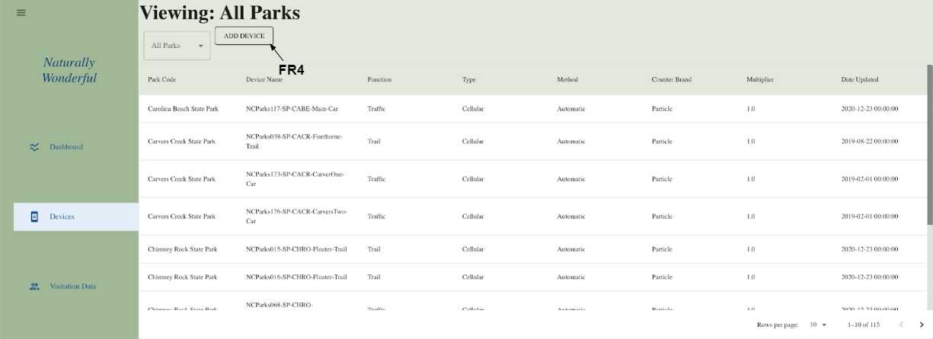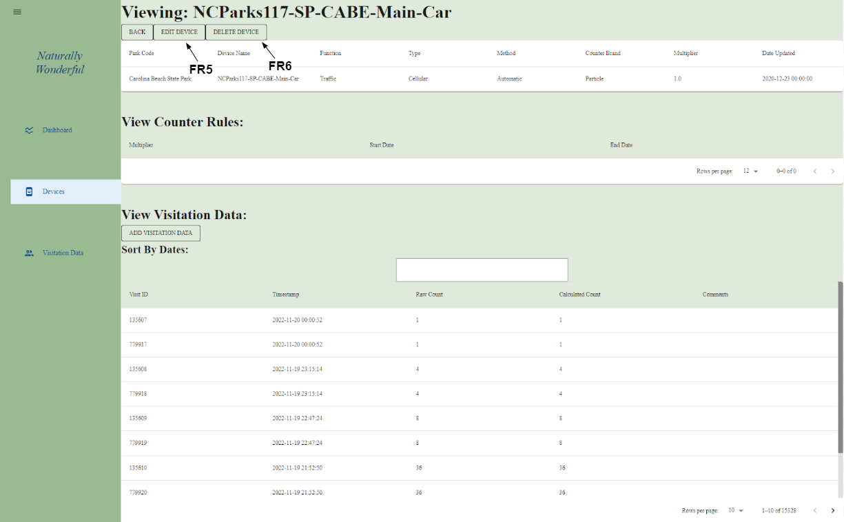

Most of the elevated permissions of a manager revolve around the ability to add/edit/delete devices from within the application and so they will often be working from the “Devices” page on the sidebar mentioned earlier or in a specific device’s page.

**FR4: Add IoT Device**

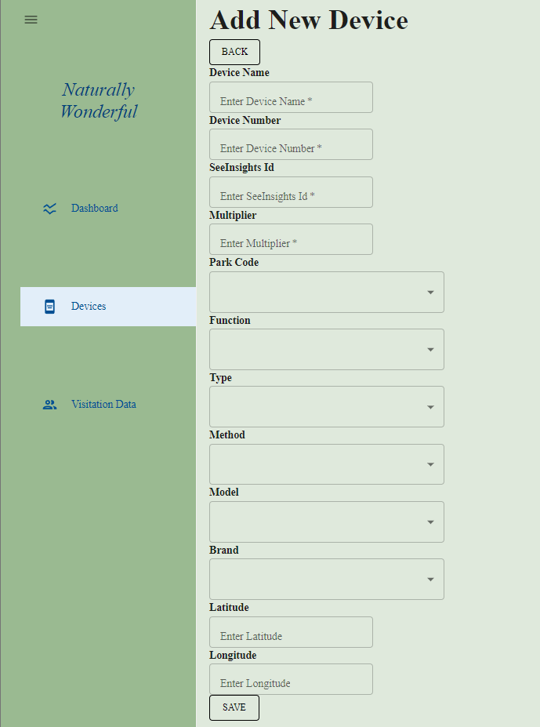

* If the user wants to add a new device to the database, then they can select the “Add Device” button next to the device list’s park filter at the top.
  + The user is then prompted to enter a name, number, SeeInsights ID, multiplier, park, function, type, method, model, brand, latitude, and longitude.
* If the user wants to verify that all of the information entered is correct, then they will be taken to a confirmation page after clicking “Save” which will print out the entered data.

**FR5: Edit IoT Device**

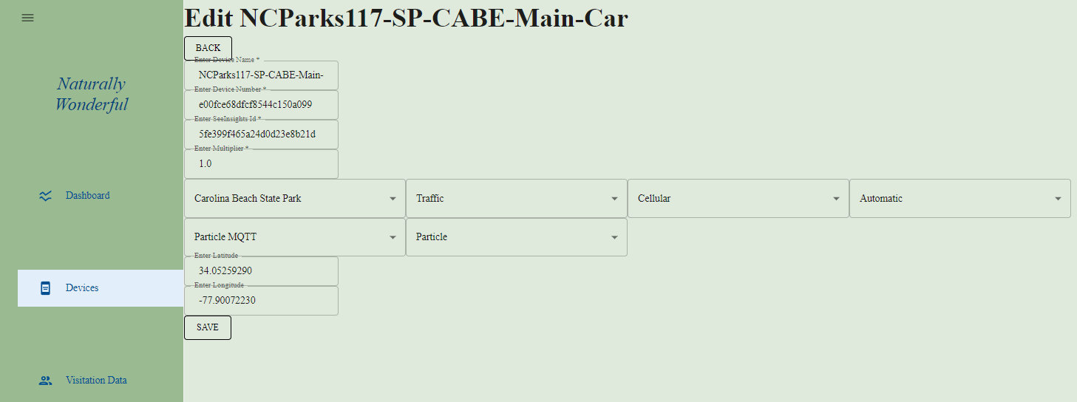

* If the user wants to edit an existing device in the database, then they can select the “Edit Device” button on the device’s page below its name at the top.
  + The user is then prompted to enter a name, number, SeeInsights ID, multiplier, park, function, type, method, model, brand, latitude, and longitude.
* If the user wants to return to the device information page, then they can select the “Back” button near the top.

**FR6: Delete IoT Device**

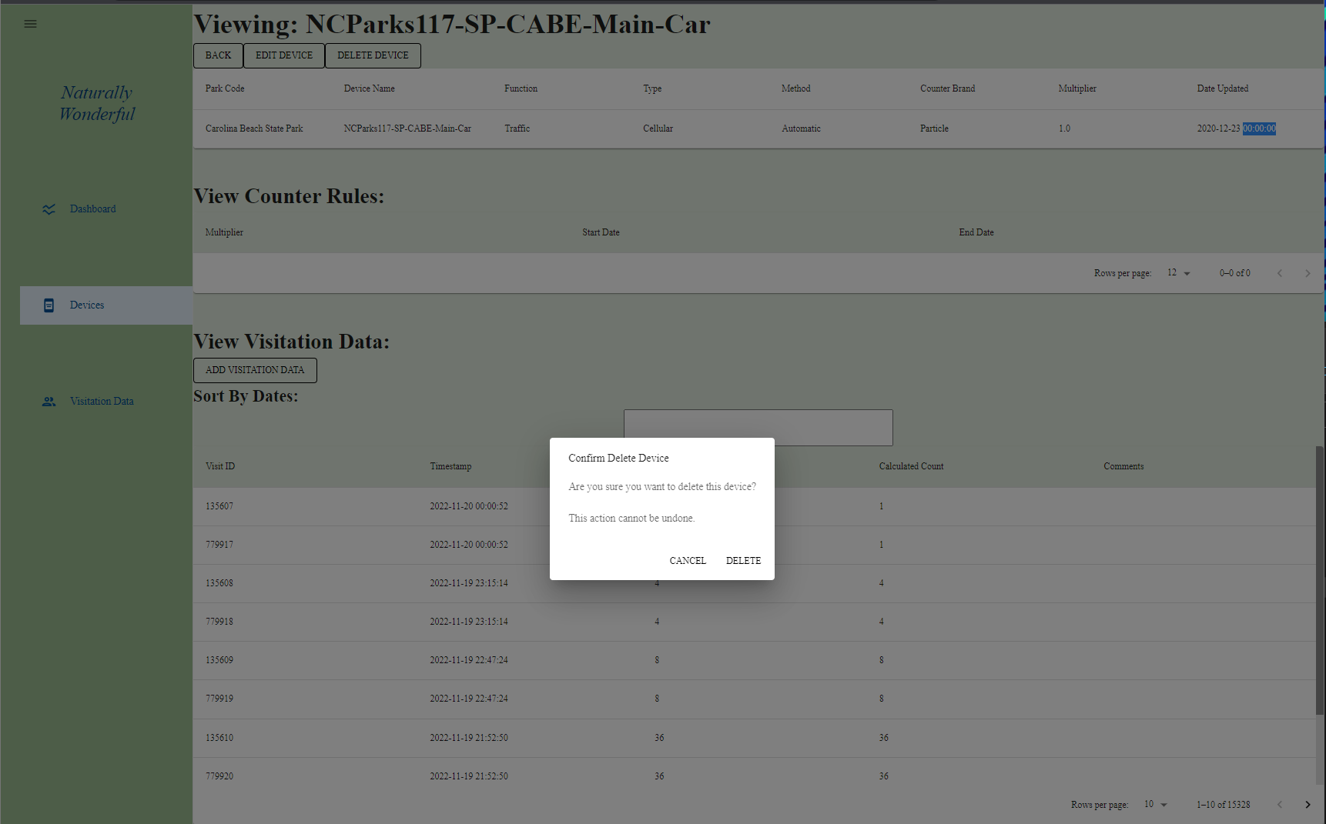

* If the user wants to remove an existing device from the database, then they can select the “Delete Device” button on the device’s page below its name at the top.
* If the user is sure they want to do this, then they will be asked to confirm their decision in a pop up menu.

## Admin Use Cases

**General Use:**

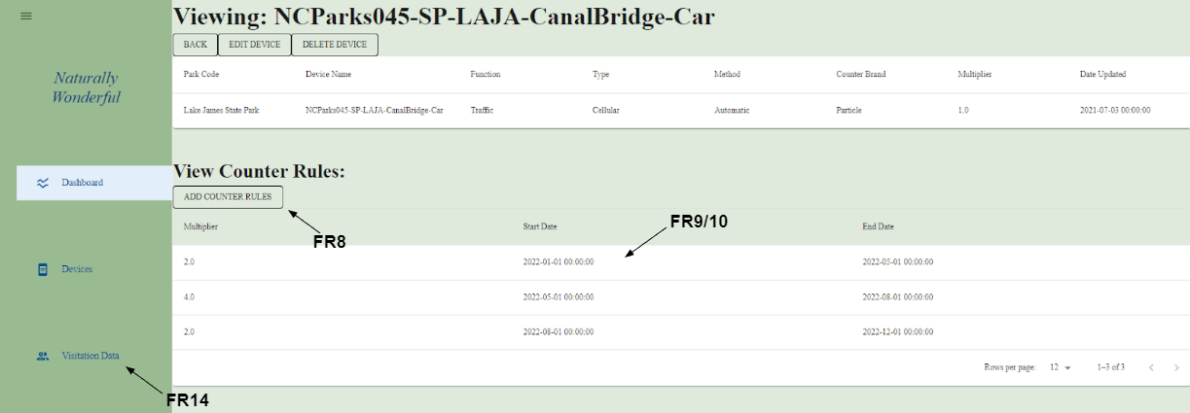

Most of the elevated permissions of a manager revolve around the ability to add/edit/delete counter rules from within the application and so they will often be working from a device’s information page which lists counter rules and visitation logs.

**FR8: Add Counter Rule**

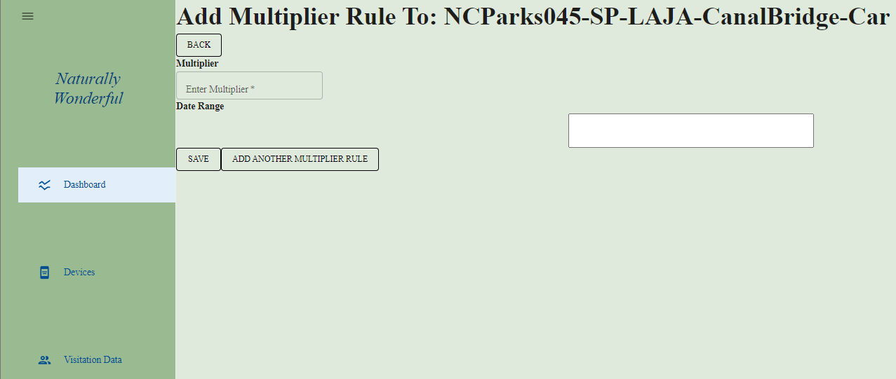

* If the user wants to add a new counter rule to a device, then they can select the “Add Counter Rule” button above the list of counter rules.
  + The user is then prompted to enter a multiplier and date range.
* If the user wants to add multiple counter rules at once, then they can select the “Add Another Multiplier Rule” button to save the counter rule currently being created and clear the form to allow another to be entered.

**FR9: Edit Counter Rule**

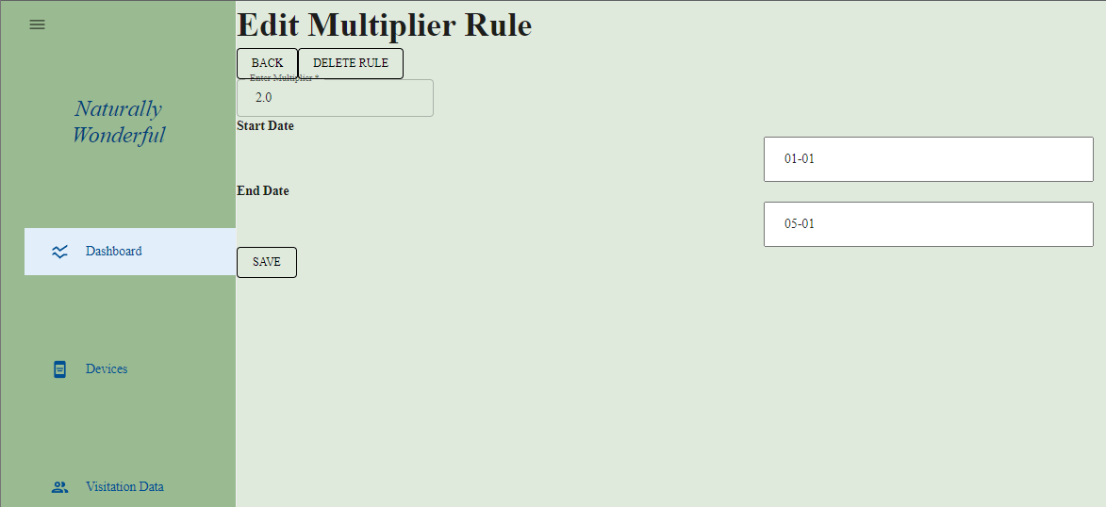

* If the user wants to edit an existing counter rule, then they can select it from the device’s list of counter rules.
  + The user is then prompted to enter a multiplier, start date, and end date.

**FR10: Delete Counter Rule**

* If the user wants to remove a counter rule from a device, then they can select the “Delete Rule” button at the top of the “Edit Multiplier Rule” webpage from FR9.
  + This option does not ask the user to confirm their decision.

**FR14: Delete Calculated Visitation Data**

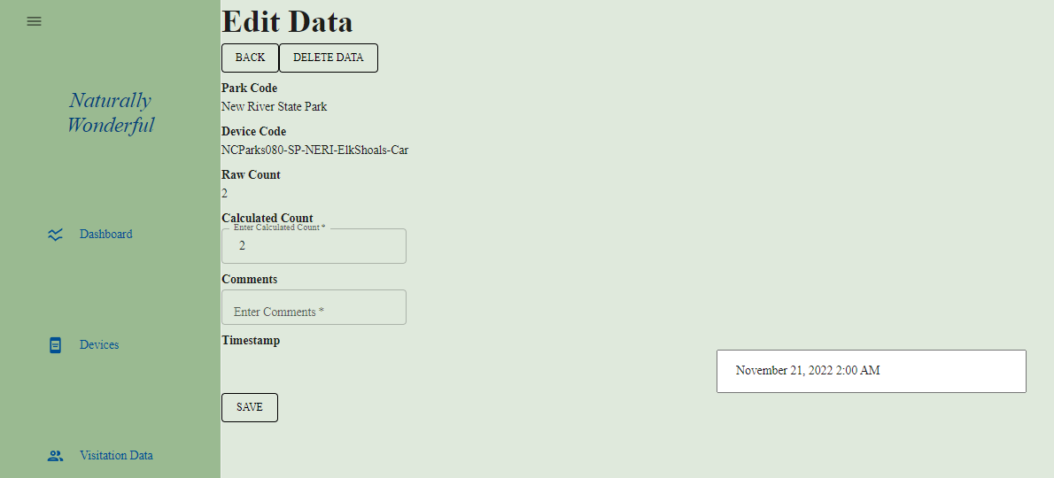

* If the user wants to remove a visitation data log from a device, then they can select the “Delete Visit” button at the top of the “Edit Data” webpage from FR13.
* If the user is sure they want to do this, then they will be asked to confirm their decision in a pop up menu.

## Super Admin Use Cases

**General Use:**

Super admin users perform mostly identically to admin users in terms of available functionality. The only difference to their workflow is that they are not restricted when editing or deleting any data. Other roles such as admins are required to leave a comment when they edit any visitation data but super admins can view/add/edit/delete any information for devices, counter rules, visitation data, and the dashboard.