North Carolina Department of Natural and Cultural Resources Division of Parks and Recreation



ROCK CLIMBING MANAGEMENT GUIDELINES

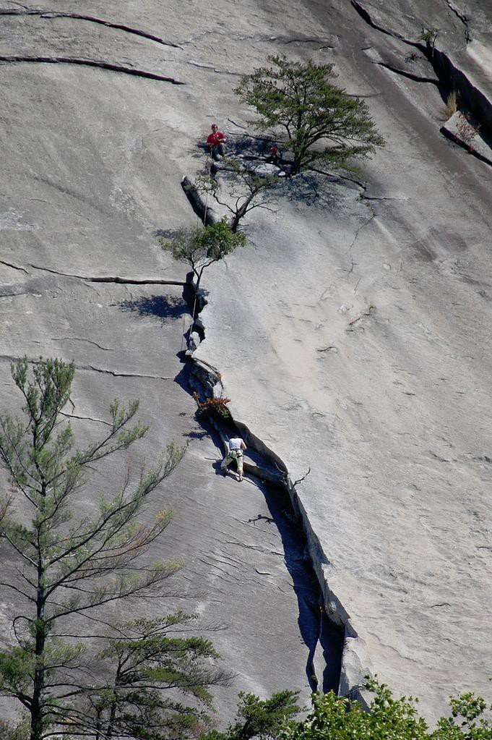

Stone Mountain State Park Photo: w[www.learnnc.com](http://www.learnnc.com/)

August 2017

## ROCK CLIMBING MANAGEMENT GUIDELINES

Table of Contents

## 1.0 INTRODUCTION

Purpose and Need

## 2.0 CLIMBING POLICY

Policy Precautions

## 3.0 GENERAL CLIMBING MANAGEMENT

Regulations and Laws Affecting Climbing Management Park-Specific Plans

Cooperative Management

## 4.0 CLIMBER REGISTRATION AND PERMITS

Individual Climbers Groups

## 5.0 FIXED ANCHORS

Fixed Anchor Installations Fixed Anchor Standards

Fixed Anchor Installation Methods Replacement of Existing Fixed Anchors Installation of New Fixed Anchors Belay/Rappel Station Anchors

## 6.0 DESIGNATED CLIMBING ZONES

**7.0 NEW ROUTES**

**8.0 ROUTE CLOSURES**

**9.0 BOULDERING**

**10.0 TOP OUT POLICY**

**11.0 LEAVE NO TRACE PRACTICES**

**12.0 RESCUE**

**13.0 GLOSSARY OF CLIMBING TERMS**

1. **LITERATURE CITED**

**1.0 INTRODUCTION**

These updated guidelines, established by the North Carolina Division of Parks and Recreation (DPR), replace those issued in 1997. These guidelines are intended to:

* + - Provide rock climbing opportunities where appropriate;
    - Protect the natural and cultural environments; and
    - Ensure positive experiences for all park visitors.

Rock climbing (defined here to include bouldering, free climbing, ice climbing, and direct aid climbing) has occurred in North Carolina's state parks since the 1950’s, when routes were established in and around Hanging Rock State Park in Stokes County. As the popularity of rock climbing increased, it became a common recreational activity at three additional state parks: Crowders Mountain, Pilot Mountain, and Stone Mountain. Today, rock climbing also occurs at Chimney Rock State Park. Additional climbing areas may be added in the future, subject to DPR approval.

As rock climbing's popularity increased, DPR recognized the need to establish regulations regarding access, the designation of climbing areas, natural resource protection, and visitor safety. This led to the establishment of the first DPR climbing policy in 1973. This policy established designated climbing areas.

In the decades since the adoption of the 1973 policy, the popularity and impact of climbing has increased dramatically. This growth has been attributed largely to the availability of modern equipment, the publication of detailed guide books, exposure in the regional and national climbing press, the proliferation of climbing gyms in urban areas, and increased media exposure (see Attarian1994).

Studies on the impacts of climbing have documented variable but wide-ranging detrimental effects to cliff-face vegetation. These include reductions of vegetation cover, shifts in natural community distributions, localized loss of species that are sensitive to such disturbances, and skewed size and age distributions for some species. North Carolina State Parks have experienced the same impacts as many areas across the country, including climber crowding, soil compaction, vegetation trampling, erosion, and social trails (See: Attarian and Keith 2008; Walker et al. 2008; McMillan and Wilson 2002; McMillan and Larson 2002; Camp and Knight 1998; Attarian 1994; Attarian 1991; Kascenska and Attarian 1990; and references therein).

The 1973 policy was replaced in 1997, largely in response to a system-wide fixed anchor replacement project undertaken by the Carolina Climbers’ Coalition (CCC). Although collaboration with the CCC and other climbing groups has proven vital in improving climber safety and resource protection, concerns persist regarding climbing management and the long-term protection of the state park system's cliff ecosystems. Accordingly, it is prudent to produce updated system-wide and park- specific climbing management guidelines similar to those produced in collaboration with the climbing community at numerous areas across the country.

# CLIMBING POLICY AND PRECAUTIONS

## Policy

Rock climbing in North Carolina State Parks is a recreational activity that, although inherently dangerous, will be permitted by DPR in specific locations and circumstances and managed in accordance with DPR’s mission to protect natural resources and provide for the enjoyment of park visitors. When managing rock climbing, DPR will strive to

* + - Protect natural and cultural resources in and around climbing areas while providing for recreational climbing;
    - Provide clearly defined regulations and a fact-based decision-making framework;
    - Develop park-specific climbing management plans;
    - Engage the climbing community in cooperative management and stewardship; and
    - Provide a framework for climber and public education, including *Leave No Trace* ethics.

## Precautions

While DPR will facilitate climbing by pr*oviding parkin*g, access trails, trail maps, and warning signage, visitors climbing in N.C. State Parks fully assume all risks associated with rock climbing, including, but not limited to, injury (including death), loss or damages, to person, property or otherwise, of any kind resulting from such risks and any associated activities. All DPR units that provide climbing as an approved recreational activity will warn visitors via signage of known objective hazards in climbing areas such as cliffs, steep terrain, potential rock fall, damaged or closed trails, etc. Barriers, such as fencing, may be present in some climbing areas. However, DPR cannot guarantee the safety of climbers or other park visitors, and will not provide equipment, supervision or instruction to climbers.

While DPR will designate appropriate climbing areas (see Section 6.0 below), DPR is not responsible for maintaining the condition of climbing terrain, climbing routes, or climbing anchors. Further, DPR is not liable for the acts or omissions of others, including, but not limited to the provision of climbing information on guidebooks or Internet websites. However, when notified, DPR will post warning signs regarding known hazards and seek to correct any misinformation provided to the public.

# GENERAL CLIMBING MANAGEMENT

## Regulations and Laws Affecting Climbing Management

The provision of climbing opportunities will be subject to a variety of policies, rules, regulations, etc., adopted by DPR, North Carolina, or the United States. For instance, relevant DPR publications governing climbing management on property owned or managed by DPR include but are not limited to:

* + 1. DPR’s mission statement;
    2. DPR’s natural resource management policy;
    3. Park-specific climbing management plans; and
    4. Park-specific master plans and/or general management plans.

Relevant state and federal laws, regulations, and policies will include but are not limited to:

* + 1. Endangered Species Act of 1973:7 U.S.C. § 136; 16 U.S.C. § 1531 et seq.
    2. NC State Environmental Policy Act: N.C. Gen. Stat. § 113A, Article 1.
    3. National Environmental Policy Act: 42 U.S.C. § 4321 et seq.

Endangered and Threatened Wildlife and Wildlife Species of Special Concern: N.C. Gen. Stat. §§ 113-331 to 113-337.

* + 1. Plant Protection and Conservation Act: N.C. Gen. Stat. §§ 106-202.12 to 106-202.22.
    2. Regulations concerning climbing at Parks and Recreation Areas: 07 NCAC 13B.0204.

Moreover, pursuant to the foregoing laws and policies, as well as additional considerations, issues affecting climbing management may include, but are not limited to:

* + 1. A site’s status as a National Natural Landmark;
    2. A site’s existence in a State Dedicated Nature Preserve, Significant Natural Heritage Area, or Registered Natural Heritage Area;
    3. The presence or discovery of high quality natural communities;
    4. The presence or discovery of state or federally-listed species;
    5. Unsustainable or unacceptably severe impacts;
    6. Visitor safety, including code compliance for trails, overlooks, railings, etc.;
    7. US Fish and Wildlife Service rare species recovery plans; and
    8. Fixed anchor safety.

## Park-Specific Plans

For each park featuring a designated climbing area, the park superintendent will consult with Division administration, Natural Resources Program staff, the Natural Heritage Program, the climbing community, and other relevant sources to develop a park-specific climbing management plan. DPR retains the responsibility for the final wording and approval of said climbing management plans.

Park-specific climbing management plans will include provisions addressing the following:

* + 1. Parking, access, and hours of operation;
    2. Designated climbing areas and access/descent points;
    3. Frequency and limitations on group reservations;
    4. Natural resource and rare species management and protection.

## Cooperative Management

Because DPR maintains a productive relationship with the climbing community, climbing in North Carolina State Parks has remained largely self-regulated. DPR welcomes the opportunity to collaborate with the climbing community on projects that are mutually beneficial. Examples include Adopt-a-Crag programs, trail construction and maintenance, anchor maintenance, No Trace Ethics education, updating route maps, search and rescue training, etc. It is only through the cooperation of these groups that park managers can understand and manage climbing’s impacts, and further, such cooperation enables climbers to understand DPR’s operational needs and resource protection mandates.

# CLIMBER REGISTRATION AND PERMITS

A climbing permit is required for individuals, whether or not they are part of a group, prior to rock climbing at any state park.(15A NCAC 12B.0204 – Rock or Cliff Climbing or Rappelling). The permit requirement is necessary for securing emergency contact information, conducting accident investigations, notifying climbers of all associated risk, ensuring compliance with all applicable rules, and coordinating search and rescue efforts. The permit requirement also enables DPR to track usage statistics which are critical in the review and approval of new or improved facilities (e.g., parking, bathrooms, and trails), as well as in decisions to justify opening additional climbing resources or limiting access to others. Lastly, the permit requirement allows DPR to inform climbers of the pertinent regulations and allows climbers to acknowledge their understanding and responsibility of the risks involved.

## Individuals

All climbers must obtain a day-use climbing permit prior to climbing. Free day-use permits are available at park offices, online at [www.ncparks.gov](http://www.ncparks.gov), and at information kiosks in all climbing areas (see Attachment 1 for a copy of the day-use climbing permit). Climbers must complete and sign the day-use climbing permit prior to climbing, return the white portion to the provided receptacle and retain the yellow portion of the permit for the duration of their activity. Day-use permits are valid for the dates specified only. All climbers under the age of eighteen (18) must have a parent or legal guardian sign their day-use permit prior to participating in any climbing activities at N.C. State Parks.

## Groups

A group is defined as any organized climbing group, that is guided or instructed by a commercial business, not-for-profit, school, church, club, private organization, or governmental organization. A group is defined as greater than five (5) but no greater than fourteen (14) people and DPR recommends a student to instructor ratio of 6:1.

Prior to climbing, all groups must obtain a DPR Group Climbing Application (GCA). The GCA is good for each group for a period of one year (January through December). The GCA must be re-submitted annually. There is a $35 annual fee which must be submitted with each GCA.

As part of the annual GCA, each group must provide proof of having liability insurance in the amount of $1 million/occurrence and $1 million/aggregate (see Attachment 2 for a copy of the group climbing application). Once GCA has been completed please email to [groupclimbing@ncparks.gov](mailto:groupclimbing@ncparks.gov) or mail to Lake Norman State Park, 759 State Park Road, Troutman, NC 28166 at least 14 days prior to the first date the group intends to climb.

Prior to the climbing event, each group must reserve a space for group climbing using the central reservation system (<http://northcarolinastateparks.reserveamerica.com/welcome.do>) or by contacting the appropriate park office:

**Chimney Rock State Park**

P.O. Box 220

Chimney Rock, NC 28720

Office: 828-625-1823

**Crowders Mountain State Park**

522 Park Office Lane

Kings Mountain, NC 28086

Office: 704-853-53-75

**Hanging Rock State Park**

1790 Hanging Rock Park Road

Danbury, NC 27016-7417

Office: 336-593-8480

**Pilot Mountain State Park**

1792 Pilot Knob Park Road

Pinnacle, NC 27043

Office: 336-325-2355

**Stone Mountain State Park**

3042 Frank Parkway

Roaring Gap, NC 28668

Office 336-957-8185

There is a $5 fee for each group climbing event and currently a $3 processing fee for use of the central reservation system.

Park Superintendents will have the discretion to limit the number of groups per day or to designate specific group climbing areas. Groups may be restricted to minimize natural resource impacts, minimize crowding and provide for a safe recreational opportunity and enhanced visitor experience.

On the day of climbing, all climbers must obtain or have previously submitted a climbing day-use permit prior to climbing. Free permits are available at park offices, online at www.ncparks.gov, and at information kiosks in all climbing areas. Climbers must complete and sign the day-use climbing permit prior to climbing, return the white portion or a copy of the permit to the provided receptacle or the Park Superintendent and retain the yellow portion or a copy of the permit for the duration of the group’s activity. Day-use permits are valid for the dates specified only. All climbers under the age of eighteen (18) must have a parent or legal guardian sign their day-use permit prior to participating in any climbing activities at N.C. State Parks.

DPR understands that individual climbing groups may have requirements regarding instructor training and certification, minimum ages, transportation, accident reporting, etc. DPR expects each climbing group to follow these requirements.

# FIXED ANCHORS

Although there are hundreds of fixed anchors, primarily expansion bolts, on state park property, fixed anchors can be controversial and DPR’s preference is to minimize their use. Thus, while fixed anchors are permitted in state parks, DPR reserves the right to prohibit new installation efforts on a case-by- case basis. DPR is not responsible for the installation, use, inspection, or maintenance of any fixed anchors. DPR makes no claims as to any fixed anchor's condition or reliability, and is not responsible for anchor information in guidebooks, Internet websites, etc.

DPR will not install or replace fixed anchors. Instead, all anchor installation and replacement efforts will be conducted on a volunteer basis by members of the climbing community. Park staff may provide logistical coordination of anchor installation and replacement efforts.

Anchor installation and replacement efforts will be coordinated through credible organizations specializing in climbing issues, including but not limited to the Carolina Climbers Coalition; professional guide services; Outward Bound; The Access Fund; the American Safe Climbing Association; the American Alpine Association; the AMGA; and the PICA. The selection and certification of all anchor installation and replacement team members will be the responsibility of the consulting organization(s).

Prior to the project's initiation, all volunteer climbers will be advised in writing by the park Superintendent of the following:

* + 1. Anchor installation projects must comply with DPR’s Volunteer Guidelines;
    2. The State will not provide medical coverage or worker's compensation in the event of an accident;
    3. All climbing equipment, tools, and anchor hardware are to be provided by the climbing community;
    4. Any material costs associated with anchor installation or replacement will be borne by the climbing community;
    5. Park staff must be notified prior to the initiation of the project, and all work must occur during posted park operating hours;
    6. Old anchors are to be completely removed and carried out. Unless otherwise warranted, the replacement(s) should occur as close as possible to the old anchor site(s);
    7. Upgrading pitons or other fixed gear with expansion bolts is strongly encouraged; and
    8. On completion of the project, climbers will provide the park superintendent with written documentation identifying the individual(s) who installed/replaced each anchor and denoting anchor location, type, and date/method of installation.

## Fixed Anchor Standards

The minimum standards for expansion bolts will be a stainless steel 3” x 3/8” wedge anchor, or a stainless steel 2.25” x 3/8” sleeve anchor, coupled to a stainless steel hanger. All anchors and hangers must be rated by the European Committee for Standardization and the International Mountaineering and Climbing Federation (CE/UIAA). Specialty anchors, such as glue-in bolts, will be considered on a case-by-case basis only after consultation with knowledgeable sources.

* + 1. Larger and longer anchors are acceptable, and camouflaged anchors are encouraged;
    2. Stainless steel ring anchors are preferred (but not required) for belay or rappel station anchors;
    3. Non-climbing specific hardware, such as home-made hangers, construction or masonry anchors, cold shuts, etc., is not allowed;
    4. Pitons are strongly discouraged;
    5. Existing anchor holes may be used in the installation of replacement anchors whenever possible; and
    6. Abandoned anchor holes that are deemed unusable may be patched with some form of moldable epoxy putty, preferably colored to match the native stone.

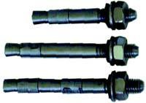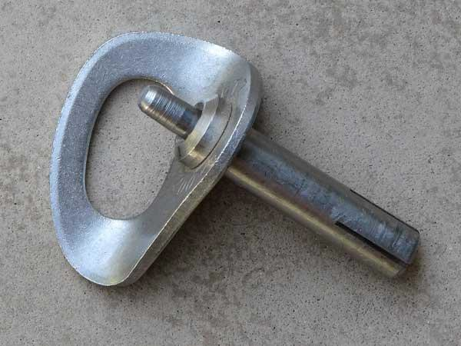

Photo: [www.fixehardware.com](http://www.fixehardware.com/) Photo: [www.petzl.com](http://www.petzl.com/)

Examples of acceptable anchors.

## Fixed Anchor Installation Methods

* + 1. Fixed anchors may be installed using either a hand-held drill or power drill;
    2. Replacement anchors may be placed on rappel or from the ground-up; and
    3. The installation of fixed anchors on new routes from the ground-up, by a lead climber, or from the top-down, on rappel, will be left to the area’s prevailing climbing style and may be addressed in park-specific management plans.

## Replacement of Existing Fixed Anchors

The replacement of fixed anchors on established routes or belay stations will be allowed whenever climbers notify park staff that existing fixed anchors are unsafe. Upon notification, park staff will immediately post information at climbing information kiosks, permit kiosks, and park offices advising climbers that suspect anchors may be present on a specific route. The route in question may remain closed until repairs are made.

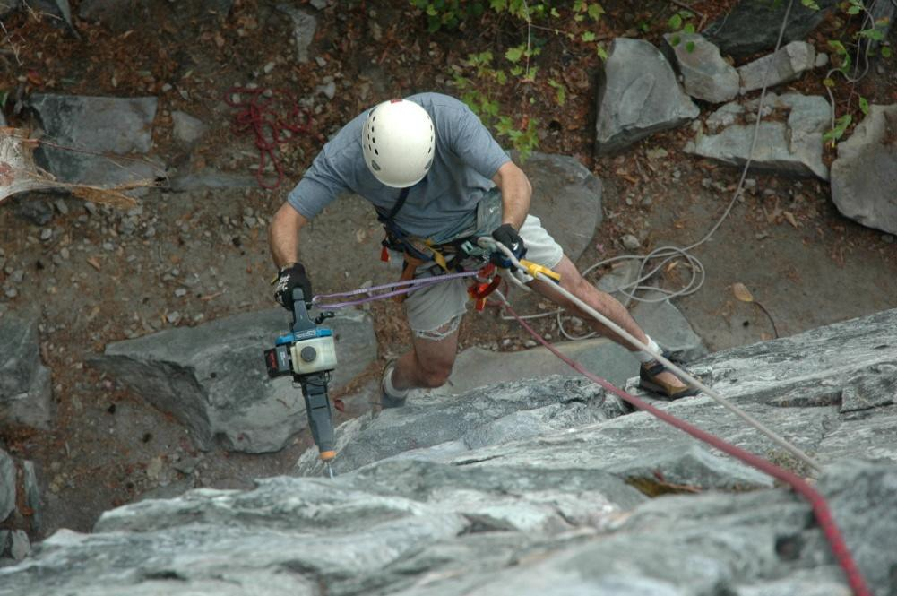

Anchor replacement, Pilot Mountain State Park Photo: NC DPR

## Installation of New Fixed Anchors

There will be situations where the installation of new fixed anchors is prudent. The placement of new fixed anchors may be allowed for:

* + 1. New climbing routes, but only in sections of the route that have no features adequate for the reliable placement of removable hardware such as camming units, wired stoppers, etc.;
    2. Rappel or belay stations, particularly at the tops of routes and for “No Top Out” areas;
    3. Resource protection; and
    4. Any situation in which climbers notify DPR of the need for additional anchors for safety or natural resource protection.

## Belay/Rappel Station Anchors

In addition to the anchor standards noted above, all fixed anchor belay and rappel stations will be located only after due consideration of the following:

* + 1. The use of vegetation for belay and rappel anchors is not recommended;
    2. Fixed belay/rappel stations must have a minimum of two anchors;
    3. CE/UIAA-rated stainless steel ring anchors are preferred but not required;
    4. Anchor stations are to be placed to avoid rope drag across obstructions or sharp edges. Where needed, anchors may be lengthened with CE/UIAA-rated stainless steel chain;
    5. Fixed anchor stations are to be installed so that the anchors can be easily equalized; and
    6. Fixed anchor stations are to remain clean of webbing and accessory cord.

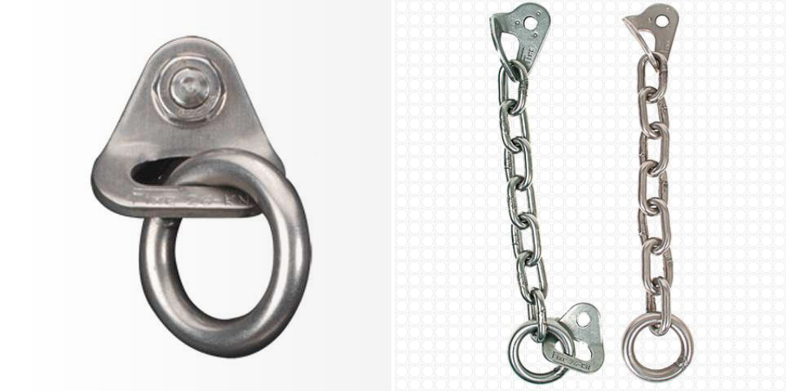

Photo[s: www.fixehardware.com](http://www.fixehardware.com/)

Preferred belay/rappel station anchor types.

# DESIGNATED CLIMBING AREAS

Recreational access may not be appropriate for each cliff and boulder ecosystem within state parks. Climbing will be allowed only in areas designated by the park superintendent. To be eligible for designation as a climbing area, a location must be:

* + 1. Entirely on DPR-owned or managed lands;
    2. Safely accessible by via either road or trail;
    3. The road or trail can be owned by DPR or by a partnership including DPR and other organizations or agencies; and
    4. Amenable to sustainable climbing activities that will not significantly impair a park’s natural or cultural resources.

# NEW ROUTES

The establishment of new routes may be addressed in park specific climbing management plans. All new routes must be located within existing designated climbing areas. In all cases, the following will apply:

**7.0.1** The removal of rock from its natural position will be allowed only if failure to remove the rock poses a risk to safety (loose slabs, flakes, etc.);

* + 1. Chipping or gluing holds is prohibited; and
    2. The intentional removal of vegetation to clean a route is prohibited.

# ROUTE CLOSURES

DPR may close any climbing area to protect wildlife, natural or cultural resources, visitor safety, or visitor experiences. Seasonal closures may be addressed in park-specific plans. Decisions on route or area closures will be made after the consideration of the following:

* + 1. Sensitivity of plant or animal species or natural communities present within the climbing zone;
    2. Sensitivity of cultural resources present within the climbing zone;
    3. Whether climbing activities have or are likely to have an unsustainable, adverse impact on natural or cultural resources; and
    4. Whether public or climber safety compromised by leaving the route(s) or area(s) open.

When appropriate, DPR staff will collaborate with biologists, safety personnel, climbing community representatives, and other qualified sources prior to closing climbing routes to determine how to best address any relevant concerns. In some instances, DPR may have no choice but to close routes to comply with state or federal regulations or conservation strategies. Responsive action may include, but will not be limited to:

* + 1. Installing safety measures, such as fencing, railings, trails, or overlooks;
    2. Visitor education; rare species monitoring; temporary route closures; and
    3. Permanent route closures; installation of new or upgraded anchors or belay stations, etc.

The relocation of rare species will be considered only under extreme circumstances. If permanent closure occurs, then appropriate restoration efforts will be conducted. Any closure will be accompanied by a public education effort.

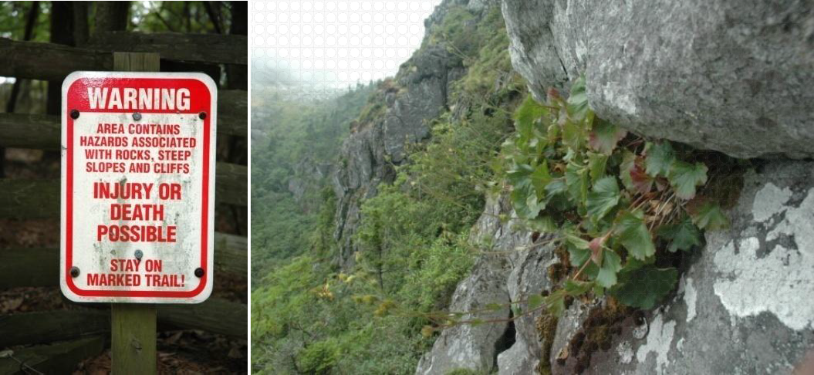

Warning sign, Stone Mountain Spreading Avens, Grandfather Mountain Photos; NC DPR

# BOULDERING

Bouldering is defined as unroped climbing within a short distance of the ground on rock formations that require the use of specialized equipment (rock climbing shoes, chalk, crash pad, etc.) Bouldering may be addressed in park-specific management plans. Bouldering plans will consider:

* + 1. The likely impacts to park resources within and adjacent to the proposed bouldering area(s);
    2. The likely impacts to park resources along and adjacent to the proposed access route(s); and
    3. The likely impacts to other visitor activities and the overall visitor experience.

# 10.0 NO TOP OUT POLICY

Where feasible, DPR climbing areas will adopt a “no top out policy” for all new and established routes, with retreat from the top of any route occurring via fixed anchor stations that are located below the rock face’s top edge. This is intended to both alleviate adverse impacts to cliff-top areas and to avoid the unsafe use of vegetation for anchors. Where desirable and feasible, centralized belay/rappel stations may be installed to serve multiple routes.

Exceptions to the no top out policy may be allowed at the park superintendent’s discretion, and park staff will be encouraged to coordinate with local climbers to establish anchor stations in appropriate locations. In the absence of a no top out program, park staff and climbers should collaborate to ensure adequate access trails that minimize impacts.

# 11.0 LEAVE NO TRACE PRACTICES

DPR will promote responsible, ethical, and environmentally sensitive climbing, which will espouse the National Outdoor Leadership School’s “Leave No Trace” program. DPR staff will collaborate with climbing groups to educate the park’s climbing community and other visitors in order to promote safe and ethical climbing.

# 12.0 RESCUE

While the courts have ruled that public land managers have no duty to rescue climbers or other visitors who are lost, injured, or killed through engagement in their activity (see Johnson v. United States, Department of Interior, 949 F.2d 332, 335, (10thCir. 1991); Kiehn v. United States, 984 F.2d 1100, 1108, (10th Cir. 1993), DPR may undertake rescue operations unless the risks to rescue personnel are deemed unacceptable.

This responsibility may be fulfilled by qualified DPR staff or by qualified search-and-rescue organizations, volunteers, or agencies that are capable of responding to life-threatening emergencies in high angle environments. The park may seek additional resources if at any time the incident commander believes it is in the best interest of the park, safety of employees and visitors, and/or the injured or stranded party. Activating outside resources adds to the response time, but in some cases must be done in order to safely respond. In all cases, efforts will be made to provide the necessary treatment and services to the sick, injured and stranded. Deceased persons will be evacuated unless the level of risk to the rescue party is deemed to be unacceptably high.

# 13.0 GLOSSARY OF CLIMBING TERMS

Most of the text of the following glossary is taken directly from Climbing Management: A Guide to Climbing Issues and the Production of a Climbing Management Plan (Access Fund, 2008).

Anchor: Any piece of protection used to secure climbers to a cliff face for belaying or rappelling. Most are removable. “Fixed anchors” are left in place for all climbers to use.

Belay or belaying: The method by which one climber secures the rope to safeguard the other climber in the event of a fall.

Bolt: Bolts are small devices (usually 3/8” diameter by about 3” length) used to protect climbers where there are no cracks for other types of protection. They are placed by drilling a hole, using either a hand-turned or battery-powered drill, and then driving in the device, which is designed to hold through mechanical expansion, forced compression, or (rarely) an epoxy adhesive.

Bouldering: Bouldering is the term given to climbing that concentrates on short, sequential moves on rock usually no more than 15 feet off the ground. Typically, falls are very short (a few feet) and inconsequential.

Chains: Short lengths of metal chain are sometimes used instead of slings at a rappel or belay station.

Chalk: Chalk dries the hands and is used in rock climbing in the same way it is used in gymnastics, to improve grip.

Climbing shoes: Snug-fitting shoes with high-friction rubber soles and carefully designed edges that allow climbers to stand on tiny footholds.

Crash Pad: Portable padding placed on the ground and used to safeguard climbers in the event of a fall while bouldering.

Fixed anchors: see Anchor and Bolt

Gear: Equipment used for protection (see Anchor and Hardware).

Hardware: Climbing equipment placed in cracks or on faces to protect climbers from falling, including wired nuts, camming devices, pitons, and bolts.

Multi-pitch: A climb of two or more roped pitches (see Pitch) in length.

Pitch: The distance a lead climber ascends before he or she stops to belay the second climber's ascent. The distance of a pitch is limited by the length of rope and the location of ledges and belay stations.

Piton: Small metal spikes, generally two to four inches long, which is placed by hammering it into existing cracks in the rock. Pitons are used only when no other form of protection is available, and are typically left in place for other climbers to use.

Protection: Any form of anchor used between belays to protect a climber. It can be removable or fixed.

Rappel: The method by which a climber descends a rope, usually by using a mechanical friction device.

Rating: A numerical value assigned to indicate the difficulty of the climbing on a particular route.

Route: Any independent line of ascent on a rock face. A climb may follow a crack system or other natural features, or it may strike out across a blank face.

Sport climbing: Climbs that are protected exclusively with fixed protection, usually bolts, are called sport climbs. Sport climbs are typically short – generally a single rope-length (50 to 60meters) or less. They rarely continue to summits, but end at fixed anchors where the sustained difficulty of the climb diminishes, the character of the rock changes, or simply at the half-rope point to allow the climber to descend by being lowered.

Top rope: Technique of practice climbing where the rope is anchored above the climber.

Traditional climbing: A style of climbing where protection is placed by the ascending climber and removed by the seconding partner. Value is placed on unpracticed ascents. Traditional climbers progress up the rock face using natural hand-and footholds, with the rope and technical climbing equipment used only for safety in case of a fall. Typically, traditional climbs are protected by equipment that is removable and does not damage the rock surface.

# 14.0 LITERATURE CITED

Attarian, A. 1991. An Investigation of the Ecological and Social Impacts Caused by Rock Climbers. Proceedings of the 1991 International Conference on Outdoor Recreation. Moscow, Idaho. pp. 7-15.

Attarian, A. 1994. Management Strategies for Reducing Climbing Related Impacts. Unpublished manuscript. 33 pp.

Attarian, A., and Jason Keith. 2008. Climbing Management: A Guide to Climbing Issues and the Production of a Climbing Management Plan. 78 pp. Web-based document from [www.accessfund.org.](http://www.accessfund.org/)

Camp, R.J., and R.L. Knight. 1998. Effects of Rock Climbing on Cliff Plant Communities at Joshua Tree National Park, California. Conservation Biology 12:6, pp. 1302-1306.

Kascenska, J.R., and A. Attarian. 1990. An Overview of the Environmental Impacts of Rock Climbing at North Carolina State Parks. Unpublished report, submitted to the North Carolina Department of Environment, Health, and Natural Resources, Division of Parks and Recreation. 7 pp.

McMillan, M.A., and D.W. Larson. 2002. Effects of Rock Climbing on the Vegetation of the Niagara Escarpment in Southern Ontario, Canada. Conservation Biology16:2, pp. 389-398.

U.S. Department of the Interior, National Park Service. 1995. Obed Wild and Scenic River: General Management Plan, Development Concept Plan, Environmental Impact Statement. 161 pp.

Walker, G.W., Emily Parisher, Peter Smith, David Whitlock, David Kramar, Uta Matthes, and Leslie Morefield. 2008. Characterization of Plant Community Structure and Abiotic Conditions on Climbed and Unclimbed Cliff Faces in the Obed River Gorge. Research report submitted to the National Park Service. 36 pp.

Acknowledgements: DPR staff have benefitted greatly from reviews, comments, and climbing management documents provided by the National Park Service; The Nature Conservancy; The Access Fund; the Carolina Climbers Coalition; the American Mountain Guides Association; and several independent reviewers. Their assistance and collaboration are greatly appreciated.

ATTACHMENT 1

Revised 8-2017

|  |  |
| --- | --- |
|  |  |
| **CLIMBING, BOULDERING & RAPPELLING**  **Registration and Activity Permit**  **Note:** All climbers and rappellers must schedule their activity in order to leave the park by the posted closing hour. See other regulations below. | For our information and your safety please complete this form.  **White copy**: deposit in the registration box or give it to a park ranger prior to activity.  **Yellow copy**: keep in your possession while engaged in climbing or rappelling.  **Name:** ________________________________________________________  **Address: ______________________________________________________**  **City: __________________________________ State: ______ Zip: ________**  **Expected Time of Return: ________________________________AM / PM**  **Vehicle License Plate Number: _____________________________________**  **State of Registration: __________**  **Person to Contact in Case of Emergency:**  **_____________________________________________________________**  **Phone Number: ( )__________________** |
| Division of Parks and Recreation / Department of Natural and Cultural Resources | |
|  | |

**DAY-USE CLIMBING PERMIT**

* All climbers must register with the park staff and must keep in their possession a valid rock climbing/rappelling permit. All climbers under the age of eighteen (18) must have a parent or legal guardian sign their permit prior to participating in any climbing activities at N.C. State Parks.
* **Climbing is an inherently dangerous activity that can result in serious injury, death and/or property damage. Climbers fully assume all risks associated with climbing in N.C. State Parks, including, but not limited to, injury (including death), loss or damages, to person, property or otherwise, of any kind resulting from such risks and any associated activities. Climbers are solely responsible for obtaining proper equipment and training. The N.C. Division of Parks and Recreation offers no supervision or instruction to climbers and does not approve or certify instructors or climbers in any manner. Unroped climbing is discouraged.**
* The N.C. Division of Parks and Recreation does not install or maintain any climbing surface, route, or fixed anchors. New routes are not permitted, unless reviewed through the Park’s climbing management plan.
* Route selection and the decision to rely on any fixed anchors are the climber's sole responsibility.
* Climbing activities are permitted in designated areas only and must coincide with a park's posted hours of operation. Climbers are not allowed to enter the park prior to posted gate opening hours and must leave the park before gate closing time.
* All accidents and injuries must be reported immediately to park staff.
* All climbers must comply with all rules and policies applicable to rock climbing in N.C. State Parks, including the most current version the Rock Climbing Management Guidelines. Copies of the Rock Climbing Management Guidelines can be found at all State Parks where rock climbing is permitted and online at [www.ncparks.gov](http://www.ncparks.gov).

I, ___________________________________, in consideration for being permitted to climb within North Carolina State Parks during the dates of __________________________, hereby acknowledge and agree that I have fully read and understand, agree, to and will comply with the above regulations, which apply to all rock climbing in North Carolina State Parks.

Furthermore, I hereby hold harmless, release and discharge the State of North Carolina, the North Carolina Department of Natural and Cultural Resources, the North Carolina Division of Parks and Recreation, and all their respective officers, employees, agents, and assigns from any and all claims, rights, liabilities, demands, actions, causes of action, damages, expenses, and costs, including but not limited to attorney’s fees, which I or my heirs, personal representative, successor, assigns or anyone claiming by, through or under me ever had, now have, or may have against the parties identified above arising from any injury, damage, act or omission relating in any way to my participation in rock climbing at North Carolina State Parks.

__________________ _____________________________________________

Date Signature of Climber

__________________ _____________________________________________

Date Signature of Parent/Guardian of Climber’s under age 18

ATTACHMENT 2

Revised 8-2017

STATE OF NORTH CAROLINA

DEPARTMENT OF NATURAL AND CULTURAL RESOURCES

DIVISION OF PARKS AND RECREATION

**GROUP CLIMBING APPLICATION**

|  |  |  |  |  |  |  |  |
| --- | --- | --- | --- | --- | --- | --- | --- |
| **Park Name:** | |  | | | | | |
| **Name of Group:** | | |  | | | | |
| **Name of Applicant:** | | | |  | **Position/Office Held:** | |  |
| **Address:** |  | | | | | | |
| **Phone Number:** | | |  | | **Email:** |  | |
| **Date of Submission:** | | | |  | | | |

ATTACHMENTS:

Proof of Liability Insurance

I hereby acknowledge with my signature a full and complete understanding of the general conditions with which this activity will comply and agree to abide by these conditions and any special provisions required by the North Carolina Division of Parks and Recreation.

|  |  |  |
| --- | --- | --- |
| **Signature of Responsible Official:** | |  |
| **Title:** |  | |

|  |  |  |  |  |  |  |  |  |  |  |
| --- | --- | --- | --- | --- | --- | --- | --- | --- | --- | --- |
| *For office use only.*   |  |  |  |  |  | | --- | --- | --- | --- | --- | | Application Code: |  | | Date of Issue: |  | | Signature of Approving Official: | |  | | | |

GENERAL CONDITIONS

1. Applicant shall not discriminate against any persons because of race, religion, color, sex, age or national origin, in the conduct of its operation under this application or other authorization.

2. Applicant agrees to exercise the privileges granted in this application, in accordance with all rules and regulations of the North Carolina Department of Natural and Cultural Resources and the Division of Parks and Recreation.

3. Applicant agrees to comply with all Federal Laws and regulations and all the laws, ordinances, and regulations of the State, County, and municipality where in the said premises are located, with regard to construction, sanitation, licenses, or permits to do business, and all other matters.

4. Applicant agrees to keep the buildings and grounds clean and in a sanitary condition. It shall be the responsibility of the Applicant to leave the buildings, grounds, equipment and facilities in a clean and orderly condition at end of occupancy. The right is reserved to charge a cleanup or repair fee if this is not done. Upon the expiration or termination of this application, the said premises shall be delivered up in as good repair and condition as the same are in at beginning of occupancy.

5. No timber, tree, or shrub shall be cut, damaged or destroyed, nor shall any other natural feature be damaged or destroyed.

6. No building or structure shall be altered, erected or constructed except as specified as a condition of this application.

7. Applicant shall use said premises only for authorized recreational purposes, and shall not operate, or permit to be operated, any concession or profit making enterprise which involves the sale of goods, food, merchandise or other article, commodity, or service to the general public, unless authorized by this application.

8. Applicant shall not transfer or assign this application, nor sublet said premises or any part thereof or grant use of any part of this application to person(s) not subject to this application.

9. Applicant shall and hereby does waive and release any and all claim against the North Carolina Department of Natural and Cultural Resources, the Division of Parks and Recreation, the State of North Carolina, and/or any of their employees, agents or assigns for any and all damages, loss, cost to person or property arising either directly or indirectly from the use of said premises and/or from the exercise of the privileges granted by this application.

10. Applicant shall take necessary and proper steps to provide for the health and safety of participants on said premises.

11. Applicant shall, prior to exercising any rights herein granted, submit a master traffic pattern for the direction and care or vehicular access and parking, if required by the site Park Superintendent.

12. The Division Chief of Operations, site’s Park Superintendent, or their designated representative shall have authority to revoke, this application and require removal of any equipment upon failure of the Applicant to comply with the terms and/or conditions of the application. In the event an application is revoked, the fee is non-refundable.

13. Applicant shall not advertise the event or activity except as specified as a condition of this application.

Climbing-Specific Conditions

1. Organized Climbing Groups
   1. An organized climbing group is defined as any organized group, which is guided or instructed by a commercial business, not-for-profit, school, church, club, private organization, or governmental organization.
   2. A group is defined as greater than five (5) and no greater than fourteen (14) persons, including climbing participants, instructors and bystanders, with a student to instructor ratio of no more than 6:1. Groups are allowed to split up to different climbing sites, but the actual group must be no more than 14 people.
   3. Groups are allowed to use no more than four (4) parking spaces. Approval of a Group Climbing Application (GCA) in no way guarantees there will be ample parking spaces. The parking lot fills often, and once it does, no additional parking is permitted until spaces become available.
   4. Groups may be limited to certain areas or routes within the climbing area at the discretion of the Park Superintendent or his/her designee.
   5. Climbing routes and areas cannot be reserved. If a climbing route or area is already in use, the group must wait until the user(s) has completed their use or select another route/area.
   6. Cooperating agencies may be exempted from specific conditions of this permit at the discretion of the park superintendent or his/her designee, not to include climber’s acknowledgment of the activity’s risk and adherence to park climbing regulations.
   7. Groups may be limited to ten reservations per quarter, six of which may fall on the weekend. Quarters are January to March, April to June, July to September, and October to December.
2. The Climbing Permit System

A GCA is required for all individuals prior to rock climbing at all North Carolina State Parks. Free permits are available at park offices, online at [www.ncparks.gov](http://www.ncparks.gov), and at information kiosks in all climbing areas. Permits are valid for the dates specified only. Each individual should complete and sign the permit, and group leaders should deposit the white portion or a copy of the permit in the provided receptacle or to the Park Superintendent and retain the yellow portion or a copy of the permit for the duration of their group’s activity. All climbers under the age of eighteen (18) must have a parent or legal guardian sign their permit prior to participating in any climbing activities at North Carolina State Parks.

1. Group Climbing Application

All organized groups are required to submit a GCA for approval for each day the group plans to climb. Groups will be assessed a $35.00 fee per climbing reservation. The group leader must carry a copy of the approved GCA and the yellow copy of each individual’s day-use permit (see above) with them during their climb.

1. Park Rules and Regulations

Groups will adhere to all park regulations, rules and policies regarding rock climbing, including the most current version the Rock Climbing Management Guidelines. It is the applicant’s responsibility to make sure all climbers associated with their group are familiar with and abide by all applicable rules.

1. Climbing is an inherently dangerous activity that can result in serious injury, death and/or property damage. Climbers fully assume all risks associated with climbing in North Carolina State Parks, including, but not limited to, injury (including death), loss or damages, to person, property or otherwise, of any kind resulting from such risks and any associated activities. Climbers are solely responsible for obtaining proper equipment and training. The N.C. Division of Parks and Recreation offers no supervision or instruction to climbers and does not approve or certify instructors or climbers in any manner. Unroped climbing is discouraged.
2. The Division of Parks and Recreation does not install or maintain any climbing surface, route or fixed anchors. New routes are not permitted, unless reviewed through the Park’s climbing management plan.
3. Route selection and the decision to rely on any fixed anchors are the climber’s sole responsibility.
4. Climbing activities are permitted in designated areas only and must coincide with the park’s posted hours of operations. Climbers are not allowed to enter the park prior to posted gate opening hours and must leave the park before gate closing time.
5. All accidents must be reported immediately to park staff.
6. Groups will not leave roped routes unattended in a fashion that limits the use of climbing routes by the general public. Roped routes left unattended will be assumed abandoned and the users are subject to be charged with unintentional littering under G.S. 14-399(c1). Ropes left unattended on routes will be discarded if the owner cannot be located.
7. Failure to abide by these conditions will result in revocation of this Special Activity Permit and affect consideration of future climbing requests. Some violations may be subject to a citation.