NC DIVISION OF PARKS AND RECREATION

June 5, 2018

**STAFF DIRECTIVE 18-05**

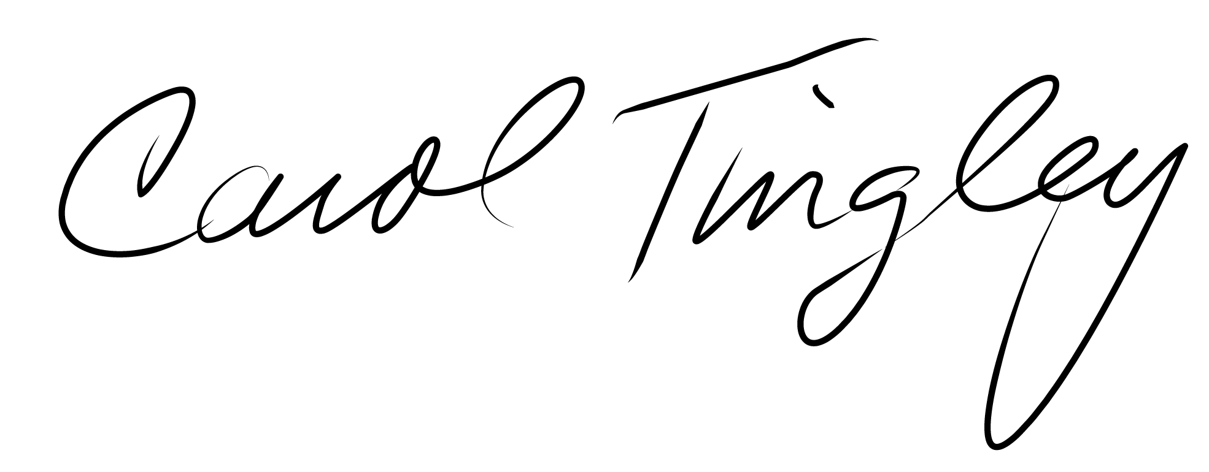

TO: All Division Staff

FROM: Carol A. Tingley, Deputy Director

SUBJECT: Safety Policy – ATV / UTV Procedure

All-terrain vehicles (ATV) and Utility task vehicles (UTV) enable division employees to accomplish a variety of tasks within the state parks. They are designed to navigate rough terrain and travel to remote areas that standard vehicles are unable to access. As there are inherent risks with operating these vehicles, proper training is necessary to minimize accidents and/or injuries.

The ATV/UTV procedure policy provides requirements and best management practices for safe operation of ATVs and UTVs by park staff. Prior to operating such equipment, staff must successfully complete ATV/UTV training and sign the operator’s acknowledgment form, which should be kept on file in the park office.

For any questions regarding this policy, please contact the division safety consultant.