**NC DIVISION OF PARKS AND RECREATION**

July 10, 2020

**STAFF DIRECTIVE 20-03**

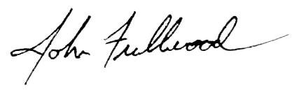TO: All Division Staff

FROM: John Fullwood, Interim Director

SUBJECT: Fire Management Guidelines

Attached are the new DPR Fire Management Guidelines. These guidelines were updated to reflect the evolution of the State Parks Fire Program and are based on recommendations from the Division Fire Management Team, made up of Natural Resource and Operations staff with expertise in fire management. Please review and retain a copy at the Park.

For questions related to the Division’s Fire Program, please contact Thomas Crate, DPR Fire Management Officer.

Attachment