**Orc's Vs Trolls Practical (Due see CA Spreadsheet)**

Complete a Polymorphic C++ console game which utilises Encapsulation, Inheritance and Polymorphism and pointers. The game must include Orc's and Trolls who battle for control of a kingdom. This is Turn Based Game, and you should be able to play as Orc or Troll.

[FANTASY BATTLE 3,000 TROLLS vs 2,000,000 ORCS | Ultimate Epic Battle Simulator 2 | UEBS 2](https://www.youtube.com/watch?v=Fx6_10M-Oy8&ab_channel=BATTLENOMERCY)

[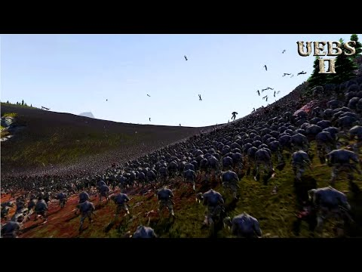](https://www.youtube.com/watch?v=Fx6_10M-Oy8&ab_channel=BATTLENOMERCY)

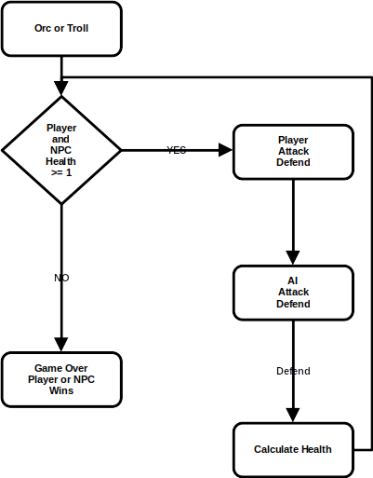

|  |  |  |  |
| --- | --- | --- | --- |
| **Game Design Brief** | | | |
| **Orc** | | **Troll** | |
| Attack | Min 2 Weapons | **Attack** | Min 2 Weapons |
| **Bat** | Power 1..n  Cooldown 1..n | **Bat** | Power 1...n  Cooldown 1..n |
| **Sword** | Power 1..n  Cooldown 1..n | **Sword** | Power 1..n  Cooldown 1..n |
| Defend | Min 1 Sheild | Defend | Min 1 Sheild |
| Shield | Power 1..n  Cooldown 1..n | **Shield** | Power 1..n  Cooldown 1..n |
| Game Balance is important, e.g sword cooldown is e.g. 2 turns after use. Sheild Cooldown is 1 turn e.g can choose Bat or Sword (but Sword can only be used after 2 turns). Otherwise, you will have included overpowered weapons.   |  |  | | --- | --- | | **Game Action** | **Internal Economy** | | Bat v Bat | – 20 Player and NPC | | Bat v Sword | – 30 Player or NPC (whichever is holding Bat) | | Bat v Sheild | + 10 Player or NPC (whichever is holding Bat) | |  |  | | Sword v Bat | + 20 Player or NPC (whichever is holding Sword) | | Sword v Sword | – 10 Player and NPC | | Sword v Sheild | + 30 Player or NPC (whichever is holding Sword) | |  |  | | Sheild v Sheild | –10 Player and NPC | | Sheild v Bat | + 10 Player or NPC (whichever is holding Sheild) | | Sheild v Sword | - 30 Player or NPC (whichever is holding Sheild) |     Player and AI (NPC) rounds are based on above or your own turn-based design. Both start on 100 Health. First turn goes to player. Then AI chooses based on the Cooldown Rules you specify.  As part of you submission include the above Game Balance Table | | | |

StarterKit available here

<https://bitbucket.org/MuddyGames/orcsvstroll/src/master/>

|  |  |  |
| --- | --- | --- |
| **0 -35** | **35-75** | **75-100** |
| * A selection of the basic game requirements have been implemented to a basic level * Game implementation will achieve minimum functionality * Game implementation may contain some syntax and/or run-time errors * Game implementation code will be poorly commented and/or formatted * Game implementation will contain basic features; application will not be tested properly * Game implementation code will not follow applicable coding conventions | * Game implementation requirement have been implemented to an acceptable level * Game implementation will achieve expected functionality * Game implementation will not contain syntax and/or run-time errors * Game implementation code will be adequately commented and/or formatted * Game will be tested to a reasonable degree * Game implementation code will follow appropriate coding conventions * Encapsulation, Inheritance and Polymorphism and pointers adequately implemented | * Game implementation requirement have been implemented to an advanced level * Game implementation will have novel gameplay * Game implementation will not contain syntax and/or run-time errors * Game implementation code will be well commented and/or formatted * Game will be expertly tested * Game implementation of code will follow coding conventions * Encapsulation, Inheritance and Polymorphism and pointers expertly implemented * Game will include Pointers to Pointers |
| **Extensions as follows**  **1-day late Mark – 25%**  **2-days late Mark–35%**  **3-days late Mark–55%**  **4-days late Mark–65%**  **5-days or more late Mark–85% (Max week 11)** | | |