Urban Heat Island Visual Correlations

tree_plot_value = ggplot(tree_value)+  
 geom_sf(aes(fill = value_disc))+  
 scale_fill_gradient2("Value Discrepency",low = "firebrick4", mid = "white", high = "deepskyblue4", breaks=c(min(tree_value$value_disc),0,max(tree_value$value_disc)),labels=c("-$9,000","$0","$15,000"))+  
 #scale_colour_brewer(palette = "PiYG")+  
 labs(x = "", y = "", title = "Tree Value Discrepency Based on Simulated Tree \nIntensity By Census Tract")+  
 geom_sf(data = Wallercreek,   
 fill = "NA",   
 color = "black",   
 size = 1)+  
 theme_minimal()+  
 coord_sf(datum=NA)  
tree_plot_value

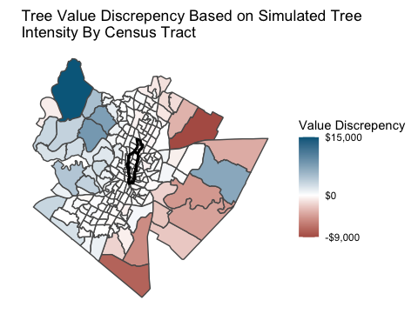

croppedcensus = st_read(dsn = ".", layer = "treewallerclipped") %>%   
 st_transform(crs = 4326)

## Reading layer `treewallerclipped' from data source `/Users/madelinegorchels/Desktop/UCSB/AustinAgua/AustinAgua/UHI/ForestCorrelations/Tree_Planting_Prioritization_2014' using driver `ESRI Shapefile'  
## Simple feature collection with 24 features and 28 fields  
## geometry type: MULTIPOLYGON  
## dimension: XY  
## bbox: xmin: -97.74495 ymin: 30.25887 xmax: -97.70772 ymax: 30.35127  
## CRS: 4326

tree_value_waller = croppedcensus %>%  
 mutate(tree_intensity = tree_sum/shape_area) %>%   
 mutate(tree_disc=tree_intensity-avg_tree) %>%   
 mutate(tree_disc_num = tree_disc*shape_area) %>%   
 mutate(value_disc = tree_disc_num*value_per_tree)

tree_plot_waller_value = ggplot(tree_value_waller)+  
 geom_sf(aes(fill = value_disc))+  
 scale_fill_gradient2("Value Discrepency",low = "firebrick4", mid = "white", high = "deepskyblue4", breaks=c(min(tree_value_waller$value_disc),0,max(tree_value_waller$value_disc)),labels=c("-$550","$0","$400"))+  
 #scale_colour_brewer(palette = "PiYG")+  
 labs(x = "", y = "", title = "Tree Value Discrepency Based on Simulated Tree \nIntensity By Census Tract")+  
 geom_sf(data = Wallercreek,   
 fill = "NA",   
 color = "black",   
 size = 1)+  
 theme_minimal()+  
 coord_sf(datum=NA)  
tree_plot_waller_value

