Urban Heat Island, Tree Cover, and the 2017 American Community Survey

Several census tracts were missing from the American Community Survey data download. I am sure this data exists, missing tracts will need to be individually searched for and added to the dataset. 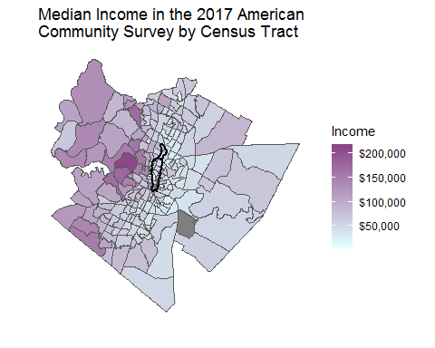

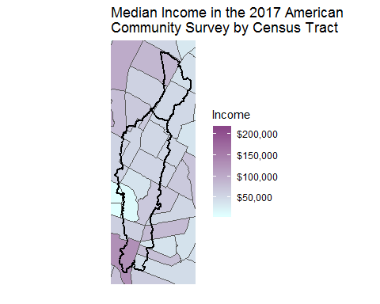

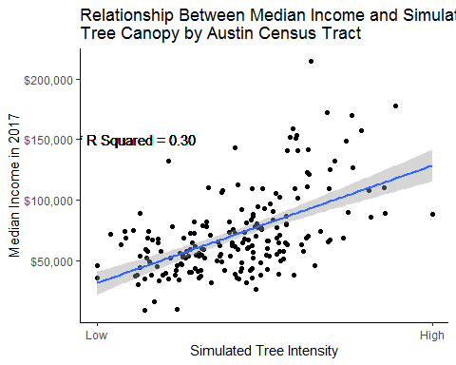 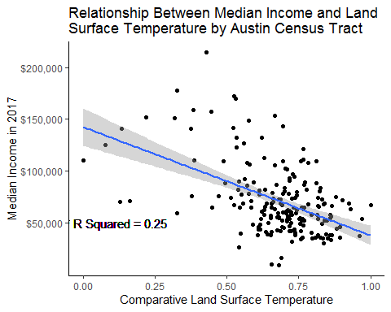

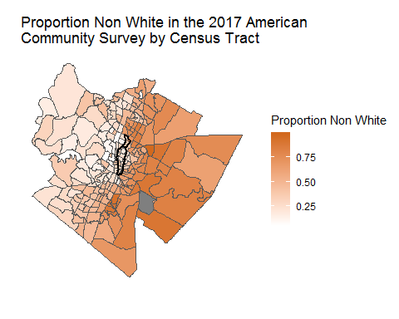

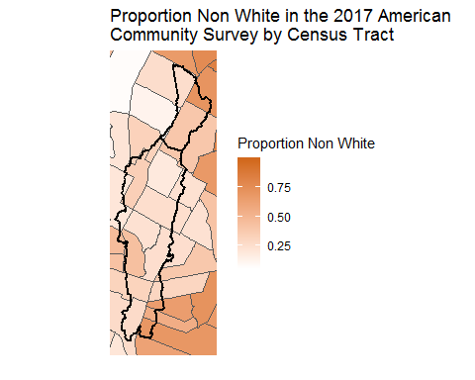

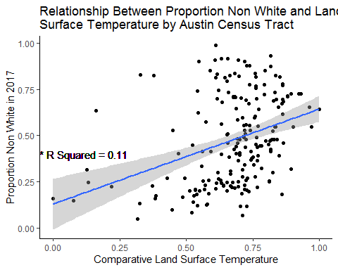

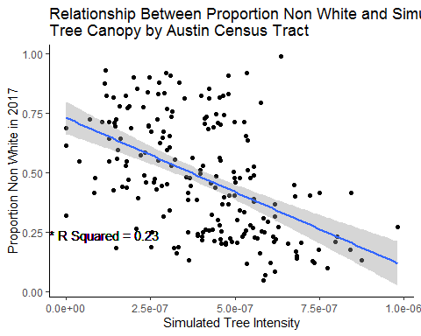

mult_uhi = lm(uhi.x~median_income+nonwhite+tree_intensity, data = racial_makeup)  
summary(mult_uhi)

##   
## Call:  
## lm(formula = uhi.x ~ median_income + nonwhite + tree_intensity,   
## data = racial_makeup)  
##   
## Residuals:  
## Min 1Q Median 3Q Max   
## -0.65262 -0.05334 0.01666 0.07828 0.24322   
##   
## Coefficients:  
## Estimate Std. Error t value Pr(>|t|)   
## (Intercept) 9.237e-01 5.042e-02 18.321 < 2e-16 ***  
## median_income -1.490e-06 3.793e-07 -3.929 0.000119 ***  
## nonwhite -2.580e-02 5.195e-02 -0.497 0.620007   
## tree_intensity -3.139e+05 6.143e+04 -5.110 7.73e-07 ***  
## ---  
## Signif. codes: 0 '***' 0.001 '**' 0.01 '*' 0.05 '.' 0.1 ' ' 1  
##   
## Residual standard error: 0.1315 on 193 degrees of freedom  
## (3 observations deleted due to missingness)  
## Multiple R-squared: 0.3356, Adjusted R-squared: 0.3253   
## F-statistic: 32.5 on 3 and 193 DF, p-value: < 2.2e-16

stargazer(mult_uhi, type = "html")

Dependent variable:

uhi.x

median_income

-0.00000***

(0.00000)

nonwhite

-0.026

(0.052)

tree_intensity

-313,866.600***

(61,426.620)

Constant

0.924***

(0.050)

Observations

197

R2

0.336

Adjusted R2

0.325

Residual Std. Error

0.131 (df = 193)

F Statistic

32.501*** (df = 3; 193)

Note:

*p<0.1;* ***p<0.05;*** p<0.01