My FindClosestPair() divide and conquer method works by implementing a recursive Divide and Conquer algorithm, saving the closest points and closest distance via static instance variables. An unusual feature of my implementation is that the “centerPoints” array of points within the “combine” step is created as the same size as the array of points passed into the initial method call. This is done in order to find and track the number of points whose horizontal distance is less than the minimum distance within a single iteration statement.

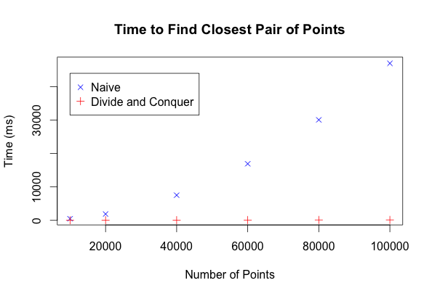

**Divide and Conquer Trials:**

Trial 1: 100 sets of of 50,000 Randomly Generated Points, different sets of points:

Maximum Time: 69 ms

Minimum Time: 20 ms

Average Time: 23.59 ± 1.45 ms (95% Confidence Interval)

Trial 2: 100 sets of of 50,000 Randomly Generated Points, same set of points:

Maximum Time: 69 ms

Minimum Time: 20 ms

Average Time: 24.17 ± 1.55 ms (95% Confidence Interval)

**Sources:**

I used a few different references in order to to help me complete my coding and analysis for this project.

**For help with the coding and algorithm:**

Cormen, Thomas H. *Introduction to Algorithms*. 3rd ed. Cambridge, Mass.: MIT, 2009. Print.

Notes from the Course Website

Professor Buhler and the TA's via Piazza

**For Help with Statistical Analysis:**

Tamhane, Ajit C., and Dorothy D. Dunlop. Statistics and Data Analysis: From Elementary to Intermediate. Upper Saddle River, NJ: Prentice Hall, 2000. Print.

[http://stattrek.com](http://stattrek.com/)– various pages.