HW 03

Tuan Bui

## Question 01:

income_data <- read.csv('~/OneDrive - Stony Brook University/SBU/MAT + AMS/Fall 2021/AMS 380/hw/03/income.data.csv', header = T)  
  
attach(income_data)  
  
fit <- lm(income ~ happiness)  
fit

##   
## Call:  
## lm(formula = income ~ happiness)  
##   
## Coefficients:  
## (Intercept) happiness   
## 0.9053 1.0497

# a. The least square regression line equation: income = 0.9053 + 1.0497 * happiness  
  
# b. Plot the points and regression line in the same figure  
plot(income, happiness)  
abline(fit)

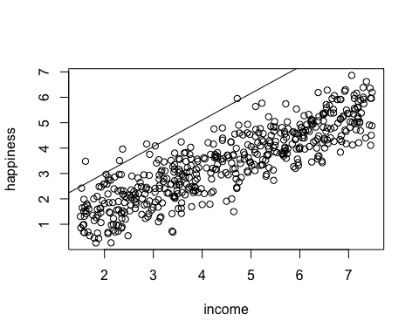

# c. Check assumptions:  
par(mfrow = c(2,2))  
plot(fit)

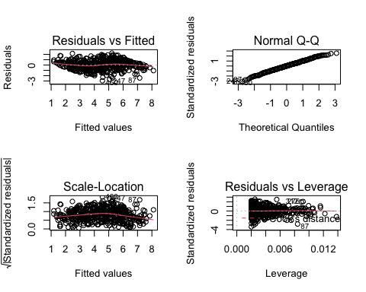

## 1. Linearity: it is satisfied because the residuals are symmetrically distributed around the 0-line in the Residuals vs Fitted plot.  
  
## 2. Homoscedasticity: it is satisfied because the square root of standardized residuals is symmetrically distributed around the 1-line in the Scale-Location plot.  
  
## 3. Independence: assume it is satisfied  
  
## 4. Normality:  
shapiro.test(residuals(fit))

##   
## Shapiro-Wilk normality test  
##   
## data: residuals(fit)  
## W = 0.99682, p-value = 0.4377

### p-value is 0.4377 greater than the significance level 0.05, so residuals is normal distributed, normality assumption is satisfied  
  
# d. Sample correlation coefficient between the 2 variables:  
cor(income, happiness)

## [1] 0.8656337

## Sample correlation coefficient is 0.8656337  
  
## The corresponding population correlation test:  
cor.test(income, happiness)

##   
## Pearson's product-moment correlation  
##   
## data: income and happiness  
## t = 38.505, df = 496, p-value < 2.2e-16  
## alternative hypothesis: true correlation is not equal to 0  
## 95 percent confidence interval:  
## 0.8417942 0.8861031  
## sample estimates:  
## cor   
## 0.8656337

### p-value is less than 2.2e-16, which is less than the significance level 0.05, reject H0. The correlation is not 0.  
  
# e.  
summary(fit)

##   
## Call:  
## lm(formula = income ~ happiness)  
##   
## Residuals:  
## Min 1Q Median 3Q Max   
## -2.94796 -0.57730 0.02277 0.55661 2.23185   
##   
## Coefficients:  
## Estimate Std. Error t value Pr(>|t|)   
## (Intercept) 0.90533 0.10039 9.018 <2e-16 ***  
## happiness 1.04973 0.02726 38.505 <2e-16 ***  
## ---  
## Signif. codes: 0 '***' 0.001 '**' 0.01 '*' 0.05 '.' 0.1 ' ' 1  
##   
## Residual standard error: 0.8708 on 496 degrees of freedom  
## Multiple R-squared: 0.7493, Adjusted R-squared: 0.7488   
## F-statistic: 1483 on 1 and 496 DF, p-value: < 2.2e-16

## The coefficient of determination is 0.7493  
## p-value for coefficient of happiness is less than 2.2e-16, which is less than the significance level 0.05, reject H0. There is a significantly linear relationship between income and happiness.  
  
# f. ANOVA table of the regression  
anova(fit)

## Analysis of Variance Table  
##   
## Response: income  
## Df Sum Sq Mean Sq F value Pr(>F)   
## happiness 1 1124.32 1124.32 1482.6 < 2.2e-16 ***  
## Residuals 496 376.13 0.76   
## ---  
## Signif. codes: 0 '***' 0.001 '**' 0.01 '*' 0.05 '.' 0.1 ' ' 1

### The p-value for ANOVA F-test is less than 2.2e-16, which is less than the significance level 0.05, reject H0. The regression effect is significant.  
  
detach(income_data)

## Question 02:

heart_data <- read.csv('~/OneDrive - Stony Brook University/SBU/MAT + AMS/Fall 2021/AMS 380/hw/03/heart.data.csv', header = T)  
attach(heart_data)  
  
fit <- lm (heart.disease ~ biking)  
fit

##   
## Call:  
## lm(formula = heart.disease ~ biking)  
##   
## Coefficients:  
## (Intercept) biking   
## 17.7779 -0.2003

# a.The least square regression line equation:   
## heart.disease = 17.7779 - 0.2003 * biking  
  
# b. Plot  
plot(heart.disease, biking)  
abline(fit)

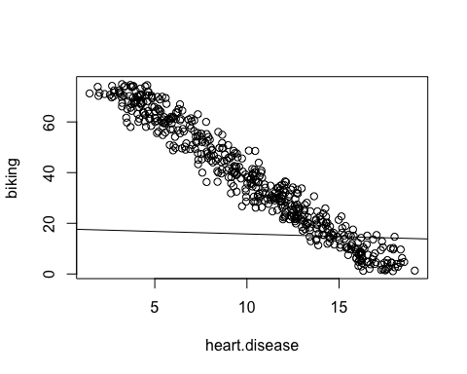

# c. Check assumptions:  
par(mfrow = c(2,2))  
plot(fit)

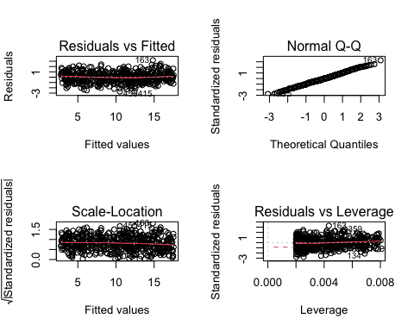

## 1. Linearity: it is satisfied because the residuals are symmetrically distributed around the 0-line in the Residuals vs Fitted plot.  
  
## 2. Homoscedasticity: it is satisfied because the square root of standardized residuals is symmetrically distributed around the 1-line in the Scale-Location plot.  
  
## 3. Independence: assume it is satisfied  
  
## 4. Normality:  
shapiro.test(residuals(fit))

##   
## Shapiro-Wilk normality test  
##   
## data: residuals(fit)  
## W = 0.99801, p-value = 0.8351

### p-value is 0.8351 greater than the significance level 0.10, so residuals is normal distributed, normality assumption is satisfied  
  
# d. Sample correlation coefficient between the 2 variables:  
cor(heart.disease, biking)

## [1] -0.9753352

## Sample correlation coefficient is -0.9753352  
  
## The corresponding population correlation test:  
cor.test(heart.disease, biking)

##   
## Pearson's product-moment correlation  
##   
## data: heart.disease and biking  
## t = -98.409, df = 496, p-value < 2.2e-16  
## alternative hypothesis: true correlation is not equal to 0  
## 95 percent confidence interval:  
## -0.9792783 -0.9706530  
## sample estimates:  
## cor   
## -0.9753352

### p-value is less than 2.2e-16, which is less than the significance level 0.10, reject H0. The correlation is not 0.  
  
# e.  
summary(fit)

##   
## Call:  
## lm(formula = heart.disease ~ biking)  
##   
## Residuals:  
## Min 1Q Median 3Q Max   
## -2.6975 -0.6277 -0.0205 0.6482 3.1787   
##   
## Coefficients:  
## Estimate Std. Error t value Pr(>|t|)   
## (Intercept) 17.777880 0.088450 200.99 <2e-16 ***  
## biking -0.200297 0.002035 -98.41 <2e-16 ***  
## ---  
## Signif. codes: 0 '***' 0.001 '**' 0.01 '*' 0.05 '.' 0.1 ' ' 1  
##   
## Residual standard error: 0.9747 on 496 degrees of freedom  
## Multiple R-squared: 0.9513, Adjusted R-squared: 0.9512   
## F-statistic: 9684 on 1 and 496 DF, p-value: < 2.2e-16

## The coefficient of determination is 0.9513  
## p-value for coefficient of biking is less than 2.2e-16, which is less than the significance level 0.10, reject H0. There is a significantly linear relationship between heart.disease and biking.  
  
# f. The percentage of people in the town who have heart disease if the percentage of people who bike to work is 65% in that town:  
heart.disease_rate <- 17.7779 - 0.2003 * 65  
heart.disease_rate

## [1] 4.7584

## There are 4.7584% people in the town who have heart disease if the percentage of people who bike to work is 65% in that town.  
  
# g. The 90% confidence interval:  
confint(fit, level = 0.90)

## 5 % 95 %  
## (Intercept) 17.6321212 17.9236392  
## biking -0.2036511 -0.1969429

detach(heart_data)