HW 05

TUAN BUI

10/3/2021

housing_data <- read.csv('~/OneDrive - Stony Brook University/SBU/MAT + AMS/Fall 2021/AMS 380/hw/05/Ames_Housing_Data.csv', header = T)  
  
library(tidyverse)

## ── Attaching packages ─────────────────────────────────────── tidyverse 1.3.1 ──

## ✓ ggplot2 3.3.5 ✓ purrr 0.3.4  
## ✓ tibble 3.1.4 ✓ dplyr 1.0.7  
## ✓ tidyr 1.1.3 ✓ stringr 1.4.0  
## ✓ readr 2.0.1 ✓ forcats 0.5.1

## ── Conflicts ────────────────────────────────────────── tidyverse_conflicts() ──  
## x dplyr::filter() masks stats::filter()  
## x dplyr::lag() masks stats::lag()

library(caret)

## Loading required package: lattice

##   
## Attaching package: 'caret'

## The following object is masked from 'package:purrr':  
##   
## lift

library(glmnet)

## Loading required package: Matrix

##   
## Attaching package: 'Matrix'

## The following objects are masked from 'package:tidyr':  
##   
## expand, pack, unpack

## Loaded glmnet 4.1-2

# Question 1

colSums(is.na(housing_data))

## Id LotArea OverallQual OverallCond YearBuilt YearRemodAdd   
## 0 0 0 0 0 0   
## CentralAir X1stFlrSF X2ndFlrSF GrLivArea FullBath HalfBath   
## 0 0 0 0 0 0   
## BedroomAbvGr KitchenAbvGr TotRmsAbvGrd Fireplaces GarageCars GarageArea   
## 0 0 0 0 0 0   
## YrSold SalePrice   
## 0 0

## There is no missing values observation in this data

# Question 2

# Dividing the data into 75% training and 25% testing  
set.seed(123)  
housing.samples <- housing_data$SalePrice %>%  
 createDataPartition(p = 0.75, list = FALSE)  
train.data <- housing_data[housing.samples, ]  
test.data <- housing_data[-housing.samples, ]

# Question 3

# Predictor variables  
x <- model.matrix(SalePrice~., train.data)[,-1]  
# Outcome variable  
y <- train.data$SalePrice

## 3.a.

# Make predictions on the test data  
cv_3 <- cv.glmnet(x, y, alpha = 0)  
# Display the best lambda value  
cv_3$lambda.min

## [1] 6452.856

## The best lambda value is 6452.856

## 3.b.

model_3 <- glmnet(x, y, alpha = 0, lambda = cv_3$lambda.min)  
# Display the coefficients of the fitted model  
coef(model_3)

## 20 x 1 sparse Matrix of class "dgCMatrix"  
## s0  
## (Intercept) -5.868377e+04  
## Id -2.400086e+00  
## LotArea 6.829978e-01  
## OverallQual 1.552083e+04  
## OverallCond 4.734443e+03  
## YearBuilt 4.367701e+02  
## YearRemodAdd 2.036837e+02  
## CentralAirY -9.163648e+03  
## X1stFlrSF 5.141967e+01  
## X2ndFlrSF 1.721007e+01  
## GrLivArea 3.865641e+01  
## FullBath -2.576679e+03  
## HalfBath 3.410324e+02  
## BedroomAbvGr -1.072097e+04  
## KitchenAbvGr -3.025974e+04  
## TotRmsAbvGrd 4.279323e+03  
## Fireplaces 5.279621e+03  
## GarageCars 2.424886e+03  
## GarageArea 3.650612e+01  
## YrSold -6.243367e+02

## 3.c.

# Make predictions on the test data  
x.test <- model.matrix(SalePrice ~., test.data)[,-1]  
predictions_3 <- model_3 %>% predict(x.test) %>% as.vector()  
  
# Plot predictions   
plot(test.data$SalePrice ,predictions_3, xlab = "SalePrice", ylab = "Prediction")

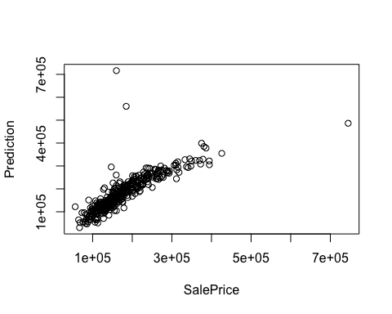

# Model performance metrics  
data.frame(  
 RMSE = RMSE(predictions_3, test.data$SalePrice),  
 Rsquare = R2(predictions_3, test.data$SalePrice)  
)

## RMSE Rsquare  
## 1 46713.63 0.6691365

# Question 4

## 4.a.

# Make predictions on the test data  
cv_4 <- cv.glmnet(x, y, alpha = 1)  
# Display the best lambda value  
cv_4$lambda.min

## [1] 352.4729

## The best lambda value is 352.4729

## 4.b.

model_4 <- glmnet(x, y, alpha = 1, lambda = cv_4$lambda.min)  
# Display the coefficients of the fitted model  
coef(model_4)

## 20 x 1 sparse Matrix of class "dgCMatrix"  
## s0  
## (Intercept) -6.160530e+05  
## Id -1.359380e+00  
## LotArea 6.885348e-01  
## OverallQual 1.673469e+04  
## OverallCond 5.628004e+03  
## YearBuilt 5.183887e+02  
## YearRemodAdd 1.105492e+02  
## CentralAirY -1.011034e+04  
## X1stFlrSF 3.613856e+01  
## X2ndFlrSF .   
## GrLivArea 6.455739e+01  
## FullBath -4.871532e+03  
## HalfBath -2.083079e+02  
## BedroomAbvGr -1.188420e+04  
## KitchenAbvGr -2.869665e+04  
## TotRmsAbvGrd 3.101192e+03  
## Fireplaces 3.087910e+03  
## GarageCars .   
## GarageArea 3.684554e+01  
## YrSold -3.393338e+02

## 4.c.

# Make predictions on the test data  
predictions_4 <- model_4 %>% predict(x.test) %>% as.vector()  
  
# Plot predictions   
plot(test.data$SalePrice ,predictions_4, xlab = "SalePrice", ylab = "Prediction")

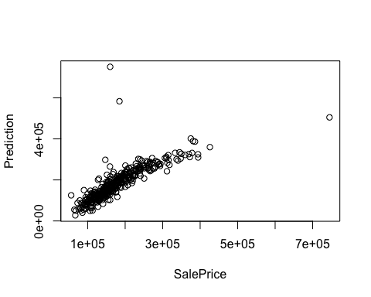

# Model performance metrics  
data.frame(  
 RMSE = RMSE(predictions_4, test.data$SalePrice),  
 Rsquare = R2(predictions_4, test.data$SalePrice)  
)

## RMSE Rsquare  
## 1 48460.31 0.6606179

# Question 5

## 5.a.

model_5 <- train(  
 SalePrice ~., data = train.data, method = "glmnet",  
 trControl = trainControl("cv", number = 10),  
 tuneLength = 10  
)  
# Best tuning parameter  
model_5$bestTune

## alpha lambda  
## 5 0.1 849.1095

## 5.b.

coef(model_5$finalModel, model_5$bestTune$lambda)

## 20 x 1 sparse Matrix of class "dgCMatrix"  
## s1  
## (Intercept) -3.184591e+05  
## Id -2.065248e+00  
## LotArea 6.999641e-01  
## OverallQual 1.641517e+04  
## OverallCond 5.931914e+03  
## YearBuilt 5.464418e+02  
## YearRemodAdd 1.242764e+02  
## CentralAirY -1.246334e+04  
## X1stFlrSF 5.519033e+01  
## X2ndFlrSF 2.097999e+01  
## GrLivArea 4.537295e+01  
## FullBath -6.947849e+03  
## HalfBath -2.248932e+03  
## BedroomAbvGr -1.256102e+04  
## KitchenAbvGr -3.025522e+04  
## TotRmsAbvGrd 3.844605e+03  
## Fireplaces 3.509950e+03  
## GarageCars .   
## GarageArea 3.757935e+01  
## YrSold -5.263536e+02

## 5.c.

predictions_5 <- model_5 %>% predict(test.data)  
  
#Plot  
plot(test.data$SalePrice ,predictions_5, xlab = "SalePrice", ylab = "Prediction")

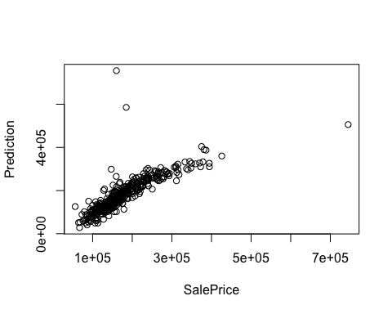

# Model performance metrics  
data.frame(  
 RMSE = RMSE(predictions_5, test.data$SalePrice),  
 Rsquare = R2(predictions_5, test.data$SalePrice)  
)

## RMSE Rsquare  
## 1 48709.54 0.6592282

## 5.d.

lambda_1 <- 10^seq(-3, 3, length = 100)  
  
# Ridge model  
ridge <- train(  
 SalePrice ~., data = train.data, method = "glmnet",  
 trControl = trainControl("cv", number = 10),  
 tuneGrid = expand.grid(alpha = 0, lambda = lambda_1)  
 )  
  
# Lasso model  
lasso <- train(  
 SalePrice ~., data = train.data, method = "glmnet",  
 trControl = trainControl("cv", number = 10),  
 tuneGrid = expand.grid(alpha = 1, lambda = lambda_1)  
 )  
  
# Elastic model  
elastic <- train(  
 SalePrice ~., data = train.data, method = "glmnet",  
 trControl = trainControl("cv", number = 10),  
 tuneLength = 10  
 )  
  
# Compare  
models <- list(ridge = ridge, lasso = lasso, elastic = elastic)  
resamples(models) %>% summary(metric = "RMSE")

##   
## Call:  
## summary.resamples(object = ., metric = "RMSE")  
##   
## Models: ridge, lasso, elastic   
## Number of resamples: 10   
##   
## RMSE   
## Min. 1st Qu. Median Mean 3rd Qu. Max. NA's  
## ridge 25407.72 28499.66 31543.68 33244.48 36674.04 45814.19 0  
## lasso 27048.45 30155.21 30940.18 33129.10 34034.23 43217.22 0  
## elastic 27627.21 31063.40 32297.70 33287.69 35716.51 40038.10 0

## It can be seen that the Lasso net model has the lowest median RMSE. Hence, Lasso model is the best for the Ames Housing data.