HW 08

TUAN BUI

11/16/2021

library(tidyverse)

## ── Attaching packages ─────────────────────────────────────── tidyverse 1.3.1 ──

## ✓ ggplot2 3.3.5 ✓ purrr 0.3.4  
## ✓ tibble 3.1.4 ✓ dplyr 1.0.7  
## ✓ tidyr 1.1.3 ✓ stringr 1.4.0  
## ✓ readr 2.0.1 ✓ forcats 0.5.1

## ── Conflicts ────────────────────────────────────────── tidyverse_conflicts() ──  
## x dplyr::filter() masks stats::filter()  
## x dplyr::lag() masks stats::lag()

library(caret)

## Loading required package: lattice

##   
## Attaching package: 'caret'

## The following object is masked from 'package:purrr':  
##   
## lift

library(randomForest)

## randomForest 4.6-14

## Type rfNews() to see new features/changes/bug fixes.

##   
## Attaching package: 'randomForest'

## The following object is masked from 'package:dplyr':  
##   
## combine

## The following object is masked from 'package:ggplot2':  
##   
## margin

library(kernlab)

##   
## Attaching package: 'kernlab'

## The following object is masked from 'package:purrr':  
##   
## cross

## The following object is masked from 'package:ggplot2':  
##   
## alpha

spambase_data <- read.table('~/OneDrive - Stony Brook University/SBU/MAT + AMS/Fall 2021/AMS 380/hw/08/spambase.data', sep = ",")  
  
spambase_names <- read.delim('~/OneDrive - Stony Brook University/SBU/MAT + AMS/Fall 2021/AMS 380/hw/08/spambase.names')  
  
spambase_names <- spambase_names[-c(1:29),]  
spambase_names <- as.data.frame(spambase_names)  
spambase_names <- spambase_names %>%  
 separate(spambase_names, c("Variable", "Type"), sep = ":")   
names(spambase_data) <- spambase_names$Variable  
names(spambase_data)[58] <- 'class'  
  
# clean data  
spambase_data <- na.omit(spambase_data)  
  
spambase_data$class <- as.factor(spambase_data$class)

# Question 01:

# Use the random seed 123 to divide the cleaned data into 75% training and 25% testing  
set.seed(123)  
training.samples <- spambase_data$class %>%   
 createDataPartition(p = 0.75, list = FALSE)  
train.data <- spambase_data[training.samples, ]  
test.data <- spambase_data[-training.samples, ]

# Question 02:

set.seed(123)  
model <- train(  
 class ~., data = train.data, method = "rf",  
 trControl = trainControl("cv", number = 10),  
 importance = TRUE  
 )  
  
predicted.classes_1 <- model %>% predict(train.data)  
  
# Confusion matrix of the training data   
table(predicted.classes_1, train.data$class)

##   
## predicted.classes_1 0 1  
## 0 2091 2  
## 1 0 1358

mean(predicted.classes_1 == train.data$class)

## [1] 0.9994205

# The overall accuracy of the training data is 0.9994205  
  
sum((train.data$class == 1)*(predicted.classes_1 == 1))/sum(train.data$class ==  
1)

## [1] 0.9985294

# The sensitivity of the test data is 0.9985294  
  
sum((train.data$class == 0)*(predicted.classes_1 == 0))/sum(train.data$class ==  
0)

## [1] 1

# The specificity of the test data is 1

# Question 03:

predicted.classes_2 <- model %>% predict(test.data)  
  
# Confusion matrix of the testing data  
table(predicted.classes_2, test.data$class)

##   
## predicted.classes_2 0 1  
## 0 674 34  
## 1 23 419

mean(predicted.classes_2 == test.data$class)

## [1] 0.9504348

# The overall accuracy of the testing data is 0.9504348  
  
sum((test.data$class == 1)*(predicted.classes_2 == 1))/sum(test.data$class ==  
1)

## [1] 0.9249448

# The sensitivity of the testing data is 0.9249448  
  
sum((test.data$class == 0)*(predicted.classes_2 == 0))/sum(test.data$class ==  
0)

## [1] 0.9670014

# The specificity of the testing data is 0.9670014

# Question 04:

# Plot MeanDecreaseAccuracy  
varImpPlot(model$finalModel, type = 1)

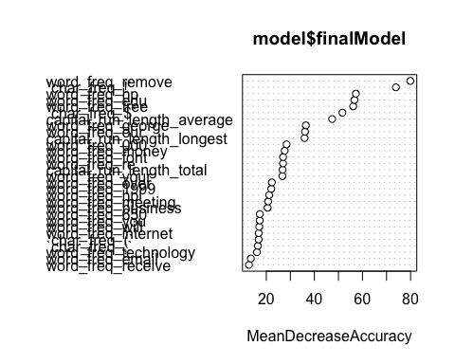

# Plot MeanDecreaseGini  
varImpPlot(model$finalModel, type = 2)

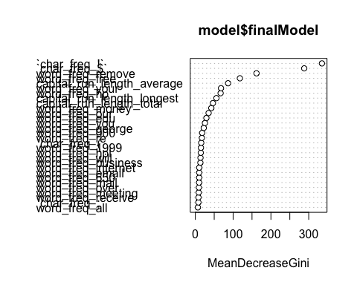

# Question 05:

# The importance of each variable in percentage based on MeanDecreaseAccuracy  
varImp(model$finalModel, type = 1)

## Overall  
## word_freq_make 8.153946  
## word_freq_address 9.367384  
## word_freq_all 6.902195  
## word_freq_3d 11.807186  
## word_freq_our 36.103842  
## word_freq_over 22.307910  
## word_freq_remove 79.892670  
## word_freq_internet 16.843599  
## word_freq_order 12.148703  
## word_freq_mail 12.358148  
## word_freq_receive 12.781801  
## word_freq_will 17.058283  
## word_freq_people 8.937479  
## word_freq_report 8.684960  
## word_freq_addresses 6.577593  
## word_freq_free 56.136717  
## word_freq_business 20.560001  
## word_freq_email 13.563499  
## word_freq_you 17.255713  
## word_freq_credit 8.753119  
## word_freq_your 26.697597  
## word_freq_font 26.977270  
## word_freq_000 28.440091  
## word_freq_money 27.628663  
## word_freq_hp 57.245508  
## word_freq_hpl 21.207529  
## word_freq_george 36.460092  
## word_freq_650 17.305336  
## word_freq_lab 12.332069  
## word_freq_labs 10.002784  
## word_freq_telnet 5.097685  
## word_freq_857 6.688856  
## word_freq_data 5.389617  
## word_freq_415 5.611032  
## word_freq_85 11.228468  
## word_freq_technology 16.113064  
## word_freq_1999 22.059059  
## word_freq_parts 3.843755  
## word_freq_pm 12.666298  
## word_freq_direct 4.832203  
## word_freq_cs 5.346080  
## word_freq_meeting 20.748908  
## word_freq_original 7.560766  
## word_freq_project 6.885084  
## word_freq_re 26.956730  
## word_freq_edu 56.642240  
## word_freq_table 1.073460  
## word_freq_conference 10.188196  
## `char_freq_;` 16.495985  
## `char_freq_(` 16.824041  
## `char_freq_[` 6.488239  
## `char_freq_!` 73.894087  
## `char_freq_$` 51.642349  
## `char_freq_#` 7.792698  
## capital_run_length_average 47.378136  
## capital_run_length_longest 35.917454  
## capital_run_length_total 26.784196

# Question 6:

mtry <- 26  
p <- mtry*3  
p

## [1] 78

# The number of variables we should (as commonly recommended) to select, at random, to be considered for that node split are 78