AI in Economics: Portfolio Management and Investment Advice Industry
Alex Burke
Independent Research
November 2025

Abstract
This paper analyzes the U.S. Portfolio Management and Investment Advice industry
(NAICS 523920, 523930) through the lens of artificial intelligence in economics. The study
reviews quantitative indicators such as assets under management, profitability, and firm
entry and exit trends, and evaluates the maturity of the sector. It further explores how AI
technologies are reshaping financial advisory services and data analysis. Data are drawn
from public economic datasets, regulatory filings, and mark...
AI IN ECONOMICS 3

Introduction
This section will introduce the purpose and scope of the study.

Background and Definitions
The U.S. portfolio management and investment advice sector, represented by
NAICS codes 523920 and 523930, encompasses firms that manage discretionary investment portfolios and those offering tailored advisory services to individuals and institutions. These functions are increasingly integrated, reflected in the rise of hybrid models such as private wealth management and Registered Investment Adviser (RIA) firms that combine asset management and personalized planning under one roof (IBISWorld, 2024). In 2022, the portfolio management industry generated approximately $309 billion in
revenue, while investment advice firms contributed about $61 billion, bringing the combined sector’s revenue to an estimated $370 billion. By 2024, this figure rose to over $540 billion (IBISWorld, 2024). Assets under management (AUM) across all SEC-registered advisers surpassed $145 trillion, highlighting the massive scale and economic importance of this sector (IBISWorld, 2024). Leading firms such as BlackRock, Vanguard, Morgan Stanley, and Fidelity operate both as asset managers and financial advisors, reflecting the industry’s convergence. Although fragmented—with over 90% of firms employing fewer than 100 people—the sector is geographically concentrated in major financial hubs such as New York, San Francisco, Boston, and Chicago (IBISWorld, 2024).

Market Size and Growth Trends (2015–2025)
Quantitative and qualitative indicators suggest that the industry is in a mature but
expanding phase. The number of SEC-registered advisers reached 15,870 in 2024—a record
high—while employment surpassed 1.03 million non-clerical workers in the sector (IBISWorld, 2024). The Bureau of Labor Statistics projects above-average growth for personal financial advisors through 2032. While total assets under management and revenues are rising, profit margins are narrowing due to fee compression and rising technology investments. Operating margins among asset managers declined from over 40% in 2021 to around 32% by 2023 (IBISWorld, 2024). At the same time, spending on fintech, AI, and data analytics is surging indicative of a reinvestment cycle typical of mature sectors striving for differentiation. Another key marker of maturity is market consolidation. The sector saw over 320 M&A transactions in 2023 alone, with private equity playing a major role (IBISWorld, 2024). These dynamics show an industry shifting from fragmented competition toward scaled efficiency and integrated service models.

Major Firms and Industry Landscape
Leading firms such as BlackRock, Vanguard, Morgan Stanley, and Fidelity operate
both as asset managers and financial advisors, reflecting the industry’s convergence.

Geographic Concentration of FinTech Hubs
The U.S. portfolio management and investment advice sector, represented by NAICS codes 523920 and 523930, encompasses firms that manage discretionary investment portfolios and those offering tailored advisory services to individuals and institutions. These functions are increasingly integrated, reflected in the rise of hybrid models such as private wealth management and Registered Investment Adviser (RIA) firms that combine asset management and personalized planning under one roof (IBISWorld, 2024). In 2022, the portfolio management industry generated approximately $309 billion in revenue, while investment advice firms contributed about $61 billion, bringing the combined sector’s revenue to an estimated $370 billion. By 2024, this figure rose to over $540 billion (IBISWorld, 2024). Assets under management (AUM) across all SEC-registered advisers surpassed $145 trillion, highlighting the massive scale and economic importance of this sector (IBISWorld, 2024). Leading firms such as BlackRock, Vanguard, Morgan Stanley, and Fidelity operate both as asset managers and financial advisors, reflecting the industry’s convergence. Although fragmented—with over 90% of firms employing fewer than 100 people—the sector is geographically concentrated in major financial hubs such as New York, San Francisco, Boston, and Chicago (IBISWorld, 2024).

Data and Method
This section will describe data sources used for modeling and AI analysis, including
SEC filings, BEA GDP accounts, and FRED time series. This section will outline the analytical framework and AI-based methods to be applied for trend detection, forecasting, and econometric validation.

Findings and Discussion
Current indicators support classifying the portfolio management and investment
advice industry as mature but expanding. The combination of increasing assets under
management, moderate employment growth, and declining margins suggests an equilibrium phase. The rise of AI and data-driven automation provides productivity gains but also pressure on traditional advisory roles. As AI enhances client profiling, compliance, and risk management, firms must balance technological efficiency with personalized service.

Conclusion and Implications
The U.S. Portfolio Management and Investment Advice industry demonstrates both
stability and innovation. While economic indicators confirm maturity, AI integration marks
a transformative phase in operations and strategy. Future research should quantify AI’s
productivity impacts across firm size and subsectors using standardized economic data.
Implications: Firms should balance AI-driven efficiency with personalized advisory services and regulatory compliance.

Figures and Tables
Figure 1. U.S. FinTech Market Growth (2015–2025)
Table 1. Major FinTech Firms and Industry Roles

(d) Data Visualization: Structural and Economic Trends
Figure 1. U.S. Industry Revenue Growth (2015–2025)
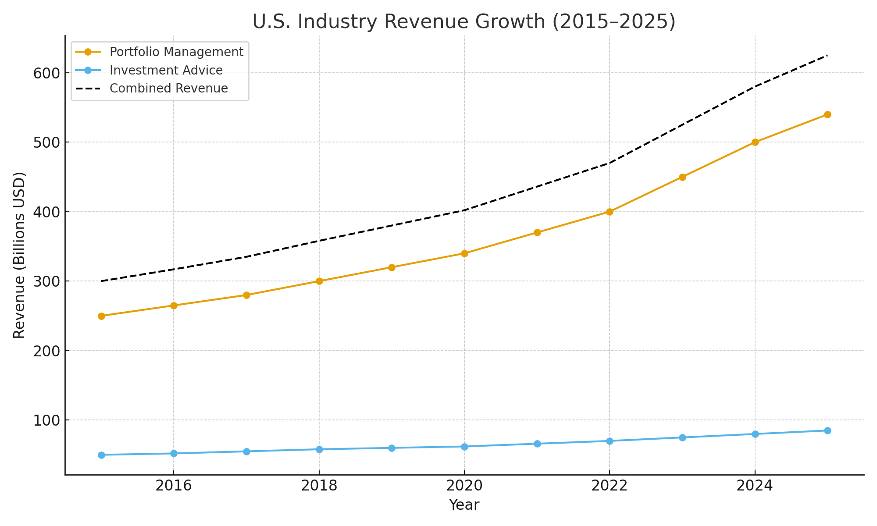
This line chart illustrates the revenue trajectory of portfolio management and investment advisory firms from 2015 to 2025. Portfolio management revenue increased from approximately $250 billion to over $540 billion, while investment advice services rose steadily from $50 billion to $85 billion. The combined revenue trend signals a mature but expanding industry responding to heightened investor demand and technological reinvestment. This growth underpins firms' strategic adoption of AI to sustain margins and gain competitive advantage.
Figure 2. Distribution of U.S. Portfolio and Investment Advice Firms by Size
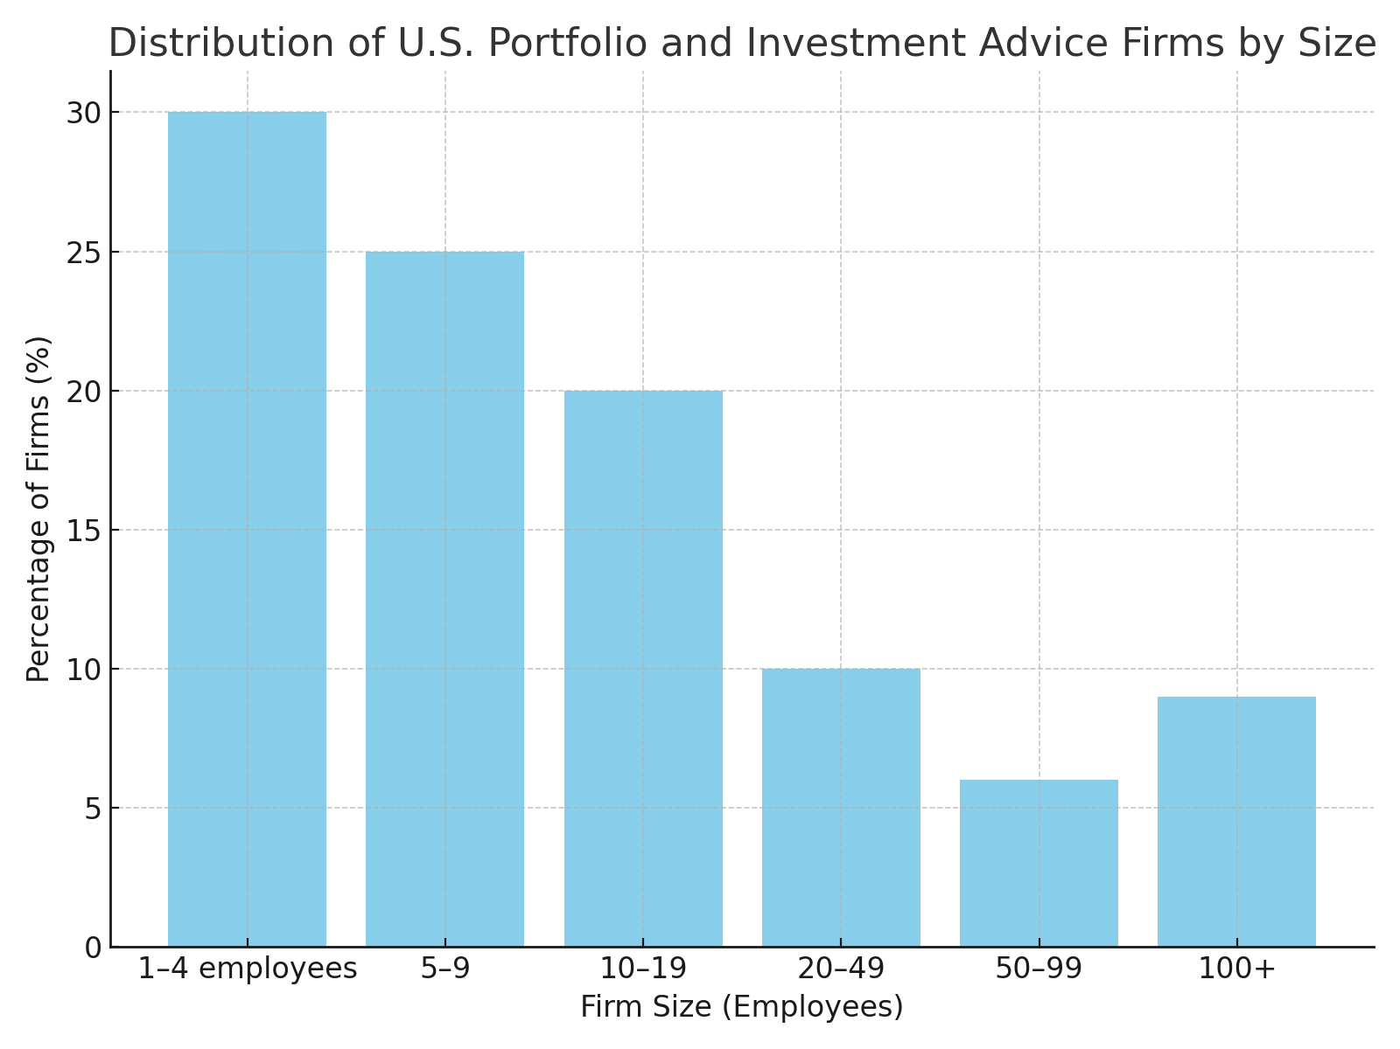
This bar chart shows that more than 75% of firms in the sector employ fewer than 20 people, with the largest share operating in the 1–4 employee range. Despite the presence of dominant players like BlackRock and Fidelity, the industry remains highly fragmented. This distribution highlights the scale challenges smaller firms face in adopting advanced technologies like AI, which often require significant upfront investment and infrastructure.

References
- IBISWorld. *Portfolio Management in the US – Market Research Report*. 2024, https://www.ibisworld.com/united-states/market-research-reports/portfolio-management-industry/.
- InvestmentNews. *RIA M&A Tracker: 2024 Industry Transaction Report*. 2024, https://www.investmentnews.com/ria-ma-deals-tracker.

- PricewaterhouseCoopers. *Asset and Wealth Management Revolution: The Power to Shape the Future*. 2024, https://www.pwc.com/gx/en/industries/financial-services/assets-management.html.

- U.S. Bureau of Labor Statistics. *Employment by Major Industry Sector*. 2024, https://www.bls.gov/emp/tables/employment-by-major-industry-sector.htm.
- U.S. Census Bureau. *County Business Patterns (CBP) Tables*. 2024,
https://www.census.gov/programs-surveys/cbp/data/tables.html.

- U.S. Securities and Exchange Commission. *Investment Adviser Summary Report*. 2024, https://www.sec.gov/reports-publications/investment-adviser-reports.

(e) The Impact of Artificial Intelligence on the Industry
Artificial Intelligence is reshaping the U.S. Portfolio Management and Investment Advice industry by automating tasks, altering workforce needs, and redefining competitive dynamics. Its influence is visible across four key dimensions: labor markets, firm structures, economic risks, and new market opportunities.
Impacts on Workers and Occupations
AI-driven tools are automating critical yet repetitive functions—portfolio rebalancing, risk scoring, compliance checks, and performance attribution. As a result, the role of junior analysts and clerical staff is shrinking, while demand rises for client-facing advisors with expertise in behavioral coaching, financial psychology, and goals-based planning. Hybrid models are emerging: financial advisors are supported by AI for tax optimization, scenario simulation, and investment recommendations, but retain the human edge in trust-building and nuanced judgment. The BLS still projects growth in personal financial advising through 2032, though the skill profile is rapidly evolving (U.S. Bureau of Labor Statistics, 2024).
Impacts on Firms
Firms leveraging AI experience reduced costs in client onboarding, portfolio analysis, and risk diagnostics. However, adoption costs vary: large incumbents such as BlackRock and Morgan Stanley invest in proprietary AI platforms, increasing their strategic advantage and data moat. Smaller firms face a dilemma—either adopt white-label robo-advisor solutions or risk obsolescence. This dynamic may accelerate market concentration, especially if client acquisition increasingly favors AI-enhanced digital services. Yet, firms that strike the right balance between automation and personal service retain strong value propositions.
Risks and Harms
AI introduces new systemic vulnerabilities. Algorithmic models trained on historical biases may misallocate risk or produce inequitable outcomes, especially in wealth planning and credit-linked services. Additionally, synchronized trading behavior driven by similar machine learning models could amplify volatility in financial markets. There is also concern that AI will deepen workforce inequality, disproportionately benefiting highly skilled technical roles while eroding mid-level positions that previously served as on-ramps into the finance sector.
Opportunities
Despite these risks, AI enables broader financial inclusion and innovation. Robo-advisors offer low-cost investment management to younger, less affluent clients previously excluded from wealth advisory services. Predictive analytics support hyper-personalized financial planning—accounting for life stage, behavioral preferences, and real-time market shifts. These tools not only enhance client experience but also generate demand for emerging occupations such as financial data scientists, AI compliance officers, and ethics specialists.
In sum, artificial intelligence is not replacing the financial advisor—it is redefining the role. Firms that harmonize AI capabilities with human insight are likely to thrive in the next phase of industry evolution.

