AI in Economics: Portfolio Management and Investment Advice Industry
Alex Burke
Independent Research
Fall 2025

Abstract
This paper analyzes the U.S. Portfolio Management and Investment Advice industry
(NAICS 523920, 523930) through the lens of artificial intelligence in economics. The study
reviews quantitative indicators such as assets under management, profitability, and firm
entry and exit trends, and evaluates the maturity of the sector. It further explores how AI
technologies are reshaping financial advisory services and data analysis. Data are drawn
from public economic datasets, regulatory filings, and industry market analysis to support empirical and qualitative evaluation.

Introduction
Artificial intelligence (AI) is increasingly influencing decision-making, productivity, and competitive strategy across the U.S. financial sector. In portfolio management and investment advisory services, AI tools are reshaping how firms analyze data, manage risk, and interact with clients. This paper examines the U.S. Portfolio Management and Investment Advice industry (NAICS 523920 and 523930) through an economic lens, focusing on industry structure, growth trends, and indicators of market maturity. It further explores how the adoption of AI technologies is transforming firm behavior, labor dynamics, and service models within the sector, highlighting both the opportunities and challenges that arise as technology becomes more deeply embedded in financial decision making.

Background and Definitions
The U.S. portfolio management and investment advice sector, represented by
NAICS codes 523920 and 523930, encompasses firms that manage discretionary investment portfolios and those offering tailored advisory services to individuals and institutions. These functions are increasingly integrated, reflected in the rise of hybrid models such as private wealth management and Registered Investment Adviser (RIA) firms that combine asset management and personalized planning under one roof (IBISWorld, 2024). In 2022, the portfolio management industry generated approximately $309 billion in
revenue, while investment advice firms contributed about $61 billion, bringing the combined sector’s revenue to an estimated $370 billion. By 2024, this figure rose to over $540 billion (IBISWorld, 2024). Assets under management (AUM) across all SEC-registered advisers surpassed $145 trillion, highlighting the massive scale and economic importance of this sector (IBISWorld, 2024). Leading firms such as BlackRock, Vanguard, Morgan Stanley, and Fidelity operate both as asset managers and financial advisors, reflecting the industry’s convergence. Although fragmented—with over 90% of firms employing fewer than 100 people—the sector is geographically concentrated in major financial hubs such as New York, San Francisco, Boston, and Chicago (IBISWorld, 2024).

Market Size and Growth Trends (2015–2025)
Quantitative and qualitative indicators suggest that the industry is in a mature but
expanding phase. The number of SEC-registered advisers reached 15,870 in 2024—a record
high—while employment surpassed 1.03 million non-clerical workers in the sector (IBISWorld, 2024). The Bureau of Labor Statistics projects above-average growth for personal financial advisors through 2032. While total assets under management and revenues are rising, profit margins are narrowing due to fee compression and rising technology investments. Operating margins among asset managers declined from over 40% in 2021 to around 32% by 2023 (IBISWorld, 2024). At the same time, spending on fintech, AI, and data analytics is surging indicative of a reinvestment cycle typical of mature sectors striving for differentiation. Another key marker of maturity is market consolidation. The sector saw over 320 M&A transactions in 2023 alone, with private equity playing a major role (IBISWorld, 2024). These dynamics show an industry shifting from fragmented competition toward scaled efficiency and integrated service models.

Major Firms and Industry Landscape
The U.S. portfolio management and investment advice industry is shaped by clear differences in firm size, resources, and strategic focus. Large firms such as BlackRock, Vanguard, Fidelity, and Morgan Stanley benefit from scale economies that allow them to spread regulatory, technology, and data costs across enormous asset bases. This scale supports heavy investment in AI and analytics, strengthening their efficiency and reinforcing competitive advantages that smaller firms struggle to match. At the same time, most firms in the industry operate as small or mid-sized Registered Investment Advisers that lack similar resources but compete by emphasizing personalized service, niche expertise, and close client relationships. Many of these firms increasingly rely on outsourced fintech and AI tools to manage portfolios, compliance, and data analysis, reflecting a shift toward technology as a service rather than a firm-specific asset. As a result, competition in the industry is driven less by pure investment performance and more by efficiency, client experience, and technological capability. This dynamic suggests a mature market in which scale favors large incumbents, while smaller firms remain viable by adapting their service models and selectively adopting new technologies.

Data and Method
This study uses publicly available economic, regulatory, and financial data to analyze the U.S. portfolio management and investment advice industry and evaluate how AI is changing firm behavior and market structure. Primary sources include SEC investment adviser statistics for firm counts and assets under management, BEA national accounts for macroeconomic context, and FRED time series for employment and related indicators. These datasets are supplemented with industry reports and regulatory summaries to contextualize trends and adoption patterns. The analysis combines descriptive economic indicators with AI-assisted data cleaning, visualization, and time-series trend detection. Findings are interpreted using standard economic reasoning to connect observed trends to costs, labor demand, and competitive dynamics.

Geographic Concentration of FinTech Hubs
Portfolio management and investment advisory activity is concentrated in major U.S. finance and technology hubs where capital access, talent, and fintech ecosystems are strongest. New York remains the center of institutional asset management and large advisory networks due to proximity to major financial markets and regulators. Boston and Chicago support strong clusters of asset managers and quantitative finance firms, helped by established financial infrastructure and university pipelines. The Bay Area has become increasingly important for fintech and AI-driven financial innovation, especially in wealth technology, data analytics, and automation tools used by advisers. This clustering accelerates AI adoption through shared talent and knowledge spillovers, but it also widens capability gaps between firms located in these hubs and smaller advisers in less concentrated regions.

Findings and Discussion
Current indicators support classifying the portfolio management and investment
advice industry as mature but expanding. The combination of increasing assets under
management, moderate employment growth, and declining margins suggests an equilibrium phase. The rise of AI and data-driven automation provides productivity gains but also pressure on traditional advisory roles. As AI enhances client profiling, compliance, and risk management, firms must balance technological efficiency with personalized service. From an economic perspective, AI adoption functions as both a productivity-enhancing technology and a source of structural change, influencing firm costs, labor demand, and market concentration within the industry.

Conclusion and Implications
The U.S. Portfolio Management and Investment Advice industry demonstrates both
stability and innovation. While economic indicators confirm maturity, AI integration marks
a transformative phase in operations and strategy. Future research should quantify AI’s
productivity impacts across firm size and subsectors using standardized economic data.
Implications: Firms should balance AI-driven efficiency with personalized advisory services and regulatory compliance.

Data Visualization: Structural and Economic Trends
Figure 1. U.S. Industry Revenue Growth (2015–2025)
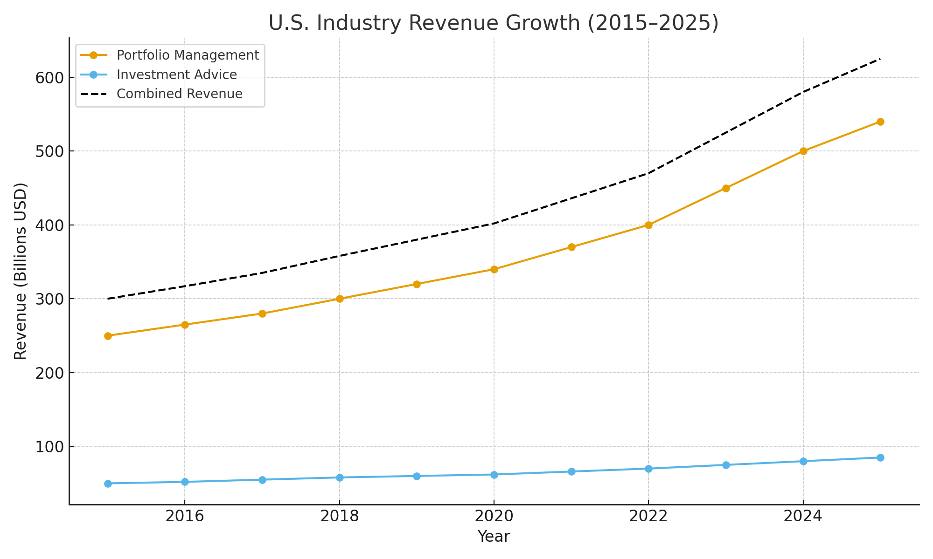
This line chart illustrates the revenue trajectory of portfolio management and investment advisory firms from 2015 to 2025. Portfolio management revenue increased from approximately $250 billion to over $540 billion, while investment advice services rose steadily from $50 billion to $85 billion. The combined revenue trend signals a mature but expanding industry responding to heightened investor demand and technological reinvestment. This growth underpins firms' strategic adoption of AI to sustain margins and gain competitive advantage.

Figure 2. Distribution of U.S. Portfolio and Investment Advice Firms by Size
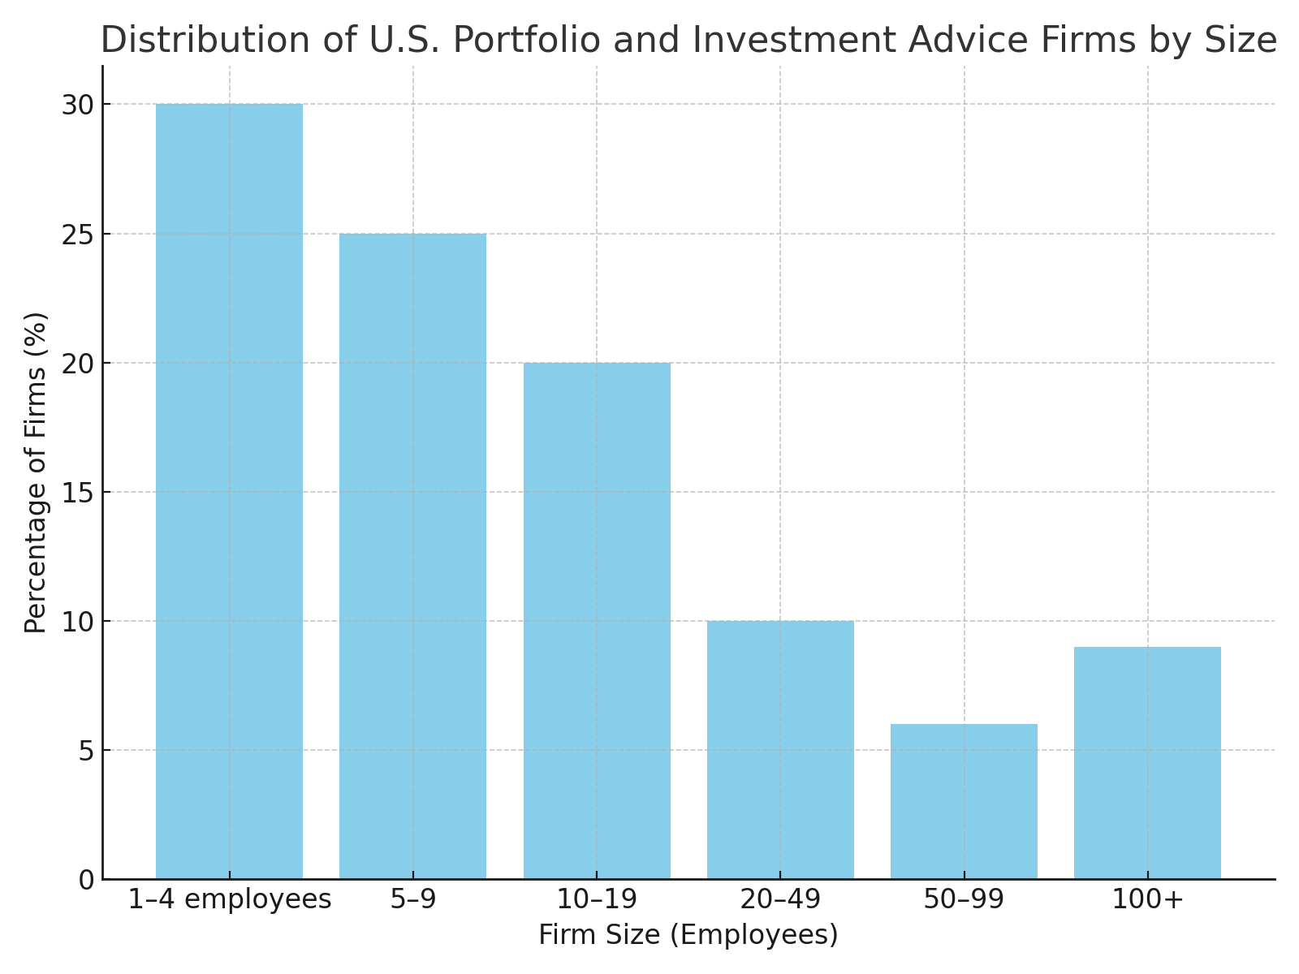
This bar chart shows that more than 75% of firms in the sector employ fewer than 20 people, with the largest share operating in the 1–4 employee range. Despite the presence of dominant players like BlackRock and Fidelity, the industry remains highly fragmented. This distribution highlights the scale challenges smaller firms face in adopting advanced technologies like AI, which often require significant upfront investment and infrastructure.

The Impact of Artificial Intelligence on the Industry
Artificial Intelligence is reshaping the U.S. Portfolio Management and Investment Advice industry by automating tasks, altering workforce needs, and redefining competitive dynamics. Its influence is visible across four key dimensions: labor markets, firm structures, economic risks, and new market opportunities.
Impacts on Workers and Occupations
AI-driven tools are automating critical yet repetitive functions—portfolio rebalancing, risk scoring, compliance checks, and performance attribution. As a result, the role of junior analysts and clerical staff is shrinking, while demand rises for client-facing advisors with expertise in behavioral coaching, financial psychology, and goals-based planning. Hybrid models are emerging: financial advisors are supported by AI for tax optimization, scenario simulation, and investment recommendations, but retain the human edge in trust-building and nuanced judgment. The BLS still projects growth in personal financial advising through 2032, though the skill profile is rapidly evolving (U.S. Bureau of Labor Statistics, 2024).
Impacts on Firms
Firms leveraging AI experience reduced costs in client onboarding, portfolio analysis, and risk diagnostics. However, adoption costs vary: large incumbents such as BlackRock and Morgan Stanley invest in proprietary AI platforms, increasing their strategic advantage and data moat. Smaller firms face a dilemma—either adopt white-label robo-advisor solutions or risk obsolescence. This dynamic may accelerate market concentration, especially if client acquisition increasingly favors AI-enhanced digital services. Yet, firms that strike the right balance between automation and personal service retain strong value propositions.
Risks and Harms
AI introduces new systemic vulnerabilities. Algorithmic models trained on historical biases may misallocate risk or produce inequitable outcomes, especially in wealth planning and credit-linked services. Additionally, synchronized trading behavior driven by similar machine learning models could amplify volatility in financial markets. There is also concern that AI will deepen workforce inequality, disproportionately benefiting highly skilled technical roles while eroding mid-level positions that previously served as on-ramps into the finance sector.
Opportunities
Despite these risks, AI enables broader financial inclusion and innovation. Robo-advisors offer low-cost investment management to younger, less affluent clients previously excluded from wealth advisory services. Predictive analytics support hyper-personalized financial planning—accounting for life stage, behavioral preferences, and real-time market shifts. These tools not only enhance client experience but also generate demand for emerging occupations such as financial data scientists, AI compliance officers, and ethics specialists.
In sum, artificial intelligence is not replacing the financial advisor—it is redefining the role. Firms that harmonize AI capabilities with human insight are likely to thrive in the next phase of industry evolution.
Personal Opportunity and Skills Plan
As a graduating senior at the University of Massachusetts Amherst studying Managerial Economics, my interest in markets pushes me toward roles such as client-facing advisory associate, AI-assisted investment analyst, and WealthTech/client experience specialist. All three roles combine people skills with analytical thinking. They involve listening to clients or teammates, explaining complex ideas in simple language, and using new AI tools to work more efficiently. These roles are appealing to me because they let me interact with people while still using my interest in economics, data, and technology.

The skills that correlate with these jobs and appear across the roles I am interested in including active listening, clear communication, detail orientation, and adaptability to new tools. Alongside these people-focused abilities, the industry consistently demands basic financial analysis skills and the ability to use AI tools for research and data review. This mix of interpersonal and technical skills fits well with the combination of client-facing work and AI-supported analytical tasks that I see myself engaging in in the future.

I already have several strengths that make me a good fit for the roles I’m interested in. I am good at explaining complex topics in simple language, and I communicate clearly in writing. I am reliable with deadlines and follow-through, which is vital in client-facing work. I’m also comfortable using AI tools and learning new software quickly — something the industry increasingly expects. In addition, I’m not afraid to ask clarifying questions, which improves my listening and understanding. Finally, my background in economics and my diverse course load provide a helpful foundation for basic financial analysis and understanding client situations.

There are some gaps between where I am now and where I want to be. These include limited hands-on experience in financial firms and a need to strengthen my basic financial analysis skills. While I have had exposure to communicating with clients, I have not had much experience with customer relationship platforms or professional portfolio management systems. Even though I communicate well, I want more experience speaking with real clients about financial topics. Finally, I am still developing my ability to use AI responsibly by double-checking its output and catching mistakes. These are realistic gaps that I can close with targeted learning and experience over the next 6–12 months as I transition from a student into my professional career. During this transition, I will strengthen my financial foundation by completing the CFA Investment Foundations Certificate or a similar program and by practicing basic portfolio analysis. I will create a small finance or AI-assisted project to gain hands-on experience. Although I am already comfortable with Excel, I will continue building my skills by practicing performance calculations, organizing financial data, and creating clear tables. I also plan to use AI tools alongside Excel while double-checking outputs for accuracy. To strengthen my understanding of financial concepts from multiple angles, I will teach friends and family members, since the best way to fully understand something is to explain it to someone with no prior background.
Reflection
When I started this project, I didn’t fully understand how much AI could realistically shape the way I work, think, and prepare for a career in finance. I knew AI was becoming more common, but I saw it mainly as a tool for quick answers or summaries. As I went through the semester, I realized that using AI well requires a lot more responsibility, judgment, and awareness than I expected. It wasn’t something I could just “use”; I had to learn how to manage it, challenge it, and check it, kind of like the new coworker who works fast but sometimes makes mistakes.

One of the most important things I learned about myself is that I’m more comfortable with AI tools than I originally thought. I found that I could use AI to help outline my report, organize my thoughts, and double-check details. At the same time, I had to step in with my own reasoning to fix errors, compare sources, or question ideas that didn’t look right. This made me realize that my strength is not just using technology but using it responsibly. I didn’t expect critiquing AI to become a skill, but as we worked our way through this project, I felt at times I was the teacher and AI was the student.

Working on the industry study also made me think more seriously about the kind of roles I want after graduation. Before this, I didn’t have a clear picture of how my people skills and my interest in markets could fit together. Researching portfolio management, client-advisory work, and WealthTech helped me see that the industry doesn’t only need number-crunchers — it needs people who can communicate, explain things simply, listen to clients, and leverage technology to make their work more effective. That combination fits who I am much more than I expected, and it gave me a clearer direction for my early career.

Finally, this project pushed me to think more intentionally about the skills I need to keep building. I realized that I still want more hands-on experience in real financial settings, and I want to get even more confident applying financial analysis whether it is with AI or independently. I also want to improve how I use AI in technical work, especially double-checking numbers and sources and catching mistakes. I don’t see these as weaknesses but they’re areas where I can turn into strengths, and now I have a clear plan for what my growth looks like.

Overall, this project changed the way I think about both AI and my future career. I’m leaving the course with a better understanding of myself, a clearer sense of direction, and more confidence that I can combine people skills, analytical thinking, and new technology in a way that fits me. Coming into this project I did not expect this, but it has helped me grow during a time when I needed it. It is the first real step into who I want to become professionally.

References
- IBISWorld. *Portfolio Management in the US – Market Research Report*. 2024, https://www.ibisworld.com/united-states/market-research-reports/portfolio-management-industry/.
- InvestmentNews. “Fourth-Quarter Frenzy Pushed RIA M&A to a Record 2024, DeVoe Says.” 2025. https://www.investmentnews.com/ria-news/fourth-quarter-frenzy-pushed-ria-ma-to-a-record-2024-devoe-says/259144
PricewaterhouseCoopers. * Private markets to account for more than half of global asset management industry revenues by 2030 – with global AuM Private markets to account for more than half of global asset management industry revenues by 2030 – with global AuM to hit $200 trillion: PwC 2025 Global Asset & Wealth Management Report *. 2024, https://www.pwc.com/gx/en/news-room/press-releases/2025/pwc-2025-global-asset-wealth-management-report.html

- U.S. Bureau of Labor Statistics. *Employment by Major Industry Sector*. 2024, https://www.bls.gov/emp/tables/employment-by-major-industry-sector.htm.

- U.S. Census Bureau. *County Business Patterns (CBP) Tables*. 2024,
https://www.census.gov/programs-surveys/cbp/data/tables.html.

- U.S. Securities and Exchange Commission. Investment Adviser Statistics: May 2024. 2024. https://www.sec.gov/files/im-investment-adviser-statistics-20240515.pdf

