**An examination of dilution in bumble bees: Spillover of RNA viruses through shared flowers depends on floral diversity**

P. Alexander Burnham

Principles of Complex Systems Project: Update 3

**Notes:** My first update was rather extensive and was formatted as a 5-page proposal with a 2-page literature review that will eventually, with modification, become the introduction of my paper. As I was out of the country and away from my computer the week before Fall Break, I had hoped that detailed first update would suffice for the week I was away. Updates from now on I will format more simply as what I have completed (in terms of last week’s proposed progress) and then propose the next week’s goals.

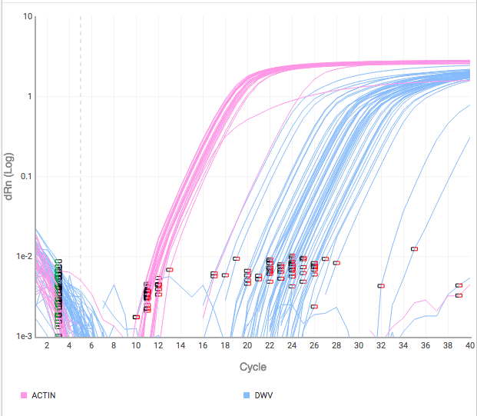**What I have completed Since my last update:**

Since my last update, all lab work for my proposed plant transmission experiment has been completed (250 RNA extractions and viral assays). For the field work, 400 RNA extraction and their viral assays have been completed. All viral assays were conducted as real time quantitative polymerase chain reactions with actual quantification protocols using standard curves (Figure 1). I have begun to clean the data by normalizing the data and quantifying each sample based on the standard curves. I have written functions in R for cleaning the data and further normalizing viral loads (measured as genome copies/individual bee) by a housekeeping gene that was run for each sample called ACTIN. This gene is present in the bee in around the same quantity between individuals so it serves as a good tool for normalization. In addition, I have added the functionality of multiple floral species with variable harboring potential to my CA model. Now I can run the model with a monoculture or with a distribution of floral species.

**Figure 1** RT-qPCR curves from an experimental run to determine viral load of infected bumble bees (genome copies/bee). Pink curves show PCR results through time for ACTIN and blue show results for Deformed Wing Virus (DWV).

**What I plan to do next week:**

This upcoming week I will begin to conduct statistical analyses on my cleaned data to derive empirical parameters for the CA model and will also work on data visualization. In addition, I will begin to do sensitivity analyses on my CA model and perform a parameter sweep on floral diversity to examine how viral prevalence (proxy for virulence) is affected by floral diversity.