**Plight of the Bumble Bee: Spillover of RNA virus through shared flowers leads to synergistic coinfections in *Bombus spp*.**

P. Alexander Burnham

**General Introduction:**

In the field of epidemiology, disease outbreaks and the mechanisms related to transmission and dissemination are traditionally studied in isolation (CITE). While, good fundamental work has been conducted in the fields of spillover, synergistic coinfection, temporal variation, and the influence of biodiversity on disease transmission (hotspot vs dilution hypothesis), it has been brought to the attention of the scientific community in recent years that, as the complexity of natural disease systems unfolds, epidemiology now requires a community ecology approach (CITE). This methodology consists of treating a disease system holistically as a community of pathogens interacting which each other and their host through a series of interconnected mechanisms (CITE). Using this disease ecology approach and a combination of survey work, lab experiments and computational modeling, I hope to show how of spillover, synergistic coinfection, temporal variation, and biodiversity, traditionally studied in isolation, may together shed light on the complexity of disease dynamics and Emerging infectious disease (Figure 1).

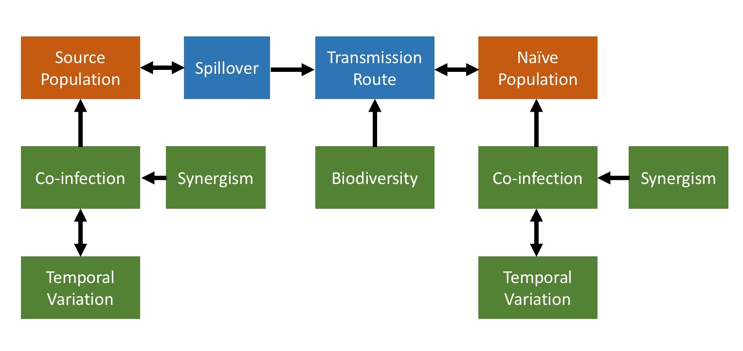

**Figure 1 Conceptual framework** of a holistic model of disease spillover based on ecological and epidemiological principles. We show how spillover, coinfection, biodiversity, synergism and temporal variation might work together to influence dynamics. Populations shown in orange, transmission mechanisms shown in blue and influential factors shown in blue.

The added complexity inherent in studying a disease system in this manner necessitates an integrated experimental and computational approach. Lab and field experiments aimed at testing this proposed model would quickly become too large and unwieldly to have the required predictive power. Likewise, a modeling exercise without any empirical framework may prove to be misguided. Here we propose a series of surveys and experiments in an appropriate model disease system with the goal of parametrizing an agent-based epidemiological model capable of its own predictions that can be compared to the empirical survey data of the system that generated its parameters. Modeling disease systems based on empirical parameters affords the scientific community with the opportunity to better understand disease dynamics without losing our understanding of the natural system. It increases our ability to predict how an outbreak will behave in future scenarios and allows the scientific community to make generalizations about large-scale emergent properties in epidemiology that may inform future decisions in human and non-human disease outbreaks alike (CITE). In order to integrate empirical science and theoretical modeling, a natural disease system is required that can be easily manipulated, measured and which has analogs for all of the required areas of study.

In addition to their agricultural value, the bumble bee (*Bombus Spp.)* system can be easily measured in the field or taken into the lab. It exhibits a diverse array of pathogens and parasites and experiences spillover, coinfection, temporal variation of disease prevalence and shares the dynamical complexity and population structure found in the human disease system. Pathogens and parasites are among the top threats to bumble bee species. Of particular interest, are *Nosema* *spp.* and several RNA viruses because the prevalence of these pathogens are linked to spillover events from commercial honey bees (Otterstatter et al., 2005; Fürst et al., 2014). The prevalence of *N. bombi* in declining bumble bee species increased dramatically between 1995 and 2010, coinciding with the importation of commercial bumble bees from Europe. More recently, *N. ceranae*, a pathogen of honey bees (*Apis mellifera*), was found to be emerging into bumble bee populations from honey bees through shared flowers (reviewed in Brown, 2017).

While both *N. bombi* and *N. ceranae* infect bumble bees, no studies have yet examined how these pathogens interact within the bumble bee and whether coinfection of both species leads to interspecific competition within the host. In addition to *Nosema*, RNA viruses, once considered specific to honey bees, have been detected in bumble bees and evidence is accumulating that these viruses are spilling over from managed honey bees into wild bees (Fürst et al., 2014; Alger & Burnham, unpub. data). Although Nosema and RNA viruses have been detected in bumble bees, no studies have examined interactions between these pathogens within the host. In addition, very few studies have examined how pathogens in bumble bees fluctuate through time (Rigaud et al., 2010).

While a useful model disease system, it also simultaneously serves to shed light on disease-related conservation factors that have led to pollinator loss. Bumble bee declines in recent years have the potential to drastically disrupt the pollination services they provide and the industries that rely on them. Many species have decreased in abundance since the 1960s (Colla et al., 2012). In honey bees, coinfection of multiple pathogens results in higher mortality and colony losses and no study to date has yet examined the effect of this phenomenon in native bumble bees (Cox-Foster et al., 2007). Recommendations for honey bee management practices to mitigate the effects disease spillover into native pollinator communities might be enacted based on this work. Flowers, thought to be the bridges through which disease spillover is occurring, harbor viruses at different prevalence based on species (Alger et al., in review). Through this work, highly optimized tolerance (HOT) models might be used to determine ideal floral composition for human-made pollinator gardens and orchard and crop field buffers and hedgerows to optimize the dilution of this potential transmission route (CITE).

Studying transmission routes, coinfection patterns, and resultant pathogen-pathogen interactions in this bumble bee system, replete with diverse pathogen types, spillover events and human-analogue transmission routes, affords the scientific community with an opportunity to better understand this complex dynamical network and help to push the fields of disease ecology and epidemiology forward. Specifically, the empirical measurements and epidemiological models proposed in this work will help shed light on the understudied areas of synergistic coinfection and the afore mentioned hotspot vs. dilution hypothesis. In order to address these knowledge gaps, I aim to use the bumble bee-honeybee disease system to examine **1)** How temporal variation in disease prevalence and coinfection are related **2)** how pathogens spillover from one population into another and how biodiversity influences the rate of that spillover, and finally, **3)** testhow pathogens interact with each other and their host environment once coinfection has occurred.

**Chapter I: Temporal variation in Bumble bee pathogens drives patterns of coinfection.**

***Objective:*** It is understood that in order to determine the trajectory and outcome of a disease outbreak, a knowledge of how the pathogen will fluctuate in intensity through time is of vital importance (CITE). Seasonal and other temporally-related effects have been shown to have strong influences on the load and prevalence of many pathogens and parasite (CITE). However, in an environment with a large community of diverse pathogens and parasites, each with their own patterns of temporal variation, the dynamics become more complex (CITE). Through evolutionary processes, pathogens might occupy their own niches leading to stable equilibria (CITE). However, the emergence of a novel parasite to the community has the ability to disrupt this equilibrium and their previous patterns of temporal variation. It is in this disrupted community that temporal variation might act as a driver of co-infection (CITE).

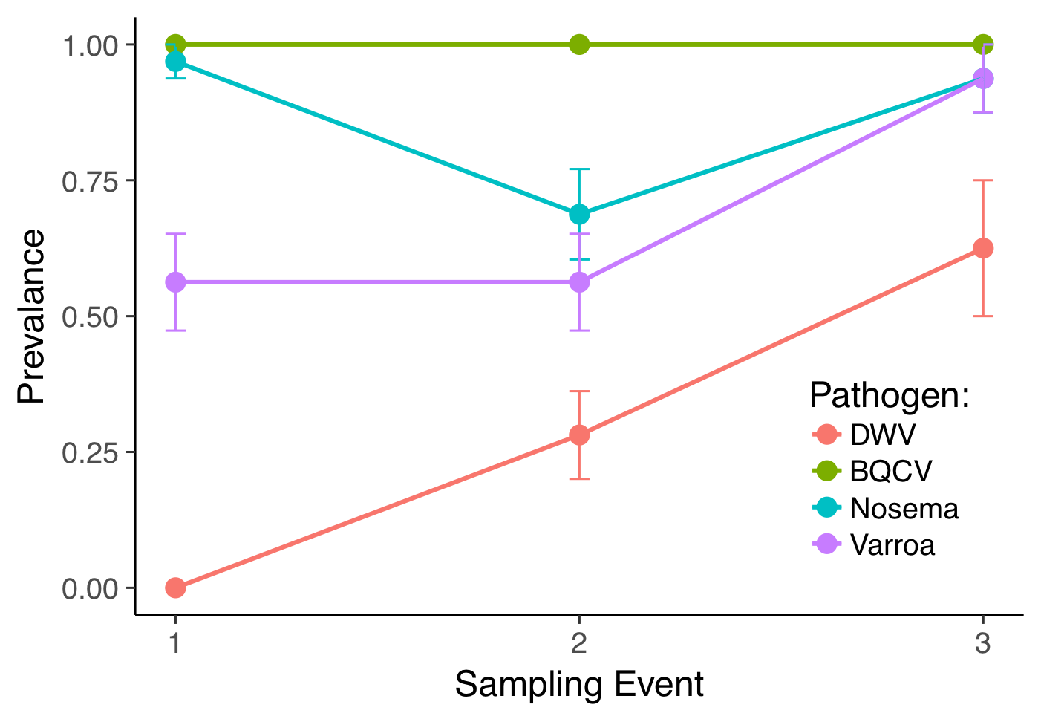

**Figure 2** **Temporal variation influences level of coinfection.** The prevalence of 4 different honeybee pathogens through time (N=30). At points where high presences converge (oval), coinfection is maximized.

In the honeybee-bumble bee disease system, the microsporidian parasite, *Nosema* and numerous RNA viruses have been detected in wild bumble bees. Evidence suggests that these pathogens are spilling over from managed honey bees into wild bumble bee communities, potentially disrupting parasite communities native to wild bees. These spillover events present an opportunity to examine the effects of disrupted temporal variation on patterns of coinfection. While many studies have examined how pathogens fluctuate through time in honey bees, very few studies have examined this in bumble bees (Rigaud et al., 2010). Varying fluctuations in disease loads between pathogens might result in particular pathogens peaking in abundance simultaneously, increasing the probability of coinfection potentially leading to synergistic interactions (Burnham et al., unpub. data, CITE). To understand the roll of temporal variation on coinfection, we aim to examine how two RNA viruses (BQCV and DWV) and two species of *Nosema* (*N. bombi* and *N. ceranae*) change in prevalence and load through time.

***Approach:***In 2016, we conducted a survey in order to determine how RNA viruses and the microsporidian parasites *N. ceranae* and *N. bombi* fluctuate in prevalence and load through time. We collected 20 specimens of *B. impatiens* at five different sites across four time points (ntotal=400, nt = 100). In addition, we collected every bumble bee across species and caste for a total of 2 hours at the beginning of each sampling period in order to measure bumble bee diversity and caste distribution at each site for each time point. RNA extractions were conducted on these 400 samples and real-time quantitative polymerase chain reaction (RT-qPCR) was used to measure the Deformed Wing and Black Queen Cell viral loads for each specimen.

***Remaining Work:***To determine *Nosema* spp. load, I will dissect a portion of the gut and use microscopy to examine each specimen for *Nosema* spores (CITE). On samples I confirm to be positive, I will use RT-qPCR to differentiate between the *Nosema* species and measure their resultant loads. Results will provide evidence of whether the newly emerging species, *N. ceranae*, has begun to outcompete native species, *N. bombi*. Using repeated measures generalized linear mixed effects I will quantify how time, bumble bee diversity and caste composition influence the prevalence and pathogen loads. I will examine how combinations of these pathogens (coinfections) change through time based on potential niche segregation. Outcomes based on this survey will be used in future work to both parameterize and check computational models that aim to show how spillover, temporal variation, coinfection and transmission dilution interact in a multiple pathogen, multiple host disease system.

***Preliminary Findings*:** In a previous honey bee survey, I found that at points in time where pathogen prevalence increased, the overall level of coinfection (i.e. pathogen richness) increased indicating that temporal variation is correlated with coinfection level (Figure 2; p=0.0125). Preliminary results from the bumble bee viral assays indicate that there is temporal variation in load and prevalence of BQCV and DWV in bumble bees. These results support the idea that coinfection is linked to temporal variation. Further analysis with the addition of the *Nosema spp*. data will shed more light on how taxonomically dissimilar pathogens fluctuate through time and how this influences coinfection.

**Chapter II: Demonstration of the shared flower viral transmission route informs our understanding of the hot-spot vs dilution hypothesis in *Bombus spp*.**

***Objective:*** In the field of disease ecology, it is well understood that biotic factors like host density and vector prevalence have an influence over the dynamics of a disease outbreak (CITE). However, the effect that bio diversity has on the trajectory and outcome of a given disease is a relatively understudied area. In the ecology literature, diversity has been shown to improve community growth and the environment in which it exists (CITE). However, only recently has diversity come to the forefront as a potential factor in the disease literature. The idea, termed the “dilution hypothesis” suggests that host diversity may dampen or “dilute” the effectiveness of a pathogen or vector reducing the prevalence of the diseased state in a hot-spot (area of high disease prevalence) (CITE). While this work has helped to improve our view of how ecological factors might influence epidemiological research, there is still much debate over this hypothesis (CITE). To better understand diversity’s influence over disease dynamics, we propose a case study in the honeybee-bumble bee disease system that aims to explore how spillover of RNA viruses from honey bees into bumble bee populations might be influenced by both host and floral diversity.



**Figure 4** **One mil. copies are sufficient to drive replicating infection.** Viral load 3 days after inoculation increases as a function of the magnitude of infection dose.

Evidence is mounting that RNA viruses, likely originating from honeybees, have been spilling over into wild bee populations (CITE). Our previous work in this system has shown that flower species can harbor viruses each with a unique prevalence. In addition, bumble bee species have different susceptibilities to these viruses (Alger et al., in review). While transmission between bee species likely occurs through the use of shared flowers, only two published studies have directly examined this floral transmission route and no study has yet examined their role in RNA virus dissemination (CITE). In addition, ours will be the first study to model the route with the goals of characterizing its emergent properties and examining how floral diversity might influence overall disease dynamics. In this study we aim to experimentally demonstrate how flowers may be facilitating the spillover of RNA viruses from honey bees into bumble bee communities. In order to examine the “hotspot vs. dilution” hypothesis, we will use a combination of experimental parametrization and mathematical modeling to examine how both floral and host diversity and density might influence the prevalence of RNA viruses in bumble bee communities.

**Figure 3**  **Bees pickup viruses on flowers.** The log (base-10) of viral load in genome copies/bee after foraging on field-realistically inoculated artificial flowers (106 genome copies) by foraging time.



***Approach:*** In the summer of 2018, we conducted a series of experiments to demonstrate the transmission route of Deformed Wing Virus from honeybees to bumble bees through red clover, a flower commonly visited by both species and known to harbor DWV. We quantified the number of virus particles per flower to order of magnitude (104 to 106). Fifteen individuals from each of four commercial bumble bee colonies were tested for DWV using qPCR and were found to be negative. Colonies were fed 30% sucrose solution and gamma-irradiated pollen to ensure no active DWV particles were introduced. Twelve micro-colonies were made from these four main colonies in four treatments (3 colonies/treatment) from 15 workers. Micro-colonies were pollen starved for three days and remaining bees were transferred to an 8”x5”x4” box and exposed to infected red clover. In the random flowers treatment (RF), three colonies were exposed to a new set of three haphazardly selected red clover flowers from an infected honeybee apiary for each of three days. In the hand inoculated experiment (HI), three colonies were exposed to 3 sets of clover inoculated with 106 genome copies per flower with a new set presented for on each of three days. In the honey bee inoculation experiment (HBI), flowers were inoculated by infected in honeybee micro-colonies for three days before being presented to bumble bee colonies. The handling control treatment were presented with sets of three artificial flowers inoculated with pure 30% sucrose to ensure no contamination occurred during the experiment.



**Figure 5** **Preliminary CA model output** shown as prevalence of infected (I) and susceptible (S) honeybees (HB), bumblebees (BB) and flowers (FL) through time. Infected BB prevalence (red) increases as a function of infected FL (black) driven by infected HB (green).

In addition to this demonstration of the route using real flowers, we conducted a series of three experiments with artificial flowers in order to estimate parameters for a cellular automata model of the system (Table 1). To determine the number of viral particles that can be acquired as a function of foraging time, we allowed 60 bees to forage on artificial flowers inoculated with 106 genome copies of DWV for between 1 and 120 seconds. Prevalence and load was analyzed as a function of foraging time in a regression design. The amount of virus required to contract a replicating infection, was determined by creating a dose curve by inoculating 50 bees with 1, 3, 5 and 10 million genome copies of DWV and allowing for three days of incubation time. To determine if the route might work in reverse (bumble bees to honeybees), the rate at which bumble bees deposit viruses on flowers was measured by allowing 30 infected bumble bees to forage on artificial flowers for 10 seconds. We then measured the number of viral particles in the bee and in the artificial nectary using RT-qPCR and analyzed with a regression model.

***Remaining Work:***RNA extractions have been completed for all samples, however RT-qPCR for the remaining experiments remains to be conducted. Data need to be analyzed in order to derive the parameter estimates required for the modeling component. We have constructed a preliminary model, but the functionalities or floral constancy, floral diversity and host diversity have yet to be added. In addition, we will conduct a parameter sweep in order to determine the emergent properties of different regions of the parameter space and their relevancy to the system and the dilution hypothesis.

**Table 1** **Model parameter description, preliminary value estimate and source.** Parameters from this study as well as from previous studies will be used to parameterize a CA model of disease spillover. Ranges of flower viral prevalence and host susceptibilities will be used to understand the mechanism behind how biodiversity influences disease transmission (hotspot vs dilution hypothesis).

|  |  |  |
| --- | --- | --- |
| Parameter description | Value | Source |
| Probability of HB deposition | - | TBD from Chapter II |
| Proportion of infected flowers | 0.1-0.5 | (Alger et al., in review) |
| Proportion of infected *Bombus* | - | TBD from Chapter I |
| Probability or reverse route | - | TBD from Chapter II |
| Probability of infection | 0.167 | Determined from Chapter II |
| Required infection dose | 106 | Determined from Chapter II |
| Probability of virus Acquisition | - | TBD from Chapter II |
| Amount of virus on one flower | 103-106 | (Alger et al., in review) |

***Preliminary Findings:*** Preliminary results show for the first time that DWV can be picked up by bumble bees from flowers (red clover) that have been visited by infected honey bees in experimental conditions. In addition, we demonstrated on artificial flowers and that forage time influences the amount acquired. A diminishing returns model of virus acquisition is implicated indicating that only a short amount of time is required for a bee to pick up a relatively large amount of DWV (Figure 3). In addition, a dosage of 1 million genome copies leads to a replicating infection 16.7% of the time. This probability of replication increases as dosage increases (Figure 4). These new data coupled with the known prevalence of DWV in nature and the high abundance of infected flowers in honey bee apiaries indicates that the route is very probable as a primary mode of spillover. In addition, the preliminary CA model shows a sensitivity to the prevalence of infected honeybee colonies (Figure 5).

**Chapter III: RNA viruses and *Nosema*: A community ecology approach to testing and modeling synergistic coinfections in *Bombus spp*.**

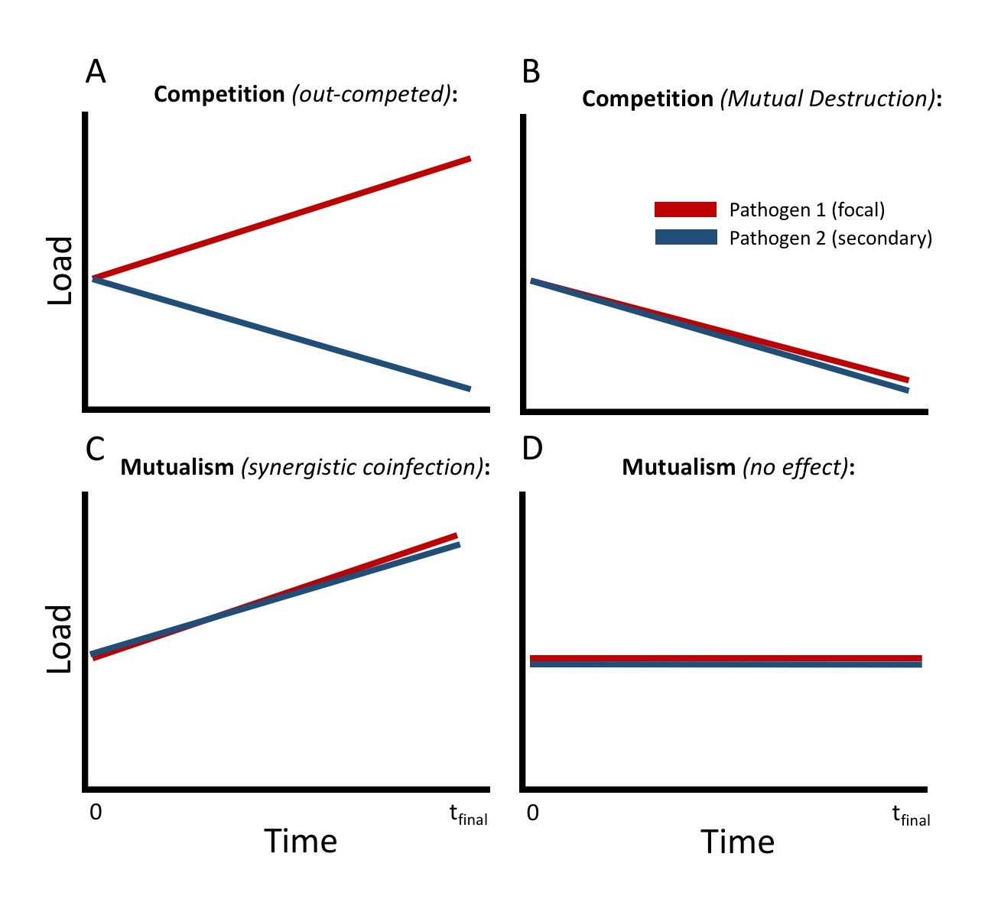

**Figure 6** **Coinfection experiment theoretical outcomes.** Thefocal pathogen (red) plotted against secondary pathogen (blue) through time. **A)** Competition leads to one pathogen succeeding **B)** Competition leads to reduction of both pathogens **C)** Synergistic coinfection leads to both pathogens succeeding **D)** Pathogen 1 has no effect on pathogen 2.

***Objective:*** Examining the effect of a parasite or pathogen on a host in isolation does not necessary give a realistic picture of how that infective agent might react in its natural environment replete with competition from a diverse array of other parasites and pathogens (CITE). For this reason, there has been a recent call for experts in infectious disease to apply a community ecology approach to studying host-parasite and multi-pathogen interactions (Johnson et. al., 2016). Through this lens, a host can be viewed as an environment in which to study a community of pathogens. Pathogen-pathogen interactions within a host also affect the process of disease dissemination. Previous work in the field has shown that synergistic coinfection can increase the rate at which diseases spread through a network (Hébert-dufresne & Althouse, 2015). However, in the human model, it is difficult to accurately measure how pathogen communities within the host environment react to the addition of a secondary pathogen.

The bumble bee disease system lends itself to this question as differential susceptibility to secondary infection is readily measurable in a laboratory setting, allowing us to model these interactions in great detail. These parameters will then be able to inform a landscape-level disease dissemination model. In addition, considering coinfection in native pollinators is of vital importance in terms of pollinator conservation as multiple infection is common and the repercussions are poorly understood (Rigaud et al., 2010).In this study, we aim totest interactions between multiple pathogens in an individual host using a series of competition experiments. In addition, we will measure how these potentially synergistic pathogen combinations affect host health and mortality. Parameters gained from this empirical work will inform a coinfection model to examine how synergistic coinfections affect pathogen dissemination in tandem with the other disease mechanisms described in chapter II.

***Approach:*** In the summer of 2019, I will conduct a series of three experiments with the aim of quantifying the pairwise pathogen-pathogen interactions. These experiments will address three categories of coinfection to test how both taxonomically similar and distinct pathogens respond when replicating in a coinfected host. A virus vs virus experiment will be conducted by inoculating 125 individual bumble bees split between four treatments and a control consisting of DWV, BQCV, DWV & BQCV (performed twice administered in reciprocal order) and neither virus (control). Two other experiments utilizing the same design will test *Nosema* vs virus (*N. bombi* and DWV) and two different species of *Nosema* (*N. bombi* and *N. ceranae*) (Figure 7). By measuring disease loads after coinfection using qPCR and comparing coinfected pathogen loads with those of single infected and control individuals, we will examine how pathogens interact within a host and characterize how the replication of the primary infection reacts to secondary infection (Figure 6). In addition, we will measure whether individuals are more likely to contract a secondary infection when already infected (synergism). Host mortality and other sub-lethal effects due to potentially synergistic coinfections will be quantified.

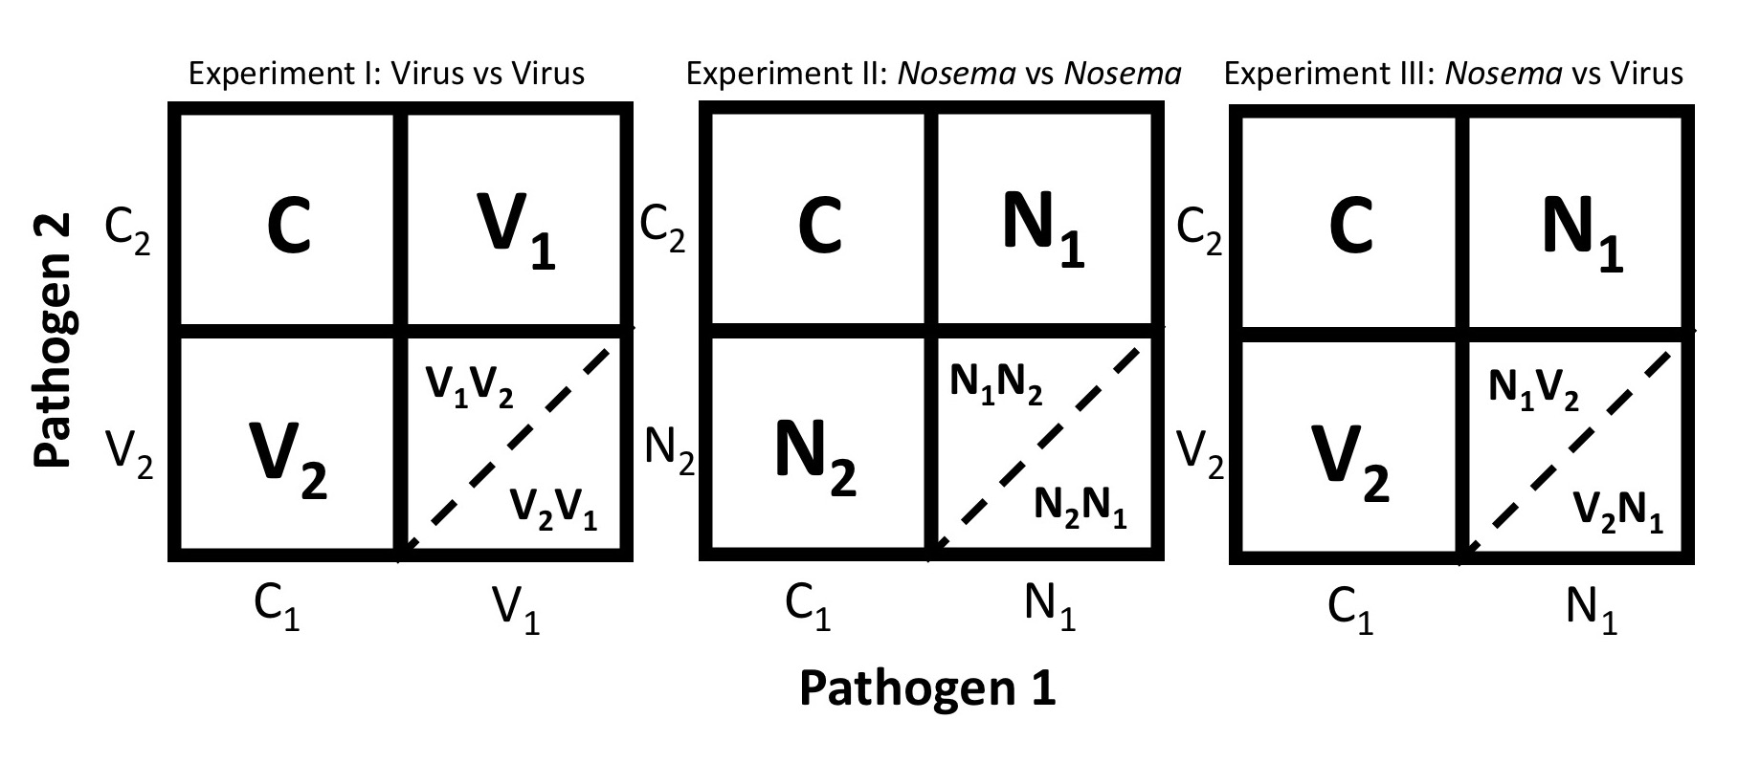

**Figure 7** **Experimental design for pairwise coinfection study.** Each of 3 experiments will include 4 treatments (Nt=25) and a control (Nc=25). Coinfection treatments (bottom right cell in each matrix) will be conducted twice in reciprocal order. C1 & C2 = 30% sucrose, V1=BQCV, V2=DWV, N1=*N. ceranae* and N2=*N. bombi*

The data from these experiments will extend our agent-based disease models to include synergistic coinfections at the individual host level. Probabilities of coinfection, parasite growth rates and host effects including mortality measured from these pair-wise experiments will increases our holistic view of disease in this system by including mechanisms for spillover, biodiversity-based dilution, differentially successful transmission routes, temporal variation and now synergistic coinfection. The model will be used to examine how all of these mechanisms work in unison with field-realistic parameters. Outcomes of the model will be compared to empirical data from our field survey from chapter I.

**Conclusion & Broader Impacts:**

The above work bridges the two import fields of conservation biology and disease ecology. The documented decline of important pollinators has garnered much attention and concern in recent years. Bumble bees in particular are important native pollinators whose decline has been understudied in light of managed honeybee losses (van Engelsdorp et al., 2008). Around 50% of bumble bee species have decreased in abundance since the 1960s (Colla et al., 2012). Spillover of honey bee diseases into naïve bumble bee populations has been implicated as one of the driving factors for these losses (CITE). This work will shed light on the mechanisms behind these losses and provide management recommendations to mitigate them. In addition to these conservation implications, this work proposes to use both experimental and modeling approaches in a single system to construct a unified principle of how spillover, temporal variation, coinfection and host diversity can operate together to affect the trajectory and outcome of a disease outbreak. While these areas have been studied in the past, a reductionist view has often been imposed (CITE). In these three chapters, I aim to show that in combining experimental biology with computational epidemiology, the relationships between isolated fields in the literature may be incorporated into a larger holistic picture of disease ecology. The implications of this understanding may be used in future to inform recommendations for dealing with Emerging infectious disease in both human and non-human systems.

**References:**

Schmidt, K. A. and Ostfeld, R. S. (2001). Biodiversity and the dilution effect in disease ecology. Ecology, 82: 609-619.

Hébert-dufresne, L., & Althouse, B. M. (2015). Complex dynamics of synergistic coinfections on realistically clustered networks, *112*(33), 1–6.

Ostfeld, R. S., & Keesing, F. (2012). Effects of Host Diversity on Infectious Disease, 157–184.

Bailey, L., Ball, B. V. & Perry, J. N. (1983). Association of viruses with two protozoal pathogens of the honey bee. Annals of Applied Biology 103, 13–20.

Bourgeois, A. L., Rinderer, T. E., Beaman, L. D., & Danka, R. G. (2010). Genetic detection and quantification of Nosema apis and N. ceranae in the honey bee. Journal of Invertebrate Pathology, 103(1), 53–58.

Brown, M. J. F. (2017). Microsporidia: An emerging threat to bumble bees? Trends in Parasitology. 33(10), 754-762.

Chen, Y. & Siede, R., (2007). Honey Bee Viruses. Advances in Virus Research, 70, 33–80.

Colla, S. R., Gadallah, F., Richardson, L., Wagner, D., & Gall, L. (2012). Assessing declines of North American bumble bees (Bombus spp.) using museum specimens. Biodiversity and Conservation, 21(14), 3585–3595. from https://pubag.nal.usda.gov/catalog/514055

Cox-Foster, D. L., Conlan, S., Holmes, E. C., Palacios, G., Evans, J. D., Moran, N., & Lipkin, W. I. (2007). A metagenomic survey of microbes in honey bee colony collapse disorder. Science, 318(5848), 283–287.

Fürst, M. A., Mcmahon, D. P., Osborne, J. L., Paxton, R. J., & Brown, M. J. F. (2014). Associations between honeybees and bumblebees as a threat to wild pollinators. Nature. 506(7488), 364–366.

Graystock, P., Meeus, I., Smagghe, G. U. Y., Goulson, D., & Hughes, W. O. H. (2015). The effects of single and mixed infections of Apicystis bombi and deformed wing virus in Bombus terrestris. Parisitology. 143(3):358-65.

Johnson, P. T. J., et al. (2016). Why infectious disease research needs community ecology. Science. 349(6252): 1-20.

Natsopoulou, M. E., Mcmahon, D. P., Doublet, V., Bryden, J., & Paxton, R. J. (2014). Interspecific competition in honeybee intracellular gut parasites is asymmetric and favours the spread of an emerging infectious disease. Proc. R. Soc. B. 282:1896.

Otterstatter, M. C., Gegear, R. J., Colla, S. R., & Thomson, J. D. (2005). Effects of parasitic mites and protozoa on the flower constancy and foraging rate of bumble bees. Behavioral Ecology and Sociobiology, 58(4), 383–389.

Rigaud, T., Perrot-Minnot, M. J., & Brown, M. J. (2010). Parasite and host assemblages: embracing the reality will improve our knowledge of parasite transmission and virulence. Proc Biol Sci, 277(1701), 3693–3702. from

Schroeder, D. C., Martin, S. J., Hill, C., & Manchester, G. (2012). Deformed wing virus: The main suspect in unexplained honeybee deaths. Virulence. 3(7):589-598.

Strange, J. P. (2015). Bombus huntii, Bombus impatiens, and Bombus vosnesenskii (Hymenoptera: Apidae) Pollinate Greenhouse-Grown Tomatoes in Western North America. Journal of Economic Entomology. 108(3):873-9

Traynor, K. S., Rennich, K., Forsgren, E., Rose, R., Pettis, J., Kunkel, G., & vanEngelsdorp, D. (2016). Multiyear survey targeting disease incidence in US honey bees. Apidologie, 47(3), 325–347.

Van Engelsdorp, D., Hayes, J., Underwood, R. M., & Pettis, J. (2008). A survey of honey bee colony losses in the U.S., Fall 2007 to Spring 2008. PLoS ONE, 3(12), 8–13.

Vermont adds nine species to threatened and endangered list. (2015) Vermont Fish and Wildlife Department. from http://www.vtfishandwildlife.com /cms/One.aspx?portalId=73163&pageId=269142