Story Board

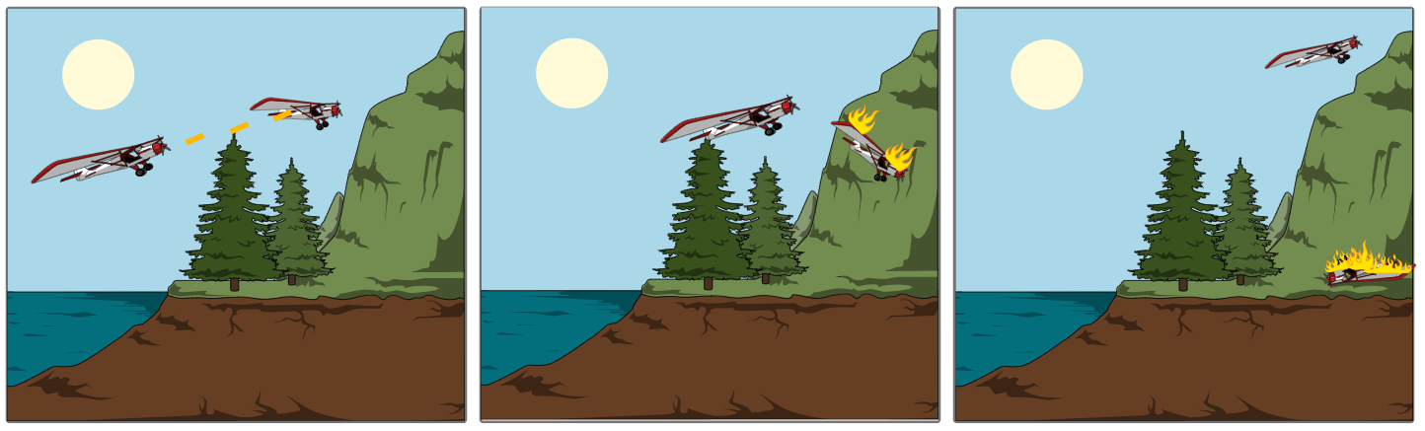

The planes will seek and try to the plane that is shot will the other plane will fight on

destroy each other. If in range get destroyed and will crash and destroy other planes until it

they will fire has beaten all the other planes

In this unity project there will be a scene from Top Gun. There will be planes dog fighting in the air and they will have different scripts to make them attach each other in different scenarios. It won’t be exactly the same as the movie but similar enough. The planes will seek each other and if they are close the perusing plane will fire until the enemy is destroyed. The American plane will always have a wingman like the movie and the Americans will win. I will have many different types of enemies for the American planes to destroy. I will have TOPGUN sound effects in the scene. Planes will have different scripts for different scenarios in the scene. The scene will have a closing clip when the Americans have destroyed the planes of the plane landing. The 2 main assets for the planes are as follows

Russian plane:

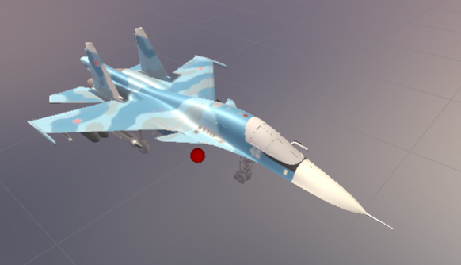

American plane:

