A RANDOM FOREST-BASED FRAUD PATTERN DETECTION AND RISK SCORING SYSTEM FOR E-WALLET TRANSACTIONS USING SMOTE AND SHAP EXPLAINABILITY

A Thesis
Presented to the Faculty of the College of Computer and Information Sciences
Polytechnic University of the Philippines
Sta.Mesa, Manila

In Partial Fulfilment of the Requirements for the Degree
Bachelor of Science in Computer Science

by

Chelsea Lauren B. Cabrera
Joshua Enzo M. Carpio
Jule Alexander B. Coralde
Arwen Therese Emmanuelle C. Matinong

May, 2026

TABLE OF CONTENTS

Title Page i
Table of Contents ii
List of Tables iv
List of Figures vi

Chapter 1 THE PROBLEM AND ITS SETTING 1
Introduction 1
Theoretical Framework 4
Conceptual Framework 12
Statement of the Problem 13
Hypothesis 14
Scope and Limitations of the Study 15
Significance of the Study 16
Definition of Terms 18

Chapter 2 REVIEW OF LITERATURE AND STUDIES 21
E-wallets & E-wallet Transactions 21
Fraud in E-wallet Transactions in the Philippines 23
Financial Fraud Detection Techniques 24
AI-Based Fraud Detection 26
Supervised Learning Algorithms in Fraud Detection 27
Random Forest 34
Class Imbalance in Financial Transaction Datasets 36
Synthetic Minority Oversampling Technique (SMOTE) 37
Fraud Risk Scoring 39
Shapley Additive exPlanations (SHAP) 40
Synthesis of the Reviewed Literature and Studies 42
Chapter 3 METHODOLOGY 47
Research Design 47
Sources of Data 47
Sampling Data 48
System Architecture 49
Research Instrument 56
Data Generation/ Gathering Procedure 59
Ethical Considerations 64
Data Analysis (Procedure and Treatment) 65
Statistical Treatment 66

REFERENCES 75

LIST OF TABLES

Number | Title | Page
1 | Classification of an E-Wallet Based on Its Digital Ecosystem Restrictions | 22
2 | Comparison of Classifiers and Evaluation Metrics | 29
3 | Evaluation of Machine Learning Algorithms | 30
4 | Model Performance for Binary Bank Data Set | 31
5 | Model Performance Summary | 33
6 | Comparison of the F1-Score Measure | 38
7 | Performance Comparison of Fraud Detection Models | 39
8 | Time-Based Features | 61
9 | Transaction Type Features | 61
10 | Amount-Based Features | 62
11 | Entity-Based Features | 63
12 | Confusion Matrix | 67
13 | McNemar’s Test 2x2 Contingency Table | 73

LIST OF FIGURES

Number | Title | Page
1 | Random Forest Classification Process | 6
2 | SMOTE Process | 7
3 | Synthetic Sample Generation Process | 8
4 | Fraud Risk Score Generation Process | 9
5 | SHAP Process | 10
6 | Gap-to-Solution Theoretical Framework of the Study | 11
7 | Conceptual Framework of the Study | 12
8 | System Architecture | 49

Chapter 1
THE PROBLEM AND ITS SETTING

Introduction
The security of e-wallet transactions depends not only on the speed of payment processing, but also on the ability of financial systems to distinguish legitimate activity from fraudulent behavior (Kumar et al., 2021; Association of Certified Fraud Examiners, n.d.). As online banking, credit card payments, e-wallets, and other electronic payment channels continue to expand, financial transactions have become more convenient and accessible. However, the same growth has also increased the opportunity for fraudulent activities to occur within e-wallet payment environments. Financial fraud detection is therefore vital in maintaining the security and integrity of transactional systems, especially as the rise of e-wallet payments has made real-time fraud identification increasingly important (Radif et al., 2025).
Financial fraud refers to intentional deception committed for financial gain. In e-wallet transaction systems, fraud may appear through unauthorized purchases, stolen credentials, phishing-related activity, identity theft, abnormal transaction behavior, and other forms of suspicious financial activity (Kumar et al., 2021). These activities do not only produce financial losses, but also reduce consumer trust and increase the operational burden of institutions responsible for monitoring suspicious transactions. In fact, according to the statistical records provided by Transunion Philippines, 74% of Filipinos have been targeted by fraud attempts through text, phone, and email wherein the average loss of an affected individual is reported to be an estimated PHP 44, 700, which is greater than the national average monthly income of PHP 21, 544 (Philippine Statistics Authority, 2025). In connection to this, some of the most vulnerable when it comes to fraud are the common e-wallet platforms like Gcash and Maya (Transunion Philippines, 2025).
Moreover, the growing sophistication of fraud patterns has made traditional detection methods insufficient (Radif et al., 2025). Earlier fraud detection systems commonly relied on rule-based or statistical approaches, where transactions were flagged based on predefined conditions such as unusually high amounts, foreign locations, or repeated transactions within a short period. Although these methods may detect simple and known fraud patterns, they often lack flexibility when fraudulent behavior changes. Radif et al. (2025) noted that conventional fraud detection methods based on statistical or rule-based systems are not flexible enough to adapt to constantly changing fraudulent behavior.
With this in mind, machine learning actually provides a more adaptive approach because it allows models to learn fraud-related patterns from historical transaction data (Verma & Dhar, 2024). Instead of depending only on fixed rules, machine learning models can analyze transaction features and classify whether a transaction is legitimate or fraudulent. In fraud detection, supervised learning models such as decision trees and neural networks learn from past fraud cases to classify new transactions (Verma & Dhar, 2024). Among these methods, Random Forest is a suitable classifier because it uses multiple decision trees and combines their outputs to produce a more stable prediction. Furthermore, Radif et al. (2025) emphasized that Random Forest offers high accuracy and robustness in fraud detection when combined with proper imbalance-handling techniques.
However, despite the strength of machine learning, fraud detection remains difficult because financial transaction datasets are usually highly imbalanced. In real-world e-wallet transactions, legitimate records greatly outnumber fraudulent ones. This creates a major problem because a classifier may become biased toward the majority class and classify most transactions as legitimate. Radif et al. (2025) identified class imbalance as one of the most significant challenges in transactional fraud datasets, explaining that fraudulent transactions form only a small fraction of the available data and that this imbalance causes conventional models to perform poorly in identifying rare fraud cases.
To address this limitation, this study uses the Synthetic Minority Over-sampling Technique, or SMOTE. SMOTE generates synthetic samples for the minority class instead of merely duplicating existing fraudulent records. This technique helps balance the training data and allows the classifier to learn more meaningful fraud-related patterns. Radif et al. (2025) explained that SMOTE handles class imbalance by synthetically oversampling the minority class, while Random Forest provides a reliable classification performance. The proposed RF-SMOTE framework was designed to improve fraud detection while maintaining computational efficiency.
Nevertheless, fraud detection should not stop at classifying a transaction as fraudulent or legitimate. In practical e-wallet transaction monitoring, institutions also need a way to determine how risky a transaction is. This introduces the need for fraud risk scoring. A fraud risk score provides a numerical value that represents the likelihood that a transaction is fraudulent. By assigning risk scores, the system can help prioritize transactions for further review. High-risk transactions may be investigated immediately, while lower-risk transactions may be monitored with less urgency.
Furthermore, another important concern in machine learning-based fraud detection is interpretability (Almaki & Masud, 2025). A system that flags a transaction as suspicious without explaining the basis of its decision may be difficult for analysts, institutions, and future researchers to evaluate. For this reason, this study incorporates SHapley Additive exPlanations, commonly known as SHAP. Almaki & Masud (2025) used SHAP to determine which dataset features influenced fraud detection the most, and its use was described as helpful in streamlining the model and potentially improving generalization.
SHAP explainability is relevant to this study because it allows the system to identify which transaction features contributed to a fraud prediction or risk score. For example, the explanation may show whether transaction amount, transaction time, device-related information, account behavior, or transaction frequency influenced the model’s output. Through SHAP, the proposed system becomes more transparent because it does not only produce a prediction, but also provides an explanation of the feature contributions behind that prediction.
In retrospect, this study, titled “A Random Forest-Based Fraud Pattern Detection and Risk Scoring System for E-wallet Transactions Using SMOTE and SHAP Explainability”, aims to develop a system that detects fraud patterns, assigns fraud risk scores, addresses class imbalance using SMOTE, and explains model predictions using SHAP. By combining Random Forest classification, SMOTE-based balancing, risk scoring, and explainable artificial intelligence, the study seeks to contribute to the development of fraud detection systems that are not only accurate, but also interpretable and useful for e-wallet transaction monitoring.

Theoretical Framework
This study is grounded on the principles of machine learning classification, ensemble learning, imbalanced data handling, risk-based decision-making, and explainable artificial intelligence. These concepts provide the theoretical basis for developing a fraud pattern detection and risk scoring system using Random Forest, SMOTE, and SHAP.
Fraud detection in e-wallet transactions can be treated as a binary classification problem. In binary classification, the model assigns each transaction to one of two classes: fraudulent or legitimate. The model learns from historical transaction records and uses the patterns found in the data to classify new transactions. In the context of this study, the classification output becomes the basis for determining whether a transaction should be considered suspicious.
The first theoretical foundation of the study is fraud pattern detection. Fraud pattern detection refers to the process of identifying transaction behaviors that differ from normal or expected activity. These patterns may involve unusual transaction amounts, repeated transactions, abnormal time intervals, suspicious account activity, or other feature combinations that indicate possible fraud. Since e-wallet transactions generate large amounts of structured data, machine learning can be used to learn these patterns and distinguish between legitimate and fraudulent behavior.
The second theoretical foundation is Random Forest classification. Breiman (2001) introduced Random Forest as an ensemble learning method that builds multiple decision trees and combines their outputs to produce a final prediction. In classification, each decision tree in the forest produces a class prediction, and the final output of the ensemble is determined through majority voting. This approach helps reduce the weakness of relying on a single decision tree and improves the stability of the prediction.

Figure 1. Random Forest Classification Process
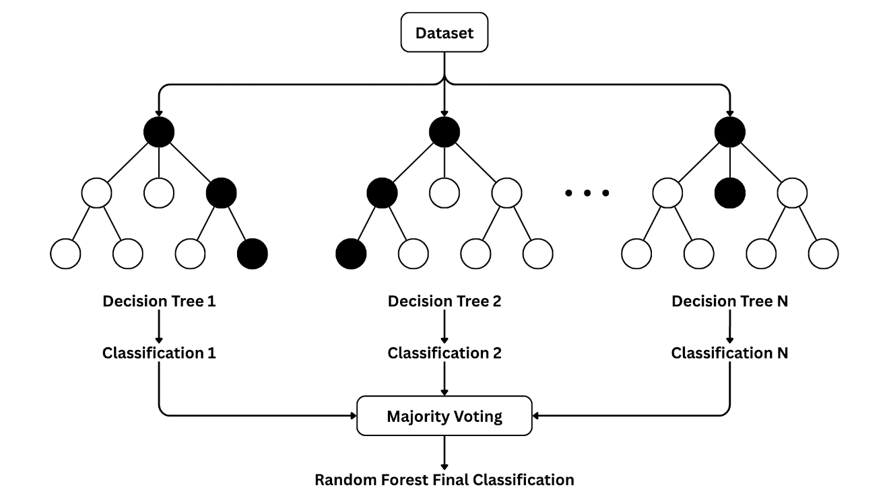
Figure 1 illustrates the process of Random Forest classification. As shown in the figure, multiple decision trees process the dataset, with each tree generating its own classification result. These individual classifications are then combined through majority voting to produce the final Random Forest classification. According to Radif et al. (2025), the ensemble approach of Random Forest through majority voting makes its classification more reliable, especially in noisy or high-dimensional datasets. In this study, Random Forest serves as the main classifier for detecting whether an e-wallet transaction is fraudulent or legitimate.
The third theoretical foundation is class imbalance learning. E-wallet transaction datasets commonly contain far more legitimate transactions than fraudulent ones. This creates an imbalance that may cause the model to favor the majority class.
Aburbeian and Ashqar (2023) explain that class imbalance in transaction datasets is a persistent problem in training fraud detection models because non-fraudulent transactions commonly outnumber fraudulent transactions. This is a critical problem in fraud detection because the minority class represents the most important cases to detect. The study of Danquah (2020) notes that models trained on imbalanced datasets have a risk of producing results that are skewed toward the majority class, making the classification results misleading. Therefore, a fraud detection model that fails to identify fraudulent transactions may still appear accurate despite being ineffective.
To address this, the study uses Synthetic Minority Over-sampling Technique (SMOTE), a data oversampling technique that generates synthetic samples for the minority class. SMOTE improves the representation of the minority class during model training and helps reduce bias toward the majority class (Chawla et al., 2002).

Figure 2. SMOTE Process
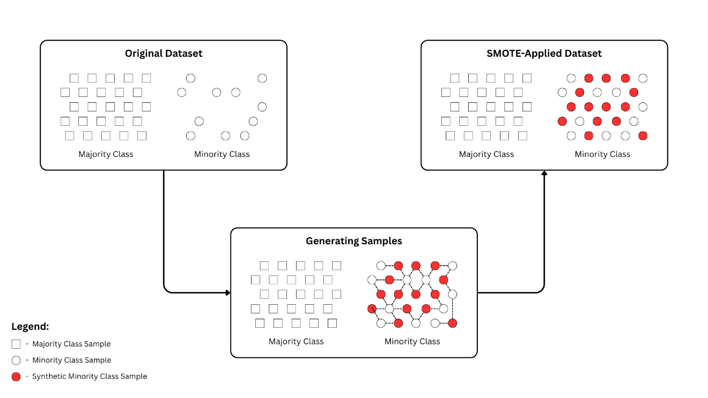
Figure 2 presents the general process of SMOTE for addressing class imbalance. In an imbalanced dataset, the number of majority class samples is much higher than the number of minority class samples. When SMOTE is applied, synthetic samples of the minority class are generated to increase its representation. This produces a training dataset where the model is exposed to more minority class samples. In this study, SMOTE will be applied to the training dataset to help the model learn fraud-related patterns more effectively and reduce bias toward legitimate transactions.

Figure 3. Synthetic Sample Generation Process
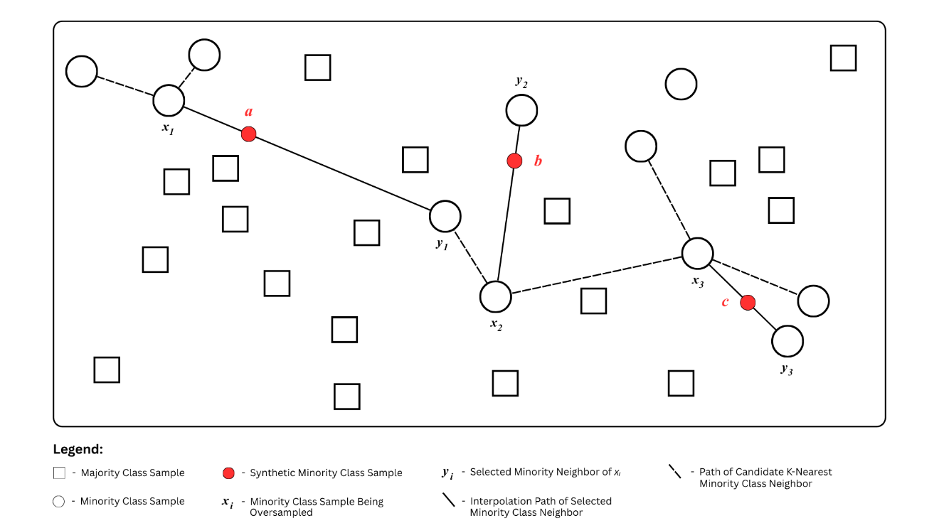
Figure 3 further explains how SMOTE generates synthetic minority class samples. For each selected minority class instance, SMOTE identifies its k-nearest minority-class neighbors and randomly selects one of these neighbors. A synthetic sample is then created by interpolating between the selected minority class instance and the chosen neighbor (Radif et al., 2025).
The fourth theoretical foundation is risk scoring. In fraud detection, classification alone may not be sufficient because not all flagged transactions carry the same level of risk. A risk score provides a numerical representation of the likelihood that a transaction is fraudulent. In this study, the fraud risk score is derived from the predicted probability of the fraud class generated by the Random Forest classifier.

Figure 4. Fraud Risk Score Generation Process
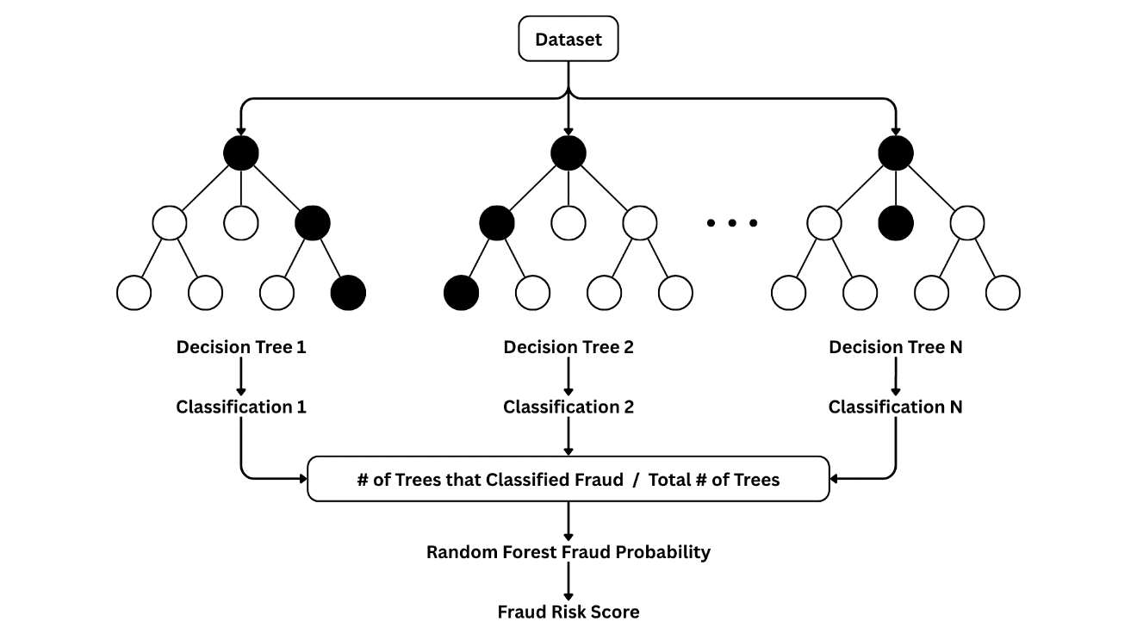
Figure 4 illustrates how the fraud risk score is derived from a Random Forest classifier model. Each decision tree produces a classification, and the number of trees that classify a transaction as fraudulent is divided by the total number of trees in the forest. In the context of this study, this predicted probability of the fraudulent class serves as the basis for the fraud risk score. A higher risk score indicates that a transaction shares stronger similarities with fraudulent patterns learned during training. This allows the user to prioritize suspicious transactions according to their estimated level of risk.
The fifth theoretical foundation is SHAP explainability. Lundberg and Lee (2017) introduced SHapley Additive exPlanations (SHAP) as an explainable artificial intelligence method that assigns contribution values to input features based on how much each feature affects the model’s prediction.

Figure 5. SHAP Process
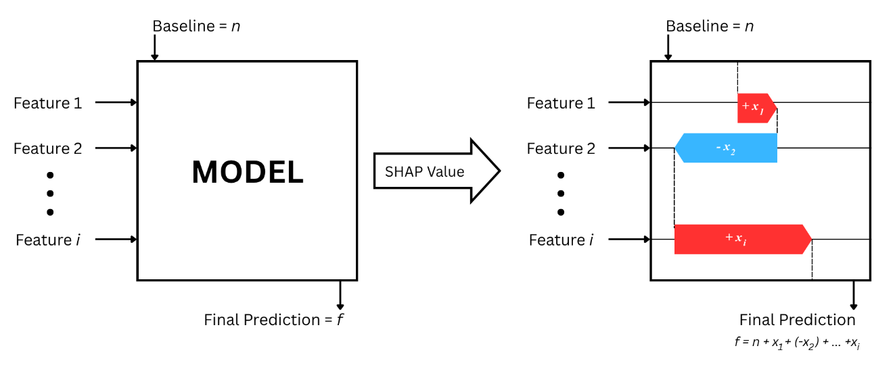
Figure 5 illustrates the process of generating SHAP-based explanations. The model receives input features and produces a prediction. SHAP then explains the generated prediction by computing the SHAP value for each feature. A SHAP value represents the contribution of a feature by showing how much it moves the prediction away from the baseline value. A positive SHAP value means that the feature helps move the prediction toward the target class, while a negative SHAP value means that the feature decreases it. In this study, SHAP is used to explain why a transaction received a certain fraud prediction or risk score. This supports model transparency by showing which transaction features had the strongest influence on the output.

Figure 6. Gap-to-Solution Theoretical Framework of the Study
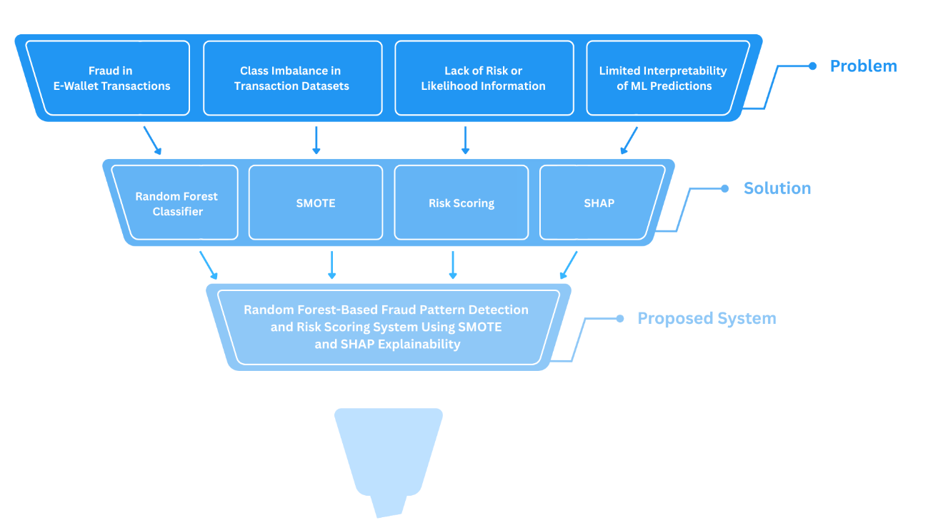
The integration of these concepts, as shown in Figure 6, forms the foundation of the proposed system. Random Forest serves as the main classifier, SMOTE addresses the problem of class imbalance, risk scoring transforms the model prediction into a more useful decision-support output, and SHAP provides interpretability by explaining the contribution of transaction features. Together, these theories support the development of a fraud detection system that is accurate, risk-aware, and explainable.
To summarize, e-wallet transaction data is treated as the input for the fraud pattern detection, and since this dataset is expected to be imbalanced, SMOTE is applied to improve the representation of fraudulent transactions. Then, after this, Random Forest is used to classify transactions and generate prediction probabilities. These probabilities will then serve as the basis for the fraud risk scoring. Finally, to identify the features that influenced the model’s prediction, SHAP explainability is used.

Conceptual Framework

Figure 7. Conceptual Framework of the Study
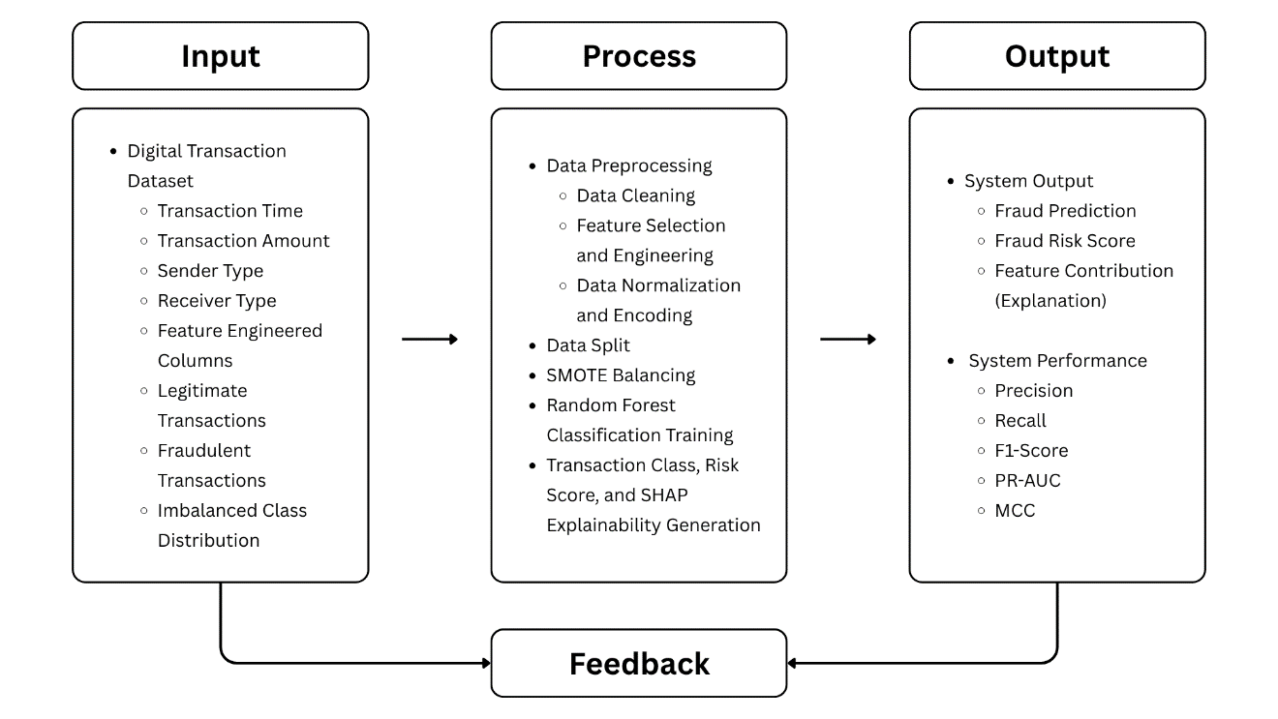
The conceptual framework of the study uses the Input-Process-Output (IPO) model. It illustrates the relationship between the input data, the process that happens with it, and the expected outputs.
The Input data includes the digital transaction dataset, which contains all the transaction-related attributes and class labels that identify whether a transaction is legitimate or fraudulent. These labels or features may include the transaction amount, transaction time, transaction type, account-related attributes, device-related information, and other available transaction characteristics.
After the input data, the process then begins with data preprocessing. This means that it will handle the missing values, encode categorical features, and split the dataset into training and testing sets. However, since fraudulent transactions are expected to be fewer than legitimate transactions, the dataset may contain class imbalance. To address this, SMOTE is applied to the training set to generate synthetic minority class samples.
Then, after balancing the data, the Random Forest classifier is trained to detect fraud patterns. The model now learns from the transaction features and class labels, then predicts whether new transactions are fraudulent or legitimate. The model also produces prediction probabilities, which are used as the basis for generating the fraud risk scores that represent the likelihood that a transaction is fraudulent.
After this, SHAP explainability is then applied to interpret the model output. This component identifies which features contributed most to the fraud prediction and risk score. Through these SHAP values, the system can explain whether the prediction was influenced by transaction amount, timing, account behavior, device-related details, or other available features, which makes the system more interpretable and useful for analysis.
Lastly, after processing the data, the system’s output will then include the fraud prediction, fraud risk score, evaluation metrics, and feature contribution explanations. The model’s performance is then evaluated using precision, recall, F1-score, MCC, and PR-AUC. These metrics determine how well the system detects fraudulent transactions and whether the use of SMOTE improves the model’s ability to identify minority-class fraud cases.

Statement of the Problem
This study aims to develop and evaluate a Random Forest-based fraud pattern detection and risk scoring system for e-wallet transactions using SMOTE and SHAP explainability.
Specifically, this study seeks to answer the following questions:
- What is the performance of the Random Forest (RF) model in detecting e-wallet fraud using the PaySim Fraud Detection dataset in terms of:
  - Precision;
  - Recall;
  - F1-Score;
  - Matthews Correlation Coefficient (MCC); and
  - PR-AUC (Precision-Recall Area Under the Curve)?
- What is the performance of the Random Forest with SMOTE (RF-SMOTE) model in detecting e-wallet fraud using the PaySim Fraud Detection dataset in terms of:
  - Precision;
  - Recall;
  - F1-Score;
  - Matthews Correlation Coefficient (MCC); and
  - PR-AUC (Precision-Recall Area Under the Curve)?
- Is there a significant difference in the performance of the two models, the Random Forest (RF) and the Random Forest with SMOTE (RF-SMOTE), in detecting e-wallet fraud using the PaySim Fraud Detection dataset?

Hypothesis
H₀ (Null Hypothesis): There is no statistically significant difference in the performance of the benchmark Random Forest model and the Random Forest-SMOTE model in detecting fraudulent e-wallet transactions.

Scope and Limitations of the Study
This study focuses on the evaluation and comparison of two Random Forest-based fraud detection models using e-wallet transaction data. Specifically, the study aims to determine whether the integration of Synthetic Minority Oversampling Technique (SMOTE) in the training dataset produces a significant improvement in the fraud detection performance.
The study will use the PaySim dataset for model training, validation, and testing. PaySim is a synthetic mobile financial transaction dataset that contains transaction-related features and a label indicating whether a transaction is fraudulent or legitimate. The dataset will undergo preprocessing steps, including data cleaning, feature engineering, encoding, and normalization.
From the preprocessed dataset, two Random Forest-based models will be developed and compared: a benchmark Random Forest model trained on the original imbalanced training dataset (RF), and a Random Forest model trained on the SMOTE-balanced training dataset (RF-SMOTE). The comparison between the two models will focus on determining whether the use of SMOTE results in differences in fraud detection performance based on precision, recall, F1-score, MCC, and PR-AUC.
Furthermore, the researchers will develop a system prototype as a supporting tool for the study. The developed tool will be used to assist in answering the study’s statement of the problem and to demonstrate the outputs of the developed models, including transaction classification, risk scoring, and SHAP feature contribution for explainability.
However, this study is also subject to several limitations. First, in this study, the RF-SMOTE model will be developed with a focus on improving the functional accuracy of classifying fraudulent e-wallet transactions, and will not address optimization of computational performance or memory usage.
Second, in the context of the used e-wallet dataset, the study will not use real transaction data from local e-wallet providers such as GCash or Maya due to confidentiality and data accessibility constraints. Instead, it will use the PaySim dataset, which is a synthetic financial transaction dataset based on financial logs from a mobile money service implemented in an African country. As a result, the dataset may not fully represent the transaction behavior and fraud patterns of local e-wallet platforms in the Philippines.
Third, the models will be evaluated exclusively on the PaySim transaction dataset. Therefore, the models may not generalize well to other datasets or real-world e-wallet environments without further adaptation. In addition, the ground truth for this study will rely entirely on the provided fraud labels in the dataset without insight from the provider into how fraud was defined and verified.
Lastly, with regard to the prototype to be developed, the Random Forest fraud detection system will be limited as a supporting tool intended only for research evaluation and displaying the model’s outputs. Therefore, the study will not address deployment concerns, such as runtime efficiency, security integration, and production-level scalability.

Significance of the Study
E-wallet transaction fraud continues to challenge users, financial institutions, and payment service providers. This study is significant because by combining Random Forest, SMOTE, risk scoring, and SHAP explainability, it contributes to the growing development of fraud detection systems that are not only focused on just classification but also on interpretability and decision-making support.
For the field of Computer Science, this study demonstrates the application of ensemble learning, imbalanced training, risk scoring, and explainable artificial intelligence in fraud detection problems, which shows how machine learning can be used to detect patterns in e-wallet transaction data and how explainability can help interpret model decisions.
For financial institutions and e-wallet payment providers, this study may serve as a basis for developing fraud monitoring tools that can identify suspicious transactions and assign risk scores since risk scoring system can support prioritization which can then help analysts to determine which transactions require immediate action or review.
For fraud analysts, SHAP may help explain why a transaction was flagged by the model. So, instead of only receiving the prediction output, analysts can see which transaction features contributed to the fraud classification or risk score which can help improve efficiency when it comes to informed decision making.
For e-wallet transactions, particularly, e-wallet users, this study may help contribute to a safer e-wallet payment environment. Even though users do not directly interact with the model, an improved fraud detection system can help reduce unauthorized transactions and strengthen trust in e-wallet financial platforms.
For future researchers, this study can serve as a reference for combining Random Forest, SMOTE, and SHAP in fraud detection tasks. It may also support further research on explainable fraud detection, risk scoring systems, imbalanced classification, and machine learning application in financial cybersecurity.
Overall, this study addresses the need for fraud detection systems that can detect suspicious transaction patterns, manage class imbalance, produce risk-based outputs, and explain the basis of model decisions. The proposed system contributes to the broader goal of making machine learning-based fraud detection more accurate, transparent, and useful in e-wallet transaction environments.

Definition of Terms
Accuracy. Accuracy is a classification metric that measures the proportion of correctly classified transactions over the total number of transactions.
Class Imbalance. Class imbalance is a condition in a dataset where one class has significantly more instances than another. In this study, legitimate transactions represent the majority class, while fraudulent transactions represent the minority class.
Confusion Matrix. A confusion matrix is a table used to evaluate classification results by showing true positives, true negatives, false positives, and false negatives.
Ensemble Learning. Ensemble Learning is a machine learning technique that combines different models and/or algorithms in order to produce better predictions.
Explainable Artificial Intelligence. Explainable Artificial Intelligence is an approach in artificial intelligence that aims to make model predictions more understandable to users and analysts.
E-Wallet. An electronic or digital wallet, which serves as a digital version of a physical wallet in the form of a software-based mobile application. This enables its users to make contactless payments, money transfers, and online transactions. The leading e-wallet platforms in the Philippines as of 2026 are GCash, Maya, and ShopeePay.
False Negative. A false negative is a case where a fraudulent transaction is incorrectly classified as legitimate.
False Positive. A false positive is a case where a legitimate transaction is incorrectly identified as fraudulent.
F1-Score. The F1-score is a performance metric that combines precision and recall into a single value. It is useful for evaluating models trained on imbalanced datasets.
Feature Contribution. Feature contribution refers to the influence of a specific transaction attribute on the model’s final prediction or risk score.
Financial Fraud. Financial fraud is a deceptive act committed for financial gain. In this study, it refers to fraudulent behavior found in transactional data.
Fraud Pattern Detection. Fraud pattern detection is the process of identifying transaction behaviors or feature combinations that suggest possible fraudulent activities.
Fraudulent Transaction. A fraudulent transaction is a transaction that is unauthorized, deceptive, or classified as fraud based on the dataset label.
Legitimate Transaction. A legitimate transaction is a transaction that is valid and is not classified as fraudulent.
Machine Learning. Machine learning is a field of computing that enables systems to learn patterns from data to make predictions or classifications without being explicitly programmed for each case.
Matthews Correlation Coefficient (MCC). MCC is a metric that measures the overall performance of a model in classifying both fraudulent and legitimate transactions.
Precision. Precision is a metric that measures how many transactions predicted as fraudulent are actually fraudulent.
Precision-Recall Area Under the Curve (PR-AUC). PR-AUC is a metric that evaluates a model’s ability to identify fraudulent transactions effectively and correctly.
Prediction Probability. Prediction probability is the probability output generated by the model, which may be used as the basis for the transaction’s fraud risk score.
Random Forest. Random Forest is an ensemble machine learning algorithm that builds multiple decision trees and combines their predictions to classify data.
Recall. Recall is a metric that measures how many actual fraudulent transactions were correctly detected by the model.
Risk Score. A risk score is a numerical value generated by the model that represents the likelihood or severity of fraud risk in a transaction.
Shapley Additive exPlanations (SHAP). SHAP is an explainability method used to determine how much each feature contributes to a machine learning model’s prediction.
Synthetic Minority Over-sampling Technique (SMOTE). SMOTE is an oversampling method that generates synthetic samples for minority classes to reduce class imbalance.
Transactional Data. Transactional data refers to data composed of recorded financial activities, such as payments, transfers, purchases, or credit card operations.
True Negative. A true negative is a case where a legitimate transaction is correctly classified as legitimate.
True Positive. A true positive is a case where a fraudulent transaction is correctly classified as fraudulent.

Chapter 2
REVIEW OF LITERATURE AND STUDIES

This part presents the body of knowledge related to the research problem. It provides a comprehensive discussion of existing literature, previous studies, and related systems that are relevant to the computing problem being investigated. The purpose of this chapter is to establish the theoretical and technical background of the study, identify gaps in existing research, and justify the need for the proposed research.

E-wallets & E-wallet Transactions
E-wallets, also known as digital wallets, are software applications that store payment details and passwords, enabling seamless transactions on connected devices, primarily mobile devices (Kagan, 2025). It is a type of virtual storage that lets people manage their money simply and securely, allowing them to make payments, transfers, and refunds online without having to use cash or physical bank cards (E-Pay Space, n.d.).
There are different types of e-wallets based on their classifications. The most common classification for these wallets is based on their digital ecosystem restrictions.

Table 1
Classification of an E-Wallet Based on Its Digital Ecosystem Restrictions
Type | Function
Closed Wallet | It is a digital wallet that can be used only within a specific platform or brand. The money stored inside cannot be used for anything other than the company’s services (Stripe, 2026).
Semi-closed Wallet | It is a digital wallet that is only accepted within a specific network of merchants or service providers (Razorpay, 2024).
Open Wallet | It is a digital wallet that can be used across different businesses or platforms as long as the merchant accepts payment via that specific wallet (Stripe, 2026).

E-wallets can be accessed and used through different technologies, including mobile devices, desktop devices, smart watches, and other internet-enabled platforms. However, this study focuses specifically on open mobile e-wallets, particularly common and widely used e-wallet applications in the Philippines, such as GCash and Maya. According to Debuque-Gonzales et al. (2023), GCash and Maya are the leading fintech services in the Philippines. GCash grew from 20 million users in 2019 to more than 60 million users in 2022, while Maya recorded 30 million users in 2020 and 40 million users in 2021. These figures reflect the growing adoption of mobile e-wallets and highlight their increasing relevance within the country’s evolving digital payment environment.
Open mobile e-wallets provide various transaction methods. These include fund transfers, QR code payments, bill payments, online purchases, cash-in, and cash-out services. In this study, GCash and Maya are used as reference platforms for examining e-wallet transactions in the Philippine context. GCash lists services such as send money, pay bills, Pay QR, cash-in, and cash-out, while Maya provides services such as QR Ph payments, bill payments, and cash-in through bank transfers via InstaPay or PESONet (GCash, n.d.; Maya, n.d.). Although both platforms have the ability for tap-to-pay or NFC-based payment, this method will not be emphasized in this study because it is subject to device compatibility and feature availability, while the rest are more commonly represented in local digital payment use. Instead, the study focuses on app-based transaction methods.

Fraud in E-wallet Transactions in the Philippines
Fraud is defined as an act that involves deception, misrepresentation of the truth, or concealment of a material fact intended to obtain gain or cause loss to another party (Kumar et al., 2021; Association of Certified Fraud Examiners, n.d.). In the digital context, online and digital scams refer to the fraudulent activities conducted through the internet, often occurring in the form of phishing emails, fake websites, or fraudulent online shopping schemes (Office of the Comptroller of the Currency, n.d.).
In general, fraud in e-wallet transactions occurs when users are deceived into sending money, when unauthorized transfers are made from a user’s account, or phishing, smishing, fake websites, fake QR codes, or account takeover methods are used to obtain money or sensitive information (Federal Trade Commission, 2022; Consumer Financial Protection Bureau, 2021). In the Philippine context, e-wallet fraud also involves scam SMS messages, phishing links, unauthorized account access, and QR-code-related scams such as quishing, which can redirect users to fraudulent websites or payment channels (Dela Cruz, 2024; Chiu, 2026; GCash, n.d.; Maya, 2026).
Recent Philippine reports state that fraud involving digital and e-wallet platforms is a growing concern. The Cybercrime Investigation and Coordinating Center (CICC) reported that there were a total of 10,004 cybercrime complaints filed with their office in 2024, more than three times the 3,317 complaints in 2023. CICC Executive Director Undersecretary Alexander Ramos said the total amount lost by cybercrime victims reached almost PHP 198 million last year alone. In the report, it was said that there were 3,242 online fraud complaints, or 32 percent of the total, which ranged from financial fraud, impersonation, job scams, investment scams, and love scams. He added that GCash was the top wallet used by victims of consumer fraud, online fraud, and phishing, with a total loss of PHP76.49 million to its users. Other financial platforms used by victims were Bank of the Philippine Islands (BPI) with PHP 28.47 million losses, GoTyme with PHP 15.38 million, and PayMaya with PHP 13.99 million (Dela Cruz, 2025).
The similarity of the e-wallet fraud patterns across different contexts suggests that fraud detection approaches capable of detecting these patterns in one country may be adapted to others. However, such adaptations require consideration of local transaction behavior, platform features, regulatory conditions, and fraud patterns specific to the target country.

Financial Fraud Detection Techniques
Fraud detection is the process of identifying suspicious activity within applications, APIs, systems, transactions, data, or user behavior that may indicate fraudulent conduct such as criminal theft of money, data, or resources, with the goal of preventing or minimizing financial loss and security risks (Lindemulder, n.d.). In financial transactions, fraud detection involves the use of advanced analytical methods, machine learning models, and artificial intelligence to recognize anomalies or abnormal behaviors that may signal fraudulent activity. Through real-time analysis of transactional data, these techniques improve the ability to detect and respond to fraud, thereby reducing financial losses by protecting assets, maintaining trust, and preserving the integrity of financial systems (Dama et al., 2024).
Traditional fraud detection methods are approaches that rely on predefined rules, thresholds, and patterns to identify potentially fraudulent transactions. Among these methods, rule-based systems are considered one of the most fundamental approaches. These systems operate using a set of predefined conditions or “rules” that, when triggered, flag transactions as potentially fraudulent (Bagwe, 2024).
Rule-based systems may be implemented through static or dynamic rules. Static Rules apply fixed thresholds and conditions to transactions. These rules are simple to implement but require regular manual updates. Dynamic Rules provide greater flexibility by adjusting thresholds based on historical patterns or customer profiles, such as varying transaction amount thresholds based on a customer’s typical spending patterns. While more sophisticated and flexible than static rules, they still rely on predefined logic (Bagwe, 2024).
Traditional fraud detection methods also incorporate various statistical techniques to identify anomalies and patterns indicative of fraud. Regression analysis examines relationships between variables to identify patterns associated with fraudulent activities. They establish baseline relationships between transaction characteristics and identify deviations from expected patterns. Anomaly detection identifies transactions or behaviors that differ significantly from normal activity, often using methods such as Z-score analysis, Interquartile Range, and control charts. Pattern recognition techniques detect recurring sequences, combinations of events, or transaction behaviors that may indicate fraud. These methods may include sequence analysis, association rules, and clustering to uncover suspicious patterns within financial transaction data (Bagwe, 2024).
Even with the use of automated fraud detection systems, manual review and human judgment are still an important part of traditional fraud detection. Fraud analysts are people who examine transactions that have been flagged as suspicious, investigate possible fraudulent activities, and decide whether a case should be treated as fraud. They provide contextual understanding and interpretation, practical experience, adaptability, and decision-making skills to the detection process (Bagwe, 2024).
Traditional fraud detection methods have formed the backbone and the foundation of fraud prevention strategies. These approaches rely on established rules, statistical techniques, and human expertise to identify and prevent fraudulent activities. While they are effective for known fraud patterns, traditional methods often struggle to adapt to rapidly evolving tactics caused by technological advances employed by sophisticated fraudsters (Bagwe, 2024).

AI-Based Fraud Detection
As technology advances and financial systems become increasingly digitalized, fraudulent activities continue to evolve in both method and sophistication (Dama et al., 2024). With these advancements, the emergence of Artificial Intelligence has significantly influenced fraud detection, offering functionalities that allow identification and prevention of sophisticated fraudulent activities (Bagwe, 2024).
Machine learning approaches in fraud detection are commonly categorized into three methods: supervised, unsupervised, and semi-supervised. These approaches vary based on the type of dataset used during model training. Supervised Learning algorithms are trained on labeled datasets where transactions are already classified as fraudulent or legitimate. In contrast, Unsupervised Learning algorithms use unlabeled data, making them valuable for detecting previously unknown fraud patterns. Semi-supervised Learning algorithms combine both approaches by using a small amount of labeled data together with a larger amount of unlabeled data (Bagwe, 2024).
In a study conducted by Compagnino et al. (2025), supervised learning was the predominant approach in fraud detection research, accounting for 57% of the techniques in the reviewed literature. Its frequent use may be attributed to the availability of labeled historical transaction data, where transactions are already classified as fraudulent or legitimate. These labels allow supervised models to learn patterns that distinguish fraudulent transactions from legitimate ones and classify new transactions more accurately. Similarly, El Mekki and Bouaziz (2025) emphasized that supervised learning algorithms use labeled historical data to classify new transactions and improve the accuracy and efficiency of fraud detection systems.

Supervised Learning Algorithms in Fraud Detection
Several supervised learning algorithms have been applied in fraud detection, such as Logistic Regression, Support Vector Machine, K-Nearest Neighbors, Decision Tree, Naïve Bayes, and Random Forest. These algorithms differ in terms of interpretability, computational cost, and their ability to capture complex fraud patterns. Recent studies have compared these models to determine their effectiveness in classifying fraudulent and legitimate transactions in different contexts.
In evaluating supervised learning models for fraud detection, several performance metrics are commonly used within different studies. This includes accuracy, precision, recall, F1-score, Matthews Correlation Coefficient (MCC), and Area Under the Curve (AUC). Accuracy is the proportion of all classifications that were correct, whether positive or negative. Precision is the proportion of all the model's positive classifications that are actually positive, while recall measures the proportion of actual fraudulent transactions that are correctly detected. F1-score is the harmonic mean of Precision and Recall, balancing the trade-off between the two. Matthews Correlation Coefficient (MCC) considers all four confusion matrix elements (True Positive, True Negative, False Positive, False Negative) to provide a balanced evaluation. Area Under the Curve (AUC) represents the probability that the model, if given a randomly chosen positive and negative example, will rank the positive higher than the negative. F1-score and MCC are particularly useful for imbalanced datasets because they provide a more balanced evaluation than accuracy alone (Google, 2026; scikit-learn, n.d.; Sujon et al., 2025).
In a credit card fraud detection study, Aftab et al. (2023) compared Logistic Regression, Random Forest, Support Vector Machine, and Decision Tree using a real-world dataset of European credit card holders, while also applying the oversampling SMOTE technique to address the class imbalance. They evaluated each method using accuracy, precision, recall, and F1-score. Additionally, the Matthews Correlation Coefficient (MCC) and Area Under the Curve (AUC) were used to provide a more reliable evaluation of binary classification performance, particularly under imbalanced class distributions. MCC was used to evaluate the quality of a binary classifier, even if the class distribution is imbalanced, and AUC was used to provide an aggregate measure of performance across all possible classification thresholds.

Table 2
Comparison of Classifiers and Evaluation Metrics
Classifier | Evaluation Metric
Classifier | Precision | Accuracy | Recall | F1-Score | MCC | AUC
Support Machine Vector | 0.1123 | 0.9898 | 0.8068 | 0.1972 | 0.2257 | 0.8984
Logistic Regression | 0.0576 | 0.9769 | 0.9090 | 0.1084 | 0.2257 | 0.9430
Decision Tree | 0.3882 | 0.9977 | 0.75 | 0.5116 | 0.2988 | 0.8741
Random Forest | 0.8780 | 0.9995 | 0.8181 | 0.8471 | 0.8473 | 0.9091

As shown in Table 2, Random Forest achieved the lowest false positives, the highest accuracy and MCC value, and a comparatively good value for AUC.
In a similar study conducted by Manorom et al. (2024), their research paper compared Decision Tree, Logistic Regression, Naïve Bayes, K-Nearest Neighbor, and Random Forest in detecting fraudulent financial transactions using a dataset containing a multi-agent virtual world simulation performed by IBM, containing both credit and debit card transactions, covering several purchases and cards from consumers using accuracy, precision, and recall as its evaluation metrics.

Table 3
Evaluation of Machine Learning Algorithms
Criteria | Machine Learning Algorithm
Criteria | Decision Tree | Logistic Regression | Naïve Bayes | K-Nearest Neighbor | Random Forest
Accuracy | 99.86% | 99.82% | 94.14% | 99.87% | 99.87%
Precision | 99.86% | 99.87% | 99.89% | 99.87% | 99.87%
Recall (Class No) | 100% | 99.95% | 94.23% | 100% | 100%
Recall  (Class Yes) | - | - | 25.00% | - | -

As presented in Table 3, all selected methods achieved high accuracy, precision, and recall scores for detecting if the transaction was legitimate. K-Nearest Neighbor and Random Forest achieved the highest accuracy with 99.87%, followed by the Decision Tree and Logistic regression with 99.86 % and 99.82%, respectively, with Naïve Bayes having the lowest score of 94.14%. In precision, Naïve Bayes had the highest score of 99.89%, with K-Nearest Neighbor, Random Forest, and Logistic Regression following close with the score of 99.87%. Decision Tree, K-Nearest Neighbor, and Random Forest had the highest recall for detecting legitimate transactions, getting a score of 100%, followed closely by Logistic Regression with a score of 99.95%, and Naïve Bayes getting the lowest score of 94.23%. However, despite these high scores, only Naïve Bayes detected some fraudulent transactions, with a fraud-class recall of 25%. This indicates that the high performance of the other models was mainly driven by their ability to classify legitimate transactions rather than their ability to detect fraud.
Manorom et al. (2024) emphasized that high accuracy does not necessarily indicate satisfactory fraud detection performance, especially when the dataset is highly imbalanced. Their findings show that models may achieve high accuracy by correctly classifying the majority legitimate class while failing to identify the minority fraud class. They concluded that the application of these methods requires in-depth performance evaluation along with suitable pre-processing techniques to deal with class imbalances.
In the context of mobile wallet fraud detection application using a binary bank data set with 20,000 records, Abdirahman et al. evaluated Random Forest, Logistic Regression, Support Vector Machine, and Artificial Neural Network models across mobile wallet platforms.

Table 4
Model Performance for Binary Bank Data Set
Model | Evaluation Metric
Model | Accuracy | Precision | Recall | F1-Score | Model
Random Forest Classifier | 90% | 77% | 87% | 82% | 90%
K-Nearest Neighbors | 87% | 76% | 69% | 72% | 87%
Logistic Regression | 77% | 54% | 57% | 56% | 77%
Support Vector Machine | 74% | 52% | 55% | 43% | 74%
Artificial Neural Network | 91.39% | 87% | 90% | 90% | 91.39%

As presented in Table 4, Random Forest achieved 90% accuracy, 77% precision, 87% recall, and 82% F1-score, while ANN achieved the highest overall performance with 91.39% accuracy, 87% precision, 90% recall, and 90% F1-score. However, Random Forest outperformed Logistic Regression, K-Nearest Neighbors (KNN), and Support Vector Machine in fraud-detection balance, particularly in recall and F1-score, making it a strong traditional supervised learning model for identifying fraudulent transactions.
A more recent, e-wallet-focused research further supports the use of supervised and ensemble-based models in digital payment fraud detection. Salsabil and Rahman (2025) evaluated traditional machine learning, ensemble learning, deep learning, and hybrid learning models for e-wallet transaction fraud detection. Using a synthetically obtained mobile money transaction dataset, they tested models such as Random Forest, K-Nearest Neighbors (KNN), Decision Tree (DT), Logistic Regression (LR), eXtreme Gradient Boosting (XGBoost), Random Forest + XGBoost Ensemble (RF+XGB), Artificial Neural Network (ANN), Convolutional Neural Network (CNN), Recurrent Neural Network (RNN), and CNN+RNN. Similar to the studies before, this paper uses precision, recall, and F1-score as its performance metrics.

Table 5
Model Performance Summary
Type of Learning | Evaluation Metric
Type of Learning | Accuracy | Precision | Recall | F1-Score
Machine Learning
RF | 0.9128 | 0.90 | 0.91 | 0.91
KNN | 0.9025 | 0.90 | 0.90 | 0.90
DT | 0.8956 | 0.89 | 0.90 | 0.89
LR | 0.8591 | 0.94 | 0.86 | 0.88
XGB | 0.9196 | 0.91 | 0.92 | 0.91
Ensemble Learning
RF + XGB | 0.9199 | 0.91 | 0.92 | 0.91
Deep Learning
ANN | 0.9221 | 0.91 | 0.92 | 0.91
CNN | 0.9224 | 0.91 | 0.92 | 0.91
RNN | 0.9178 | 0.91 | 0.92 | 0.91
Hybrid Learning
CNN + RNN | 0.9222 | 0.91 | 0.92 | 0.91

As presented in Table 5, their results showed that CNN achieved the highest accuracy at 0.9224, followed by CNN+RNN at 0.9222 and ANN at 0.9221. Among traditional machine learning models, XGBoost achieved 0.9196 accuracy, while Random Forest achieved 0.9128 accuracy, 0.90 precision, 0.91 recall, and 0.91 F1-score. Although deep learning models slightly outperformed traditional models, Random Forest remained competitive and practical because it produced strong results with lower complexity than deep learning models.
Collectively, these studies show that no single supervised learning algorithm is universally best for fraud detection. Model performance varies and vastly depends on the dataset, class imbalance, selected features, preprocessing techniques, and evaluation metrics used. However, Random Forest consistently appears as a strong and practical model across fraud detection studies. It performs competitively against other supervised learning algorithms, can capture complex and nonlinear transaction patterns, and offers better interpretability than deep learning models. Although deep learning models such as ANN, CNN, and CNN-RNN may achieve slightly higher performance in some studies, Random Forest remains a suitable model for this study because it provides a practical balance between predictive performance, interpretability, and implementation feasibility.

Random Forest
Decision Trees are a supervised machine learning algorithm used for classification and regression tasks. It is a hierarchical and tree-based model that divides the dataset based on features in terms of thresholds, with the main objective of minimising impurity (Bagwe, 2024). In classification tasks, this means creating groups that are more clearly separated according to their class labels. It classifies data through a tree-like structure composed of a root node, decision nodes, branches, and leaf nodes. A root node is the starting point representing the whole dataset, branches are the possible outcomes when a condition is set, decision nodes are the nodes where decisions are made based on those conditions, and leaf nodes are the endpoints of the tree where the final decision or prediction is made (Salman et al., 2024). This structure makes this algorithm easy to understand and interpret, but makes it prone to overfitting.
Random forest is an ensemble supervised machine learning technique that combines multiple decision trees to make better predictions. Similar to Decision Trees, it is also used for classification and regression tasks. It works by constructing multiple Decision Trees, each using a random part of the data, it makes it so every tree is a bit different. When building each tree, it does not use all of the features of the dataset when deciding a split, instead it picks a few at random. The training for each tree is done on a random subset of data, thus enhancing the robustness and accuracy of the model while reducing overfitting. The final output is determined through majority voting. This approach provides accurate predictions and reduces the risk of overfitting the model, but is harder to interpret compared to its predecessor (El Mekki and Bouaziz, 2025; Salman et al., 2024).
In terms of computational feasibility, Random Forest can be practical for fraud detection because its trees can be trained and evaluated in parallel. However, its efficiency depends on factors such as the number of trees and runtime requirements. Salman et al. (2024) described Random Forest as an algorithm that is often efficient in real-world applications, but noted that its performance is dependent on the number of trees created. A large number of trees may result in a prolonged training time that renders it sluggish and inefficient for real-time predictions.
Nevertheless, Random Forests play a significant role in fraud detection because of their ability to handle complex and imbalanced data. They can also identify subtle and nonlinear patterns that distinguish fraudulent behavior from legitimate transactions, while also providing information about important variables used in fraud detection (El Mekki and Bouaziz, 2025; Salman et al., 2024).
However, in real fraud detection, class imbalance can still be a major problem. If the dataset has too many legitimate transactions and very few fraud cases, Random Forest may still become biased toward predicting the majority class. Manorom et al. (2024) demonstrated this issue with their findings. Their findings show that several models achieved high accuracy by correctly classifying the majority legitimate class while failing to identify the minority fraud class. This indicates that high accuracy alone may be misleading in imbalanced fraud datasets and supports the need for imbalance-handling techniques and different evaluation metrics.

Class Imbalance in Financial Transaction Datasets
Class imbalance is a common issue in fraud detection datasets because fraudulent transactions are usually much fewer than legitimate transactions. Aftab et al. (2023), for example, used the European credit card fraud dataset containing 284,807 transactions, of which only 492 were fraudulent, representing approximately 0.173% of the dataset. Similarly, Manorom et al. (2024) used a synthetic credit/debit card transaction dataset containing 19,964 transactions, of which 19,937 were legitimate, and only 27 were fraudulent, representing only 0.14% of the whole dataset. This problem extends to other datasets aside from credit cards. In an e-wallet context, İşcan et al. (2023) used 471,787 digital wallet transactions from a Turkish e-wallet platform and reported that fraud cases accounted for only 0.05% of the dataset, approximating to about 236 fraud transactions. While the exact number of transactions was not stated, Salsabil & Rahman (2025), using a Synthetic Mobile Money Transaction Dataset, stated that the legitimate records significantly exceeded fraudulent records, showing class imbalance. These studies show that fraud detection datasets are commonly dominated by legitimate transactions, which can cause models to favor the majority class and fail to detect fraud cases.

Synthetic Minority Oversampling Technique (SMOTE)
In order to address the class imbalance problem, there are two common approaches used: undersampling and oversampling. Undersampling reduces the number of the majority-class samples, in this case, it would be the legitimate transactions, while oversampling does the opposite and increases the number of minority-class samples, such as the fraudulent transactions. Although undersampling can balance the dataset, oversampling is often preferred because it preserves the original data distribution and avoids information loss. Legitimate transactions may also contain important behavioral information needed to distinguish normal activity from suspicious activity so their deletion would be problematic (Li et al., 2025).
Synthetic Minority Oversampling Technique (SMOTE) is one of the most well-established oversampling algorithms, effectively mitigating the overfitting issue caused by random oversampling. Compared to other oversampling methods, SMOTE generates more diverse synthetic samples, which helps improve the generalization ability of models. Additionally, the generation logic of SMOTE is relatively simple and easy to implement, and it performs well in addressing class imbalance across various fields, especially in small and medium-sized datasets. SMOTE balances the dataset by inserting synthetic samples between minority class samples. It synthesizes new minority samples by randomly selecting a minority class sample and one of its k-nearest neighbors, then generates a new minority class sample by performing linear interpolation between the two (Li et al., 2025).
Gostkowski et al. (2024) conducted a study using the European credit card fraud dataset with 284,807 transactions, of which only 492 were fraudulent, or about 0.173% of all observations, where they compared SMOTE, random oversampling, random undersampling, and the original dataset, then evaluated Decision Tree, Random Forest, and Artificial Neural Network using F1-score. As shown in Table 6, SMOTE obtained the highest F1-score among the data preparation methods.

Table 6
Comparison of the F1-Score Measure
Model | F1-Score
Model | SMOTE | Random Oversampling | Random Undersampling | Source Data
Decision Tree | 0.9894 | 0.9758 | 0.9690 | 0.9996
Random Forest | 0.9997 | 0.9997 | 0.9855 | N/A
Artificial Neural Network | 0.9968 | 0.9626 | 0.9905 | N/A

The original source dataset produced unavailable F1-score results for Random Forest and Artificial Neural Network because the models were not built due to too much imbalance between the classes.
Similarly, Radif et al. (2025) proposed an RF-SMOTE framework for transactional fraud detection because of the highly imbalanced dataset. The study states that conventional models may perform poorly when detecting rare fraud cases due to this imbalance. The RF-SMOTE model was compared with other existing approaches, such as Support Vector Machine (SVM), Random Under-Sampling (RUS) + Random Forest (RF), and Conditional Generative Adversarial Network for Tabular Data (CTGAN) + XGBoost.

Table 7
Performance Comparison of Fraud Detection Models
Model | Evaluation Metrics
Model | Precision (%) | Recall (%) | F1-Score(%)
SVM | 88.1 | 89.7 | 88.9
RUS + RF | 91.2 | 92.8 | 92.0
CTGAN + XGBOOST | 97.6 | 98.1 | 97.8
RF + SMOTE | 98.5 | 99.0 | 98.7

Table 7 shows that the proposed RF-SMOTE framework achieved 98.5% precision, 99.0% recall, and 98.7% F1-score, outperforming SVM, RUS+RF, and CTGAN + XGBoost in their comparison. These findings support the use of SMOTE in this study because it improves minority fraud-class representation while remaining compatible with Random Forest-based fraud detection.

Fraud Risk Scoring
Kandula (2024) defined a fraud risk score as a numerical indicator that reflects the probability of fraudulent behavior associated with a transaction, user, or account. The study explained that higher fraud risk scores indicate higher levels of risk and can help financial institutions prioritize investigations, implement preventive measures, reduce financial losses, and strengthen automated fraud detection.
In a Random Forest-based fraud detection system, fraud risk scoring can be derived from the model’s predicted probability for the fraudulent class. Random Forest consists of multiple decision trees, where each tree produces a class prediction. The final classification is commonly determined through majority voting, while the fraud probability can be estimated by averaging the votes assigned to the fraud class across all trees. Radif et al. (2025) explained that Random Forest calculates the probability of a sample belonging to a class by averaging the number of votes for that class across all trees, and helps make threshold-based decisions, and is useful when probabilistic outputs are required for downstream tasks or confidence evaluation.
Although fraud risk scoring provides a numerical estimate of how likely a transaction is fraudulent, it does not explain why the model assigned that level of risk. Therefore, an explainability method is needed to interpret the risk score and identify which features contributed to the model’s prediction.

Shapley Additive exPlanations (SHAP)
A major limitation of many artificial intelligence and machine learning models is their black-box nature. In black-box models, the system may produce accurate predictions, but the reasoning behind the prediction is difficult for users to understand due to their complexity. Black box AI models arise for one of two reasons: either their developers make them into black boxes on purpose, or they become black boxes as a by-product of their training (Kosinski, 2024). Ali et al. (2023) explained that many AI model outputs are difficult to comprehend and trust because of their black-box nature, which creates the need for Explainable Artificial Intelligence (XAI). Similarly, Hassija et al. (2024) described XAI as a way to address the black-box nature of AI by improving transparency and interpretability.
This limitation is also present in the existing fraud detection studies discussed because they commonly emphasize improving classification performance through supervised learning algorithms and imbalance-handling techniques such as SMOTE. However, many of these studies focus mainly on predictive metrics such as accuracy, precision, recall, and F1-score, with limited explanation of the factors that influence individual fraud predictions. Andrade-Arenas and Yactayo-Arias (2025) stated that a notable drawback for Random Forest is the computational complexity, especially when dealing with large datasets or extensive hyperparameter tuning, and that it is often regarded as a “black-box” model, making it less interpretable than simpler algorithms like LR or DT. In addition to that, Radif et al. (2025) and Manorom et al. (2024) emphasized that future research should focus on improving model interpretability using tools such as Explainable AI to provide valuable insights into trust-building mechanisms and refine fraud detection techniques.
eXplainable Artificial Intelligence (XAI) are techniques aimed at producing machine learning models with a good interpretability-accuracy tradeoff by either building white/ gray-box ML models, which are interpretable by design to some degree, while achieving high accuracy, or endowing black-box models with a minimum level of interpretability when white/gray-box models are not able to achieve an admissible level of accuracy. Its goal is to make AI systems more comprehensible and transparent without sacrificing performance (Ali et al., 2023). There are two common frameworks used for explainable artificial intelligence: SHapley Additive exPlanations (SHAP) and Local Interpretable Model-Agnostic Explanations (LIME).
SHapley Additive exPlanations (SHAP) and Local Interpretable Model-Agnostic Explanations (LIME) are widely used for post-hoc explanations of black-box models. In a study conducted by James et al. (2025), the study found that SHAP produced more stable and globally coherent explanations, while LIME provided faster but less consistent local explanations. This suggests that SHAP is more suitable for fraud detection systems that require reliable and trustworthy explanations.
SHapley Additive exPlanations is an explainable artificial intelligence method used to interpret the output of machine learning models. It is based on Shapley values from cooperative game theory, where each feature is treated as a contributor to the final prediction. This means that in a fraud detection dataset, each feature can be assigned a SHAP value that indicates how much it increases or decreases the predicted fraud risk. SHAP can also provide both local and global interpretability. Local interpretability explains why a specific transaction was classified as fraudulent or legitimate, while global interpretability shows which features are most influential across the whole dataset (Ali et al., 2023).
SHAP specifically has a specialized algorithm designed to calculate SHAP values for tree-based machine learning models, and since this study uses Random Forest, a tree-based ensemble model, using SHAP is appropriate. TreeExplainer can compute SHAP values efficiently for tree models, making it suitable for explaining Random Forest fraud-risk predictions (SHAP, n.d.).

Synthesis of the Reviewed Literature and Studies
E-wallets, also known as digital wallets, are software applications that store payment details and passwords, enabling seamless transactions on connected devices, primarily mobile devices. There are different types of e-wallets based on their classifications. The most common classification for these wallets is based on their digital ecosystem restrictions. In the Philippines, the most commonly used e-wallet applications are GCash and Maya, which are open mobile e-wallets that have transaction methods such as fund transfers, QR code payments, bill payments, online purchases, cash-in, and cash-out services. The increasing usage of e-wallets has expanded the role of digital payment systems in everyday financial transactions. This growing adoption also increases the importance of securing e-wallet transactions against fraud, especially because e-wallet-related fraud may involve phishing, smishing, fake QR codes, unauthorized account access, and other forms of digital deception.
Existing fraud detection approaches include traditional methods, such as rule-based systems, statistical techniques, anomaly detection, and manual review. These methods remain useful for identifying known fraud patterns and supporting fraud analysts. However, these methods may struggle when fraud tactics evolve because they rely heavily on predefined rules, thresholds, and human judgment. AI-Based Fraud Detection solves this issue.
Among the artificial intelligence-based approaches, supervised learning is the most frequently used in fraud detection because it can learn from labeled historical transactions classified as fraudulent or legitimate. The reviewed studies show that several supervised learning algorithms have been applied in fraud detection, such as Logistic Regression, Support Vector Machine, K-Nearest Neighbors, Decision Tree, Naïve Bayes, Random Forest, XGBoost, and Artificial Neural Networks. These models differ in predictive performance, interpretability, computational cost, and ability to capture complex fraud patterns within differing datasets and contexts. Across the reviewed studies, no single model was universally best because performance depended on the dataset, class imbalance, features, preprocessing techniques, and evaluation metrics used. Although there are existing studies on e-wallet and mobile wallet fraud detection, fewer studies have applied the specific setup used in this research: Random Forest for fraud classification, SMOTE for class imbalance, fraud risk scoring for transaction prioritization, and SHAP for model explainability. This creates a methodological gap. While findings from these studies provide methodological support for model selection, class imbalance handling, and evaluation metrics, they may not fully represent e-wallet fraud patterns without adaptation to the e-wallet context.
Despite the differences, Random Forest consistently appeared as a practical and competitive model for fraud detection. It showed that Random Forest performed strongly against other traditional supervised learning models and remained competitive even when deep learning models achieved slightly higher results. Random Forest is suitable because it combines multiple Decision Trees, reduces overfitting compared with a single Decision Tree, can capture nonlinear transaction patterns, and provides information about important variables. However, Random Forest is not free from limitations. It may still be affected by severe class imbalance, where the model favors the majority legitimate class and fails to detect minority fraud cases. This was demonstrated in studies where high accuracy was achieved even when fraud-class detection remained weak.
Class imbalance was identified as one of the most important challenges in fraud detection datasets. Studies showed that fraudulent transactions are usually much fewer than legitimate transactions. This imbalance can cause models to appear accurate because they correctly classify legitimate transactions while failing to identify fraudulent ones. For this reason, accuracy alone is insufficient in fraud detection, and metrics such as precision, recall, F1-score, AUC, and MCC are necessary to provide a more balanced evaluation of model performance. The reviewed literature also supports the use of imbalance-handling techniques and evaluation metrics that focus on fraud-class detection rather than overall accuracy alone.
To address the problem of class imbalance, there are two common approaches: undersampling and oversampling. Oversampling is usually preferred because unlike undersampling, which removes the majority-class samples and may discard useful legitimate transaction patterns, oversampling increases the number of minority-class samples. SMOTE is one of the most well-established oversampling algorithms that generates synthetic minority-class samples to increase the representation of fraud cases. Studies comparing SMOTE with random oversampling, random undersampling, and original imbalanced datasets showed that SMOTE can improve model performance, particularly when combined with Random Forest.
The reviewed studies also show the importance of fraud risk scoring. A fraud risk score provides a numerical estimate of the likelihood that a transaction is fraudulent. In a Random Forest-based system, this score may be derived from the predicted probability of the fraudulent class. Fraud probability can be estimated by averaging the votes assigned to the fraud class across all trees. This allows the system to rank transactions according to their estimated risk level instead of only labeling them as fraud or non-fraud. However, there is still a gap in interpretability as it does not explain why the model assigned that level of risk.
Explainable Artificial Intelligence, particularly SHAP, addresses this gap by identifying which transaction features increase or decrease the predicted fraud risk. SHAP is suitable for the proposed study because it can provide both local explanations for individual transactions and global explanations of overall feature importance. Since the proposed model uses Random Forest, TreeExplainer is appropriate because it is designed for tree-based models.
Overall, the reviewed studies support the development of a Random Forest-based fraud pattern detection and risk scoring system for e-wallet transactions using SMOTE and SHAP explainability. However, the review also shows that many existing fraud detection studies are based on credit card, banking, or general financial transaction datasets rather than e-wallet-specific transactions. This creates a contextual gap because e-wallet platforms involve distinct transaction methods and fraud patterns, including wallet transfers, QR payments, cash-in, cash-out, and account-based mobile transactions. Therefore, the proposed study contributes by applying established fraud detection techniques to the e-wallet context while also addressing class imbalance through SMOTE, prioritizing transactions through fraud risk scoring, and improving model transparency through SHAP explainability.

Chapter 3
METHODOLOGY

Research Design
This study will utilize an experimental research design to determine whether the integration of Synthetic Minority Oversampling Technique (SMOTE) into an imbalanced e-wallet transaction training dataset will significantly improve the performance of the Random Forest fraud detection model. To address the statement of the problem, the researchers will develop, evaluate, and compare two models: the benchmark Random Forest without SMOTE (RF) model and the Random Forest with SMOTE (RF-SMOTE) model. Both models will be tested using the same PaySim testing dataset and evaluated using standardized evaluation metrics. Moreover, the evaluation results will be treated using an appropriate statistical tool to determine whether the use of SMOTE produces a statistically significant improvement in fraud detection performance.

Sources of Data
The data to be used in this study will be sourced from the PaySim dataset, which is a publicly available synthetic dataset on Kaggle, specifically designed for financial fraud detection in the mobile transactions domain. Due to the strict and inherently private nature of financial transactions, there exists no real-world transactional data for e-wallet platforms accessible for public research. To overcome this, PaySim serves as an alternative by simulating mobile money transactions based on a sample of one month of financial transaction logs from a real mobile money service. The dataset contains over 6 million customer transactions, where less than 1% of the total records are labeled as fraud, which mirrors a real-world e-wallet environment ratio from non-fraud transactions.
The dataset contains various transactional features such as time step, transaction type, transaction amount, and alphanumeric identifiers for both the sender and recipient of the transaction. It also includes the account balance of both the sender and the recipient before and after the transaction. Furthermore, each transaction is labeled as either fraudulent or non-fraudulent (legitimate).

Sampling Data
The primary dataset that will be used for this study is the PaySim dataset, and stratified sampling will be used to divide the dataset into three sets. This sampling method is commonly used for imbalanced datasets, being able to preserve the relative proportions of each class across the dataset splits (Buhl, 2024). As a result, the three sets maintain the original class proportion of fraudulent and non-fraudulent transactions. The dataset will be divided using an 80-10-10 split, where 80 percent of the data will be used as the training set, 10 percent will be used as the validation set, and the remaining 10 percent will be used as the testing set. The researchers will allocate 80 percent of the data for the training set to allow the models to learn complex transactional behaviors more effectively, while the remaining 20 percent will be evenly distributed for the validation and testing set.
After the initial stratified split, two versions of the training set will be prepared to account for the two models that this study will evaluate. The first version will retain the original class distribution and will be used to train the baseline Random Forest without SMOTE (RF) model. The second version will undergo SMOTE, which will generate synthetic transactions of the minority fraud class. This version’s training set will then be used to train the Random Forest with SMOTE (RF-SMOTE) model. SMOTE will only be used for the training set and not the validation and testing set to prevent data leakage and to ensure that the validation and training sets still reflect the model’s performance that follows the original transaction distribution.
Both models will use the same validation and testing sets to allow a fair comparison between the model trained on the original imbalanced data and the model where it is trained using data with SMOTE applied.

System Architecture

Figure 8. System Architecture
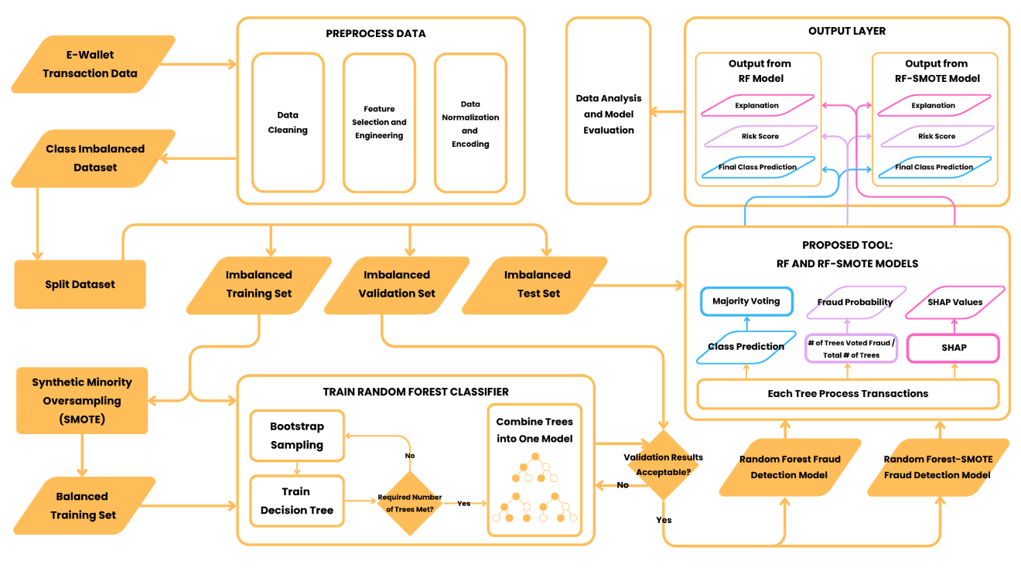

Data Preprocessing
The first step of the system is data preprocessing, which aims to refine the raw dataset and prepare it for model training. This stage involves the steps of data cleaning, feature selection, feature engineering, and data transformation through encoding and normalization.
Data cleaning involves removing duplicate records and handling missing values. Feature selection involves separating the target label from the input features and removing columns that risk data leakage. Feature engineering involves deriving new features from existing columns to help the model identify meaningful transaction patterns. Lastly, data encoding and normalization involve converting categorical and numerical features into formats that will be more suitable for machine learning.

Data Split
The output of data preprocessing will be an imbalanced yet suitable dataset ready for machine learning. The PaySim dataset will be divided into an 80-10-10 split, where 80% of the dataset will be for training, 10% will be for validation, and the remaining 10% will be for testing.

SMOTE Integration
The study will develop two fraud detection models: a benchmark Random Forest without SMOTE (RF) model and a Random Forest with SMOTE (RF-SMOTE) model. The benchmark RF model will be trained using the original imbalanced training dataset, while the RF-SMOTE model will be trained using a balanced training dataset produced through SMOTE.
The balanced training dataset will be obtained by applying Synthetic Minority Over-sampling Technique (SMOTE) to the imbalanced training dataset. SMOTE generates synthetic samples of the minority (fraudulent) class. This will help increase the representation of fraudulent transactions in the training data, helping the RF-SMOTE model to learn fraud patterns more effectively.
SMOTE creates synthetic samples by interpolating between a minority-class instance and one of its nearest minority-class neighbors (Radif et al., 2025). The newly created synthetic sample is created along the line segment connecting the original sample and the selected nearest neighbor. This process of SMOTE can be expressed using the following formula:

Equation 1. SMOTE Minority Class Interpolation Formula
$$x_{synthetic}=x_{i}+δ*(x_{nn}-x_{i})$$
where:
- $x_{synthetic}$ = Generated synthetic sample.
- $x_{i}$ = Minority-class instance.
- $δ ϵ [0, 1]$ = A random number between 0 and 1.
- $x_{nn}$ = One of the k-nearest neighbors of $x_{i}$.
The generated synthetic samples will then be added to the original imbalanced training dataset, producing a separate balanced training dataset. This balanced training dataset will be used only to train the RF-SMOTE model. Moreover, the validation and test datasets will remain unchanged to ensure that both models are evaluated under the same real-world distribution.

Model Training
After preparing both training datasets for RF and RF-SMOTE models, the model training phase will begin. Both models will undergo the same training procedure, with the only difference being the dataset that will be used for training.
A Random Forest classifier is developed and trained by constructing multiple decision trees and combining them into a single ensemble classification model. The construction of each decision tree begins with bootstrap sampling, which randomly selects rows from the training dataset. In a sample, a transaction record may appear more than once or may not be selected at all. As a result, each decision tree is trained using a slightly different version of the training dataset. Bootstrap sampling ensures that each tree is different from one another, improving the developed model’s ability to generalize transaction records.
After bootstrap sampling, the decision tree is developed. During the development of each decision tree, the tree undergoes a process of recursive splitting. At each node, the algorithm randomly selects a subset of features and derives possible decision rules from it. The split chosen for a node will be based on which decision rule most effectively separates transactions into legitimate and fraudulent. This splitting process continues recursively for each child node until a stopping condition is reached, such as a maximum tree depth.
The process of bootstrap sampling and the development of decision trees is repeated until the specified number of trees has been constructed. These trained decision trees are then combined to form a Random Forest-based fraud detection model.

Model Validation
After both the RF and RF-SMOTE models have been trained and developed, model validation will be conducted by using each model to predict the class labels of the validation dataset. The predicted labels will then be compared to ground truth labels to compute performance metrics of precision, recall, F1-score, MCC, and PR-AUC. The validation results will help determine whether the models require further tuning, such as hyperparameter adjustments, before proceeding to the final testing.

Final Testing and System Outputs
Following model validation, the study proceeds to the final testing phase of the developed Random Forest-based fraud detection models. This phase evaluates the finalized RF and RF-SMOTE models using the untouched test dataset.
Both models follow the same high-level process and produce the same categorical outputs. The system takes transaction records as input and classifies each record as either legitimate or fraudulent. In addition to the classification result, the system will also provide an attributed risk score and an explanation for the classification decision for each transaction. The system output of the final transaction classification and explanation will be used for data analysis to evaluate the models and answer the study’s SOPs.

Random Forest Classification
The classification of each transaction is performed by the model’s trained Random Forest classifier. Each decision tree in the forest consists of internal parent nodes representing decision rules that guide the transaction through the tree, and terminal leaf nodes that store the final class prediction for that individual tree. The final classification of the Random Forest is determined by aggregating the predictions of all individual decision trees through majority voting. The process of class prediction by the Random Forest can be expressed with the following formula:

Equation 2. Random Forest Class Prediction Formula
$$\hat{y}=modes(e_{1}\left(x\right), e_{2}\left(x\right), …, e_{t}\left(x\right))$$
where:
- $\hat{y}$ = Final class prediction.
- $(e_{1}\left(x\right), e_{2}\left(x\right), …, e_{t}\left(x\right))$ = Total number of trees in the forest.

Risk Scoring
The risk score of each transaction will be derived from the fraud probability generated by the Random Forest classifier. In this study, the fraud probability represents the proportion of decision trees in the Random Forest that classify the given transaction as fraudulent. This probability can be expressed with the following formula:

Equation 3. Fraud Probability Formula
$$P\left(y=c | x\right)=\frac{1}{T}\sum_{t=1}^{T}{1(e_{t}\left(x\right)=c)}$$
where:
- $P\left(y=c | x\right)$ = Fraud probability.
- $x$ = Input transaction.
- $c$ = Fraud class label.
- $T$ = Total number of decision trees in the Random Forest.
- $1(e_{t}\left(x\right)=c)$ = Indicator function that outputs 1 if tree $t$ predicts class $c$, and 0 otherwise
- $e_{t}\left(x\right)$ = Prediction of tree $t$ for input transaction $x$.
This formula can also be used to estimate the probability of a transaction belonging to the opposite class, which makes it useful for any probabilistic outputs, such as confidence evaluation and risk scoring (Radif et al., 2025).

SHAP Explanation
The explanation of each transaction classification will be performed using SHapley Additive exPlanations (SHAP). SHAP is an explainable artificial intelligence technique that explains a model’s prediction by assigning a contribution value (SHAP value) to each input feature. These SHAP values indicate how much each feature increases or decreases the model’s prediction. The process of calculating the SHAP value of a feature for a specific prediction can be expressed with the following formula (Brenndoerfer, 2025):

Equation 4. SHAP Value Formula
$$ϕ_{i}=\sum_{S⊆F\{i\}}{\frac{\left|S\right|!\left(\left|F\right|-\left|S\right|-1\right)!}{\left|F\right|!}[f\left(S∪\left\{i\right\}\right)-f\left(S\right)]}$$
where:
- $ϕ_{i}$ = SHAP value for feature $i$.
- $∑_{S⊆F\{i\}}$ = Summation that ensures every possible subset $S$ of features that do not include feature $i$ is considered.
- $[f\left(S∪\left\{i\right\}\right)-f\left(S\right)]$ = Marginal contribution representing how much feature $i$ adds when included alongside subset $S$.
- $\frac{\left|S\right|!\left(\left|F\right|-\left|S\right|-1\right)!}{\left|F\right|!}$ = Weighing factor that ensures each feature’s contribution is fairly averaged across all possible feature combinations.
A positive SHAP value means that the feature increases the model’s prediction toward the fraud class, while a negative SHAP value means that the feature decreases the prediction toward the fraud class.
In this study, SHAP will be used after the RF and RF-SMOTE models generate their predictions. For transactions classified as fraudulent, the SHAP values will be analyzed to identify the features that most strongly influenced the fraud prediction. These SHAP-based explanations will support the interpretability of the fraud detection system by providing feature-level reasons behind the model’s classification.

Research Instrument
To collect the necessary data for this study, the researchers will use various tools to support the evaluation of the study’s proposed computational solution. These will help facilitate the data generation, model training, and system performance analysis required for this ongoing research.

Python
Python will serve as the tool’s main programming language. It provides an environment equipped for handling large-scale datasets, developing machine learning models, and integration of multiple libraries. The language supports the entire workflow of the study, from the preprocessing of data stage, to the model’s evaluation and explainability.

Pandas
Pandas is a Python library used for data manipulation and analysis. It will be used for the study to import the PaySim dataset into a structured, tabular format, which allows the researchers to load, manage, and prepare the records prior to the actual training of the model.

NumPy
NumPy is a Python library for mathematical and scientific computing. This will be used in the study to translate the transaction records into a format suitable for Scikit-Learn and imBLEearn to efficiently execute needed mathematical operations.

Matplotlib
Matplotlib is a Python library dedicated for data visualization. This will be used by the researchers to translate the complex statistical evaluations into an interpretable graphical format for the evaluation phase of this study.

Seaborn
Seaborn is a Python data visualization library based on Matplotlib. It will be used in the study to create more advanced and interpretable statistical visualizations.

Scikit-Learn
Scikit-Learn is a machine learning Python library that will be used by the researchers to implement the Random Forest classifier and to split the dataset into the three required sets. It will also be used in calculating the evaluation metrics to assess the performance of the models.

Imbalanced-Learn
Imbalanced-Learn is a Python library designed for handling imbalanced datasets. This will be used to apply the SMOTE on the appropriate training dataset to generate synthetic fraud samples and improve the representation of the minority class.

SHAP
SHAP is a Python library that will be used by the researchers to identify and visualize the contribution of transaction features to the model’s fraud prediction, along with the generated risk score.

Data Generation/ Gathering Procedure
The data generation and gathering procedure will follow a systematic approach to ensure that the data gathering process is organized, reproducible, and clearly documented.
The primary data for this study, the publicly available PaySim dataset, will be acquired as a CSV file from Kaggle. The raw CSV file will then be loaded into the local development environment using Pandas to prepare for data ingestion. The researchers will then confirm the total row count and assess the distribution of the target variable “isFraud”. This also includes the checking of missing values, duplicate records, inconsistent data types, and unusual transaction values to prepare for data preprocessing.
The PaySim transaction dataset will then undergo data processing to ensure that the data is suitable for the machine learning analysis. Missing numerical values will be handled using the median value of the corresponding feature. Missing categorical values, on the other hand, will be replaced with the appropriate placeholder values such as “unknown”. Duplicate records will be removed to prevent identical transactions from artificially inflating the importance of specific patterns. Inconsistent data types will be resolved by standardizing all features to their correct formats, such as casting transaction amounts to floating-point numbers. This ensures that the dataset is free from computational errors during model training. Lastly, any unusual transaction values will be handled based on their nature. If they are caused by data errors or the like, they are corrected or removed from the dataset. However, if they represent a valid transaction behavior, they will be retained as they may indicate potential fraud patterns relevant to the study.
Feature selection will then be performed. The target variable “isFraud” will be separated from the predictor variables as it represents the class label that the model will learn to predict. Features that may cause data leakage will be removed from the training data, and these are: “oldbalanceOrg”, “newbalanceOrig”, “oldbalanceDest”, and “newbalanceDest”. Removing these features helps ensure that the model learns fraud-related transaction patterns rather than relying on information that may or may not be available in a real-world prediction setting. Additionally, features that represent simulated business rules, such as “isFlaggedFraud”, will be removed as they do not reflect organic user behavior and would possibly affect the model and make it dependent on the rule-based flag.
After feature selection, feature engineering will then be conducted to create additional variables and transform the cleaned data in order to maximize the model’s ability to identify fraud patterns more effectively.

Table 8
Time-Based Features
Feature | Purpose
hour_of_day | Captures transaction time within a day
day_of_week | Captures transaction day within a week

Table 8 details the time-based features that will be derived from the “step” feature of the dataset to capture temporal transaction behavior. This includes the hour of the day and the day of the week. These features are important as they help the model to identify abnormal timing patterns that are associated with fraudulent transaction behavior.

Table 9
Transaction Type Features
Feature | Purpose
type_CASH_IN | Captures if the transaction is a cash deposit
type_CASH_OUT | Captures if the transaction is a cash withdrawal
type_DEBIT | Captures if the transaction is a standard debit
type_PAYMENT | Captures if the transaction is a payment to a merchant
type_TRANSFER | Captures if the transaction is a money transfer to another account

Table 9 details the transformation of the categorical feature “type” of the dataset into distinct binary variables using one-hot encoding. This will be done because machine learning algorithms require numerical input, and they cannot evaluate strings such as “PAYMENT” or “TRANSFER”. This information is crucial for fraud detection as it allows the model to focus its predictive capabilities on specific categories where fraudulent transaction behavior is known to occur.

Table 10
Amount-Based Features
Feature | Purpose
log_amount | Reduces skewness caused by huge transaction values
is_zero_amount | Captures transaction values with a 0 amount

Table 10 details the amount-based features derived from the “amount” feature in the dataset. Because financial datasets inherently suffer from skewness from huge transaction values, a logarithmic transformation will be applied to the “amount” feature. This feature reduces the influence of those transaction values, which will make it suitable for model training and feature interpretation. The formula for this will be:

Equation 5. Logarithmic Transformation of the Amount Feature
$$log_amount=log⁡(1+amount)$$
Moreover, a feature that captures transactions with a 0 amount will be created as such records may represent unusual transaction behavior.

Table 11
Entity-Based Features
Feature | Purpose
is_merchant_origin | Captures where the initiating entity of the transaction is a registered merchant
is_merchant_dest | Captures whether the receiving entity of the transaction is a registered merchant

Table 11 details entity-based features that will be extracted from the “nameOrig” and “nameDest” features of the dataset, as they both contain alphanumeric identifiers that are incompatible with the model to be developed. The “is_merchant_origin” feature indicates whether the sender is a merchant, while the “is_merchant_dest” feature indicates whether the receiver holds the same status.
After feature engineering and encoding, the dataset will be divided into three sets using stratified sampling, where 80 percent of the data will be for training, 10 percent will be for validation, and the remaining 10 percent will be for testing. Two training sets will be prepared, wherein one will be imbalanced, and one will be balanced through the application of SMOTE.
The imbalanced training dataset will be used to train the benchmark Random Forest without SMOTE (RF) model, while the SMOTE-balanced training dataset will be used to train the Random Forest with SMOTE (RF-SMOTE) model. After training, both models will undergo validation to assess their initial performance and allow necessary tuning before final testing.
Once the RF and RF-SMOTE models have been validated, both models will undergo final testing using the same test dataset. The results of the final testing will be used to evaluate their performance and determine whether integrating SMOTE into the training dataset produces a statistically significant improvement in fraud detection performance.

Ethical Considerations
The researchers will follow proper ethical guidelines and appropriate university policies throughout the conduct of this study. All of the data and information that are used in this study will be obtained only from credible and publicly available sources, all of which will be properly acknowledged and credited.
The researchers will use the PaySim dataset obtained from Kaggle for the data preprocessing, training, validation, and testing. Because the dataset is synthetically generated and does not contain any actual identifiable financial record or information, the study does not involve human participants nor confidential banking data. Regardless, the researchers will still handle the dataset responsibly and ensure that it will only be used for the purposes of this study.
All data preprocessing, model training, and evaluation activities will be ensured to be conducted ethically and solely within the scope of the study. Furthermore, all reported findings will be presented objectively to maintain the integrity and transparency of the study.
Additionally, this study involves no data that could cause harm to any individual or organization of any kind.

Data Analysis (Procedure and Treatment)
The data analysis of this study will focus on evaluating the performance of the two developed fraud detection models, namely the benchmark Random Forest without SMOTE (RF) model and the Random Forest with SMOTE (RF-SMOTE) model, using the PaySim transaction dataset. Through this analysis, the researchers aim to determine whether the integration of SMOTE into the training dataset will significantly improve the performance of the Random Forest fraud detection model.
After model training, both the RF and RF-SMOTE models will be evaluated using the same testing dataset to observe a fair comparison. The classifications produced by each model will be tested against ground truth labels from the testing dataset. The result will be summarized using a confusion matrix, which will identify the number of True Positives (TP), True Negatives (TN), False Positives (FP), and False Negatives (FN). These values will then be used to compute and evaluate both models’ performance metrics of precision, recall, F1-score, precision-recall area under the curve (PR-AUC), and Matthews correlation coefficient (MCC), which aim to answer SOP 1 and SOP 2.
Precision will measure how many transactions classified as fraudulent by the models are actually fraudulent. Recall will measure how many of the actual fraudulent transactions are detected by the models. The F1-score will measure the harmonic mean between precision and recall. PR-AUC will measure the overall performance of the models regarding the positive (fraudulent) class. MCC will measure the models’ overall performance across the four values in the confusion matrix.
The metric findings will be interpreted by comparing the results of the two models. To provide a descriptive comparison between the benchmark RF model and the RF-SMOTE model, the percentage difference in performance metrics of the two models will be computed. This will provide insights into whether the application of SMOTE to the dataset will result in a relative increase or decrease in the model’s precision, recall, F1-score, PR-AUC, and MCC.
However, to determine whether the difference between the benchmark RF model and the RF-SMOTE model is statistically significant, McNemar’s test will be used. It is a statistical test that evaluates whether changes in paired binary outcomes are statistically significant. McNemar’s test will ensure that the evaluation of SOP 3 and the hypothesis will be grounded in statistical evidence.
Overall, the data analysis will provide the basis for comparing the RF and RF-SMOTE models and determining whether any observed performance differences are statistically significant.

Statistical Treatment

Confusion Matrix
The predicted results of both the benchmark Random Forest without SMOTE (RF) model and the Random Forest with SMOTE (RF-SMOTE) model will be tested against ground truth labels from the test set and summarized using a confusion matrix. As binary classifiers, the predictions of both models will be categorized into four possible outcomes: True Positive (TP), True Negative (TN), False Positive (FP), and False Negative (FN).

Table 12
Confusion Matrix
 | Labeled Fraudulent | Labeled Legitimate
Actual Fraudulent | True Positive (TP) | False Negative (FN)
Actual Legitimate | False Positive (FP) | True Negative (TN)

where:
- TP: A fraudulent transaction correctly classified as fraudulent.
- TN: A legitimate transaction correctly classified as legitimate.
- FP: A legitimate transaction incorrectly classified as fraudulent.
- FN: A fraudulent transaction incorrectly classified as legitimate.
The predicted results of both the benchmark Random Forest without SMOTE (RF) model and the Random Forest with SMOTE (RF-SMOTE) model will be tested against ground truth labels from the test set and summarized using a confusion matrix. As binary classifiers, the predictions of both models will be categorized into four possible outcomes: True Positive (TP), True Negative (TN), False Positive (FP), and False Negative (FN).

Precision
Precision is a metric that measures how many of the positive predictions made by the model are actually correct (GeekforGeeks, 2026). It is defined as:

Equation 6. Precision Formula
$$Precision=\frac{correctly classified actual positives}{all classified as positive}=\frac{TP}{TP+FP}$$
Specifically, precision is the ratio of all correctly classified fraudulent transactions to the total number of transactions classified as fraudulent by the model. Its values range from 0 to +1, where:
- 0 = All classified frauds are incorrect.
- +1 = All classified frauds are correct.

Recall
Recall is a metric that measures how many of the actual positive cases were correctly identified by the model (GeekforGeeks, 2026). It is defined as:

Equation 7. Recall Formula
$$Recall=\frac{correctly classified actual positives}{all actual positive}=\frac{TP}{TP+FN}$$
Specifically, recall is the ratio of all correctly classified fraudulent transactions to the total number of transactions that are actually fraudulent. Its values range from 0 to +1, where:
- 0 = No actual frauds are detected.
- +1 = All actual frauds are detected.

F1-Score
F1-score is a metric that measures the harmonic mean of precision and recall (GeekforGeeks, 2026). It provides a balanced performance measure and is suitable for imbalanced datasets because it considers both false positives and false negatives. It is defined as:

Equation 8. F1-Score Formula
$$F1=2*\frac{precision*recall}{precision+recall}=2*\frac{2TP}{2TP+FN+FN}$$
Specifically, the F1-score measures the balance between the model’s ability to correctly identify fraudulent transactions and the reliability of its fraud predictions. Its values range from 0 to +1, where:
- 0 = Poor precision and recall balance.
- +1 = Perfect precision and recall balance.

Matthews Correlation Coefficient (MCC)
Matthews Correlation Coefficient (MCC) is a metric that measures how well a binary classification model performs (KoshurAI, 2026). It takes into account all four values in a confusion matrix: True Positive, True Negative, False Positive, and False Negative. It is defined as:

Equation 9. MCC Formula
$$MCC=\frac{TR*TN-FP*FN}{√(TP+FP)(TP+FN)(TN+FP)(TN+FN)}$$
Specifically, MCC measures the correlation between predicted and actual classification. Its values range from -1 to +1, where:
- -1 = Worst possible prediction. The model’s classification is in complete disagreement with the actual labels.
- 0 = Random prediction. The model’s classification is no better than random guessing.
- +1 = Perfect prediction. The model’s classification is in complete agreement with the actual labels.
In this study, MCC will be used to determine whether the benchmark RF and RF-SMOTE models have reliable performance in classifying both fraudulent and legitimate transactions.

Precision and Recall Area Under the Curve (PR-AUC)
Precision-Recall Area Under the Curve (PR-AUC) is a threshold-independent metric that evaluates the trade-off between precision and recall across different decision thresholds. (Alon, 2023). It takes into account both a model’s ability to correctly predict positive cases (recall) and not to label negative cases as positive (precision). It is defined as:

Equation 10. PR-AUC Formula
$$PR-AUC=\int_{0}^{1}{Precision\left(Recall\right)*d(Recall)}$$
PR-AUC is calculated by plotting precision on the y-axis and recall on the x-axis at different classification thresholds, then computing the area under the resulting Precision-Recall curve (GeekforGeeks, 2025). Its values range from 0 to +1, where higher AUC indicates better model performance. A high PR-AUC means that a model has strong precision and recall across different thresholds.
PR-AUC is used particularly for imbalanced binary classification problems where the positive class is rare and of greater interest (Alon, 2023). Saito and Rehmsmeier (2015) explain that Precision-Recall plots are more informative than Receiver Operating Characteristic (ROC) plots when evaluating binary classifiers on imbalanced datasets.
Since fraud detection operates with imbalanced data, where the number of legitimate transactions is far more than the number of fraudulent ones, PR-AUC will be a good metric to be used in this study to evaluate the ability of both the benchmark RF and RF-SMOTE models in identifying fraudulent transactions effectively.

Percentage Difference
Percentage Difference calculates the absolute value of change between two numbers that belong to the same category (CUEMATH, n.d.). It is expressed as a percentage and is defined as:

Equation 11. Percentage Difference Formula
$$Percentage Difference=\frac{|A-B|}{\frac{(A+B)}{2}}*100$$
where:
- $A$ = Benchmark RF metric score.
- $B$ = RF-SMOTE metric score.
Specifically, the percentage difference describes the relative increase or decrease in the performance metrics of the RF-SMOTE model compared with the benchmark RF model in terms of accuracy, precision, recall, F1-score, MCC, and PR-AUC. However, in this study, it will only be used as a descriptive comparison and not to interpret whether the performance difference is meaningful.

McNemar’s Test
McNemar’s Test is a statistical tool that determines whether there is a significant difference in binary outcomes between two related samples (JAMES HOWARD, 2024). The test focuses on the cases where the two samples disagree, which discovers and validates subtle improvements that traditional metrics like accuracy can overlook. Moreover, by isolating disagreements, McNemar’s test also evaluates whether the improvement is meaningful or just statistical noise.
McNemar’s test is specifically designed for paired nominal data that is measured twice, or for two different models applied to the same dataset (JAMES HOWARD, 2024). Since the study falls under the second category, McNemar’s test is an appropriate tool to evaluate whether the difference between the benchmark RF model and the RF-SMOTE model is statistically significant.
In this study, McNemar’s test will be applied by summarizing the results in a 2x2 contingency table that compares whether each model predicted each transaction correctly or incorrectly.

Table 13
McNemar’s Test 2x2 Contingency Table
 | RF-SMOTE Correct | RF-SMOTE Incorrect
RF Model Correct | A | B
RF Model Incorrect | C | D

where:
- A: Cases where both models are correct.
- B: Cases where the RF model is correct, but the RF-SMOTE model is incorrect.
- C: Cases where the RF model is incorrect, but the RF-SMOTE model is correct.
- D: Cases where both models are incorrect.
Since McNemar’s test focuses solely on disagreements, the accordant pairs (A and D) will be excluded from the computation. Only the discordant pairs (B and C) will be used in the following formula, continuity-corrected McNemar’s test formula:

Equation 12. McNemar’s Test Formula
$$x^{2}=\frac{{(\left|B-C\right|-1)}^{2}}{B+C}$$
The computed p-value from McNemar’s test will then be compared with the significance level of α = 0.05, which is commonly used in empirical research.
- If p-value < 0.05: Reject the null hypothesis. The difference between the benchmark RF model and the RF-SMOTE model is statistically significant.
- If p-value >= 0.05: Accept the null hypothesis. The difference between the benchmark RF model and the RF-SMOTE model is not statistically significant.

REFERENCES
Abdirahman, A. A., Hashi, A. O., Dahir, U. M., Elmi, M. A., & Rodriguez, O. E. R. (2024). Enhancing security in mobile wallet payments: Machine learning-based fraud detection across prominent wallet platforms. International Journal of Electronics and Communication Engineering, 11(3), 96–105. https://doi.org/10.14445/23488549/IJECE-V11I3P110

Aburbeian, A. H. M., & Ashqar, H. I. (2023). Credit card fraud detection using enhanced random forest classifier for imbalanced data. arXiv. https://doi.org/10.48550/arXiv.2303.06514

Aftab, A. U., Shahzad, I., Sajid, A., Anwar, M., & Anwar, N. (2023). Fraud detection of credit cards using supervised machine learning techniques. Pakistan Journal of Emerging Science and Technologies, 4(3). https://doi.org/10.58619/pjest.v4i3.114

Ali, S., Abuhmed, T., El-Sappagh, S., Muhammad, K., Alonso-Moral, J. M., Confalonieri, R., Guidotti, R., Del Ser, J., Díaz-Rodríguez, N., & Herrera, F. (2023). Explainable artificial intelligence (XAI): What we know and what is left to attain trustworthy artificial intelligence. Information Fusion, 99, Article 101805. https://doi.org/10.1016/j.inffus.2023.101805

Alon, T. (2023, August 7). Ultimate guide to PR-AUC: Calculations, uses, and limitations. Coralogix. https://coralogix.com/ai-blog/ultimate-guide-to-pr-auc-calculations-uses-and-limitations/

Andrade-Arenas, L., & Yactayo-Arias, C. (2025). Comparative analysis of machine learning models for credit card fraud detection using SMOTE for class imbalance. International Journal of Safety and Security Engineering, 15(5), 893–901. https://doi.org/10.18280/ijsse.150504

Association of Certified Fraud Examiners. (n.d.). Fraud 101: What is fraud? https://www.acfe.com/fraud-resources/fraud-101-what-is-fraud

Bagwe, C. (2024). Fraud detection in financial institutions: AI vs. traditional methods. International Journal of Scientific Research & Engineering Trends, 10(6). https://ijsret.com/wp-content/uploads/2024/11/IJSRET_V10_issue6_654.pdf

Breiman, L. (2001). Random forests. Machine Learning, 45, 5–32. https://doi.org/10.1023/A:1010933404324

Brenndoerfer, M. (2025, July 15). SHAP (SHapley Additive ExPlanations): Complete guide to model interpretability. Michael Brenndoerfer. https://mbrenndoerfer.com/writing/shap-shapley-additive-explanations-complete-guide-model-interpretability-feature-attribution

Buhl, N. (2024, November 19). Training, validation, test split for machine learning datasets. Encord. https://encord.com/blog/train-val-test-split/

Chawla, N. V., Bowyer, K. W., Hall, L. O., & Kegelmeyer, W. P. (2002). SMOTE: Synthetic minority over-sampling technique. Journal of Artificial Intelligence Research, 16, 321–357. https://doi.org/10.1613/jair.953

Chiu, R. A. (2026, April 6). BSP warns against “quishing,” urges caution when scanning QR codes. Philippine Information Agency. https://pia.gov.ph/news/bsp-warns-against-quishing-urges-caution-when-scanning-qr-codes/

Compagnino, A. A., Maruccia, Y., Cavuoti, S., Riccio, G., Tutone, A., Crupi, R., & Pagliaro, A. (2025). An introduction to machine learning methods for fraud detection. Applied Sciences, 15(21), Article 11787. https://doi.org/10.3390/app152111787

Consumer Financial Protection Bureau. (2021, December 13). Electronic fund transfers FAQs. https://www.consumerfinance.gov/compliance/compliance-resources/deposit-accounts-resources/electronic-fund-transfers/electronic-fund-transfers-faqs/

CUEMATH. (n.d.). Percentage difference formula: What is percentage difference formula? Examples. https://www.cuemath.com/percent-difference-formula/

Dama, Krishna, Reddy, K. P. K., Hrithik, K., Raheem, D., & Vyshnavi. (2024). Fraud detection in financial transactions. https://doi.org/10.13140/RG.2.2.33977.99685

Danquah, R. A. (2020). Handling imbalanced data: A case study for binary class problems. arXiv. https://doi.org/10.48550/arXiv.2010.04326

Debuque-Gonzales, M., Miral, R. M. L., & Ruiz, M. G. C. (2023). Financial inclusion, financial technology, and the COVID-19 pandemic: The Philippine case (PIDS Discussion Paper Series No. 2023-45). Philippine Institute for Development Studies. https://doi.org/10.62986/dp2023.45

Dela Cruz, R. C. (2024, November 7). CICC warns of scam SMS in e-wallet services. Philippine News Agency. https://www.pna.gov.ph/index.php/articles/1237296

Dela Cruz, R. C. (2025, January 31). Scam complaints triple in 2024 – CICC. Philippine News Agency. https://www.pna.gov.ph/articles/1243101

El Mekki, H., & Bouaziz, S. M. (2025). The role of supervised learning algorithms in fraud detection for financial risk management: A literature review. In A. O. Abdellah et al. (Eds.), Proceedings of the International Conference on Multidisciplinary Research in Management and Economics (ICMRME 2025) (Advances in Economics, Business and Management Research, Vol. 356, pp. 7–19). Atlantis Press. https://doi.org/10.2991/978-94-6463-892-9_2

E-Pay Space. (n.d.). What is an e-wallet? Definition, features and benefits. https://epayspace.com/en/blog-en/definition-e-wallet/

Federal Trade Commission. (2022, May). Mobile payment apps: How to avoid a scam when you use one. https://consumer.ftc.gov/articles/mobile-payment-apps-how-avoid-scam-when-you-use-one

GCash. (n.d.). Cash out. https://gcash.com/services/cash-out

GCash. (n.d.). GCash - #1 finance super app. https://gcash.com/

GCash. (n.d.). How to scan to pay with my QR. GCash Help Center. https://help.gcash.com/hc/en-us/articles/360017563034-How-to-scan-to-pay-with-my-QR

GCash. (n.d.). Pay bills with zero frills. https://gcash.com/services/bills

GCash. (n.d.). Report a scam. GCash Help Center. https://help.gcash.com/hc/en-us/articles/4413295284377-Report-a-scam

GeeksforGeeks. (2025, July 12). Precision-recall curve ML. https://www.geeksforgeeks.org/machine-learning/precision-recall-curve-ml/

GeeksforGeeks. (2026, March 30). Evaluation metrics in machine learning. https://www.geeksforgeeks.org/machine-learning/metrics-for-machine-learning-model/

Google. (2026). Classification: Accuracy, recall, precision, and related metrics. Google Machine Learning Crash Course. https://developers.google.com/machine-learning/crash-course/classification/accuracy-precision-recall

Gostkowski, M., Krasnodębski, A., & Niedziółka, A. (2024). Credit card fraud detection using machine learning techniques. European Research Studies Journal, 27(2), 571–585. https://doi.org/10.35808/ersj/3804

Howard, J. (2024, December 17). McNemar’s test: The hidden gem for paired binary data. James Howard. https://jameshoward.us/2024/12/17/mcnemars-test-the-hidden-gem-for-paired-binary-data

İşcan, C., Kumas, O., Patlar Akbulut, F., & Akbulut, A. (2023). Wallet-based transaction fraud prevention through LightGBM with the focus on minimizing false alarms. IEEE Access. https://doi.org/10.1109/ACCESS.2023.3321666

James, W., Kardh, J., & Olaniran, O. (2025, September). Evaluating explain ability frameworks (e.g., SHAP, LIME) in fraud detection models. ResearchGate. https://www.researchgate.net/publication/395136073_Evaluating_explain_ability_frameworks_eg_SHAP_LIME_in_fraud_detection_models

Kagan, J. (2025, July 30). What is a digital wallet? Investopedia. https://www.investopedia.com/terms/d/digital-wallet.asp

Kandula, N. (2024). Machine learning based fraud risk scoring for financial transactions using a comparative study of random forest and support vector regression models. International Journal of Intellectual Advancements and Research in Engineering Computations, 12(4), 1–9. https://doi.org/10.61096/ijiarec.v12.iss4.2024.1-9

Kosinski, M. (2024, October 29). What is black box AI and how does it work? IBM. https://www.ibm.com/think/topics/black-box-ai

KoshurAI. (2024, September 8). Understanding the Matthews correlation coefficient (MCC) in machine learning. Medium. https://koshurai.medium.com/understanding-the-matthews-correlation-coefficient-mcc-in-machine-learning-26e8049f8572

Li, Y., Yang, Y., Song, P., Duan, L., & Ren, R. (2025). An improved SMOTE algorithm for enhanced imbalanced data classification by expanding sample generation space. Scientific Reports, 15, Article 23521. https://doi.org/10.1038/s41598-025-09506-w

Lindemulder, G. (n.d.). What is fraud detection? IBM. https://www.ibm.com/think/topics/fraud-detection

Lundberg, S. M., & Lee, S.-I. (2017). A unified approach to interpreting model predictions. arXiv. https://doi.org/10.48550/arXiv.1705.07874

Manorom, P., Detthamrong, U., & Chansanam, W. (2024). Comparative assessment of fraudulent financial transactions using the machine learning algorithms decision tree, logistic regression, naïve Bayes, K-nearest neighbor, and random forest. Engineering, Technology & Applied Science Research, 14(4), 15676–15680. https://doi.org/10.48084/etasr.7774

Maya. (n.d.). Bills payment. https://www.maya.ph/bills-payment

Maya. (n.d.). Cash in. https://www.maya.ph/cashin

Maya. (n.d.). Maya – e-wallet, savings, loans, credit cards. https://www.maya.ph/

Maya. (n.d.). Scan to pay. https://www.maya.ph/pay-with-qr

Maya. (2026, March 16). Someone got access on my account information or hacked my account and made unauthorized transactions. What do I do? Maya Support. https://support.maya.ph/s/article/Someone-got-access-on-my-account-information-or-hacked-my-account-and-made-unauthorized-transactions-What-do-I-do

Moschini, G., Houssou, R., Bovay, J., & Robert-Nicoud, S. (2021). Anomaly and fraud detection in credit card transactions using the ARIMA model. Engineering Proceedings, 5(1), Article 56. https://doi.org/10.3390/engproc2021005056

Office of the Comptroller of the Currency. (n.d.). Online and digital scams. https://www.occ.gov/topics/consumers-and-communities/consumer-protection/fraud-resources/online-and-digital-scams.html

Radif, M., Banana, M. Z. H., Hadi, A. A., Abbas, A. F., Rammoo, H. M., & Alkhafaji, S. M. S. (2025). Detecting financial fraud with random forest and SMOTE in transactional data. In 2025 3rd International Conference on Cyber Resilience (ICCR). IEEE. https://doi.org/10.1109/ICCR67387.2025.11291785

Razorpay. (2024, June 1). What are the 5 different types of digital wallets? https://razorpay.com/learn/types-of-digital-wallets/

Saito, T., & Rehmsmeier, M. (2015). The precision-recall plot is more informative than the ROC plot when evaluating binary classifiers on imbalanced datasets. PLOS ONE. https://doi.org/10.1371/journal.pone.0118432

Salman, H. A., Kalakech, A., & Steiti, A. (2024). Random forest algorithm overview. Babylonian Journal of Machine Learning, 2024, 69–79. https://doi.org/10.58496/BJML/2024/007

Salsabil, F., & Rahman, A. S. M. M. (2025). Intelligent detection of e-wallet transaction fraud using hybrid deep learning and ensemble machine learning models. International Journal of Science and Research Archive, 17(1), 1156–1166. https://doi.org/10.30574/ijsra.2025.17.1.2923

SHAP. (n.d.). shap.TreeExplainer. Read the Docs. https://shap.readthedocs.io/en/latest/generated/shap.TreeExplainer.html

Stripe. (2026, April 20). Open wallets vs. closed wallets: What they are and how they are different. https://stripe.com/resources/more/open-wallets-vs-closed-wallets-what-they-are-and-how-they-are-different

Sujon, K. M., et al. (2025). Accuracy, precision, recall, f1-score, or MCC? Empirical evidence from advanced statistics, ML and XAI for evaluating business predictive models. Journal of Big Data. https://doi.org/10.1186/s40537-025-01313-4

