I want you to build a power point with my project. I want that it has this slides, (i Will tell you what i am going to talk about on each slide:
- Front page
- cool picture about a train
- title: Predictive-Maintenance-for-Railway-Aircompressor-MetroPT-3
- Data Set Metro3PT
This data set is real data from a study that was taking place in Porto from March to September of 2020, where an onboard embedded device was several measurements of the functioning of a train

- Data Set columns:
- 17 columns:
  - 8 digital sensors -> numerical continuous data: like pressure on the compressor, oil temperature and motor current
  - 7 analog sensors -> categorical Boolean data: like the Pressure sitch the electrical signal that control the compressor outlet valve or the electrical signal that of the caudal impulse
  - Timestamp column with the time. Each time that one sensor changes it gives a new row and it is on average each 10 seconds so we have 15.169.948 rows
  - Failure column that is Boolean and it was not given but with the time frames of the 4 failures that were of one type: air leak in the Air Production Unit that makes the brakes suspensions and doors of the train work correctly
  - No missing data, no duplicated rows

- Data Set chosen: Failure imbalance
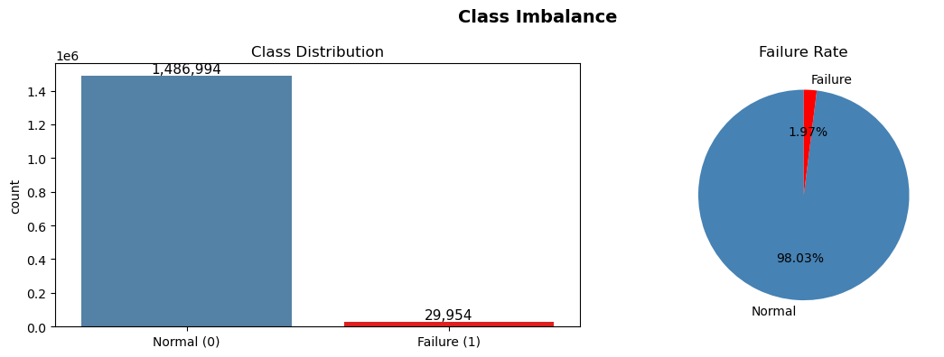
Difficult shit
- EDA
- Picture 1.png
- Picture 2.png
- Picture 3.png
- 4.png

- Baseline: random forest. chronological split: chronological_split.png
- Baseline: why use y_pred threshold : classification_report.png
- Baseline:
metrics.png
confusion_matrices.png
- election of the scores that are important
- undersample 50/50
- undesample 70/30
- oversample smote
- smotetomek
- feature engineering
- feature importance and correlation(feature_importance.png and correlation.png)
- Feature engineering: Hyperparameter Optimization with Time-Series Cross-Validation
- RandomizerSearchCV vs Optuna
- Results: best random forest metrics.png
- Future ideas
- Make a column one week before failure and make it target to predict failure and apply all what I learned
- Try other models like XGBoost or Light GBM
- May be try deep learning like LSTM or TabNet

