| Section Metadata | |
| --- | --- |
| style | content |



# Block Party

The Block Party is a place for the AEM developer community to showcase what they have built on AEM sites. It also allows others to avoid reinventing the wheel and reuse these blocks / code snippets / integrations built by the community and tweak the code as necessary to fit their own projects.

**Note: While we love and support our AEM developer community, Adobe is not responsible for maintaining or updating the code that is showcased in Block Party. Please use the code at your own discretion.**

If you are an AEM Developer and would like to submit your cool block / code snippet or integration, please enter your submission [using this form](https://www.aem.live/developer/block-party/submission).

| Card List |
| --- |
| [https://main--helix-website--adobe.hlx.page/developer/block-party/block-party.json?sheet=curated-list](/developer/block-party/block-party.json?sheet=curated-list) |

| Metadata | |
| --- | --- |
| name | card-list |

---

| Section Metadata | |
| --- | --- |
| style | content |

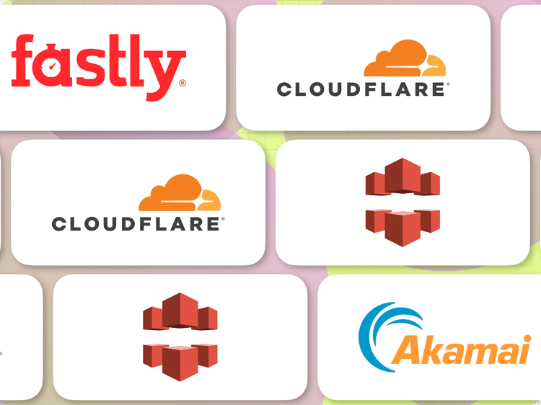

# BYO CDN Setup

Customers may use their own CDN to deliver AEM content under their own domain (aka *BYO Production CDN*). While customers are generally free to configure their CDN according to their own needs there are some settings mandated/recommended by Adobe Experience Manager:

* Origin url  
  https://main--<yoursite>--<yourorg>.aem.live
* Headers sent to origin
  + X-Forwarded-Host: <production domain>
  + X-Push-Invalidation: enabled  
    (see [Configuring Push Invalidation](https://www.hlx.live/docs/setup-byo-cdn-push-invalidation))
* Origin cache control  
  I.e. Cache TTL on the production CDN is controlled via origin cache control response headers. This should be enabled (if available).
* Compression (gzip)  
  Should be enabled
* Query parameters
  + Must be forwarded to origin
  + Must be included in cache key
* Age response header  
  The Age response header must be either suppressed or overridden (Age: 0)

## Vendor-specific setup instructions

If you already have a CDN, follow the instructions below. If you are not sure which CDN to pick, follow [our guide to CDN selection](/docs/cdn-guide).

| Card List (image-card-listing) | |
| --- | --- |
|  | [Cloudflare Worker Setup](/docs/byo-cdn-cloudflare-worker-setup) Learn how to configure Cloudflare to deliver content. |
|  | [Akamai Setup](/docs/byo-cdn-akamai-setup) Discover how to use the Akamai Property Manager to configure a property to deliver content |
|  | [Fastly Setup](/docs/byo-cdn-fastly-setup) This guide illustrates how to configure Fastly to deliver content. |
|  | [CloudFront Setup](/docs/byo-cdn-cloudfront-setup) Set up Amazon Web Services Cloudfront to deliver your AEM site with push invalidation |
|  | [Adobe-managed CDN](/docs/byo-cdn-adobe-managed) Use the CDN included in your Adobe Experience Manager Sites as a Cloud Service license. |

**IMPORTANT**: The production CDN setup should be validated and tested in a stage environment prior to going public.

**Note**: In case you have not yet completed the [upgrade from hlx.live to aem.live](/developer/upgrade), you can find links to the [hlx.live-specific versions of the CDN documentation here](/previous/byo-cdn-setup).

| Metadata | |
| --- | --- |
| name | card-list (image-card-listing) |