| Cards | | |
| --- | --- | --- |
| The tools your editors already know | The shortest learning curve for any CMS | No faster way to review content |

| Metadata | |
| --- | --- |
| name | cards |

---

| Section Metadata | |
| --- | --- |
| style | content |

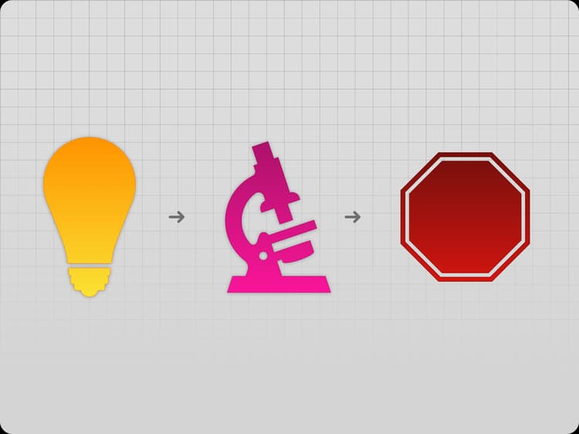

# Feature Lifecycle

Simplicity and productivity guide everything we do. To stay lean and fast, we’ve redefined our approach—focusing only on features that customers actively use.

**What does this look like?**

Edge Delivery Services follows a feature lifecycle, not a traditional roadmap. When our existing features don’t meet a business need, we collaborate with customers to develop a solution. If it gains traction across multiple customers, we productize it and monitor usage. When a feature is no longer actively used, we replace it with a better solution.

**Feature Lifecycle Components:**

* **Map of Interest** – A collection of business needs that cannot yet be met with our existing features.
* **Adobe-led Implementation** – Solutions developed in collaboration with customers to address a Map of Interest need.
* **Product Feature** – A fully productized feature, proven in real-world usage, and available as part of the product offering.
* **Deprecation** – Features no longer in use across our customer base are removed in favor of better alternatives.

This approach ensures Edge Delivery Services remains agile, customer-driven, and optimized for real-world needs.

<https://www.aem.live/docs/featurelifecycle.svg>

## Map of Interest

Through active collaboration and discussion with customers, our Map of Interest is populated. It represents a list of needs that are under consideration for solution development in partnership with a customer team.

1. “Bring your own Git” support for Bitbucket, Gitlab, GitHub Enterprise
2. Reviews and snapshots
3. "Bring your own Git" support for Azure DevOps

## Early-access technology

Recently added features now available for customer use.

| Cards (alternate, earlyaccess) | | |
| --- | --- | --- |
| [Experimentation](https://www.aem.live/docs/experimentation)  Experimentation is the practice of making your site more effective by changing content or functionality, comparing the results with the prior version, and picking the improvements that have measurable effects. | [Adobe Experience Manager Assets Sidekick Plugin](https://www.aem.live/docs/aem-assets-sidekick-plugin)  With the Experience Manager Assets Sidekick plugin, you can use assets from your Experience Manager Assets repository while authoring documents in Microsoft Word or Google Docs. | [Configuring Adobe Target Integration](https://www.aem.live/developer/target-integration)  This article will walk you through the steps of setting up an integration with Adobe Target so you can personalize your pages via the Adobe Target Visual Experience Composer (VEC). |
| [Getting Started – DA Developer Tutorial](https://www.aem.live/developer/da-tutorial)  Document Authoring (DA) is an alternative to SharePoint or Google Drive that provides a document-based authoring interface focused on the AEM Document model (Blocks, Sections, etc.). It provides an SDK, APIs, and built-in Adobe technologies. | [Configuring Adobe Experience Cloud Integration](https://www.aem.live/developer/martech-integration)  This article will walk you through the steps of setting up an integration with the Adobe Marketing Technology stack. The stack combines Adobe Experience Platform WebSDK, Adobe Analytics, Adobe Target or Adobe Journey Optimizer, Adobe Client Data Layer and Adobe Experience Platform Tags. | [Web Components](https://www.aem.live/developer/web-components)  Web Components are a collection of web standards that allow the creation and use of reusable, modular functionality in web sites and web apps. |

## Deprecations

Features that have been removed from the product based on lack of usage. See [Deprecation and end-of-service](/docs/deprecation) for features slated for removal

## Questions or Ideas?

Please contact the community via [Discord](https://discord.gg/aem-live).

| Metadata | |
| --- | --- |
| name | cards (alternate) |

---

| Section Metadata | |
| --- | --- |
| style | content |



# Feature Lifecycle

Simplicity and productivity guide everything we do. To stay lean and fast, we’ve redefined our approach—focusing only on features that customers actively use.

**What does this look like?**

Edge Delivery Services follows a feature lifecycle, not a traditional roadmap. When our existing features don’t meet a business need, we collaborate with customers to develop a solution. If it gains traction across multiple customers, we productize it and monitor usage. When a feature is no longer actively used, we replace it with a better solution.

**Feature Lifecycle Components:**

* **Map of Interest** – A collection of business needs that cannot yet be met with our existing features.
* **Adobe-led Implementation** – Solutions developed in collaboration with customers to address a Map of Interest need.
* **Product Feature** – A fully productized feature, proven in real-world usage, and available as part of the product offering.
* **Deprecation** – Features no longer in use across our customer base are removed in favor of better alternatives.

This approach ensures Edge Delivery Services remains agile, customer-driven, and optimized for real-world needs.

<https://www.aem.live/docs/featurelifecycle.svg>

## Map of Interest

Through active collaboration and discussion with customers, our Map of Interest is populated. It represents a list of needs that are under consideration for solution development in partnership with a customer team.

1. “Bring your own Git” support for Bitbucket, Gitlab, GitHub Enterprise
2. Reviews and snapshots
3. "Bring your own Git" support for Azure DevOps

## Early-access technology

Recently added features now available for customer use.

| Cards (alternate, earlyaccess) | | |
| --- | --- | --- |
| [Experimentation](https://www.aem.live/docs/experimentation)  Experimentation is the practice of making your site more effective by changing content or functionality, comparing the results with the prior version, and picking the improvements that have measurable effects. | [Adobe Experience Manager Assets Sidekick Plugin](https://www.aem.live/docs/aem-assets-sidekick-plugin)  With the Experience Manager Assets Sidekick plugin, you can use assets from your Experience Manager Assets repository while authoring documents in Microsoft Word or Google Docs. | [Configuring Adobe Target Integration](https://www.aem.live/developer/target-integration)  This article will walk you through the steps of setting up an integration with Adobe Target so you can personalize your pages via the Adobe Target Visual Experience Composer (VEC). |
| [Getting Started – DA Developer Tutorial](https://www.aem.live/developer/da-tutorial)  Document Authoring (DA) is an alternative to SharePoint or Google Drive that provides a document-based authoring interface focused on the AEM Document model (Blocks, Sections, etc.). It provides an SDK, APIs, and built-in Adobe technologies. | [Configuring Adobe Experience Cloud Integration](https://www.aem.live/developer/martech-integration)  This article will walk you through the steps of setting up an integration with the Adobe Marketing Technology stack. The stack combines Adobe Experience Platform WebSDK, Adobe Analytics, Adobe Target or Adobe Journey Optimizer, Adobe Client Data Layer and Adobe Experience Platform Tags. | [Web Components](https://www.aem.live/developer/web-components)  Web Components are a collection of web standards that allow the creation and use of reusable, modular functionality in web sites and web apps. |

## Deprecations

Features that have been removed from the product based on lack of usage. See [Deprecation and end-of-service](/docs/deprecation) for features slated for removal

## Questions or Ideas?

Please contact the community via [Discord](https://discord.gg/aem-live).

| Metadata | |
| --- | --- |
| name | cards (earlyaccess) |

---

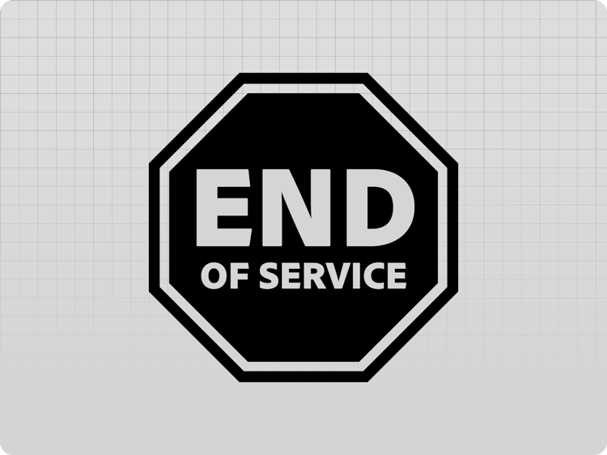

# Deprecations and End-of-Service

Features in AEM that are not used anymore, or have been replaced with better solutions will be removed. Before these features are removed, they are declared deprecated and we provide suggestions for possible replacements.

In the next step, Adobe posts an end-of-service date on this page. After the end-of-service date, the respective service or feature will no longer be available.

| Section Metadata | |
| --- | --- |
| style | content |

## *.hlx.live and *.hlx.page

The *.hlx.live and *.hlx.page domains **are deprecated** as of August 23rd, 2024 and [will be replaced with *.aem.live and *.aem.page](/blog/hlx-is-now-aem-live). Instructions for [upgrades to aem.live and aem.page are available](/developer/upgrade).

* **After February 14 2025, newly created sites will only be available on** aem.page **and** aem.live.
* **After December 18 2025,** hlx.page **and** hlx.live **will no longer be available.** We encourage you to upgrade before that.

## Feature Deprecations

| Cards (alternate, deprecated) | | |
| --- | --- | --- |
| [Custom domains without a custom CDN](https://www.aem.live/docs/byo-dns)  **Deprecation notice**  We no longer accept new domains for the Bring-your-own-DNS service. Please use Adobe Managed CDN. | [Cloudflare Setup (config only, no worker) for hlx.live](https://www.aem.live/previous/byo-cdn-cloudflare-setup)  **Deprecation notice**  This setup has been deprecated, we recommend to use the cloudflare worker setup instead. | [Manual Forms Sheet Setup](https://www.aem.live/docs/manual-forms-sheet-setup)  **Deprecation notice**  This feature has been deprecated and will be replaced by a dedicated Forms service in the near future. |
| [Configuring Site Authentication](https://www.aem.live/previous/authentication-setup-site)  **Deprecation notice**  IDP-based site authentication will no longer be supported on aem.page and aem.live. It will still be possible to enable token-based authentication, with self-service generation of site tokens using the config service. |  |  |

| Metadata | |
| --- | --- |
| name | cards (deprecated) |