| Section Metadata | |
| --- | --- |
| style | content |

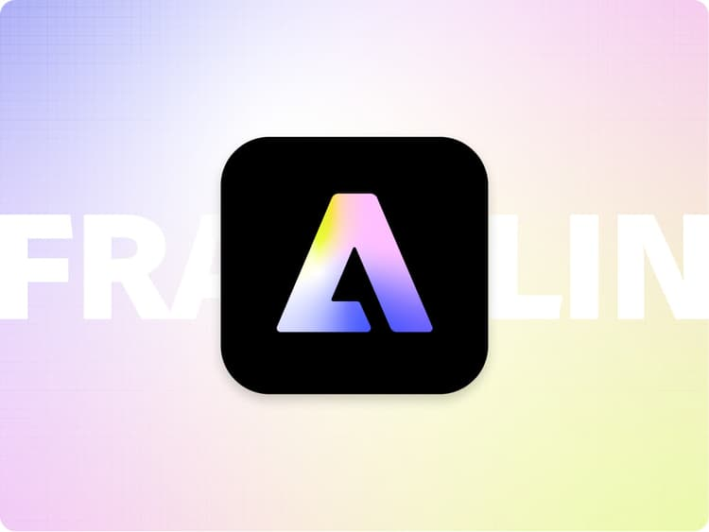

# AEM Block Party

With Block Party, we would like to give our passionate developer community a place to showcase what they have built on AEM sites. It also allows others to avoid reinventing the wheel and reuse these blocks / code snippets / integrations built by the community and tweak the code as necessary to fit their own projects.

**Note: While we love and support our AEM developer community, Adobe is not responsible for maintaining or updating the code that is showcased in Block Party. Please use the code at your own discretion.**

If you are an AEM developer and would like to submit your cool block / code snippet or integration, please enter your submission in the form below:

| Form |
| --- |
| [https://main--helix-website--adobe.hlx.page/developer/block-party/block-party.json](/developer/block-party/block-party.json) |

| Metadata | |
| --- | --- |
| name | form |