| Section Metadata | |
| --- | --- |
| style | content |



# Cloudflare Setup (with wrangler)

The following screenshots illustrate how to configure [Cloudflare](https://www.cloudflare.com/) using the wrangler command line interface to deliver AEM content. Essential settings are marked with a red circle.

## Create a Cloudflare site

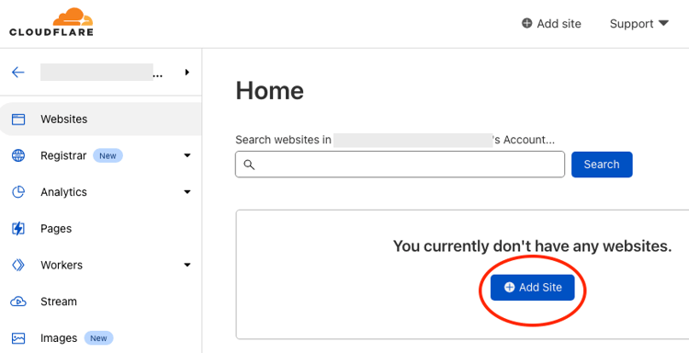

Enter the domain:  
  
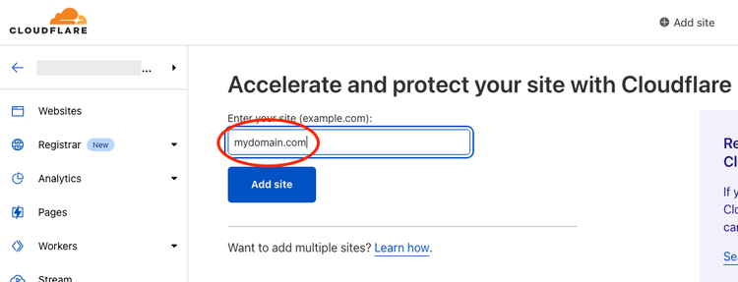

Select a plan:

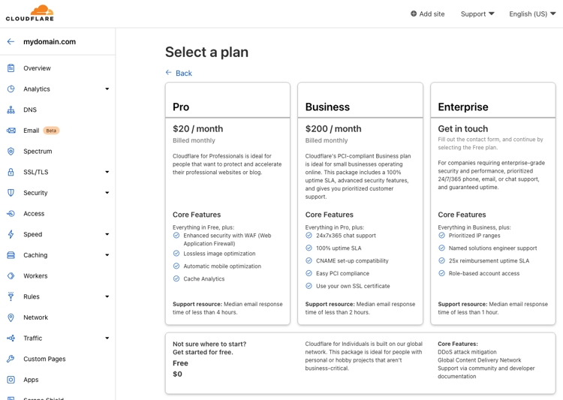

Note that surgical push invalidations are only supported on the **Enterprise** plan. On all other plans the entire cache of the site will be purged every time an author publishes a content change.  
  
For this walk-through we’ll use the [Free plan](https://www.cloudflare.com/plans/free/).

| Fragment |
| --- |
| [https://main--helix-website--adobe.hlx.page/docs/setup-byo-cdn-push-invalidation-for-cloudflare](/docs/setup-byo-cdn-push-invalidation-for-cloudflare) |

## DNS Setup

We’ll skip the DNS setup step as this would be beyond the scope of this simple walk-through. Make sure the CNAME record is [Proxied](https://developers.cloudflare.com/dns/manage-dns-records/reference/proxied-dns-records/):

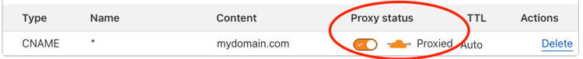

## SSL/TLS Setup

Select **SSL/TLS** from the left pane and **Edge Certificates** in the dropdown list:

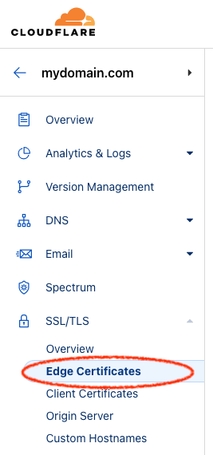

On the right side, scroll down to **Always Use HTTPS** and enable it:  
  
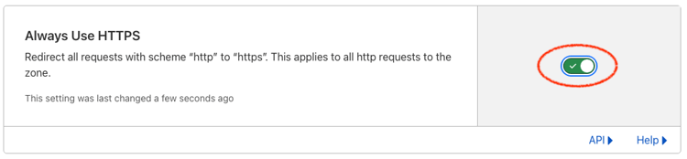

## Configure Caching

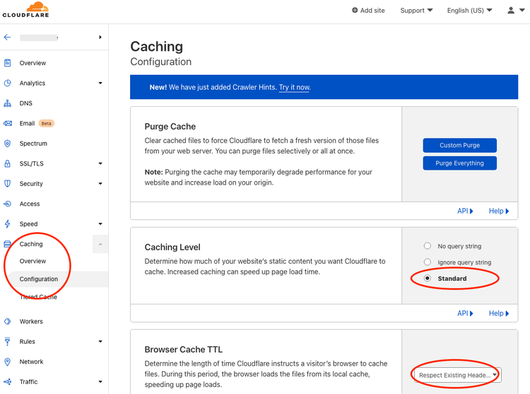

## Create Page Rule

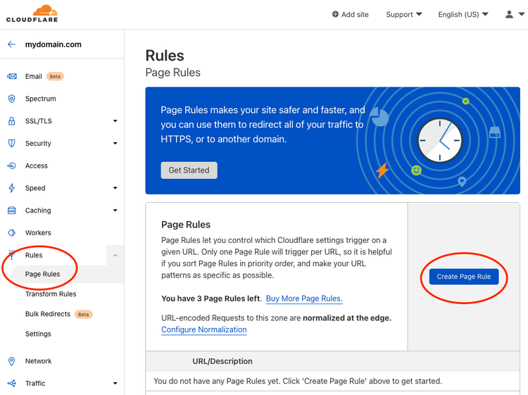

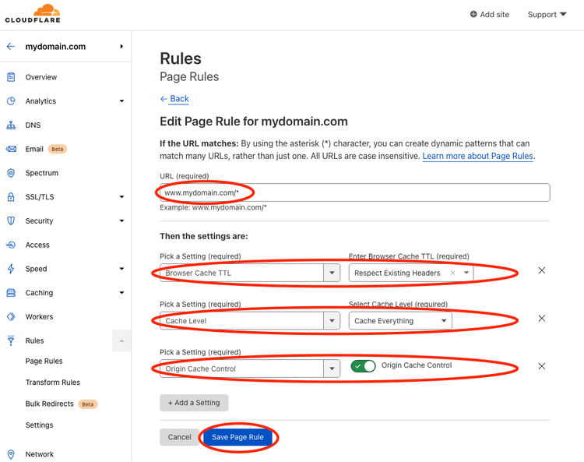

## Create Worker

Fork or create a new GitHub repository using this [template](https://github.com/adobe/helix-cloudflare-prod-worker-template).  
  
Clone the repository and follow the instructions in the [README](https://github.com/adobe/helix-cloudflare-prod-worker-template#readme). You can skip directly to [step 2](https://github.com/adobe/helix-cloudflare-prod-worker-template#2-edit-wranglertoml).  
  
After completing all steps you should be all set.

| Metadata | |
| --- | --- |
| name | fragment |