| Section Metadata | |
| --- | --- |
| style | content |



# Breadcrumbs

## Notes:

Breadcrumbs are a list of page titles and relevant links showing the location of the current page in the navigational hierarchy.

## Example:

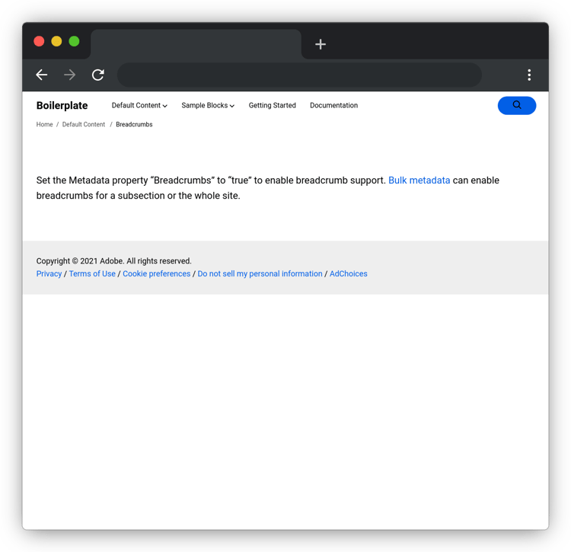

[See Live output](https://bit.ly/48T6Azl)

## Content Structure:

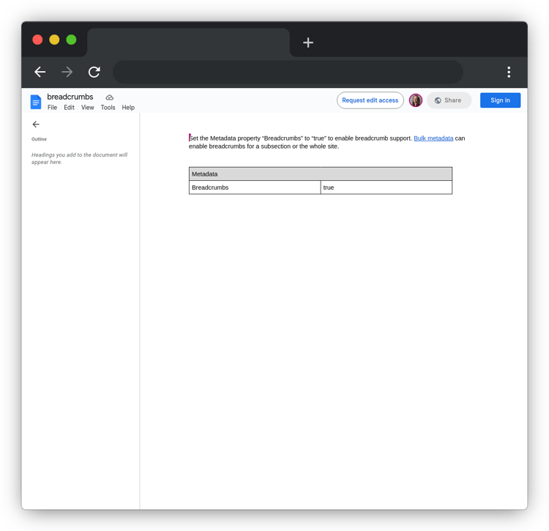

[See Content in Document](https://docs.google.com/document/d/1NQ7DHAzwJW-KzEZnyOGxRLlhDlv9jOc0lZhmSgMmD8E/edit)

## Code:

This code is included in the header block in AEM Block Collection, simply copying the .css file and the .js file will add this block to your project.

[Block Code](https://github.com/adobe/helix-block-collection/tree/main/blocks/header)

| Pagination (contained) | |
| --- | --- |
| Previous [Fragment](/developer/block-collection/fragment) | Up Next [Block Party](/developer/block-collection#block-party) |

| Metadata | |
| --- | --- |
| name | pagination |

---

| Section Metadata | |
| --- | --- |
| style | content |



# Breadcrumbs

## Notes:

Breadcrumbs are a list of page titles and relevant links showing the location of the current page in the navigational hierarchy.

## Example:



[See Live output](https://bit.ly/48T6Azl)

## Content Structure:



[See Content in Document](https://docs.google.com/document/d/1NQ7DHAzwJW-KzEZnyOGxRLlhDlv9jOc0lZhmSgMmD8E/edit)

## Code:

This code is included in the header block in AEM Block Collection, simply copying the .css file and the .js file will add this block to your project.

[Block Code](https://github.com/adobe/helix-block-collection/tree/main/blocks/header)

| Pagination (contained) | |
| --- | --- |
| Previous [Fragment](/developer/block-collection/fragment) | Up Next [Block Party](/developer/block-collection#block-party) |

| Metadata | |
| --- | --- |
| name | pagination (contained) |