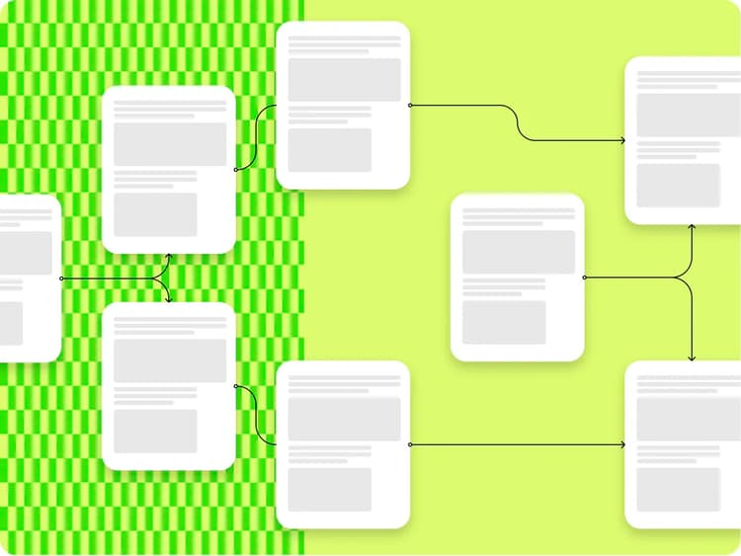

# Recent Releases

Please find a current list of recent releases of various components of AEM below. This information is directly pulled from our code repositories and some of the information is in public repositories and other aspects are considered internal, beyond the summary release information. If you would like to get more information on a particular release please let us know, so we can consider adding more public detail or release more information to you as a customer, if we consider the information internal.

| Section Metadata | |
| --- | --- |
| style | content |

| Releases |
| --- |
| <https://aem-release-feed.david8603.workers.dev/> |

| Metadata | |
| --- | --- |
| name | releases |